Pharmacy Information System (PhIS)
and
Clinic Pharmacy System (CPS)

Clinical Mobile Configuration
Version : v1.1
Document ID : Clinical_Mobile_Configuration
Version : 0.1
Document ID : PhIS_CPS/USERGUIDE/INV(BDGT)
© 2011-2019 Pharmacy Information System & Clinic Pharmacy System (PhIS& CPS) Project

CONFIDENTIAL COPYRIGHTED MATERIAL – The information includes all concepts, comments, recommendations, and material, contained herein shall remain the property of Pharmacy Information System & Clinic Pharmacy System (PhIS & CPS) Project. No portion of this document shall be disclosed, duplicated or used in whole or in part of any purpose other than the purpose of the Pharmacy Information System & Clinic Pharmacy System (PhIS & CPS) Project execution only.

Application reference: PhIS & CPS v2.1

Installation – Clinical Mobile
User first need to install Clinical Mobile application from valid URL as the steps below:

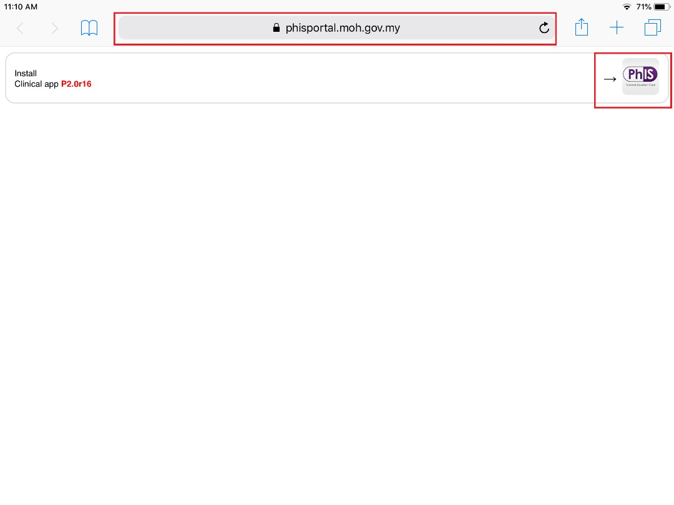  Figure 1.0-1 Clinical Mobile Installation on Browser (URL)  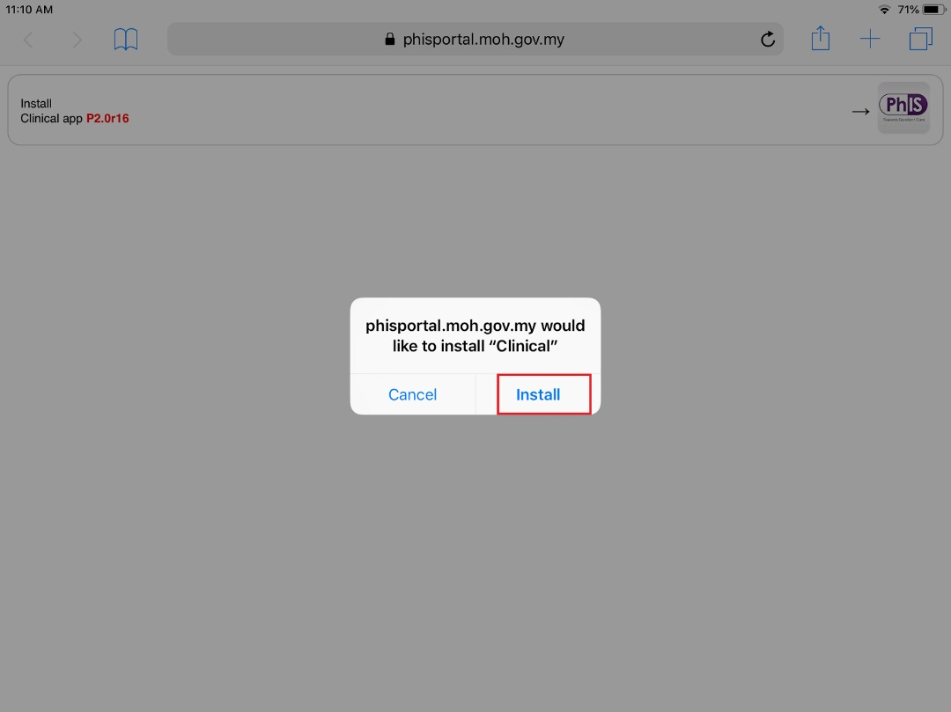  Figure 1.0-2 Clinical Mobile Installation on Browser (Install)  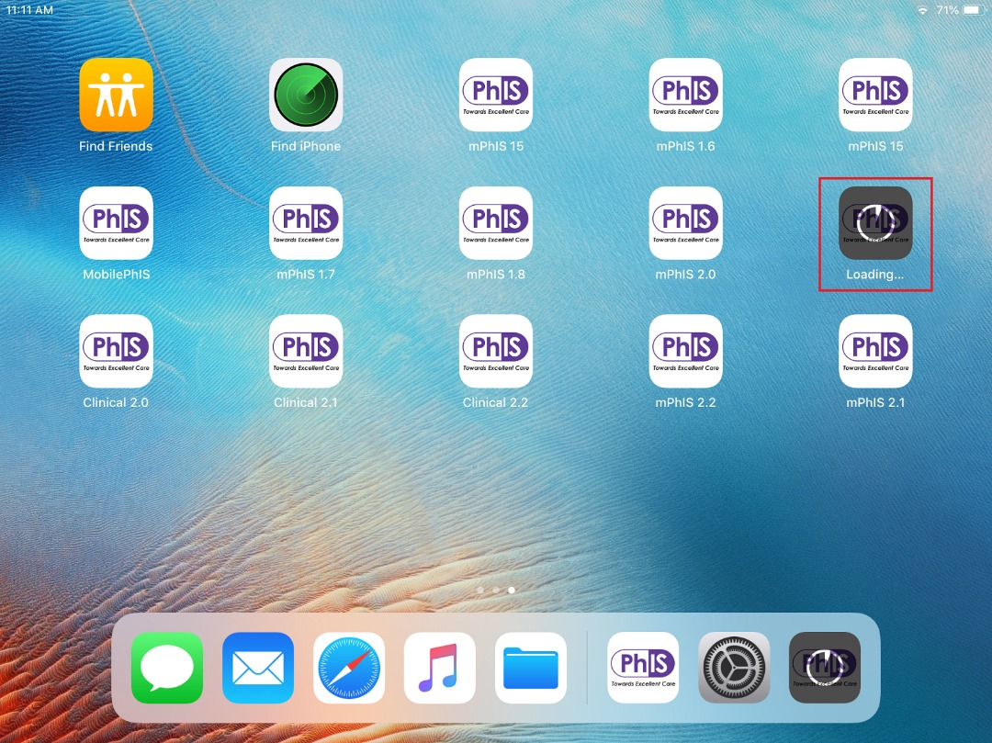  Figure 1.0-3 Clinical Mobile Installation on Browser (Load)  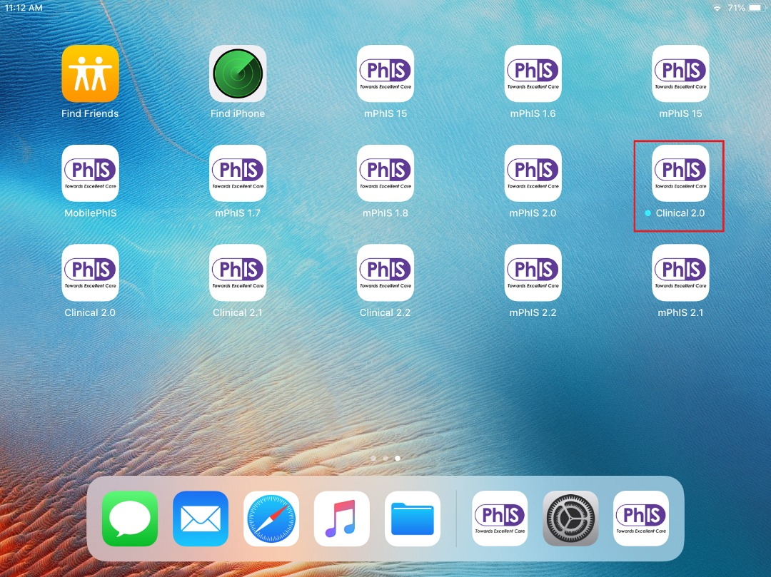  Figure 1.0-4 Clinical Mobile Installation on Browser (Successfully Installed) | Clinical Mobile Installation  This is required once new clinical mobile version is available  STEP 1  Open Browser and enter valid URL  https://phisportal.moh.gov.my/clinical/  Browser shall display Clinical Mobile PhIS Installation page as “Figure 1.0-1 Clinical Mobile Installation on Browser (URL)”. Tap on PhIS logo to continue.  STEP 2  Click on ‘Install’ to install new clinical mobile version. iPad shall load clinical mobile version as “Figure 1.0-3 Clinical Mobile Installation on Browser (Load)”.  STEP 3  Once iPad is finished downloaded and installed, the complete PhIS icon will be displayed as “Figure 1.0-4 Clinical Mobile Installation on Browser(Successfully Installed)”  STEP 4  Clinical mobile version is successfully downloaded and installed.

Trusted Application – Clinical Mobile
User need to trust Clinical Mobile application in order to use the application. The steps as below:

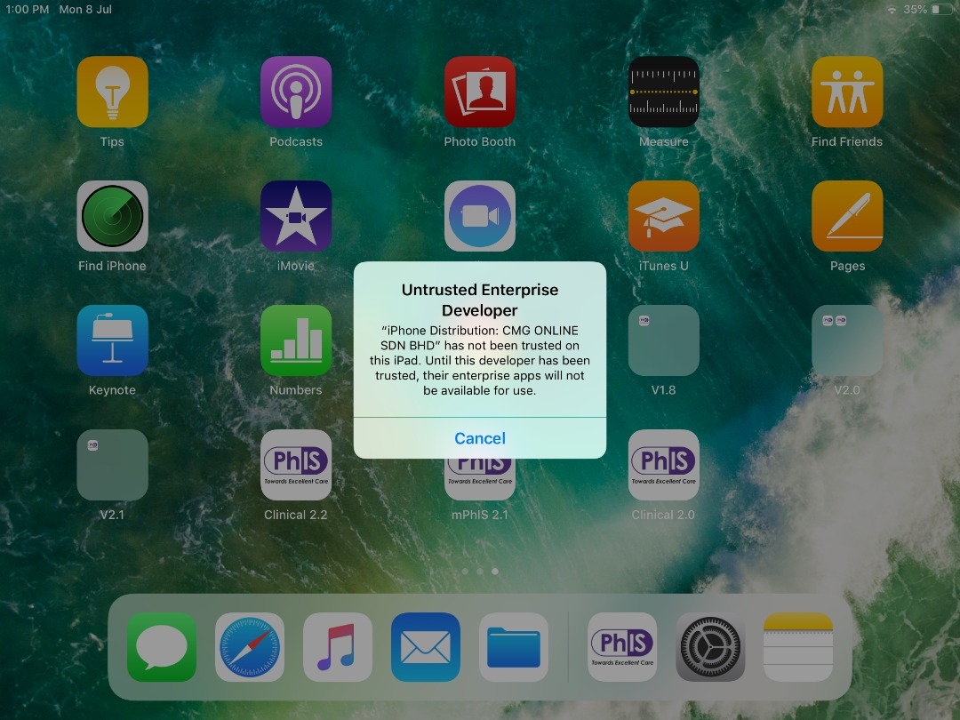  Figure 2.0-1 Clinical Mobile Untrusted Enterprise Application  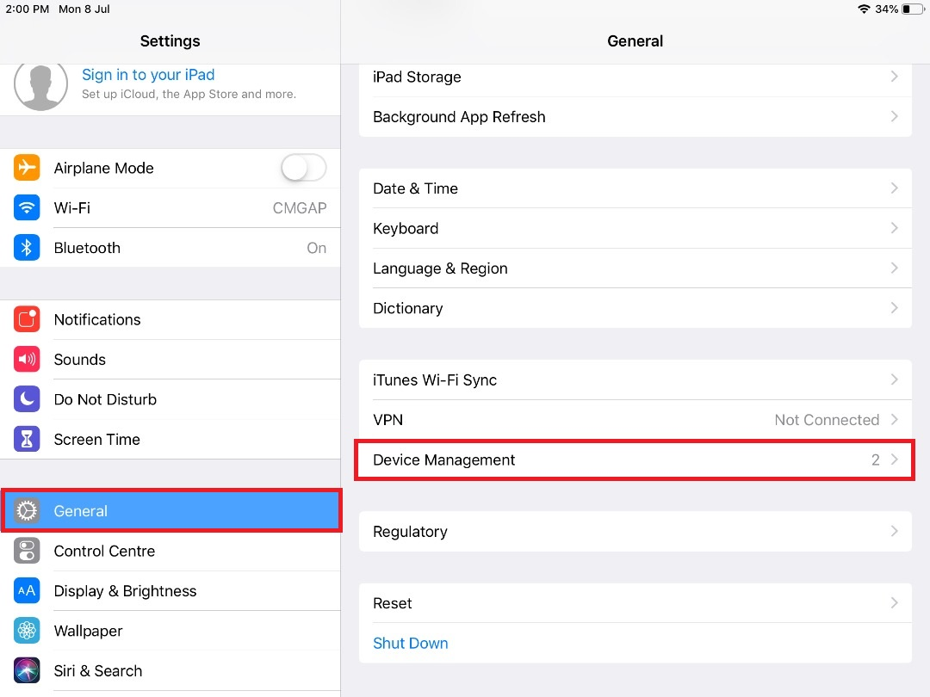  Figure 2.0-2 Settings > General > Device Management  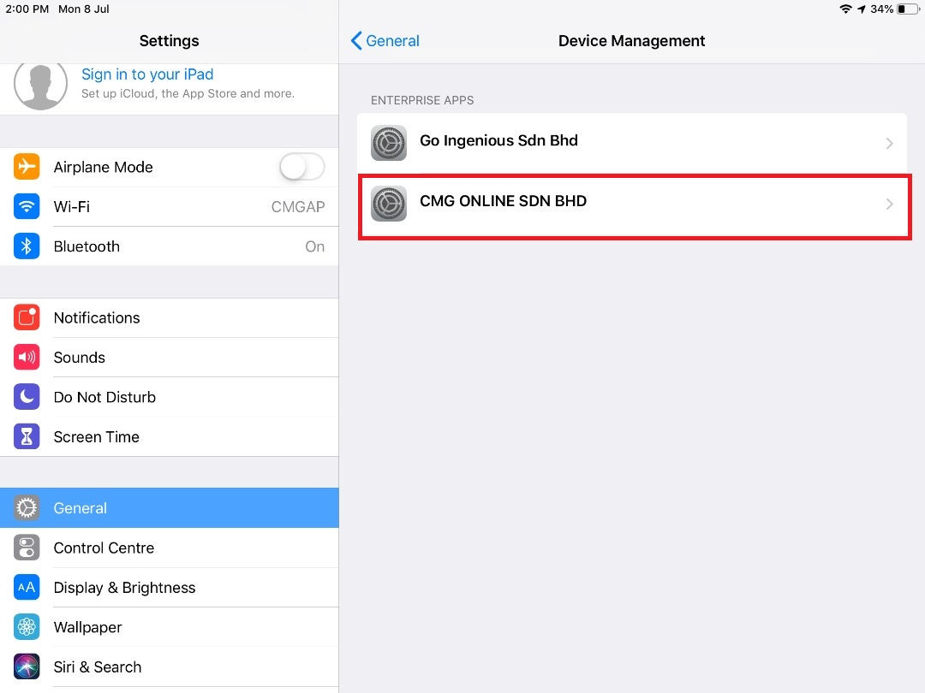  Figure 2.0-3 Settings > General > Device Management > Enterprise Apps  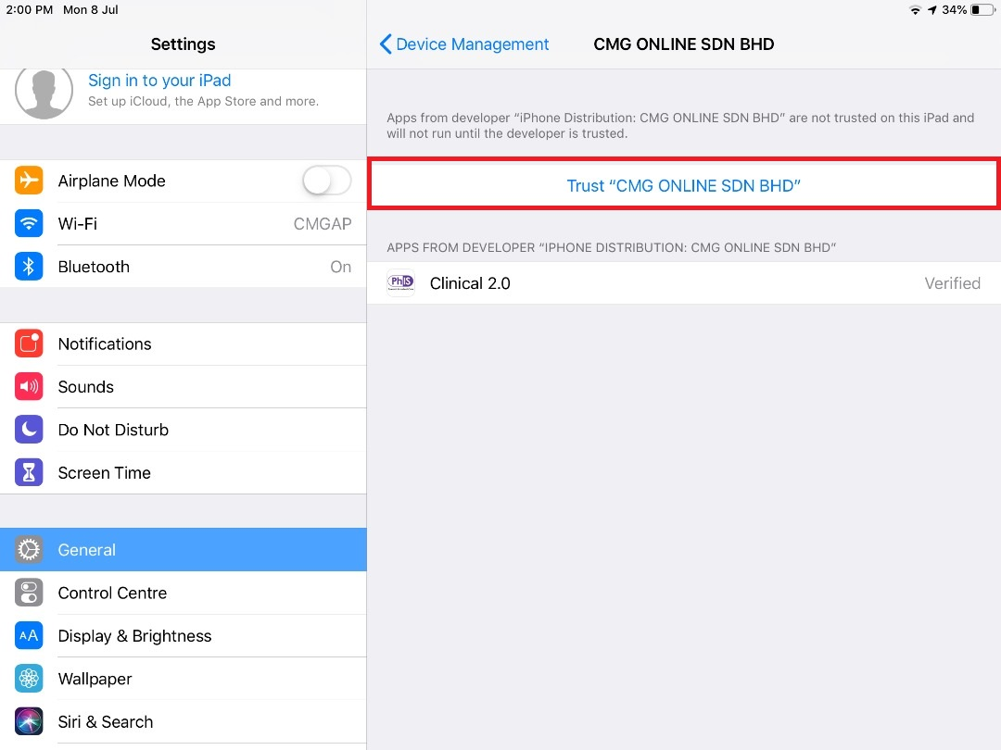  Figure 2.0-4 Settings > General > Device Management > Enterprise Apps > Trust Apps  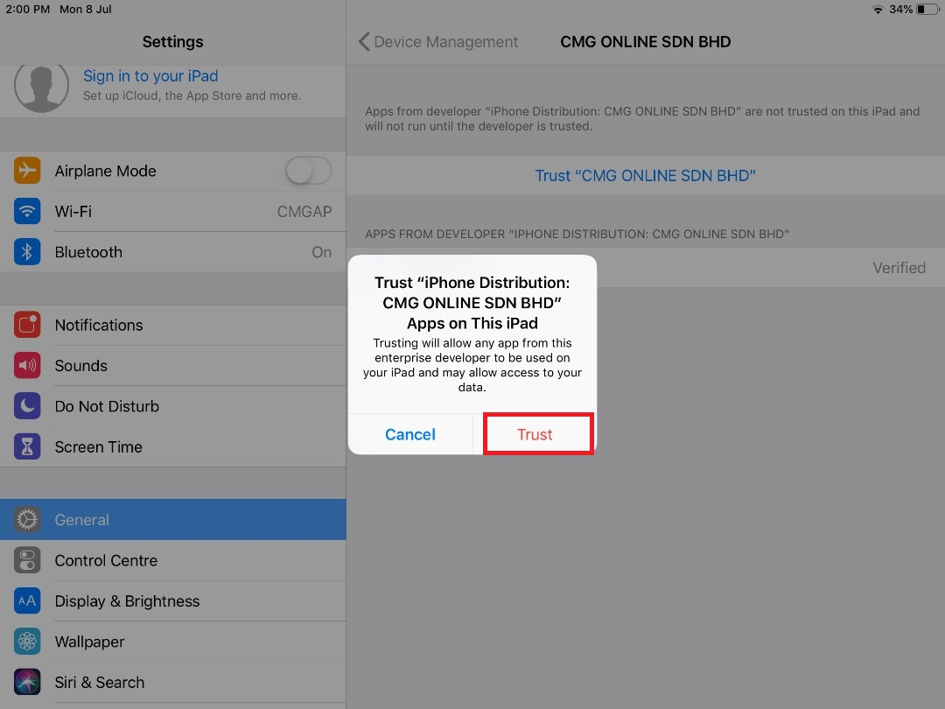  Figure 2.0-5 Settings > General > Device Management > Enterprise Apps > Trust Apps > CMG Online | Clinical Mobile Trusted Application  If user have not downloaded an app before and it is not in the App Store, user will be prompted as “Figure 2.0-1 Clinical Mobile Untrusted Enterprise Application” when clicking on PhIS icon (First time user).  STEP 1  To trust application, tap Settings > General > Device Management.  Screen shall display Device Management setting as “Figure 2.0-2 Settings > General > Device Management”. Tap on Device Management to continue.  STEP 2  Screen as “Figure 2.0-3 Settings > General > Device Management > Enterprise Apps” will be displayed once tapping on Device Management. Tap on ‘CMG ONLINE SDN BHD’ inside Enteprise Apps section. iPad shall display ‘Trust ‘CMG ONLINE SDN BHD’’ as “Figure 2.0-4 Settings > General > Device Management > Enterprise Apps > Trust Apps”.  STEP 3  Tap on Trust ‘CMG ONLINE SDN BHD’ to continue. Alert message like in “Figure 2.0-5 Settings > General > Device Management > Enterprise Apps > Trust Apps > CMG Online” will be displayed.  STEP 4  Tap on Trust to trust CMG Online Sdn Bhd application. Now clinical mobile app is successfully trusted on iPad.

Login to PhIS – Clinical Mobile
Before can login into the system, user need to perform the configuration steps as below:

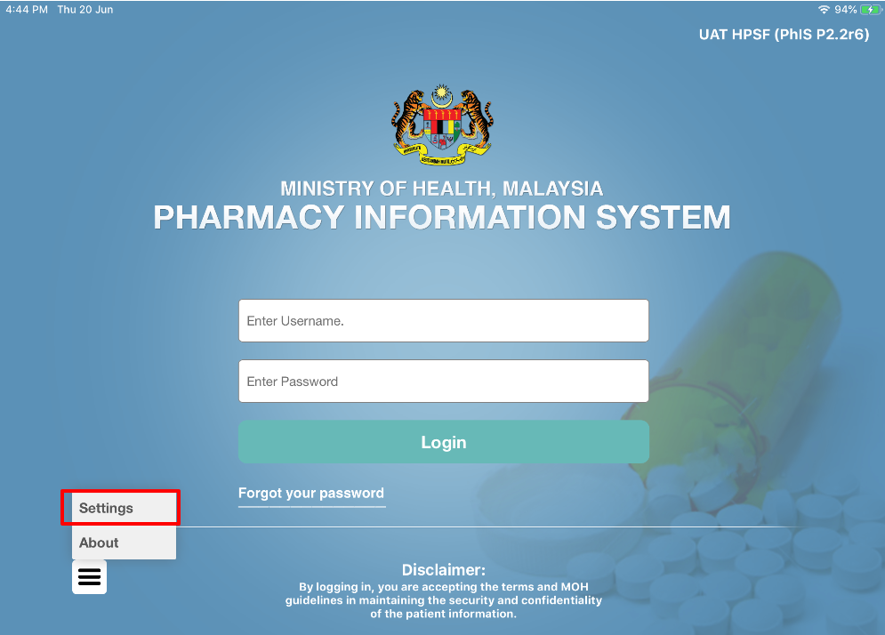  Figure 3.0-1 Clinical Mobile Login Page  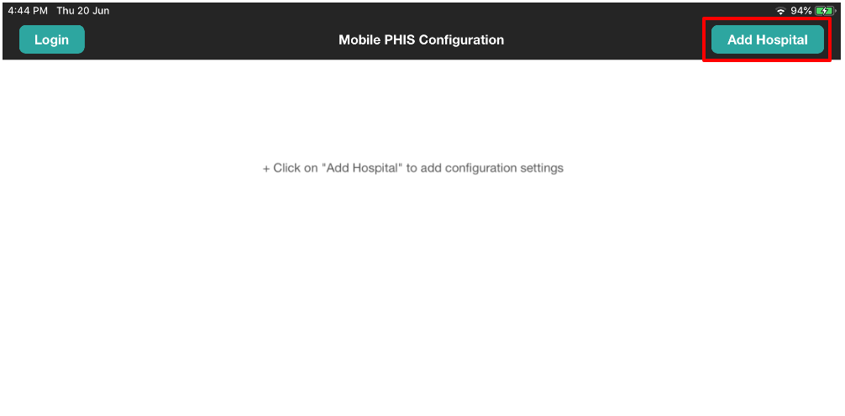  Figure 3.0-2 Mobile PhIS Configuration  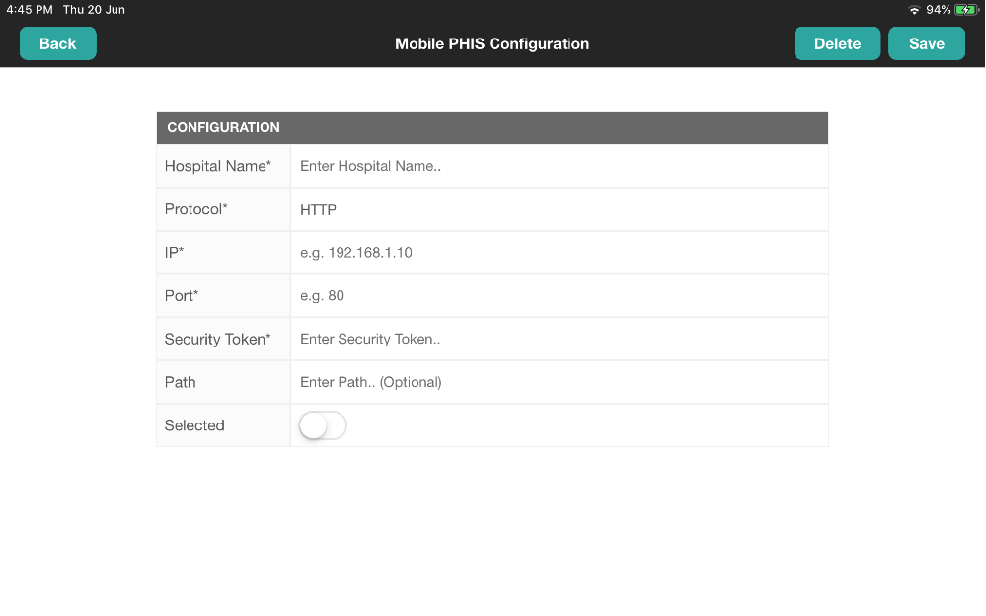  Figure 3.0-3 Mobile PhIS Configuration  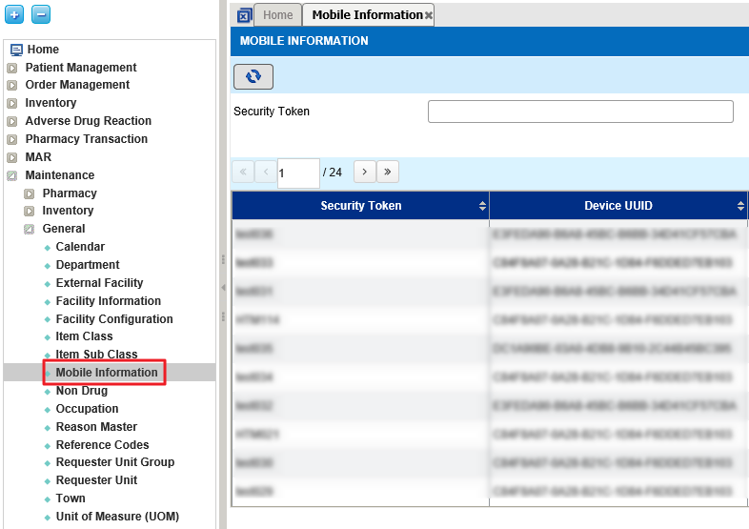  Figure 3.0-4 PhIS Main Menu  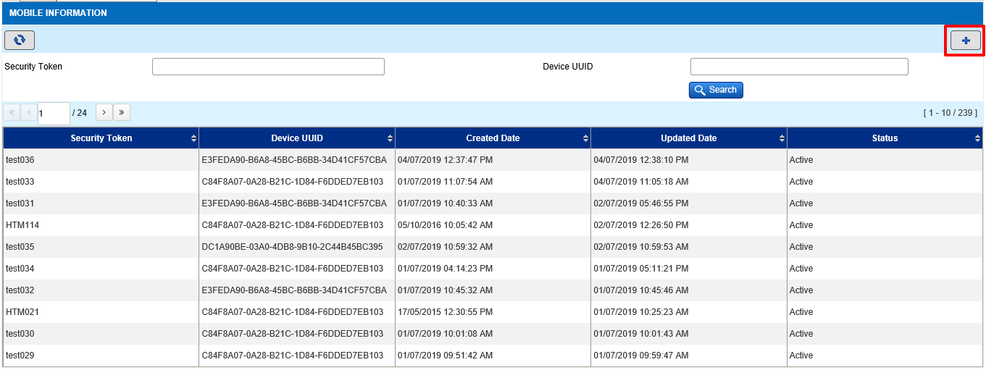  Figure 3.0-5 PhIS Web Application – Mobile Information listing  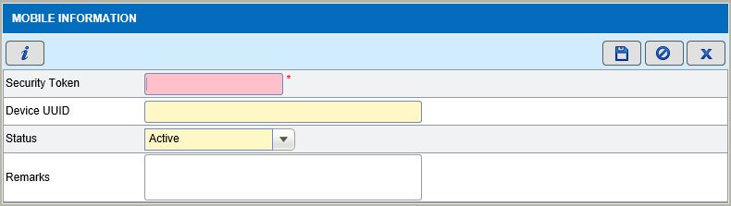  Figure 3.0-6 PhIS Web Application - Mobile Information Details  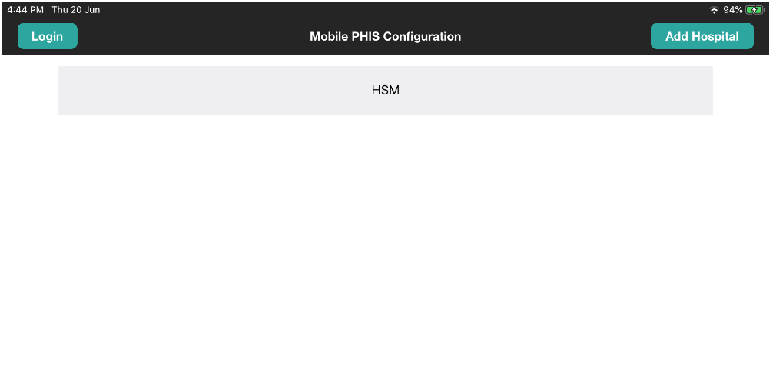  Figure 3.0-7 Mobile PhIS Configuration | Clinical Mobile Configuration  This is one time configuration only  STEP 1  Click on ‘Setting’ at the bottom of Clinical Mobile Main page  Application shall display Mobile PhIS Configuration page as “Figure 3.0-2 Mobile PhIS Configuration”  This page shall list all the Hospital/ facility which has been set before  STEP 2  Click on ‘Add Hospital’ to setup new Hospital/ facility  In this page user need to configure by fill in below information:  STEP 1  Fill in Hospital Name  STEP 2  Fill in the ‘Protocol’ as “HTTP”  STEP 3  Fill in the ‘IP’ details. IP details shall be refer to facility “Domain Name” from screen Facility Information at PhIS Web application.  Maintenance>General>Facility Information  STEP 4  Fill in the ‘Port’ details as 8080  STEP 5  Fill in the ‘Security Token’ details  Note:  Security token shall be created from PhIS Web application. Step; refer to ‘PhIS Web Application’  STEP 6  ‘Path’ shall be leave as blank  STEP 7  Tap on ‘Selected’ button, to make it as a default facility configured for this Ipad.  STEP 8  Tap on Save button  PhIS Web Application  STEP 1  Login as Administrator  STEP 2  Go to Maintenance General Mobile Information  System shall open screen for ‘Mobile Information’  Refer to (Figure 3.0-5 PhIS Web Application – Mobile Information listing)  STEP 3  Click on ‘Add’ button  System shall display ‘Mobile Information’ Screen details  STEP 4  Key in the ‘Security Token’  Note:  Security Token must be unique  STEP 5  Click on Save button  Note:  ‘Device UUID’ shall be appear after user successfully key In security token at Mobile PhIS Configuration.  Facility configuration has been successfully configured

