Pharmacy Information System (PhIS)
and
Clinic Pharmacy System (CPS)

Release Note
For version 1.2.2.6 (7)

Version : 1.0
Document ID : PhIS_CPS/ReleaseNote/Refinement/13062014

© 2011-2014 Pharmaniaga Logistics Sdn Bhd (PLSB)

CONFIDENTIAL COPYRIGHTED MATERIAL – The information includes all concepts, comments, recommendations, and material, contained herein shall remain the property of Pharmaniaga Logistics Sdn Bhd (PLSB). No portion of this document shall be disclosed, duplicated or used in whole or in part of any purpose other than the purpose of the Pharmacy Information System & Clinic Pharmacy System (PhIS& CPS) Project execution only.

Revision History

Version No | Date of Release | Prepared by | Reviewed / Verified by | List of changes from Previous Version
1.0 | 13/06/2014 | Kee Tuan Hwa | Chew Ming Ping | First Version

Verified and Acknowledged by:
Name | Role/Designation | Organization | Signature & Date
Chew Ming Ping | Team Leader – SA & QC | Pharmaniaga Logistics Sdn Bhd
Wilson Chan | Team Leader - Development | Pharmaniaga Logistics Sdn Bhd
Hoh Choon Seng | Project Manager | Pharmaniaga Logistics Sdn Bhd

Name | Role/Designation | Organization | Signature & Date
 |  | Bahagian Perkhidmatan Farmasi (BPF), KKM
 |  | Bahagian Pengurusan Maklumat (BPM), KKM

Peer Review
Version No | Reviewed / Verified by | List Of Changes from Previous Version
1.0 | Juridah (QA) | Initial document

1 Introduction 1
1.1 Project Information 1
1.2 Objectives 1
2 Purpose 2
3 Summary – Refinement and Defect List 3
3.1 Refinement List 3
3.1.1 Hospital Pakar Sultanah Fatimah 3
3.1.2 KK Greentown 5
3.1.3 HQ - IWP 6
3.2 Resolved Defect List 7
3.2.1 Hospital Pakar Sultanah Fatimah 7
3.2.2 HQ - IWP 18
4 Refinement List – Detail Changes 21
4.1 P-PhIS001609414 & R-PhIS001609314 21
4.2 R-PhIS001607314 22
4.3 R-PhIS001613314 23
4.4 R-PhIS001611414 23
4.5 R-PhIS001651314 24
4.6 I-PhIS007054214S 26
5 Deployment - Procedures 28
5.1 List of Items to be Deployed 28
5.2 Backup Procedure before Deploy 28
5.2.1 Backup Procedure 28
5.3 Deployment/Installation Guidelines 29
5.3.1 Deployment at Facility 29
5.3.2 Deployment at HQ - IWP 29

Introduction

Project Information

Project ID : | PhIS and CPS
Project Name : | Pharmacy Information System and Clinic Pharmacy System
Version No : | 1.2.2.6 (7)
Client Name : | Ministry of Health
Release ID : | RL14/008
Release Date : | 13/06/2014

Objectives
No. | Objective | Reference
1. | Release PhIS & CPS Application to Facility | Refer Section 3 – Refinement and Defect list

Purpose
The purpose of the document is to update the end-user of the changes and defects have been resolved to be included in the new version of application and will be deployed to production server.
This document outlines the list of request and issue to be delivered in the newer version of application and also the guidelines on how to deploy the new version of application in production.

Summary – Refinement and Defect List

Refinement List
The following are the summary of refinement list that included in PhIS and CPS version 1.2.2.6 (7).

Hospital Pakar Sultanah Fatimah
No | Ticket No. | Module | Reported Date | Description | Additional Information | Solution | Resolved Date | Verify Status
1 | P-PhIS001609414 | Pharmacy Inventory | 5/6/2014 | Distribution - Offline Issue : Request for Offline issue (internal and own consumption) when search item code , those item with 0 quantity still allow to be display at listing page but should not allow to issue the quantity due to quantity is 0. The purpose to avoid the confusion at user level because currently whenever they search an item and the item is stock is 0 , it will not populate at listing page so they taught the item not exist in unit catalogue, so a bit troublesome to the user to log out and log in.  *for more info,pls refer to sham | No remarks given | Remove filtering, and add validation for 0 available quantity.  Refer screenshot at 4.1 | 13/6/2014
2 | R-PhIS001607314 | Pharmacy Inventory | 5/6/2014 | User request for stock adjustment module for option Routine Checking, need to Add Expiry Date and Quantity during down batch no. Login ID : 750214015762 |  | Add display field  Refer screenshot at 4.2 | 13/6/2014
3 | R-PhIS001609314 | Pharmacy Inventory | 5/6/2014 | Distribution - Offline Issue : Request for Offline issue (internal and own consumption) when search item code , those item with 0 quantity still allow to be display at listing page but should not allow to issue the quantity due to quantity is 0. The purpose to avoid the confusion at user level because currently whenever they search an item and the item is stock is 0 , it will not populate at listing page so they taught the item not exist in unit catalogue, so a bit troublesome to the user to log out and log in. | same as P-PhIS001609414 | Remove filtering, and add validation for 0 available quantity  Refer screenshot at 4.1 | 13/6/2014
4 | R-PhIS001613314 | Adverse Drug Reaction (ADR) | 6/5/2014 | Request: (DAC Registry) at the listing screen, to add new filtering rule. Filter record by “Status”. |  | (DAC Registry) at the listing screen, added new filtering rule. Filter record by “Status”.  Refer screenshot at 4.3 | 13/6/2014
5 | R-PhIS001611414 | Adverse Drug Reaction (ADR) | 6/5/2014 | Request to allow delete record when the ADR record is not yet verified/confirmed. In the case of wrongly entered data.  Time: 5.30 pm, 04/06/2014 | QC Note :  Add 'Delete' button in Add Drug Detail screen. | Added Delete Functionality to allow delete record when the ADR record is not yet verified/confirmed  Refer screenshot at 4.4 | 13/6/2014

Verified and Acknowledged By:
Signature: |  | Name:
Date: |  | Designation:
Signature: |  | Name:
Date: |  | Designation:

KK Greentown
No | Ticket No. | Module | Reported Date | Description | Additional Information | Solution | Resolved Date | Verify Status
1 | R-PhIS001651314 | Pharmacy Inventory | 11/6/2014 | System should allow level 1 user to see units from level 2 and level 3.  Meanwhile level 2 user only able to see units from level 3.  **HIGH Priority | Additional function from R-PhIS001591314 | Able to view and issue item to the requester unit that same or lower level  Refer screenshot at 4.5 | 13/6/2014

Verified and Acknowledged By:
Signature: |  | Name:
Date: |  | Designation:
Signature: |  | Name:
Date: |  | Designation:

HQ - IWP
No | Ticket No. | Module | Reported Date | Description | Additional Information | Solution | Resolved Date | Verify Status
1 | I-PhIS007054214S | Pharmacy Inventory | 5/6/2014 | Distribution Module-Main Store level, allow to issue out based on SKU or PKU (Applicable at Offline Issue screen and RIQ screen). By default the value will be in PKU and the quantity suggested is in conversion factor. The quantity issued out must based on the PKU and conversion factor. IF the selection is in SKU, then allow user to issue out from main store in SKU and no need to be based on conversion factor. Issue out can be in loose quantity based on the indent quantity. At Sub store level â€“ Default UOM for Offline issue and RIQ is only in SKU. Make it the UOM field dimmed from allow user to select. | P-PhIS001645714 | Provide flexibility to main store to issue either PKU or SKU  Refer screenshot at 4.5 | 13/6/2014

Verified and Acknowledged By:
Signature: |  | Name:
Date: |  | Designation:
Signature: |  | Name:
Date: |  | Designation:

Resolved Defect List
The following are the summary of resolved defect list that included in PhIS and CPS version 1.2.2.6 (7).

Hospital Pakar Sultanah Fatimah
No | Ticket No. | Module | Reported Date | Description | Additional Information | Root Caused | Resolved Date | Verify Status
1 | I-PhIS006948514 | Pharmacy Inventory | 23/5/2014 | Physical checking wrong spelling in physical checking information screen. | To get the detail | Spelling issue | 13/6/2014
2 | I-PhIS006982514S | Outpatient Pharmacy | 27/5/2014 | User reported that the dose should be 1.25ml instead of 1 1/4ml. Details as below :  MRN : HPSF00016653  Item : ERYTHROMYCIN ETHYLSUCC 400mg/5ml SUSP | Username : 851220145814  Name : Tan Sui Lim | By dosage form of the drug when printing drug label | 13/6/2014
3 | I-PhIS006991714S | Order Management - Mobile | 28/5/2014 | Error displayed when doctor try to search for drug start with 'Hydro' (e.g.:Hydrocortisone Sodium Succinate 100mg Inj)  No issue when search for the same drug in web.  Doctor Name : Dr. Yia Hua Jern  User ID : 720302015095 | Reported by SA team Zainura Said.  Issue reported by user today around 5pm.  P-PhIS001579414 | Null data causing NullPointerException | 13/6/2014
4 | I-PhIS006995714S | Order Management - Mobile | 29/5/2014 | Doctor Name : Nuratiqah Binti Mohd Jalil  ID : 880116145702  Patient Name : Mardyah Binti M.Nasir  MRN : HPSF00018037  Order Management > Medication Order  User report unable to view prescribe medication history for particular patient using Ipad. PC can view, no problem.Ordered 7 drug and can view from pc,in ipad show unable to connect to server | Reported by Meziane Musa(Helpdesk) at HPSF  *Unable to provide incident time  P-PhIS001575514 | Null data causing issue in hibernate because of not-nullable type boolean of the field | 13/6/2014
5 | I-PhIS007015714S | Pharmacy Inventory | 1/6/2014 | User reported system display wrong number of data after user edit any one of the records.  Replication Step:  1) Open Unit Catalogue list and search for ward 8 records.  2) Filter Item Group = All, system will display 267 records.  3) Filter Item Group = Drug, system will display 149 records.  4) Click on 1 any item record and then edit and Save the record. Close the record.  5) System will go back to the previous screen and show Item Group = Drug with 267 records instead of 149 records.  6) System should display record with Item Group = Drug only since user already filters to search for â€˜Drugâ€™ earlier.  User ID : 881212235032 (Koh Chia Yan)  Location : Ward 8  Time: 12.00pm | reported by Norlaileza (SA). Refer attachment for details.  P-PhIS001569314 | List was not rendered after the Item Content Update | 13/6/2014
6 | I-PhIS007019714S | Order Management - Mobile | 1/6/2014 | Doctor unable to view ward 2 Isolation patient list on mobile version.  User: Dr.Surinder  User ID:880919235648  Date:01/06/2014  Time:2pm | Reported by Syazwan (SIT)-unable to provide image for attachment.  P-PhIS001573414 | Not filtered by "visit department should be same as prescriber department" | 13/6/2014
7 | I-PhIS007041714S | Inpatient Pharmacy | 4/6/2014 | Screening and Verification - User reported when allocate manually, the Item Batch Details shows no info. Error message Please do setup for dispense UOM was prompted when user exit from the item batch details screen.  Pharmacist: Koh Chia Yan  ID: 881212-23-5032  Drug name: Rifanpicin.  Patient name: Bista Shambhu.  MRN: HPSF00017677. | Reported by : Hisyam SIT team  Issue occurred around 10pm 03/06/2014  P-PhIS001597514 | Missing value for Dispense UOM inside Drug Master | 13/6/2014
8 | I-PhIS007041814S | Inpatient Pharmacy | 4/6/2014 | User reported unable to alternate drug. Edit Supply Duration to '7' days and Quantity per dose to '1', but the allocation quantity is not Auto changed.  Pharmacist: Koh Chia Yan.  ID: 881212-23-5032.  Drug name: Salbutamol 200mcg Inhalation Powder.  Patient name: Lim Eng. | Reported by : Asyran SIT team  Issue occurred around 1:30am 04/06/2014  P-PhIS001597314 | Previously the system consider the Frequency of Admin value inside Frequency | 13/6/2014
9 | I-PhIS007041914S | Inpatient Pharmacy | 4/6/2014 | User reported that unable to dispense drugs for a patient. When user login to dispense drugs and select the patient's name in Screening and verification, a notification Order is hold by prescriber, you cannot proceed with verification appeared. According to user, doctor hold only 1 drug: Azithromycin 250mg tablet/Frequency: Stat., for the patient.  Pharmacist: Koh Chia Yan  ID: 881212-23-5032  Doctor: Dr Raja Muhahad Fadhlan bin Raja Rosly  ID: 870806-14-5823  Patient's name: Quek Long Peow  MRN: HPSF00019144 | Reported by : Hisyam SIT team  Issue occurred around 4:30am 04/06/2014  P-PhIS001597414 | System hold the order instead of drug | 13/6/2014
10 | I-PhIS007047714S | Manufacturing - CDR | 4/6/2014 | In MOH HQ for CDR Regimen, drug already set as no diluent, but in order screen, diluent/diluent volume/infuse over still auto-default (based on drug master). Expected Result: Default value in order screen, should based only on CDR Regimen, if no value setup in CDR Regimen, then display as empty in order screen. No need to default based on drug master for CDR diluent/diluent volume/infuse over. Example Drug: Vincristine. Example Regimen: CDROT00001 | Issue reported by Ilya Syarah (SA)  Location: Farmasi Bekalan Wad  Time: 4.00 pm, 04/06/2014  Module: CDR Order  P-PhIS001605314 | Data extract from wrong master data | 13/6/2014
11 | I-PhIS007051714S | Adverse Drug Reaction (ADR) | 5/6/2014 | Time: 5.30 pm, 04/06/2014  Module: ADR Reporting  Username/Password: 810930016282/phis1922  Missing record and duplicate record. In ADR Reporting, 6 records created but only 3 records displayed. 1 record is duplicate.  In ADR Report Listing, 1 record is not displayed (..03), other records displayed, but got duplicate.  Screenshot attached. | Request Ticket No = P-PhIS001607414 | Only 1 suspected record should created for the same ADR No. System not allows both drug save as concomitant. The alert message not appearing while saving. | 13/6/2014
12 | I-PhIS007054314S | Inpatient Pharmacy | 5/6/2014 | Doctor confirmed 10drugs in 1 prescription and hold 1 drug. At pharmacy screen, user can see the patient name but when click to open hit error message drug has been hold by prescriber .  Patient name: Zaharah bt Haron.  MRN: HPSF0011220  Pharmacist ID: 860622235120 | same as I-PhIS007041914S  P-PhIS001597414 | System hold the order instead of by drug | 13/6/2014
13 | I-PhIS007054414S | Inpatient Pharmacy | 5/6/2014 | In medication profile showing the order status is prepared and the duration is still active, but at pharmacy screen (verify,prepare&dispense) user cannot find the patient name, it's missing. Patient details:  1) Patimah Abu Bakar (HPSF0019333).  2) Lim Guat Hwah (HPSF0017763).  3) Suhana bt. Sulaiman (HPSF0019537).  Pharmacist ID: 860622235120 | P-PhIS001611614 | Null data causing issue in hibernate because of not-nullable type boolean of the field | 13/6/2014
14 | I-PhIS007055714S | Inpatient Pharmacy | 5/6/2014 | Reported unable to allocate drug quantity due to error stock not available .  Patient name: Hoom Ah Hua.  MRN: HPSF0019560  Drugs details: Amoxicillin 500mg; Clavulanate 125mg tablet.  Pharmacist ID: 860622235120 | Reserve qty should not include as qty available  P-PhIS001613414 | Previously Quantity Available in Unit Catalogue is displaying wrongly. Qty is not deducted after dispensed. Even actual data is 0 but it is still displayed as non zero value in Unit Catalogue | 13/6/2014
15 | I-PhIS007056014S | Order Management - Mobile | 5/6/2014 | User reported unable to view patient details using iPad. User able to view using PC  User - Dr Muhammad Afham Ab Ghani  Id - 880407235011  Location - Ward 2 (Male) | Not able to view patient listing for Ward 2  P-PhIS001573414 | Not filtered by "visit department should be same as prescriber department" | 13/6/2014
16 | I-PhIS007059914S | Order Management - Mobile | 6/6/2014 | User unable to view patients' name in ipad.  User: Dr Samuel Goh Jing Ern.  Id: 890101-06-5469.  Location: Ward 2 (Male). | P-PhIS001573414 | Not filtered by "visit department should be same as prescriber department" | 13/6/2014
17 | I-PhIS007059714S | Order Management - Web | 6/6/2014 | User report unable to view patient list on ward 8 only. User need to type patient name or MRN to view the details.  Name : Dr.Boon Wei Jie  ID : 900308045103  Incident : 3pm  Reported by Asyraf(SIT) | P-PhIS001621414 | End visit was done in ipad, thus remove the close patient feature | 13/6/2014
18 | I-PhIS007057714S | Order Management - Mobile | 6/6/2014 | User report unable to renew medication for particular patient using iPad. But for other patient no issue.  Doctor Name : Boon Wei Jie  ID : 900308045103  Patient Name : Tan Bu San  Location : Ward 8  Modul : Order Management | P-PhIS001617414 | NullPointerException because of Null data | 13/6/2014
19 | I-PhIS007061814S | Pharmacy Inventory | 7/6/2014 | User unable to do fill list at Pharmacy Transaction > Dispensing > Inpatient; When try to save, error 'An error has occurred. Please contact your administrator' appear.  User name: Loo Poh Ling  Time:8.30am  Date:07/06/2014 | P-PhIS001625314 | Last time system unable to save the fill list if patient list is more than 10. Now after fixing, able to save more than 10 patients | 13/6/2014
20 | I-PhIS007063814S | Order Management - Mobile | 8/6/2014 | User reported that order quantity not defaulted to PRN quantity defined in drug master when user select frequency PRN.  Drug name: Tramadol HCl 50 mg/ml Injection.  Time: 1.00 pm | P-PhIS001627414 |  | 13/6/2014
21 | I-PhIS007069714S | Pharmacy Inventory | 9/6/2104 | Value for â€˜Kuantiti Dipesanâ€™ truncated and didnâ€™t display full, at report layout only display 200,00 but the actual quantity through back end is 200,000  Login ID : 851117045268 (Stephanie) | P-PhIS001635414 | Display issue | 13/6/2014
22 | I-PhIS007067814S | Pharmacy Inventory | 9/6/2104 | Receive Item Against : APPL DO  Receive Category : Blank  Search LPO No , not all LPO no display for example:  L0251090401141997  L0251090401142053  L0251090401141855  But when search by put in LPO No 1997, 2053 & 1855 the LPO no is available.  Login ID : 851117045268 | Confirm with Sham this is pagination issue. Currently on the search box only display 1 page. Most probably data is more than 1 page.  P-PhIS001633314 | Paging was not functioning properly | 13/6/2014
23 | I-PhIS007067914S | Adverse Drug Reaction (ADR) | 9/6/2104 | Reported that system auto check â€œSkin Reactionâ€ check box after user SAVE the ADR Reporting record.  Replication Step:  1) Create new ADR record and fill up all required information without tick on â€œSkin Reactionâ€ check box.  2) SAVE and close the record.  3) Open back the record from listing screen.  4) Check box â€œSkin Reactionâ€ has been auto checked. | Request ticket created : P-PhIS001633414 | System default and auto check “Skin Reaction” check box after user SAVE the ADR Reporting record. | 13/6/2014
24 | I-PhIS007065714S | Outpatient Pharmacy | 9/6/2104 | User reported the message prompts current balance quantity is.. when clicks save.  Client name: Yeo Eng Huat.  MRN: HPSF00019178  Pharmacist ID: 84604015695  Screenshot attached. | P-PhIS001629314 | Previously haven't display the current balance qty value | 13/6/2014
25 | I-PhIS007075714S | Patient Management | 10/6/2014 | User reported patient telephone number not print out in patient label sticker. Same issue happened at MOPC, ENT, BDM, Psychiatric, Pediatric & others registration counter too. Details: Problem Time: 12am, 10/6/2014. Patient MRN: HPSF00020855)Azeman B. Esa). User id : 630621016088 (Hapidzah) | P-PhIS001637514 | Patient phone will not print if only mobile phone no is entered | 13/6/2014
26 | I-PhIS007075914S | Pharmacy Inventory | 10/6/2014 | Sub module : Purchase Order screen against Contract tab  Description : Choose Request Type as 'Contract'  search : KKM Code Contract Ref No and at Item description key in any drug name But it's not functioning | Request ticket created : P-PhIS001641314 | Searching not functioning | 13/6/2014
27 | I-PhIS007075814S | Outpatient Pharmacy | 10/6/2014 | When user use the alternate drug function, Hydrocortisone 450g PRN dose change to Hydrocortisone 1% cream 250g. After user insert quantity per dose, allocation quantity not change accordingly based on quantity per dose (allocation quantity is still 0 even the quantity per dose is 2z).  Patient name: Ng San Teng.  MRN: HPSF00020774  Pharmacist ID:840604015695  Screenshot attached. | P-PhIS001639514 | Previously the system consider the Frequency of Admin value inside Frequency table. For PRN, the Frequency of Admin = 0. So the calculation will always zero. As a solution, will enable the Allocation Qty field for PRN order only. | 13/6/2014
28 | I-PhIS007073714S | Order Management - Web | 10/6/2014 | User reported that doctor unable to scroll down to save drug after prescribe 10 drugs for one patient.  Patient name: Hau Moy Eng@How Boon Eng | user:821004045272  P-PhIS001635514 | Display issue | 13/6/2014

Verified and Acknowledged By:
Signature: |  | Name:
Date: |  | Designation:

Signature: |  | Name:
Date: |  | Designation:

HQ - IWP
No | Ticket No. | Module | Reported Date | Description | Additional Information | Root Caused | Resolved Date | Verify Status
1 | I-PhIS007007714S | Pharmacy Inventory | 30/5/2014 | Inventory Module â€“ Indent Approval process  Approval & Reject button for Indent has been assigned to role â€˜task list indent approvalâ€™.  Supposed task list indent approval, is only to show the task list at home page. | Reported by shamsul-'ariza shuib (S.A. Team)  P-PhIS001639414 | Right for approval/reject has been setup on the indent approval tasklist | 13/6/2014
2 | I-PhIS007081914S | IWP | 10/6/2014 | Module : Maintenance (General)  screen : Manufacturer screen.  When edit the existing data then when try to save the data , user cant select the country. Prompt message this field can't be empty. | P-PhIS001643514 | country list fetched from "ISO_COUNTRY_CODE" column or manufacture dialog | 13/6/2014
3 | I-PhIS007082014S | IWP | 10/6/2014 | Module : Maintenance (General)  screen : Manufacturer screen.  When create new transaction and drop down country only country Malaysia is available supposed various country should be available to be selected | P-PhIS001643314 | country list fetched from "ISO_COUNTRY_CODE" column or manufacture dialog | 13/6/2014
4 | I-PhIS007073914S | General Module | 10/6/2014 | Noticed that a few item create at DC on 4/6/2014 (between time 11.51am - 2.36pm. Example if search drug/non drug name as 'purple' at DC will be display 4 lines but at facility only display 2 line. And noticed there a numbers of items is missing between this time. | - | Network Error in HQ Distribution | 13/6/2014
5 | I-PhIS007083814S | IWP | 10/6/2014 | Drug Master, not able to set default value for Indication.  1. Open drug master screen, select 1 drug  2. Click on edit button  3. Try to set default value for indication, not able to click on the radio button.  Time: 3.40 pm. | P-PhIS001645414 | Drug Indication and Selection Not Enabled | 13/6/2014
6 | I-PhIS007074014S | General Module | 10/6/2014 | User updated the item description at DC but not updated at facility. Data not sync. Item code D1390010001.01 | - | Network Error in HQ Distribution | 13/6/2014
7 | I-PhIS007089714S | General Module | 10/6/2014 | Cannot scroll down to see full information  Date :10/06/2014 | Happened both at HQ and Facility  P-PhIS001649314 | Paging and display issue | 13/6/2014

Verified and Acknowledged By:
Signature: |  | Name:
Date: |  | Designation:

Signature: |  | Name:
Date: |  | Designation:

Refinement List – Detail Changes

P-PhIS001609414 & R-PhIS001609314
Module | Reported Date | Description | Solution
Pharmacy Inventory | 5/6/2014 | Distribution - Offline Issue : Request for Offline issue (internal and own consumption) when search item code , those item with 0 quantity still allow to be display at listing page but should not allow to issue the quantity due to quantity is 0. The purpose to avoid the confusion at user level because currently whenever they search an item and the item is stock is 0 , it will not populate at listing page so they taught the item not exist in unit catalogue, so a bit troublesome to the user to log out and log in.  *for more info,pls refer to sham | Remove filtering, and add validation for 0 available quantity
Pharmacy Inventory | 5/6/2014 | Distribution - Offline Issue : Request for Offline issue (internal and own consumption) when search item code , those item with 0 quantity still allow to be display at listing page but should not allow to issue the quantity due to quantity is 0. The purpose to avoid the confusion at user level because currently whenever they search an item and the item is stock is 0 , it will not populate at listing page so they taught the item not exist in unit catalogue, so a bit troublesome to the user to log out and log in. | Remove filtering, and add validation for 0 available quantity

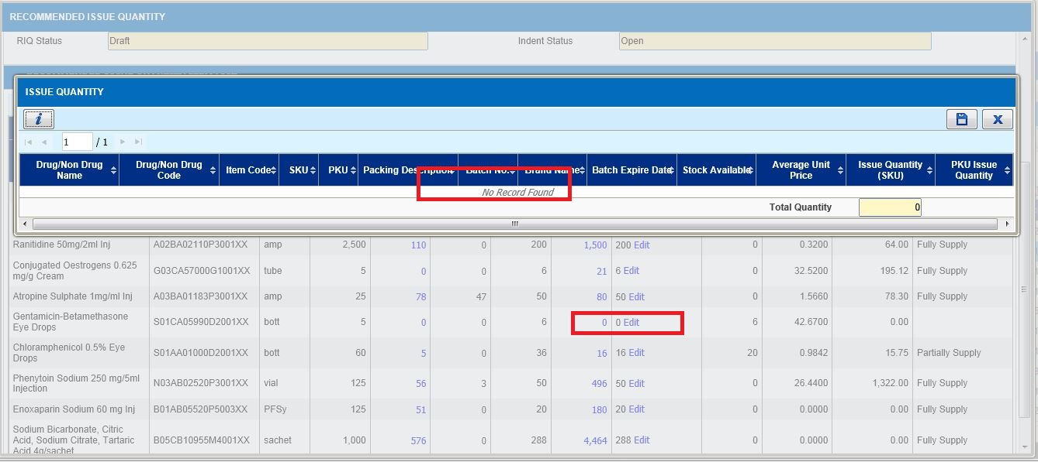

R-PhIS001607314
Module | Reported Date | Description | Solution
Pharmacy Inventory | 5/6/2014 | User request for stock adjustment module for option Routine Checking, need to Add Expiry Date and Quantity during down batch no. Login ID : 750214015762 | Add display field

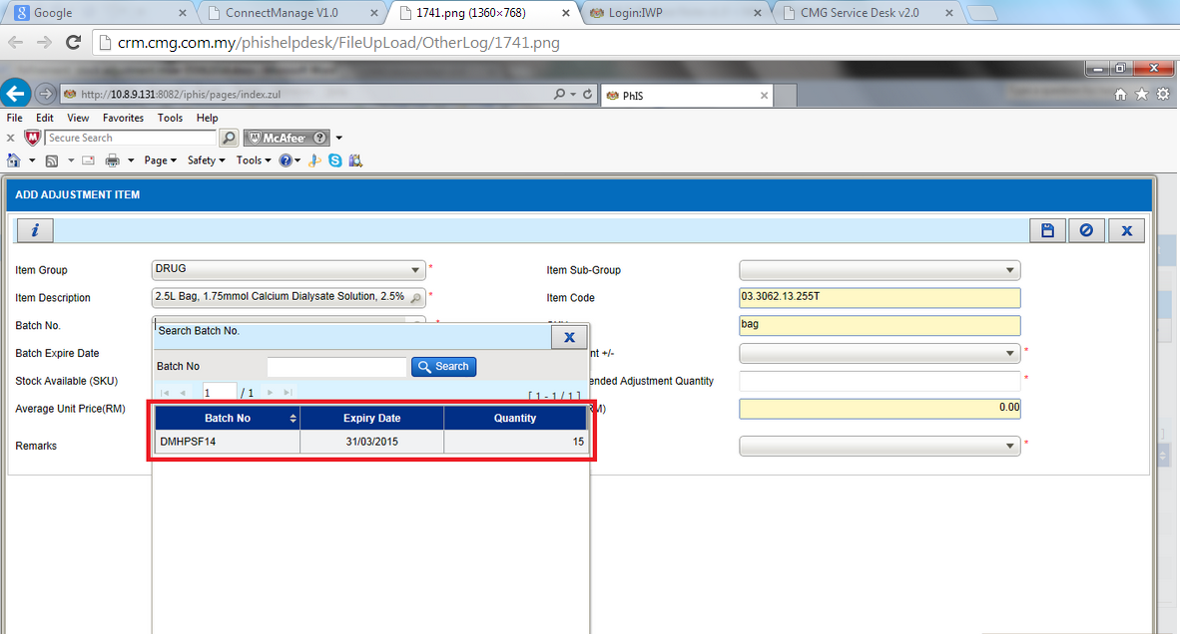

R-PhIS001613314
Module | Reported Date | Description | Solution
Adverse Drug Reaction (ADR) | 6/5/2014 | Request: (DAC Registry) at the listing screen, to add new filtering rule. Filter record by “Status”. | (DAC Registry) at the listing screen, added new filtering rule. Filter record by “Status”.

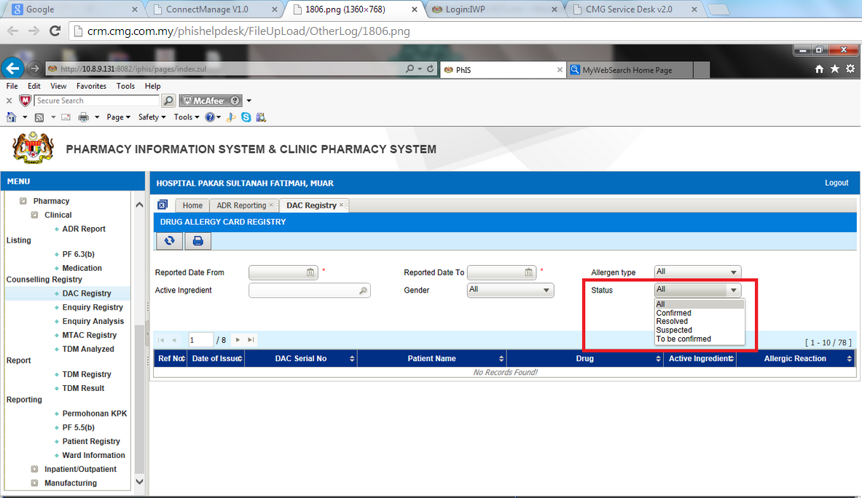

R-PhIS001611414
Module | Reported Date | Description | Solution
Adverse Drug Reaction (ADR) | 6/5/2014 | Request to allow delete record when the ADR record is not yet verified/confirmed. In the case of wrongly entered data.  Time: 5.30 pm, 04/06/2014 | Added Delete Functionality to allow delete record when the ADR record is not yet verified/confirmed

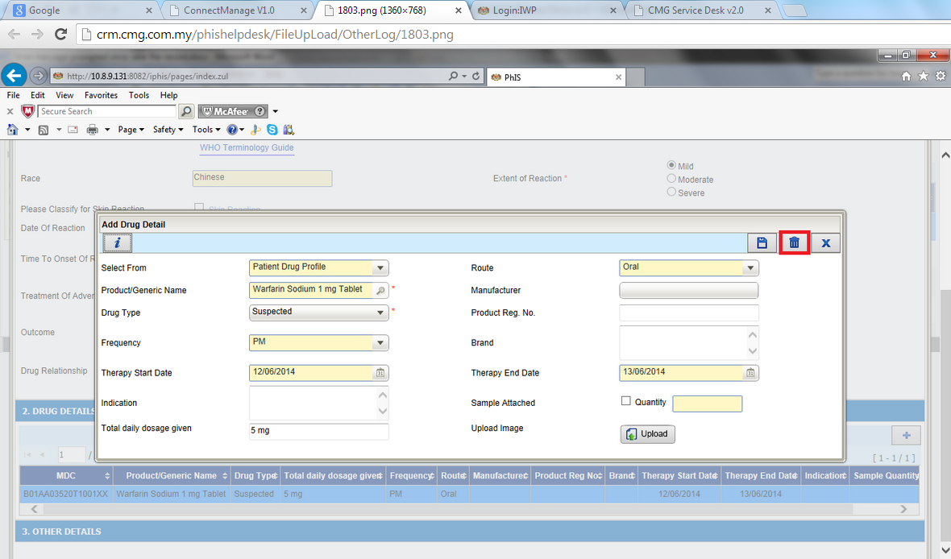

R-PhIS001651314
Module | Reported Date | Description | Solution
Pharmacy Inventory | 11/6/2014 | System should allow level 1 user to see units from level 2 and level 3.  Meanwhile level 2 users only able to see units from level 3.  **HIGH Priority | Able to view and issue item to the requester unit that same or lower level

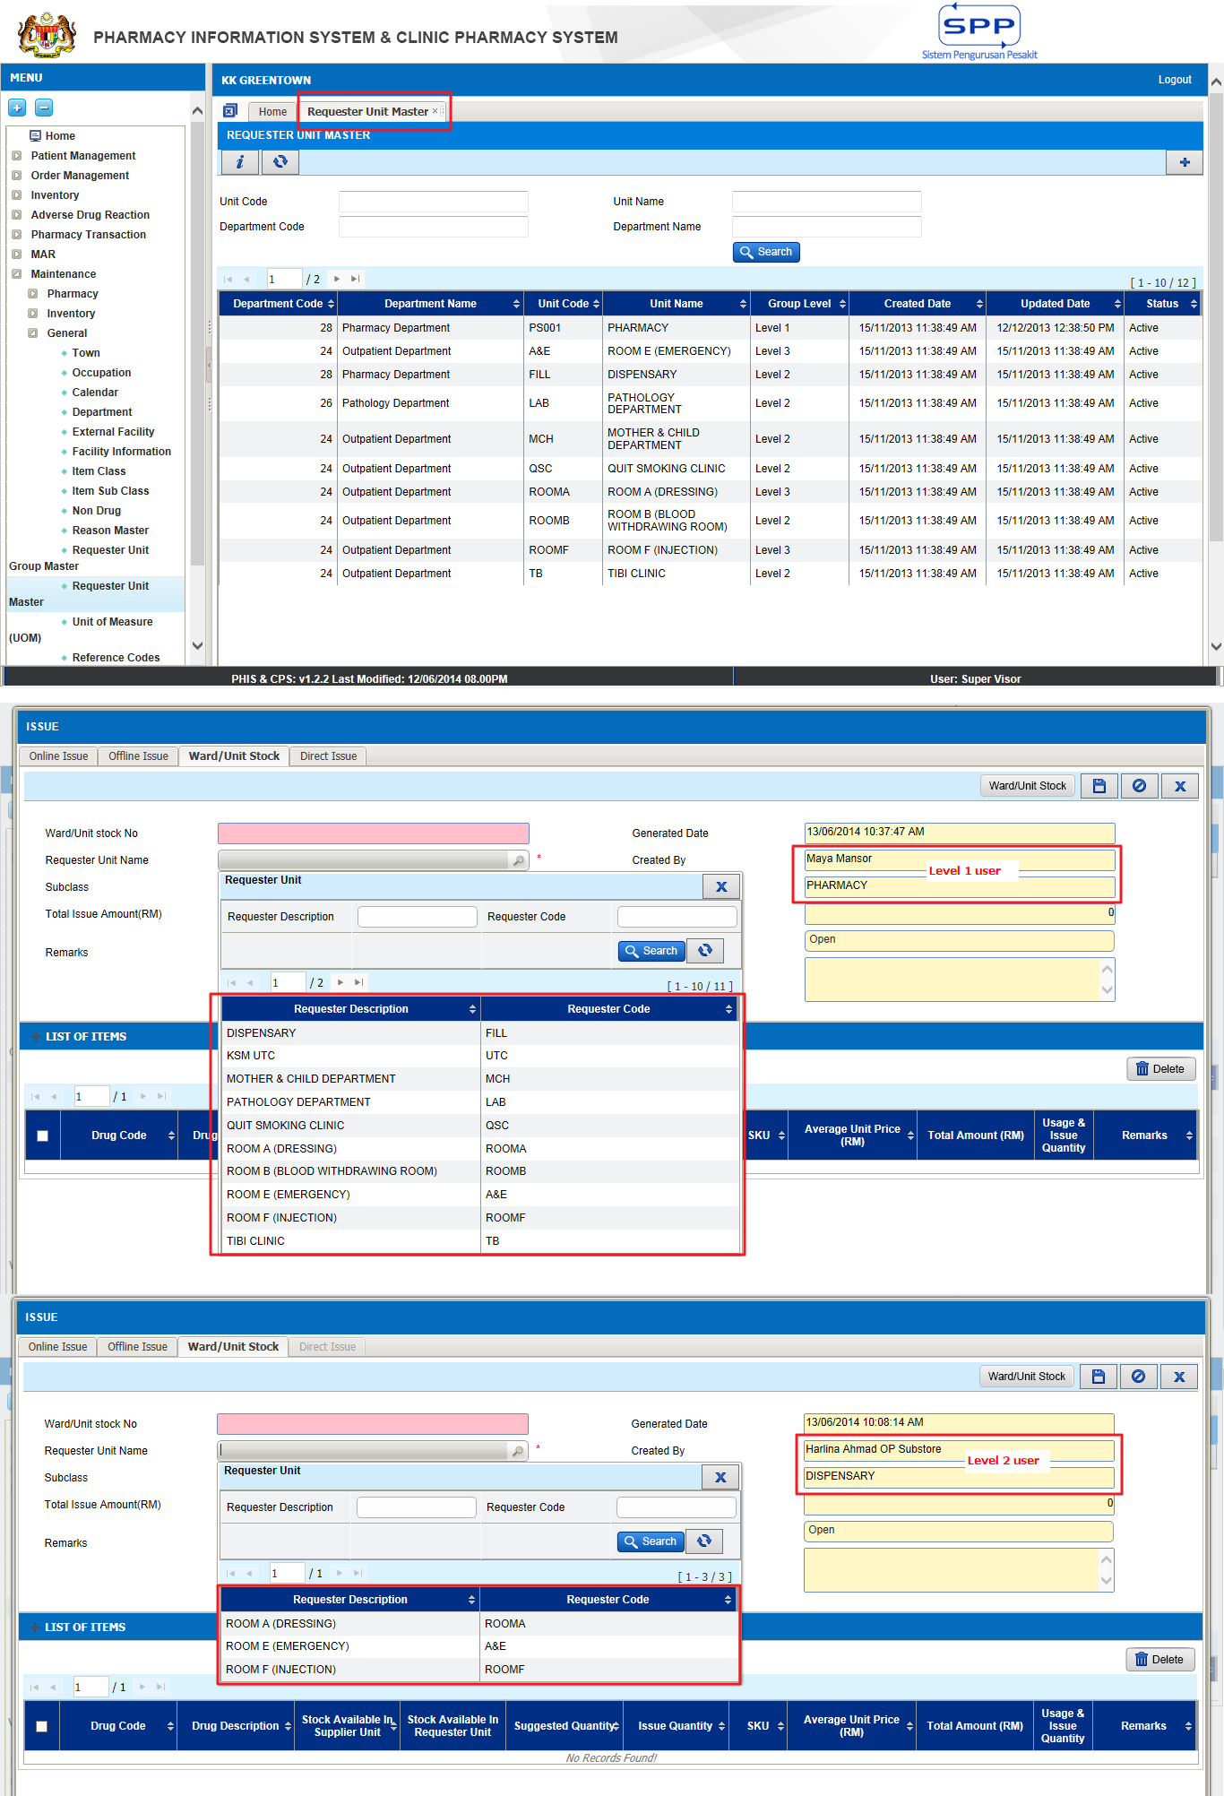

I-PhIS007054214S
Module | Reported Date | Description | Solution
Pharmacy Inventory | 5/6/2014 | Distribution Module-Main Store level, allow to issue out based on SKU or PKU (Applicable at Offline Issue screen and RIQ screen). By default the value will be in PKU and the quantity suggested is in conversion factor. The quantity issued out must based on the PKU and conversion factor. IF the selection is in SKU, then allow user to issue out from main store in SKU and no need to be based on conversion factor. Issue out can be in loose quantity based on the indent quantity. At Sub store level â€“ Default UOM for Offline issue and RIQ is only in SKU. Make it the UOM field dimmed from allow user to select. | Provide flexibility to main store to issue either PKU or SKU

- Main Store
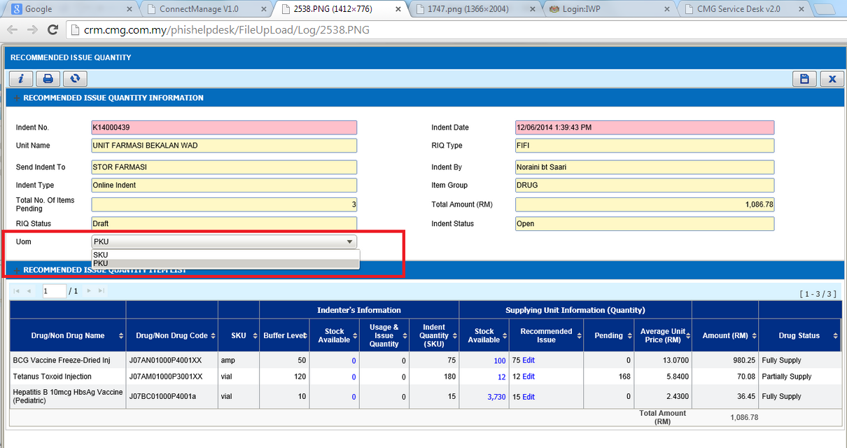

- Sub Store
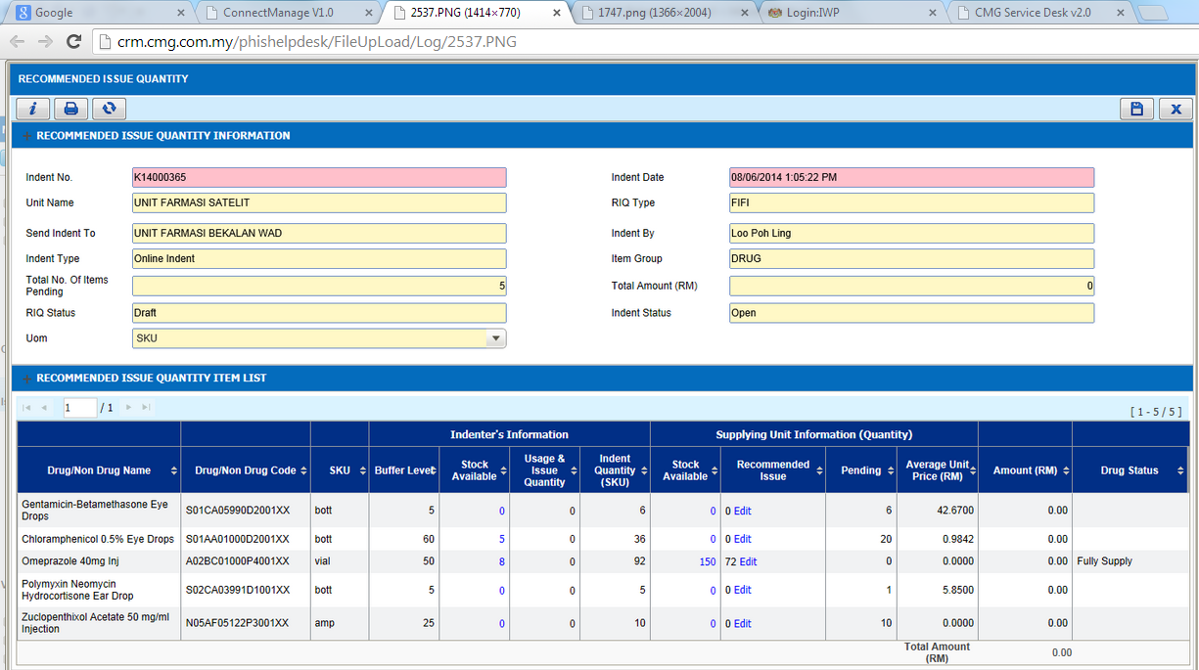

Deployment - Procedures

List of Items to be Deployed

No. | Items | Components | Path
1. | Facility Application | iphis.war | https://10.8.9.130:44330/svn/Workspace_Dataware/31_Implementation/Applications/PhIS Release V.1.2.2.006/facility/war
2. | Facility Patch Scripts | PatchScriptsV1_6_713062014.txt | https://10.8.9.130:44330/svn/Workspace_Dataware/31_Implementation/Applications/PhIS Release V.1.2.2.006/facility/Scripts
3. | HQ Application | phishq.war | https://10.8.9.130:44330/svn/Workspace_Dataware/31_Implementation/Applications/PhIS Release V.1.2.2.006/hq/war
4. | Facility Patch Scripts | PatchScriptsV1_6_706132014.txt | https://10.8.9.130:44330/svn/Workspace_Dataware/31_Implementation/Applications/PhIS Release V.1.2.2.006/hq/Scripts
5. | Mobile Application | ipadhosp.war | https://10.8.9.130:44330/svn/Workspace_Dataware/31_Implementation/Applications/PhIS Release V.1.2.2.006/facility/mobile

Backup Procedure before Deploy

Backup Procedure
Using backup tool, backup the following files and folder and database as per table below;
No. | Type | Backup Item | Description
1 | Application | /home/phisesb  /opt/phisesb  /usr/share/fonts/truetype | PhIS Integration Application  PhIS Core Application  Fonts required by PhIS
2 | Database | phisprod database | PhIS Live database

Deployment/Installation Guidelines

Deployment at Facility
Below table is described the deployment steps at Facility:
Step | Items | File Name | Source Path | Action
1 | Facility Application | iphis.war | https://10.8.9.130:44330/svn/Workspace_Dataware/31_Implementation/Applications/PhIS Release V.1.2.2.006/facility/war | Deployment @ Both HA Servers
2 | Facility Patch Scripts | PatchScriptsV1_6_713062014.txt | https://10.8.9.130:44330/svn/Workspace_Dataware/31_Implementation/Applications/PhIS Release V.1.2.2.006/facility/Scripts | Run the scripts @ Postgres DB using PGAdmin
3 | Mobile Application | Ipadhosp.war | https://10.8.9.130:44330/svn/Workspace_Dataware/31_Implementation/Applications/PhIS Release V.1.2.2.006/facility/mobile | Deployment @ Both HA Servers

Deployment at HQ - IWP
Below table is described the deployment steps at HQ - IWP:

Step | Items | File Name | Source Path |  | Action
1 | HQ Application | phishq.war | https://10.8.9.130:44330/svn/Workspace_Dataware/31_Implementation/Applications/PhIS Release V.1.2.2.006/hq/war | Deployment @ Both HA Servers
2 | Facility Patch Scripts | PatchScriptsV1_6_706132014.txt | https://10.8.9.130:44330/svn/Workspace_Dataware/31_Implementation/Applications/PhIS Release V.1.2.2.006/hq/Scripts | Run the scripts @ Postgres DB using PGAdmin

