Pharmacy Information System (PhIS)
and
Clinic Pharmacy System (CPS)

Release Note
For version 1.2.2.6.8

Version : 1.2
Document ID : PhIS_CPS/ReleaseNote/Refinement/26062014

© 2011-2014 Pharmaniaga Logistics Sdn Bhd (PLSB)

CONFIDENTIAL COPYRIGHTED MATERIAL – The information includes all concepts, comments, recommendations, and material, contained herein shall remain the property of Pharmaniaga Logistics Sdn Bhd (PLSB). No portion of this document shall be disclosed, duplicated or used in whole or in part of any purpose other than the purpose of the Pharmacy Information System & Clinic Pharmacy System (PhIS& CPS) Project execution only.

Revision History

Version No | Date of Release | Prepared by | Reviewed / Verified by | List of changes from Previous Version
1.0 | 26/06/2014 | Kee Tuan Hwa | Chew Ming Ping | First Version
1.1 | 29/06/2014 | Kee Tuan Hwa | Chew Ming Ping | Remove 3 tickets related to mobile application -  I-PhIS006975714S, I-PhIS007063814S and I-PhIS007085714S  Remove mobile application deployment step in Section 5.1 and 5.3.1
1.2 | 01/07/2014 | Kee Tuan Hwa | Chew Ming Ping | Add 2 tickets related to mobile application -  I-PhIS007063814S and I-PhIS007085714S  Add mobile application deployment step in Section 5.1 and 5.3.1

Verified and Acknowledged by:
Name | Role/Designation | Organization | Signature & Date
Chew Ming Ping | Team Leader – SA & QC | Pharmaniaga Logistics Sdn Bhd
Wilson Chan | Team Leader - Development | Pharmaniaga Logistics Sdn Bhd
Hoh Choon Seng | Project Manager | Pharmaniaga Logistics Sdn Bhd

Name | Role/Designation | Organization | Signature & Date
 |  | Bahagian Perkhidmatan Farmasi (BPF), KKM
 |  | Bahagian Pengurusan Maklumat (BPM), KKM

Peer Review
Version No | Reviewed / Verified by | List Of Changes from Previous Version
1.0 | Juridah (QA) | Initial document
1.1 | Juridah (QA) | Remove 3 tickets related to mobile application –  I-PhIS006975714S, I-PhIS007063814S and  I-PhIS007085714S  Remove mobile application deployment step in Section 5.1 and 5.3.1
1.2 | Juridah (QA) | Add 2 tickets related to mobile application -  I-PhIS007063814S and I-PhIS007085714S  Add mobile application deployment step in Section 5.1 and 5.3.1

1 Introduction 1
1.1 Project Information 1
1.2 Objectives 1
2 Purpose 2
3 Summary – Refinement and Defect List 3
3.1 Refinement List 3
3.1.1 Hospital Pakar Sultanah Fatimah 3
3.2 Resolved Defect List 5
3.2.1 Hospital Pakar Sultanah Fatimah 5
3.2.2 KK Greentown 13
3.2.3 HQ - IWP 14
4 Refinement List – Detail Changes 16
4.1 R-PhIS001611514 16
4.2 R-PhIS001659314 16
4.3 R-PhIS001659414 17
5 Deployment - Procedures 19
5.1 List of Items to be Deployed 19
5.2 Backup Procedure before Deploy 20
5.2.1 Backup Procedure 20
5.3 Deployment/Installation Guidelines 20
5.3.1 Deployment at Facility 20
5.3.2 Deployment at HQ - IWP 20

Introduction

Project Information

Project ID : | PhIS and CPS
Project Name : | Pharmacy Information System and Clinic Pharmacy System
Version No : | 1.2.2.6.8
Client Name : | Ministry of Health
Release ID : | RL14/009
Release Date : | 01/07/2014

Objectives
No. | Objective | Reference
1. | Release PhIS & CPS Application to Facility | Refer Section 3 – Refinement and Defect list

Purpose
The purpose of the document is to update the end-user of the changes and defects have been resolved to be included in the new version of application and will be deployed to production server.
This document outlines the list of request and issue to be delivered in the newer version of application and also the guidelines on how to deploy the new version of application in production.

Summary – Refinement and Defect List

Refinement List
The following are the summary of refinement list that included in PhIS and CPS version 1.2.2.6.8.

Hospital Pakar Sultanah Fatimah
No | Ticket No. | Module | Reported Date | Description | Additional Information | Solution | Resolved Date | Verify Status
1 | R-PhIS001611514 | Adverse Drug Reaction (ADR) | 5/6/2014 | Request: (Print Allergy Card) Add new column 'Visit Location' and 'Recorded Date' in listing. Visit Location is for user to track user in which location to give the printed DAC. Recorded Date for user to print the card according to sequence of recorded date.  Time: 5.30 pm, 04/06/2014 | Refer to 4.1 | (Print Allergy Card) Added new column 'Visit Location' and 'Recorded Date' in listing. | 16/6/2014
2 | R-PhIS001659314 | Adverse Drug Reaction (ADR) | 12/6/2014 | User request to add new column and new filtering rules.  1) To change Date Occurrance column to Date Recorded column.  2) To change filtering Date Occurrence From to Date Recorded From  3) To change filtering Date Occurrence To to Date Recorded To  4) To add column Printed at the search listing  5) To add filtering rulesPrinted  6) To add column Location at the search listing  Replication Step:  1) Open Print Allergy Card screen  2) System will display Print Allergy Card listing scree | Refer to 4.2 | To add new column and new filtering rules.  New parameter was added in Ref code table, and value will require to,sync from HQ IWP to facility | 17/6/2014
3 | R-PhIS001659414 | Adverse Drug Reaction (ADR) | 12/6/2014 | Request: To set Products/ Generic name field maximum up to 250 characters.Replication Step:  1) Open ADR reporting screen  2)Open Drug Detail section  3) Click on Add New drug  4) ChoosSelect From= Others  5) Filin Product/Generic Name | Refer to 4.3 | Set ‘Products/ Generic name” field maximum up to 250 characters. | 13/6/2014
4 | R-PhIS001755414 | Patient Management | 24/6/2014 | Reported when clerk register patient and want to save system just processing around 3 minutes. user reported this problem happen more than 4 times this morning. Details;  user ID: 760510065034  User name: Liza Ahmad | No screenshot | Remove queue checking related to pharmacy based | 25/6/2014

Verified and Acknowledged By:
Signature: |  | Name:
Date: |  | Designation:
Signature: |  | Name:
Date: |  | Designation:

Resolved Defect List
The following are the summary of resolved defect list that included in PhIS and CPS version 1.2.2.6.8.

Hospital Pakar Sultanah Fatimah
No | Ticket No. | Module | Reported Date | Description | Additional Information | Root Caused | Resolved Date | Verify Status
1 | I-PhIS006983714S | Outpatient Pharmacy | 28/5/2014 | Screening & Verification Screen : User reported when user click proceed to dispense he unable to print balance medication ship. Balance medication ship was disabled.  User ID : 870606355279  Fauzan  Actual Date & Time Problem :28 May 2014 / 11AM | Reported by Muazzam Zulzalalin (Trainer) | Program logic issue | 17/6/2014
2 | I-PhIS007053714S | Adverse Drug Reaction (ADR) | 5/6/2014 | Issue: 1. In ADR Report Listing, the concomittent drug details is displayed in Active Ingredient/Brand Name/Drug Name column, should display the suspected drug (non-KKM), not the concomittent. 2. In ADR Report Listing: Non-KKM drug is not displayed on the report.  Username/Password: 810930016282/phis1922  Time: 5.30 pm, 04/06/2014  Module: ADR Report Listing | Request Ticket No = P-PhIS001611314 | No filtering function in Active Ingredient/Brand Name/Drug Name column to display only suspected drug & Concomitant Medication column to display only concomitant drug. | 25/6/2014
3 | I-PhIS007053814S | Adverse Drug Reaction (ADR) | 5/6/2014 | Module: ADR Reporting-In Drug Details list, already has suspected drug, but when user edit existing concomittent drug, and save record, alert message No suspected drug is displayed.  Username/Password: 810930016282/phis1922  Time: 5.30 pm, 04/06/2014 | Request ticket No = P-PhIS001609514 | ADR Reporting-In Drug Details list, already has suspected drug, but when user edit existing concomittent drug, and save record, alert message ‘No suspected drug’ is not displaying. | 13/6/2014
4 | I-PhIS007067714S | Adverse Drug Reaction (ADR) | 9/6/2014 | Reported that system created new record instead of update the record when user update and SAVE record.  Replication Step:  1) Open ADR reporting screen  2) Open Drug Details Section  3) Double click on any record and edit the record.  4) Then Click on SAVE button.  5) System will create new record instead of SAVE and update the record.  Time: 4.00 pm  Date: 09/06/2014 |  | System not creating new record instead of update the record when user update and SAVE record | 17/6/2014
5 | I-PhIS007089814S | Pharmacy Inventory | 11/6/2014 | 1) DRUG/NON DRUD NAME (Spelling)  2) ESOMEprazole 40mg Inj (Drug name still appear after the 1st search even after click on the refresh button)  3) DRUG/NON DRUD NAME (Spelling)  4) Page 1 of 1 (Actual data consist of 15 pages but print out only capture 1st page) |  | fix spelling | 13/6/2014
6 | I-PhIS007091714S | Adverse Drug Reaction (ADR) | 11/6/2014 | Reported that field Department empty  Replication Step:  1) Open ADR reporting screen  2) Open tab 3 Other Details  3) Field Department shown no value. Suppose to captured user department which has been set at user profile. |  | Did not extract user department which has been set at user profile | 13/6/2014
7 | I-PhIS007094014S | Pharmacy Inventory | 11/6/2014 | Main store user (Stephanie) when she wants to perform stock adjustment against routine checking, there is no item shows either for Drug/Non Drug group.Based on the checking thru back end, it is referring to unit product list whereby level 1 has no unit product list.  Sub Module: Stock Taking - Adjustment (Routine Checking)  Login ID: 851117045268 |  | Validation missing | 13/6/2014
8 | I-PhIS007094214S | Pharmacy Inventory | 11/6/2014 | Under KEW.PS-10, the total balance at stock (Baki di Stok) only capture balance of current balance of the respective no for batch no that have been issued out. Supposed it's referring to Total quantity of the item. User ID: 810125145321 |  | Qty display is by batch not by item | 18/6/2014
9 | I-PhIS007099914S | Manufacturing - PN | 12/6/2014 | Verified order for patient mrn = HPSF00021096 on 10/6/2014, order flow success to preparation stage 2 days after (12/6/2014), view back preparation screen, no record founds.  login = 841119055276  order from web- refer attachment |  | Filtering issue | 16/6/2014
10 | I-PhIS007101814S | MTAC | 12/6/2014 | Open MTAC reporting, click medication order button, order warfarin from medication order. Confirm order.Fill up diagnosis, and no known allergy.Close screen medication order.  login = 810125145321 /1234  Date : 12/6/2014  Remarks : happen for new patient with no diagnosis and allergy, and do medication order without save assessment details.  Error display per attachment. |  | Program logic issue | 16/6/2014
11 | I-PhIS007101914S | Pharmacy Inventory | 12/6/2014 | Sub Module: Receive Item - Intra Facility.  System show negative figure at the 'Pending Quantity in SKU' and 'Pending Quantity in PKU' column.  Login ID: 770413055730  Unit: FKP  Screenshot attached. |  | calculation issue | 18/6/2014
12 | I-PhIS007102014S | Pharmacy Inventory | 12/6/2014 | On screen, the Prepacked By value is displayed based on current login. But in worksheet, the correct username is displayed.  Expected result: After record already saved, when user reopen the record, should retrieve username based on the saved value, not based on login.  User : Mohd Izzuddin bin Nojumuddin  ID : 830824016287  Incident : 3:30pm  Module: Inventory - Prepacking |  | Wrong value is retrieved | 17/6/2014
13 | I-PhIS007102114S | Inpatient Pharmacy | 12/6/2014 | Module: Inpatient - Preparation/Dispensing  Patient details is displayed in Preparation screen listing, but when user opens the record, no drug/order is displayed.  Time: 2.30 pm, 12/06/2014  Username/Password: 851220145814/tan6763  [Screenshot as per attached] |  | There are 2 criteria system check for patient and drug list.  1. Drug status.  2. Order End date.  Previously system check on OR condition, which means either 1 is true. Now system using AND condition, which means BOTH criteria need to be TRUE. | 19/6/2014
14 | I-PhIS007113814S | Manufacturing - PN | 16/6/2014 | Create new work order and update the Pack Size value.  Result: Material Qty is not calculated correctly when create work order with this item: Cocaine 10% Solution.  Username/password: 750610016687/1234  Time: 12.00 pm, 16/06/2014  [Screenshot as per attached] |  | calculation issue | 17/6/2014
15 | I-PhIS007117814S | Outpatient Pharmacy | 16/6/2014 | Reported that negative value on waiting time.  Username : Puan Aisyah  Location : OP pharmacy  Time & date : 11am & 15/06/14 |  | User cannot CALL PATIENT if patient arrival info is not yet recorded. | 25/6/2014
16 | I-PhIS007118214S | Outpatient Pharmacy | 16/6/2014 | Reported that duration in order detail is for 3 months (90 days) but patient TCA is 99 days. Unable to supply more than the duration in order detail. Patient’s medication will not be enough until appointment.  Time & date : 11am & 15/06/14 | QC Remarks: User is not allowed to supply more then order end that. if it is required, please modify the order and extend the order end date. | Clinic TCA and Next Collection Date value cannot be removed. | 25/6/2014
17 | I-PhIS007118514S | Outpatient Pharmacy | 16/6/2014 | Reported that Diclofenac 1% Emulgel order qty is 4 tube. This is first supply. Reserve qty 1 tube. Balance qty should be 3 tube.  Time & date : 2pm & 16/06/14 |  | Absolute Dispense Qty setting in Drug Master required to update to ‘N’, then system will calculate the reserve qty. The update of drug master is maintained at HQ. | 19/6/2014
18 | I-PhIS007126514S | MTAC | 17/6/2014 | Reported that unable to search patient by ID number at MTAC Order.  Username : Tan Lim Hui  Location : Clinic INR  Time : 10am |  | Searching and retrieving issue | 18/6/2014
19 | I-PhIS007126614S | MTAC | 17/6/2014 | Reported that unable to click LAB RESULT button at MTAC order.  Username : Tan im Hui  Location : Clinic INR  Time 3pm  Module : MTAC |  | Patient have no visit the " Lab result " button will disable.If have visit it will enable | 18/6/2014
20 | I-PhIS007126714S | MTAC | 17/6/2014 | MTAC Reporting patient listing. Wrong information at column Updated By, Supposedly system should show last update person instead of ordering person.  Username : Tan im Hui  Location : Clinic INR  Time 3pm  Severity : 2  Modul : MTAC |  | Wrong value is retrieved | 24/6/2014
21 | I-PhIS007157714S | Patient Management | 24/6/2014 | User reported unable to transfer patient from ward 8 to ward 2. Found error message 'An error has occurred. Please contact your system administrator'.  Patient: Zaenal Abidin (AP970226).  Time: 11.00pm  ID: 890222065756 (nurul aisyah bt mohd zan) |  | not called table IV Order and Normal Order properly | 25/6/2014
22 | I-PhIS007063814S | Order Management - Mobile | 8/6/2014 | User reported that order quantity not defaulted to PRN quantity defined in drug master when user select frequency PRN.  Drug name: Tramadol HCl 50 mg/ml Injection.  Time: 1.00 pm |  | prnQuantityYn field was set as Boolean but @Type annotation was not specified to convert from 'Y/N' to true/false. | 14/6/2014
23 | I-PhIS007085714S | Order Management - Mobile | 10/6/2014 | Reported that doctor prescribed wrong medication â€˜Lovastatinâ€™ and pharmacist ask doctor to change to â€˜Atorvastatinâ€™. After doctor modified, in screening and verification still show â€˜Lovastatinâ€™.  In Clinical summary and MAR showed Atorvastatin. |  | Shouldn't allow to change drug after order is confirmed. | 17/6/2014

Verified and Acknowledged By:
Signature: |  | Name:
Date: |  | Designation:

Signature: |  | Name:
Date: |  | Designation:

KK Greentown
No | Ticket No. | Module | Reported Date | Description | Additional Information | Root Caused | Resolved Date | Verify Status
1 | I-PhIS007141714S | Patient Management | 20/6/2014 | Unable to use the Tab button function on the keyboard to change field.  STEP 1: Create New Record for new patient  STEP 2: Save the record and visit alert message will appear and proceed with visit.  STEP 3: Insert information on the Visit Management screen and click save > click close and system will back to patient registration screen.  STEP 4: On the registration screen, Click on the add button on the top right of the screen to register a new patient.  User: Sharmila Sidhu A/P Santok Singh.  ID: 751105085176. |  | Query issue | 23/6/2014
2 | I-PhIS007142214S | Pharmacy Inventory | 20/6/2014 | Sub Module : Request Order Report  STATUS Abbreviation in the Request Order Report  Change the Status from PKDA to PKD Approved |  | proper description not displayed for STATUS | 25/6/2014

Verified and Acknowledged By:
Signature: |  | Name:
Date: |  | Designation:

Signature: |  | Name:
Date: |  | Designation:

HQ - IWP
No | Ticket No. | Module | Reported Date | Description | Additional Information | Root Caused | Resolved Date | Verify Status
1 | I-PhIS007083914S | IWP | 10/6/2014 | User created new transaction and the transaction no jumping to NO14000021 from NO1400001. Module : Product Recall Notification |  | Sequence No issue | 17/6/2014

Verified and Acknowledged By:
Signature: |  | Name:
Date: |  | Designation:

Signature: |  | Name:
Date: |  | Designation:

Refinement List – Detail Changes

R-PhIS001611514
Module | Reported Date | Description | Solution
Adverse Drug Reaction (ADR) | 5/6/2014 | Request: (Print Allergy Card) Add new column 'Visit Location' and 'Recorded Date' in listing. Visit Location is for user to track user in which location to give the printed DAC. Recorded Date for user to print the card according to sequence of recorded date.  Time: 5.30 pm, 04/06/2014 | (Print Allergy Card) Added new column 'Visit Location' and 'Recorded Date' in listing.

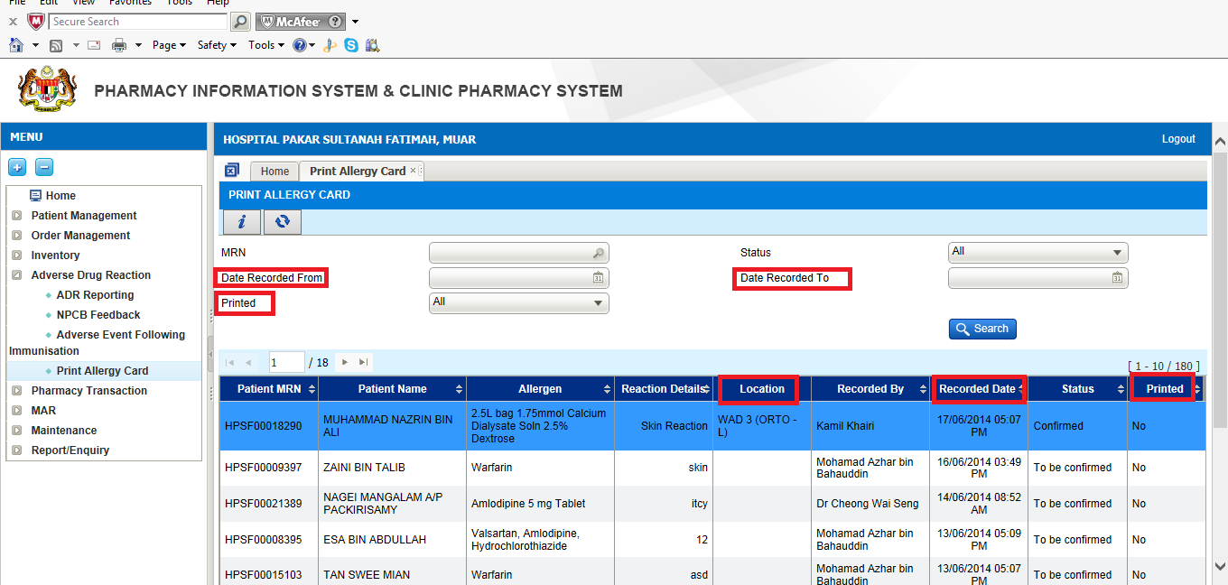

R-PhIS001659314
Module | Reported Date | Description | Solution
Adverse Drug Reaction (ADR) | 12/6/2014 | User request to add new column and new filtering rules.  1) To change Date Occurrance column to Date Recorded column.  2) To change filtering Date Occurrence From to Date Recorded From  3) To change filtering Date Occurrence To to Date Recorded To  4) To add column Printed at the search listing  5) To add filtering rulesPrinted  6) To add column Location at the search listing  Replication Step:  1) Open Print Allergy Card screen  2) System will display Print Allergy Card listing scree | To add new column and new filtering rules.  New parameter was added in Ref code table, and value will require to,sync from HQ IWP to facility

R-PhIS001659414
Module | Reported Date | Description | Solution
Adverse Drug Reaction (ADR) | 12/6/2014 | Request: To set Products/ Generic name field maximum up to 250 characters.Replication Step:  1) Open ADR reporting screen  2)Open Drug Detail section  3) Click on Add New drug  4) ChoosSelect From= Others  5) Filin Product/Generic Name | Set ‘Products/ Generic name” field maximum up to 250 characters.

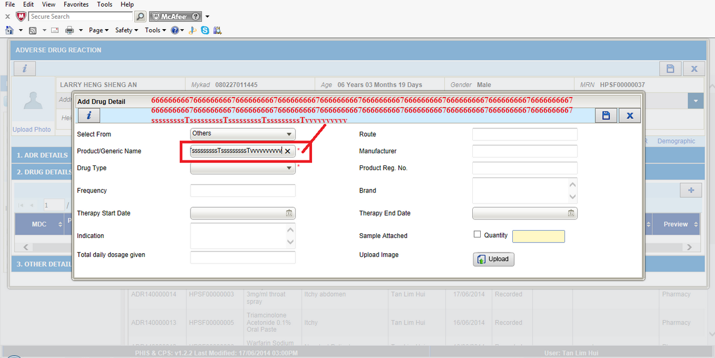

Deployment - Procedures

List of Items to be Deployed

No. | Items | Components | Path
1. | Facility Patch Scripts | - PH_REF_CODES_ResetAllDate_PostgreSQL_Facility_20140620.SQL PatchScriptsv1.2.2.6.8.txt | https://10.8.9.130:44330/svn/Workspace_Dataware/31_Implementation/Applications/PhIS Release V.1.2.2.006/facility/Scripts
2. | Facility Application | iphis.war | https://10.8.9.130:44330/svn/Workspace_Dataware/31_Implementation/Applications/PhIS Release V.1.2.2.006/facility/war
3. | HQ Patch Scripts | - T_REF_CODES_ResetAllData_ORACLE_HQ_20140620.SQL  - PatchScriptsHQv1.2.2.6.8.txt | https://10.8.9.130:44330/svn/Workspace_Dataware/31_Implementation/Applications/PhIS Release V.1.2.2.006/hq/Scripts
4. | HQ Application | - phishq.war  - epservice.war | https://10.8.9.130:44330/svn/Workspace_Dataware/31_Implementation/Applications/PhIS Release V.1.2.2.006/hq/war
5. | HQ Integration | masterRelease.jar | https://10.8.9.130:44330/svn/Workspace_Dataware/31_Implementation/Applications/PhIS Release V.1.2.2.006/hq/jar
6. | Mobile Application | ipadhosp-1.2.7b12.war | https://10.8.9.130:44330/svn/Workspace_Dataware/31_Implementation/Applications/PhIS Release V.1.2.2.006/facility/mobile

Backup Procedure before Deploy

Backup Procedure
Using backup tool, backup the following files and folder and database as per table below;
No. | Type | Backup Item | Description
1 | Application | /home/phisesb  /opt/phisesb  /usr/share/fonts/truetype | PhIS Integration Application  PhIS Core Application  Fonts required by PhIS
2 | Database | phisprod database | PhIS Live database

Deployment/Installation Guidelines

Deployment at Facility
Below table is described the deployment steps at Facility:
Step | Items | File Name | Source Path | Action
1 | Facility Patch Scripts | - PH_REF_CODES_ResetAllDate_PostgreSQL_Facility_20140620.SQL (execute 1st)  - PatchScriptsv1.2.2.6.8.txt (execute after item no#1) | https://10.8.9.130:44330/svn/Workspace_Dataware/31_Implementation/Applications/PhIS Release V.1.2.2.006/facility/Scripts | Run the scripts @ Postgres DB using PGAdmin
2 | Facility Application | iphis.war | https://10.8.9.130:44330/svn/Workspace_Dataware/31_Implementation/Applications/PhIS Release V.1.2.2.006/facility/war | Deployment @ Both HA Servers
3 | Mobile Application | ipadhosp-1.2.7b12.war | https://10.8.9.130:44330/svn/Workspace_Dataware/31_Implementation/Applications/PhIS Release V.1.2.2.006/facility/mobile | Deployment @ Both HA Servers

Deployment at HQ - IWP
Below table is described the deployment steps at HQ - IWP:

Step | Items | File Name | Source Path | Action
1 | HQ Patch Scripts | - T_REF_CODES_ResetAllData_ORACLE_HQ_20140620.SQL (execute 1st)  - PatchScriptsHQv1.2.2.6.8.txt (execute after item no#1) | https://10.8.9.130:44330/svn/Workspace_Dataware/31_Implementation/Applications/PhIS Release V.1.2.2.006/hq/Scripts | Run the scripts @ Postgres DB using PGAdmin
2 | HQ Application | phishq.war | https://10.8.9.130:44330/svn/Workspace_Dataware/31_Implementation/Applications/PhIS Release V.1.2.2.006/hq/war | Deployment @ Both HA Servers

