Pharmacy Information System (PhIS)
and
Clinic Pharmacy System (CPS)

Release Note
For version 1.2.2.6.9

Version : 1.0
Document ID : PhIS_CPS/ReleaseNote/Refinement/11072014

© 2011-2014 Pharmaniaga Logistics Sdn Bhd (PLSB)

CONFIDENTIAL COPYRIGHTED MATERIAL – The information includes all concepts, comments, recommendations, and material, contained herein shall remain the property of Pharmaniaga Logistics Sdn Bhd (PLSB). No portion of this document shall be disclosed, duplicated or used in whole or in part of any purpose other than the purpose of the Pharmacy Information System & Clinic Pharmacy System (PhIS& CPS) Project execution only.

Revision History

Version No | Date of Release | Prepared by | Reviewed / Verified by | List of changes from Previous Version
1.0 | 11/07/2014 | Kee Tuan Hwa | Chew Ming Ping | First Version

Verified and Acknowledged by:
Name | Role/Designation | Organization | Signature & Date
Chew Ming Ping | Team Leader – SA & QC | Pharmaniaga Logistics Sdn Bhd
Wilson Chan | Team Leader - Development | Pharmaniaga Logistics Sdn Bhd
Hoh Choon Seng | Project Manager | Pharmaniaga Logistics Sdn Bhd

Name | Role/Designation | Organization | Signature & Date
 |  | Bahagian Perkhidmatan Farmasi (BPF), KKM
 |  | Bahagian Pengurusan Maklumat (BPM), KKM

Peer Review
Version No | Reviewed / Verified by | List Of Changes from Previous Version
1.0 | Juridah (QA) | Initial document

1 Introduction 1
1.1 Project Information 1
1.2 Objectives 1
2 Purpose 2
3 Summary – Refinement and Defect List 3
3.1 Refinement List 3
3.1.1 Hospital Pakar Sultanah Fatimah 3
3.1.2 KK Greentown 6
3.1.3 Data Centre - IWP 7
3.2 Resolved Defect List 8
3.2.1 Hospital Pakar Sultanah Fatimah 8
3.2.2 KK Greentown 18
4 Refinement List – Detail Changes 27
4.1 I-PhIS007171714S (R-PhIS001522414) & I-PhIS007171814S (R-PhIS001571314) 27
4.2 R-PhIS001631314 28
4.3 R-PhIS001667314 & I-PhIS007196214S 29
4.4 R-PhIS001673314 33
4.5 I-PhIS007181714S 38
4.6 I-PhIS007185714S 39
4.7 I-PhIS007101714S & I-PhIS007218114S 40
5 Deployment - Procedures 47
5.1 List of Items to be Deployed 47
5.2 Backup Procedure before Deploy 48
5.2.1 Backup Procedure 48
5.3 Deployment/Installation Guidelines 48
5.3.1 Deployment at Facility 48
5.3.2 Deployment at HQ - IWP 49

Introduction

Project Information

Project ID : | PhIS and CPS
Project Name : | Pharmacy Information System and Clinic Pharmacy System
Version No : | 1.2.2.6.9
Client Name : | Ministry of Health
Release ID : | RL14/0010
Release Date : | 11/07/2014

Objectives
No. | Objective | Reference
1. | Release PhIS & CPS Application to Facility | Refer Section 3 – Refinement and Defect list

Purpose
The purpose of the document is to update the end-user of the changes and defects have been resolved to be included in the new version of application and will be deployed to production server.
This document outlines the list of request and issue to be delivered in the newer version of application and also the guidelines on how to deploy the new version of application in production.

Summary – Refinement and Defect List

Refinement List
The following are the summary of refinement list that included in PhIS and CPS version 1.2.2.6.9.

Hospital Pakar Sultanah Fatimah
No | Ticket No. | Module | Reported Date | Description | Additional Information | Solution | Resolved Date | Verify Status
1 | I-PhIS006945814 | Inpatient Pharmacy | 22/5/2014 | When user click search at pharmacy screen (screening, prepare & dispense) page keep processing for more than 10 seconds. | Reported by Meziane. | Rewrite the query  No screenshot | 30/6/2014
2 | I-PhIS007139714S | Outpatient Pharmacy | 19/6/2014 | Module :(Outpatient > Preparation )(Outpatient > screening)(Outpatient >DISPENSING)  Time motion (Every time click will took more than 3 seconds not the whole step which obviously will take more time) and this was not during peak hours.  a. Screening  i. Search patient 5 seconds  ii. Select patient 8 seconds  iii. Confirm verify 6 seconds  b. Preparation  i. Search patient 4 seconds  ii. Select patient 7 seconds  iii. Submit print report 5 seconds  iv. Close print report 6 seconds  Time Occurred : 12:05PM |  | Rewrite the query No screenshot | 8/7/2014
3 | I-PhIS007160014S | Patient Management | 24/6/2014 | Reported when clerk register patient and want to save system just processing around 3 minutes. user reported this problem happen more than 4 times this morning. Details;  user ID: 760510065034  User name: Liza Ahmad |  | Rewrite the query  No screenshot | 25/6/2014
4 | I-PhIS007171714S  R-PhIS001522414 | Patient Management | 25/6/2014 | User request to print warganegara at sticker. | BDM - Bilik Daftar Masuk  27/5: not necessary to print in patient label.  16/6: Need further discussion on patient label because KK Greentown has another request on patient label | Change format and add visit label  Refer to 4.1 | 1/7/2014
5 | I-PhIS007171814S  R-PhIS001571314 | Patient Management | 25/6/2014 | Request to amend the patient label by making the hospital name smaller and make the patient name bigger for easier reading. | Reported by Marzuki (SIT).  Refer attachment. | Change format and add visit label  Refer to 4.1 | 1/7/2014
6 | R-PhIS001631314 | Pharmacy Inventory | 9/6/2014 | User request to provide changes and function on RIQ screen.  1) RIQ screen able to reject Indent if haven't supply the Indent yet and able to notify the requester with the status is Rejected by Supplying unit.  2) Able to reject item in the indent.  3) Able to reject any item that partial supply before.  Login ID: 750214015762 (Noraini Saari) | reported by Shamsul Ariza (SA). Screen shot not provided.  16/6: Indent will auto 'Reject' after 14 days, still need manual reject? | Add Reject function in RIQ screen  Refer to 4.2 | 2/7/2014
7 | R-PhIS001667314 | Order Management - Web | 12/6/2014 | Allow user to save and confirm the order at the same time to when create the order.  Apply to both mobile and web application.  Date: 06/06/2014 | To be included in v1.2.2.006.09. | As per request  Refer to 4.3 | 27/6/2014
8 | R-PhIS001673314 | Order Management - Mobile | 13/6/2014 | Allow user to save and confirm the order at the same time to when create the order.  Apply to both mobile and web application.  Date: 06/06/2014 | To be included in v1.2.2.006.09. | As per request  Refer to 4.4 | 2/7/2014

Verified and Acknowledged By:
Signature: |  | Name:
Date: |  | Designation:
Signature: |  | Name:
Date: |  | Designation:

KK Greentown
No | Ticket No. | Module | Reported Date | Description | Additional Information | Solution | Resolved Date | Verify Status
1 | I-PhIS007196214S | Order Management - Web | 30/6/2014 | Doctor request to add another button SAVE & CONFIRM one line with the SAVE button. Currently, doctor need to save then confirm button will appear at button of the page. Instead need to click twice to confirm the order, Doctor request to combine SAVE & CONFIRM button. |  | As per request  Refer to 4.3 | 30/6/2014

Verified and Acknowledged By:
Signature: |  | Name:
Date: |  | Designation:
Signature: |  | Name:
Date: |  | Designation:

Data Centre - IWP
No | Ticket No. | Module | Reported Date | Description | Additional Information | Solution | Resolved Date | Verify Status
1 | I-PhIS007171814S | Patient Management | 25/6/2014 | request to change Visit label format. Allow user to print from visit management screen. |  | Change label format  Refer to 4.1 | 2/7/2014
2 | I-PhIS007171714S | Patient Management | 25/6/2014 | request to add new Patient label. Allow user to print from patient registration and visit management screen. |  | Change label format  Refer to 4.1 | 2/7/2014
3 | I-PhIS007181714S | General Module | 26/6/2014 | User request to add 1 column Packaging Description at listing page.  (please refer attached file) |  | Add additional column  Refer to 4.5 | 1/7/2014
4 | I-PhIS007185714S | Pharmacy Inventory | 26/6/2014 | User requests something on the Issue module > offline Issue as below;  1. Change the label Uom to UOM. (refer image 1)  2. When they key in the value in Issue QTY (SKU) or Issue QTY (PKU) , and the value must be more than 0. Then the check box will auto be tick. (refer image 2) |  | Change the label  Refer to 4.6 | 1/7/2014

Verified and Acknowledged By:
Signature: |  | Name:
Date: |  | Designation:
Signature: |  | Name:
Date: |  | Designation:

Resolved Defect List
The following are the summary of resolved defect list that included in PhIS and CPS version 1.2.2.6.9.

Hospital Pakar Sultanah Fatimah
No | Ticket No. | Module | Reported Date | Description | Additional Information | Root Cause | Resolved Date | Verify Status
1 | I-PhIS007089914S | Inpatient Pharmacy | 11/6/2014 | Patient Prescriptions at pharmacy screen does not follow after patient has been transfer from ward to other ward.  User id = 750214015762  Time = 11am |  | Previously Order Location in patient list is not displayed based on new patient transfer location. The value only displayed when double clicking the record. | 30/6/2014
2 | I-PhIS007101714S | Inpatient Pharmacy | 12/6/2014 | Cannot do complete dispensing in Fill List, error message 'Contact Administrator' displayed.  Time: 2.30 pm, 12/06/2014.  Username/Password: 851220145814 |  | Current flow not able to handle complicated scenario. Change the flow of Fill List and refer to 4.7 | 17/6/2014
3 | I-PhIS007218114S | Inpatient Pharmacy | 3/7/2014 | User reported that, partially dispensed patient cannot be found in the system.  ID:Siti Aisyah binti Mohd Roslan -810108145418  Patient :LEE AH CHOO  Mykad 500901015746  MRN HPSF00017739 |  | Current flow not able to handle complicated scenario. Change the flow of Fill List and refer to 4.7 | 8/7/2014
4 | I-PhIS006975714S | Order Management - Mobile | 27/5/2014 | User reported once doctor change status to hold/cancel the medication profile for drug list not in sequence. | Issue reported by Syazwan SIT team.  Full name : Dr. Tan Siu Lin  Login ID : Unable to provide.  Contact Num : Unable to provide.  Incident Time : 12.20 PM  Date : 27 May 2014  Choose patient - medication profile - drug list - click hold / cancel /stop button (on right bar) - list appear not in sequence  user:810404015909  **expected result:stop partial and cancel order in previous medication.**  refer ticket id :I-PHIS007569314 | No sort column specified. | 27/6/2014
5 | I-PhIS007035714S | Order Management - Web | 3/6/2014 | Specialist (HOD) request for special drug. Specialist enter the remarks. Pharmacist review the request. Remarks from specialist not displayed in pharmacist screen. Pharmacist not able to view the remarks.  User:  Specialist - 640916045176, Dr. Wan Seng Lian, Angeline  Pharmacist - 810930016282, Tan Lim Hui  Datetime: 2/6/2014 6.00 pm | Reported by Zainura Said (SA Team) | Display and interface error | 12/6/2014
6 | I-PhIS007055914S | Order Management - Web | 5/6/2014 | User report unable to order medication for different dosage and date.  User - Dr Muhammad Afham Ab Ghani  Id - 880407235011  Location - Ward 2 (Male)  *Reported by Alif (SIT) |  | Formula & Program Logics Error | 10/6/2014
7 | I-PhIS007218014S | Order Management - Web | 3/7/2014 | user reported Doctor able to prescribe same drug yesterday (2/7/2014) evening but this morning doctor can't search the drug on medication order screen to prescribe again. Details;  Drug name: Salmeterol 50mcg  Patient name: Masrah binti Ithnin  user name: Dr. Muhammad Afham Ab.Ghani |  |  | 8/7/2014
8 | I-PhIS007229814S | Order Management - Web | 6/7/2014 | User reported cannot find drugs Zoledronic using normal search button. But, drug can be found if using advance search. |  | Query to search the drugs orderable by discipline is incomplete | 8/7/2014
9 | I-PhIS007229914S | Order Management - Web | 6/7/2014 | User reported cannot find drugs as below using normal search button. But, all the drug below can be found using advance search.  1. Pramipexole dihydrocloride  2. salmeterol+fluticasone propionate  3. montelukast sodium | Similar issue as I-PhIS007229814S | The query for search the drugs using drugOrderables is incomplete | 8/7/2014
10 | I-PhIS007245714S | Order Management - Web | 8/7/2014 | User reported Several drug cant be order by doctors. Drug details : Budesonide 320 mcg Formoterol 9 mcg Inhalation - GENERAL MEDICINE only can order.  DR HO KIM WAH - GENERAL MEDICINE  Please refer attachment for further details. | Similar issue as I-PhIS007229814S | Query for search the drugs using drug Orderables is incomplete | 9/7/2014
11 | I-PhIS007033714S | Outpatient Pharmacy | 3/6/2014 | Outpatient -> Screening and verification  After confirm the order and order flow to pharmacy, open screening to view the details.  Order details show as blue link (intervention link).  This should not display because no intervention made to this order.  User ID:850811015494  User Name: Nurul Juliana bt Muhamad  Datetime: 2/6/2014 6.00 pm | Reported by Zainura Said (S.A. Team)  Screenshot attached. | Before this there is requirement if pharmacist from MTAC create order it will automatically create endorsement record. We used this indicator as Intervention in Dispensing. Now if Assign To value is not blank when creating order, then the order is treated as new. So in Dispensing it will not treated as Intervention. | 4/6/2014
12 | I-PhIS007126414S | Outpatient Pharmacy | 17/6/2014 | Drug orderable by discipline  Some drugs are still orderable by other discipline even though is already set in â€œdrug orderable by disciplineâ€ under pharmacy as shown below. Drugs that are detected up to today :  i. Simvastatin 20mg  ii. Calcitriol 0.25mcg  iii. Atorvastatin 80mg  iv. Multivitamin tab  v. Hydrocortisone 1% cream, 450g  Username : Puan Aisyah  Location : OP pharmacy  Time : 3pm |  | Query for search the drugs using drug Orderable is incomplete | 24/6/2014
13 | I-PhIS007133814S | Outpatient Pharmacy | 19/6/2014 | Outpatient-Preparation.  User reported unable to allocate quantity for Atorvastatin 40mg tablet. Refer attachment for further details.  User already proceed with preparation even though details not correct (prepare quantity).  Patient name: Timan bin Tulus.  MRN:HPSF00002761  User ID: 810108145418 |  | Problem occurred due to Available Qty is still zero even after data patching. | 8/7/2014
14 | I-PhIS007149914S | Outpatient Pharmacy | 23/6/2014 | Unable to do anything (floor stock) â€“ other floor stock cases would just flow to dispensing and disappears. This one is stuck here.  Error unable to resume / prepare.  Patient Details : Lim Kim Bee & Teo Chee Wan  Location : FKP  Time : 5:10 PM |  | System still checking for Wardstock drug in OP dispensing even that Wardstock status is only checking for IP dispensing. | 26/6/2014
15 | I-PhIS007150114S | Outpatient Pharmacy | 23/6/2014 | Unidentify drug/data in prescription list .It write just œIncom  Patient Details : Jiminton binti Misbah  Location : FKP  Time : 5:10 PM |  | Previously system does not allow more than 1 same reason linked to one dispense normal. If user hold and put reason 'Inappropriate Dose' and then resume. Later error will display if user hold again using same reason 'Inappropriate Dose'. | 30/6/2014
16 | I-PhIS007248214S | Outpatient Pharmacy | 8/7/2014 | User reported system wrongly calculate for allocation. Alternating inhaler. Quantity per dose is changed to â€˜1â€™ but the allocation quantity automatically becomes 60.which is wrong.  Drug Details: R03AK07989A2102XX - Budesonide 320 mcg Formoterol 9 mcg Inhalation  User ID : Siti Aisyah binti Mohd Roslan - 810108145418 |  | Previously system not consider the SKU calculation and directly display Allocation Qty from Qty value. | 8/7/2014
17 | I-PhIS007105814S | Patient Management | 12/6/2014 | User reported unable to transfer patient to another ward from ward 3 to ward 2.  User : Siti Syafikah  Patient Name : Ahmad Bin Sahad |  | Formula & Program Logics Error | 17/6/2014
18 | I-PhIS007157714S | Patient Management | 24/6/2014 | User reported unable to transfer patient from ward 8 to ward 2. Found error message 'An error has occurred. Please contact your system administrator'.  Patient: Zaenal Abidin (AP970226).  Time: 11.00pm  ID: 890222065756 (nurul aisyah bt mohd zan) |  | ot called table IV Order and Normal Order properly. | 25/6/2014
19 | I-PhIS007215714S | Patient Management | 3/7/2014 | User reported unable to search patient by IC number for patient below.  IC: 750525-01-6586  Name: Hee Yi Jou  However able to search using MRN, HPSF00027355. |  | search by id number not select from other identification number | 8/7/2014
20 | I-PhIS007029714S | Pharmacy Inventory | 2/6/2014 | Online Indent - during approval process ,transaction allow to save duplicate data. Data duplicate only can be seen through back end.  Impact during RIQ screen, when edit the respective item, no details will be displayed. On click the close button, pop up error message 'Please contact your administrator'.  Pls use the details below to simulate the error:-  login ID : 860622235120  Indent No : K14000235 | Reported by Shamsul-'Ariza Bte. Shuib (S.A Team) | Added more filter's for creating uniq record | 3/7/2014
21 | I-PhIS007069814S | Pharmacy Inventory | 9/6/2014 | User reported data duplicate for most of the item.  Indent No : K14000363  Indent Date : 8/6/2014  Issue Note No : N02-0000819  Reported by : En.Azhar  Unit : Main Store |  | Added more filter's for creating uniq record | 3/7/2014
22 | I-PhIS007079714S | Pharmacy Inventory | 10/6/2014 | Received item from APPL (Pharmaniaga)where the DO is capturing through integration. Supposed the manufacturer date is auto populate the value  but it's not as per request.  LPO No: L0251090401142074  Do NO : 85745155 |  | Display and interface error | 11/6/2014
23 | I-PhIS007090014S | Pharmacy Inventory | 11/6/2014 | When double click the detail of the product recall notification from HQ/IWP, only header is available but the detail not display at all.  Sub Module - Product Recall Notification  Login ID: 810125145321 |  | There was uncheck for unit list for Item Batch | 3/7/2014
24 | I-PhIS007099714S | Pharmacy Inventory | 12/6/2014 | User report unable to do receiving for issue note F02FBW0000040, error: 0779 no record found.  User : Jamaliah che Embi  ID : 680503085328  Incident : 10AM |  | Issue out all Drug/nonDrug with issueQty zero . This one refactored with validation | 1/7/2014
25 | I-PhIS007127814S | Pharmacy Inventory | 18/6/2014 | YTD Purchase by Month report show wrong value. Eg; Total amount from 01/01/14 to 18/06/2014 is RM86,565,707.41. This is not correct. | Suppose report should be base on ep approve only | Previous query was wrong to extract the purchase amount | 24/6/2014
26 | I-PhIS007206114S | Pharmacy Inventory | 2/7/2014 | User reported unable to confirm issue note due to after user click button confirm at page issue ,nothing happen. details;  Online Issue  Indent No: K14000719  Unit Name (Requester:Unit rawatan rapi neonatal Indent to :STOR FARMASI Date indent : 24/06/2014 12:05:11PM.  User ID: 851117045268 |  | Logic error | 3/7/2014
27 | I-PhIS007211714S | Pharmacy Inventory | 2/7/2014 | User reported still not receive EDO for all Lpo below;  APPL;  L142107  L142114  L142119  L142120  L142252  L142256  L142262  L142263  L142264 |  | EDO from IWP not flow to facility due to problem related to sequence no | 3/7/2014
28 | I-PhIS007234114S | Pharmacy Inventory | 7/7/2014 | user reported unable to find the drug Mecobalamin 500 mcg Tablet at add adjustment item screen.  UserID : 810125145321 |  | Based on our investigation, the drug Mecobalamin 500 mcg Tablet do not have any stock in system. The batch no for this drug also did not exist. | 7/7/2014
29 | I-PhIS007127714S | Report/Enquiry | 18/6/2014 | User reported pending quantity more than indent quantity which is not correct in â€œPending list reportâ€. Report was generated from 04/06 to 18/06. Incident time: 10am |  | Data problem because of pending Qty stored wrong value. | 30/6/2014
30 | I-PhIS007127914S | Report/Enquiry | 18/6/2014 | User reported missing LPO in back order report. Supposed the LPO(drug) from 16/05 to 16/06 for not receive is 20 but in report only show 6. Incident time: 10am | Not bug | Unable to retrieve orders from HQ to HPSF. | 4/7/2014
31 | I-PhIS007207714S | Report/Enquiry | 2/7/2014 | user reported an error pop out after user click icon print causing user Unable to generate report Prescription Management. details;  User ID : 810108145418  User name: Siti Aisyah binti Mohd Roslan |  | calculation of the redundant variable | 2/7/2014

Verified and Acknowledged By:
Signature: |  | Name:
Date: |  | Designation:

Signature: |  | Name:
Date: |  | Designation:

KK Greentown
No | Ticket No. | Module | Reported Date | Description | Additional Information | Root Caused | Resolved Date | Verify Status
1 | I-PhIS007189714S | MTAC | 26/6/2014 | Medication Therapy Adherence Report data not displayed after convert to PDF file.  Time: 4.30pm  User ID: 850601085400 |  | The Description Data was displayed even if user selects "NO" also. | 2/7/2014
2 | I-PhIS007219114S | Order Management - Web | 3/7/2014 | 1) User using advance search - favourite - double click on the drug - close favourite list (currently at page 3 of 5)  2) Repeat step 1, but current page is page 1 , not page 3.  Time Incident Happen:8.45am  User Id:740428125124 |  | page number not reset to 1 | 7/7/2014
3 | I-PhIS007120114S | Outpatient Pharmacy | 17/6/2014 | 1. Acknowledge patient without arrival  2. Under Screening & Verification Screen, click on Queue Details to acknowledge patient arrival  3. Check/Tick on patient arrive and enter Queue No  4. Click on save button  5. Message box Print Queue No appear  For KKGT the system should not prompt message box to Print Queue No  User ID & password: 840528085914 |  | Suspected due to missing/not updated file in KKGT. Alert on Print Queue No should not be displayed since for OPD Pharmacy: i. Location Setup - Auto Generate Queue No is not selected. ii. Facility Information - QMS Active = NO | 30/6/2014
4 | I-PhIS007161914S | Outpatient Pharmacy | 24/6/2014 | Order Quantity is 20 Tab but Pharmacist decide to dispense only 10 tabs. The 'Complete' check box is checked but the 'Balance Quantity' is still shown as 10 tab. The 'Balance Quantity' should be shown as '0'  Drug: Paracetamol 500 mg Tablet  PRN 7 days  Time : 8.23pm  User ID : 670412085454 |  | Previously Complete checkbox in drug list is set disabled if the order is PRN | 2/7/2014
5 | I-PhIS007120014S | Patient Management | 17/6/2014 | Reported that under Patient Details section, Town Search screen show wrong information for the searching criteria.  User ID & password: 821110075926 |  | Screen Display & User Interface Error | 17/6/2014
6 | I-PhIS007141714S | Patient Management | 20/6/2014 | Unable to use the Tab button function on the keyboard to change field.  STEP 1: Create New Record for new patient  STEP 2: Save the record and visit alert message will appear and proceed with visit.  STEP 3: Insert information on the Visit Management screen and click save > click close and system will back to patient registration screen.  STEP 4: On the registration screen, Click on the add button on the top right of the screen to register a new patient.  User: Sharmila Sidhu A/P Santok Singh.  ID: 751105085176. |  | Screen Display & User Interface Error. | 23/6/2014
7 | I-PhIS007119814S | Pharmacy Inventory | 17/6/2014 | Reported that missing comma (,) for value = 1000 and above.  User ID & password: admin. |  | Display issue | 18/6/2014
8 | I-PhIS007123714S | Pharmacy Inventory | 17/6/2014 | Screen: Stock Taking and Verification - Stock Adjustment  System show Duplicate Item where each of the item have a same Batch No, Expiry Date and Quantity.  STEP 1: Login as Inventory User at Main Store  STEP 2: Click on Store Inventory > Stock Taking and Verification > Adjustment  STEP 3: Click on add button (+) to create new record.  STEP 4: Choose Transaction Type: Routine Checking, Click on Add Item  STEP 5: Choose Item Group: Drug, Click on Item Description and search for Water Distilled 10ml Inj and system show multiple item.  User ID:670412085454  KKGT Prod Serv: 1.2.2.006.07 |  | issing filter For Requester unit in current stock table. | 20/6/2014
9 | I-PhIS007127014S | Pharmacy Inventory | 17/6/2014 | Order Quantity in SKU column under Inter Facility Item List Section show a different figure  login id:670412085455 | Prod Serv: 1.2.2.006.07  Refer Inter Facility Worksheet : | SKU currently display value from Current Stock Detail table. | 30/6/2014
10 | I-PhIS007127114S | Pharmacy Inventory | 17/6/2014 | STEP 1: Login as Inventory User at Main Store  STEP 2: Click on Store Inventory > Stock Taking and Verification > Adjustment  STEP 3: Click on add button (+) to create new record.  STEP 4: Choose Transaction Type: Routine Checking, Click on Add Item  STEP 5: Choose Item Group: Drug, Click on Item Description and search for the item need to adjust.  STEP 6: Choose Batch No.  Stock Available Quantity not showing a right figure. Suppose it show SKU quantity not PKU quantity  User ID: 670412085454. | Prod Serv: 1.2.2.006.07 | Wrong value captured in Quantity Available in SKU field in Inter Facility screen. | 7/7/2014
11 | I-PhIS007141914S | Pharmacy Inventory | 20/6/2014 | Sub Module : PKD Order Authorization  The Date Created: Date Time is incorrect. |  | Date Created not saved with timestamp | 1/7/2014
12 | I-PhIS007142114S | Pharmacy Inventory | 20/6/2014 | PKD Order Authorization screen: The scroll bar is missing. Mouse scroll is also unable to be used.  User is unable to see all the items in the Order List.  User: Siti Zubidah bt. Ishak.  ID: 590116025158. | na | no scroll in dialog | 25/6/2014
13 | I-PhIS007162014S | Pharmacy Inventory | 24/6/2014 | In the receive item: Intra Facility screen.  Receive Type: Manual  Click on the '+ Add Item' button  Item Group is left as 'All'  Nothing happen when user click on the magnifying glass icon. As a result, item cannot be search in the 'Add Item' screen  User ID: 670412085454  Time:7.40pm |  | Unit Product list based on drug / non drug. So it was difficult to have unit product | 1/7/2014
14 | I-PhIS007167714S | Pharmacy Inventory | 25/6/2014 | User unable to send record with transaction No P140000004 for approval. Error 'Please Contact Your System Administrator' appeared.  Transaction is dated 21/06/2014  However, user is able to send for approval for today's transaction P140000008  Incident time 5.32pm  User ID:670412085454 |  | Problem raise may be network disturbance durring transaction. | 27/6/2014
15 | I-PhIS007190414S | Pharmacy Inventory | 26/6/2014 | User reported encounter error after save the transaction.  STEP 1: Log in as inventory user.  STEP 2: Go to Inventory > Store Inventory > Receive Item > Inter Facility  STEP 3: click on (+) add button to add new record  STEP 4: Choose Facility Name : Pejabat Kesihatan Daerah Kinta  STEP 5: Receive Item Against : Manual  STEP 6: Click Add Item button  STEP 7: Item Group: Non-Drug and fill all the mandatory field  STEP 8: Click on the save button and system encounter error please contact your system administrator  User id : 791020086088  Time : 4.30 pm |  | Logic issue | 3/7/2014
16 | I-PhIS007200014S | Pharmacy Inventory | 1/7/2014 | Receive Item Intra Facility - Add Item window  Error to save the item selected as the Expiry Date field is yellow in coloured (disabled to be selected) (Refer to Attachment 4)  Error as in : Attachment 5  Calendar field is enabled once user click on the OK for the alert message in Attachment 5  (Refer to Attachment 6) |  | Enabled Expiry Date Field on enter value of batch | 7/7/2014
17 | I-PhIS007219214S | Pharmacy Inventory | 3/7/2014 | Receive Item Against: Manual.  Error to add in same Item description into the list with a different batch.  1) Add in Item A. Batch A  2) Add in Item A. Batch B  Error: This record already existed pop up  ID: 670412085454  time: 12.02pm |  | alidation on selection of Item was - User can not add same Item again | 7/7/2014
18 | I-PhIS007219414S | Pharmacy Inventory | 3/7/2014 | Receive Item Against: Manual  1) User add in 9 items. Click on the 'Save' button and the record is successfully saved  2) Add in another 3 items. Click on the 'Save' button and the error appear  3) Close and re-open the screen, items maintained as 9.  4) Add another 1 item, Click on the 'Save' button and the record is successfully saved.  Total Item = 10.  5) Add another 1 item, go to page 2. Click on the 'Save' button and the record is successfully saved.  Total Item = 11.  6) Add another 1 item. Click on the 'Save' button and the error appear. Go to page 1 and click on the save button again. the record is successfully saved with no error.  ID: 670412085454  Time: 12.02pm |  | Cause problem to check item for unrendered listItems during validations | 9/7/2014
19 | I-PhIS007131814S | Report/Enquiry | 18/6/2014 | PKD Kinta User Allocated two budget to KK Greentown but only one appear in the Budget Balance screen.  PKD User - 731107086158 |  | data problem | 26/6/2014
20 | I-PhIS007141814S | Report/Enquiry | 20/6/2014 | Screen Budget Movement:  Current Balance section: First (ET) Total Allocation column showing no amount.  User: Kee (PLSB SA).  ID: 670412085454. |  | Get RefCodes Value Displayed | 2/7/2014

Verified and Acknowledged By:
Signature: |  | Name:
Date: |  | Designation:

Signature: |  | Name:
Date: |  | Designation:

Refinement List – Detail Changes

I-PhIS007171714S (R-PhIS001522414) & I-PhIS007171814S (R-PhIS001571314)
Module | Reported Date | Description | Solution
Patient Management | 25/6/2014 | User request to print warganegara at sticker. | Change format
Patient Management | 25/6/2014 | Request to amend the patient label by making the hospital name smaller and make the patient name bigger for easier reading. | Change format
Patient Management | 25/6/2014 | request to change Visit label format. Allow user to print from visit management screen. | Change label format
Patient Management | 25/6/2014 | request to add new Patient label. Allow user to print from patient registration and visit management screen. | Change label format

Patient Label
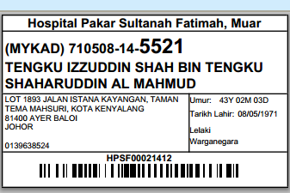

Visit Label
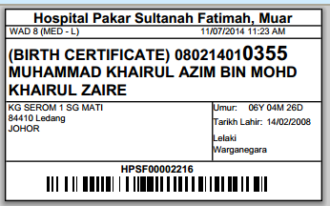

R-PhIS001631314
Module | Reported Date | Description | Solution
Pharmacy Inventory | 9/6/2014 | User request to provide changes and function on RIQ screen.  1) RIQ screen able to reject Indent if haven't supply the Indent yet and able to notify the requester with the status is Rejected by Supplying unit.  2) Able to reject item in the indent.  3) Able to reject any item that partial supply before.  Login ID: 750214015762 (Noraini Saari) | Add Reject function in RIQ screen

- Click Reject Indent button
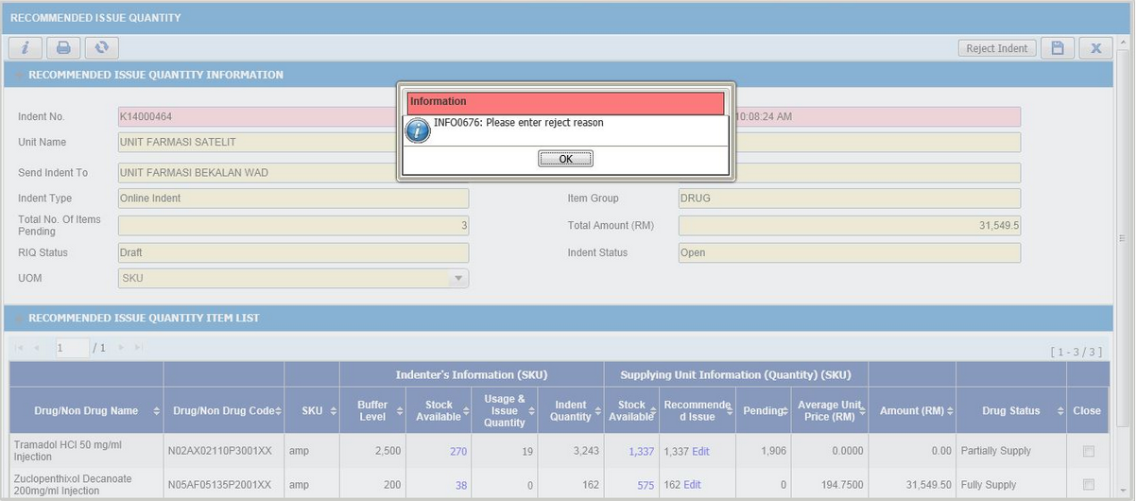
- Enter Reject Reason
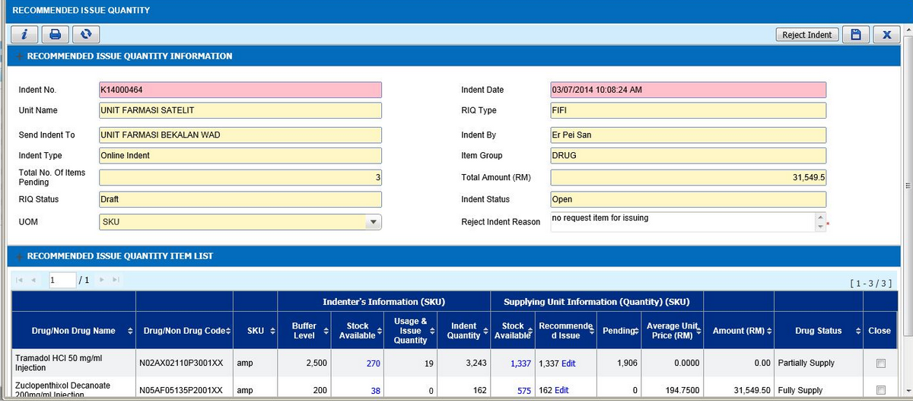

- Reject Indent
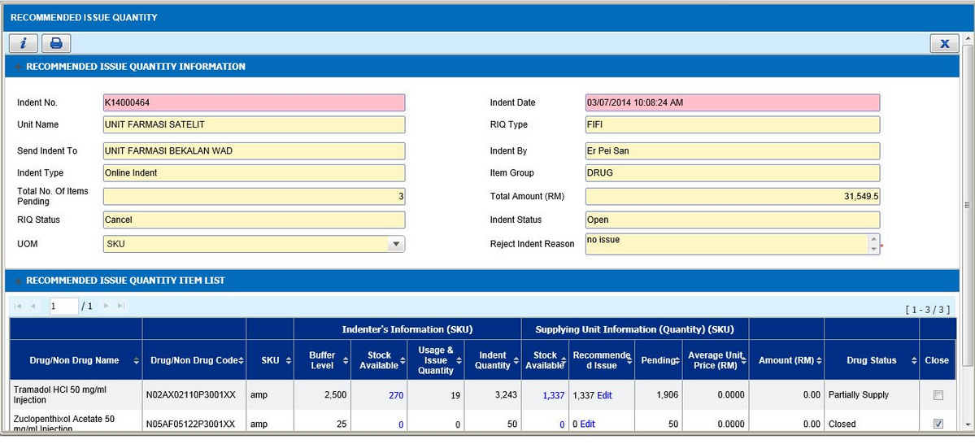

R-PhIS001667314 & I-PhIS007196214S
Module | Reported Date | Description | Solution
Order Management - Web | 12/6/2014 | Allow user to save and confirm the order at the same time to when create the order.  Apply to both mobile and web application.  Date: 06/06/2014 | As per request
Order Management - Web | 30/6/2014 | Doctor request to add another button SAVE & CONFIRM one line with the SAVE button. Currently, doctor need to save then confirm button will appear at button of the page. Instead need to click twice to confirm the order, Doctor request to combine SAVE & CONFIRM button. | As per request

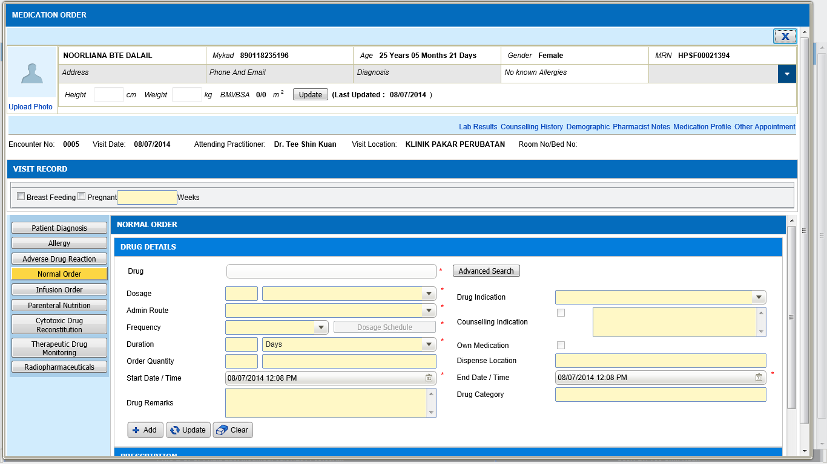

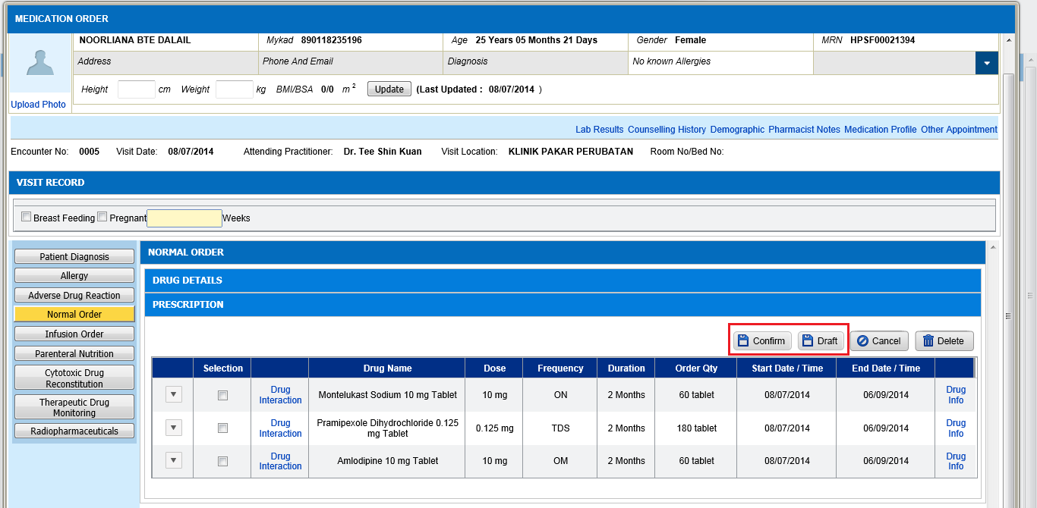
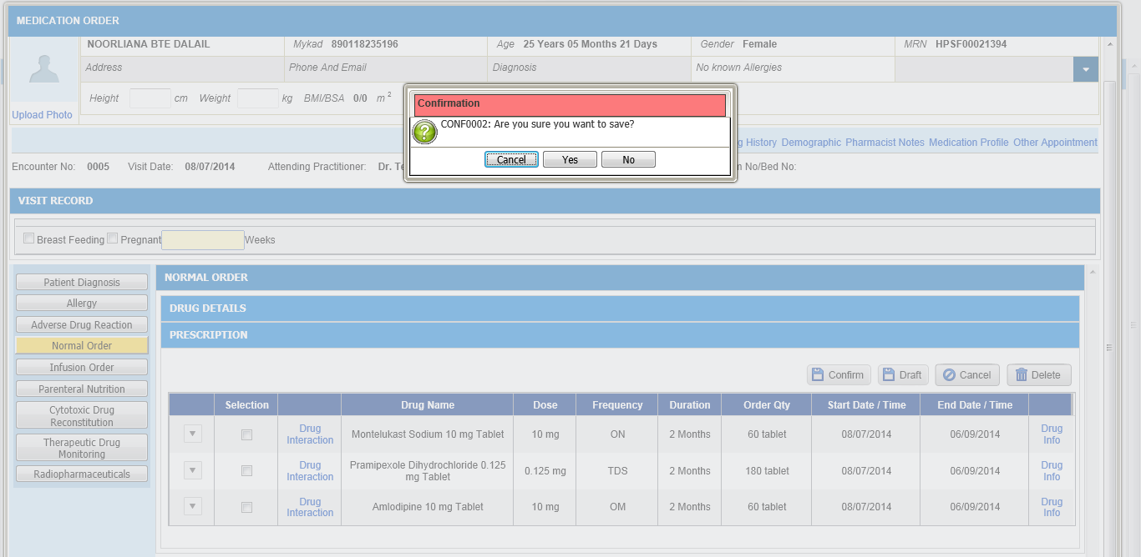

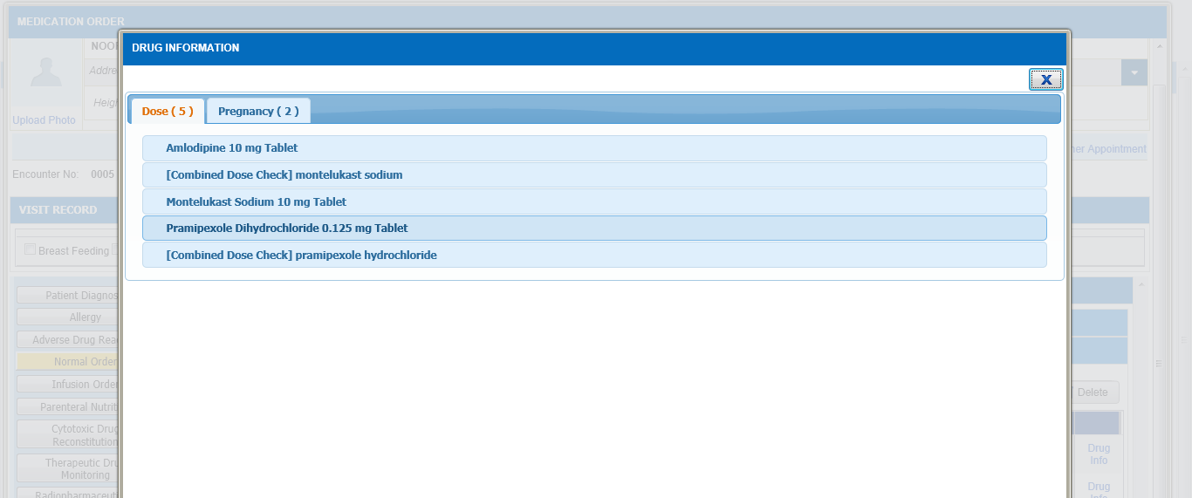

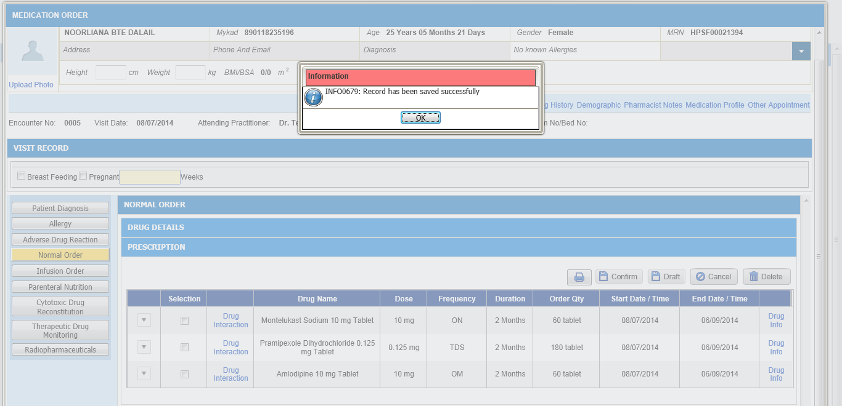
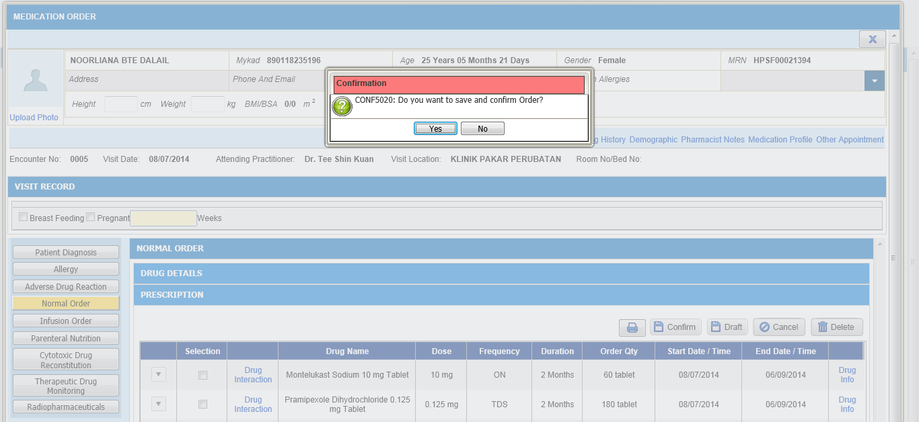

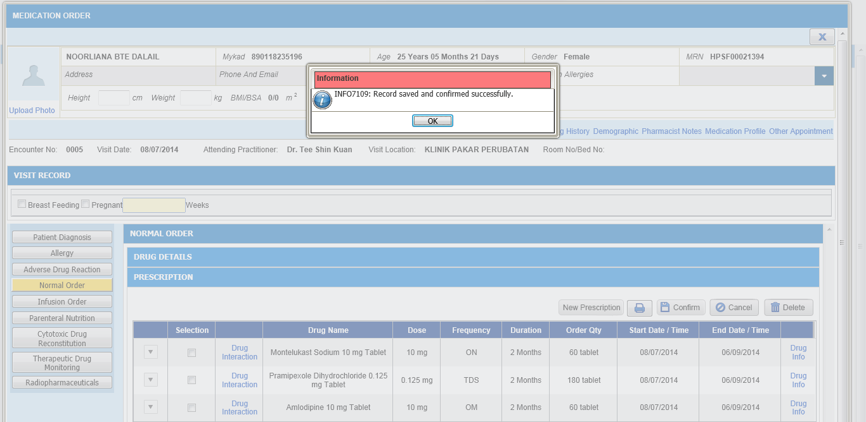

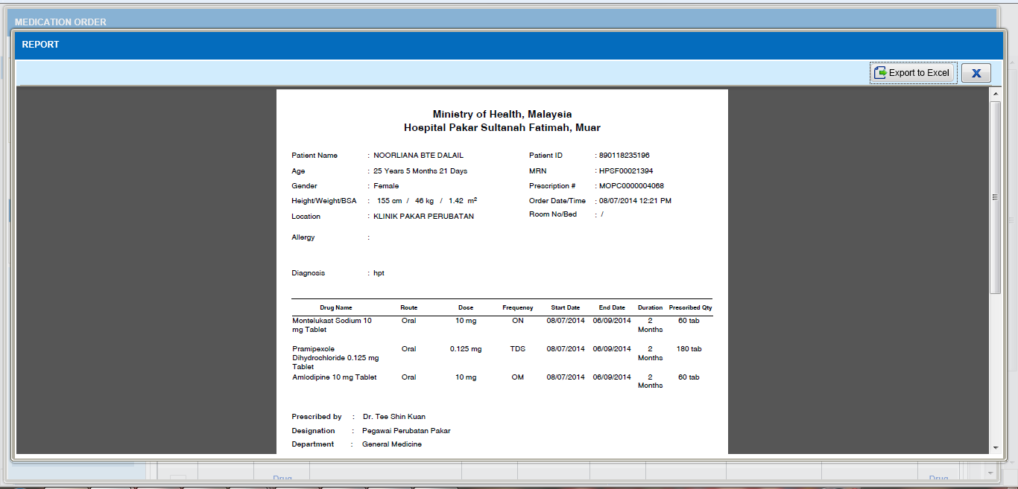

R-PhIS001673314
Module | Reported Date | Description | Solution
Order Management - Mobile | 13/6/2014 | Allow user to save and confirm the order at the same time to when create the order.  Apply to both mobile and web application.  Date: 06/06/2014 | As per request

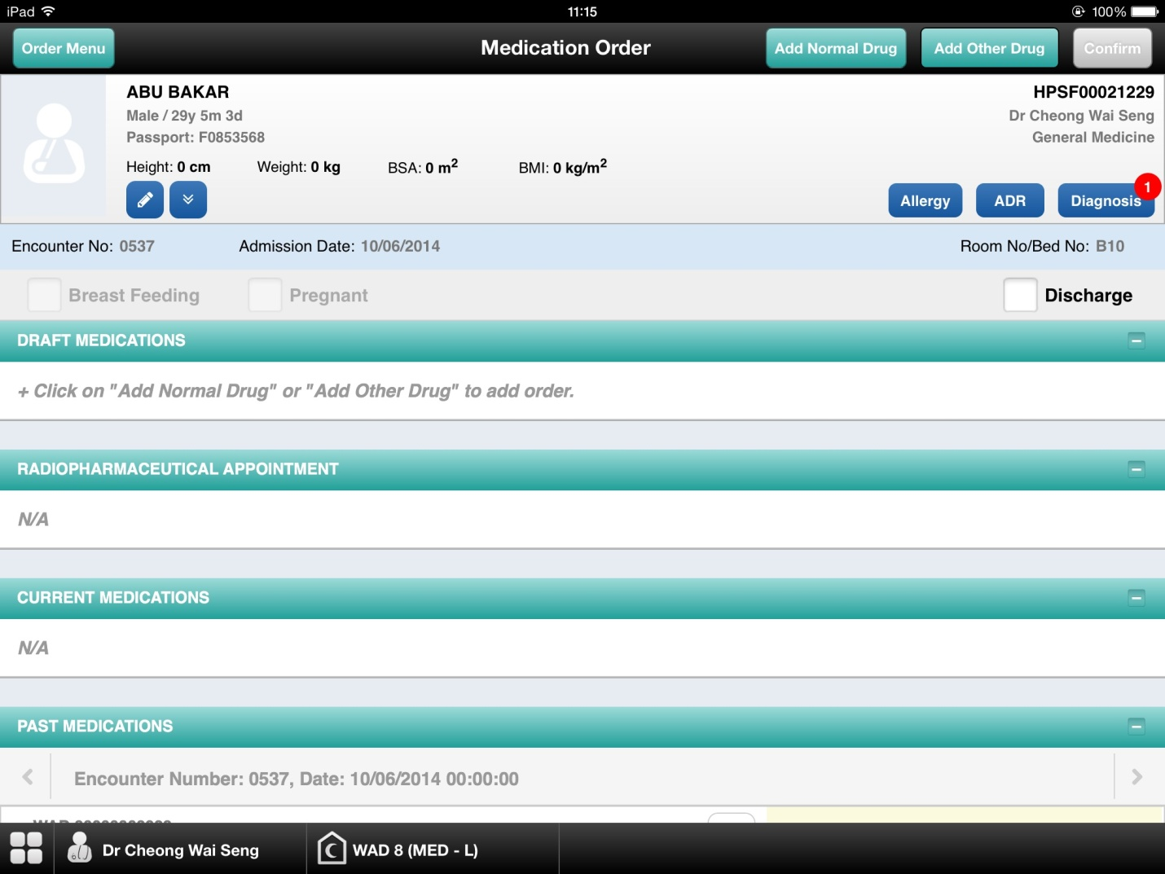
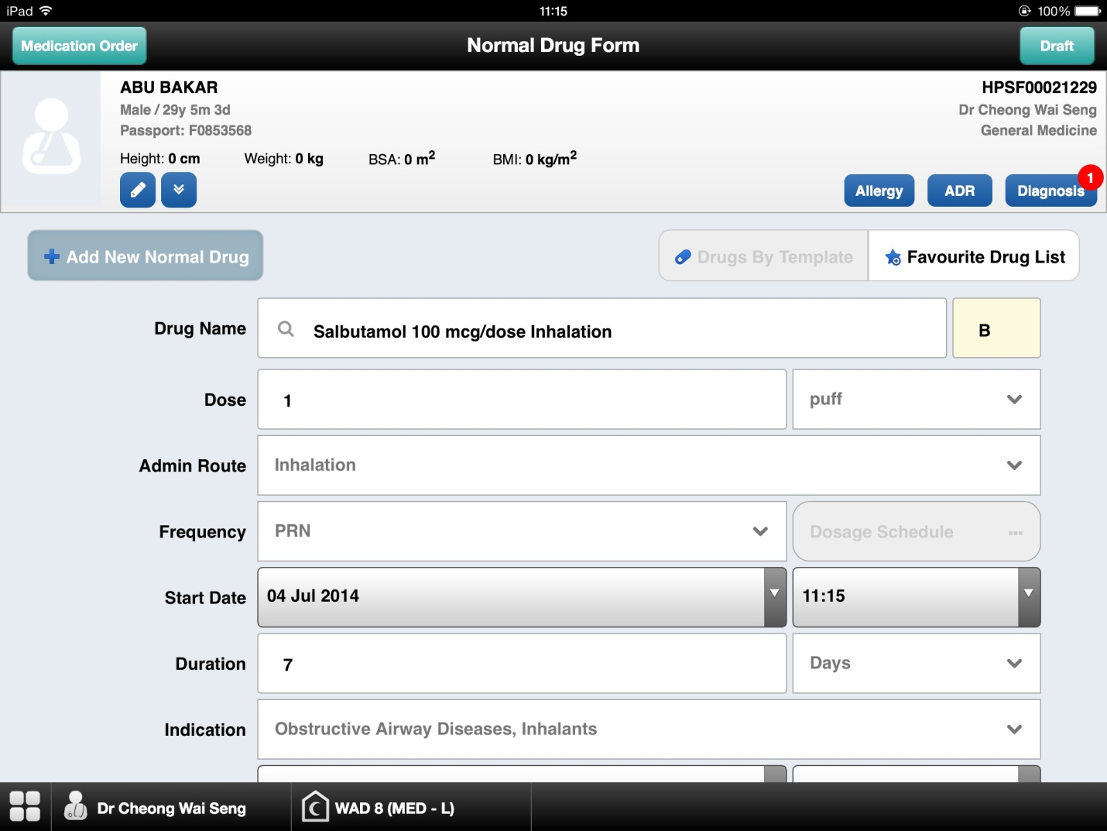

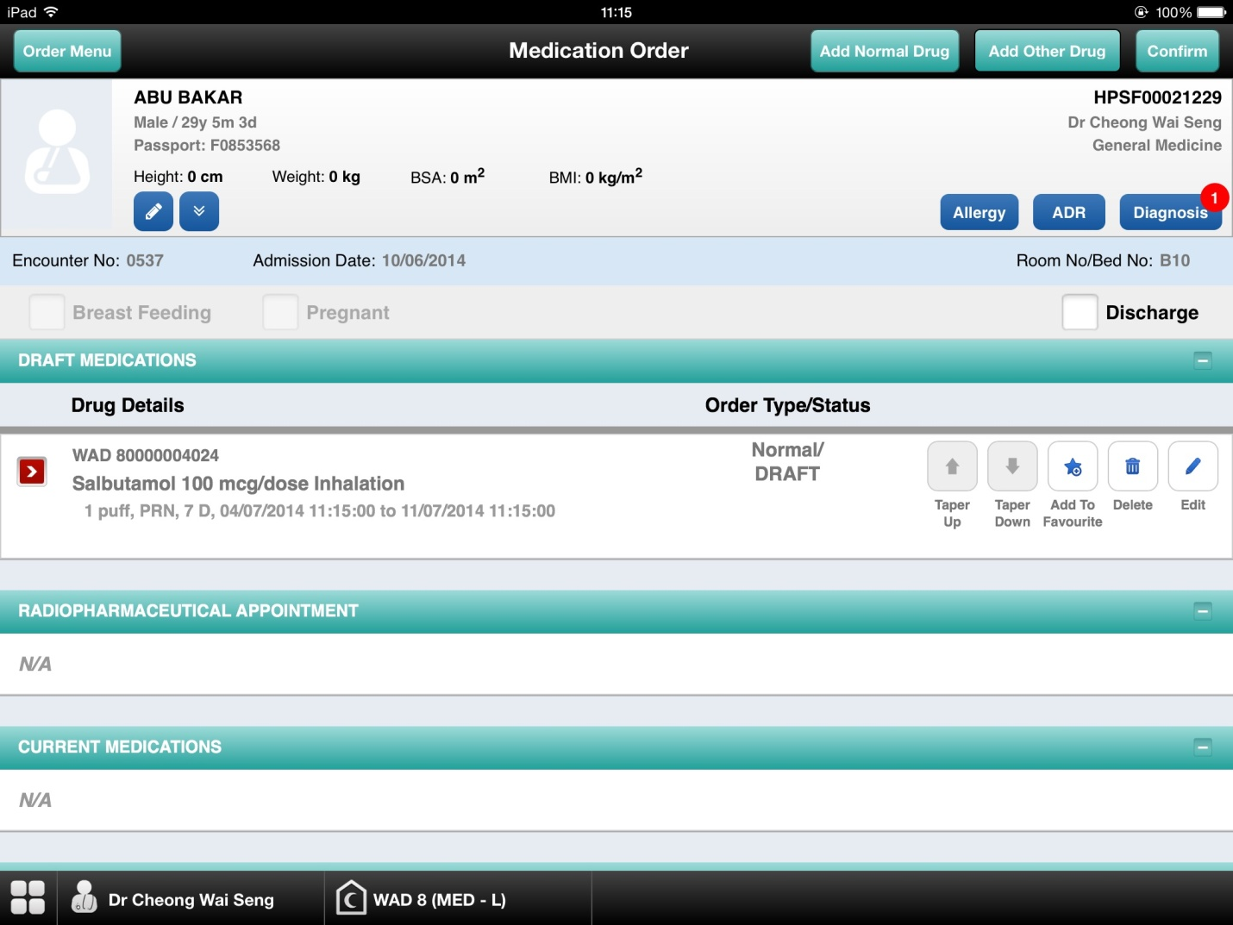
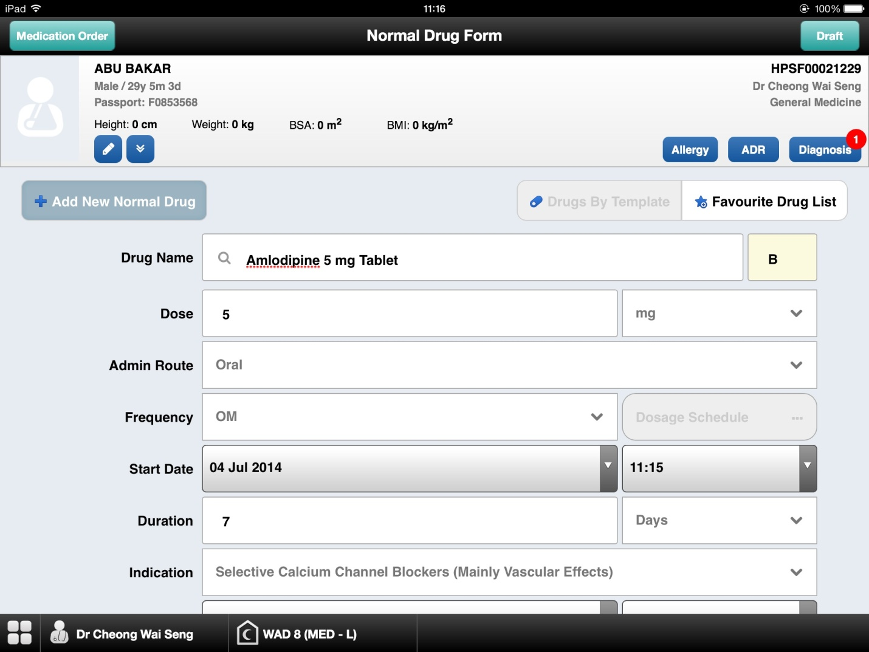

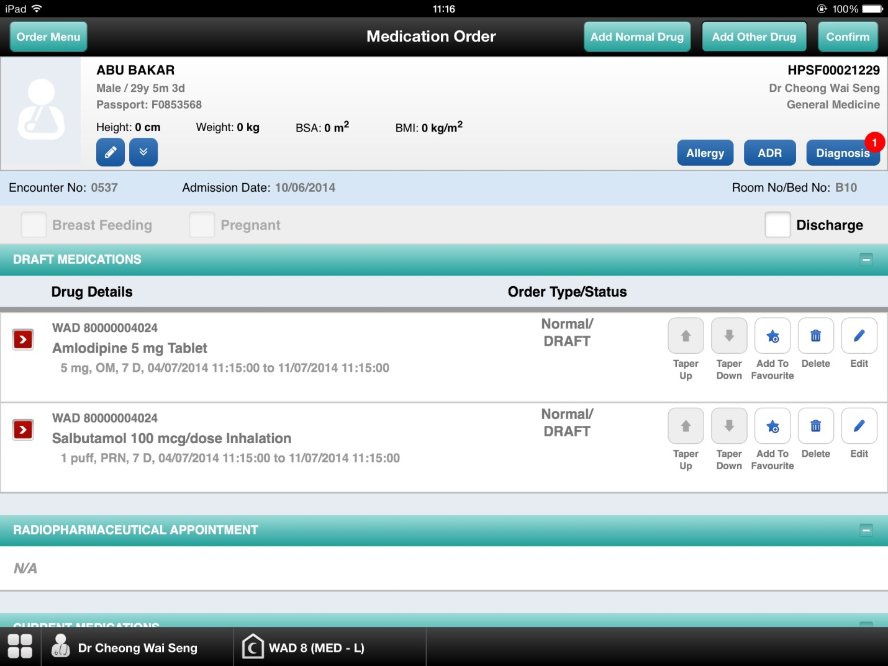
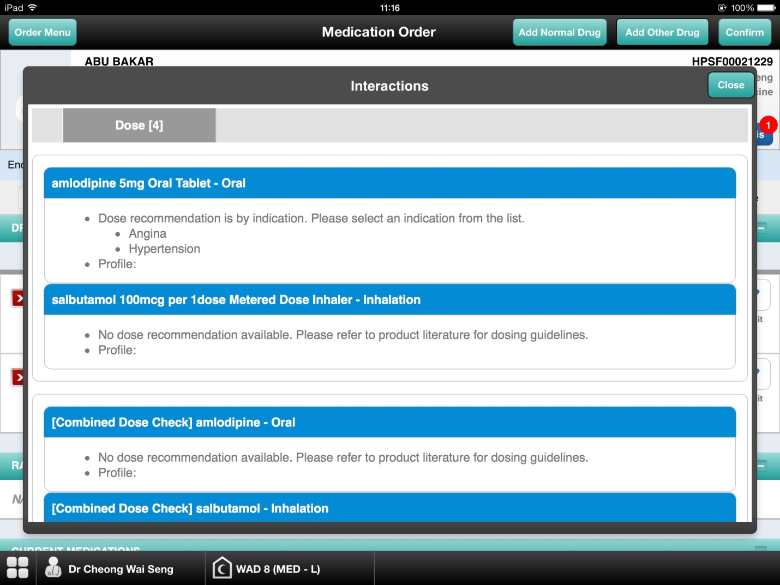

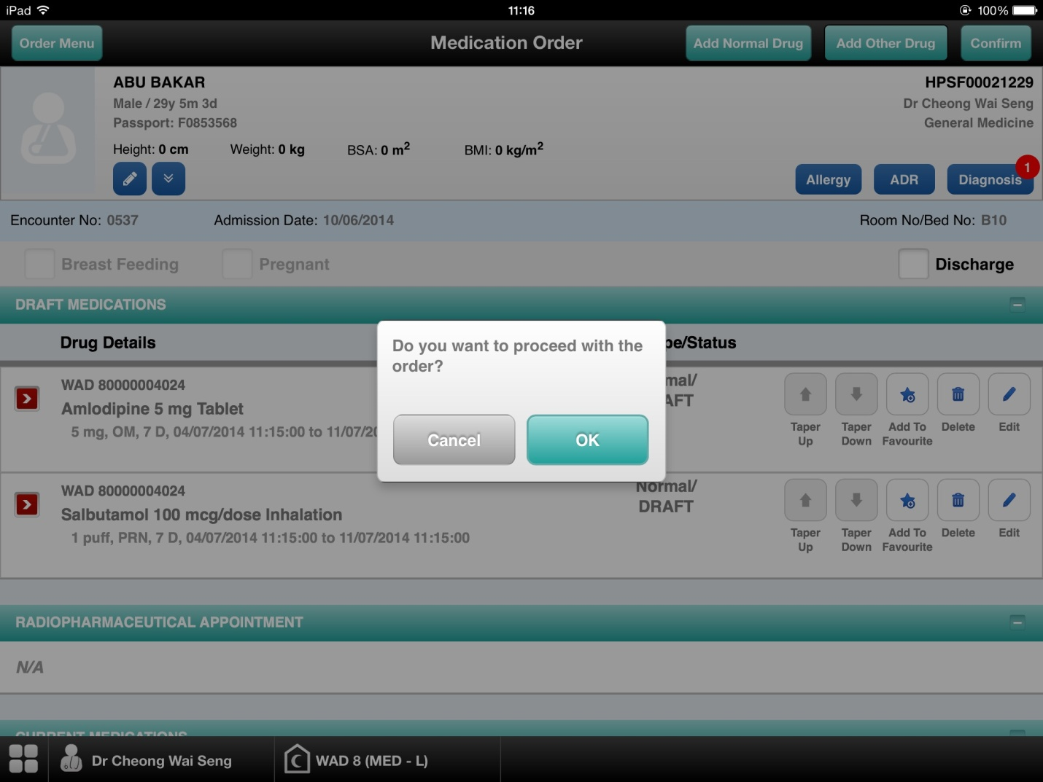
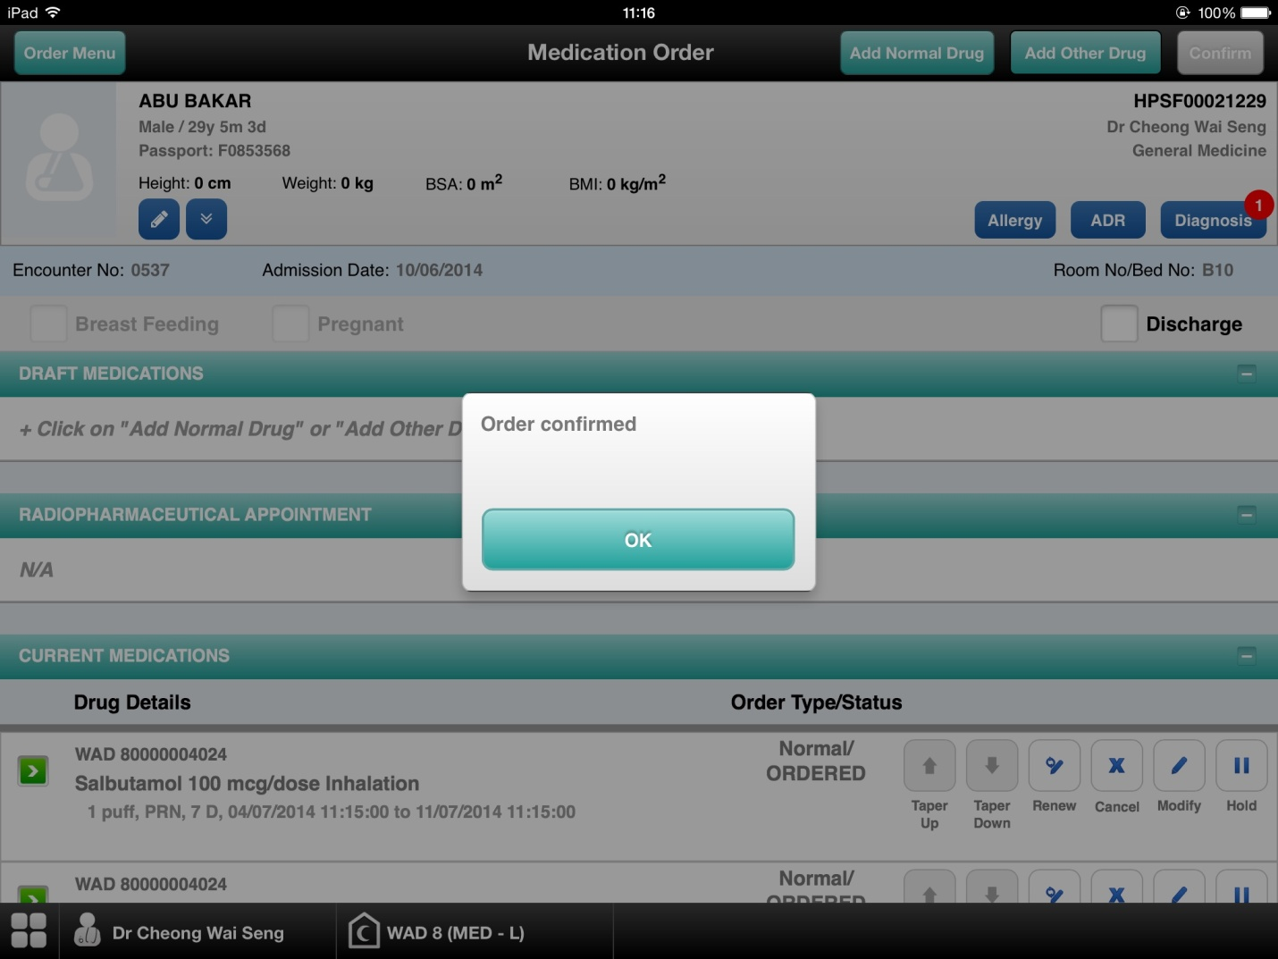

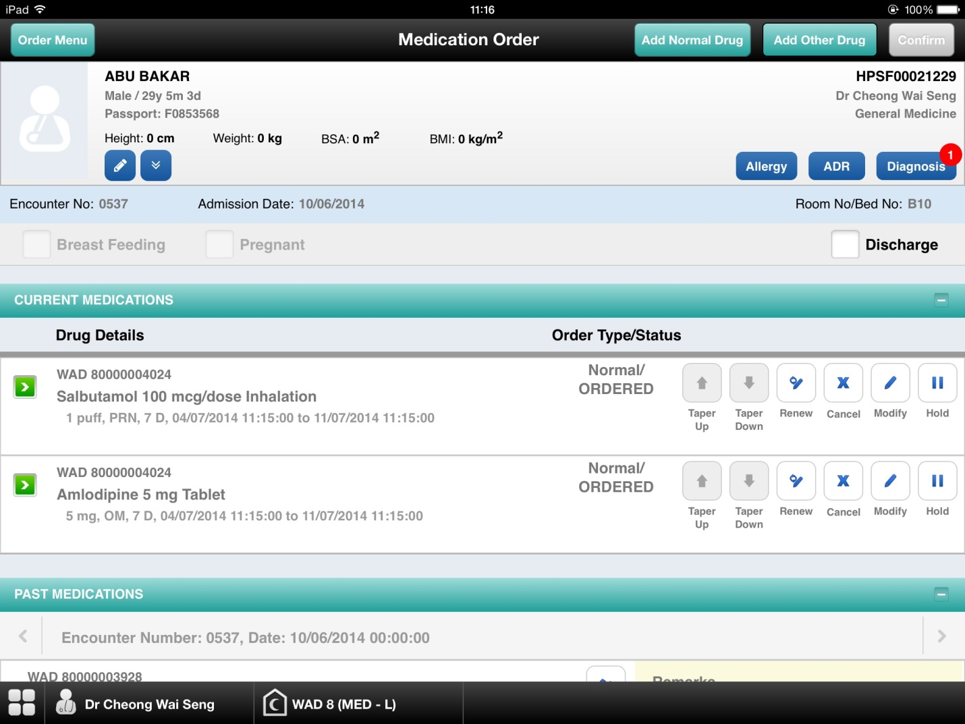

I-PhIS007181714S
Module | Reported Date | Description | Solution
General Module | 26/6/2014 | User request to add 1 column Packaging Description at listing page.  (please refer attached file) | Add additional column

Facility
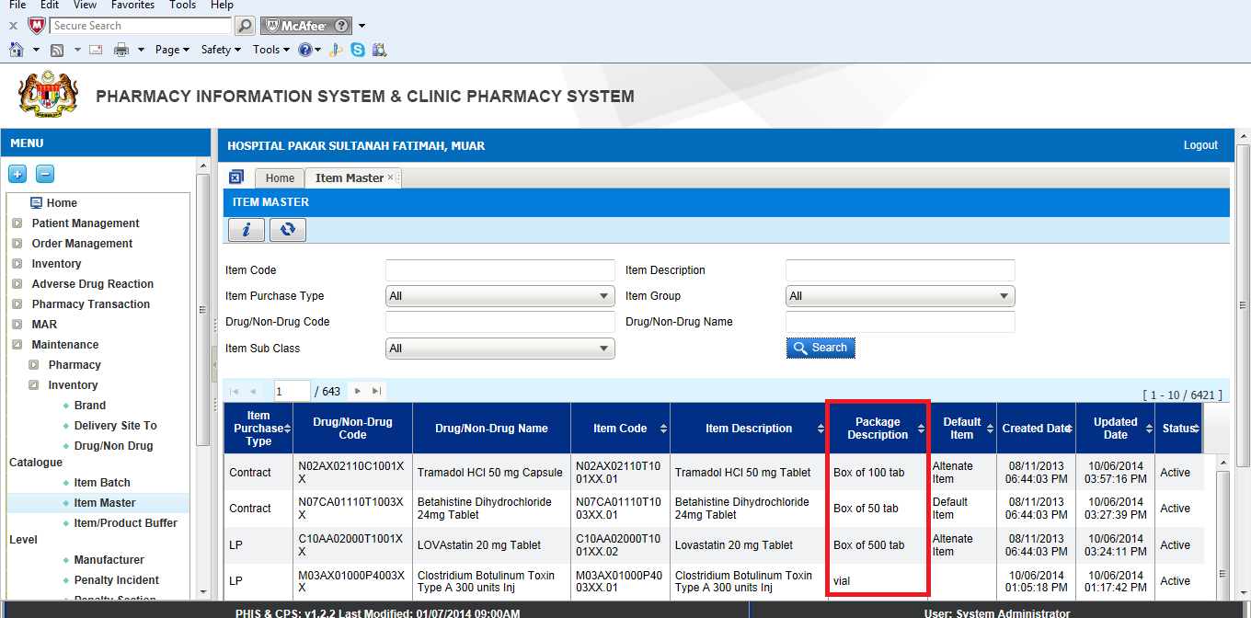

IWP
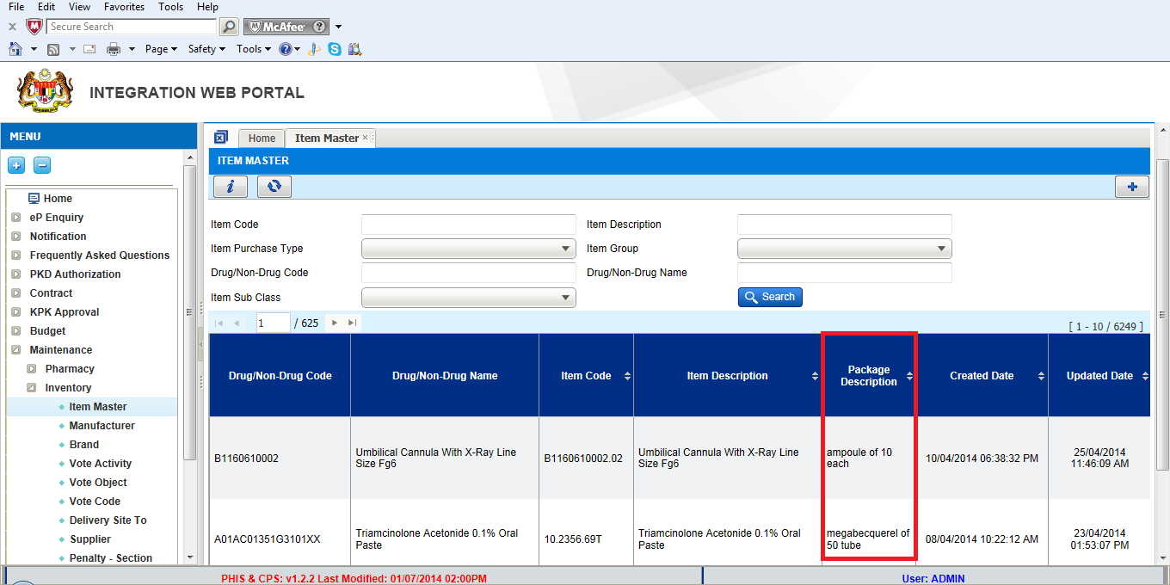

I-PhIS007185714S
Module | Reported Date | Description | Solution
Pharmacy Inventory | 26/6/2014 | User requests something on the Issue module > offline Issue as below;  1. Change the lable Uom to UOM. (refer image 1)  2. When they key in the value in Issue QTY (SKU) or Issue QTY (PKU) , and the value must be more than 0. Then the check box will auto be tick. (refer image 2) | Change the label

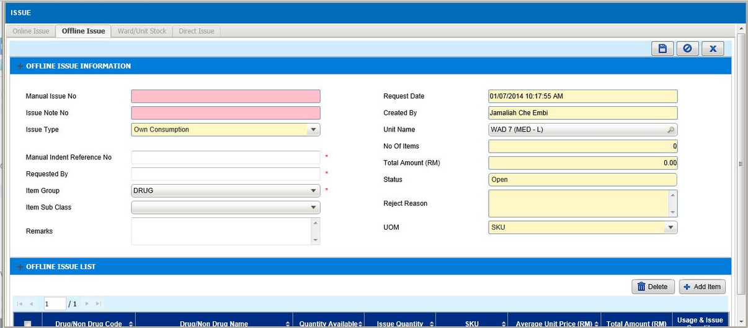
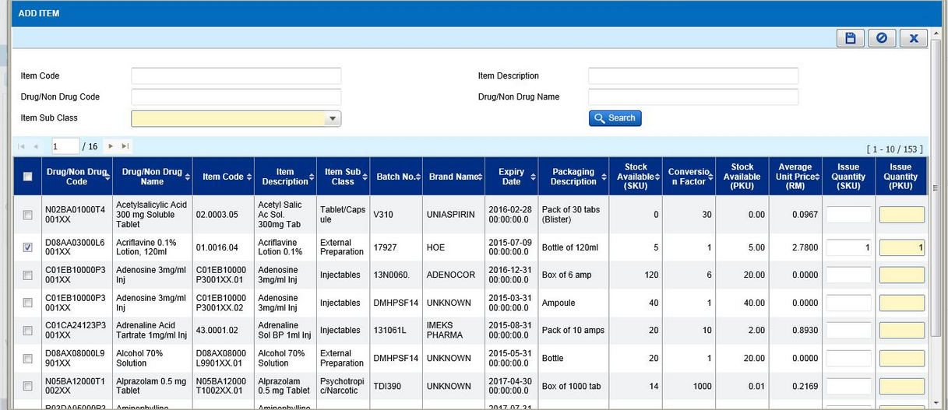

I-PhIS007101714S & I-PhIS007218114S
Module | Reported Date | Description | Solution
Inpatient Pharmacy | 12/6/2014 | Cannot do complete dispensing in Fill List, error message 'Contact Administrator' displayed.  Time: 2.30 pm, 12/06/2014.  Username/Password: 851220145814 | Current flow not able to handle complicated scenario. Change the flow of Fill List and refer to 4.x
Inpatient Pharmacy | 3/7/2014 | User reported that, partially dispensed patient cannot be found in the system.  ID:Siti Aisyah binti Mohd Roslan -810108145418  Patient :LEE AH CHOO  Mykad 500901015746  MRN HPSF00017739 | Current flow not able to handle complicated scenario. Change the flow of Fill List and refer to 4.x

Generate Fill List
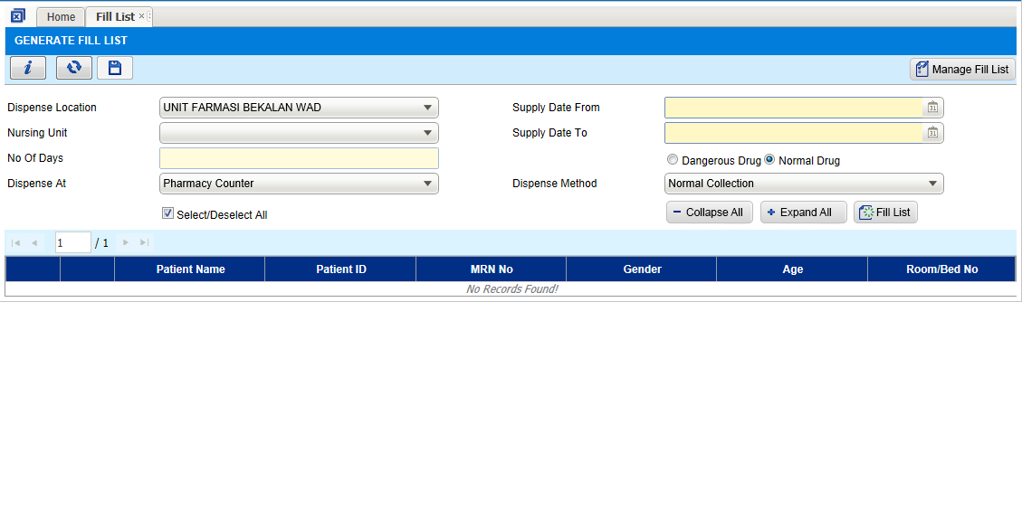
- On generation of fill list, the following item will be included in the list:
- Prescription date still valid
- Next Collection Date smaller than current date.
- Status of the drug is not Hold, Cancelled, Stop or Discontinued.
- Drug is verified (for new order) or partial supply status.
- Drug is not ward stock item

- Fill list will show latest information if there is any intervention done by pharmacist.
- If pharmacist modifies the order during screening, latest modification data will be included.
- If the pharmacist decided to use alternate drug or alternate/combination drug, the alternate drug will be displayed in fill list together with original ordered drug. Alternate or alternate/combination process can be done in screening or preparation screen (multi stage)

- Enter the fill list criteria and click on Fill List Button. Minimum supply duration is 1 day.
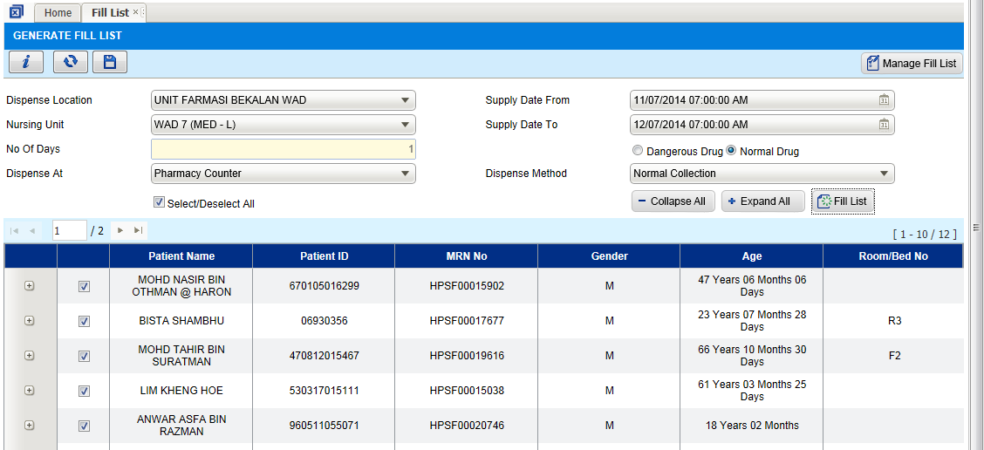

- Fill list will be generated based on selected criteria. User still can change the list before save the fill list. User is allowed to:
  - Remove selected order/drug from the list
  - Remove selected patient from fill list
  - View order details
- User can expand patient name to view details of the fill list or click on ‘Expand All’ button to view all.
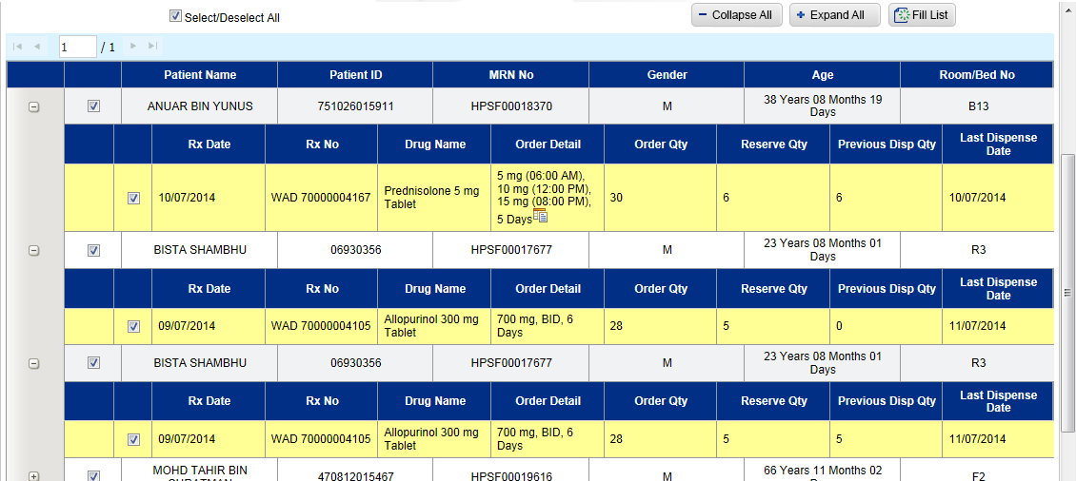
- Only Original drug can be dispensed from fill list. Alternate or alternate/combination dispensing need to use multi stage dispensing.
(Alternate or alternate/combination process available in screening or preparation screen)

- Click on patient name or drug name to view details of the order.
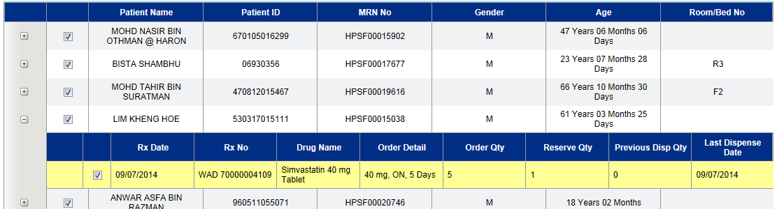
Details screen is read only.
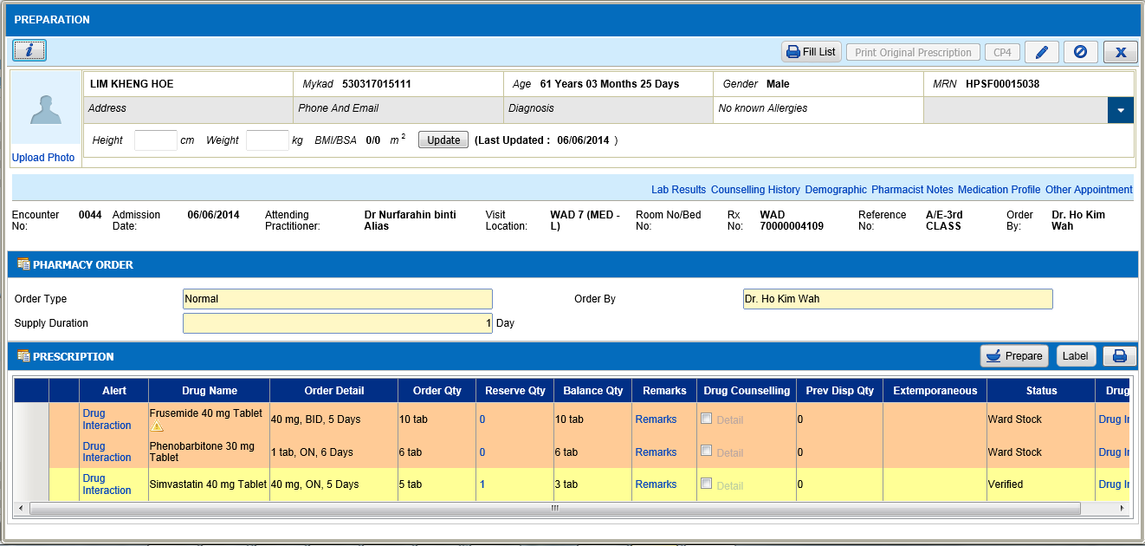
- If user wants to change allocation for specific patient please remove this patient from the fill list and user can continue to do it in preparation screen (Multi Stage Dispensing).

- To remove patient from fill list, uncheck the check box next to the patient name or drug name. Unselect record will not be included in the fill list when save the fill list.
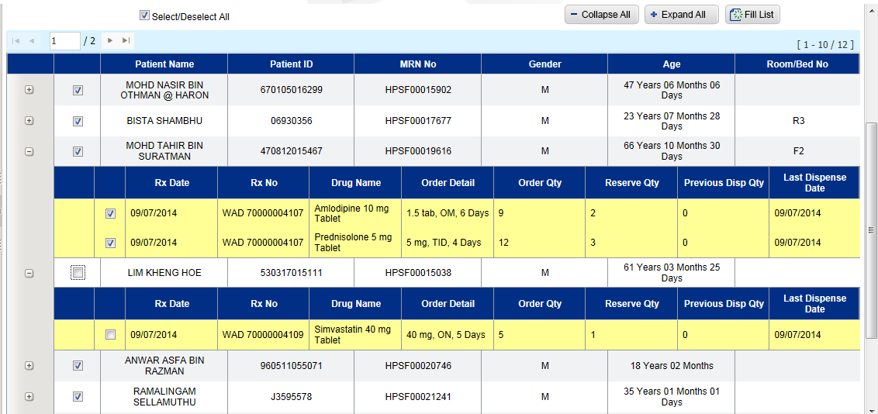

- Select patient and click on Save button to proceed with fill list generation.
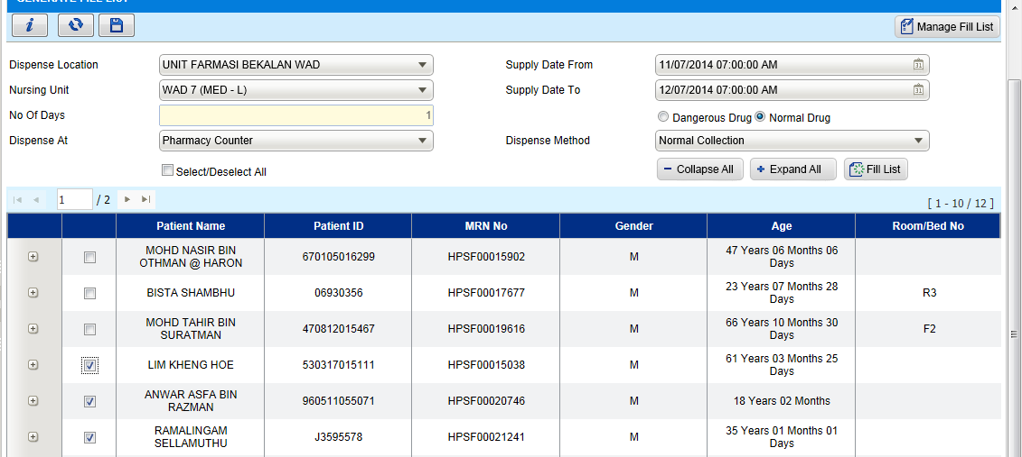

- Alert message will be displayed on click of save button. Click on yes to proceed.
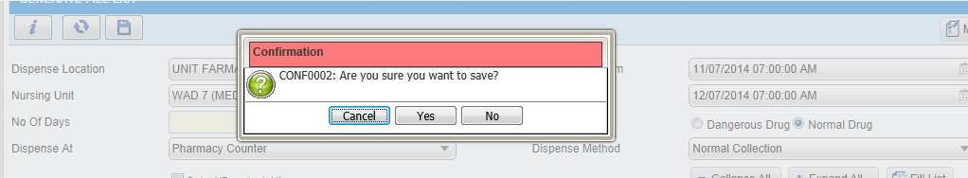
- Once successfully generate, fill list number will be displayed in alert message. User can proceed to manage fill list screen by clicking on Yes button. To stay in the same page and proceed to generate new fill, click on No.
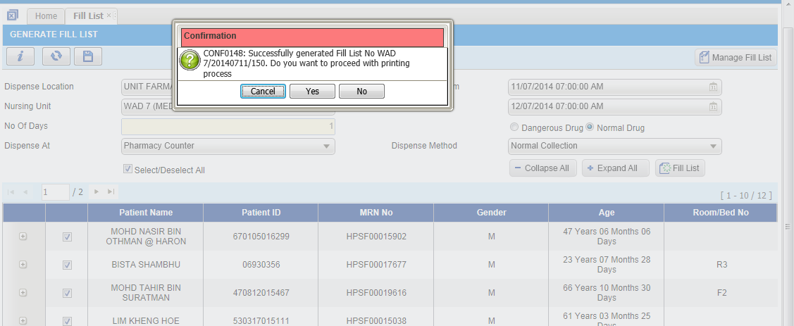

Manage Fill List
- Manage fill list screen will be displayed with fill list generated. In Manage fill list user is able to:
  - Print fill List
  - Print drug label
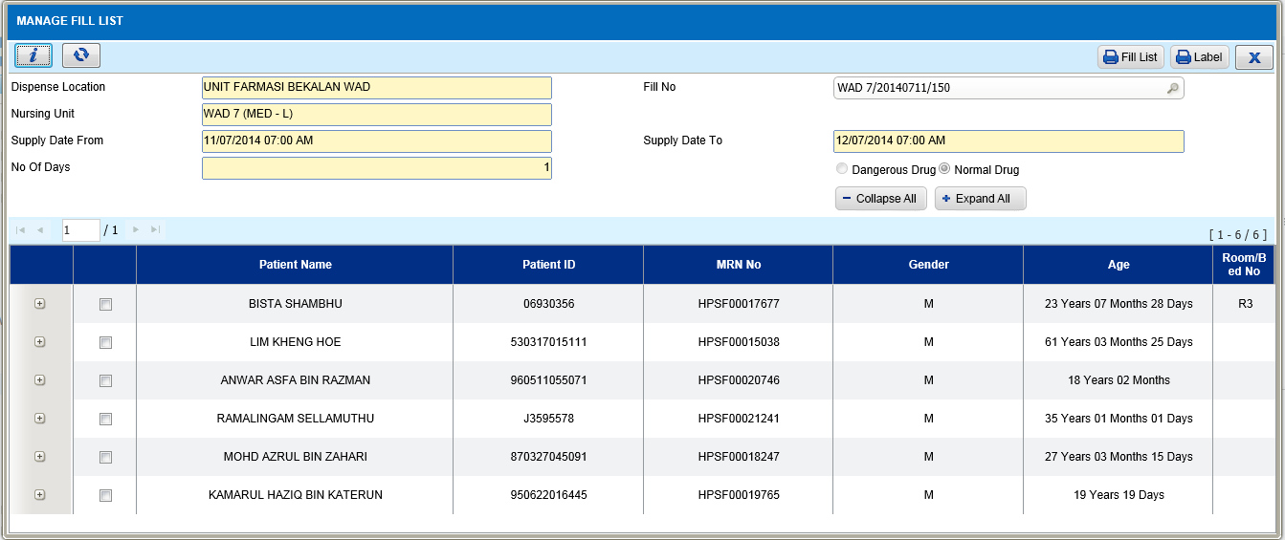
- Click on fill list button to print the fill list.
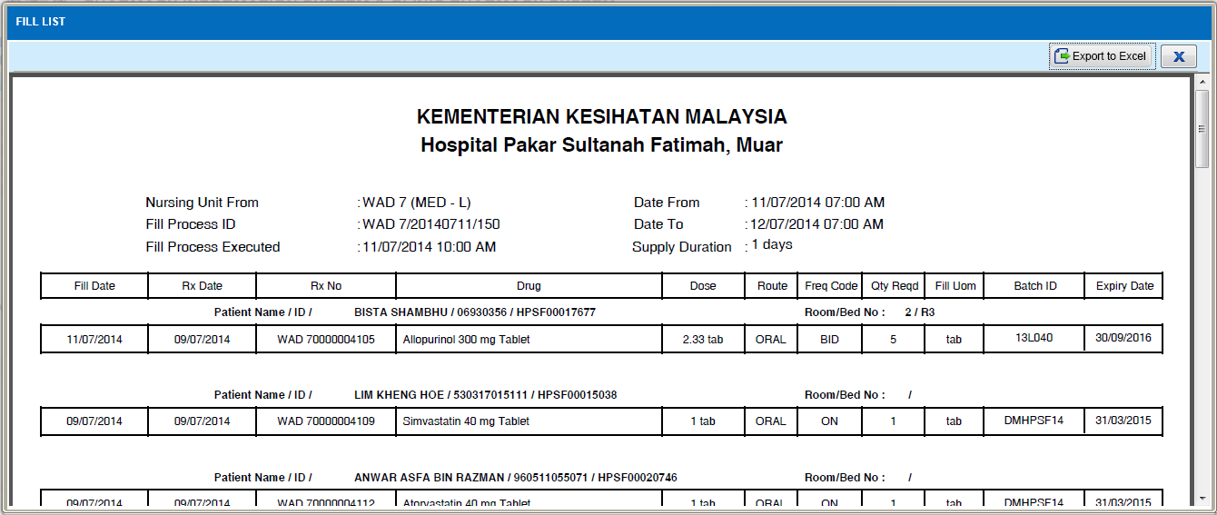
- Select patient to print and click on label button.
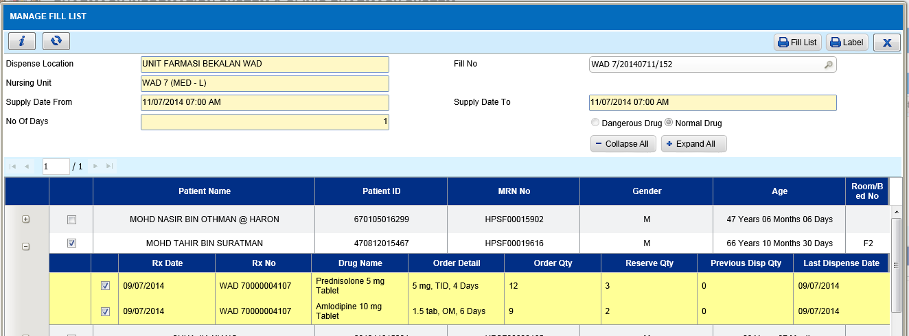
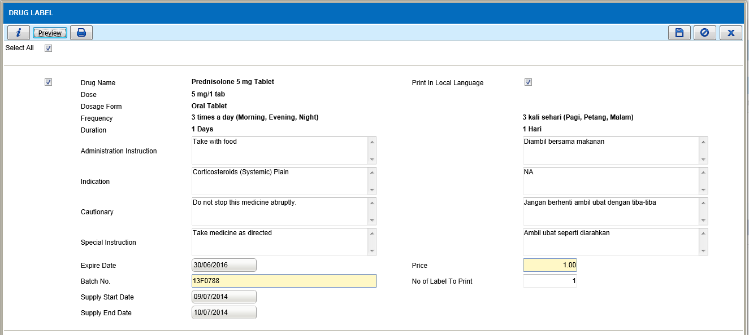
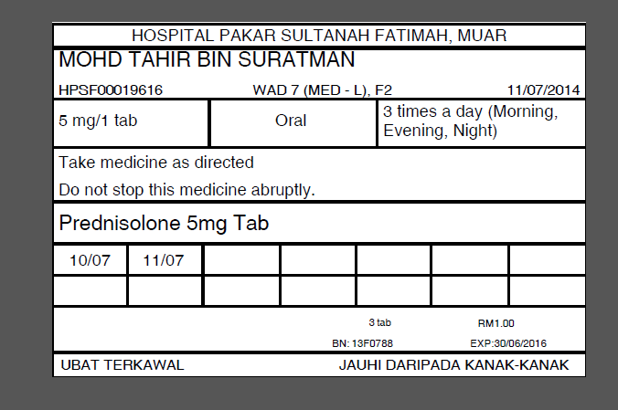

Reminder:
- Please make sure all information is correct before save the fill list:
  - Once fill list is saved, all transactions will consider as ‘Dispensed’ in system and No Changes can be done to the fill list. Prescription and dispensing status will be updated to partial dispensed or fully dispensed (depends on drug quantity). Stock movement is recorded.
  - If any mistake found after fill list is generated, this process cannot be reversed. Fill list can’t be deleted.
- User can generate multiple fill lists for same supply duration but 1 prescription can only Exist in 1 fill list. When fill list is saved, system will update ‘next collection date’ for the selected prescription based on supply duration. Prescription will be included in next fill list generation if it meets the fill list condition. (Refer to ‘Generate Fill List’, point no. 1)
- User is advice to do medication return if it is require to return the medication cause by mistake during fill list generation such as wrong patient selected. Medication return will not reverse the fill list/dispensing process. It will only return the wrong dispensed/unused stock back to pharmacy. (User can use stock adjustment to return in bulk, but user will no able to keep the history by patient)
- Release batch cannot be done after save fill list/dispensing. Only reserve stock can be released. (status = verified, prepared or prepared/hold).
- Alternate drug cannot be dispensed from fill list, it can be dispensed from 3 stage dispensing process. To dispense alternate drug from fill list will be in future release
- Ward stock drug will not available in the fill list printing. The printing of ward stock will only available in future release.

Deployment - Procedures

List of Items to be Deployed

No. | Items | Components | Path
1. | HQ Patch Scripts | PatchScripts_v1.2.2.6.9.txt | https://10.8.9.130:44330/svn/Workspace_Dataware/31_Implementation/Applications/PhIS Release V.1.2.2.006/hq/Scripts
2. | HQ Patch Scripts – Item Master | - 1_items_item_information.txt  - 2_item_brands.txt  - 3_item_price_update_effective_date_30062014.txt  - 4_item_price_128_05price_correction.txt  - 5_item_price_rest.txt  - 6_items_to_I.txt | https://10.8.9.130:44330/svn/Workspace_Dataware/31_Implementation/Applications/PhIS Release V.1.2.2.006/hq/Scripts/APPL ITEM and PRICE_v1.2.2.6.9
3. | HQ Application | - phishq.war  - epservice.war  - dcrepows.war | https://10.8.9.130:44330/svn/Workspace_Dataware/31_Implementation/Applications/PhIS Release V.1.2.2.006/hq/war
4. | HQ Integration | - masterRelease.jar  - BlueBookMap.jar | https://10.8.9.130:44330/svn/Workspace_Dataware/31_Implementation/Applications/PhIS Release V.1.2.2.006/hq/jar
5. | Gateway Workstation | ePBackend.jar | https://10.8.9.130:44330/svn/Workspace_Dataware/31_Implementation/Applications/PhIS Release V.1.2.2.006/hq/Gateway
6. | MIMS Database | - FastTrackData.MR2  - BlueBookMapping.xlsx | https://10.8.9.130:44330/svn/Workspace_Dataware/31_Implementation/Applications/PhIS Release V.1.2.2.006/hq/Gateway
7. | Facility Patch Scripts | PatchScriptsv1.2.2.6.9.txt | https://10.8.9.130:44330/svn/Workspace_Dataware/31_Implementation/Applications/PhIS Release V.1.2.2.006/facility/Scripts
8. | Facility Application | - iphis.war  - PhISService.war | https://10.8.9.130:44330/svn/Workspace_Dataware/31_Implementation/Applications/PhIS Release V.1.2.2.006/facility/war
9. | Facility Application | PhISSchedulers.jar | https://10.8.9.130:44330/svn/Workspace_Dataware/31_Implementation/Applications/PhIS Release V.1.2.2.006/facility/jar
10. | Mobile Application | ipadhosp-1.2.7b15.war | https://10.8.9.130:44330/svn/Workspace_Dataware/31_Implementation/Applications/PhIS Release V.1.2.2.006/facility/mobile

Backup Procedure before Deploy

Backup Procedure
Using backup tool, backup the following files and folder and database as per table below;
No. | Type | Backup Item | Description
1 | Application | /home/phisesb  /opt/phisesb  /usr/share/fonts/truetype | PhIS Integration Application  PhIS Core Application  Fonts required by PhIS
2 | Database | phisprod database | PhIS Live database

Deployment/Installation Guidelines

Deployment at Facility
Below table is described the deployment steps at Facility:
Step | Items | File Name | Source Path | Action
1 | Facility Patch Scripts | PatchScriptsv1.2.2.6.9.txt | https://10.8.9.130:44330/svn/Workspace_Dataware/31_Implementation/Applications/PhIS Release V.1.2.2.006/facility/Scripts | Run the scripts @ Postgres DB using PGAdmin
2 | Facility Application | - iphis.war  - PhISService.war | https://10.8.9.130:44330/svn/Workspace_Dataware/31_Implementation/Applications/PhIS Release V.1.2.2.006/facility/war | Deployment @ Both HA Servers
3 | Facility Application | PhISSchedulers.jar | https://10.8.9.130:44330/svn/Workspace_Dataware/31_Implementation/Applications/PhIS Release V.1.2.2.006/facility/jar | copy into /home/phisesb/phisjars folder
4 | Mobile Application | ipadhosp-1.2.7b15.war | https://10.8.9.130:44330/svn/Workspace_Dataware/31_Implementation/Applications/PhIS Release V.1.2.2.006/facility/mobile | Deployment @ Both HA Servers

Deployment at HQ - IWP
Below table is described the deployment steps at HQ - IWP:

Step | Items | File Name | Source Path | Action
1 | HQ Patch Scripts | - PatchScripts_v1.2.2.6.9.txt | https://10.8.9.130:44330/svn/Workspace_Dataware/31_Implementation/Applications/PhIS Release V.1.2.2.006/hq/Scripts | Run the scripts @ Postgres DB using PGAdmin
2 | HQ Patch Scripts | - 1_items_item_information.txt  - 2_item_brands.txt  - 3_item_price_update_effective_date_30062014.txt  - 4_item_price_128_05price_correction.txt  - 5_item_price_rest.txt  - 6_items_to_I.txt | https://10.8.9.130:44330/svn/Workspace_Dataware/31_Implementation/Applications/PhIS Release V.1.2.2.006/hq/Scripts/APPL ITEM and PRICE_v1.2.2.6.9 | Run the scripts @ Postgres DB using PGAdmin
3 | HQ Application | - phishq.war  - epservice.war  - dcrepows.war | https://10.8.9.130:44330/svn/Workspace_Dataware/31_Implementation/Applications/PhIS Release V.1.2.2.006/hq/war | Deployment @ Both HA Servers
4 | HQ Integration | - masterRelease.jar  - BlueBookMap.jar | https://10.8.9.130:44330/svn/Workspace_Dataware/31_Implementation/Applications/PhIS Release V.1.2.2.006/hq/jar | copy into /home/phisesb/phisjars folder
5 | Gateway Workstation | ePBackend.jar | https://10.8.9.130:44330/svn/Workspace_Dataware/31_Implementation/Applications/PhIS Release V.1.2.2.006/hq/Gateway | copy into C:\Deployment\ePIntegration folder in GATEWAY PC
6 | MIMS Database | - FastTrackData.MR2  - BlueBookMapping.xlsx | https://10.8.9.130:44330/svn/Workspace_Dataware/31_Implementation/Applications/PhIS Release V.1.2.2.006/hq/Gateway | copy into /home/phisesb/MIMS folder

