Pharmacy Information System (PhIS)
and
Clinic Pharmacy System (CPS)

Release Note
For version 1.2.2.7.2

Version : 1.0
Document ID : PhIS_CPS/ReleaseNote/Refinement/12082014

© 2011-2014 Pharmaniaga Logistics Sdn Bhd (PLSB)

CONFIDENTIAL COPYRIGHTED MATERIAL – The information includes all concepts, comments, recommendations, and material, contained herein shall remain the property of Pharmaniaga Logistics Sdn Bhd (PLSB). No portion of this document shall be disclosed, duplicated or used in whole or in part of any purpose other than the purpose of the Pharmacy Information System & Clinic Pharmacy System (PhIS& CPS) Project execution only.

Revision History

Version No | Date of Release | Prepared by | Reviewed / Verified by | List of changes from Previous Version
1.0 | 12/08/2014 | Kee Tuan Hwa | Chew Ming Ping | First Version

Verified and Acknowledged by:
Name | Role/Designation | Organization | Signature & Date
Chew Ming Ping | Team Leader | Pharmaniaga Logistics Sdn Bhd
Hoh Choon Seng | Project Manager | Pharmaniaga Logistics Sdn Bhd

Name | Role/Designation | Organization | Signature & Date
 |  | Bahagian Perkhidmatan Farmasi (BPF), KKM
 |  | Bahagian Pengurusan Maklumat (BPM), KKM

Peer Review
Version No | Reviewed / Verified by | List Of Changes from Previous Version
1.0 | Juridah (QA) | Initial document

1 Introduction 1
1.1 Project Information 1
1.2 Objectives 1
2 Purpose 2
3 Summary – Refinement and Defect List 3
3.1 Refinement List 3
3.1.1 Hospital Pakar Sultanah Fatimah 3
3.1.2 KK Greentown 6
3.2 Resolved Defect List 6
3.2.1 Hospital Pakar Sultanah Fatimah 6
3.2.2 KK Greentown 9
3.2.3 Data Center - IWP 10
4 Refinement List – Detail Changes 11
4.1 I-PhIS001521314S 11
4.2 I-PhIS001521514S and I-PhIS001539614S 11
4.3 I-PhIS001537314S 12
4.4 I-PhIS007292714S 13
4.5 I-PhIS001531414S 14
4.6 I-PhIS007286614S 14
5 Deployment - Procedures 16
5.1 List of Items to be Deployed 16
5.2 Backup Procedure before Deploy 16
5.2.1 Backup Procedure 16
5.3 Deployment/Installation Guidelines 16
5.3.1 Deployment at Facility 16

Introduction

Project Information

Project ID : | PhIS and CPS
Project Name : | Pharmacy Information System and Clinic Pharmacy System
Version No : | 1.2.2.7.2
Client Name : | Ministry of Health
Release ID : | RL14/013
Release Date : | 12/08/2014

Objectives
No. | Objective | Reference
1. | Release PhIS & CPS Application to Facility | Refer Section 3 – Refinement and Defect list

Purpose
The purpose of the document is to update the end-user of the changes and defects have been resolved to be included in the new version of application and will be deployed to production server.
This document outlines the list of request and issue to be delivered in the newer version of application and also the guidelines on how to deploy the new version of application in production.

Summary – Refinement and Defect List

Refinement List

Hospital Pakar Sultanah Fatimah
No | Ticket No. | Module | Reported Date | Description | Additional Information | Solution | Resolved Date | Verify Status
1 | I-PhIS001521314S | Inventory | 19/5/2014 | User request to allow indent from level 2 to level 2. | Request proceed | Change as per request  Please refer to 4.1 | 1/8/2014
2 | I-PhIS001521514S | Inventory | 19/5/2014 | User request In the issue process for ward/unit stock - requester unit need to have all units from level 3. |  | Change as per request  Please refer to 4.2 | 1/8/2014
3 | I-PhIS001537314S | Inventory | 21/5/2014 | At unit catalog user request to remove mandatory field of sub class because troublesome to the user and not user friendly. | 27/5: Refinement, will include in future refinement release  16/6: Will do it in 1.2.4 | Change as per request  Please refer to 4.3 | 1/8/2014
4 | I-PhIS001539614S | Inventory | 22/5/2014 | If user had granted the location only 1 unit(FBW), user from FBW cannot issue ward stock item to unit that are being catered by satelit pharmacy vise versa.  Jabatan Kecemasan tiada dalam requestor Unit. | Need to be discuss with project team.  Work around - To create new user id to use for issuing purpose.  27/5: Refinement, will include in next release | Change as per request  Please refer to 4.2 | 1/8/2014
5 | I-PhIS007292714S | Inventory | 16/7/2014 | User request to add searching filter by Status or by default, page will auto filter item that in status Active and show item that in the status Active only.  user request due to unit Catalogue unable to print all active medications because there is no search field for active drugs only. Please add search field for status or just remove all the inactive drugs from this list. Only the active drugs are important. If at one point the inactive ones should be used the add item function is already there.  screen: Inventory> Unit catalogue  User ID : 810108145418 |  | Change as per request  Please refer to 4.4 | 17/7/2014
6 | I-PhIS001531414S | OM-Web | 21/5/2014 | User request enable/allow to amend dosage time. item name:Insulin isophane (Insulatard) 100 IU/mL Penfill. | 22/5: Quick solution to allow user to ament schedule time for split dose. Split dose only applicable to specific drug with defined in Drug Master  27/5: Will discuss and propose permanent solution  18/6: Modify admin time can be done for certain drug only | Only allow to change the dosage for drug with split dose flag.  Please refer to 4.5 | 5/8/2014
7 | I-PhIS007286614S | Outpatient | 15/7/2014 | Unable to prepare extemporaneous drugs. Extemporaneous check box not applicable.  1. Domperidone 10 mg Tablet  2. Atenolol 50 mg Tablet  3. Lamotrigine 50 mg Tablet  4. Hydrochlorothiazide 50 mg Tablet  5. Trimethoprim 300 mg Tablet  6. Metronidazole 200 mg Tablet  Username : Noraini  UserID : 750214015762 |  | 1. Domperidone  o MOTIDOM ORAL SUSPENSION 1MG/ML  o RABUGEN 5 MG/ 5 ML SUSPENSION  o MOTINORM SYRUP 5MG/5ML  o MOTIGUT SUSPENSION 1MG/ML  o DOMNE SUSPENSION 1MG/ML  o etc..  2. Lamotrigine - no syrup or  suspension product but there is a chewable tablet available (LAMICTAL CHEWABLE DISPERSIBLE 2MG TABLETS)  3. Metronidazole  o METRONIDAZOLE SYRUP 100MG  o FOGYL SUSPENSION 200MG/5ML  Please refer to 4.6 | 16/7/2014

Verified and Acknowledged By:
Signature: |  | Name:
Date: |  | Designation:

Signature: |  | Name:
Date: |  | Designation:

KK Greentown
N/A

Resolved Defect List
The following are the summary of resolved defect list that included in PhIS and CPS version 1.2.2.7.2.

Hospital Pakar Sultanah Fatimah
No | Ticket No. | Module | Reported Date | Description | Additional Information | Root Caused | Resolved Date | Verify Status
4 | I-PhIS007319714S | Inpatient Pharmacy | 20/7/2014 | User reported Null Value in report Fill List  HPSF00028695 - LIM LEE GOE  UserID : 750214015762 (Noraini) |  | When Fill List is printed, the data is not fully loaded due to paging inside system. The first page only is loaded while the next pages is not loaded thus the data become null. | 6/8/2014
5 | I-PhIS007320014S | Inpatient Pharmacy | 20/7/2014 | User reported Button REFRESH NOT FUNCTION.  UserID : 750214015762 (Noraini) |  | Unused Refresh button is displayed in Manage Fill List | 6/8/2014
10 | I-PhIS007375914S | Order Management - Web | 4/8/2014 | Doctor unable to order Dutasteride 0.5mg and Tamsulosin 0.4mg Capsule due to the drug not show up in order screen .  Drug Name : Dutasteride 0.5mg and Tamsulosin 0.4mg Capsule.  Time occur: 9.40 a.m. | Informed by Syazwan (trainer) this issue was classified as priority 1 due to patient safety doctor cannot find the drug even that drug was active. | Query for search the drugs using drug Orderables is incomplete | 7/8/2014
13 | I-PhIS007291914S | Outpatient Pharmacy | 16/7/2014 | user reported Drugs Salbutamol 100 mcg/dose inhalation missing in dispensing list.  User ID : 810108145418 |  | System change the status of PRN drug to full dispense even there is still balance qty for that PRN drug. | 7/8/2014
15 | I-PhIS007319814S | Outpatient Pharmacy | 20/7/2014 | User reported that All PRN item not available in repeat prescription e.g:  a. HPSF00022812 Glyceryltrinitrate (there is still balance in BMS) if prn is set to one month only then if patient gets heart attack at 3 months? GTN efficacy will last for 2 months only.  b. HPSF00023684 Diclofenac gel  User ID :810108145418 (Siti Aisyah binti Mohd Roslan) |  | System change the status of PRN drug to full dispense even there is still balance qty for that PRN drug. | 7/8/2014
19 | I-PhIS007339714S | Patient Management | 24/7/2014 | Reported automatic End Visit not functioning. The scenario as below;  Patient admit to Ward 11 at 20/7(Refer Picture 1) and refer to Dermatology Clinic at 22/7(Refer Picture 2). Today 24/7, patient name still active as OP. The automatic End Visit not function. At Clinical Summary show as OP (Refer Picture 3).  Patient: Salmiah Binti mohamed@Ismail (HPSF00029834)  Time occur: 24-Jul-14 10:10 AM |  | system always show latest visit | 5/8/2014
21 | I-PhIS007335714S | Pharmacy Inventory | 23/7/2014 | Description :User unable to do stock adjustment due to the batch received from supplier not show up in the list of batch.  Item Code: B1430550001.01 - Withdrawal & Injection Spike with air filter  Batch : NOT APPLICABLE  Store : STOR FARMASI  User ID : Stephanie  Module : Inventory> Store Inventory> Stock Taking and Verification >Adjustment |  | batch does not have expiry date but in Adjustment add item has filter for batch expiry date so batch was not full filling expiry date criteria | 6/8/2014
22 | I-PhIS007355914S | Pharmacy Inventory | 27/7/2014 | User unable to issue drug to requester (ward 18) due to cant modify Issue Quantity. When modify an error(refer attach 3) prompt. Data(refer attach 1 & 2,purple square) not tally between each other. Try to approve without change the Issue Quantity but system prompt error(refer attach 4)  User: Loo Poh Ling  Screen: Inventory-> Store Inventory -> Issue -> Issue -> Ward/Unit Stock |  | coding issue | 7/8/2014

Verified and Acknowledged By:
Signature: |  | Name:
Date: |  | Designation:

Signature: |  | Name:
Date: |  | Designation:

KK Greentown
No | Ticket No. | Module | Reported Date | Description | Additional Information | Root Caused | Resolved Date | Verify Status
1 | I-PhIS007190014S | Order Management - Web | 26/6/2014 | System allow to save the drug although it is active in the previous medication. Details of the drug's current medication is no longer available.  1. Renew Rx for patient and the drug is displayed in the order screen  2. Change the start date to today's date and save the order  3. Drug is successfully saved although the drug is active in the previous medication  4. Click back on the Medication Profile hyperlink  5. Previous active medication is no longer displayed in the Medication Profile: Current Medication section  Time: 12.00pm  User ID: 820610086205 |  | system allow to add renew drug even though drug is in active medication when modify start date to current date. | 7/8/2014
2 | I-PhIS007334014S | Pharmacy Inventory | 23/7/2014 | Drug Name : Ipratropium Bromide 0.5 mg and Salbutamol 2.5 mg per UDV  In receive item - Inter facility, quantity approved in SKU is 200.  But when check at the Stock Taking and Verification, system show quantity available quantity in SKU is 30.  User Id: 670412085454  Time Incident Happen: 2.30 p.m | Refer Attachment 1 (Inter Facility)  Refer Attachment 2a & 2b (Stock Taking and Verification) | coding issue of fetching details cause exception and record could not saved in current stock | 5/8/2014
3 | I-PhIS007347814S | Pharmacy Inventory | 25/7/2014 | Receive Item Against: Manual  reported The Expiry Date field has no * that indicate that the field is mandatory but the alert message as in Attachment is shown after user click on the save button.  User Id: 721126086226  Time Incident Happen: 09.00am |  | mandatory * mark was missing for drug Items | 6/8/2014

Verified and Acknowledged By:
Signature: |  | Name:
Date: |  | Designation:

Signature: |  | Name:
Date: |  | Designation:

Data Center - IWP
N/A

Refinement List – Detail Changes

I-PhIS001521314S
Module | Reported Date | Description | Solution
Inventory | 19/5/2014 | User request to allow indent from level 2 to level 2. | Change as per request
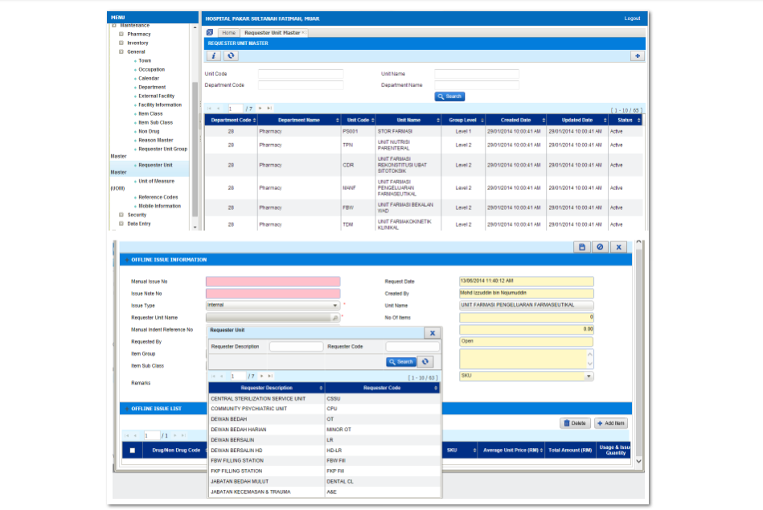

I-PhIS001521514S and I-PhIS001539614S
Module | Reported Date | Description | Solution
Inventory | 19/5/2014 | User request In the issue process for ward/unit stock - requester unit need to have all units from level 3. | Change as per request
Inventory | 22/5/2014 | If user had granted the location only 1 unit(FBW), user from FBW cannot issue ward stock item to unit that are being catered by satelit pharmacy vise versa.  Jabatan Kecemasan tiada dalam requestor Unit. | Change as per request

I-PhIS001537314S
Module | Reported Date | Description | Solution
Inventory | 21/5/2014 | At unit catalog user request to remove mandatory field of sub class because troublesome to the user and not user friendly. | Change as per request

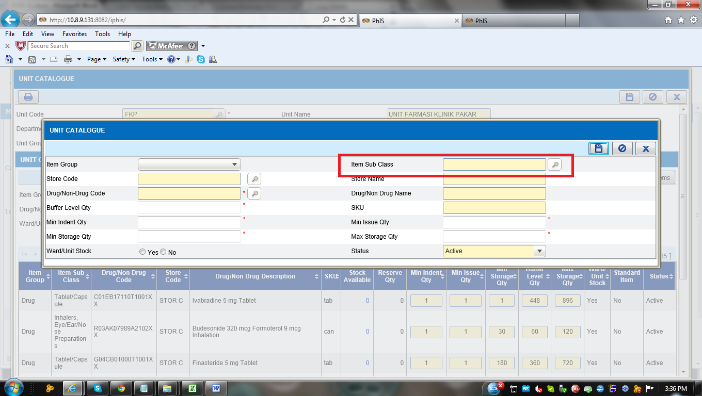

I-PhIS007292714S
Module | Reported Date | Description | Solution
Inventory | 16/7/2014 | User request to add searching filter by Status or by default, page will auto filter item that in status Active and show item that in the status Active only.  user request due to unit Catalogue unable to print all active medications because there is no search field for active drugs only. Please add search field for status or just remove all the inactive drugs from this list. Only the active drugs are important. If at one point the inactive ones should be used the add item function is already there.  screen: Inventory> Unit catalogue  User ID : 810108145418 | Change as per request

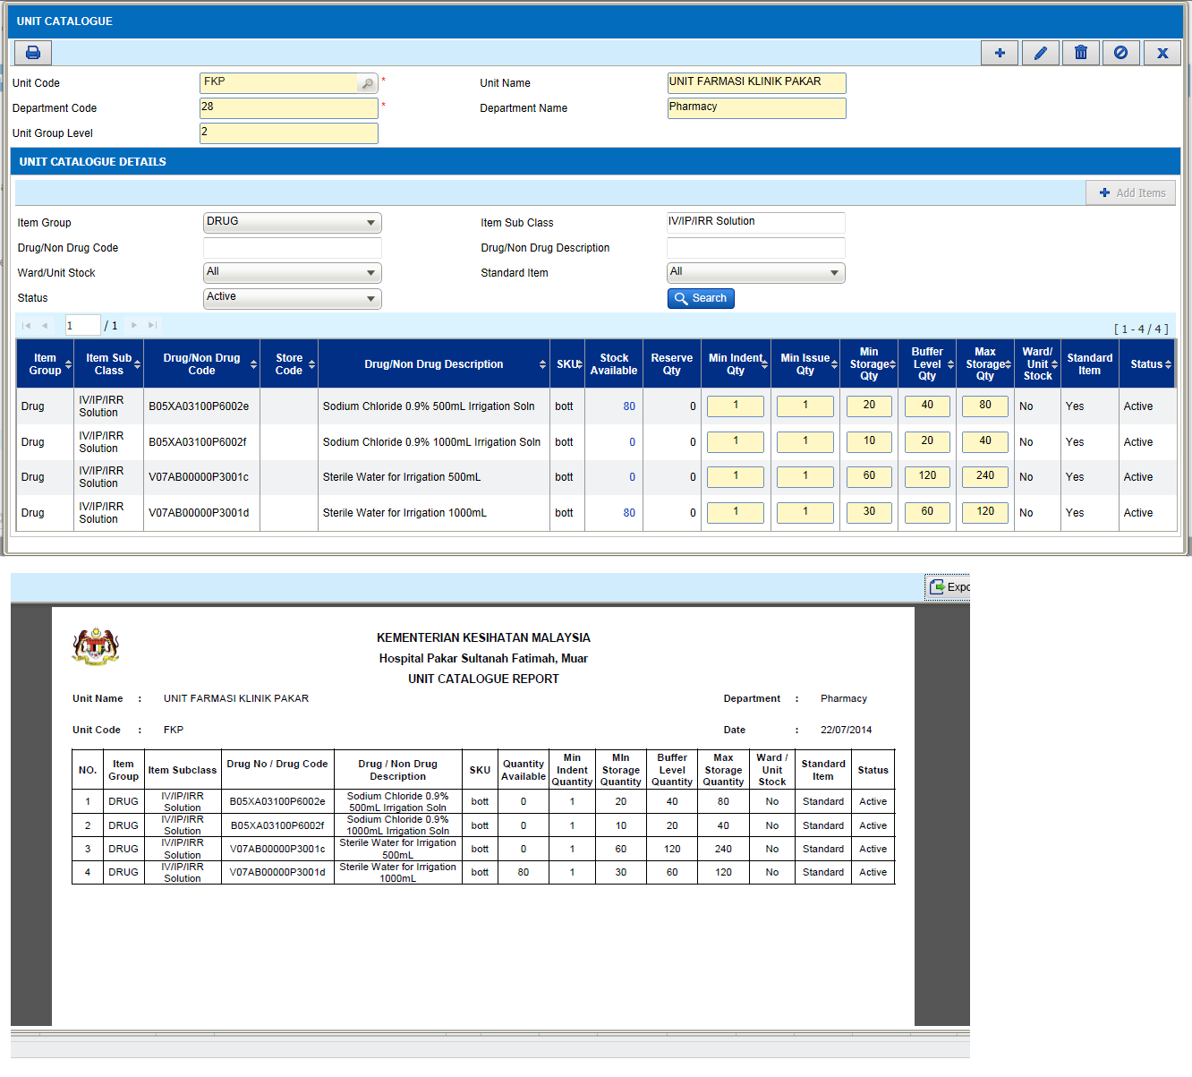

I-PhIS001531414S
Module | Reported Date | Description | Solution
OM-Web | 21/5/2014 | User request enable/allow to amend dosage time. item name:Insulin isophane (Insulatard) 100 IU/mL Penfill. | Only allow to change the dosage for drug with split dose flag.

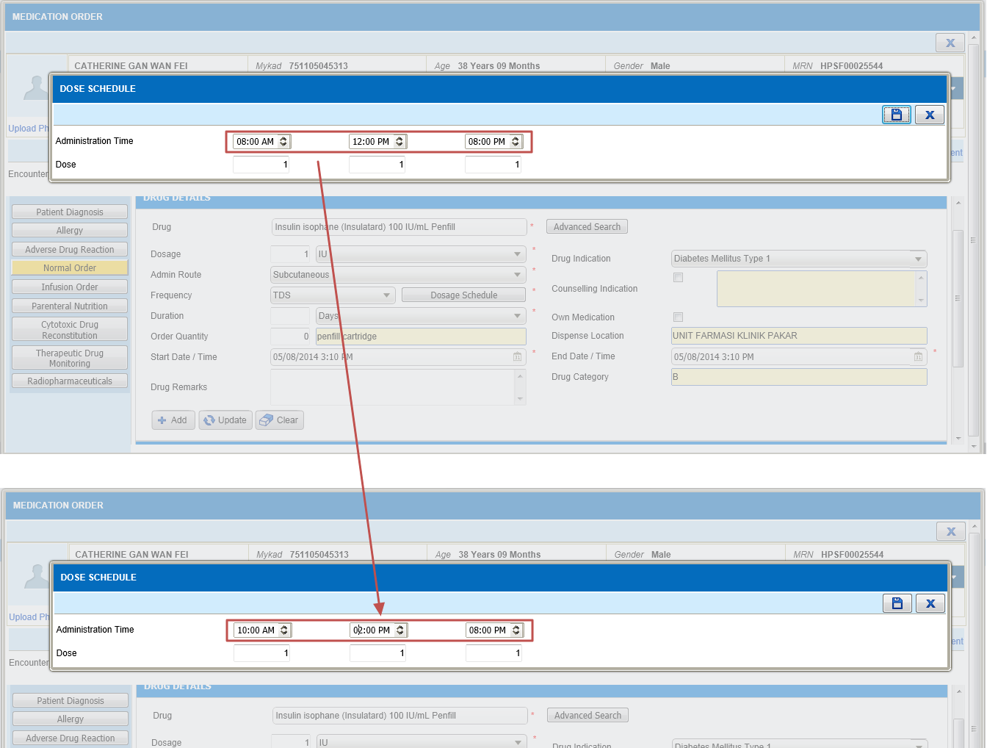

I-PhIS007286614S
Module | Reported Date | Description | Solution
Outpatient | 15/7/2014 | Unable to prepare extemporaneous drugs. Extemporaneous check box not applicable.  1. Domperidone 10 mg Tablet  2. Atenolol 50 mg Tablet  3. Lamotrigine 50 mg Tablet  4. Hydrochlorothiazide 50 mg Tablet  5. Trimethoprim 300 mg Tablet  6. Metronidazole 200 mg Tablet  Username : Noraini  UserID : 750214015762 | 1. Domperidone  o MOTIDOM ORAL SUSPENSION 1MG/ML  o RABUGEN 5 MG/ 5 ML SUSPENSION  o MOTINORM SYRUP 5MG/5ML  o MOTIGUT SUSPENSION 1MG/ML  o DOMNE SUSPENSION 1MG/ML  o etc..  2. Lamotrigine - no syrup or  suspension product but there is a chewable tablet available (LAMICTAL CHEWABLE DISPERSIBLE 2MG TABLETS)  3. Metronidazole  o METRONIDAZOLE SYRUP 100MG  o FOGYL SUSPENSION 200MG/5ML

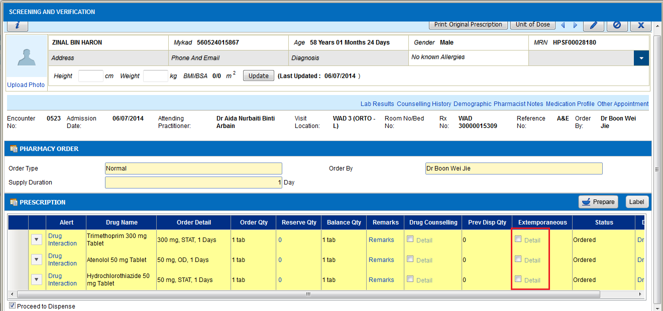

Deployment - Procedures

List of Items to be Deployed
No. | Items | Components | Path
1. | Facility Patch Scripts | PatchScripts_v1.2.2.7.2_KKGT.txt | https://10.8.9.130:44330/svn/Workspace_Dataware/31_Implementation/Applications/PhIS Release V.1.2.2.7/facility/Scripts
2. | Facility Application | iphis.war | https://10.8.9.130:44330/svn/Workspace_Dataware/31_Implementation/Applications/PhIS Release V.1.2.2.7/facility/war

Backup Procedure before Deploy

Backup Procedure
Using backup tool, backup the following files and folder and database as per table below;
No. | Type | Backup Item | Description
1 | Application | /home/phisesb  /opt/phisesb  /usr/share/fonts/truetype | PhIS Integration Application  PhIS Core Application  Fonts required by PhIS
2 | Database | phisprod database | PhIS Live database

Deployment/Installation Guidelines

Deployment at Facility
Below table is described the deployment steps at Facility:
Step | Items | File Name | Source Path | Action
1 | Facility Patch Scripts | PatchScripts_v1.2.2.7.2_KKGT.txt (All) | https://10.8.9.130:44330/svn/Workspace_Dataware/31_Implementation/Applications/PhIS Release V.1.2.2.7/facility/Scripts | Run the scripts @ Postgres DB using PGAdmin
2 | Facility Application | iphis.war | https://10.8.9.130:44330/svn/Workspace_Dataware/31_Implementation/Applications/PhIS Release V.1.2.2.7/facility/war | Deployment @ Both HA Servers

