Pharmacy Information System (PhIS)
and
Clinic Pharmacy System (CPS)

Release Note
For version 1.2.2.7.3

Version : 1.0
Document ID : PhIS_CPS/ReleaseNote/Refinement/19082014

© 2011-2014 Pharmaniaga Logistics Sdn Bhd (PLSB)

CONFIDENTIAL COPYRIGHTED MATERIAL – The information includes all concepts, comments, recommendations, and material, contained herein shall remain the property of Pharmaniaga Logistics Sdn Bhd (PLSB). No portion of this document shall be disclosed, duplicated or used in whole or in part of any purpose other than the purpose of the Pharmacy Information System & Clinic Pharmacy System (PhIS& CPS) Project execution only.

Revision History

Version No | Date of Release | Prepared by | Reviewed / Verified by | List of changes from Previous Version
1.0 | 19/08/2014 | Kee Tuan Hwa | Chew Ming Ping | First Version

Verified and Acknowledged by:
Name | Role/Designation | Organization | Signature & Date
Chew Ming Ping | Team Leader | Pharmaniaga Logistics Sdn Bhd
Hoh Choon Seng | Project Manager | Pharmaniaga Logistics Sdn Bhd

Name | Role/Designation | Organization | Signature & Date
 |  | Bahagian Perkhidmatan Farmasi (BPF), KKM
 |  | Bahagian Pengurusan Maklumat (BPM), KKM

Peer Review
Version No | Reviewed / Verified by | List Of Changes from Previous Version
1.0 | Juridah (QA) | Initial document

1 Introduction 1
1.1 Project Information 1
1.2 Objectives 1
2 Purpose 2
3 Summary – Refinement and Defect List 3
3.1 Refinement List 3
3.1.1 Hospital Pakar Sultanah Fatimah 3
3.1.2 KK Greentown 3
3.2 Resolved Defect List 4
3.2.1 Hospital Pakar Sultanah Fatimah 4
3.2.2 KK Greentown 5
3.2.3 Data Center - IWP 6
4 Refinement List – Detail Changes 7
4.1 I-PhIS001539514S 7
5 Deployment - Procedures 8
5.1 List of Items to be Deployed 8
5.2 Backup Procedure before Deploy 8
5.2.1 Backup Procedure 8
5.3 Deployment/Installation Guidelines 8
5.3.1 Deployment at Facility 8

Introduction

Project Information

Project ID : | PhIS and CPS
Project Name : | Pharmacy Information System and Clinic Pharmacy System
Version No : | 1.2.2.7.3
Client Name : | Ministry of Health
Release ID : | RL14/014
Release Date : | 19/08/2014

Objectives
No. | Objective | Reference
1. | Release PhIS & CPS Application to Facility | Refer Section 3 – Refinement and Defect list

Purpose
The purpose of the document is to update the end-user of the changes and defects have been resolved to be included in the new version of application and will be deployed to production server.
This document outlines the list of request and issue to be delivered in the newer version of application and also the guidelines on how to deploy the new version of application in production.

Summary – Refinement and Defect List

Refinement List

Hospital Pakar Sultanah Fatimah
No | Ticket No. | Module | Reported Date | Description | Additional Information | Solution | Resolved Date | Verify Status
1 | I-PhIS001539514S | Inventory | 22/5/2014 | User request to add Requester Ward in KEW.PS-11 form. | To discuss with project team.  27/5: Refinement, will include in future release once module owner reviewed and agreed | Change as per request  Please refer to 4.1 | 18/8/2014

Verified and Acknowledged By:
Signature: |  | Name:
Date: |  | Designation:

Signature: |  | Name:
Date: |  | Designation:

KK Greentown
N/A

Resolved Defect List
The following are the summary of resolved defect list that included in PhIS and CPS version 1.2.2.7.3.

Hospital Pakar Sultanah Fatimah
No | Ticket No. | Module | Reported Date | Description | Additional Information | Root Caused | Resolved Date | Verify Status
1 | I-PhIS007397714S | Clinical Pharmacokinetic Services (CPS) & TDM | 7/8/2014 | Cannot save TDM order, system shows error, even after change the order date. (WEB). |  | alert message is not in meaningful sentences | 14/8/2014

Verified and Acknowledged By:
Signature: |  | Name:
Date: |  | Designation:

Signature: |  | Name:
Date: |  | Designation:

KK Greentown
No | Ticket No. | Module | Reported Date | Description | Additional Information | Root Caused | Resolved Date | Verify Status
1 | I-PhIS007441914S | Outpatient Pharmacy | 17/8/2014 | Pharmacist cannot enter queue number at Queue Details link in Dispensing screen.  Time Incident Happen:12.33pm  User Id:870330015854  Reported Date:8/15/2014 | Patient MRN number: 7476 & 8566 | Wrong code on checking duplicate queue no in Queue Detail screen. | 18/8/2014
2 | I-PhIS007442014S | Outpatient Pharmacy | 17/8/2014 | Screening & Verification - No list of drug after scan patient MRN using Barcode Snanner. Error only shows when using barcode scanner, if enter MRN manually it works fine.  Username: LEE LAI FONG.  ID: 840528085914.  Patient MRN number: 7476 & 8566.  Reported date: 14/08/14.  Incident time: 1.00pm. |  | Code for loading patient record from barcode scanner is wrong | 18/8/2014

Verified and Acknowledged By:
Signature: |  | Name:
Date: |  | Designation:

Signature: |  | Name:
Date: |  | Designation:

Data Center - IWP
N/A

Refinement List – Detail Changes

I-PhIS001539514S
Module | Reported Date | Description | Solution
Inventory | 22/5/2014 | User request to add Requester Ward in KEW.PS-11 form. | Change as per request

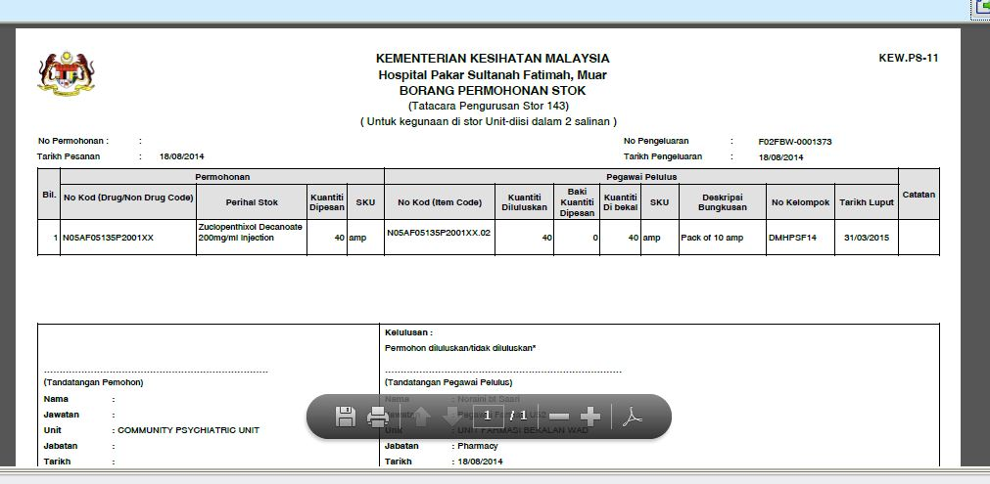

Deployment - Procedures

List of Items to be Deployed
No. | Items | Components | Path
1. | Facility Patch Scripts | PatchScripts_v1.2.2.7.3.txt | https://10.8.9.130:44330/svn/Workspace_Dataware/31_Implementation/Applications/PhIS Release V.1.2.2.7/facility/Scripts
2. | Facility Application | iphis.war | https://10.8.9.130:44330/svn/Workspace_Dataware/31_Implementation/Applications/PhIS Release V.1.2.2.7/facility/war

Backup Procedure before Deploy

Backup Procedure
Using backup tool, backup the following files and folder and database as per table below;
No. | Type | Backup Item | Description
1 | Application | /home/phisesb  /opt/phisesb  /usr/share/fonts/truetype | PhIS Integration Application  PhIS Core Application  Fonts required by PhIS
2 | Database | phisprod database | PhIS Live database

Deployment/Installation Guidelines

Deployment at Facility
Below table is described the deployment steps at Facility:
Step | Items | File Name | Source Path | Action
1 | Facility Patch Scripts | PatchScripts_v1.2.2.7.3.txt | https://10.8.9.130:44330/svn/Workspace_Dataware/31_Implementation/Applications/PhIS Release V.1.2.2.7/facility/Scripts | Run the scripts @ Postgres DB using PGAdmin
2 | Facility Application | iphis.war | https://10.8.9.130:44330/svn/Workspace_Dataware/31_Implementation/Applications/PhIS Release V.1.2.2.7/facility/war | Deployment @ Both HA Servers

