Pharmacy Information System (PhIS)
and
Clinic Pharmacy System (CPS)

Release Note
For version 1.2.2.7.4

Version : 1.0
Document ID : PhIS_CPS/ReleaseNote/Refinement/20082014

© 2011-2014 Pharmaniaga Logistics Sdn Bhd (PLSB)

CONFIDENTIAL COPYRIGHTED MATERIAL – The information includes all concepts, comments, recommendations, and material, contained herein shall remain the property of Pharmaniaga Logistics Sdn Bhd (PLSB). No portion of this document shall be disclosed, duplicated or used in whole or in part of any purpose other than the purpose of the Pharmacy Information System & Clinic Pharmacy System (PhIS& CPS) Project execution only.

Revision History

Version No | Date of Release | Prepared by | Reviewed / Verified by | List of changes from Previous Version
1.0 | 20/08/2014 | Kee Tuan Hwa | Chew Ming Ping | First Version

Verified and Acknowledged by:
Name | Role/Designation | Organization | Signature & Date
Chew Ming Ping | Team Leader | Pharmaniaga Logistics Sdn Bhd
Hoh Choon Seng | Project Manager | Pharmaniaga Logistics Sdn Bhd

Name | Role/Designation | Organization | Signature & Date
 |  | Bahagian Perkhidmatan Farmasi (BPF), KKM
 |  | Bahagian Pengurusan Maklumat (BPM), KKM

Peer Review
Version No | Reviewed / Verified by | List Of Changes from Previous Version
1.0 | Juridah (QA) | Initial document

1 Introduction 1
1.1 Project Information 1
1.2 Objectives 1
2 Purpose 2
3 Summary – Refinement and Defect List 3
3.1 Refinement List 3
3.1.1 Hospital Pakar Sultanah Fatimah 3
3.1.2 KK Greentown 4
3.2 Resolved Defect List 4
3.2.1 Hospital Pakar Sultanah Fatimah 4
3.2.2 KK Greentown 7
3.2.3 Data Center - IWP 8
4 Refinement List – Detail Changes 9
4.1 I-PhIS001595314S 9
5 Deployment - Procedures 13
5.1 List of Items to be Deployed 13
5.2 Backup Procedure before Deploy 13
5.2.1 Backup Procedure 13
5.3 Deployment/Installation Guidelines 14
5.3.1 Deployment at Facility 14
5.3.2 Deployment at HQ - IWP 14

Introduction

Project Information

Project ID : | PhIS and CPS
Project Name : | Pharmacy Information System and Clinic Pharmacy System
Version No : | 1.2.2.7.4
Client Name : | Ministry of Health
Release ID : | RL14/015
Release Date : | 20/08/2014

Objectives
No. | Objective | Reference
1. | Release PhIS & CPS Application to Facility | Refer Section 3 – Refinement and Defect list

Purpose
The purpose of the document is to update the end-user of the changes and defects have been resolved to be included in the new version of application and will be deployed to production server.
This document outlines the list of request and issue to be delivered in the newer version of application and also the guidelines on how to deploy the new version of application in production.

Summary – Refinement and Defect List

Refinement List

Hospital Pakar Sultanah Fatimah
No | Ticket No. | Module | Reported Date | Description | Additional Information | Solution | Resolved Date | Verify Status
1 | I-PhIS001595314S | Inventory | 3/6/2014 | Request to remove the time stamp for:-  Indent screen - Indent date field  RIQ screen - Indent date field  Issue screen  Online issue - Issue date & Indent date fields  Offline issue - Request date field  Direct Issue - Request Date field  Ward/unit stock - Issue Date field  Receiving  Receive from supplier - Created Date field  Inter facility - Created Date field  Intra Facility receive items - Goods Receive Date field | Reported by Siti Azna (S.A Team)  16/6: In progress, will do it by batch | Change as per request  Please refer to 4.1 | 19/8/2014

Verified and Acknowledged By:
Signature: |  | Name:
Date: |  | Designation:

Signature: |  | Name:
Date: |  | Designation:

KK Greentown
N/A

Resolved Defect List
The following are the summary of resolved defect list that included in PhIS and CPS version 1.2.2.7.4.

Hospital Pakar Sultanah Fatimah
No | Ticket No. | Module | Reported Date | Description | Additional Information | Root Caused | Resolved Date | Verify Status
1 | I-PhIS007443814S | Clinical Pharmacokinetic Services (CPS) & TDM | 17/8/2014 | User unable to generate report, Error popup â€œAn Error has occurred. Please contact your system administrator.â€ while click on select.  Patient name: Ummu Atiqah Binti Yondi  MRN: HPSF00025825  Time: 10AM |  | Function for checking normal dose frequencies is added | 19/8/2014
2 | I-PhIS007191714S | Inpatient Pharmacy | 27/6/2014 | User reported that drug label on system and label printed is not tally detail as below:  1) Drug name : CEFTRIAXONE 1G INJ  On system display 2000mg but label printed 1000mg  2) Drug name:TRANEXAMIC ACID 100mg/ml injection  On system display 500mg but label printed 100mg  Patient name:Azizi bin Abd Aziz  MRN: HPSF00025706  User ID:841119016242  Report time: 1.00am |  | Previously system directly takes Strength and Qty value inside Drug Master without consider prescribed Dose value | 19/8/2014
3 | I-PhIS007447714S | Manufacturing - Extemporaneous | 18/8/2014 | Unable display decimal on extemporaneous, but in drug master have a check on Fractional Dosage Applicable.  Item name: baclone suspension 5mg/ml(A). Name patient: Nur Ariana Iman Binti Mohd Azwan , MRN: HPSF00024993. Happen: 18/08/2014 , Time: 9.00AM |  | Formula Error | 19/8/2014
4 | I-PhIS007417714S | Order Management - Web | 12/8/2014 | Doctor from General Surgery Order List A drug, but the authorisation flow to Specialist from Paediatric.  HO name : Dr Leow Khai Jeng  Department : General Surgery  Specialist name : Dr Wang Seng Lian, Angeline  Department : Paediatric Medicine  Time: happen since 7/8/2014 at 4.14pm |  | Authorisation is open to all department. | 19/8/2014
5 | I-PhIS007292214S | Outpatient Pharmacy | 16/7/2014 | User reported an error appear if unable to alternate Bisoprolol.  Page: Pharmacy transaction> Outpatient> Preparation  User ID: 810108145418 |  | Previously the default zero value inside Qty per Dose field is null, not 0. So when user edit that value, error will be prompted. | 19/8/2014
6 | I-PhIS007320514S | Outpatient Pharmacy | 20/7/2014 | Unable to alternate Betamethasone. BVC 1:2, BVC 1:8, BVC 1:4.  Description :Unable to alternate Betamethasone. BVC 1:2, BVC 1:8, BVC 1:4.And for BVC 1:6 is already inactive but still appears here.  User ID :810108145418 (Siti Aisyah binti Mohd Roslan) | BVC 1:2, BVC 1:8, BVC 1:4.These drugs not appear in alternate since the active ingredient is not the same. Active ingredient for these drugs is Betamethasone while active ingredient for Betamethasone 17-Valerate 0.1% Cream is Betamethasone Valearate. Now the issue is INACTIVE drug is still displayed when do alternate. | System not checking Inactive drug inside Alternate screen. | 19/8/2014
7 | I-PhIS007363714S | Outpatient Pharmacy | 1/8/2014 | User report unable to select alternate drug for 'Prazosin HCI 2mg Tablet'. When user click the quantity per dose error(attach 1) appear.  User : Tang Chen Jew  ID : 860918236448  Patient Name : Zulkifli Bin Nawi  810509015905 / HPSF34271  Incident Time : 4:15am |  | Previously the default zero value inside Qty per Dose field is null, not 0. So when user edit that value, error will be prompted. | 19/8/2014

Verified and Acknowledged By:
Signature: |  | Name:
Date: |  | Designation:

Signature: |  | Name:
Date: |  | Designation:

KK Greentown
No | Ticket No. | Module | Reported Date | Description | Additional Information | Root Caused | Resolved Date | Verify Status
1 | I-PhIS007394914S | Outpatient Pharmacy | 7/8/2014 | Unable to allocate quantity for alternate drug Patient: Muniandy MRN: 12311  Drug name: Hydrochlorothiazide 25 mg Tablet  User ID : 840528085914  Reported Date: 8/5/2014 |  | Previously the default zero value inside Qty per Dose field is null, not 0. So when user edit that value, error will be prompted. | 19/8/2014

Verified and Acknowledged By:
Signature: |  | Name:
Date: |  | Designation:

Signature: |  | Name:
Date: |  | Designation:

Data Center - IWP
No | Ticket No. | Module | Reported Date | Description | Additional Information | Root Caused | Resolved Date | Verify Status
1 | I-PhIS007315714S | General Module | 18/7/2014 | User reported missing 'Contract' value at Item Purchase type drop down. User cannot proceed to add contract item. |  | Issue with method to populate the drop down value. | 19/8/2014

Verified and Acknowledged By:
Signature: |  | Name:
Date: |  | Designation:

Signature: |  | Name:
Date: |  | Designation:

Refinement List – Detail Changes

I-PhIS001595314S
Module | Reported Date | Description | Solution
Inventory | 3/6/2014 | Request to remove the time stamp for:-  Indent screen - Indent date field  RIQ screen - Indent date field  Issue screen  Online issue - Issue date & Indent date fields  Offline issue - Request date field  Direct Issue - Request Date field  Ward/unit stock - Issue Date field  Receiving  Receive from supplier - Created Date field  Inter facility - Created Date field  Intra Facility receive items - Goods Receive Date field | Change as per request

Indent screen - Indent date field
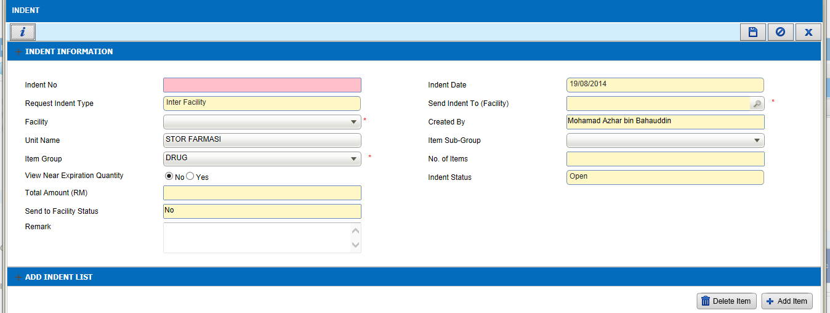

RIQ screen - Indent date field
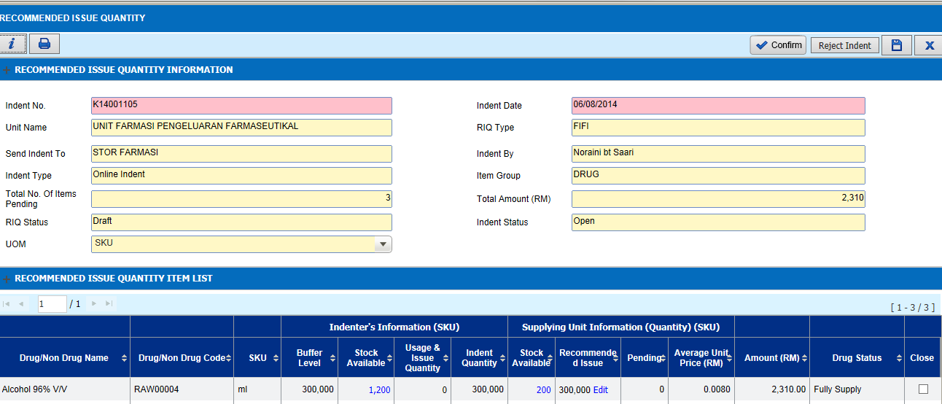

Issue screen
Online issue - Issue date & Indent date fields
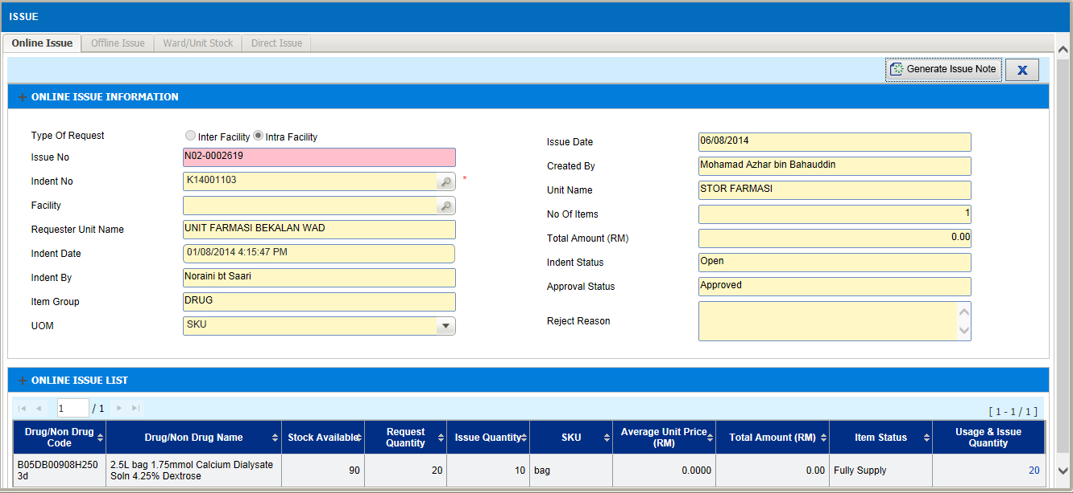

Offline issue - Request date field
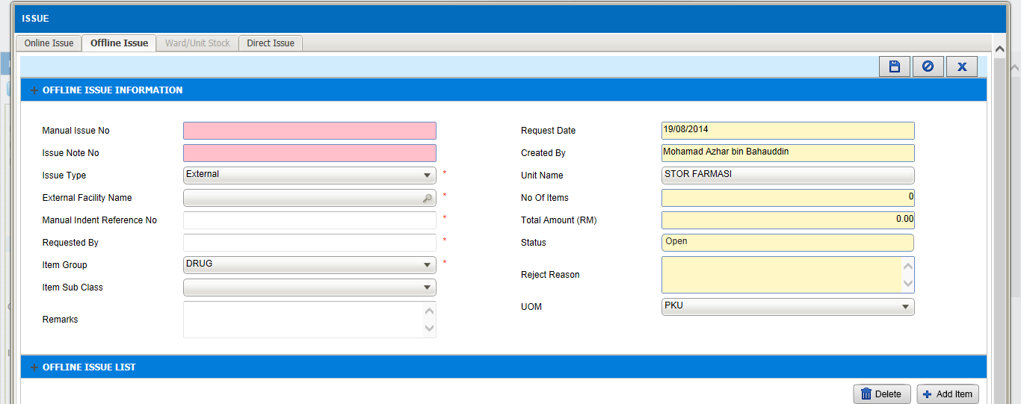

Direct Issue - Request Date field
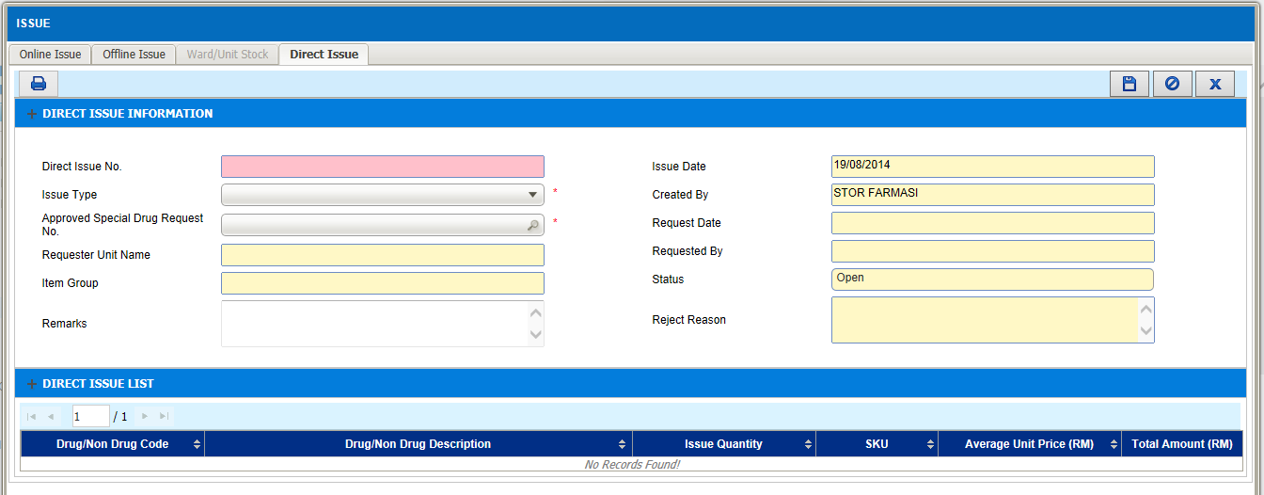

Ward/unit stock - Generated Date field
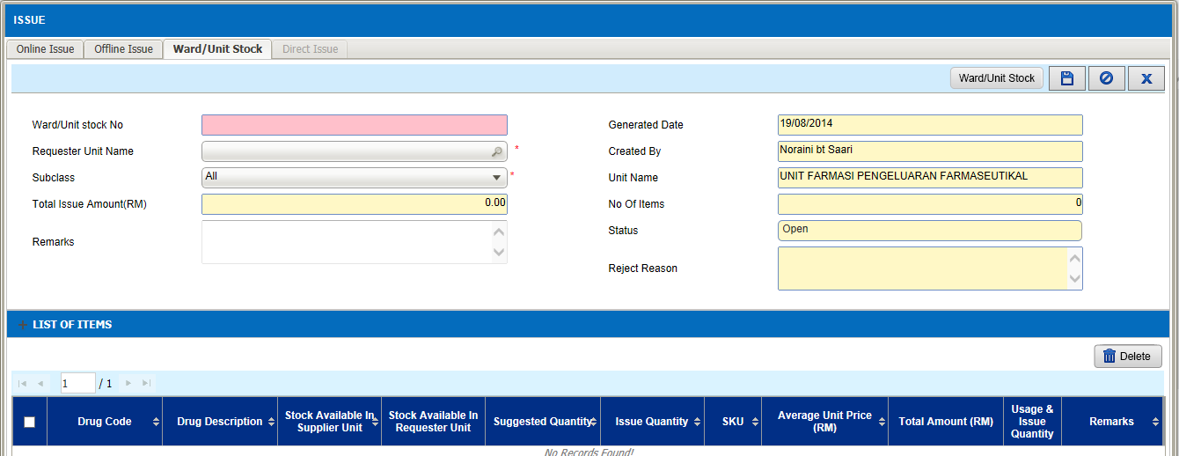

Receiving
Receive from supplier - Created Date field
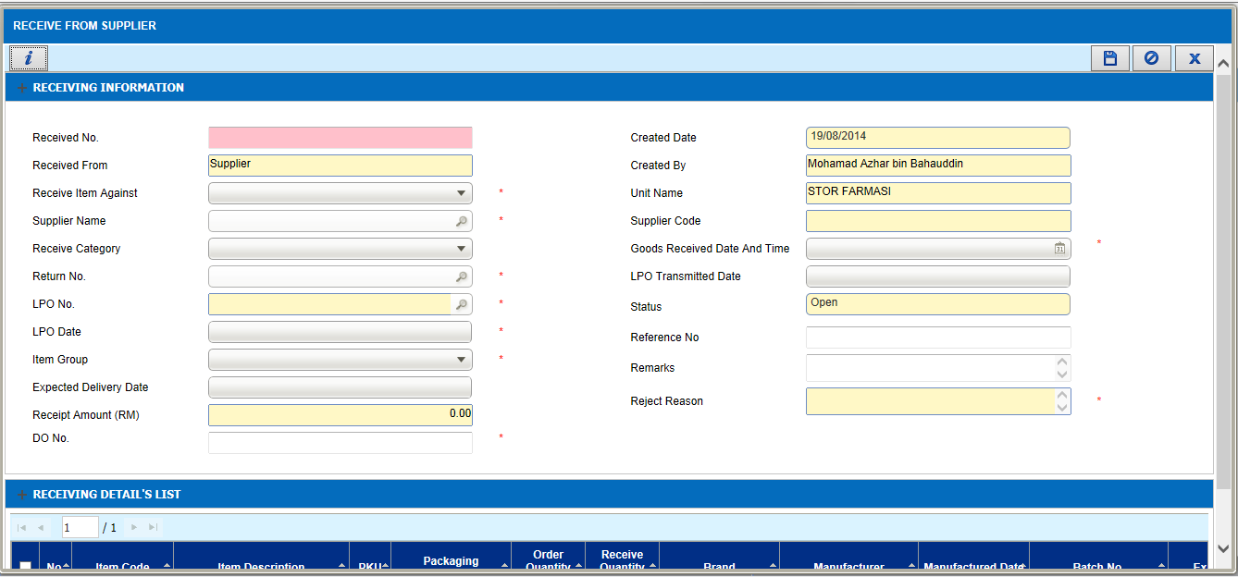

Inter facility - Created Date field
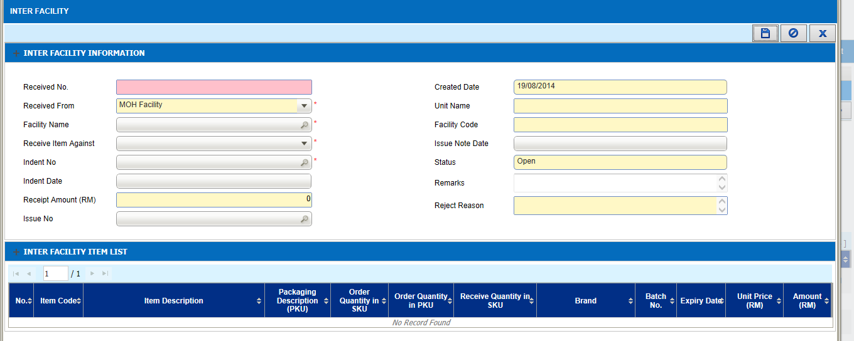

Intra Facility receive items - Goods Receive Date field
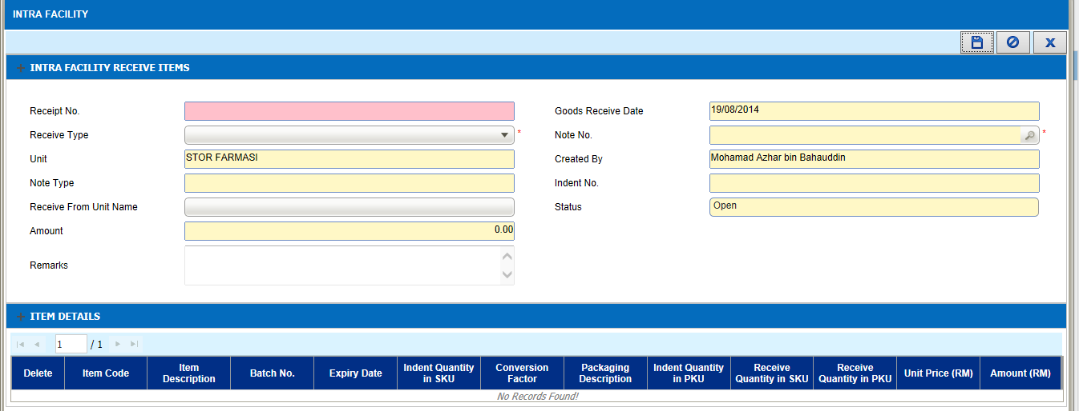

Deployment - Procedures

List of Items to be Deployed
No. | Items | Components | Path
1. | HQ Patch Scripts | PatchScripts_v1.2.2.7.txt PatchScripts_v1.2.2.7.1.txt | https://10.8.9.130:44330/svn/Workspace_Dataware/31_Implementation/Applications/PhIS Release V.1.2.2.7/hq/Scripts
2. | HQ Application | phishq.war  epservice.war | https://10.8.9.130:44330/svn/Workspace_Dataware/31_Implementation/Applications/PhIS Release V.1.2.2.7/hq/war
3. | Facility Patch Scripts | PatchScripts_v1.2.2.7.txt PatchScripts_v1.2.2.7.1.txt  PatchScripts_v1.2.2.7.4_HPSF.txt (HPSF only) | https://10.8.9.130:44330/svn/Workspace_Dataware/31_Implementation/Applications/PhIS Release V.1.2.2.7/facility/Scripts
4. | Facility Application | iphis.war | https://10.8.9.130:44330/svn/Workspace_Dataware/31_Implementation/Applications/PhIS Release V.1.2.2.7/facility/war
5. | Facility Application | PhISSchedulers.jar  smrpextpush.jar | https://10.8.9.130:44330/svn/Workspace_Dataware/31_Implementation/Applications/PhIS Release V.1.2.2.7/facility/jar
6. | Mobile Application | ipadhosp-1.2.7b17.war | https://10.8.9.130:44330/svn/Workspace_Dataware/31_Implementation/Applications/PhIS Release V.1.2.2.7/facility/mobile

Backup Procedure before Deploy

Backup Procedure
Using backup tool, backup the following files and folder and database as per table below;
No. | Type | Backup Item | Description
1 | Application | /home/phisesb  /opt/phisesb  /usr/share/fonts/truetype | PhIS Integration Application  PhIS Core Application  Fonts required by PhIS
2 | Database | phisprod database | PhIS Live database

Deployment/Installation Guidelines

Deployment at Facility
Below table is described the deployment steps at Facility:
Step | Items | File Name | Source Path | Action
1 | Facility Patch Scripts | PatchScripts_v1.2.2.7.txt PatchScripts_v1.2.2.7.1.txt | https://10.8.9.130:44330/svn/Workspace_Dataware/31_Implementation/Applications/PhIS Release V.1.2.2.7/facility/Scripts | Run the scripts @ Postgres DB using PGAdmin
2 | Facility Application | PatchScripts_v1.2.2.7.txt PatchScripts_v1.2.2.7.1.txt  PatchScripts_v1.2.2.7.4_HPSF.txt (HPSF only) | https://10.8.9.130:44330/svn/Workspace_Dataware/31_Implementation/Applications/PhIS Release V.1.2.2.7/facility/war | Deployment @ Both HA Servers
3 | Facility Application | PhISSchedulers.jar  smrpextpush.jar | https://10.8.9.130:44330/svn/Workspace_Dataware/31_Implementation/Applications/PhIS Release V.1.2.2.7/facility/jar | copy into /home/phisesb/phisjars folder
4 | Mobile Application | ipadhosp-1.2.7b17.war | https://10.8.9.130:44330/svn/Workspace_Dataware/31_Implementation/Applications/PhIS Release V.1.2.2.7/facility/mobile | Deployment @ Both HA Servers

Deployment at HQ - IWP
Below table is described the deployment steps at HQ - IWP:

Step | Items | File Name | Source Path | Action
1 | HQ Patch Scripts | PatchScripts_v1.2.2.7.txt PatchScripts_v1.2.2.7.1.txt | https://10.8.9.130:44330/svn/Workspace_Dataware/31_Implementation/Applications/PhIS Release V.1.2.2.7/hq/Scripts | Run the scripts @ Postgres DB using PGAdmin
2 | HQ Application | phishq.war  epservice.war | https://10.8.9.130:44330/svn/Workspace_Dataware/31_Implementation/Applications/PhIS Release V.1.2.2.7/hq/war | Deployment @ Both HA Servers

