Pharmacy Information System (PhIS)
and
Clinic Pharmacy System (CPS)

Release Note
For version 1.2.2.7.6

Version : 1.0
Document ID : PhIS_CPS/ReleaseNote/Refinement/24082014

© 2011-2014 Pharmaniaga Logistics Sdn Bhd (PLSB)

CONFIDENTIAL COPYRIGHTED MATERIAL – The information includes all concepts, comments, recommendations, and material, contained herein shall remain the property of Pharmaniaga Logistics Sdn Bhd (PLSB). No portion of this document shall be disclosed, duplicated or used in whole or in part of any purpose other than the purpose of the Pharmacy Information System & Clinic Pharmacy System (PhIS& CPS) Project execution only.

Revision History

Version No | Date of Release | Prepared by | Reviewed / Verified by | List of changes from Previous Version
1.0 | 24/08/2014 | Kee Tuan Hwa | Chew Ming Ping | First Version

Verified and Acknowledged by:
Name | Role/Designation | Organization | Signature & Date
Chew Ming Ping | Team Leader | Pharmaniaga Logistics Sdn Bhd
Hoh Choon Seng | Project Manager | Pharmaniaga Logistics Sdn Bhd

Name | Role/Designation | Organization | Signature & Date
 |  | Bahagian Perkhidmatan Farmasi (BPF), KKM
 |  | Bahagian Pengurusan Maklumat (BPM), KKM

Peer Review
Version No | Reviewed / Verified by | List Of Changes from Previous Version
1.0 | Juridah (QA) | Initial document

1 Introduction 1
1.1 Project Information 1
1.2 Objectives 1
2 Purpose 2
3 Summary – Refinement and Defect List 3
3.1 Refinement List 3
3.1.1 Hospital Pakar Sultanah Fatimah 3
3.1.2 KK Greentown 4
3.2 Resolved Defect List 5
3.2.1 Hospital Pakar Sultanah Fatimah 5
3.2.2 KK Greentown 6
3.2.3 Data Center - IWP 7
4 Refinement List – Detail Changes 8
4.1 I-PhIS007218214S, I-PhIS007393914S and I-PhIS007459714S 8
5 Deployment - Procedures 11
5.1 List of Items to be Deployed 11
5.2 Backup Procedure before Deploy 11
5.2.1 Backup Procedure 11
5.3 Deployment/Installation Guidelines 12
5.3.1 Deployment at Facility 12
5.3.2 Deployment at HQ - IWP 12

Introduction

Project Information

Project ID : | PhIS and CPS
Project Name : | Pharmacy Information System and Clinic Pharmacy System
Version No : | 1.2.2.7.6
Client Name : | Ministry of Health
Release ID : | RL14/017
Release Date : | 24/08/2014

Objectives
No. | Objective | Reference
1. | Release PhIS & CPS Application to Facility | Refer Section 3 – Refinement and Defect list

Purpose
The purpose of the document is to update the end-user of the changes and defects have been resolved to be included in the new version of application and will be deployed to production server.
This document outlines the list of request and issue to be delivered in the newer version of application and also the guidelines on how to deploy the new version of application in production.

Summary – Refinement and Defect List

Refinement List

Hospital Pakar Sultanah Fatimah
No | Ticket No. | Module | Reported Date | Description | Additional Information | Solution | Resolved Date | Verify Status
1 | I-PhIS007218214S | Outpatient | 3/7/2014 | user request to allow system to dispense more than prescribe quantity due to when Doctor prescribe for 3 month(90 days), but TCA was given for 96 day. Pharmacy need to do the intervention to change the duration in order to supply for 96 days. This will cause the time consuming and impact to waiting time. |  | • In drug master, there is flag for ‘Allow dispensing more than prescribed quantity’ at facility level.  • If this flag is checked, allow user to allocate and dispense more than order quantity.  Please refer to 4.1 | 23/8/2014

Verified and Acknowledged By:
Signature: |  | Name:
Date: |  | Designation:

Signature: |  | Name:
Date: |  | Designation:

KK Greentown
No | Ticket No. | Module | Reported Date | Description | Additional Information | Solution | Resolved Date | Verify Status
1 | I-PhIS007393914S | Outpatient Pharmacy | 7/8/2014 | Allow to change drug quantity more then order quantity  User ID : 840528085914  Reported Date: 8/1/2014 |  | • In drug master, there is flag for ‘Allow dispensing more than prescribed quantity’ at facility level.  • If this flag is checked, allow user to allocate and dispense more than order quantity.  Please refer to 4.1 | 23/8/2014
2 | I-PhIS007459714S | Outpatient Pharmacy | 20/8/2014 | User request to allow pharmacist to allocate/dispense more than order quantity if â€˜Allow dispensing more than prescribed quantityâ€™ flag is checked. refer attachment for further details and screenshot. |  | • In drug master, there is flag for ‘Allow dispensing more than prescribed quantity’ at facility level.  • If this flag is checked, allow user to allocate and dispense more than order quantity.  Please refer to 4.1 | 22/8/2014

Verified and Acknowledged By:
Signature: |  | Name:
Date: |  | Designation:

Signature: |  | Name:
Date: |  | Designation:

Resolved Defect List
The following are the summary of resolved defect list that included in PhIS and CPS version 1.2.2.7.6.

Hospital Pakar Sultanah Fatimah
No | Ticket No. | Module | Reported Date | Description | Additional Information | Root Caused | Resolved Date | Verify Status
1 | I-PhIS007409714S | MAR - Mobile | 9/8/2014 | Staff nurse unable to access MAR from iPad.  User : Nur Syaariah Binti Zainab  Incident : 11am |  | Retrieving the MAR status for each patient takes around 1 second. Retrieving the MAR status for almost 50 patients will likely take more than 50 seconds causing a timeout in the request. | 22/8/2014
2 | I-PhIS007471714S | MAR - Web | 21/8/2014 | Reported that unable to see patient in medication administration record screen using pc. But in ipad shown that patient.  User : Staffnurse Dezharia md. Desa  Patient name : tan kim heng  Patient mrn no : 39694 |  | Previously after user end visit for Outpatient visit, then when create new visit for inpatient, this new visit is saved as checkout since system not clear the checkout value when clicking on Create new button in visit screen. | 22/8/2014
3 | I-PhIS007413714S | Pharmacy Inventory | 10/8/2014 | Reported that stock available for item â€œChinese Paperâ€ not tally from RPL screen and Stock balance screen.  Username : Azhar  UserID : 810125145321  Screen : RPL |  | Refcode for transaction was not compared with correct value while populate data. | 22/8/2014

Verified and Acknowledged By:
Signature: |  | Name:
Date: |  | Designation:

Signature: |  | Name:
Date: |  | Designation:

KK Greentown
No | Ticket No. | Module | Reported Date | Description | Additional Information | Root Caused | Resolved Date | Verify Status
1 | I-PhIS007269814S | Order Management - Web | 11/7/2014 | Unit Catalogue List shows drug quantity not equal 0 Stock Qty said to be null at dispensing unit  Drug: metFORMIN HCl 500 mg Tablet. In despensary's Unit Catalogue List show quantity = 5649 (Refer to Attachment 1). At dispensing stage, error appear saying that quantity of drug = 0 (Refer to Attachment 2)  Patient's Details:  NAME: ZAINUDDIN BIN MOHD NENGAH  MYKAD: 531111085733  MRN: KKE08004500014719  Attending Practitioner: DR. MARINA DHAMAYANTHI  Time: 01.31pm  User ID: 670412085454 |  |  | 23/8/2014

Verified and Acknowledged By:
Signature: |  | Name:
Date: |  | Designation:

Signature: |  | Name:
Date: |  | Designation:

Data Center - IWP
N/A

Refinement List – Detail Changes

I-PhIS007218214S, I-PhIS007393914S and I-PhIS007459714S
Module | Reported Date | Description | Solution
Outpatient | 3/7/2014 | user request to allow system to dispense more than prescribe quantity due to when Doctor prescribe for 3 month(90 days), but TCA was given for 96 day. Pharmacy need to do the intervention to change the duration in order to supply for 96 days. This will cause the time consuming and impact to waiting time. | • In drug master, there is flag for ‘Allow dispensing more than prescribed quantity’ at facility level.  • If this flag is checked, allow user to allocate and dispense more than order quantity.
Outpatient Pharmacy | 7/8/2014 | Allow to change drug quantity more then order quantity  User ID : 840528085914  Reported Date: 8/1/2014 | • In drug master, there is flag for ‘Allow dispensing more than prescribed quantity’ at facility level.  • If this flag is checked, allow user to allocate and dispense more than order quantity.  Please refer to 4.1
Outpatient Pharmacy | 20/8/2014 | User request to allow pharmacist to allocate/dispense more than order quantity if â€˜Allow dispensing more than prescribed quantityâ€™ flag is checked. refer attachment for further details and screenshot. | • In drug master, there is flag for ‘Allow dispensing more than prescribed quantity’ at facility level.  • If this flag is checked, allow user to allocate and dispense more than order quantity.  Please refer to 4.1

- Dispense quantity.
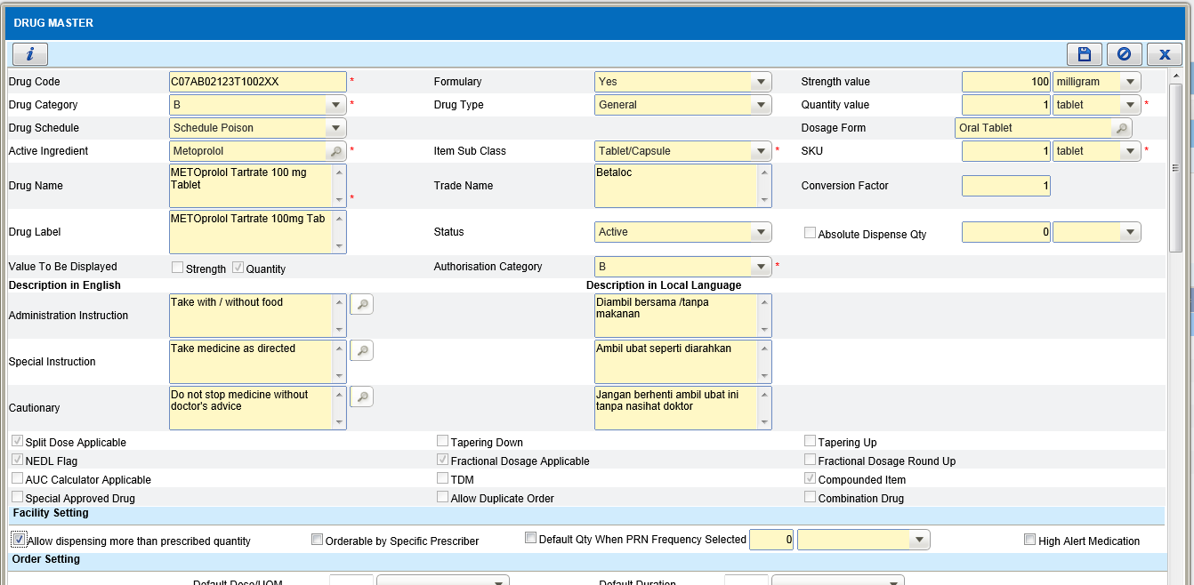
- In drug master, there is flag for ‘Allow dispensing more than prescribed quantity’ at facility level.
- If this flag is checked, allow user to allocate and dispense more than order quantity.

- Screening and verification
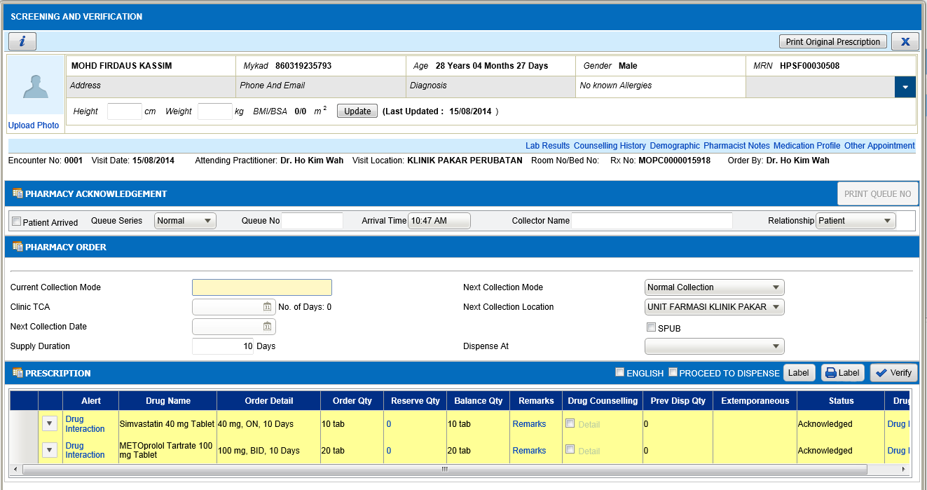
- During Allocation system will auto calculate based on frequency and duration
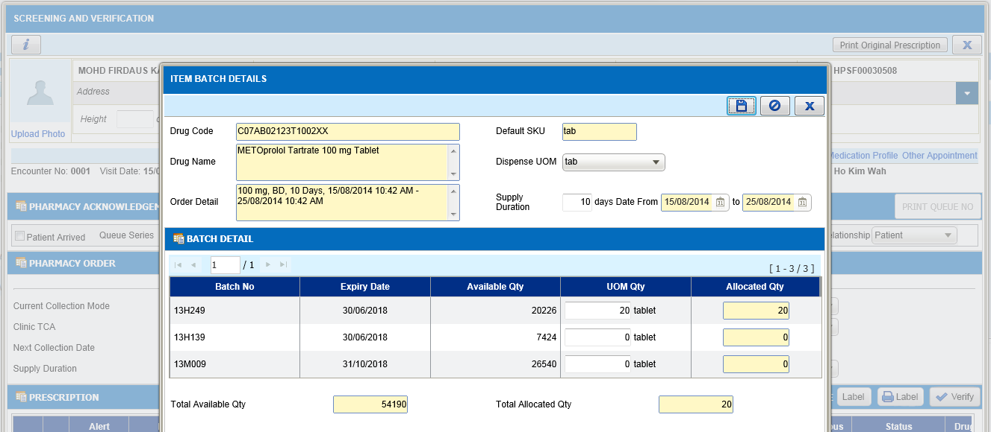
- Allow user to change the quantity more than order quantity/balance quantity
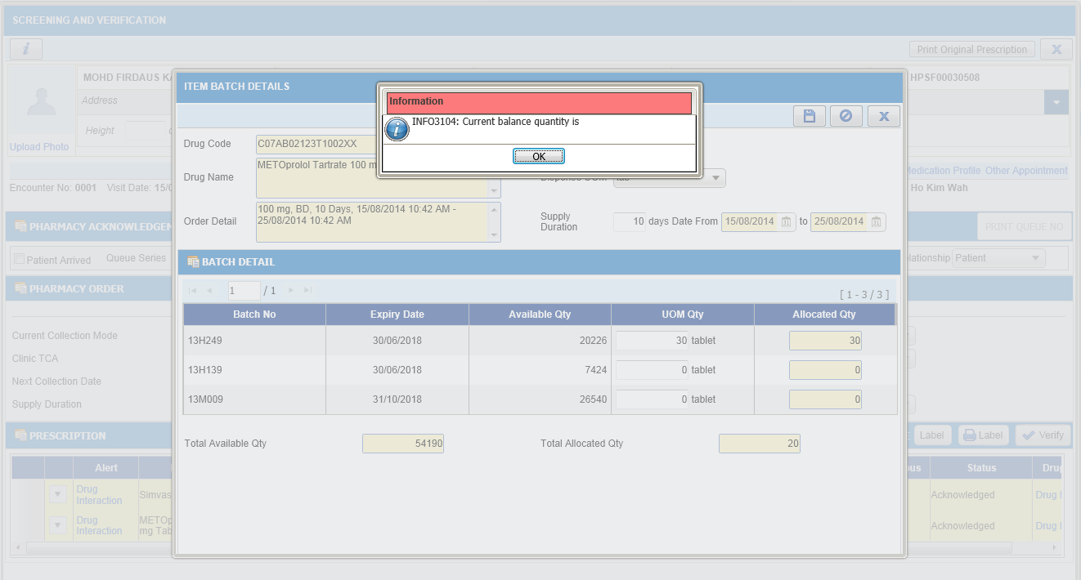
- Currently alert message displayed if user allocate more than ordered/balance quantity. Allow user to change the quantity if ‘Allow dispensing more than prescribed quantity’ for this drug is checked in drug master.

Note:
- By default system will calculate based on ‘frequency X supply duration’. System will auto calculate when user change the supply duration only. When user change the supply quantity, DO NOT calculate the supply duration.
- End supply date cannot more than end order date. If user wants to supply more than order end date, user has to do intervention and change the order end date.

Deployment - Procedures

List of Items to be Deployed
No. | Items | Components | Path
1. | HQ Patch Scripts | PatchScripts_v1.2.2.7.txt | https://10.8.9.130:44330/svn/Workspace_Dataware/31_Implementation/Applications/PhIS Release V.1.2.2.7/hq/Scripts
2. | HQ Application | phishq.war | https://10.8.9.130:44330/svn/Workspace_Dataware/31_Implementation/Applications/PhIS Release V.1.2.2.7/hq/war
3. | Facility Patch Scripts | PatchScripts_v1.2.2.7.txt (All)  PatchScripts_v1.2.2.7.6.txt (All Facility)  PatchScripts_v1.2.2.7.6_HPSF_IP.sql (HPSF only)  PatchScripts_v1.2.2.7.6_HPSF_OP.sql (HPSF only)  PatchScripts_v1.2.2.7.6_KKGT.txt | https://10.8.9.130:44330/svn/Workspace_Dataware/31_Implementation/Applications/PhIS Release V.1.2.2.7/facility/Scripts
4. | Facility Application | iphis.war | https://10.8.9.130:44330/svn/Workspace_Dataware/31_Implementation/Applications/PhIS Release V.1.2.2.7/facility/war
5. | Facility Application | PhISSchedulers.jar  phissitedatarepo.jar | https://10.8.9.130:44330/svn/Workspace_Dataware/31_Implementation/Applications/PhIS Release V.1.2.2.7/facility/jar
6. | Mobile Application | ipadhosp-1.2.7b21.war | https://10.8.9.130:44330/svn/Workspace_Dataware/31_Implementation/Applications/PhIS Release V.1.2.2.7/facility/mobile

Backup Procedure before Deploy

Backup Procedure
Using backup tool, backup the following files and folder and database as per table below;
No. | Type | Backup Item | Description
1 | Application | /home/phisesb  /opt/phisesb  /usr/share/fonts/truetype | PhIS Integration Application  PhIS Core Application  Fonts required by PhIS
2 | Database | phisprod database | PhIS Live database

Deployment/Installation Guidelines

Deployment at Facility
Below table is described the deployment steps at Facility:
Step | Items | File Name | Source Path | Action
1 | Facility Patch Scripts | PatchScripts_v1.2.2.7.txt (All)  PatchScripts_v1.2.2.7.6.txt (All Facility)  PatchScripts_v1.2.2.7.6_HPSF_IP.sql (HPSF only)  PatchScripts_v1.2.2.7.6_HPSF_OP.sql (HPSF only)  PatchScripts_v1.2.2.7.6_KKGT.txt | https://10.8.9.130:44330/svn/Workspace_Dataware/31_Implementation/Applications/PhIS Release V.1.2.2.7/facility/Scripts | Run the scripts @ Postgres DB using PGAdmin
2 | Facility Application | iphis.war | https://10.8.9.130:44330/svn/Workspace_Dataware/31_Implementation/Applications/PhIS Release V.1.2.2.7/facility/war | Deployment @ Both HA Servers
3 | Facility Application | PhISSchedulers.jar  phissitedatarepo.jar | https://10.8.9.130:44330/svn/Workspace_Dataware/31_Implementation/Applications/PhIS Release V.1.2.2.7/facility/jar | copy into /home/phisesb/phisjars folder
4 | Mobile Application | ipadhosp-1.2.7b21.war | https://10.8.9.130:44330/svn/Workspace_Dataware/31_Implementation/Applications/PhIS Release V.1.2.2.7/facility/mobile | Deployment @ Both HA Servers

Deployment at HQ - IWP
Below table is described the deployment steps at HQ - IWP:

Step | Items | File Name | Source Path | Action
1 | HQ Patch Scripts | PatchScripts_v1.2.2.7.txt | https://10.8.9.130:44330/svn/Workspace_Dataware/31_Implementation/Applications/PhIS Release V.1.2.2.7/hq/Scripts | Run the scripts @ Postgres DB using PGAdmin
2 | HQ Application | phishq.war | https://10.8.9.130:44330/svn/Workspace_Dataware/31_Implementation/Applications/PhIS Release V.1.2.2.7/hq/war | Deployment @ Both HA Servers

