Pharmacy Information System (PhIS)
and
Clinic Pharmacy System (CPS)

Release Note
For version 1.2.2.8

Version : 1.0
Document ID : PhIS_CPS/ReleaseNote/Refinement/04092014

© 2011-2014 Pharmaniaga Logistics Sdn Bhd (PLSB)

CONFIDENTIAL COPYRIGHTED MATERIAL – The information includes all concepts, comments, recommendations, and material, contained herein shall remain the property of Pharmaniaga Logistics Sdn Bhd (PLSB). No portion of this document shall be disclosed, duplicated or used in whole or in part of any purpose other than the purpose of the Pharmacy Information System & Clinic Pharmacy System (PhIS& CPS) Project execution only.

Revision History

Version No | Date of Release | Prepared by | Reviewed / Verified by | List of changes from Previous Version
1.0 | 04/09/2014 | Kee Tuan Hwa | Chew Ming Ping | First Version

Verified and Acknowledged by:
Name | Role/Designation | Organization | Signature & Date
Chew Ming Ping | Team Leader | Pharmaniaga Logistics Sdn Bhd
Hoh Choon Seng | Project Manager | Pharmaniaga Logistics Sdn Bhd

Name | Role/Designation | Organization | Signature & Date
 |  | Bahagian Perkhidmatan Farmasi (BPF), KKM
 |  | Bahagian Pengurusan Maklumat (BPM), KKM

Peer Review
Version No | Reviewed / Verified by | List Of Changes from Previous Version
1.0 | Juridah (QA) | Initial document

1 Introduction 1
1.1 Project Information 1
1.2 Objectives 1
2 Purpose 2
3 Summary – Refinement and Defect List 3
3.1 Refinement List 3
3.1.1 Hospital Pakar Sultanah Fatimah 3
3.1.2 KK Greentown 5
3.2 Resolved Defect List 7
3.2.1 Hospital Pakar Sultanah Fatimah 7
3.2.2 KK Greentown 19
3.2.3 PKD Kinta 23
3.2.4 Data Center - IWP 23
4 Refinement List – Detail Changes 24
4.1 I-PhIS007319914S 24
4.2 I-PhIS007234514S 25
4.3 I-PhIS007286214S 26
4.4 I-PhIS007293714S 27
4.5 I-PhIS007234014S 28
4.6 I-PhIS007491214S 28
4.7 I-PhIS007431714S 29
4.8 I-PhIS007317814S 30
4.9 I-PhIS007439714S 31
5 Deployment - Procedures 33
5.1 List of Items to be Deployed 33
5.2 Backup Procedure before Deploy 33
5.2.1 Backup Procedure 33
5.3 Deployment/Installation Guidelines 34
5.3.1 Deployment at Facility 34
5.3.2 Deployment at HQ - IWP 34

Introduction

Project Information

Project ID : | PhIS and CPS
Project Name : | Pharmacy Information System and Clinic Pharmacy System
Version No : | 1.2.2.8
Client Name : | Ministry of Health
Release ID : | RL14/018
Release Date : | 04/09/2014

Objectives
No. | Objective | Reference
1. | Release PhIS & CPS Application to Facility | Refer Section 3 – Refinement and Defect list

Purpose
The purpose of the document is to update the end-user of the changes and defects have been resolved to be included in the new version of application and will be deployed to production server.
This document outlines the list of request and issue to be delivered in the newer version of application and also the guidelines on how to deploy the new version of application in production.

Summary – Refinement and Defect List

Refinement List

Hospital Pakar Sultanah Fatimah
No | Ticket No. | Module | Reported Date | Description | Additional Information | Solution | Resolved Date | Verify Status
1 | I-PhIS007319914S | Inpatient Pharmacy | 20/7/2014 | User request to do sorting alphabetical in Fill List and Manage Fill List.  UserID : 750214015762 (Noraini) | refer attachment | as per request | 25/8/2014
2 | I-PhIS007234514S | Outpatient Pharmacy | 7/7/2014 | System should not check Prompt ERR0410 : next collection is not valid! for next collection date if Pharmacist prepare less than next TCA and If all drug in the prescription detected full supply/no balance QTY.  for example when next TCA is on November but the drug should be dispense only 1 month such as Paracetamol and etc. System wrongly auto fill for next collection date. System should not choose next collection date same as next TCA.  Current Condition spec: Only Certain drugs that should be dispense until next TCA. If occurred, then pharmacist advised to do intervention on duration.  User ID : Siti Aisyah binti Mohd Roslan - 810108145418 | This logic issue, change to request. | System always check on Invalid Next Collection Date even there is no balance qty when click Dispense btn | 23/8/2014
3 | I-PhIS007286214S | Outpatient Pharmacy | 15/7/2014 | Patient available in acknowledgement list but when clicked theres no drug.  Patient Details : Ho Lai Ming HPSF00022972  User ID : 810108145418 | This is logic issue, change to request | Data patching | 25/8/2014
4 | I-PhIS007293714S | Outpatient Pharmacy | 16/7/2014 | User reported drug missing in patient`s prescription.  User ID : 810108145418  Patient MRN: HPSF00020439  patient name: Soh Yok Cheng | This is logic issue, change to request | Some record that have invalid end date is not included into filtering function | 25/8/2014
5 | I-PhIS007234014S | Pharmacy Inventory | 7/7/2014 | Request to have the filter by drug or non drug at item/product buffer level screen.  UserID : 810125145321 | 1/8: need to get confirmation from MOH Core team  6/8: need to get confirmation from Azhar | as per request | 3/9/2014
6 | I-PhIS007491214S | Pharmacy Inventory | 26/8/2014 | User reported that,Inactive item cannot be found in Item Movement.  Please check for other module as well and For enquiry/report related transaction,user should able to filter by item status.  User : Stephanie / 851117045268  Time: 9:00 AM  Date reported:25/08/2014 |  | Do not filter inactive item | 3/9/2014
7 | I-PhIS007431714S | Report/Enquiry | 14/8/2014 | User reported that at column 'source information', the information should come from respective unit (unit yang meminta), but currently the information its defaulted to stor farmasi only.  User: Aslinda bt. Muhammad  I/C: 750923045016  Screen: Item movement |  | Source information not pointed to the correct unit | 3/9/2014

Verified and Acknowledged By:
Signature: |  | Name:
Date: |  | Designation:

Signature: |  | Name:
Date: |  | Designation:

KK Greentown
No | Ticket No. | Module | Reported Date | Description | Additional Information | Solution | Resolved Date | Verify Status
1 | I-PhIS007317814S | Outpatient Pharmacy | 18/7/2014 | User cannot dispense medication to patient.System show alert message An error has occurred. Please contact your system administrator  Patient Name : VILLAMAH @ VELAMAH A/P MUNIANDY  MRN NO : KKE08004500015473  User id : 830115085853  Time : 10.00am  Contact Number : 05-2530801 | Related to logic process, change to request | Previously not all the data is loaded when saving Collection Details after clicking on Dispense btn thus it will give error when save. | 25/8/2014
2 | I-PhIS007439714S | Outpatient Pharmacy | 16/8/2014 | Doctor prescribed total 5 drugs in one prescription. At 1st dispensing, pharmacy was only allocate and dispense 4 drugs due to no stock or any other reason. Now the status for the prescription is partial dispense. But for drugs which is not dispensed the status is acknowledge. When the next cycle for partial supply, user only can see the dispensed drug in acknowledge screen. The drug with the status acknowledge cannot be seen.  Also try to search in other screen (verify, prepare n dispense) but the drug is still cannot be found.  Patient = KKE08004500016905  Patient name = SAROJINI N @ SAROJINI  Drug name = Irbesartan 300 mg Tablet | Related to logic process, change to request | Data patching | 25/8/2014

Verified and Acknowledged By:
Signature: |  | Name:
Date: |  | Designation:

Signature: |  | Name:
Date: |  | Designation:

Resolved Defect List
The following are the summary of resolved defect list that included in PhIS and CPS version 1.2.2.8.

Hospital Pakar Sultanah Fatimah
No | Ticket No. | Module | Reported Date | Description | Additional Information | Root Caused | Resolved Date | Verify Status
1 | I-PhIS007321114S | Inpatient Pharmacy | 20/7/2014 | Unable to dispense fill list for ward 10, 12 and 8. Hit error after click save. please contact your system administrator . Checked in the manage fill list, the record is there. But if checked at medication profile\previous dispense for few patient the drug is not dispense yet.  ID: 750214015762 |  | 1. Fill No format not support WAD 16. If Wad 5 ok.If Wad 10 above not OK. Previously the length Fill No format is 20.  2. Coding in fill list treat Queue verified should have 1 record for 1 med order at 1 time. Suppose can have multiple queue verified for 1 med order at 1 time. | 26/8/2014
2 | I-PhIS007395714S | Inpatient Pharmacy | 7/8/2014 | User report when click fill list for ward 16 error message appear(refer attachment).  User : Loo Toh Ling  ID : 880623235024 |  | 1. Fill No format not support WAD 16. If Wad 5 ok.If Wad 10 above not OK. Previously the length Fill No format is 20.  2. Coding in fill list treat Queue verified should have 1 record for 1 med order at 1 time. Suppose can have multiple queue verified for 1 med order at 1 time. | 26/8/2014
3 | I-PhIS007483314S | Inpatient Pharmacy | 25/8/2014 | Error while user makes Fill list, when user click on save button. The error dialog appears An error has occurred. Please contact your system administrator. Some of the process successes some ward fail to make it Example: ward 16 CRW.  Username: Lau Siau Wee  MRN Patient: HPSF00040499  Happen: Today Time: 10.30 AM |  | 1. Fill No format not support WAD 16. If Wad 5 ok.If Wad 10 above not OK. Previously the length Fill No format is 20.  2. Coding in fill list treat Queue verified should have 1 record for 1 med order at 1 time. Suppose can have multiple queue verified for 1 med order at 1 time. | 26/8/2014
4 | I-PhIS007483514S | Inpatient Pharmacy | 25/8/2014 | User able to make verify and preparation on the same screen on verify module, un able to make the last stage which is dispensing. After click prepares information dialog popup appear.  Username: Lau Siau Wee.  Patient Name: Ghanimah Binti Abd Karim.  Happen: 25/08/2014 Time: 12:00 PM |  | Problem happened due to previously when selecting Proceed To Dispense checkbox and click Prepare, system not auto close the record even record is already prepared. So the error will come up when user click again the YES button. | 27/8/2014
5 | I-PhIS007483814S | Inpatient Pharmacy | 25/8/2014 | User reported try to print Drug Label but an error prompt as below;  1) INFO03212: Price is mandatory  2) INFO0532: please enter no of label to print for all selected label.  3) An error has occurred. please contact your administrator.  Drug name : Cefuroxime Axetil 125 mg/5 ml Suspension  Dosage : 3.6 ml  Patient name : Wong Wei Sheng  User : Noraini Shaari |  | resolved (Price was in comma(,) separated when converting to numberformat error was coming) | 2/9/2014
6 | I-PhIS007489914S | Inpatient Pharmacy | 26/8/2014 | Dose drug on label not same with prescribe detail on application in screen prepare drug.  Patient Name: Muhammad Hamzi Bin Mohd Hamim.  HPSF00040535  Incident Time : 8:30pm  Reported by : Sh Kamarul 'Ariffin B. Seh Nilamuddin |  | dosage not updated during modify in manage order | 2/9/2014
7 | I-PhIS007490114S | Inpatient Pharmacy | 26/8/2014 | User unable print label after make an alternate drug, after click print for the label error dialog popup.  Patient Name: Saw Sew Hong  Reported by : Sh Kamarul 'Ariffin B. Seh Nilamuddin |  | Lazy Inittialization error | 2/9/2014
8 | I-PhIS007499714S | Inpatient Pharmacy | 26/8/2014 | Unable to prepare in system even though the stock is available and the status is not hold or discontinued. Please refer attachment.  Drug name : Ampicilin 1 g + Sulbactam 500 mg Inj  Patient name : Lee Ai Chen  Module : Pharmacy Transaction>Inpatient>Preparation |  | Problem happened due to previously when selecting Proceed To Dispense checkbox and click Prepare, system not auto close the record even record is already prepared. So the error will come up when user click again the YES button. | 27/8/2014
9 | I-PhIS007515814S | Inpatient Pharmacy | 28/8/2014 | User reported thet, when user want to do preview printing , there is an Information message appear shows price is mandatory .  But only one of the three drugs has no price which is Sodium Valproate 200 mg/5 ml Syrup while the other have the prices.  When user try to select the other two drugs that have prices, the information message still appear.  So user print the label using direct printing and all the three drugs have all the information including the prices. No issue when using direct printing.  Patient Name : Zaharah Binti Abdullah  MRN Number : HPSF00024060  Drug Nama : Sodium Valproate 200 mg/5 ml Syrup, Lamotrigine 50 mg Tablet, Ranitidine 50 mg/2 ml Inj |  | PRICE_MANDATORY check for all Drug Label | 2/9/2014
10 | I-PhIS007526314S | Inpatient Pharmacy | 29/8/2014 | Reported that drug not flow to pharmacy.  Patient Details:  1) Salmah Binti Abdullah MRN 38806  2) Ng Ah Liat MRN 38481  3) Habibah Binti Ismail MRN 10327  4) Jannah Naemah Binti MD Noor MRN 26243  Location : Ward Supply Pharmacy  User : Cik Juliana  Time: 3.00 PM  Module : Inpatient Screening and Verification |  | In order routing not checking active flag, | 3/9/2014
11 | I-PhIS007537914S | Inpatient Pharmacy | 2/9/2014 | User issue that System not allow user to change dispense location. No issue if no default location selected. |  | wrong code,system not allow to change Dispensing Location if select Location when login | 4/9/2014
12 | I-PhIS007541714S | Inpatient Pharmacy | 3/9/2014 | User reported that all prescription from ward 5 didn't flow to fbw.  User name : cik noraini  time:since yesterday 1.14am. |  | In order routing not checking active flag | 3/9/2014
13 | I-PhIS007481814S | Manufacturing - CDR | 25/8/2014 | User reported unable to make CDR order due to system hit error when click CDR order.  Steps.  Medication order > select patient > click CDR order.  Patient MRN : HPSF00004361  User ID : 851016045031 |  | Web - because of the referral encounter  Mobile - because of web added new column in database. | 3/9/2014
14 | I-PhIS007481814S | Manufacturing - CDR | 25/8/2014 | User reported unable to make CDR order due to system hit error when click CDR order.  Steps.  Medication order > select patient > click CDR order.  Patient MRN : HPSF00004361  User ID : 851016045031 |  | Web - because of the referral encounter  Mobile - because of web added new column in database. | 3/9/2014
15 | I-PhIS007507714S | Manufacturing - Galenical | 27/8/2014 | User issue that the Item is not selected as Manufactured Item in Item Master, but item is displayed in Users Galenical Work Order screen.  Example Item: Chloral Hydrate Mixture 1000mg/10ml  Username: 830705016524 (Fairuzee)  Time: 12.00 pm, 27/08/2014  Module: Galenical Work Order |  | Program Logic | 3/9/2014
16 | I-PhIS007409714S | MAR - Mobile | 9/8/2014 | Staff nurse unable to access MAR from iPad.  User : Nur Syaariah Binti Zainab  Incident : 11am |  | Retrieving the MAR status for each patient takes around 1 second. Retrieving the MAR status for almost 50 patients will likely take more than 50 seconds causing a timeout in the request. | 22/8/2014
17 | I-PhIS007471714S | MAR - Web | 21/8/2014 | Reported that unable to see patient in medication administration record screen using pc. But in ipad shown that patient.  User : Staffnurse Dezharia md. Desa  Patient name : tan kim heng  Patient mrn no : 39694 |  | Previously after user end visit for Outpatient visit, then when create new visit for inpatient, this new visit is saved as checkout since system not clear the checkout value when clicking on Create new button in visit screen. | 22/8/2014
18 | I-PhIS007493714S | MAR - Web | 26/8/2014 | User reported that information missing for patient as below.  Shahrudin Bin Samsudin (MRN : 6255)  Time Incident: 11.30 AM | user confirmed for I pad have the information. refer attachment. | There is more than one row returned by a subquery used as an expression. | 29/8/2014
19 | I-PhIS007433914S | Order Management - Web | 14/8/2014 | Doctor unable to stop medication that put on hold by the pharmacy. Pharmacy clicked button resume but the status still not change.  Module :Pharmacy transaction > inpatient > dispense.  Patient ID : HPSF00038422.  Patient : Toh Yu Wen.  User name : Loo Poh Ling.  Item name: Metronidazole 500mg 100ml inj.  Happen: 14/08/2014 Time 6:50 PM. |  | cannot resume due to wrong code | 29/8/2014
20 | I-PhIS007292514S | Outpatient Pharmacy | 16/7/2014 | user reported for Oxymethazoline 0.05% the order quantity is only 2 but system auto allocates 4 cans. system should enable to amend the quantity accordingly.  screen: Pharmacy transaction> Outpatient> Preparation  User ID : 810108145418 |  | Previously system dont have any indicator to check whether this drug can be dispensed more than order qty or not. Now system already implemented that method. THus whichever drug set as 'Allow to dispense more than prescribed qty' flag is false, so system wont allow to allocate more than order qty. | 25/8/2014
21 | I-PhIS007346514S | Outpatient Pharmacy | 24/7/2014 | User reported Label incomplete & double info cautionary such as Elakkan minuman... .  Drug Name : Risperidone 2mg tab. | It is not duplicate info in drug label. 1 record is for Cautionary and another 1 record is for Special Instruction. | unable to display the following in linux machine with font size 8 * drug instruction * drug cautionary * drug special instruction | 3/9/2014
22 | I-PhIS007365814S | Outpatient Pharmacy | 1/8/2014 | User reported error appeared when selecting alternate drug for Prazoxin HCL 2mg tab (refer attachment).  Patient name: Chua Guan Tick  MRN no: HPSF00019081  User ID: 901128-01-5120.  Time incident happened: 11am. |  | Previously the default zero value inside Qty per Dose field is null, not 0. So when user edit that value, error will be prompted. | 21/8/2014
23 | I-PhIS007456014S | Outpatient Pharmacy | 19/8/2014 | Missing end date of supply although the drug have been dispense.  User Id: Puan Aishah  Time: 9:05AM |  | End Of Supply Date For Dispense Normal fetched incorrectly | 2/9/2014
24 | I-PhIS007481914S | Outpatient Pharmacy | 25/8/2014 | Unable to proceed to dispensing stage.  Example 1 (So we use the normal flow. We verify. After verification only 1 drug appears. The other goes missing): refer attachment 1 for screenshot.  Example 2 (Unable to proceed to dispense. So verify normally but reserve quantity not auto allocated by system. Tried to reserve manually but failed also. Another error popped up): refer attachment 2a, 2b, 2c, for screenshot.  Example 3: No drug is on hold but this pop up appears. refer attachment 3 for screenshot.  Example 4: No drug is on hold but this pop up appears. refer attachment 4 for screenshot.  Example 5: No drug is on hold but this pop up appears.refer attachment 5 for screenshot.  Example 6: No drug is on hold but this pop up appears.refer attachment 6 for screenshot.  ***If all these drugs are already discontinued. Why is it still hanging around in our screen.  User : Puan Aishah  Time: 5:30 PM |  | Problem in initialization of DurationStartDate of Drug | 4/9/2014
25 | I-PhIS007482714S | Outpatient Pharmacy | 25/8/2014 | Module : Outpatient Screening and Verification  Direct printing missing data end supply date at printed drug label.  User : Puan Aishah  Time: 8:40 AM | This issue happen when using direct printing | resolved (components width was smaller then text it hold) | 3/9/2014
26 | I-PhIS007483014S | Outpatient Pharmacy | 25/8/2014 | Module : Outpatient Screening and Verification  For alternate preparation the label doesnt show up the dose and frequency for the. Second label which have different dose.  Drug: Fluvoxamine 50 mg tab and Fluvoxamine 100 mg tab  User : Puan Aishah  Time: 10:00 AM |  | Alternate Screen has problem with save data | 3/9/2014
27 | I-PhIS007483214S | Outpatient Pharmacy | 25/8/2014 | Outpatient Screening and Verification > Label printing for direct printing not aligned nicely. Too much to the right. Leaving empty spaces at the Left side.  Time: 8:45 AM |  | Alignment setting problem | 3/9/2014
28 | I-PhIS007505914S | Outpatient Pharmacy | 27/8/2014 | Unable to verify after alternating & combining drug. Then after re-opening this prescription the drug goes missing.  User ID : Pn Aishah  Time : 11:30 AM |  | The reserve qty was not based on alternate drug and it was checking in dispense normal table and value was coming 0 in case alternate drug | 3/9/2014
29 | I-PhIS007513814S | Outpatient Pharmacy | 28/8/2014 | Supply duration presetly reduced 1day of actual order duration from doctor.  Time Happen: 11pm  User name: jasmine sia  User id: 880206015784  Module: Pharmacy/Dispensing/Outpatient |  | The calculate date include the time calculate also, then it causes wrong value for supply duration. We should only care about date. | 3/9/2014
30 | I-PhIS007536014S | Outpatient Pharmacy | 2/9/2014 | User reported unable to resume drug Fluticasone Propionate.  MRN: HPSF00021103  User  Time: 9:00 AM |  | Resume function is disabled when user want to resume after prescription has been dispensed. | 4/9/2014
31 | I-PhIS007536314S | Outpatient Pharmacy | 2/9/2014 | user reported there are so many missing prescription. Prescription does not flow to the next stage (Screening to preparation stage). Especially prescription with alternate/combine drugs (e.g. Bisoprolol).  Location : Outpatient Pharmacy  User : Puan Siti Aishah  Time: 9:00 AM |  | The reserve qty was not based on alternate drug and it was checking in dispense normal table and value was coming 0 in case alternate drug | 3/9/2014
32 | I-PhIS007413714S | Pharmacy Inventory | 10/8/2014 | Reported that stock available for item Chinese Paper not tally from RPL screen and Stock balance screen.  Username : Azhar  UserID : 810125145321  Screen : RPL |  | Refcode for transaction was not compared with correct value while populate data. | 22/8/2014
33 | I-PhIS007449714S | Pharmacy Inventory | 18/8/2014 | User able makes multiple receiving items on the same issues note. Happen: 18/08/2014 , Time: 9.30AM |  | coding issue to populate transfer note no | 28/8/2014
34 | I-PhIS007491014S | Pharmacy Inventory | 26/8/2014 | The PO number is missing/wrong at system upon receiving, PO code L145165 DO950/M as per below the printed DO snapshot.  User :Stephanie  Time: 9:00 AM  Date: 25/8/2014
35 | I-PhIS007491114S | Pharmacy Inventory | 26/8/2014 | User reported that error appeared when user double click the item at Item Master.  Drug Details :Frusemide 40mg tablet  User : Stephanie  Time: 9:00 AM  Date reported:25/08/2014 |  | Data problem | 28/8/2014
36 | I-PhIS007491114S | Pharmacy Inventory | 26/8/2014 | User reported that error appeared when user double click the item at Item Master.  Drug Details :Frusemide 40mg tablet  User : Stephanie  Time: 9:00 AM  Date reported:25/08/2014 |  | Data problem | 28/8/2014
37 | I-PhIS007503714S | Pharmacy Inventory | 27/8/2014 | User reported Unable to create Purchase Order due to Item not appear at drop down list. Check at Item Master, the Item Purchase Type for these item is null. Item Code : N05AD01000P3001XX.01, N05AD01000P3001XX.02 |  | Item purchase type have no value. | 28/8/2014
38 | I-PhIS007516214S | Pharmacy Inventory | 28/8/2014 | Order No (PO14000533) already approved at eP dated on 18/8/2014 but not flow to PhIS.  User unable to do receiving. |  | Scheduler budget Calculation issue | 2/9/2014
39 | I-PhIS007285814S | Report/Enquiry | 15/7/2014 | When check for Source Information for Issue Transaction Its doesnt display to which unit or facility that have been issue out. All transaction related to Issue only display Store Farmasi referring to unit that issue out the transaction  Item name : Acyclovir 200mg tab  Module : Report  Sub Module : Store Transaction  Report Name : Item Movement  Login : 810125145321 |  | Source information not pointed to the correct unit | 3/9/2014
40 | I-PhIS007413814S | Report/Enquiry | 10/8/2014 | User reported that he unable to find item Alginate at stock balance screen. |  | Previously had filter for main store Drug must be in product buffer level SA said to remove this filter | 27/8/2014

Verified and Acknowledged By:
Signature: |  | Name:
Date: |  | Designation:

Signature: |  | Name:
Date: |  | Designation:

KK Greentown
No | Ticket No. | Module | Reported Date | Description | Additional Information | Root Caused | Resolved Date | Verify Status
1 | I-PhIS007435714S | IWP | 15/8/2014 | User cannot create new Vote Code for Farmasi Logistik Kinta because error message shows Vote Code already exist but the Clinic Code/Name is different.  Contact No.: 05-2530801  Time occur: 10.30am  User ID: 590116025158 |  | 1 vote code just can assign to 1 facility, cannot duplicate in 1 facility | 25/8/2014
2 | I-PhIS007269814S | Order Management - Web | 11/7/2014 | Unit Catalogue List shows drug quantity not equal 0 Stock Qty said to be null at dispensing unit  Drug: metFORMIN HCl 500 mg Tablet. In despensary's Unit Catalogue List show quantity = 5649 (Refer to Attachment 1). At dispensing stage, error appear saying that quantity of drug = 0 (Refer to Attachment 2)  Patient's Details:  NAME: ZAINUDDIN BIN MOHD NENGAH  MYKAD: 531111085733  MRN: KKE08004500014719  Attending Practitioner: DR. MARINA DHAMAYANTHI  Time: 01.31pm  User ID: 670412085454 |  | There is some error to load drug list in Item Batch screen thus system unable to display the drug. Wrong calculation of available qty at Order Screen(it was not considering lock and allocated Qty) | 27/8/2014
3 | I-PhIS007345714S | Outpatient Pharmacy | 24/7/2014 | Cannot dispense medication for patient.System show alert message Please Contact your system administration  Patient Name: KALIAMMAH A/P SINNAPETHAN  MRN No : KKE08004500020073  Drug : Beclomethasone Dipropionate 100 mcg/dose Inhalation  User Id: 840325086108  Time Incident Happen: 3.00 p.m | Refer Attachment 1  same as I-PhIS007317814S | Previously not all the data is loaded when saving Collection Details after clicking on Dispense btn thus it will give error when save. | 25/8/2014
4 | I-PhIS007375814S | Outpatient Pharmacy | 4/8/2014 | user cannot do dispense. System shows error An error has occurred. Please contact your system administrator . Patient MRN: KKE08004500019772.  User Id: 840325086108  Time Incident Happen: 12.33pm | same as I-PhIS007375814S | Previously not all the data is loaded when saving Collection Details after clicking on Dispense btn thus it will give error when save. | 25/8/2014
5 | I-PhIS007441814S | Outpatient Pharmacy | 17/8/2014 | Preparation - Cannot edit Reserve Qty to 0 for Salbutamol 100 mcg/dose Inhalation. Happened to all patients for a same drug.  Username: LEE LAI FONG.  ID: 840528085914.  Incident happened: 9.46am.  Reported date: 15/08/14. |  | Previously system doesnt allow UOM quantity as zero when saving in Item Batch screen. | 26/8/2014
6 | I-PhIS007459714S | Outpatient Pharmacy | 20/8/2014 | User request to allow pharmacist to allocate/dispense more than order quantity if â€˜Allow dispensing more than prescribed quantityâ€™ flag is checked. refer attachment for further details and screenshot. |  | None | 22/8/2014
7 | I-PhIS007490314S | Outpatient Pharmacy | 26/8/2014 | Cannot edit Reserve Qty to for Salbutamol 100mcg/dose inhalation, after edit to 0 and save, the quantity is remain as before. Happened to all patients for a same drug. Other drugs can.  User : FIRDAUS BIN BAHARUDIN  ID : 690410085352  Incident : 8.40am  Reported date 25/8/2014 |  | Previously system doesnt allow UOM quantity as zero when saving in Item Batch screen. | 26/8/2014
8 | I-PhIS007490814S | Outpatient Pharmacy | 26/8/2014 | Patient not appear in the acknowledgement screen. Already check at doctor screen and the patient status is Ordered.  Patient MRN number: 27299. New order  User : LEE LAI FONG  ID : 840528085914  Incident : 1.00pm  Reported date 25/8/2014 |  | Medication Order has problem and created duplicated Queue Order, that's why we can see duplicated record in pharmacy acknowledgement screen. We need to patch data and add code to check if exist queue order for medication order, don't create new queue order. | 26/8/2014
9 | I-PhIS007510314S | Outpatient Pharmacy | 27/8/2014 | Reserved quantity for drugs prescribed by doctor are auto-calculate wrongly ie: Diclofenac Sodium 20 tabs, auto-calculated to be 8 tabs. Allocation have to be done individually.  Time Incident Happen:9.02am  User ID:840528085914 |  | Calculation the date wrong because we consider time also. | 3/9/2014
10 | I-PhIS007459814S | Pharmacy Inventory | 20/8/2014 | Fail to do purchase for all items by using steps below:  Step 1: Go to PO screen  Step 2: Select the Supplementary Order  Step 3: Add one of the items  Step 4: press the button save.  System will prompt the error as the image.  Time problem occurred: 9am  Module/Sub Module: Inventory PO |  | Problem in coding, no filter for inactive item | 21/8/2014

Verified and Acknowledged By:
Signature: |  | Name:
Date: |  | Designation:

Signature: |  | Name:
Date: |  | Designation:

PKD Kinta
No | Ticket No. | Module | Reported Date | Description | Additional Information | Root Caused | Resolved Date | Verify Status
1 | I-PhIS007497714S | Pharmacy Inventory | 26/8/2014 | Steps:  Step 1: Go to Receiving inter screen  Step 2: Select receiving manual  Step 3: Add one of the items  Step 4: Select brand  Step 5: fill in the expiry date. This is a time in the expiry date. Should not have time. |  | change request | 28/8/2014
2 | I-PhIS007503814S | IWP | 27/8/2014 | Unable to search record for PKD Kinta. Not appear in the list.  Budget>Allocation/Deduct/Transfer listing screen>Check on the Clinic Name drop down value. |  | New request to add PKD in the list | 4/9/2014

Verified and Acknowledged By:
Signature: |  | Name:
Date: |  | Designation:

Signature: |  | Name:
Date: |  | Designation:

Data Center - IWP
N/A

Refinement List – Detail Changes

I-PhIS007319914S
Module | Reported Date | Description | Solution
Inpatient Pharmacy | 20/7/2014 | User request to do sorting alphabetical in Fill List and Manage Fill List.  UserID : 750214015762 (Noraini) | as per request

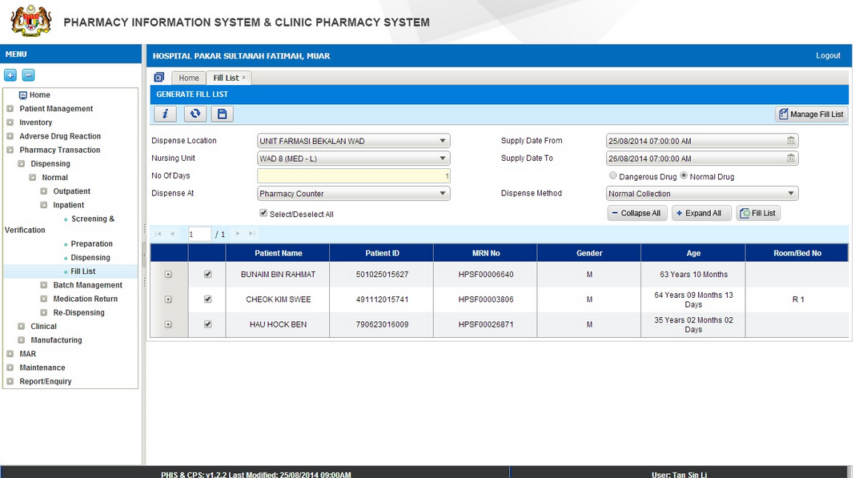

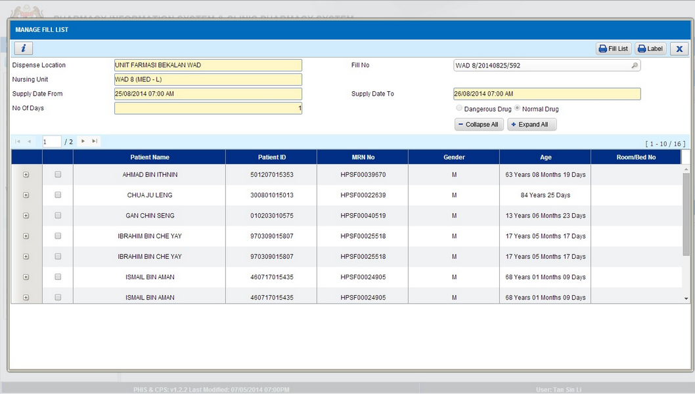

I-PhIS007234514S
Module | Reported Date | Description | Solution
Outpatient Pharmacy | 7/7/2014 | System should not check Prompt ERR0410 : next collection is not valid! for next collection date if Pharmacist prepare less than next TCA and If all drug in the prescription detected full supply/no balance QTY.  for example when next TCA is on November but the drug should be dispense only 1 month such as Paracetamol and etc. System wrongly auto fill for next collection date. System should not choose next collection date same as next TCA.  Current Condition spec: Only Certain drugs that should be dispense until next TCA. If occurred, then pharmacist advised to do intervention on duration.  User ID : Siti Aisyah binti Mohd Roslan - 810108145418 | System always check on Invalid Next Collection Date even there is no balance qty when click Dispense btn

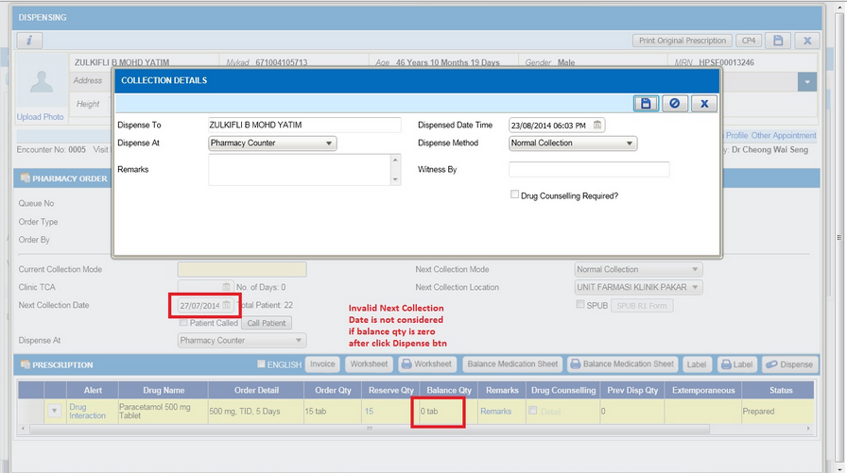

I-PhIS007286214S
Module | Reported Date | Description | Solution
Outpatient Pharmacy | 15/7/2014 | Patient available in acknowledgement list but when clicked theres no drug.  Patient Details : Ho Lai Ming HPSF00022972  User ID : 810108145418 | Data patching

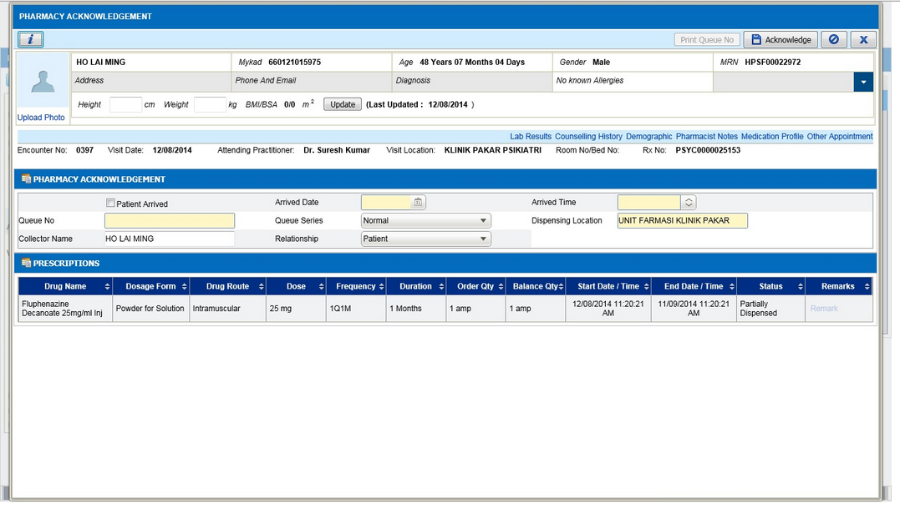

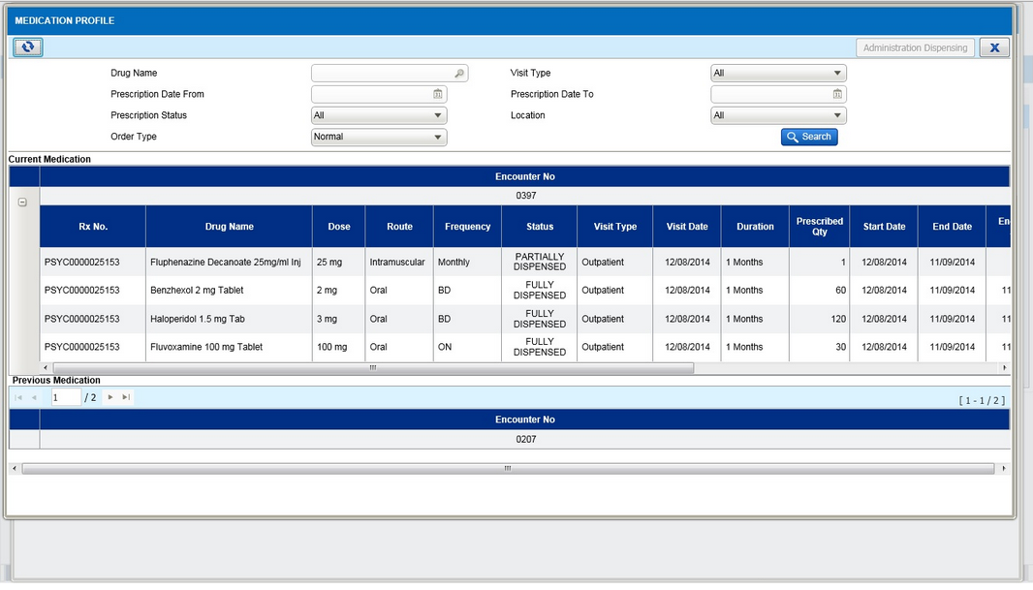

I-PhIS007293714S
Module | Reported Date | Description | Solution
Outpatient Pharmacy | 16/7/2014 | User reported drug missing in patient`s prescription.  User ID : 810108145418  Patient MRN: HPSF00020439  patient name: Soh Yok Cheng | Some record that have invalid end date is not included into filtering function

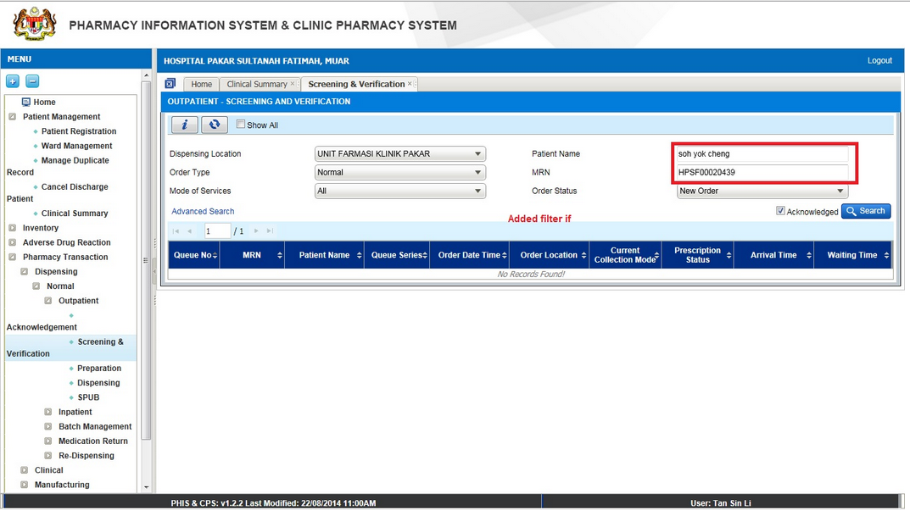

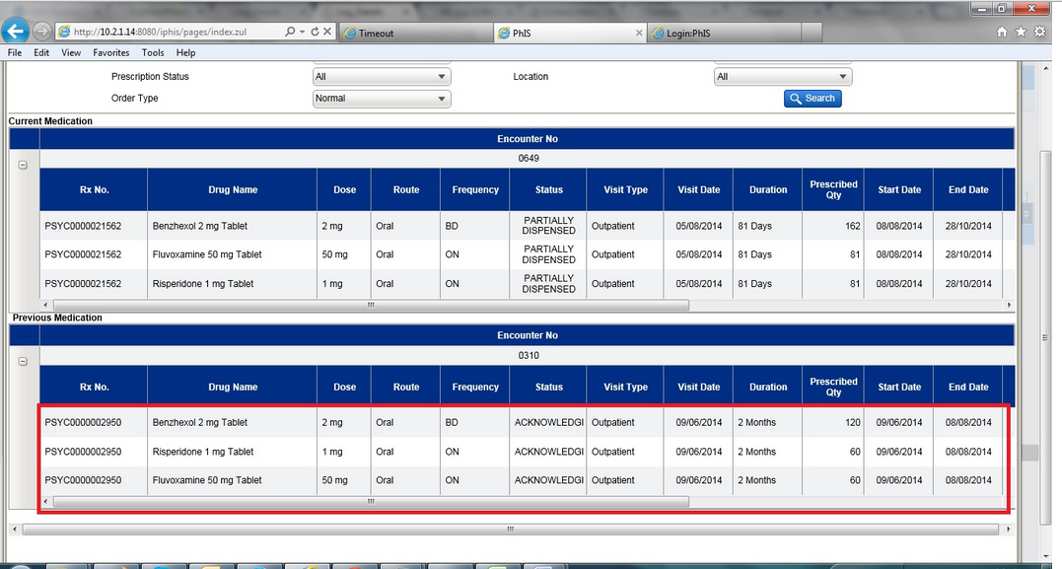

I-PhIS007234014S
Module | Reported Date | Description | Solution
Pharmacy Inventory | 7/7/2014 | Request to have the filter by drug or non drug at item/product buffer level screen.  UserID : 810125145321 | as per request

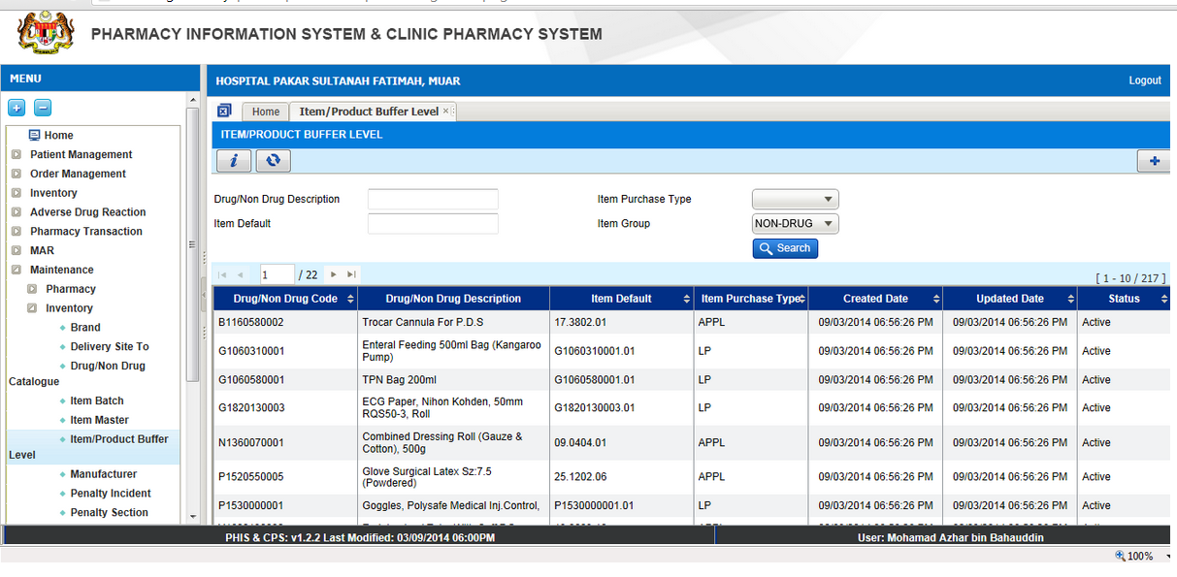

I-PhIS007491214S
Module | Reported Date | Description | Solution
Pharmacy Inventory | 26/8/2014 | User reported that,Inactive item cannot be found in Item Movement.  Please check for other module as well and For enquiry/report related transaction,user should able to filter by item status.  User : Stephanie / 851117045268  Time: 9:00 AM  Date reported:25/08/2014 | Do not filter inactive item

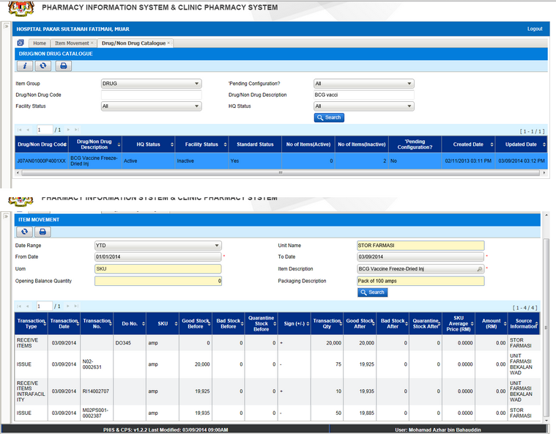

I-PhIS007431714S
Module | Reported Date | Description | Solution
Report/Enquiry | 14/8/2014 | User reported that at column 'source information', the information should come from respective unit (unit yang meminta), but currently the information its defaulted to stor farmasi only.  User: Aslinda bt. Muhammad  I/C: 750923045016  Screen: Item movement | Source information not pointed to the correct unit

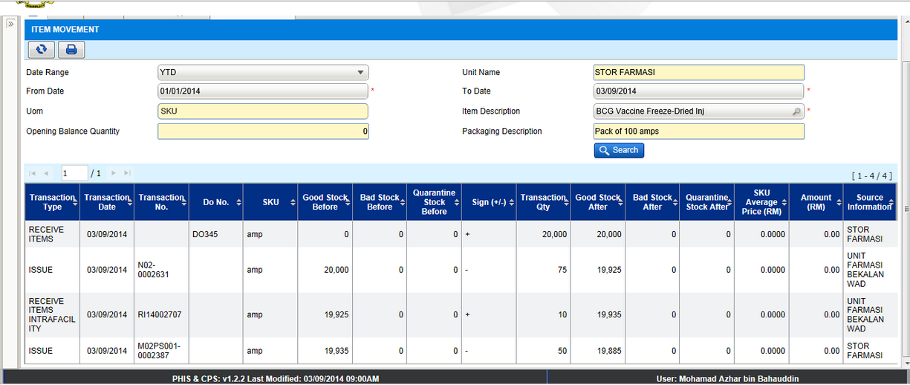

I-PhIS007317814S
Module | Reported Date | Description | Solution
Outpatient Pharmacy | 18/7/2014 | User cannot dispense medication to patient.System show alert message An error has occurred. Please contact your system administrator  Patient Name : VILLAMAH @ VELAMAH A/P MUNIANDY  MRN NO : KKE08004500015473  User id : 830115085853  Time : 10.00am  Contact Number : 05-2530801 | Previously not all the data is loaded when saving Collection Details after clicking on Dispense btn thus it will give error when save.

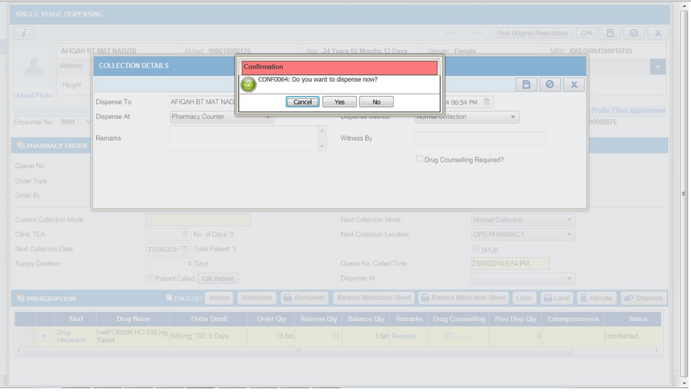

I-PhIS007439714S
Module | Reported Date | Description | Solution
Outpatient Pharmacy | 16/8/2014 | Doctor prescribed total 5 drugs in one prescription. At 1st dispensing, pharmacy was only allocate and dispense 4 drugs due to no stock or any other reason. Now the status for the prescription is partial dispense. But for drugs which is not dispensed the status is acknowledge. When the next cycle for partial supply, user only can see the dispensed drug in acknowledge screen. The drug with the status acknowledge cannot be seen.  Also try to search in other screen (verify, prepare n dispense) but the drug is still cannot be found.  Patient = KKE08004500016905  Patient name = SAROJINI N @ SAROJINI  Drug name = Irbesartan 300 mg Tablet | Data patching

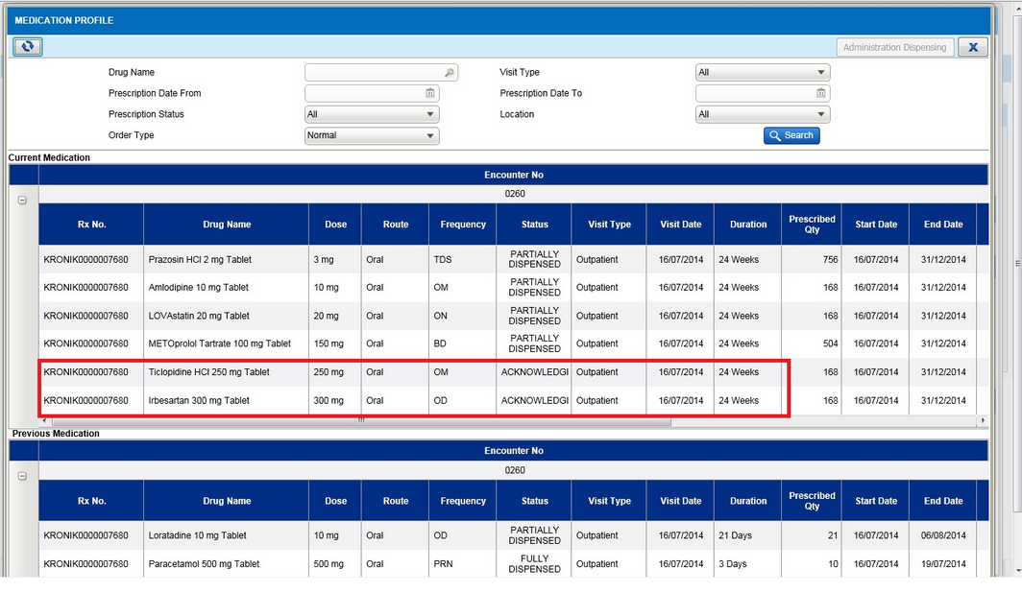

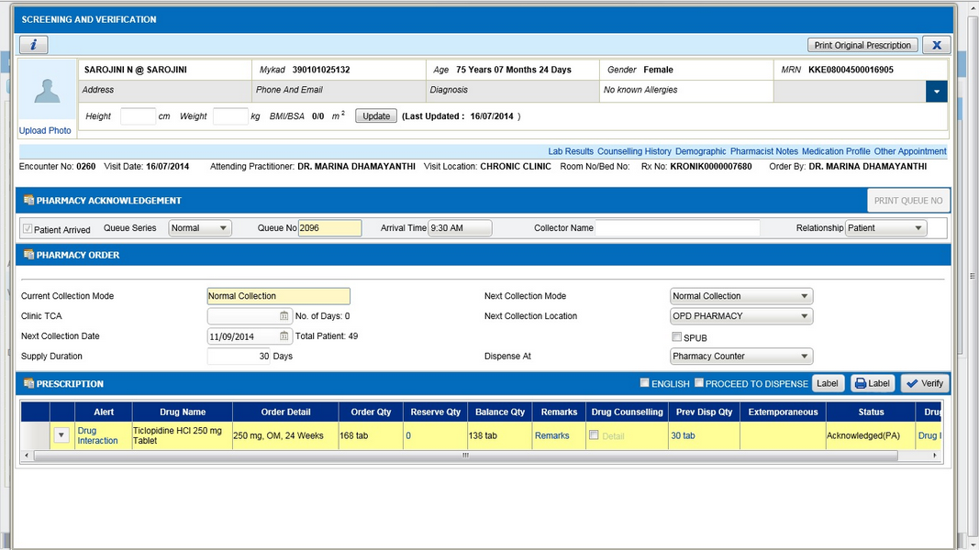

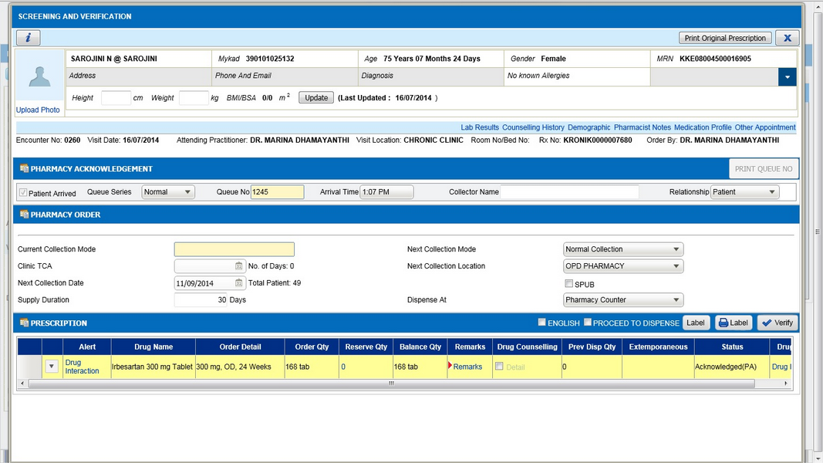

Deployment - Procedures

List of Items to be Deployed
No. | Items | Components | Path
1. | HQ Patch Scripts | PatchScripts_v1.2.2.8.txt | https://10.8.9.130:44330/svn/Workspace_Dataware/31_Implementation/Applications/PhIS Release V.1.2.2.8/hq/Scripts
2. | HQ Application | phishq.war | https://10.8.9.130:44330/svn/Workspace_Dataware/31_Implementation/Applications/PhIS Release V.1.2.2.8/hq/war
3. | HQ MIMS – Blue Book Excel | BlueBookMapping.xlsx | https://10.8.9.130:44330/svn/Workspace_Dataware/31_Implementation/Applications/PhIS ReleaseV.1.2.2.8/hq/MIMS
4. | HQ MIMS – JAR | BlueBookMapping.jar | https://10.8.9.130:44330/svn/Workspace_Dataware/31_Implementation/Applications/PhIS ReleaseV.1.2.2.8/hq/jar
5. | Facility Patch Scripts | PatchScripts_v1.2.2.8.txt  PatchScripts_v1.2.2.8_PKDKinta.txt (PKD Kinta only) | https://10.8.9.130:44330/svn/Workspace_Dataware/31_Implementation/Applications/PhIS Release V.1.2.2.8/facility/Scripts
6. | Facility Application | iphis.war | https://10.8.9.130:44330/svn/Workspace_Dataware/31_Implementation/Applications/PhIS Release V.1.2.2.8/facility/war
7. | Facility Application | PhISSchedulers.jar | https://10.8.9.130:44330/svn/Workspace_Dataware/31_Implementation/Applications/PhIS Release V.1.2.2.8/facility/jar
8. | Facility MIMS – JAR | FastTrackData.MR2 | https://10.8.9.130:44330/svn/Workspace_Dataware/31_Implementation/Applications/PhIS ReleaseV.1.2.2.8/facility/MIMS
9. | Mobile Application | ipadhosp-1.2.7b23.war | https://10.8.9.130:44330/svn/Workspace_Dataware/31_Implementation/Applications/PhIS Release V.1.2.2.8/facility/mobile

Backup Procedure before Deploy

Backup Procedure
Using backup tool, backup the following files and folder and database as per table below;
No. | Type | Backup Item | Description
1 | Application | /home/phisesb  /opt/phisesb  /usr/share/fonts/truetype | PhIS Integration Application  PhIS Core Application  Fonts required by PhIS
2 | Database | phisprod database | PhIS Live database

Deployment/Installation Guidelines

Deployment at Facility
Below table is described the deployment steps at Facility:
Step | Items | File Name | Source Path | Action
1 | Facility Patch Scripts | PatchScripts_v1.2.2.8.txt PatchScripts_v1.2.2.8_PKDKinta.txt (PKD Kinta Only) | https://10.8.9.130:44330/svn/Workspace_Dataware/31_Implementation/Applications/PhIS Release V.1.2.2.8/facility/Scripts | Run the scripts @ Postgres DB using PGAdmin
2 | Facility Application | iphis.war | https://10.8.9.130:44330/svn/Workspace_Dataware/31_Implementation/Applications/PhIS Release V.1.2.2.8/facility/war | Deployment @ Both HA Servers
3 | Facility Application | PhISSchedulers.jar | https://10.8.9.130:44330/svn/Workspace_Dataware/31_Implementation/Applications/PhIS Release V.1.2.2.8/facility/jar | copy into /home/phisesb/phisjars folder
4 | Facility Application - MIMS | FastTrackData.MR2 | https://10.8.9.130:44330/svn/Workspace_Dataware/31_Implementation/Applications/PhIS ReleaseV.1.2.2.8/facility/MIMS | copy into /home/phisesb/MIMS folder
5 | Mobile Application | ipadhosp-1.2.7b23.war | https://10.8.9.130:44330/svn/Workspace_Dataware/31_Implementation/Applications/PhIS Release V.1.2.2.8/facility/mobile | Deployment @ Both HA Servers

Deployment at HQ - IWP
Below table is described the deployment steps at HQ - IWP:

Step | Items | File Name | Source Path | Action
1 | HQ Patch Scripts | PatchScripts_v1.2.2.8.txt | https://10.8.9.130:44330/svn/Workspace_Dataware/31_Implementation/Applications/PhIS Release V.1.2.2.8/hq/Scripts | Run the scripts @ Postgres DB using PGAdmin
2 | HQ Application | phishq.war | https://10.8.9.130:44330/svn/Workspace_Dataware/31_Implementation/Applications/PhIS Release V.1.2.2.8/hq/war | Deployment @ Both HA Servers
3 | HQ MIMS – Blue Book Excel | BlueBookMapping.xlsx | https://10.8.9.130:44330/svn/Workspace_Dataware/31_Implementation/Applications/PhIS ReleaseV.1.2.2.8/hq/MIMS | copy into /home/phisesb/MIMS folder
4 | HQ MIMS – JAR | BlueBookMapping.jar | https://10.8.9.130:44330/svn/Workspace_Dataware/31_Implementation/Applications/PhIS ReleaseV.1.2.2.8/hq/jar | copy into /home/phisesb/phisjars folder

