Pharmacy Information System (PhIS)
and
Clinic Pharmacy System (CPS)

Release Note
For version 1.2.2.9

Version : 1.0
Document ID : PhIS_CPS/ReleaseNote/Refinement/24092014

© 2011-2014 Pharmaniaga Logistics Sdn Bhd (PLSB)

CONFIDENTIAL COPYRIGHTED MATERIAL – The information includes all concepts, comments, recommendations, and material, contained herein shall remain the property of Pharmaniaga Logistics Sdn Bhd (PLSB). No portion of this document shall be disclosed, duplicated or used in whole or in part of any purpose other than the purpose of the Pharmacy Information System & Clinic Pharmacy System (PhIS& CPS) Project execution only.

Revision History

Version No | Date of Release | Prepared by | Reviewed / Verified by | List of changes from Previous Version
1.0 | 24/09/2014 | Kee Tuan Hwa | Chew Ming Ping | First Version

Verified and Acknowledged by:
Name | Role/Designation | Organization | Signature & Date
Chew Ming Ping | Team Leader | Pharmaniaga Logistics Sdn Bhd
Hoh Choon Seng | Project Manager | Pharmaniaga Logistics Sdn Bhd

Name | Role/Designation | Organization | Signature & Date
 |  | Bahagian Perkhidmatan Farmasi (BPF), KKM
 |  | Bahagian Pengurusan Maklumat (BPM), KKM

Peer Review
Version No | Reviewed / Verified by | List Of Changes from Previous Version
1.0 | Juridah (QA) | Initial document

1 Introduction 1
1.1 Project Information 1
1.2 Objectives 1
2 Purpose 2
3 Summary – Refinement and Defect List 3
3.1 Refinement List 3
3.1.1 Hospital Pakar Sultanah Fatimah 3
3.1.2 KK Greentown 4
3.1.3 Data Centre – Integration Web Portal 5
3.2 Resolved Defect List 6
3.2.1 Hospital Pakar Sultanah Fatimah 6
3.2.2 KK Greentown 16
3.2.3 PKD Kinta 19
3.2.4 Data Center - IWP 21
4 Refinement List – Detail Changes 23
4.1 I-PhIS007585714S 23
4.2 C2-INT000451214R 24
4.3 I-PhIS007425714S 25
5 Deployment - Procedures 26
5.1 List of Items to be Deployed 26
5.2 Backup Procedure before Deploy 26
5.2.1 Backup Procedure 26
5.3 Deployment/Installation Guidelines 27
5.3.1 Deployment at Facility 27
5.3.2 Deployment at HQ - IWP 27

Introduction

Project Information

Project ID : | PhIS and CPS
Project Name : | Pharmacy Information System and Clinic Pharmacy System
Version No : | 1.2.2.9
Client Name : | Ministry of Health
Release ID : | RL14/019
Release Date : | 24/09/2014

Objectives
No. | Objective | Reference
1. | Release PhIS & CPS Application to Facility | Refer Section 3 – Refinement and Defect list

Purpose
The purpose of the document is to update the end-user of the changes and defects have been resolved to be included in the new version of application and will be deployed to production server.
This document outlines the list of request and issue to be delivered in the newer version of application and also the guidelines on how to deploy the new version of application in production.

Summary – Refinement and Defect List

Refinement List

Hospital Pakar Sultanah Fatimah
No | Ticket No. | Module | Reported Date | Description | Additional Information | Solution | Resolved Date | Verify Status
1 | I-PhIS007585714S | Ward Pharmacy | 9/9/2014 | Request added frequency at CP1 on printing form. Currently in cp1 report, no freq column - already have this request in batch 1 comment log  refer crm ticket - I-PHIS007575014  refer CM ticket - R-PhIS001817514 |  | already add frequency at cp1 report  Refer to 4.1 | 9/9/2014

Verified and Acknowledged By:
Signature: |  | Name:
Date: |  | Designation:

Signature: |  | Name:
Date: |  | Designation:

KK Greentown
No | Ticket No. | Module | Reported Date | Description | Additional Information | Solution | Resolved Date | Verify Status
1 | C2-INT000451214R | Patient Management | 23/6/2014 | To allow system to read and retrieve Mykad into PhIS system.  1. If new patient, system will retrieve information from Mykad into PhIS when scanned.  2. For existing patient, system will use existing information from PhIS when scanned. | Request during PAT review meeting | Add 1 button; Scan Card inside Patient Registration screen. Once click, will retrieve the information from Mykad into PhIS. | 22/9/2014

Verified and Acknowledged By:
Signature: |  | Name:
Date: |  | Designation:

Signature: |  | Name:
Date: |  | Designation:

Data Centre – Integration Web Portal
No | Ticket No. | Module | Reported Date | Description | Additional Information | Solution | Resolved Date | Verify Status
1 | I-PhIS007425714S | IWP | 13/8/2014 | Request to add coloumn 'RO NO.' at IWP-eP Enquiry-EPO Status. |  | As per request | 25/8/2014

Verified and Acknowledged By:
Signature: |  | Name:
Date: |  | Designation:

Signature: |  | Name:
Date: |  | Designation:

Resolved Defect List
The following are the summary of resolved defect list that included in PhIS and CPS version 1.2.2.9.

Hospital Pakar Sultanah Fatimah
No | Ticket No. | Module | Reported Date | Description | Additional Information | Root Caused | Resolved Date | Verify Status
1 | I-PhIS007463814S | Inpatient Pharmacy | 20/8/2014 | Error appeared when user clicked button prepare.  Patient Details: HPSF00038838 - NUR AISHA HAYATI BINTI ABDULLAH  Drug name: Gamma Benzene Hexacloride 0.1% Lotion.  Location : Satellite Pharmacy  User : Poo chin  Time: 3:30PM |  | Because the alternate drug 'Gamma Benzene Hexachloride 1% Lotion' has strength is null. | 9/9/2014
2 | I-PhIS007537914S | Inpatient Pharmacy | 2/9/2014 | User issue that System not allow user to change dispense location. No issue if no default location selected. |  | wrong code,system not allow to change Dispensing Location if select Location when login | 4/9/2014
3 | I-PhIS007538014S | Inpatient Pharmacy | 2/9/2014 | Generate fill list for 02/09/2014-03/09/2014. No dispensing record displayed in clinical summary. Only previous dispensing record displayed. | NA | Because user skip the previous date for fill list. Normally Fill List needs to do for everyday or the day needs to be continue. But they have the date which they don't do fill list. | 5/9/2014
4 | I-PhIS007538314S | Inpatient Pharmacy | 2/9/2014 | No report generated for inpatient prescription report | Not able to generate report for month of august. report only generated filter by September. | Previously the date format is converted to character those sometimes it will not work properly when do query to DB. | 10/9/2014
5 | I-PhIS007559814S | Inpatient Pharmacy | 5/9/2014 | Reported that error appear after click save button.The time user save button after select from fill list, user cant save because error pop up appear.  Pharmacy Transaction>Dispensing>Normal>Inpatient>Inpatient>Fill List.  User ID : 850611016492  User Name: Low Yee Shan |  | Previously system do not have the code to control skip day cases in fill list. E.g. Order from 1/9-10/9. But user skip 3/9 to 5/9. When try to search fill list for 6/9 to 7/9, system will deallocate and allocate back. But when deallocate, some data does not have dispensing qty lock, thus it cause an error. In latest code, system will validate this kind of scenario. | 12/9/2014
6 | I-PhIS007589714S | Inpatient Pharmacy | 9/9/2014 | Drug inpatient ward 5 should not flow to pharmacy satellite according to current order routing because within an office hour, in screen order routing set as office hour will flow to Famasi Bekalan Wad (FBW) and after office hour should flow to satellite pharmacy.  User name: Loo Poh Ling.  Module: Pharmacy transaction > dispensing > inpatient > screening and verification.  Patient name: MD SIDIK BIN NOR.  Date happen: 09/09/2014.  Time 3.30PM.  Scenario screen screening and verification.  Step:  1) Go to Pharmacy Transaction > dispensing > inpatient > screening and verification.  2) Search order location for ward 5.  3) Select patient for sample: MD SIDIK BIN NOR. |  | In order routing not checking active flag | 18/9/2014
7 | I-PhIS007646114S | Inpatient Pharmacy | 18/9/2014 | User report Ward Stock medication flow to Farmasi Bekalan Wad but cant dispense the medication. The drug will remain in dispensing screen(Pic 1). | Please refer attchment | This bug is because the Queue Prepared is still active | 22/9/2014
8 | I-PhIS007333814S | Order Management - Mobile | 23/7/2014 | Reported authorisation alert message didn't appear upon order confirmation. Order via mobile.Drug as per picture on current medication. Prescribed by HO, drug category A*.  User: Dr. Mohd Hakim bin Mohd Azam  Patient: Zaid bin Md Top / HPSF00032588 |  | Authorisation alert message did not appear after new changes for Draft and Confirm button. | 12/9/2014
9 | I-PhIS007429814S | Order Management - Mobile | 13/8/2014 | Doctor prescribe PERINDOpril 8 mg Tablet, but error PERINDOpril 8 mg Tablet is active in the previous medication. Check in Previous and Current Medication, there is no PERINDOpril for patient.  Patient name : Teo Ah Aeh  MRN : HPSF00025517  Location : Ward 9(Med P)  Doctor name : Dr Izzatul Nadiah Zolkiply  Module : Order Management  Accident Time : 5.15 pm |  | Old Normal Order with Draft status in an old Outpatient visit cause the issue. | 12/9/2014
10 | I-PhIS007381714S | Order Management - Web | 5/8/2014 | User reported system unable upload and Download document  step;  Uploaded pdf files (few files from big to small size)  View the attachment of the uploaded file  PDF viewer unable to view the file (refer screenshot at attachment)  Check at downloaded folder, file size is 0 byte  How can we determine the file upload is successful?  User name: Tay Han Siang  User ID: 870108235549  Time and Date : 3:30 / 5.8.2014 |  | Previous function is not proper. some pdf files may be uploaded correctly while others not. | 12/9/2014
11 | I-PhIS007415814S | Order Management - Web | 10/8/2014 | Different dose at authorization with medication profile.  Item name:WAD 170000023025  MRN patient : HPSF00036353  ID: 751113105894 (Dr. Ngian Geok Hoon)  Time: 5pm |  | Dose displayed in Authorisation is not updated as in medication profile and endorsement screen. | 8/9/2014
12 | I-PhIS007533814S | Order Management - Web | 2/9/2014 | User reported that,when Dr Ngian try to authorise order in task list page but an error prompt.Check at Authorisation page, there is no authorise list for the period.  User name : Dr Ngian Geok Hoon  Location: Ward 17(Paediatric) |  | Error when authorize from mobile | 5/9/2014
13 | I-PhIS007546714S | Order Management - Web | 3/9/2014 | Difference information was displayed at manage order screen if user log in with selected location and without selected location.  Scenario with selected location  steps  1. Enter user id  2. Enterpassword  3. Select location as NICU  4. Go to manage order  5. Select location NICU click search  Notes: there is olny one patient was display.  Scenario without selected location  Steps  1. Enter user id  2. Enter password  3. Location as select location (don't select any location)  4. Go to manage order  5. Select location and click search  Notes: thousands of name was display  Time happen : 3.30PM  User ID : 860923235693 |  | Patient records is not filtered by user department and location in manage order when login without select Location | 12/9/2014
14 | I-PhIS007610114S | Order Management - Web | 12/9/2014 | User reported that an error appear when Doctor wants to confirm order for drug name :Propofol 1% injection.  User: DrNurulAin  ID: 880305015034  Time happen : 12.00 am  Patient: RosnahbtHatemo (44459) |  | Formula & Program Logics Error | 18/9/2014
15 | I-PhIS007651714S | Order Management - Web | 19/9/2014 | User already confirm order but the order status still in draft.  Description: User have try a few times but the problem still persist.  Drug name: 1)Vitamin K1 1 mg/ml Inj  2) Beractant Intratracheal Suspension (200 mg phospholipids in 8 ml vial) | Please refer attchment | increase the length of drug name in drug master | 22/9/2014
16 | I-PhIS007293814S | Outpatient Pharmacy | 16/7/2014 | User reported searching problem filtration data Order Status not functioning. Searched for partial supply prescription but the results are all in progress/new prescription. Searched for new orders but the results are all partially supply prescriptions.  Page : Pharmacy transaction> Outpatient> Preparation  User ID : 810108145418 |  | Wrongly Status Managed | 12/9/2014
17 | I-PhIS007482814S | Outpatient Pharmacy | 25/8/2014 | Module : Outpatient Screening and Verification  After user allocate drug then save the reserve quantity doesnt change.Have tried many time but still not change.  User : Puan Aishah  Time: 8:40 AM |  | Previously system will always take full value for order qty when do allocation. | 5/9/2014
18 | I-PhIS007483414S | Outpatient Pharmacy | 25/8/2014 | Outpatient Screening and Verification > Drug missing from Prescription after user acknowledge then when user open the prescription details no drug is in the list at screening and verification.  Patient Details : Abu Rahman Bin Sulaiman - 450803015539  Time: 9:00 AM |  | drug not displayed in Screening and Verification screen after acknowledge | 11/9/2014
19 | I-PhIS007505714S | Outpatient Pharmacy | 27/8/2014 | System shows up inappropriate message and show up error every time opening screen Outpatient Screening and Verification  The error shows Duration must be greater than zero!  Patient Details: NafsahBtJalal - HPSF00012885  User ID :PuanAishah  Time : 8:30 AM |  | Problem happened when user want to verify the order that its arrival time (exclude arrival date) is future compared to current time. E.g. Pharmacist want to verify order for record that its arrival time is 3 pm but current time is 1 pm. Then after verify, system records new arrival time at the back end (using current time) thus the value become negative. | 8/9/2014
20 | I-PhIS007535814S | Outpatient Pharmacy | 2/9/2014 | Collectors name display staff name after tick patient arrive at pharmacy acknowledgement. the collector name should be empty.  Patient MRN: HPSF00018742  User : Puan Siti Aishah.  Time: 9:00 AM |  | Previously system display user login name when user select Patient Arrived checkbox. | 18/9/2014
21 | I-PhIS007536014S | Outpatient Pharmacy | 2/9/2014 | User reported unable to resume drug Fluticasone Propionate.  MRN: HPSF00021103  User : Puan Siti Aishah  Time: 9:00 AM |  | Resume function is disabled when user want to resume after prescription has been dispensed. | 4/9/2014
22 | I-PhIS007558214S | Outpatient Pharmacy | 4/9/2014 | Alternate conversion problem. Alternate successful but label does not convert to Â½ tablet. |  | Qty UOM for 'Levodopa 200 mg, Benserazide 50 mg Tablet' is in TABLET while Qty UOM for 'Levodopa 100 mg, Benserazide 25 mg HBS capsule' is in CAPSULE. When doing alternate, if 2 drugs have different Qty UOM, system will take the qty value for main drug, not the alternated one. | 15/9/2014
23 | I-PhIS007595714S | Outpatient Pharmacy | 10/9/2014 | Multidosing Drug preparation cannot be allocate accordingly. User prepare Fluvoxamine 100 mg, 30 Tablet and Fluvoxamine 50 mg,30 Tablet but reserve quantity is 45. |  | Previously system saves both main and main/alternate values when saving for alternate/combination drugs. | 15/9/2014
24 | I-PhIS007595814S | Outpatient Pharmacy | 10/9/2014 | Second label for Fluvoxamine 50 mg is missing if user both Preview Label and Direct printing. |  | allocation was going wrong. | 15/9/2014
25 | I-PhIS007596114S | Outpatient Pharmacy | 10/9/2014 | Issue: Unable to prepare all this prescription (Prescription 2 9). When prepare button is clicked nothing happens. |  | Because the alternate drug strength is 0. | 15/9/2014
26 | I-PhIS007460014S | Pharmacy Inventory | 20/8/2014 | Please refer attachment. Error pop-up after save the transaction via receiving module (inventory).  error pup-up mentioned that DO no. cannot be empty but DO no. field in screen was already entered.  module: inventory  user: aslinda bt muhammad  i/c: 750923045016  screen:receiving  location: main store, level 1  time: 11:00 am |  | For Contract ,Supplier is Pharmaniaga, DO are being receive through INTEGRATION. No text field to enter the DO numbers.  Contract item code will be changed to MDC code and for time being receiving contract DO will proceed by entered the DO no. . | 8/9/2014
27 | I-PhIS007490914S | Pharmacy Inventory | 26/8/2014 | Task List status is open but in receiving screen the status is rejected. Transaction number: P14000046.  ID : Stephanie  Time: 9:00 AM  Date: 25/08/2014 |  | Currently after 'Reject' record, one task List record will be created to notify creator. But there was no scenario to close that task list. | 8/9/2014
28 | I-PhIS007543814S | Pharmacy Inventory | 3/9/2014 | Please refer KEW.PS-10 form.  1) Picture 1 in attachment mention That In (Column) Kuantiti Diluluskan (Sku) Are Not Tally With (Column) Kuantiti Dikeluarkan (Pku). From 6 Approved But 0 For Kuantiti Dikeluarkan.  User Id/Pass : 810125145321/1234  Step :  1. store inventory - issue - create new record - select criteria external type - add item - select item and fill qty and must field on PKU value = 0  Expected result :  1. if column on PKU,should be value 0 should be show in decimal point. | No remarks given. | format of pku column in report was applied wrongly | 9/9/2014
29 | I-PhIS007545714S | Pharmacy Inventory | 3/9/2014 | User reported issue transaction offline (external) missing transaction no. at listing page  Transaction No : M02PS001-0004688.  User tried to search this transaction, unable to find.  User: En Azhar  Unit : Main Store  Login ID : 810125145321 |  | condition to populate data on listing page was incorrect for internal and external issue | 8/9/2014
30 | I-PhIS007571914S | Pharmacy Inventory | 8/9/2014 | Pharmacist can't find drug when proceed stock adjustment but the drug available in ward 7 catalogue. Refer attachments  Login id/pass : 750214015762 /1234  step :  1. go maintenance - unit catalogue - search drug name example Fru then appear at unit catalogue listingFrusemide 20mg/2ml lnj and Frusemide 40 mg Tablet.  2. Then go screen adjustment in module stock taking & verification - adjustment - create new record - select type Routine checking - add item - search item description Frusemide 20 mg Tablet and search not found item |  | Hq status for mentioned Item was inactive In current practice Hq status must be active for an Item to populate anywhere. | 9/9/2014
31 | I-PhIS007614014S | Pharmacy Inventory | 12/9/2014 | In the stock adjustment screen, users fail to send for approval. Possible more than 14 items. Repeat again, this error will not be repeat again. |  | Coding issue Zk renders only those records which comes under limit of pageSize attribute of Paging component But here the problem was 2nd page records has not recognized at time save or send for approval. | 18/9/2014
32 | I-PhIS007635914S | Pharmacy Inventory | 18/9/2014 | Level 3 - Requested By should default to login ID supposed same as level 1 & Level. But now need to key in detail manually | NA | Requested to show name of login user in requested by field that user belongs to level 3. | 19/9/2014
33 | I-PhIS007557714S | Report/Enquiry | 4/9/2014 | Unable to search for new order at prescription status report. Search came out no record found. Search was successful for partial dispense only. URGENT.  Location : FKP  User : Siti Nor Aishah | NA | system not filter for order status = New Order | 11/9/2014
34 | I-PhIS007557914S | Report/Enquiry | 4/9/2014 | Unable to search by date and time.  Location : FKP  User : Siti Nor Aishah | NA | Previously system is checking today's time record for Dispensing Time From/To when searching thus result cannot be generated. | 10/9/2014
35 | I-PhIS007558414S | Report/Enquiry | 4/9/2014 | System calculates wrongly in prescription dispensed report. 26/8/2014 total 0 but there was one prescription on the 26th.  Location : FKP  User : Siti Nor Aishah | NA | Previously system wrongly calculate the total for Appointment Card and Others sections. | 15/9/2014
36 | I-PhIS007558614S | Report/Enquiry | 4/9/2014 | Date/Day still not arranged. Mixed up. All reports must follow date arrangements.  Location : FKP  User : Siti Nor Aishah | NA | Previously date format in report in 'From DD/MM/YYYY To DD/MM/YYYY' | 10/9/2014

Verified and Acknowledged By:
Signature: |  | Name:
Date: |  | Designation:

Signature: |  | Name:
Date: |  | Designation:

KK Greentown
No | Ticket No. | Module | Reported Date | Description | Additional Information | Root Caused | Resolved Date | Verify Status
1 | I-PhIS007599914S | Order Management - Web | 10/9/2014 | Pharmacy already confirm by checking at Clinical Summary that the patient is been Discontinued. But doctor said she never did it. And it also cannot be happened because in KKGT all patient is Outpatient.  Time: 4.04pm  Date: 10/09/14  user: Le Lai Fong  Patient Name: CHAN YUET YENG  MRN: KKE08004500011284 |  | Formula & Program Logics Error | 18/9/2014
2 | I-PhIS007477714S | Outpatient Pharmacy | 23/8/2014 | as attached scenario  User Id: for testing purpose |  | Previously System do not checking on filtering/calculation function first before doing saving function after change Supply Qty and immediately clicking on Save btn. | 9/9/2014
3 | I-PhIS007490714S | Outpatient Pharmacy | 26/8/2014 | After compete clicking checkbox, system automatically uncheck itself.  Patient MRN number: 10721  User : LEE LAI FONG  ID : 8840528085914  Incident : 9.02am  Reported date 25/8/2014 |  | Previously system does not trigger PRN order thus if PRN drug is selected, the complete checkbox is always unchecked. | 12/9/2014
4 | I-PhIS007510214S | Outpatient Pharmacy | 27/8/2014 | After verified at screening screen, the patient do not appear at Preparation screen.  Patient MRN number: 19346  ID: 870330015854 (NOR HANISAH SARAH BT. MOHD)  time: 8.55am |  | previously at the time of verify some error was coming and queue verified was not creating that's why listing some records was not flowing | 12/9/2014
5 | I-PhIS007526614S | Outpatient Pharmacy | 29/8/2014 | Nothing happened after clicking button Dispense.  Time Incident Happen : 6.30pm  User name : LEE LAI FONG  User Id : 870330015854 |  | value of status column is not saving proper value in the table ph_queue_verified | 18/9/2014
6 | I-PhIS007559714S | Pharmacy Inventory | 5/9/2014 | hit error after open the transaction. This error appear for all the 6 PO:  1. PO14000024  2.PO14000025  3.PO14000026  4.PO14000027  5.PO14000032  6.PO14000034  STEP 1 : Login as PKD User at IWP  STEP 2: Click on PKD Authorization > Request Order Authorization  STEP 3: Click on the transaction  user : Pn Siti Zubidah , Time happen : 10.05 am. | Refer Attachment 1. | Vote code problem. Same vote code exist for the same facility. | 9/9/2014
7 | I-PhIS007591714S | Pharmacy Inventory | 9/9/2014 | cannot approved quantity: hit error  PO14000036  STEP 1 : Login as PKD User at IWP  STEP 2: Click on PKD Authorization > Request Order Authorization  STEP 3: Click on the transaction PO14000036  STEP 4: Click on the item and insert PKD Approved Qty and save.cannot approved quantity: hit error  Time Incident: 4.55 pm  User ID: 590116025158 |  | lazy initialization exception | 19/9/2014
8 | I-PhIS007666014S | Outpatient Pharmacy | 22/9/2014 | After resume and click yes for release drug, no effect.  Patient MRN number: 05879  ID: 841108086392  time: 4.20pm |  | Previously system not tackle scenario if the drug is being hold in Single Stage Dispensing and want to resume in Screening. Now system will allow to resume in Screening if the drug is being hold in Single Stage Dispensing screen. | 23/9/2014

Verified and Acknowledged By:
Signature: |  | Name:
Date: |  | Designation:

Signature: |  | Name:
Date: |  | Designation:

PKD Kinta
No | Ticket No. | Module | Reported Date | Description | Additional Information | Root Caused | Resolved Date | Verify Status
1 | I-PhIS007510014S | Pharmacy Inventory | 27/8/2014 | Step 1: Go to issue module  Step 2: Go to offline Issue  Step 3: Go to add one item 2 different batches  Step 4: save and send for approval and approved  Step 5: Print the issue note, the value in Daripada and Kepada are incorrect  PKD Kinta issue to KKGT.  Currently, The result is:  The value in Daripada = KKGT  The value in Kepada = PKD Kinta  The correct result should be:  The value in Daripada = PKD Kinta  The value in Kepada = KKGT  User:HONG JEE YAN  ID :890109085237  Time :3:40pm |  | in Report Parameter to print both these values were added wrongly | 3/9/2014

Verified and Acknowledged By:
Signature: |  | Name:
Date: |  | Designation:

Signature: |  | Name:
Date: |  | Designation:

Data Center - IWP
No | Ticket No. | Module | Reported Date | Description | Additional Information | Solution | Resolved Date | Verify Status
1 | I-PhIS007549714S | IWP | 4/9/2014 | Reported that at item master screen, when selection the item brand row it will display huge column. |  | UI changes | 11/9/2014
2 | I-PhIS007549814S | IWP | 4/9/2014 | Reported that Item detail at Item Quantity section not deleted once drug at Item Information deleted. New transaction created and at Item Information section, drug have been deleted but at Item Quantity section , the item code detail that tie to the drug still available and delete off from the list. |  | overlapping date range condition for items in contract additional condition for contract status added | 12/9/2014
3 | I-PhIS007573714S | IWP | 8/9/2014 | Sample can be seen in KKM Code Contract Ref No : KKM-18/2014/F(U) , status = Cancel  Drug name : Pramipexole Tablet. |  | overlapping date range condition for items in contract additional condition for contract status added | 12/9/2014
4 | I-PhIS007603714S | IWP | 11/9/2014 | Create new record - no data when click 'Country' drop down list. |  | Query to fetch country value was wrongly written. | 12/9/2014
5 | I-PhIS007611714S | IWP | 12/9/2014 | IWP-Header Title should be User Profile  1. Go to Maintenance-HQ Security-User Profile  2. Double click one existing record.  3. The header title should be 'User Profile' |  | change header title | 17/9/2014
6 | I-PhIS007611814S | IWP | 12/9/2014 | PhIS-Maintenance-Header Title should be User Profile  1. Go to Maintenance-HQ Security-User Profile  2. Double click one existing record.  3. The header title should be 'User Profile' |  | rename header title | 17/9/2014
7 | I-PhIS007631714S | IWP | 17/9/2014 | User had edit and save data before approve open order. while trying to save the data error Contract of this item already exist of this date range effective start and end date . Attached is the print screen from user. |  | condition for date range | 19/9/2014

Verified and Acknowledged By:
Signature: |  | Name:
Date: |  | Designation:

Signature: |  | Name:
Date: |  | Designation:

Refinement List – Detail Changes

I-PhIS007585714S
Module | Reported Date | Description | Solution
Ward Pharmacy | 9/9/2014 | Request added frequency at CP1 on printing form. Currently in cp1 report, no freq column - already have this request in batch 1 comment log  refer crm ticket - I-PHIS007575014  refer CM ticket - R-PhIS001817514 | already add frequency at cp1 report

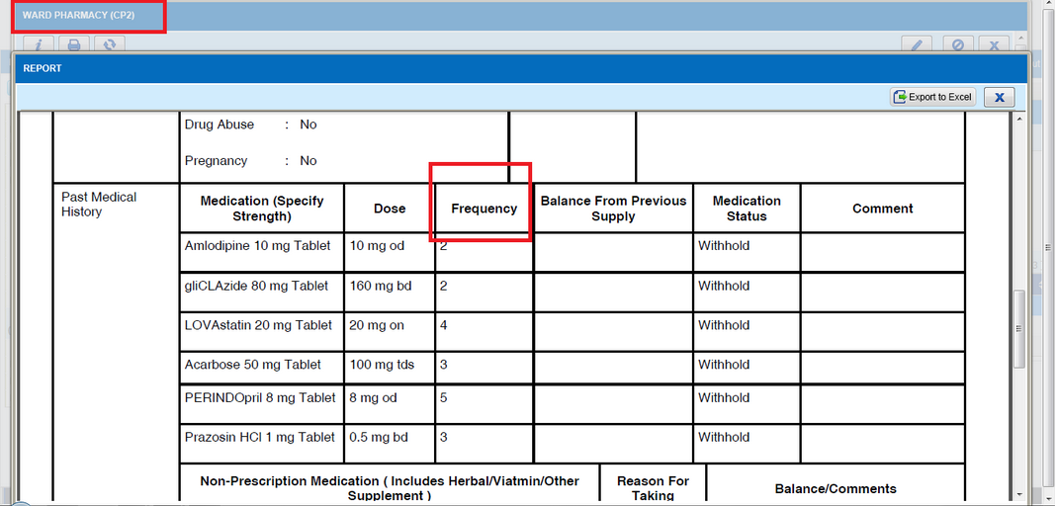

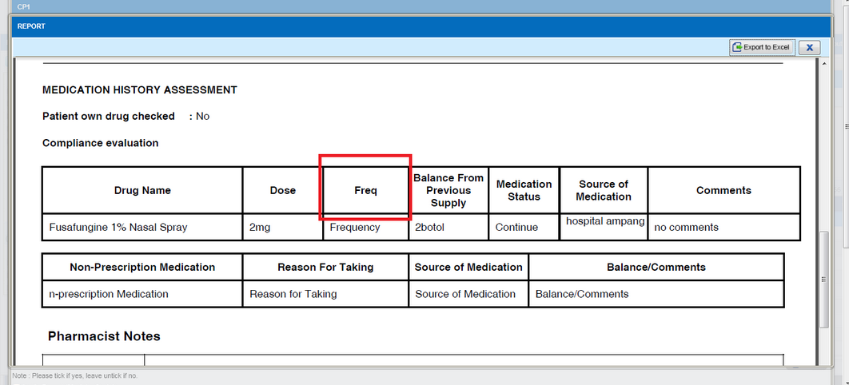

C2-INT000451214R
Module | Reported Date | Description | Solution
Patient Management | 23/6/2014 | To allow system to read and retrieve Mykad into PhIS system.  1. If new patient, system will retrieve information from Mykad into PhIS when scanned.  2. For existing patient, system will use existing information from PhIS when scanned. | Add 1 button; Scan Card inside Patient Registration screen. Once click, will retrieve the information from Mykad into PhIS.

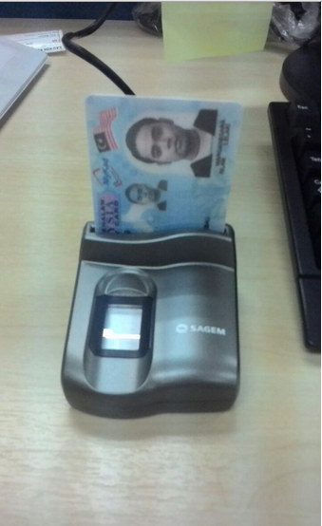

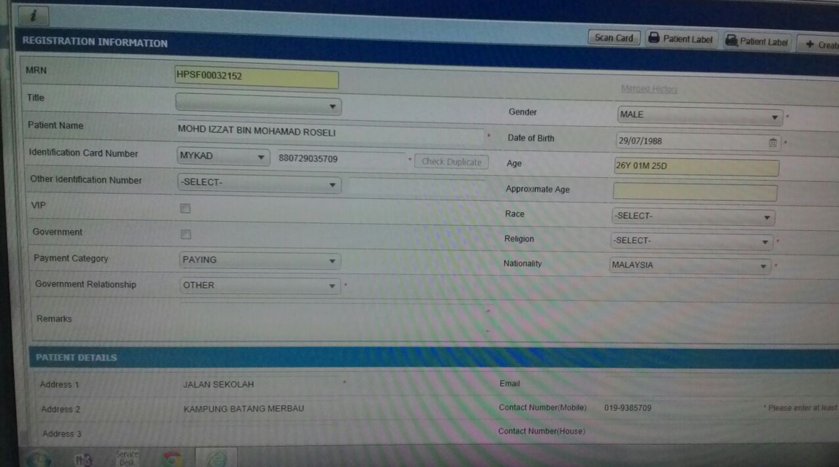

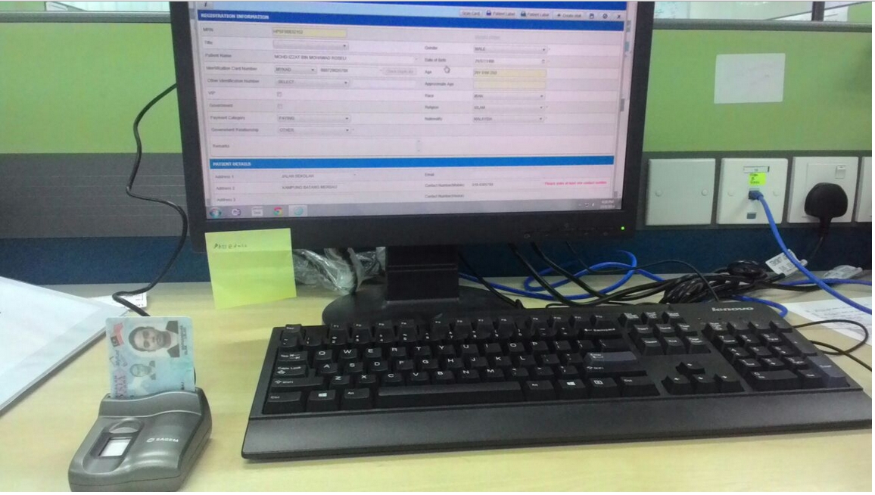

I-PhIS007425714S
Module | Reported Date | Description | Solution
IWP | 13/8/2014 | Request to add coloumn 'RO NO.' at IWP-eP Enquiry-EPO Status. | As per request

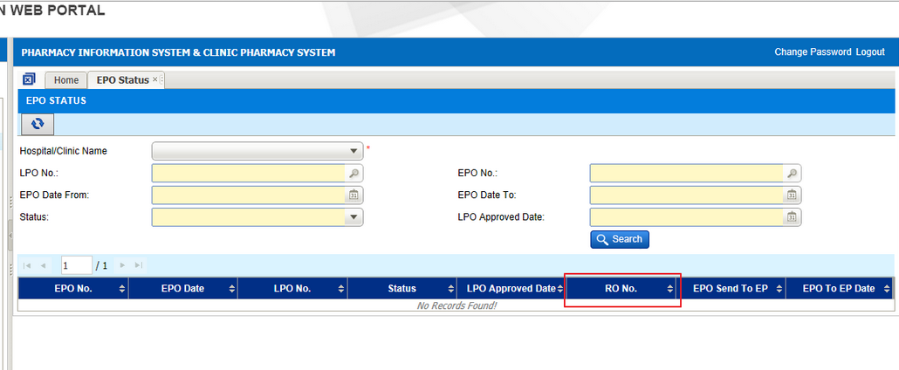

Deployment - Procedures

List of Items to be Deployed
No. | Items | Components | Path
1. | HQ Patch Scripts | PatchScripts_v1.2.2.9.txt | https://10.8.9.130:44330/svn/Workspace_Dataware/31_Implementation/Applications/PhIS Release V.1.2.2.9/hq/Scripts
2. | HQ Application | phishq.war | https://10.8.9.130:44330/svn/Workspace_Dataware/31_Implementation/Applications/PhIS Release V.1.2.2.9/hq/war
3. | HQ Application – JAR | masterRelease_v1.2.2.9.jar | https://10.8.9.130:44330/svn/Workspace_Dataware/31_Implementation/Applications/PhIS ReleaseV.1.2.2.9/hq/jar
4. | Facility Patch Scripts | PatchScripts_PhIS_v1.2.2.9.txt  PatchScripts_v1.2.2.9_HPSF.txt (HPSF only) | https://10.8.9.130:44330/svn/Workspace_Dataware/31_Implementation/Applications/PhIS Release V.1.2.2.9/facility/Scripts
5. | Facility Application | iphis.war | https://10.8.9.130:44330/svn/Workspace_Dataware/31_Implementation/Applications/PhIS Release V.1.2.2.9/facility/war

Backup Procedure before Deploy

Backup Procedure
Using backup tool, backup the following files and folder and database as per table below;
No. | Type | Backup Item | Description
1 | Application | /home/phisesb  /opt/phisesb  /usr/share/fonts/truetype | PhIS Integration Application  PhIS Core Application  Fonts required by PhIS
2 | Database | phisprod database | PhIS Live database

Deployment/Installation Guidelines

Deployment at Facility
Below table is described the deployment steps at Facility:
Step | Items | File Name | Source Path | Action
1 | Facility Patch Scripts | PatchScripts_PhIS_v1.2.2.9.txt  PatchScripts_v1.2.2.9_HPSF.txt (HPSF only) | https://10.8.9.130:44330/svn/Workspace_Dataware/31_Implementation/Applications/PhIS Release V.1.2.2.9/facility/Scripts | Run the scripts @ Postgres DB using PGAdmin
2 | Facility Application | iphis.war | https://10.8.9.130:44330/svn/Workspace_Dataware/31_Implementation/Applications/PhIS Release V.1.2.2.9/facility/war | Deployment @ Both HA Servers

Deployment at HQ - IWP
Below table is described the deployment steps at HQ - IWP:

Step | Items | File Name | Source Path | Action
1 | HQ Patch Scripts | PatchScripts_v1.2.2.9.txt | https://10.8.9.130:44330/svn/Workspace_Dataware/31_Implementation/Applications/PhIS Release V.1.2.2.9/hq/Scripts | Run the scripts @ Postgres DB using PGAdmin
2 | HQ Application | phishq.war | https://10.8.9.130:44330/svn/Workspace_Dataware/31_Implementation/Applications/PhIS Release V.1.2.2.9/hq/war | Deployment @ Both HA Servers
3 | HQ MIMS – JAR | masterRelease_v1.2.2.9.jar | https://10.8.9.130:44330/svn/Workspace_Dataware/31_Implementation/Applications/PhIS ReleaseV.1.2.2.9/hq/jar | copy into /home/phisesb/phisjars folder

