Pharmacy Information System (PhIS)
and
Clinic Pharmacy System (CPS)

Release Note
For version 1.3.4

Version : 1.0
Document ID : PhIS_CPS/ReleaseNote/Refinement/12062015

© 2011-2015 Pharmaniaga Logistics Sdn Bhd (PLSB)

CONFIDENTIAL COPYRIGHTED MATERIAL – The information includes all concepts, comments, recommendations, and material, contained herein shall remain the property of Pharmaniaga Logistics Sdn Bhd (PLSB). No portion of this document shall be disclosed, duplicated or used in whole or in part of any purpose other than the purpose of the Pharmacy Information System & Clinic Pharmacy System (PhIS& CPS) Project execution only.

Revision History

Version No | Date of Release | Prepared by | Reviewed / Verified by | List of changes from Previous Version
1.0 | 12/06/2015 | Kee Tuan Hwa | Chew Ming Ping | First Version

Verified and Acknowledged by:
Name | Role/Designation | Organization | Signature & Date
Chew Ming Ping | Team Leader | Pharmaniaga Logistics Sdn Bhd
Hoh Choon Seng | Project Manager | Pharmaniaga Logistics Sdn Bhd

Name | Role/Designation | Organization | Signature & Date
 |  | Bahagian Perkhidmatan Farmasi (BPF), KKM
 |  | Bahagian Pengurusan Maklumat (BPM), KKM

Peer Review
Version No | Reviewed / Verified by | List Of Changes from Previous Version
1.0 | Juridah (QA) | Initial document

1 Introduction 1
1.1 Project Information 1
1.2 Objectives 1
2 Purpose 2
3 Summary – Refinement and Defect List 3
3.1 Refinement List 3
3.2 Resolved Defect List 6
4 Refinement List – Detail Changes 18
4.1 I-PhIS009794315S 18
4.2 I-PhIS009796315S 18
4.3 I-PhIS009798315S 19
4.4 I-PhIS009557815S 19
4.5 I-PhIS009848315S 20
4.6 I-PhIS010120415S 20
4.7 I-PhIS009571915S 21
4.8 I-PhIS009880315S 21
4.9 I-PhIS009563815S 22
4.10 I-PhIS009746315S 22
4.11 I-PhIS009748615S 24
5 Deployment - Procedures 25
5.1 List of Items to be Deployed 25
5.2 Backup Procedure before Deploy 25
5.2.1 Backup Procedure 25
5.3 Deployment/Installation Guidelines 26
5.3.1 Deployment at Facility 26
5.3.2 Deployment at HQ - IWP 26

Introduction

Project Information

Project ID : | PhIS and CPS
Project Name : | Pharmacy Information System and Clinic Pharmacy System
Version No : | 1.3.4
Client Name : | Ministry of Health
Release ID : | RL15/007
Release Date : | 12/06/2015

Objectives
No. | Objective | Reference
1. | Release PhIS & CPS Application to Facility | Refer Section 3 – Refinement and Defect list

Purpose
The purpose of the document is to update the end-user of the changes and defects have been resolved to be included in the new version of application and will be deployed to production server.
This document outlines the list of request and issue to be delivered in the newer version of application and also the guidelines on how to deploy the new version of application in production.

Summary – Refinement and Defect List

Refinement List

The following refinement tickets to be delivered in PhIS ver 1.3.4.
No | Ticket No. | Facility | Module | Reported Date | Title | Description | Solution | Resolved Date | Verify Status
1 | I-PhIS009794315S | HPSF | General Module | 15/5/2015 | Security-User Role | User request to search by designation at User Role | Change as per request  Refer to 4.1 | 5/6/2015
2 | I-PhIS009796315S | BPF | General Module | 15/5/2015 | Inventory - Unit Catalogue External Facility | User request to remove stock available column because not applicable. User : Fayizatul report date : 9/4/15 | Change as per request  Refer to 4.2 | 9/6/2015
3 | I-PhIS009798315S | HPSF | General Module | 15/5/2015 | Security - User Profile | User Profile - Request to search by designation Reported By: Noraini Reported Date:14/4/15 | Change as per request  Refer to 4.3 | 5/6/2015
4 | I-PhIS009557815S | BPF | IWP | 27/4/2015 | IWP/HQ Maintenance (IWP/HQ Vote Code screen) | User request changes on the Vote Code screen at IWP/HQ | Change as per request  Refer to 4.4 | 11/6/2015
5 | I-PhIS009848315S | HPSF | MAR - Web | 18/5/2015 | MAR-Medication Chart - update format. | User Request to update medication chart based on nurse feedback from 1.3.1 release. 1. To remove split line in medication date column (for admin/witness column) 2. Bold the details column 3. Bold the frequency value 4. Bold the '(WS)' 5. Sort by created date. | Change as per request  Refer to 4.5 | 20/5/2015
6 | I-PhIS010120415S | BPF | Patient Management | 3/6/2015 | Patient Registration - remove default of gender field | User request to remove default of gender field after keyed in IC no do not default gender, let user to fill in | Change as per request  Refer to 4.6 | 9/6/2015
7 | I-PhIS009571915S | JKWP | Pharmacy Inventory | 27/4/2015 | Contact Facility - To add 'Drug/Non Drug Description' at the Contract Facility listing page | To add 'Drug/Non Drug Description' at the Contract Facility listing page. | Change as per request  Refer to 4.7 | 4/6/2015
8 | I-PhIS009880315S | KKGT | Pharmacy Inventory | 20/5/2015 | External Indent - Option for FLK in not appear in the system | Option for FLK is not appear in the system to do External Indent. Only option for Clinic & Hospital are appear in the system. Staff id:721126086226 Incident time:10.00am | Change in coding to add PKD and MUSB into the external indent selection.  Refer to 4.8 | 20/5/2015
9 | I-PhIS009563815S | HRC | Report/Enquiry | 27/4/2015 | Budget Movement- To select multiple choice for 'Transaction Type' | For report purpose, if user need to gather information regarding how much the total amount of RM received, they need to add in several types of Transaction Type. E.g: Allocation + Virement In | Change as per request  Refer to 4.9 | 29/5/2015
10 | I-PhIS009746315S | BPF | Report/Enquiry | 13/5/2015 | Inventory - Ward Stock Report | Report layout 1. remove 'Item sub group' 2. rename 'total cost (RM) to 'Total Issue Amount (RM)' 3. format report follow the standard at footer section make it in line (1 line) and font size 6 3. content section make it font size = 8 follow the standard format 4. Total section at the bottom make it bold Reported Date: 14/04/2015 | Change as per request  Refer to 4.10 | 25/5/2015
11 | I-PhIS009748615S | BPF | Report/Enquiry | 13/5/2015 | Inventory - Issue Report | Report layout 1. Add on Supplying Unit at the bottom of Item Group 2. Type rename to 'Transaction Type' 3. Add on Item Class next to 'Item group' on top 4. Format report follow the standard at footer section make it in line (1 line) and font size 6 5. Content section make it font size = 8 follow the standard format 6. Total section at the bottom make it bold | Change as per request  Refer to 4.11 | 27/5/2015
12 | I-PhIS009750415S | BPF | Report/Enquiry | 13/5/2015 | Inventory - Ward Stock Report | Listing page 1.Dispense From' need to have search function. 2. In the last page required to have:- a. total No of Item b. Total Issue Amount (RM) | Change as per request  Refer to 4.10 | 25/5/2015
13 | I-PhIS009752615S | BPF | Report/Enquiry | 13/5/2015 | Inventory - Ward Stock Report | This report should be open to all level (level 1, 2 & 3). | Change as per request  Refer to 4.10 | 25/5/2015

Verified and Acknowledged By:
Signature: |  | Name:
Date: |  | Designation:

Signature: |  | Name:
Date: |  | Designation:

Resolved Defect List
The following are the summary of resolved defect list that included in PhIS and CPS version 1.3.4.
No | Ticket No. | Facility | Module | Reported Date | Description | Additional Information | Root Caused | Resolved Date | Verify Status
1 | I-PhIS009928315S | HTM | General Module | 25/5/2015 | User unable to activate department Nephrology, field cannot be active,even click edit. User id: 870202146112 Incident time : 10.00am |  | System allow user to change the department = Inactive. | 3/6/2015
2 | I-PhIS010128415S | KKGT | General Module | 3/6/2015 | User reported Absolute Qty setting different as before that user already set in Drug Master. User claimed effect to almost all items that user already set. User ID: 721126086226 Time Incident: 12.00 pm |  | Same columns maintained HQ earlier v12.3 version, latest moved to facility to maintain, but the cols not removed from IWP production. | 4/6/2015
3 | I-PhIS009870315S | HTM | Inpatient Pharmacy | 20/5/2015 | User reported in fill list function she detect medication of patient was duplicate. MRN No. HTM00007531. | Require patch data | Because duplicated dispensing | 11/6/2015
4 | I-PhIS009986315S | HSM | Inpatient Pharmacy | 28/5/2015 | User give partial supply for drug Tinzaparin, supplying drug is fine from 25/5 until 27/5. But today the patient prescription are not found in Preparation as usual. Not found in other screen too. ID user: Time incident: 10 AM | 811129115386 HSM00074052 | Screen Display & User Interface Error. Earlier Scheduler has an issue, it was updating queues to Inactive even if at least 1 drug is expired among all the drugs. For given medication Order, some of the drugs were expired on 28th so all queues related to that order becomes Inactive. | 11/6/2015
5 | I-PhIS010033215S | HPSF | Inpatient Pharmacy | 31/5/2015 | User reported partialy dispense status prescription appeared in all stage inpatient transaction. Username : Noraini bt Saari ID : 750214015762 | This issue found out at testing server PhIS Version 1.3.3 | Multithreading in coding issue | 11/6/2015
6 | I-PhIS010046415S | HSM | Inpatient Pharmacy | 1/6/2015 | User reported she can't find prescription for 5 patient at screen preparation or dispensing. Prescription status for all drug is either verified or prepared. User: Murni Bt. Hamil ID: 851028075692 Patient: 1) Sitti Peldam Bt Abdua - HSM00074232 2) Noraishah Bt. Majid - HSM00074602 3) Siti Zarifah Binti Ramli - HSM00074481 4) Norshahera Bt. Roni - HSM00014169 5) Royahida Bt Mad Daros - HSM00074457 |  | 2 cases actually are out patient, I think user has mistake to find in inpatient screens 1 case is stop/discontinue or fully can't check 2 cases are expired when I checked today. | 9/6/2015
7 | I-PhIS009938315S | BPF | IWP | 25/5/2015 | User reported for new contract, she able to select all facility but the data not in the list after click save button. User need to select the facility one by one. Contract No: KKM-60/2015/F(U) & KKM-26/2015/F(U) | check and found save button not function | Unable to add facility on click of all facility. We only check combobox select index null or not, its hitting error if selected value is null | 25/5/2015
8 | I-PhIS010234315S | JKWP | IWP | 10/6/2015 | When click on the main menu, automatically hit this error |  | Tatus Band Box got issue on loading, because of this error all hit error | 11/6/2015
9 | I-PhIS010238315S | JKWP | IWP | 10/6/2015 | Suppose when search the LPO No should only display all the transaction for transaction that have been done which is refer to the user PTJ Code. Currently display all the transaction for all PTJ. |  | ptjcode criteria was missed out on lpo search bandbox | 11/6/2015
10 | I-PhIS010032315S | HPSF | MAR - Web | 31/5/2015 | User reported on MAR screen stat frequancy dosage become double surve on MAR record. Reported By:Noraini bt Saari User Id: 750214015762 | This issue have be found under testing server for Phis v1.3.3. | Dr Ibrahim have 2 prescriber record in Prescriber screen master. Which means, two user is using the same user ID. Dr Ibrahim and Azizah. This problem cause MAR screen to display double record. | 4/6/2015
11 | I-PhIS010086315S | HTM | Order Management - Web | 1/6/2015 | User reported when Doctor confirm order for Normal Order an error "Error processing your request!. Please contact system admin" was prompted. User : DR SITI NUR ADNI BT MOHD ALI ID : 850807035898 Time : 2.00 pm, 31/05/15 |  | Duplicate Row in Mims Mapping | 1/6/2015
12 | I-PhIS009670215S | HPSF | Outpatient Pharmacy | 7/5/2015 | User reported prescribed status partially dispensed disappeared from Screening & verification screen for patient : HPSF00066853, HPSF00038125, HPSF00014422, HPSF00025216, HPSF00031839, HPSF00045428 & HPSF00015982 User: Siti Aisyah binti Mohd Roslan ID: 810108145418 |  | Data & Data Type Error. Due to schedule misbehaviour some of queues are gone in inactive status | 27/5/2015
13 | I-PhIS009675815S | KKGT | Outpatient Pharmacy | 7/5/2015 | "User click button ""confirm"" error ""Please contact administrator"" appear. Step 1: Search patient at screen medication return Step 2: Click patient and then screen medication return appear. Step 3: Click button""confirm""." ID : 840528085914 Time : 8.26AM | KKE08004500011148 | Formula and Logic issue | 4/6/2015
14 | I-PhIS009728715S | HPSF | Outpatient Pharmacy | 12/5/2015 | User reported after renew presricption and click confirm popup "please contact administrator" and save prescription as draft. Its happen when status ordered = ordered / hold. No attachment, user already confirm order after identify ther problem, advice user stop drug status = ordered/hold and prescribe new. MRN : HPSF00090845 Patient Name : Che Mah Binti Md Johar Steps: -User Renew Rx for drug status as Ordered/Hold -The drugs appear into Normal Order screen as usual -Click Confirm -HIT ERROR Please contact system admin -(Cannot confirm due to error) -Rx become status as a draft ID: 860928045063 time: 2.50pm | Patient name not included. | The order details for drug gentamicin is too long, that when confirm order, the order is not confirmed properly and stay as draft | 25/5/2015
15 | I-PhIS009728815S | HPSF | Outpatient Pharmacy | 12/5/2015 | User reported Unable to find prescription after prepare stage. Status prescription = PREPARED Discharge Medication = yes. Steps :- 1) Pharmacy Transaction 2) Outpatient 3) Dispensing Patient name : Rositah Binti Abdullah MRN No : HPSF00006502 User ID : 810108145418 Time Happen : 1.21 PM |  | Code handled wrong location setup then cause the error but that error isn't displayed, then user don't know about it | 2/6/2015
16 | I-PhIS009774315S | HKulim | Outpatient Pharmacy | 14/5/2015 | User reported cannot hold and allocate drug at preparation screen.when user click allocate popup error "Insunfficient balance" and when click reserve quantity "0" popup item screen base detail, batch NO not have a detail.L15 Drug :Betamethasone valerate 1 in 4 cream.This happen for 2 patient Tan Ah Bin and Rosli B Abd Rahim Reported By: Nur Husna Time Incident Happen: 3.25 Location: Outpatient Pharmacy User Id: 871231146132 |  | code didn't handle this case before | 9/6/2015
17 | I-PhIS009808315S | HSM | Outpatient Pharmacy | 15/5/2015 | User reported that shes not found prescription for 2 patient at screen screening and verification. The drug status for this 2 patient is partially dispensed. She also search at another screen which is screen acknowledgement, preparation and dispensing but not found it either. User: Leow Sheh Leng (Pharmacist) I/D Number: 870908025830 Location: Outpatient Pharmacy |  | Data & Data Type Error. Scheduler was updating queqe to inactive | 9/6/2015
18 | I-PhIS009908315S | KKBM | Outpatient Pharmacy | 21/5/2015 | User reported user allocated drug for 30days but system automatically allocated dossage for fully dispense. ID : 830424105432 Time : 3.00PM |  | auto allocation calculation wrong. supply Duration calculation was incorrect | 25/5/2015
19 | I-PhIS009914615S | HPSF | Outpatient Pharmacy | 22/5/2015 | User reported after click direct print button, error contact administrator appeared. Username : Mohd Fauzan bin Sahimi ID : 870606355279 Patient MRN - HPSF00034627 STage - single stage at 1.2.3 |  | Code error was in auto allocation function. because of that label was not printing. | 25/5/2015
20 | I-PhIS009966315S | HKulim | Outpatient Pharmacy | 27/5/2015 | User reported patient didn't flow to any screen. User do normal order transcribing but when she check at acknowledgment screen, screening and verification screen, preparation screen and dispensing screen, it's not exist. Patient Name 1 : Chua Chye Lan MRN : HKLM00069242 Time Incident Happen: 4.30 PM User Id: 871231146132 |  | Dispensing and dispense normal are not created when we do partialy dispensed. | 27/5/2015
21 | I-PhIS009972315S | KK Bakri | Outpatient Pharmacy | 27/5/2015 | User reported that can't to allocate and dispense because of wrong drug status. MRN Patient : KKE01003100008271 ID Patient : 940503015256 Patient Name : NUR HUSNIZA User ID: 860921235454 Time incident: 04.10 p.m |  | Screen Display & User Interface Error | 5/6/2015
22 | I-PhIS009982315S | HSM | Outpatient Pharmacy | 28/5/2015 | User cannot acknowledge for patient at acknowledgement screen. One of the drug doesnt appear on the screen and message appear, 'could not initialize proxy - no session'. An error popup , 'An error has occurred. Please contact your system administrator', appear. Patient: : Nurul Atieyyah Bt Zulkafli IC: 060718030028 MRN: HSM00039535 Missing drug: Diphenhydramine HCI Expectorant (Paediatric) 7mg/5ml(Taper Down) ID: 850811055040 Date: 27/05/2015 time: 9.15pm |  | Screen Display & User Interface Error.; For taper drugs fetches was not added for Drug Route | 10/6/2015
23 | I-PhIS010032415S | HPSF | Outpatient Pharmacy | 31/5/2015 | User report after click prepared and tick check box proceed to dispense, status won't change to "prepared" Id: 810108145418 | This issue found on testing server for version 1.3.3 | Due to multi threading method for performance function. | 12/6/2015
24 | I-PhIS010032515S | HPSF | Outpatient Pharmacy | 31/5/2015 | User reported Metformin & acetyl available qty is still have a value but turn into red color. User : Siti Aisyah binti Mohd Roslan ID : 810108145418 | This issue have be found under HPSF testing server for v1.3.3. | Data & Data Type Error | 9/6/2015
25 | I-PhIS010032715S | HPSF | Outpatient Pharmacy | 31/5/2015 | User reported, done tick patient arrived at dispensing stage. But pop up appeared ask user to enter patient arrived details. Id:810108145418 | This issue found on Testing Server for PhIS version 1.3.3 | Arrival was checking on java object rather than actual value | 1/6/2015
26 | I-PhIS010044315S | HSM | Outpatient Pharmacy | 1/6/2015 | User reported shes not found prescription at screen acknowledgement for patient Othman Bin Ahmad, MRN HSM00005881. At screen medication profile, all drug status for this patient is ordered where his prescription is supposed to be found at screen acknowledgment or screening and verification when user search. User: ERIN BT. AZMEE ID : 830821105444 |  | I see that we still can search this patient, pls check my attachment image. | 9/6/2015
27 | I-PhIS010070315S | KKGT | Outpatient Pharmacy | 1/6/2015 | At clinical summary the drug status already prepared, but at dispensing stage the status changed into ordered and user can't dispense the drug because of this. ID : 871112086114 Time : 12.59pm |  | status of between order_normal and dispense_normal is not synchronization | 9/6/2015
28 | I-PhIS010110315S | KKGT | Outpatient Pharmacy | 2/6/2015 | User alternate drug Diphenhydramamine HCI Expecctorant (Adult) to Diphenhydramamine HCI Expecctorant (Paed) 7mg/5ml. After allocate drug quantity, user click save button but pop up an error "Allocation quantity cannot more than Available quantity" but the amount of drug in stock a lot. Time Incident Happen: 07:00PM User Id: 831213085587 |  | Screen Display & User Interface Error. On Blur function of supply duration was missing to check of checkbox whether it is checked or not | 5/6/2015
29 | I-PhIS010130315S | KKGT | Outpatient Pharmacy | 3/6/2015 | Cannot find drug on release batch Screen but the drug is appear at Dispense Screen as Uncollected status PT NAME : LAM MOOI MRN : KKE08004500007518 User id: 890107086148 Incident time: 1.39pm | fixed | Data & Data Type Error | 12/6/2015
30 | I-PhIS010134315S | HKulim | Outpatient Pharmacy | 4/6/2015 | User reported patient didn't flow to any screen. She do normal order transcribing She try to check at acknowledgment screen, screening and verification screen, preparation screen and dispensing screen but it's not exist. Patient Name 1 : Zainab Abdullah (HKLM00067136) Patient Name 2 : Yaziz Bin Hashim Sub Module : Outpatient (Acknowledgement - Screening and Verification - Preparation - Dispensing) User id : 871231146132 Time : 04.30 PM |  | Data & Data Type Error. For both of above orders 1 of drug was expired, and previously we have bug in scheduler which was updating queue's and dispesning to close even if one drug expires. | 11/6/2015
31 | I-PhIS010170415S | KKGT | Outpatient Pharmacy | 5/6/2015 | Patient pescription data cannot be found at Dispensing. At clinical summary the prescription status is Prepared. Already test check at all stage and search by name but still cannot found. MRN : KKE08004500049935 MRN : KKE08004500010362 ID: 871112086114 time: 10.20am | Patch Data is required | Data & Data Type Error  Issue was created in1.2.3.x | 12/6/2015
32 | I-PhIS010188315S | KKGT | Outpatient Pharmacy | 7/6/2015 | User want to alternate drug Diphenhydramine HCI Expectorant (adult) to Diphenhydramine HCI Expectorant (Paediatric) 7mg/5ml. User click alternate and enter quantity per dose and save it. All allocation quantity automatically become 100 . It also happen when user want to alternate Diphenhydramine HCI Expectorant (Paediatric) 7mg/5ml to Diphenhydramine HCI Expectorant (adult). PT NAME : MUHAMMAD SYAWAL ADIB MRN : KKE08004500023046 Time incident happened : 11.39 AM User ID : 890107086148 |  | Screen Display & User Interface Error. On Blur function of supply duration was missing to check of checkbox whether it is checked or not | 11/6/2015
33 | I-PhIS010198315S | KKGT | Outpatient Pharmacy | 8/6/2015 | Patient cannot find at Acknowledgment screen. Verified that the patient status is Partially Dispense User: SHERDILA BAIZURA BT KAMARUL ZAMAN ID: 871112086114 Time Incident Happen: 11.26 am | Patch Data is required | Data & Data Type Error | 12/6/2015
34 | I-PhIS010200315S | KKGT | Outpatient Pharmacy | 8/6/2015 | Cannot find patient at Release Batch screen. Verified patient drug status is Uncollected MRN : KKE08004500027177 Name : SHERDILA BAIZURA BT KAMARUL ZAMAN User : 871112086114 Incident Time : 10.30 am | Patch Data is required | Data & Data Type Error | 12/6/2015
35 | I-PhIS010206315S | KKGT | Outpatient Pharmacy | 8/6/2015 | Pop up shows No allocation done but the drug is already allocated with alternate drug Drug : Perindopril 8mg Name : NURLIYANA HUDA User : 890906085360 Time Incident : 11.00 am | Patch Data is required | Data & Data Type Error | 12/6/2015
36 | I-PhIS009978315S | KKGT | Pharmacy Inventory | 27/5/2015 | User reported that, she already do stock adjustment and save it. But she found out that some file are missing, one of that is : SA15000060. |  | Same as previous ticket (I-PhIS009828715S). The adjustment record missing in listing screen due to exception error appear while saving and deleting record when user add more than 10 items in adjustment screen. The error was fix in latest version (1.3.3). User are able to add more than 10 item. | 28/5/2015
37 | I-PhIS009980315S | HKulim | Pharmacy Inventory | 28/5/2015 | User reported after he do adjustment stock suppose to be stock will be zero. But when he check at "stock balance by item" screen stock still have available. User id : 760707136019 Time : 10.45 AM Item : B02AA02000P3001XX.01 |  | The item which have more than 1 batch cause the error. When all the batch have added in 1 single adjustment record, system not updated in Stock balance by item report. | 4/6/2015
38 | I-PhIS010032815S | HPSF | Pharmacy Inventory | 31/5/2015 | User reported PO screen can't close, always pop up contact administrator and after click ok won't close and need to prees F5 each time to go another module. Reported By: Noraini bt Saari User ID: 750214015767 | This issue have be found under HPSF testing server for v1.3.3. | 1.3.3 structure missing few ref codes and messages | 2/6/2015
39 | I-PhIS010144315S | HPSF | Pharmacy Inventory | 4/6/2015 | When select the requester unit as FKP Filling Station and select item group as Drug then system will prompt error Contract System Admin |  | C2-INT005504315B this ticket already fixed and verified by qc | 4/6/2015
40 | I-PhIS010152315S | HSM | Pharmacy Inventory | 4/6/2015 | User reported that, system generate duplicate item after generate issue note. Issue No - 1)F02FBW-0002120 2)F02FBW-0002112 User id: 910409106146 |  | possibility due to while too many transaction approved at 1 time it will impact on the item details. | 4/6/2015
41 | I-PhIS010160415S | HSM | Pharmacy Inventory | 4/6/2015 | User reported stock adjustment still not change after adjust. Details as below: 1) Morphine Sulphate 10mg: Transaction ISSUE on(29/5/2015) good stock before is (637) with transaction on quantity (7) but suddenly in transaction ADJUSTMENT (1/6/2015) total good stock before become (891). 2) Dihydrocodeine Bitartrate 30mg Tab good stock didnt change even after adjustment. From 528 46 = 482, so the next good stock value should be 482 but it still using the previous value 528. Please refer attachment for details. User ID: 860716335528 Time incident: 2.30AM |  | The issue are fixed in latest version 1.3. | 9/6/2015
42 | I-PhIS010108315S | KKGT | Report/Enquiry | 2/6/2015 | User already fill up KPI 2(b) detail, then when user click search button it appear an error "An error has occurred. Please contact your system administrator". User try to change the other date but still pop up error. Date from: 01/05/2015 Date to: 31/05/2015 id: 640923025253 time: 3.00pm date: 1/6/2015 |  | Missing Columns total_waiting_time,pres_less_30m | 4/6/2015
43 | I-PhIS010118315S | HSM | Report/Enquiry | 3/6/2015 | User reported that item movement not tally between physical and system. Physical item : 7000 Move outi item :3600 In system : 6000 Item code - C09DB04935T1002XX.01 |  | The issue are fixed in latest version 1.3. | 9/6/2015
44 | I-PhIS010174315S | H Kapit | Report/Enquiry | 5/6/2015 | Pharmacist already select outsource to send sample and send it. When trace back in reporting no sample details found in TDM Add Results screen. ( Scenario online | Offline). Outsource sent in both ways, transcribe until outsource and from clinical menu. |  | Formula & Program Logics Error | 9/6/2015
45 | I-PhIS010212315S | KKGT | Report/Enquiry | 8/6/2015 | User reported appear error "Please contact system admin" at KP!2(b) screen. User : GANESAN ID : 640923025253 Time Incident Happen : 02.00 pm |  | Missing Columns total_waiting_time,pres_less_30m | 11/6/2015

Verified and Acknowledged By:
Signature: |  | Name:
Date: |  | Designation:

Signature: |  | Name:
Date: |  | Designation:

Refinement List – Detail Changes

I-PhIS009794315S
Module | Reported Date | Title | Description | Solution
General Module | 15/5/2015 | Security-User Role | User request to search by designation at User Role | Change as per request

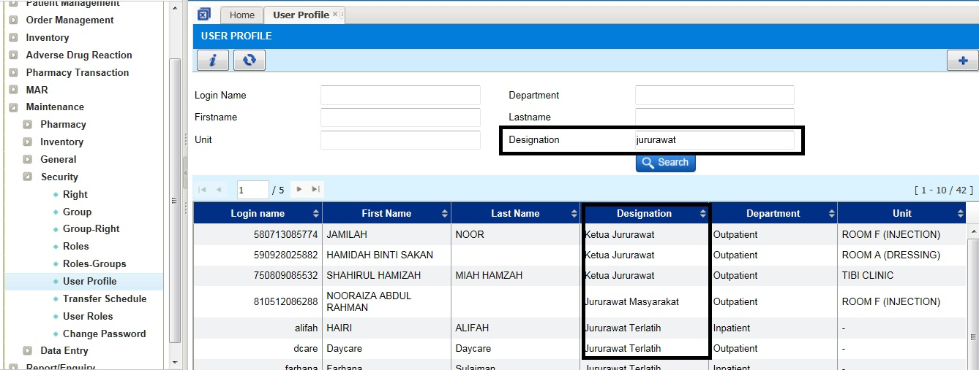

I-PhIS009796315S
Module | Reported Date | Title | Description | Solution
General Module | 15/5/2015 | Inventory - Unit Catalogue External Facility | User request to remove stock available column because not applicable. User : Fayizatul report date : 9/4/15 | Change as per request

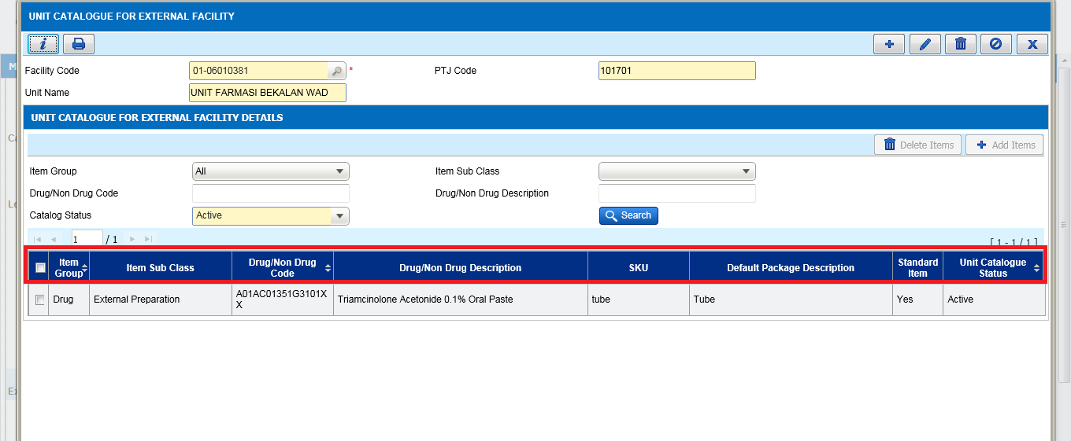

I-PhIS009798315S
Module | Reported Date | Title | Description | Solution
General Module | 15/5/2015 | Security - User Profile | User Profile - Request to search by designation Reported By: Noraini Reported Date:14/4/15 | Change as per request

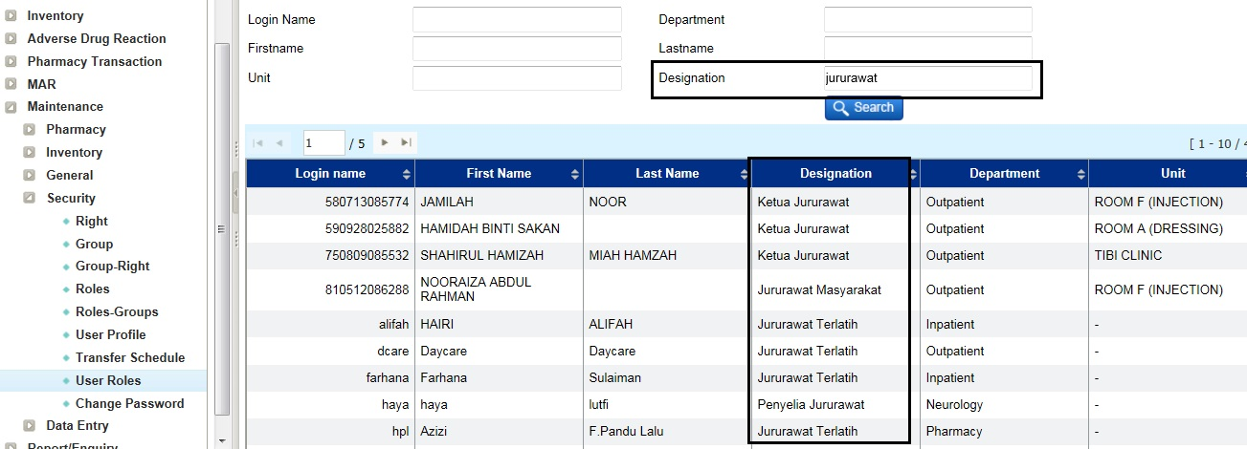

I-PhIS009557815S
Module | Reported Date | Title | Description | Solution
IWP | 27/4/2015 | IWP/HQ Maintenance (IWP/HQ Vote Code screen) | User request changes on the Vote Code screen at IWP/HQ | Change as per request

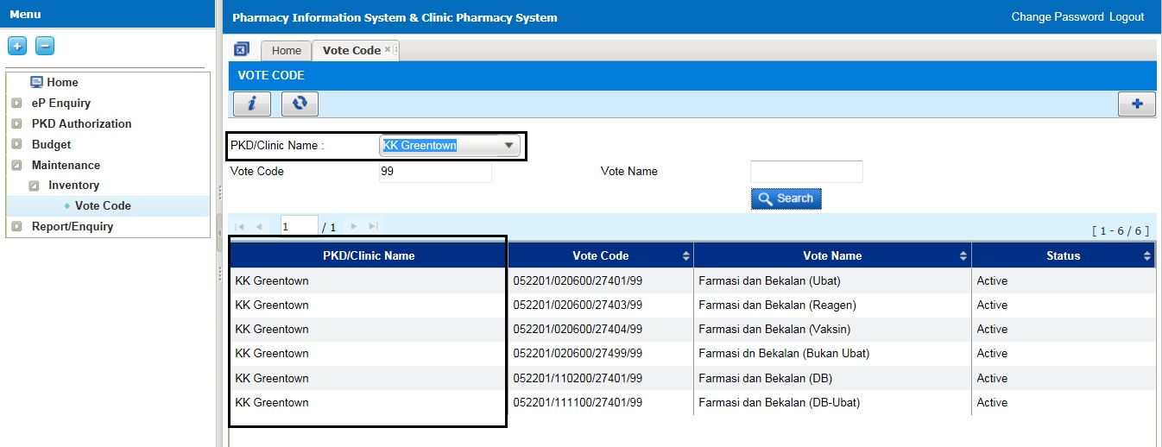

I-PhIS009848315S
Module | Reported Date | Title | Description | Solution
MAR - Web | 18/5/2015 | MAR-Medication Chart - update format. | 1. To remove split line in medication date column (for admin/witness column) 2. Bold the details column 3. Bold the frequency value 4. Bold the '(WS)' 5. Sort by created date. | Change as per request

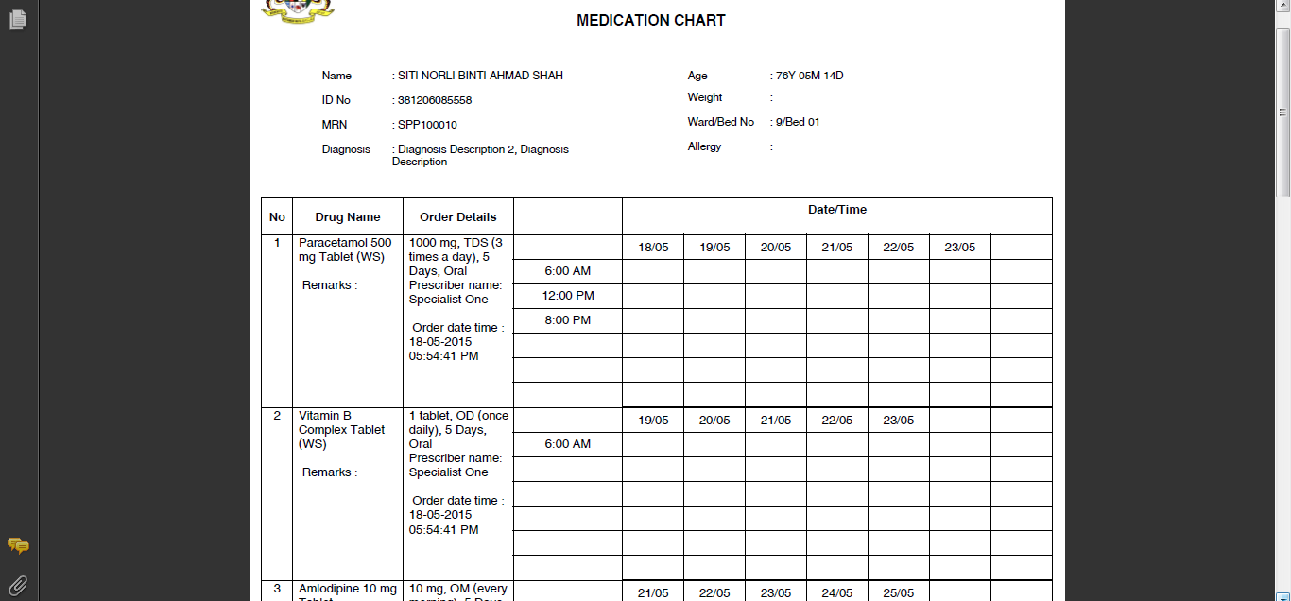

I-PhIS010120415S
Module | Reported Date | Title | Description | Solution
Patient Management | 3/6/2015 | Patient Registration | User request to remove default of gender field after keyed in IC no do not default gender, let user to fill in | Change as per request

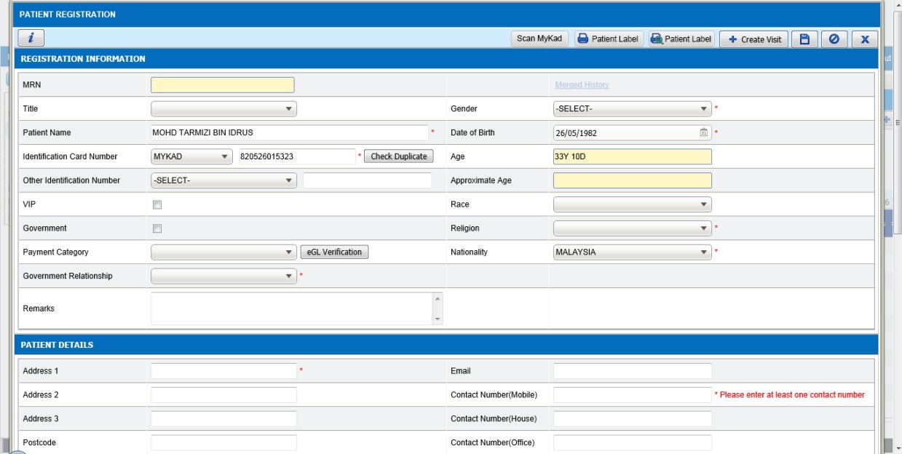

I-PhIS009571915S
Module | Reported Date | Title | Description | Solution
Pharmacy Inventory | 27/4/2015 | Contact Facility | To add 'Drug/Non Drug Description' at the Contract Facility listing page. | Change as per request

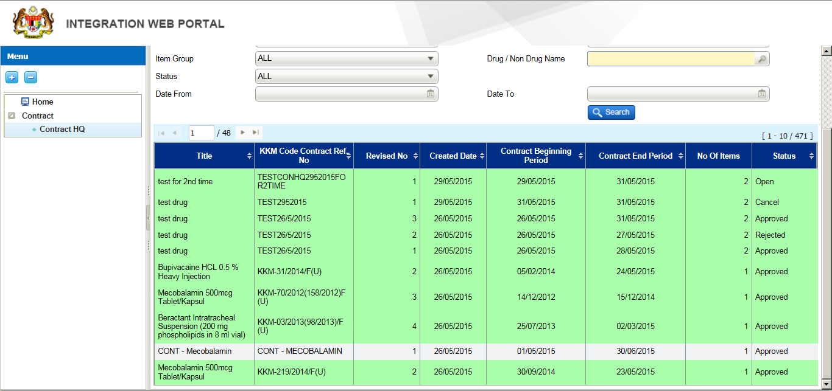

I-PhIS009880315S
Module | Reported Date | Title | Description | Solution
Pharmacy Inventory | 20/5/2015 | External Indent - Option for FLK in not appear in the system | Option for FLK is not appear in the system to do External Indent. Only option for Clinic & Hospital are appear in the system. Staff id:721126086226 Incident time:10.00am | Change in coding to add PKD and MUSB into the external indent selection.

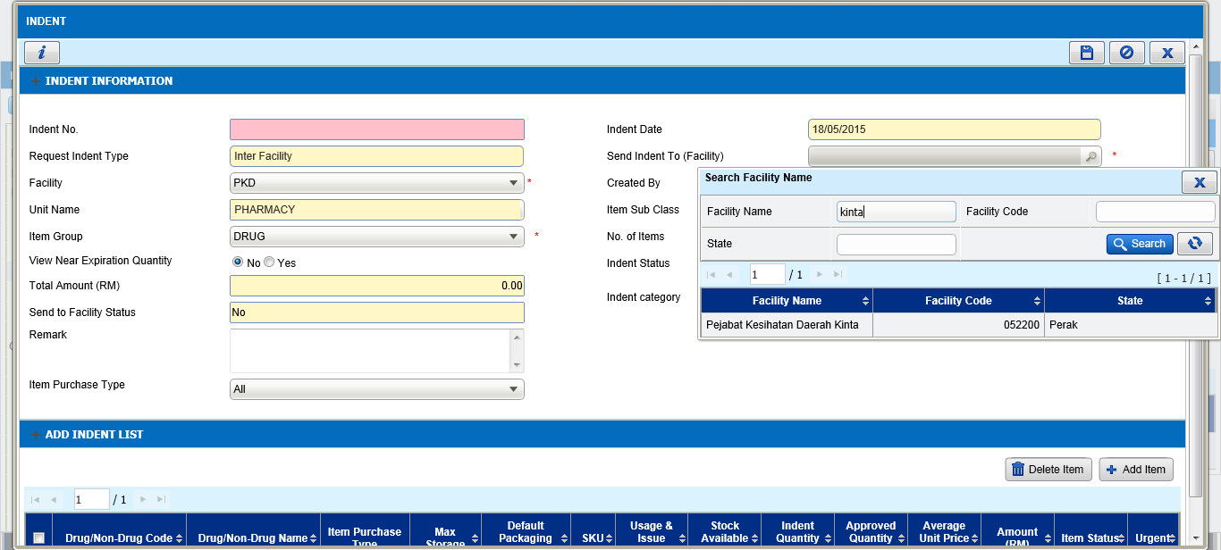

I-PhIS009563815S
Module | Reported Date | Title | Description | Solution
Report/Enquiry | 27/4/2015 | Budget Movement- To select multiple choice for 'Transaction Type' | if user need to gather information regarding how much the total amount of RM received, they need to add in several types of Transaction Type. E.g: Allocation + Virement In | Change as per request

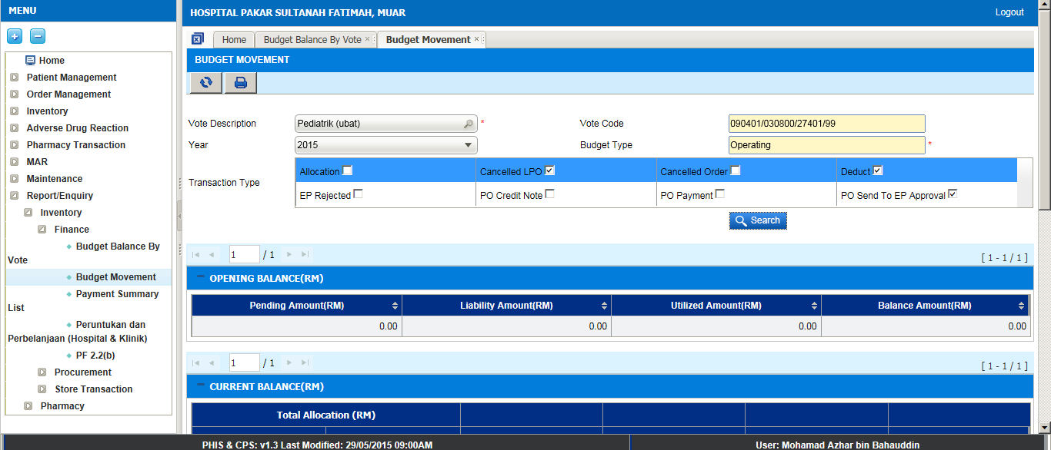

I-PhIS009746315S
Module | Reported Date | Title | Description | Solution
Report/Enquiry | 13/5/2015 | Inventory - Ward Stock Report | Report layout 1. remove 'Item sub group' 2. rename 'total cost (RM) to 'Total Issue Amount (RM)' 3. format report follow the standard at footer section make it in line (1 line) and font size 6 3. content section make it font size = 8 follow the standard format 4. Total section at the bottom make it bold Reported Date: 14/04/2015 | Change as per request
Report/Enquiry | 13/5/2015 | Inventory - Ward Stock Report | Listing page 1.Dispense From' need to have search function. 2. In the last page required to have:- a. total No of Item b. Total Issue Amount (RM) | Change as per request
Report/Enquiry | 13/5/2015 | Inventory - Ward Stock Report | This report should be open to all level (level 1, 2 & 3). | Change as per request

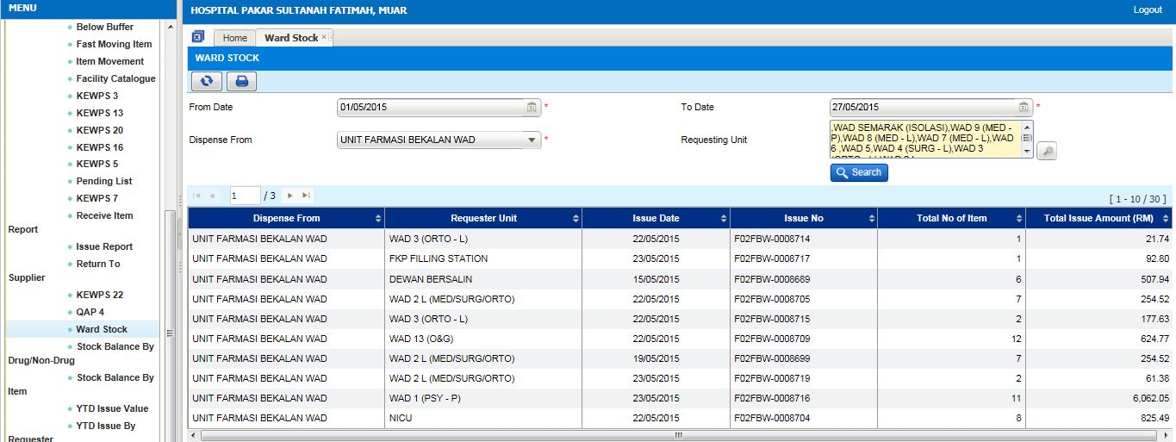
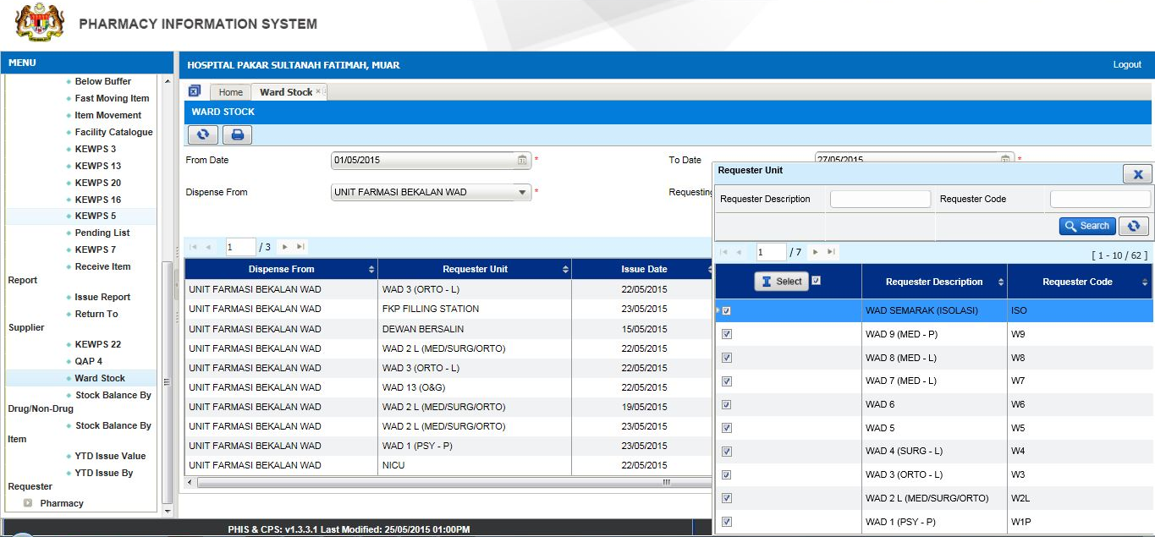

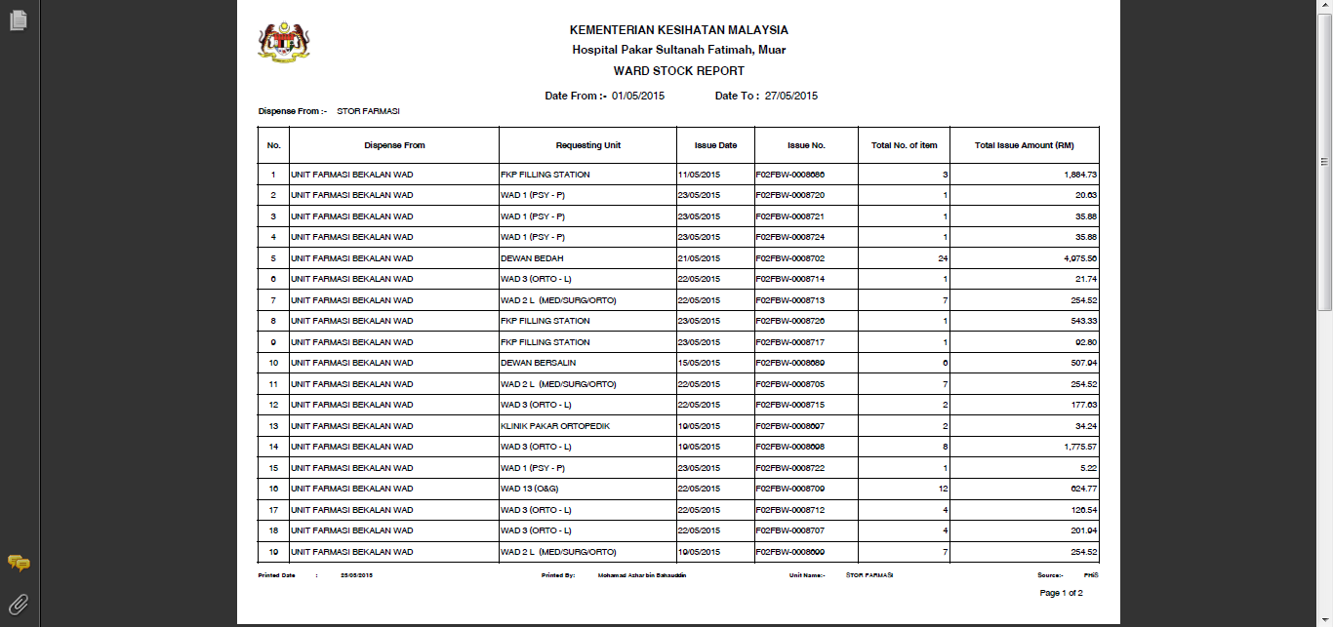

I-PhIS009748615S
Module | Reported Date | Title | Description | Solution
Report/Enquiry | 13/5/2015 | Inventory - Issue Report | Report layout 1. Add on Supplying Unit at the bottom of Item Group 2. Type rename to 'Transaction Type' 3. Add on Item Class next to 'Item group' on top 4. Format report follow the standard at footer section make it in line (1 line) and font size 6 5. Content section make it font size = 8 follow the standard format 6. Total section at the bottom make it bold | Change as per request

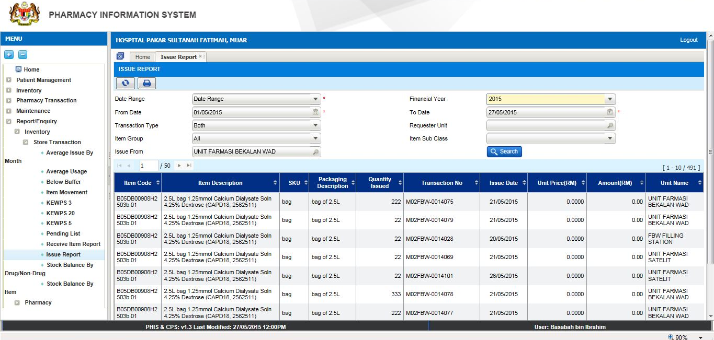

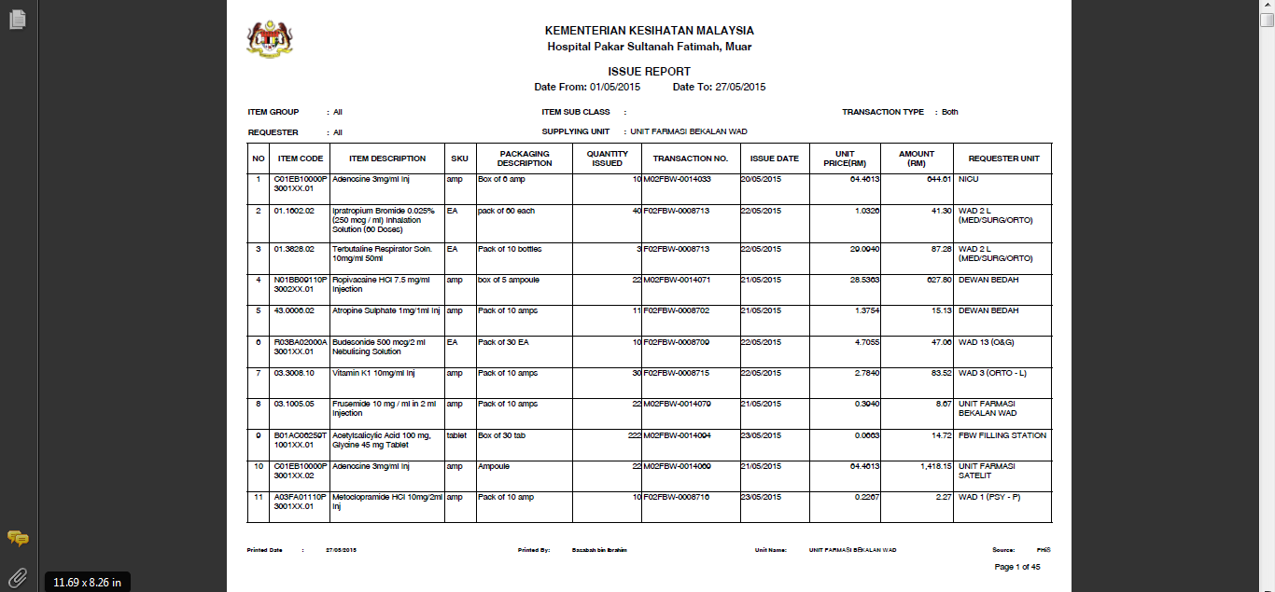

Deployment - Procedures

List of Items to be Deployed
No. | Items | Components | Path
1 | HQ Patch Script | PatchScripts_IWP_v1.3.4.txt | https://10.8.9.130:44330/svn/Workspace_Dataware/31_Implementation/Applications/PhIS ReleaseV1.3.4/hq/scripts
2 | HQ Application | phishq_v1.3.4.war | https://10.8.9.130:44330/svn/Workspace_Dataware/31_Implementation/Applications/PhIS ReleaseV1.3.4/hq/war
3 | HQ Application | epservice_v1.3.4.war | https://10.8.9.130:44330/svn/Workspace_Dataware/31_Implementation/Applications/PhIS ReleaseV1.3.4/hq/war
4 | Facility Patch Script | PatchScripts_PhIS_v1.3.4.txt  PatchScripts_PhIS_v1.3.4_DataPatch.txt  PatchScripts_PhIS_v1.3.4_HKM.txt PatchScripts_PhIS_v1.3.4_HTM.txt  PatchScripts_PhIS_v1.3.4_KKGT.txt | https://10.8.9.130:44330/svn/Workspace_Dataware/31_Implementation/Applications/PhIS ReleaseV1.3.4/facility/scripts
5 | Facility Application | iphis_v1.3.4.war | https://10.8.9.130:44330/svn/Workspace_Dataware/31_Implementation/Applications/PhIS ReleaseV1.3.4/facility/war
6 | Mobile Application | ipadhosp-1.4.0b26-PhISDS.war | https://10.8.9.130:44330/svn/Workspace_Dataware/31_Implementation/Applications/PhIS ReleaseV1.3.4/Mobile

Backup Procedure before Deploy

Backup Procedure
Using backup tool, backup the following files and folder and database as per table below;
No. | Type | Backup Item | Description
1 | Application | /home/phisesb  /opt/phisesb  /usr/share/fonts/truetype | PhIS Integration Application  PhIS Core Application  Fonts required by PhIS
2 | Database | phisprod database | PhIS Live database

Deployment/Installation Guidelines

Deployment at Facility
Below table is described the deployment steps at Facility:
Step | Items | File Name | Source Path | Action
1 | Facility Patch Script | PatchScripts_PhIS_v1.3.4.txt  PatchScripts_PhIS_v1.3.4_DataPatch.txt  PatchScripts_PhIS_v1.3.4_HKM.txt PatchScripts_PhIS_v1.3.4_HTM.txt  PatchScripts_PhIS_v1.3.4_KKGT.txt | https://10.8.9.130:44330/svn/Workspace_Dataware/31_Implementation/Applications/PhIS ReleaseV1.3.4/facility/scripts | Please ensure all the script is execute before iphis.war deploy.  Please ensure the script is executed in sequence. Script files 1 & 3 Execute as pgScript and other two Run as highlight the Script and press (F5)
2 | Facility Application | iphis_v1.3.4.war | https://10.8.9.130:44330/svn/Workspace_Dataware/31_Implementation/Applications/PhIS ReleaseV1.3.4/facility/war | Please rename the war file from iphis_v1.3.4.war to iphis.war then deploy.
3 | Mobile Application | ipadhosp-1.4.0b26-PhISDS.war | https://10.8.9.130:44330/svn/Workspace_Dataware/31_Implementation/Applications/PhIS ReleaseV1.3.4/Mobile | Rename ipadhosp-1.4.0b16-PhISDS.war to ipadhosp.war and deploy.  Frontend Apps: 1.4.0r1t26  Backend Apps: 1.4.0b26

Deployment at HQ - IWP
Below table is described the deployment steps at HQ - IWP:

Step | Items | File Name | Source Path | Action
1 | HQ Patch Script | PatchScripts_IWP_v1.3.4.txt | https://10.8.9.130:44330/svn/Workspace_Dataware/31_Implementation/Applications/PhIS ReleaseV1.3.4/hq/scripts | Please ensure all the script is execute before phishq.war deploy.
2 | HQ Application | phishq_v1.3.4.war | https://10.8.9.130:44330/svn/Workspace_Dataware/31_Implementation/Applications/PhIS ReleaseV1.3.4/hq/war | Rename the war file from phishq_v1.3.4.war to phishq.war then Deploy using Glassfish Administration Console
3 | HQ Application | epservice_v1.3.4.war | https://10.8.9.130:44330/svn/Workspace_Dataware/31_Implementation/Applications/PhIS ReleaseV1.3.4/hq/war | Rename the war file from epservice_v1.3.4.war to epservice.war then Deploy using Glassfish Administration Console.

