Pharmacy Information System (PhIS)
and
Clinic Pharmacy System (CPS)

Release Note
For version 1.3.5

Version : 1.0
Document ID : PhIS_CPS/ReleaseNote/Refinement/08072015

© 2011-2015 Pharmaniaga Logistics Sdn Bhd (PLSB)

CONFIDENTIAL COPYRIGHTED MATERIAL – The information includes all concepts, comments, recommendations, and material, contained herein shall remain the property of Pharmaniaga Logistics Sdn Bhd (PLSB). No portion of this document shall be disclosed, duplicated or used in whole or in part of any purpose other than the purpose of the Pharmacy Information System & Clinic Pharmacy System (PhIS& CPS) Project execution only.

Revision History

Version No | Date of Release | Prepared by | Reviewed / Verified by | List of changes from Previous Version
1.0 | 08/07/2015 | Kee Tuan Hwa | Chew Ming Ping | First Version

Verified and Acknowledged by:
Name | Role/Designation | Organization | Signature & Date
Chew Ming Ping | Team Leader | Pharmaniaga Logistics Sdn Bhd
Hoh Choon Seng | Project Manager | Pharmaniaga Logistics Sdn Bhd

Name | Role/Designation | Organization | Signature & Date
 |  | Bahagian Perkhidmatan Farmasi (BPF), KKM
 |  | Bahagian Pengurusan Maklumat (BPM), KKM

Peer Review
Version No | Reviewed / Verified by | List Of Changes from Previous Version
1.0 | Juridah (QA) | Initial document

1 Introduction 1
1.1 Project Information 1
1.2 Objectives 1
2 Purpose 2
3 Summary – Refinement and Defect List 3
3.1 Refinement List 3
3.2 Resolved Defect List 9
4 Refinement List – Detail Changes 25
4.1 Drug Master 25
4.2 IWP – External Facility 25
4.3 Manufacturing PN 26
4.4 Medication Counselling 26
4.5 MTAC - PCI 27
4.6 MTAC - Morisky 27
4.7 Order Management – Validate Duplicate Active Ingredient 27
4.8 Outpatient Pharmacy – Complete Dispense 28
4.9 Outpatient Pharmacy - QMS 28
4.10 Patient Management – Quick Registration 29
4.11 Pharmacy Inventory – External Indent 29
4.12 Pharmacy Inventory – PKD/MUSN/MUSB Order Flow 29
4.13 Pharmacy Inventory – Stock Replenish 32
4.14 Pharmacy Inventory – Prepacking 32
4.15 Pharmacy Inventory – Offline Issue 33
4.16 Pharmacy Inventory – Receive Inter Facility 33
4.17 Report/Enquiry – YTD Issue 33
5 Deployment - Procedures 34
5.1 List of Items to be Deployed 34
5.2 Backup Procedure before Deploy 34
5.2.1 Backup Procedure 34
5.3 Deployment/Installation Guidelines 35
5.3.1 Deployment at Facility 35
5.3.2 Deployment at HQ - IWP 36

Introduction

Project Information

Project ID : | PhIS and CPS
Project Name : | Pharmacy Information System and Clinic Pharmacy System
Version No : | 1.3.5
Client Name : | Ministry of Health
Release ID : | RL15/008
Release Date : | 08/07/2015

Objectives
No. | Objective | Reference
1. | Release PhIS & CPS Application to Facility | Refer Section 3 – Refinement and Defect list

Purpose
The purpose of the document is to update the end-user of the changes and defects have been resolved to be included in the new version of application and will be deployed to production server.
This document outlines the list of request and issue to be delivered in the newer version of application and also the guidelines on how to deploy the new version of application in production.

Summary – Refinement and Defect List

Refinement List

The following refinement tickets to be delivered in PhIS ver 1.3.5.
No | Ticket No | Reported Date | Facility | Module | Title | Description | Resolution | Resolved Date | Verify Status
1 | C2-INT005528315R | 26/5/15 | BPF | General | Drug Master | Drug Master - Absolute Dispense Quantity  The value for both UOM for 'Absolute Dispense Qty' and 'Default Qty When PRN Frequency Selected' should be tally with SKU UOM.  By default, the UOM will follow the SKU UOM and user cannot edit/change the UOM. | As per Request  Refer to quick guide | 5/7/15
2 | I-PhIS010250315S | 10/6/15 | JKWP | IWP | IWP-Maintenance-External Facility | Request not to allow save Facility Name with special character ( ' )  Impact while issue out item transaction, selecting the facility, system will prompt system admin error if the facility have the special character | As per Request  Refer to quick guide | 30/6/15
3 | I-PhIS008479814S | 29/12/14 | HPSF | Manufacturing - PN | Request to display infusion line in label based on the order | User order infusion line as peripheral but in label displayed as central due to the value in label is hard coded based on the label template. | Updated in PN Label to display the shelf life and infusion line according to value as displayed in Edit Label screen.  Refer to quick guide | 3/7/15
4 | I-PhIS009193815S | 31/3/15 | HMiri | Manufacturing - PN | PN-shelf life and admin route not following the medication order | User inform shelf life and admin routh(central & peripheral line) not following the medication order | Updated in PN Label to display the shelf life and infusion line according to value as displayed in Edit Label screen. | 30/6/15
5 | I-PhIS009818615S | 9/6/15 | BPF | Medication Counseling | Medication Counselling Order listing - 'ordered by' | In 'mc order' screen, field 'ordered by' search, to remove column 'user no' ,  'user login name'  and 'user last name'.  Change to :  User name  Department  Designation  Changes apply to mc and mtac listing screen | Changed 'ordered by' searching fields according to the request.  Refer to quick guide | 23/6/15
6 | I-PhIS010060315S | 9/6/15 | BPF | MTAC | MTAC Reporting - PCI - Type of Intervention – Miscellaneous | PCI screen under - Type of Intervention – Miscellaneous and Description – to add 'Others'  This changes applies to all PCI screen in MTAC and WP also | Added 'others' in the drop down menu when select for 'Miscellaneous'.  Refer to quick guide | 30/6/15
7 | I-PhIS010414315S | 17/6/15 | KKGT | MTAC | Request to adjust Morisky Scale | Request to adjust Morisky scale for question No 8 as below:  Never/Rarely = 1  Once in a while = 0.75  Sometimes = 0.5  Usually = 0.25  All the time = 0  Changes should apply to Morisky screen in medication counselling also | Changed score for question no 8.  Refer to quick guide | 30/6/15
8 | I-PhIS009817015S | 15/5/15 | BPF | Order Management - Web | Order Management -To check for duplicate at ingredient level | To check for duplicate at ingredient level.  1. Alert message will be displayed when prescriber order for drug:  i. Drug currently active in medication profile  ii. Drug master – duplicate order flag = false  iii. New order is not discharge medication.  2. Alert checking for duplicate (during add new drug) will appear if the new drug has same active ingredient and same dosage with a drug in current edication.  3. If the drug has same active ingredient but with different dosage form, for example: Salbutamol 0.5 % Nebulising Solution with Salbutamol 100 mcg/dose inhaler), we will allow user to create these two rugs together.  4. Changes apply to web (Order Medication - add new function) and mobile (Medication Order - add new function). | As per Request  Refer to quick guide | 1/7/15
9 | I-PhIS009822715S | 15/5/15 | BPF | Outpatient Pharmacy | Complete dispense checkbox | For drug which intended to Supply PRN basic monthly(eg. GTN), system will show fully dispensed and not allow for partial supply next mont even though there is still balance quantity | Remove default value for complete if balance > 0 for PRN and absolute dispense qty. | 2/7/15
10 | I-PhIS010012515S | 28/5/15 | HPSF | Outpatient Pharmacy | QMS- Double que number appeared on screen. | User reported, yesterday que number appeared on screen for today and it will cause double que number on QMS page. | In QMS (when clicking on Patient Call or Dispense btn), system will check if got duplicate Queue No value, then system will check what is the date of patient arrival. Only today's date will be displayed inside QMS system. Others will not update into QMS. | 6/7/15
11 | I-PhIS009930315S | 25/5/15 | HKulim | Patient Management | Patient Quick Registration - User unable to edit patient name. | User reported she can't edit patient name. User edit at Patient Registration screen and Patient Quick Registration without insert visit type. | Allow user to edit and save patient information at Patient quick registration screen  Refer to quick guide | 3/7/15
12 | I-PhIS010564315S | 20/06/15 | MUSN Kuching | Pharmacy Inventory | External Indent | - Request to allow more than 10 drug/non drug per transaction. | Restrict to add more then 10 item if both facility does not have same ptj code. However, If same PTJ code, allow more than 10 items | 6/7/15
13 | C2-INT006382315R | 25/06/15 | BPF | Pharmacy Inventory | Facility type = PKD/MUSN/MUSB | facility type = Purchase order MUSN/MUSB and should be to flow to IWP in PKD Authorization | The order that created by PKD/MUSB/MUSN will have same flow as KK | 6/7/15
14 | I-PhIS009441815S | 17/04/15 | KK Bakri | Pharmacy Inventory | Stock Replenish | Issue (Ward / unit Stock)-Request to do stock replenish with add on new option UOM = SKU. Curently for Clinic environment - Stock Replenish only in PKU. User request to add on UOM as SKU. Default set to SKU | Provide option to user to choose either issue by PKU or SKU  Refer to quick guide | 6/7/15
15 | I-PhIS010428315S | 17/6/15 | BPF | Pharmacy Inventory | Prepacking - Allow prepacking module for all Level 1, Level 2 and Level 3 | To allow Prepacking module for all Level 1, Level 2 and Level 3 Unit due to KK scenario where KK only have Level 1 and Level 3 Unit.  If only allow Level 3 to do Prepacking, Level 3 don’t have function to issue to other facility.  In actual scenario, user in Level 1 will do Prepacking and will issue to other requesting facility.  Currently, only Level 2 and Level 3 can use their stock for Prepacking, resulting to Prepacking Item cannot be issued to other facility. | When searching the Unit Name, Level 1 unit is also listed and user able to do prepacking using Level 1 unit. | 3/7/15
16 | I-PhIS010562315S | 20/06/15 | MUSN Kuching | Pharmacy Inventory | Offline Issue from Main Store - Changes on the KEWPS 10 | User request for Offline Issue External/Internal from level 1 (main store). When generate Issue Note, ‘Harga Seunit’ should refer to Item Average Price not Drug Average Price  In KEWPS 10, when generate from level 1 (main store), column ‘Harga Seunit’ should refer to ‘Item Average Price’ , currently referring to Drug Average Price. | Added value in that column as per the same condition. if issue type is offline and user unit level is 1 then showing item avg unit price instead of drug unit price.  Refer to quick guide | 5/7/15
17 | I-PhIS010564415S | 20/06/2015 | MUSN Kuching | Pharmacy Inventory | Receive Inter Facility (manual) – | Request unit price field make it non mandatory. | The Unit price are still mandatory field but allow to enter value 0.  Refer to quick guide | 5/7/15
18 | I-PhIS010706315S | 25/06/15 | BPF | Pharmacy Inventory | Receive Inter Facility (manual) – | Overwrite ticket I-PhIS010564415S (as per request by Cik Liza)  unit price should be it mandatory field and allow to key '0' | The Unit price are still mandatory field but allow to enter value 0.  Refer to quick guide | 5/7/15
19 | I-PhIS010706415S | 25/06/15 | BPF | Pharmacy Inventory | External Indent | Overwrite ticket I-PhIS010564315S (as per request by Cik Liza)  Request to allow more than 10 drug/non drug (for the same PTJ Code only) | Restrict to add more then 10 item if both facility does not have same ptj code. However, If same PTJ code, allow more than 10 items  Refer to quick guide | 6/7/15
20 | I-PhIS007735914S | 3/10/14 | PKD Kinta | Report/Enquiry | Report Enquiry-YTD Issue by Requester | Request to add 'From Date' and 'To Date' function for search criteria at YTD issue by requester report. | As per Request  Refer to quick guide | 4/6/15
21 | I-PhIS007736214S | 3/10/14 | PKD Kinta | Report/Enquiry | YTD Issue by Month- | Request to add 'From Date' and 'To Date' function for search criteria | As per Request  Refer to quick guide | 26/5/15

Verified and Acknowledged By:
Signature: |  | Name:
Date: |  | Designation:

Signature: |  | Name:
Date: |  | Designation:

Resolved Defect List
The following are the summary of resolved defect list that included in PhIS and CPS version 1.3.5.
No | Ticket No | Facility | Module | Reported Date | Title | Description | Root Cause/Analysis | Resolved Date | Verify Status
1 | I-PhIS010446315S | HKulim | Clinical Pharmacokinetic Services (CPS) & TDM | 17/6/15 | TDM Lab parameter | Scr key in TDM order came out in Ca value, and Crcl came out at SCr value in lab parameter. | The Serum Creatinine wrongly assign to ca in lab parameter, now it's assign to SrCr in lab parameter. Creatinine Clearance assign to SrCr in lab parameter table, now it's assign to CrCl | 25/6/15
2 | I-PhIS010360315S | KKT Tualang | General Module | 15/6/15 | Facility Information-Cannot set default delivery site code | Cannot set default delivery site code.appear error "too many are entered. at most 30 charecters allowed". User : Chong Lai Fong ID : 850204085482 | Max Length for the Textbox of Delivery site desc set to 30 characters where as actual length is more than that. | 17/6/15
3 | I-PhIS010362515S * | JKWPKL&P | General Module | 15/6/15 | Facility Information - An error occurred when user select delivery site code & description | Unable to select site code due to error message appeared "Too mane characters are entered. At most 30 characters area allowed" Reported by: Ms. Leow Chuan Ying Contact Number: 017-3330297 Time Incident Happen: 12.00PM Location: Main Store User Id: 820704145034 | Max Length for the Textbox of Delivery site desc set to 30 characters where as actual length is more than that. | 17/6/15
4 | I-PhIS010366315S * | MUSN Kuching | General Module | 16/6/15 | Facility Information | When click search delivery site,hit error will appear " Too many character are entered. At most 30 character are allowed." Step : Maintenance - General - Facility Information - Click Search for Default Delivery Site Code | Max Length for the Textbox of Delivery site desc set to 30 characters where as actual length is more than that. | 17/6/15
5 | I-PhIS010478415S | HTM | General Module | 18/6/15 | User Profile - An Error appear when admin want to delete granted location | Admin want to delete granted location, click button edit, tick granted location and click delete. An error "An Error has occured. Please contact your system administrator" appear. User ID: 1234 Time incident: 10.00Am | delete check-box checking for unrendered locations in the list | 19/6/15
6 | I-PhIS010498315S | BPF | General Module | 18/6/15 | Item Master - Conversion Factor | User cannot edit conversion factor in the item master. User click edit, change the value and when save it revert back to previous value. | Changes done for LP Item Type where Group NonDrug, cause issue on Edit Mode, Request to Disable fields for New Item only but changes applied for Existing Items too. | 19/6/15
7 | I-PhIS010536315S | BPF | General Module | 19/6/15 | Item Master (IWP) â€“ User cannot change the price at Item Master screen | User cannot change the price at item master screen. Suppose system should allow user to change the item price which is still not expired yet. | The item price fail to edit due to the erroneous validation of effective price dates. | 23/6/15
8 | I-PhIS010570315S | KKT Rambutan | General Module | 21/6/15 | Facility Information-Unable to set default delivery site code | Cannot set default delivery site code.appear error "too many are entered.at most 30 charecters allowed. User id:880311025001 Incident time: 10am Version: 1.3.3 Date Modify : 22may | The max length for Delivery site code are 30 character. The Klinik Kesihatan Tanjung Rambutan have more than 30 character. So the message prompted while select the delivery site code. | 24/6/15
9 | I-PhIS010580415S | KKPP11 | General Module | 22/6/15 | Facility Information - Unable to save facility information | User want to edit the facility information but after edit and want to save the changes an error 'An error has occurred. Please contact your system administrator.' was pop up. Name :CHIN YEE LING User ID :851020105834 Incident Happen : 10.30am | The max length for Delivery site code are 30 character. The Klinik Kesihatan Tanjung Rambutan have more than 30 character. So the message prompted while select the delivery site code. | 24/6/15
10 | I-PhIS010616415S | KK Dato Keramat | General Module | 23/6/15 | Drug/Non Drug Catalogue - Unable to see page 4 & 24 (facility status : active). Page 80 | When user (Pharmacist) search on Drug/Non Drug catalogue page 4 & 24 (facility status : active). Page 80 & 189 (facility status : all), an error message appear "An error has occurred. Please contact your system administrator" . Refer File Upload. Name:NORSHAZIRA IBRAHIM ID :851012145596 | Generic Name which is used for two Drugs not available in Facility, Gap Missing from Facility for Generic Names | 30/6/15
11 | I-PhIS010616515S | KK Tronoh | General Module | 23/6/15 | User Profile - Unable to click 'Create New Record' | SIT (Zarifah) inform Unable to click 'Create New Record' in 'User Profile' profile. Need to click User Profile Menu then click '+' everytime want to add new user. User ID: Admin | Wrong validation place applied on create new instead of on save of NEw User Details | 26/6/15
12 | I-PhIS010642315S | HPSF | General Module | 23/6/15 | User Profile - Error appear when delete Granted Location | User reported that inactive location setup still appear at Location Login Page. User: Norani Saari ID: 750214015762 | delete check-box checking for unrendered locations in the list | 25/6/15
13 | I-PhIS010850315S | PK Putrajaya | General Module | 29/6/15 | Facility Information - Unable to save facility information | User Inform unable to save facility information. Error message shows at Default SPUB Location part, "this field may not be empty or contain spaces" . User inform SPUB Location drop down list is empty. Since there no list they cannot proceed to save facility information. Time Incident Happened : 3.30 PM ID : 870223035294 User name : Nurul Ain | The Default SPUB Location field appear when user edit the screen. For Category = PKD not required default SPUB location field. Condition missing for category = PKD. | 30/6/15
14 | I-PhIS010978315S | MUSN Kuching | General Module | 1/7/15 | Notification - Waiting Contract Update. | User click on the notification, an information appeared. User inform got save button at the screen. After user click save button, requested to enter unit name but no space to enter. User not sure what to do and request assistance from helpdesk. Advice user to send the screenshot of the issue. Contract Name : Amlodipine Contract Update Contract No : NO15000030 User : Kho Wei Fung Id : 800810135050 Time Incident : 1/7/2015 | musn have only one requester unit (main store) so it cant send notification to any requester unit | 6/7/15
15 | I-PhIS010596315S | HTM | Inpatient Pharmacy | 22/6/15 | Preparation - Next Supply Date not appear | User notice that certain patient, partial medication next supply date is not appear at preparation screen. Time Incident Happened : 10 AM | Next Supply Date is null | 6/7/15
16 | I-PhIS010842315S | HTM | Inpatient Pharmacy | 28/6/15 | TDM -Sample Management-Cannot print | user click on print icon. Nothing happen. Time Incident Happen: 1200Pm User Id : 870516115626 | The print button function in Sample management still not implement. The button not function. Remove from the Screen. | 30/6/15
17 | I-PhIS010306415S | JKWPKL&P | IWP | 13/6/15 | IWP-Print out and approval appear DMI USER | User reported when print out the Approval, appear DMI USER. Should be will blank or name person incharge of PKD. Username:Leow Chuan Ying UserID:820704145034 Time incident: 4.30PM | Wrongly fetch the approval data. | 18/6/15
18 | I-PhIS010306515S | JKWPKL&P | IWP | 13/6/15 | IWP - Error pop out "Error 500" always appear when proceed task | Always need to click continue on pop put "Error 500. Unknown exception: Java.lang.NullPointerException" to proceed task unless click reload and will refresh back to home page User id : 820704145034 Time : 3.00PM | wrong varaible name budget type. Orphan component budget type dropdown. | 15/6/15
19 | I-PhIS010330415S | HTM | MAR - Mobile | 14/6/15 | MAR (Mobile) - Medication Administration Chart on mobile different with web | View MAR IPAD different with PC. Time Incident Happened : 9.00 AM Username : Miss Ainani Bt Muhamad Husin. ID : 690824035216 | Displaying for every record in mar Alternate | 28/6/15
20 | I-PhIS011008315S | HTM | MAR - Mobile | 1/7/15 | View Mar - No schedule for PAST in Medication Administration Recording (Mar Module - Nurse) | User inform doctor unable to check the PAST schedule meanwhile can view the PAST schedule in View MAR. PATIENT NAME : MUHAMMAD ABD RAHMAN MRN : HTM00011015 User : MISS AINAINI BT MUHAMAD HUSIN Id : 690824035215 Time Incident : 10:00 AM | The past medication currently only display for the same day. For yesterday record it is not displayed. | 3/7/15
21 | I-PhIS010394415S | HTM | MAR - Web | 16/6/15 | MAR - Medication Chart not Same | User print medication chart thru medication administration record, then user tick patient and print, when user print user find drugs that been hold are still there. User try to click name of the patient and print medication chart, but the hold drugs been cut with a line. Please refer attachment. | Normally order is stoped/cancelled , MARs are cancelled. Adding the logic if any MAR for the order normal drug is cancelled drug name will strike in mar chart | 25/6/15
22 | I-PhIS010876315S | HTM | MAR - Web | 29/6/15 | MAR - MAR with wrong status | When user do remark on specific drug with status WITHOLD. After click save, the MAR status became LATE not WITHOLD. MAR Status come out incorrectly. Name : KAMARIAH BT AWANG (Staff Nurse) Id : 600601035428 Time Incident : 9.00 AM | Before if mar is overdue mar status is administerd disabled else enable the Mar Remarks radio buttons Not Administered , Late Administered and Reason Cmobox. Now changed the logic if mar is overdue mar status is administerd or cancelled, disconinued, late administerd, mar type PRN disabled else enable the Mar Remarks radio buttons Not Administered , Late Administered and Reason Cmobox. | 3/7/15
23 | I-PhIS010520315S | HTM | MTAC | 19/6/15 | MTAC - Close screen tab not appear | User report that after she complete for the patient on MTAC and try to view back for calculation record she cannot close screen tab because there are no close or 'X' button. User ID : 860330015046 Time Happen : 10.30 AM | Close button has been invisible after transaction has been completed | 23/6/15
24 | I-PhIS010572315S | HTM | Order Management - Mobile | 21/6/15 | Medication order - Past Medication on ipad is missing | Pass medication on ipad is missing with error "Unable to connect to server" and this only happen to certain patient. Everytime user use the pass medication for both patient, error message appear. 1. Zahari Bin Othman, MRN : HTM00014731 2. Muhammad Hazam Bin Zahari, MRN : HTM00014397 User ID: 690824035216 Time incident: 9.30 AM | Due to the servers processing power is too slow to meet the bandwidth, it takes more than 30 sec to finish request response. And in glassfish servers http-listner timeout by default is set to 30 sec. | 2/7/15
25 | I-PhIS010776315S | HPSF | Order Management - Mobile | 25/6/15 | Discharge Medication - Order routing flow is not right | When doctor prescribe discharge medication using iPad, the medication will flow to FBW(Inpatient) instead to FKP(Outpatient). No prblem if doctor prescribe using web. Username : Ms Norairin Sani ID : 750214015762 Time Incident Happened : 9.00 AM | discharge medication property was missing from the draft multiple favorite medications. | 2/7/15
26 | I-PhIS010494315S | HTM | Order Management - Web | 18/6/15 | Authorisation- Pop error appear when authorise | User want to authorise drug, after click authorise an pop show up. Please refer attachment. User : Miss Roslida BT Awang User ID : 770510115758 Time Happen : 1400 | Task List is not properly closed. Need to do data patch. Patch script file sent to pramod and attached to this tikcet HTM_C2-PhIS006222315B_PatchScript.sql | 22/6/15
27 | I-PhIS010560415S | HPSF | Order Management - Web | 20/6/15 | Discharge Medication-Unable to confirm order | User reported pop up error display "An error has occurred. Please contact your system administrator". Step 1 : Order Management>Discharge Medication Step 2 : Search patient MRN "16765" Step 3 : Double Click patient name Username:Dr.Muhammad Nazrin b. Kassim User id:901029015125 Time incident:6.00 P.M | Error when double click Draft status record | 22/6/15
28 | I-PhIS010750315S | HTM | Order Management - Web | 25/6/15 | Medication Order - Drug Master - Drug Still can order more than 1 month | Pharmacy already set drug " Warfarin Sodium" maximun duration is 1 month, but doctor still can order more than 1 month ID : 901017015232 Time 14.00 | Before drug duration record for the drug, consider if the default dose and dose uom are there or default duration duration uom are there otherwise not consider, so the issue happened. Now changed the logic consider the drug duration record for the drug if the default dose and dose uom are there take those values OR default duration duration uom are there take there values OR if IP Max duration and duration uom OR OP Max duration and duration uom are there take those values and do the validation. | 2/7/15
29 | I-PhIS010950315S | HTM | Order Management - Web | 1/7/15 | Discharge Medication-An error occur, Please contact System Administrator | When Doctor select patient for medication discharge, then an error pop up ("please contact system admin") and doctor not redirect to medication order pages. But doctor still can made the order because doctor can find the pages of medication order if he/she scroll down of pages. | Error when double click Draft status record | 2/7/15
30 | I-PhIS011184315S | HPSF | Order Management - Web | 4/7/15 | Discharge Medication - Cannot confirm order | User reported pop up error display "An error has occurred. Please contact your system administrator". Name : Dr.Farah Adibah binti Mohd Sapari ID: 900808016018 Time Happen :11.15 A.M | Formula & Program Logics Error. Null pointer exception, haldling now. | 6/7/15
31 | I-PhIS010342315S | KKGT | Outpatient Pharmacy | 15/6/15 | Dispensing - Cannot print drug label due to error message. | "User want to print drug label for this patient. But when user click Print Preview button, Popup error appear "" An Error Occurred. Please Contact Your System Administration"". User already print using direct printing, when click Direct Print button, the same popup appear. Name : MARIAMAH A/P THANGAYAH MRN : KKE08004500018512" User : NOR HANISAH SARAH BT. MOHD ID : 870330015854 Time Incident : 12.31PM | Screen Display & User Interface Error | 18/6/15
32 | I-PhIS010388315S | KKGT | Outpatient Pharmacy | 16/6/15 | Screening & Verification - Duplicate Patient | User already enter the queue no and tick the patient arrival and click Acknowledge button. When user search the patient at Screening & Verification,the user have duplicate patient at the same time and don't have queue no. Name : SOO LIAN MRN : KKE08004500033317" ID : 721126086226 Time : 12.31PM | Duplicate Queue Acknowledge records created for same dispensing records | 29/6/15
33 | I-PhIS010466315S | KK Bakri | Outpatient Pharmacy | 18/6/15 | Single Stage Dispensing-Error Pop-up | User reported an error have pop-up. At patient list have shown error cause of java but still need recognize the causes. I have informed QC team about this matter. Patient Name: Lee Wei Shen MRN: KKE0100310007692 Reported by: Goh Choon Ling Contact Number: 06-9864808 Time Incident Happen: 02.30 P.M Location: Pharmacy OPD User Id: 880313235774 | Missing pharmacy acknowledgement table for affected records | 18/6/15
34 | I-PhIS010682315S | KK Bakri | Outpatient Pharmacy | 24/6/15 | SPUB - Wrong Dosage | SPUB sent from KK Bakri to KK BM. But at KKBM the dosage received is wrong for all split dose drug. ID: 860921235454 Time: 2.30 pm | Formula & Program Logics Error. Split dose logic is not there in SpubR1Form when click on spub request received --> Spub No . Added the logic for displaying split dose | 29/6/15
35 | I-PhIS010790315S | KKGT | Outpatient Pharmacy | 26/6/15 | Dispensing-Unable to dispense | User reported that she unable to dispense .User inform that she cannot dispense for this drug simvastatin 10mg Tablet. When she click dispense this error appear "all drug must be prepared". User inform status drug was partially dispense. User already proceed to call patient and status for other drug change to uncollected. At clinical summary other drug status uncollected but for drug simvastatin partially dispense. User also claim cannot allocate for that drug when she want to do allocate the stock is 0. User already check at unit catalog have a stock and stock is active. Patient MRN: KKE08004500049291 User: SHERDILA BAIZURA BT KAMARUL ZAMAN ID: 871112086114 | - wrong data | 2/7/15
36 | I-PhIS010878315S | HTM | Outpatient Pharmacy | 29/6/15 | Dispensing - Drug cannot be prepared because of stock unavailable | An error pop up (stock not available) when pharmacist want to allocate the quantity of drug for the patient under SCREENING AND VERIFICATION pages. Even the number of stock available in Unit Catalogue for the drug is still enough. User ID: 901017015232 Time Incident: 11.00 AM | no validation for auto allocation function to consider order qty and allocation validation. | 29/6/15
37 | I-PhIS010332515S | HTM | Patient Management | 14/6/15 | Discharge Medication - Error while discharge medication patient | Doctor want to discharge medication patient "KHAIRUL AFWAN BIN MUHAMMAD" , when double click at the patient name an error appear. User ID : 900810085880 | Formula & Program Logics Error. Null pointer exception, haldling now. | 19/6/15
38 | I-PhIS010314815S | KK Tronoh | Pharmacy Inventory | 13/6/15 | Adjustment - Stock Adjustment Report Problem | Printed report adjustment show PKU at column "Adjustment Quantity" but data in SKU. User id : 870531025266 Time : 11.00 am Date : 06/11/15 Adjustment no.:SA15000003 | Initially it was taken in report from adjustment header and in screen from combo box. Due to data error it might be coming different values. So now it refer first combo box value. If combo box value is null then only take from adjustment header. | 23/6/15
39 | I-PhIS010314915S | KK Tronoh | Pharmacy Inventory | 13/6/15 | Count Sheet- too many number decimal point at 'Penyata Pelarasan Stok' (KEW.PS-17) | Steps STEP 1:At count sheet screen user print KEW.PS-17 STEP 2:At column lebihan(kuantiti) too many number decimal point Drug: Acyclovir 800 mg tablet ID: 870531025266 time: 10.00am date: 11/6/2015 | The report quantity pattern are show decimal point. Change quantity pattern report show only 2 decimal point. | 23/6/15
40 | I-PhIS010366415S | MUSN Kuching | Pharmacy Inventory | 16/6/15 | Physical Checking - Alignment detail display problem | Alignment detail at Physical Checking Screen not displaying properly. Refer attachment | The list of item in Physical checking screen are display in wrong style. | 22/6/15
41 | I-PhIS010404315S * | MUSN Kuching | Pharmacy Inventory | 17/6/15 | Contract Facility - Searching Criteria | User could not search KKM Code Contract Ref. No for the code KKM-167/2013/F(U) by using searching criteria by entering the item name: Antithymocyte. User also could not search the KKM Code Contract Ref. No by using searching criteria by entering the KKM Code Contract Ref. No for KKM-14/2015/F(U). Scenario: 1) Can not find using either KKM Code Contract Ref. No or item name Example: Drug name: Adalimumab 40mg Injection KKM Code Contract Ref. No: KKM-142/2014/F(U) 2) Can not find using item name but can find using KKM Code Contract Ref. No Example: Drug name: Amisulpiride 100mg Tablet KKM Code Contract Ref. No: KKM-75/2015/F(U) Name: Phang Lee Ling User ID: 821212135192 Time Incident Happen: 10.00am | Removed filter for product buffer level please find attachment | 26/6/15
42 | I-PhIS010436315S | MUSB Miri | Pharmacy Inventory | 17/6/15 | Purchase Order - EP approval | After user has done APPL purchase order. Status still pending for EP approval. EPO not appear at EP website. Previous report no: 15018268C. PO No.: 1) PO15000005 2) PO15000004 3) PO15000003 4) PO15000002 5) PO15000001 User: Peter Ting Tiew kong ID: 890719135975 Time Incident Happen: 8.30 AM | For KK and PKD there is required one more level approval @ IWP, this functionality missing from code. And all the Budget for MUSB created in Facility itself, it should be created in HQ since its PKD facility. | 22/6/15
43 | I-PhIS010448315S * | MUSN Kuching | Pharmacy Inventory | 17/6/15 | Contract Facility - Searching Criteria Issue | User could not search KKM Code Contract Ref. No for the code KKM-167/2013/F(U) by using searching criteria by entering the item name: Antithymocyte. User also could not search the KKM Code Contract Ref. No by using searching criteria by entering the KKM Code Contract Ref. No for KKM-14/2015/F(U). Scenario: 1) Can not find using either KKM Code Contract Ref. No or item name Example: Drug name: Adalimumab 40mg Injection KKM Code Contract Ref. No: KKM-142/2014/F(U) 2) Can not find using item name but can find using KKM Code Contract Ref. No Example: Drug name: Amisulpiride 100mg Tablet KKM Code Contract Ref. No: KKM-75/2015/F(U) Name: Phang Lee Ling User ID: 821212135192 Time Incident Happen: 10.00am | Removed filter for product buffer level please find attachment | 26/6/15
44 | I-PhIS010488315S * | MUSN Kuching | Pharmacy Inventory | 18/6/15 | Contract Facility- Searching Criteria | User could not search KKM Code Contract Ref. No for the code KKM-167/2013/F(U) by using searching criteria by entering the item name: Antithymocyte. User also could not search the KKM Code Contract Ref. No by using searching criteria by entering the KKM Code Contract Ref. No for KKM-14/2015/F(U). Scenario: 1) Can not find using either KKM Code Contract Ref. No or item name Example: Drug name: Adalimumab 40mg Injection KKM Code Contract Ref. No: KKM-142/2014/F(U) 2) Can not find using item name but can find using KKM Code Contract Ref. No Example: Drug name: Amisulpiride 100mg Tablet KKM Code Contract Ref. No: KKM-75/2015/F(U) Name: Phang Lee Ling User ID: 821212135192 Time Incident Happen: 10.00am | Removed filter for product buffer level please find attachment | 26/6/15
45 | I-PhIS010504315S | MUSB Miri | Pharmacy Inventory | 18/6/15 | Physical Checking - Item not found in Physical Checking | User want to check item balance in Physical Checking for item Sodium Biphosphate 16%, Sodium Phosphate 6% Solution (Fleet Oral Soln) but it not appear at the screen. When user check in screen issue the item has a balance. Name: Yong Nyuk Cheng User ID: 850205135744 Time Incident Happen: 8.30 AM | 1.Main store can not generate physical checking for Non_standard item. Item 'Sodium Biphosphate 16%' is non standard Item. Please refer item 2. Item 'Sodium Biphosphate 16%, Sodium Phosphate 6% Enema' is not available in current stock | 25/6/15
46 | I-PhIS010522315S | MUSN Kuching | Pharmacy Inventory | 19/6/15 | Indent - Stock Available not tally | Stock available at the user 'pharmacy officer' indent screen not tally with the user 'pembantu tadbir' indent screen. User : Miss Debbie User ID : 870711525794 Contact No : 0128892880 Time Happen : 1630 Update from user User inform many pharmacy officer facing same issue.Value inside the user 'pembantu tadbir' is the correct amount.If user check inside stock balance, they found the correct amount. Both pharmacy officer and pembantu tadbir come from same unit. Step: Indent - Request Receive - MUSB Miri - External Indent Scenario Acetylcysteine 200mg Indent user 'Pembantu Tadbir' - Stock Available = 215 Indent user 'Pharmacy Officer' - Stock Available = 16 If user check in Stock Balance the quantity equal to 215. The correct amount is 215. Pharmacy Officer Id : 821212135192 Id :800810135050 Pembantu Tadbir Id : 870128525930 | on approval part good stock Quantity was being calculated wrongly | 26/6/15
47 | I-PhIS010604315S | KK Bakri | Pharmacy Inventory | 23/6/15 | Inter Facility indent - Not receive indent request. | User had created indent to Hospital Muar on 11 June. User called hospital Muar and informed not received indent request from KK bakri. Indent number : R15000078 R15000079 R15000080 R15000081 R15000082 R15000083 R15000084 Hospital Muar only receive request indent from KK Bakri for date 8 June. | v1.3.4 had code changes on Unit Code filter Criteria, based on this criteria Manufacturing Unit's users can see Indent requests of Main Store, HPSF TPN unit Users already uploaded Indents from Bakri to their unit. | 26/6/15
48 | I-PhIS010694315S | MUSN Kuching | Pharmacy Inventory | 24/6/15 | Adjustments- "Created by" column show different name. | User reported when see the stock adjustment screen the name at the 'Create by' same with the 'Approved by'. Suppose it shows name Chung Eng Wong instead of Lee Ling Phang. Username:Lee Ling Phang Time Incident: 12pm User id: 821212135192 | Created by and approved by showing same name because at the time of approval code was updating created by with approval id. | 29/6/15
49 | I-PhIS010778315S | HPSF | Pharmacy Inventory | 25/6/15 | Drug/Non Drug Catalogue - User reported information in system is not standard | When user search for Item Group: Drug and Standard Item : N/A, the data show is not tally(It show Standard Status : N/A) with data appear when search Item Gorup: Non Drug and Standard Item: N/A(It show Standard Status : Empty) | Empty text added when Standard Status Select N/A | 29/6/15
50 | I-PhIS010986315S | MUSN Kuching | Pharmacy Inventory | 1/7/15 | Budget Movement - Budget does not flow back into system | User Ms Debby reported related PO when rejected at EP status, the budget does not flow back into the system's budget. Upon reject EP, payment status still remains as Open. PO: 15000017 | This PO budget they can see from report not belongs to MUSN | 5/7/15
51 | I-PhIS010990315S | PK Putrajaya | Pharmacy Inventory | 1/7/15 | Online Issue - Cannot click save button. | User want to create online issue. When click Save button, error popup appear "Please contact your system administrator". Step: Inventory > Store Inventory > Issue Name: AZYNIN NUZLINA BINTI ABDUL RAHIM User Id: 780211025794 Contact Number: 0388810062 Time Incident Happen: 12.15PM | ph_issue_batches.packaging_desc length was 30 and value from ph_items.packaging(50) was storing thats why got ERROR value too long for type character varying(30) New root cause Database table of Issue batch's packaging description does not have enough length to store value from Item master's packaging description at issue screen. Due to this system prompt error message. | 6/7/15
52 | I-PhIS010940315S | HKulim | Report/Enquiry | 30/6/15 | Receive Item Report- Popup error appear when click button search | User reported when click search at screen receive item report have a pop-up error "An Error has occurred. Please contact system administrator." ID : Admin Time Happen : 12.55 PM Scenario 1.User click report/enquiry 2. Report/Enquiry > Inventory > store transaction > Receive item report 3. Only choose receive type supplier a pop-up error messsage come out | statement leak exception was coming, due to this hit with nullpointer exception | 6/7/15

Verified and Acknowledged By:
Signature: |  | Name:
Date: |  | Designation:

Signature: |  | Name:
Date: |  | Designation:

Refinement List – Detail Changes

Drug Master

Ticket No | Module | Title | Description | Resolution
C2-INT005528315R | General | Drug Master | Drug Master - Absolute Dispense Quantity. The value for both UOM for 'Absolute Dispense Qty' and 'Default Qty When PRN Frequency Selected' should be tally with SKU UOM. By default, the UOM will follow the SKU UOM and user cannot edit/change the UOM. | As per request

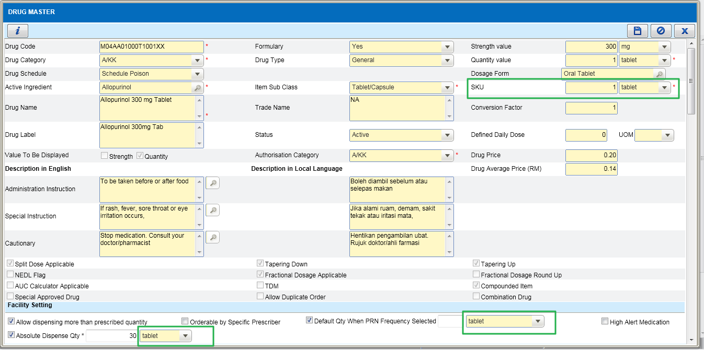

IWP – External Facility
Ticket No | Module | Title | Description | Resolution
I-PhIS010250315S | IWP | IWP-Maintenance-External Facility | Request not to allow save Facility Name with special character ( ' )  Impact while issue out item transaction, selecting the facility, system will prompt system admin error if the facility have the special character | As per Request  Refer to quick guide

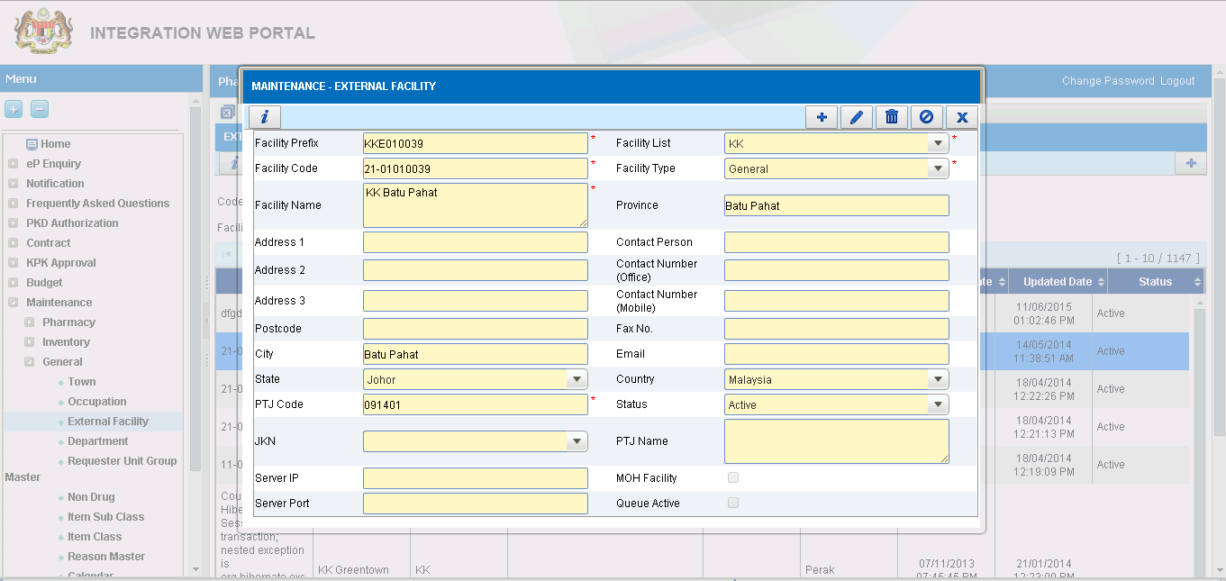

Manufacturing PN
Ticket No | Module | Title | Description | Resolution
I-PhIS008479814S | Manufacturing - PN | Request to display infusion line in label based on the order | User order infusion line as peripheral but in label displayed as central due to the value in label is hard coded based on the label template. | Refer to PhIS_CPS_Quick_Guide_1.3.5_PN Label_v1.0
I-PhIS009193815S | Manufacturing - PN | PN-shelf life and admin route not following the medication order | User inform shelf life and admin routh(central & peripheral line) not following the medication order | Refer to PhIS_CPS_Quick_Guide_1.3.5_PN Label_v1.0

Medication Counselling
Ticket No | Module | Title | Description | Resolution
I-PhIS009818615S | Medication Counselling | Medication Counselling Order listing - 'ordered by' | In 'mc order' screen, field 'ordered by' search, to remove column 'user no' ,  'user login name'  and 'user last name'.  Change to :  User name  Department  Designation  Changes apply to mc and mtac listing screen | Refer to PhIS_CPS_Quick_Guide_1.3.5_MC_OrderBy_v1.0

MTAC - PCI
Ticket No | Module | Title | Description | Resolution
I-PhIS010060315S | MTAC | MTAC Reporting - PCI - Type of Intervention – Miscellaneous | PCI screen under - Type of Intervention – Miscellaneous and Description – to add 'Others'  This changes applies to all PCI screen in MTAC and WP also | Refer to PhIS_CPS_Quick_Guide_1.3.5_PCI_Others_v1.0

MTAC - Morisky
Ticket No | Module | Title | Description | Resolution
I-PhIS010414315S | MTAC | Request to adjust Morisky Scale | Request to adjust Morisky scale for question No 8 as below:  Never/Rarely = 1  Once in a while = 0.75  Sometimes = 0.5  Usually = 0.25  All the time = 0  Changes should apply to Morisky screen in medication counselling also | Refer to PhIS_CPS_Quick_Guide_1.3.5_Morisky_v1.0

Order Management – Validate Duplicate Active Ingredient
Ticket No | Module | Title | Description | Resolution
I-PhIS009817015S | Order Management - Web | Order Management -To check for duplicate at ingredient level | To check for duplicate at ingredient level.  1. Alert message will be displayed when prescriber order for drug:  i. Drug currently active in medication profile  ii. Drug master – duplicate order flag = false  iii. New order is not discharge medication.  2. Alert checking for duplicate (during add new drug) will appear if the new drug has same active ingredient and same dosage with a drug in current edication.  3. If the drug has same active ingredient but with different dosage form, for example: Salbutamol 0.5 % Nebulising Solution with Salbutamol 100 mcg/dose inhaler), we will allow user to create these two rugs together.  4. Changes apply to web (Order Medication - add new function) and mobile (Medication Order - add new function). | Refer to PhIS_CPS_Quick_Guide_1.3.5_Order_Management_Duplicate_Order_v1.0

Outpatient Pharmacy – Complete Dispense
Ticket No | Module | Title | Description | Resolution
I-PhIS009822715S | Outpatient Pharmacy | Complete dispense checkbox | For drug which intended to Supply PRN basic monthly(eg. GTN), system will show fully dispensed and not allow for partial supply next mont even though there is still balance quantity | Refer to PhIS_CPS_Quick_Guide_1.3.5_OP_Complete_Dispense_v1.0

Outpatient Pharmacy - QMS
Ticket No | Module | Title | Description | Resolution
I-PhIS010012515S | Outpatient Pharmacy | QMS- Double que number appeared on screen. | User reported, yesterday que number appeared on screen for today and it will cause double que number on QMS page. | In QMS (when clicking on Patient Call or Dispense btn), system will check if got duplicate Queue No value, then system will check what is the date of patient arrival. Only today's date will be displayed inside QMS system. Others will not update into QMS.

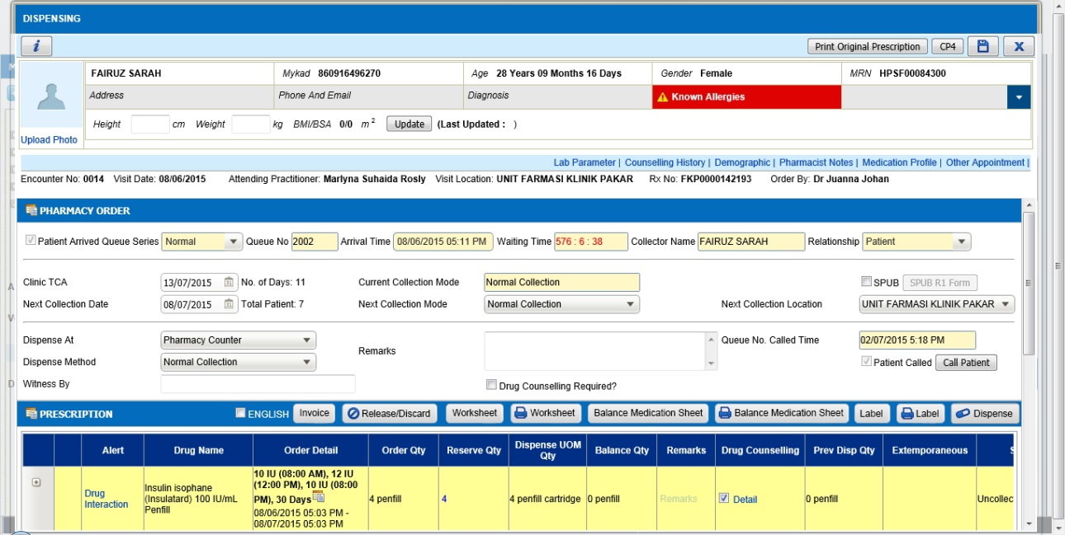

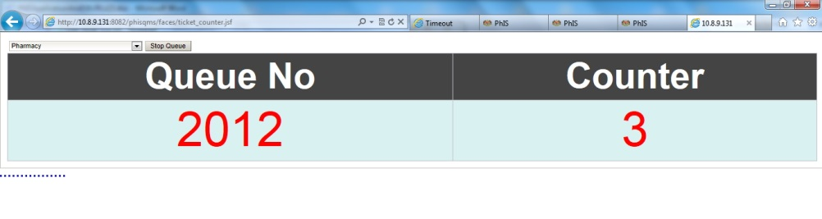

Patient Management – Quick Registration
Ticket No | Module | Title | Description | Resolution
I-PhIS009930315S | Patient Management | Patient Quick Registration - User unable to edit patient name. | User reported she can't edit patient name. User edit at Patient Registration screen and Patient Quick Registration without insert visit type. | Refer to PhIS_CPS_Quick_Guide_1.3.5_PB_Edit_Patient_v1.0

Pharmacy Inventory – External Indent
Ticket No | Module | Title | Description | Resolution
I-PhIS010564315S | Pharmacy Inventory | External Indent | - Request to allow more than 10 drug/non drug per transaction. | Refer to PhIS_CPS_Quick_Guide_1.3.5_INV_ext indent 1.0
I-PhIS010706415S | Pharmacy Inventory | External Indent | Overwrite ticket I-PhIS010564315S (as per request by Cik Liza)  Request to allow more than 10 drug/non drug (for the same PTJ Code only) | Refer to PhIS_CPS_Quick_Guide_1.3.5_INV_ext indent 1.0

Pharmacy Inventory – PKD/MUSN/MUSB Order Flow
Ticket No | Module | Title | Description | Resolution
C2-INT006382315R | Pharmacy Inventory | Facility type = PKD/MUSN/MUSB | facility type = Purchase order MUSN/MUSB and should be to flow to IWP in PKD Authorization | The order that created by PKD/MUSB/MUSN will have same flow as KK

PKD
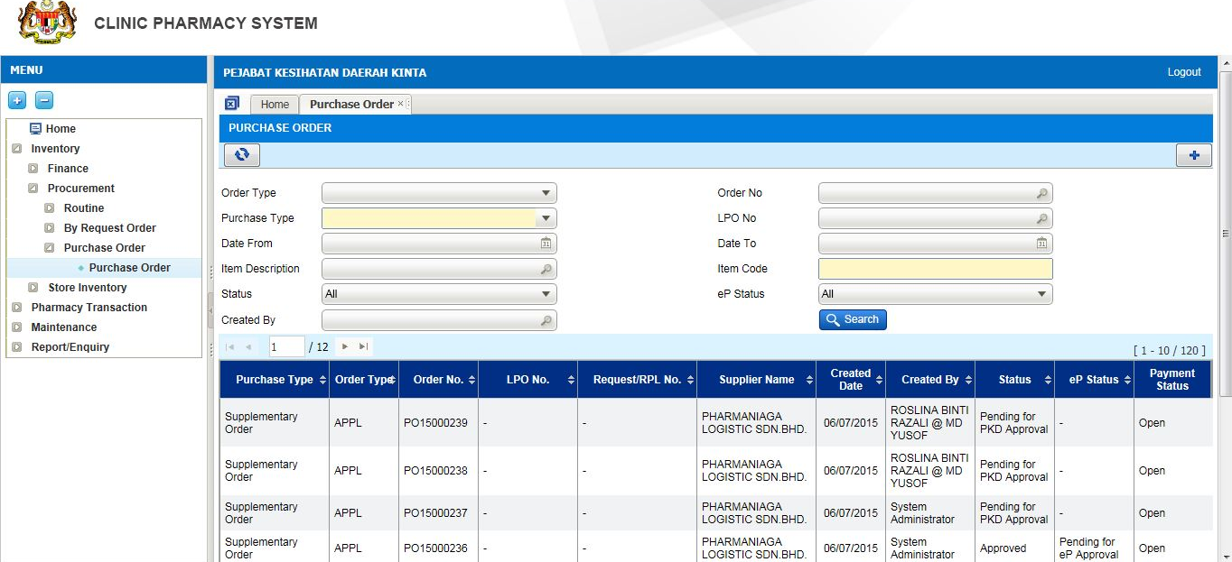
IWP
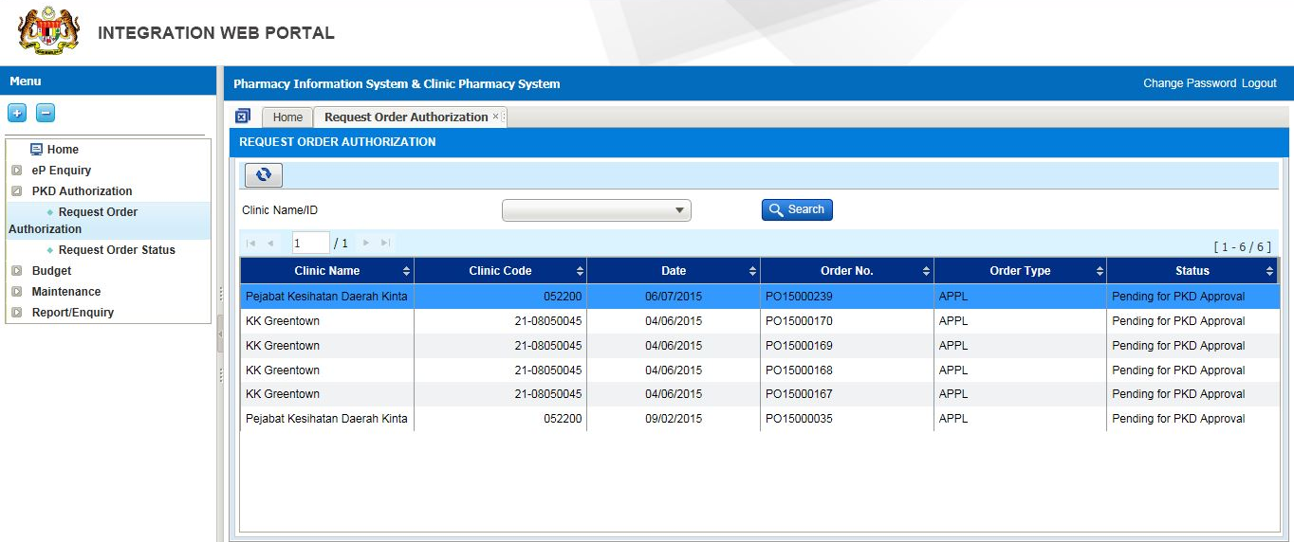
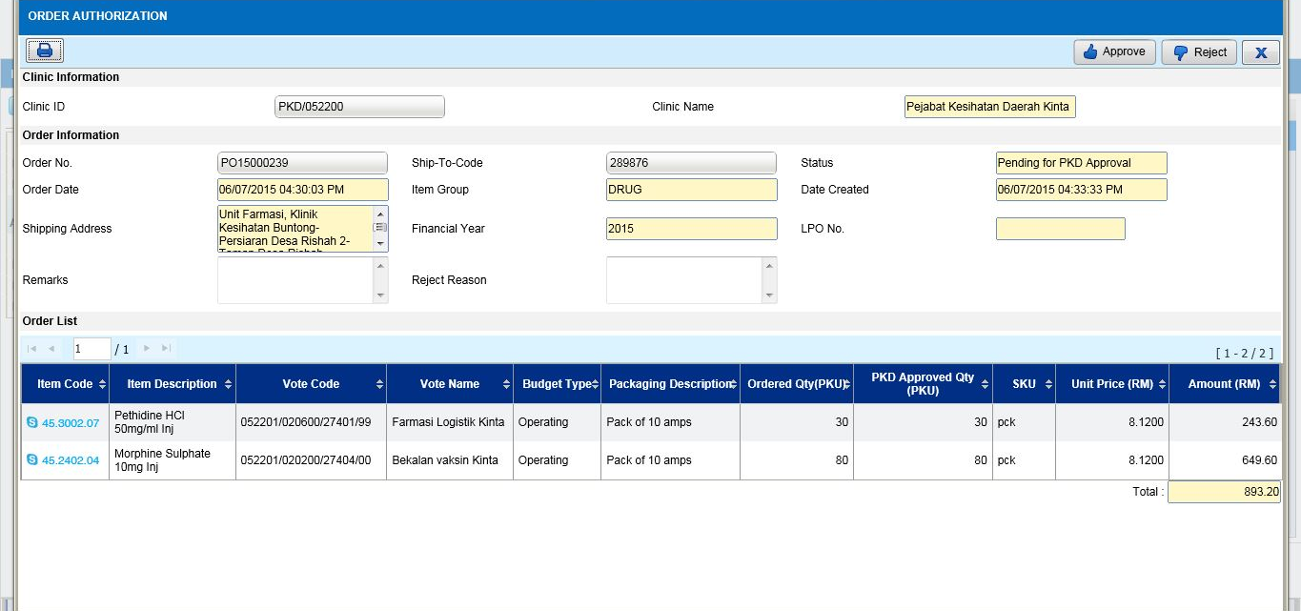
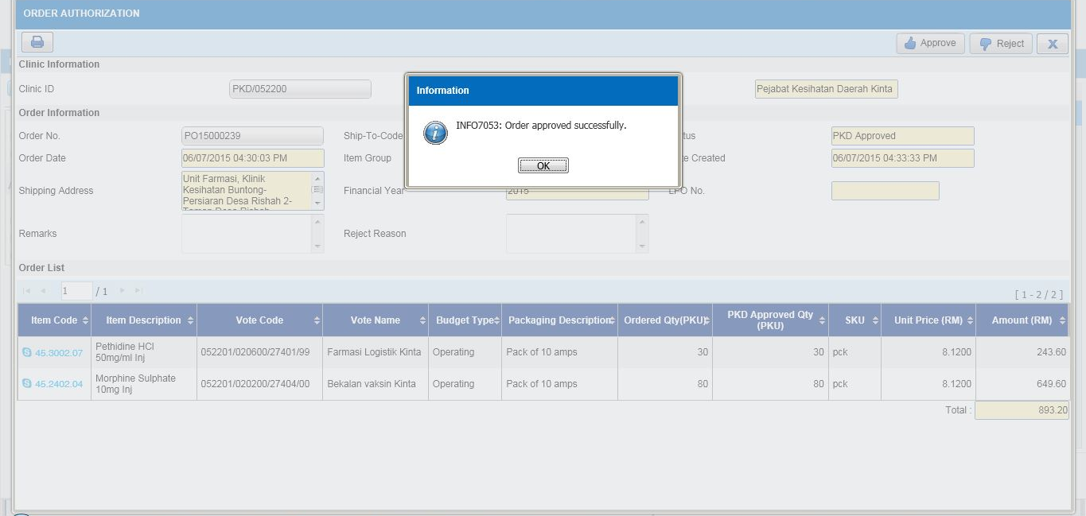
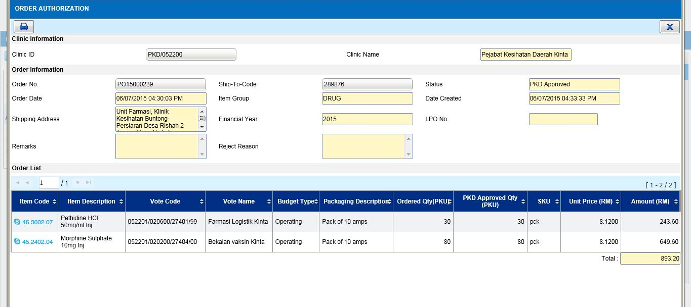
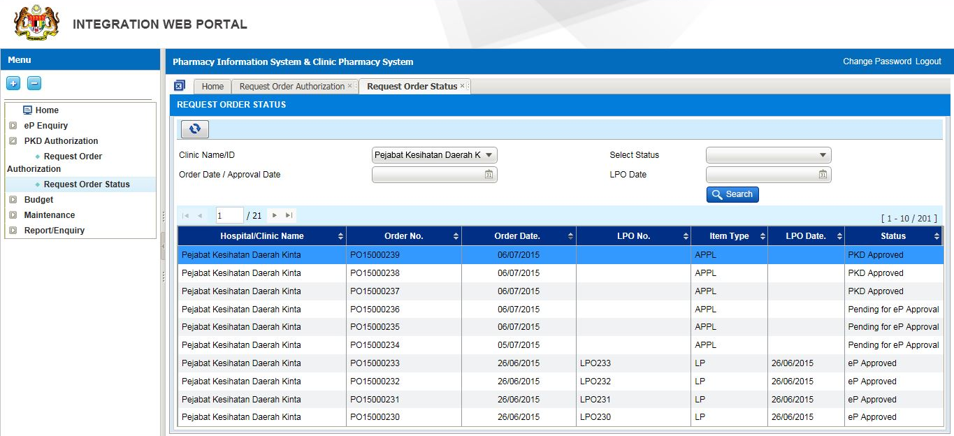
PKD KINTA
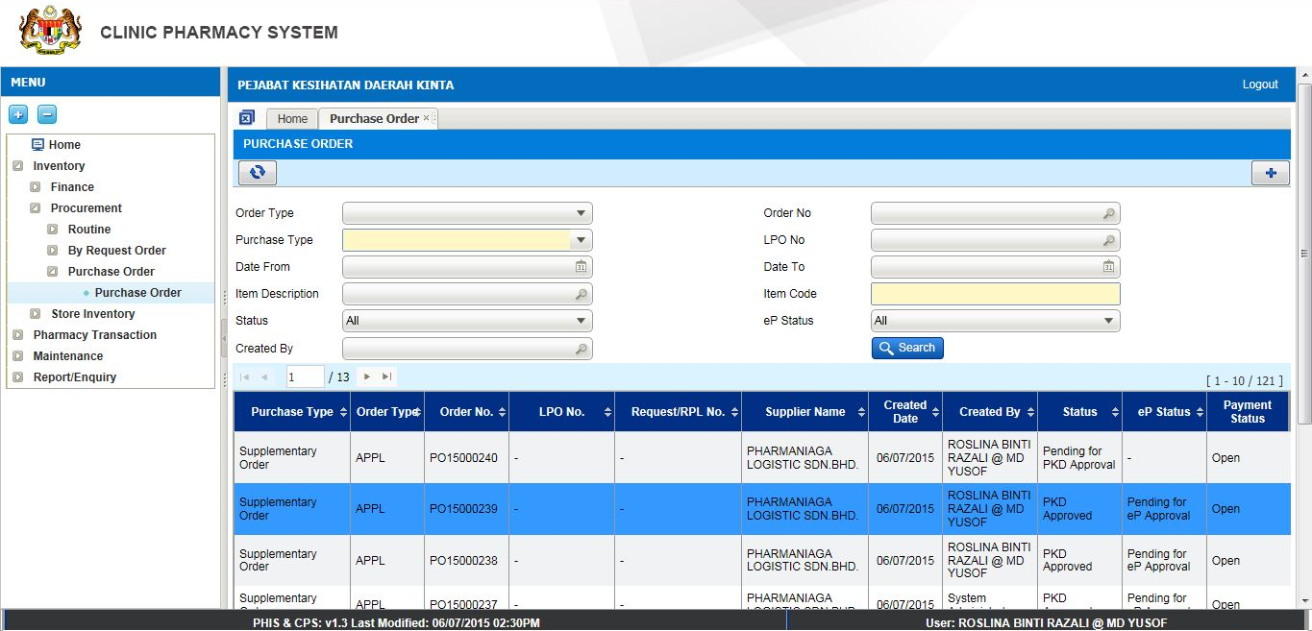

Pharmacy Inventory – Stock Replenish
Ticket No | Module | Title | Description | Resolution
I-PhIS009441815S | Pharmacy Inventory | Stock Replenish | Issue (Ward / unit Stock)-Request to do stock replenish with add on new option UOM = SKU. Curently for Clinic environment - Stock Replenish only in PKU. User request to add on UOM as SKU. Default set to SKU | Refer to PhIS_CPS_Quick_Guide_1.3.5_INV_stock replenish 1.0

Pharmacy Inventory – Prepacking
Ticket No | Module | Title | Description | Resolution
I-PhIS010428315S | Pharmacy Inventory | Prepacking - Allow prepacking module for all Level 1, Level 2 and Level 3 | To allow Prepacking module for all Level 1, Level 2 and Level 3 Unit due to KK scenario where KK only have Level 1 and Level 3 Unit.  If only allow Level 3 to do Prepacking, Level 3 don’t have function to issue to other facility.  In actual scenario, user in Level 1 will do Prepacking and will issue to other requesting facility.  Currently, only Level 2 and Level 3 can use their stock for Prepacking, resulting to Prepacking Item cannot be issued to other facility. | Refer to PhIS_CPS_Quick_Guide_1.3.5_Prepacking_Level_1_v1.0

Pharmacy Inventory – Offline Issue
Ticket No | Module | Title | Description | Resolution
I-PhIS010562315S | Pharmacy Inventory | Offline Issue from Main Store - Changes on the KEWPS 10 | User request for Offline Issue External/Internal from level 1 (main store). When generate Issue Note, ‘Harga Seunit’ should refer to Item Average Price not Drug Average Price  In KEWPS 10, when generate from level 1 (main store), column ‘Harga Seunit’ should refer to ‘Item Average Price’ , currently referring to Drug Average Price. | Refer to PhIS_CPS_Quick_Guide_1.3.5_INV_Offline issue 1.0

Pharmacy Inventory – Receive Inter Facility
Ticket No | Module | Title | Description | Resolution
I-PhIS010564415S | Pharmacy Inventory | Receive Inter Facility (manual) – | Request unit price field make it non mandatory. | Refer to PhIS_CPS_Quick_Guide_1.3.5_INV_receive inter facility 1.0
I-PhIS010706315S | Pharmacy Inventory | Receive Inter Facility (manual) – | Overwrite ticket I-PhIS010564415S (as per request by Cik Liza)  unit price should be it mandatory field and allow to key '0' | Refer to PhIS_CPS_Quick_Guide_1.3.5_INV_receive inter facility 1.0

Report/Enquiry – YTD Issue
Ticket No | Module | Title | Description | Resolution
I-PhIS007735914S | Report/Enquiry | Report Enquiry-YTD Issue by Requester | Request to add 'From Date' and 'To Date' function for search criteria at YTD issue by requester report. | Refer to PhIS_CPS_Quick_Guide_1.3.5_INV report 1.0
I-PhIS007736214S | Report/Enquiry | YTD Issue by Month- | Request to add 'From Date' and 'To Date' function for search criteria | Refer to PhIS_CPS_Quick_Guide_1.3.5_INV report 1.0

Deployment - Procedures

List of Items to be Deployed
No. | Items | Components | Path
1 | HQ Patch Script | PatchScripts_IWP_v1.3.5.txt  PatchScripts_IWP_v1.3.5_Functions.txt | https://10.8.9.130:44330/svn/Workspace_Dataware/31_Implementation/Applications/PhIS ReleaseV1.3.5/hq/scripts
2 | HQ Application | phishq_v1.3.5.war | https://10.8.9.130:44330/svn/Workspace_Dataware/31_Implementation/Applications/PhIS ReleaseV1.3.5/hq/war
3 | HQ Application | epservice_v1.3.5.war | https://10.8.9.130:44330/svn/Workspace_Dataware/31_Implementation/Applications/PhIS ReleaseV1.3.5/hq/war
4 | HQ Application | masterRelease_v1.3.5.jar | https://10.8.9.130:44330/svn/Workspace_Dataware/31_Implementation/Applications/PhIS ReleaseV1.3.5/hq/jar
5 | Facility Patch Script | PatchScripts_PhIS_v1.3.5.txt  PatchScripts_PhIS_v1.3.5_DataPatch.txt  PatchScripts_PhIS_v1.3.5_HPSF.txt PatchScripts_PhIS_v1.3.5_HSM.txt PatchScripts_PhIS_v1.3.5_HKM.txt PatchScripts_PhIS_v1.3.5_HTM.txt  PatchScripts_PhIS_v1.3.5_KKGT.txt | https://10.8.9.130:44330/svn/Workspace_Dataware/31_Implementation/Applications/PhIS ReleaseV1.3.5/facility/scripts
6 | Facility Application | iphis_v1.3.5.war | https://10.8.9.130:44330/svn/Workspace_Dataware/31_Implementation/Applications/PhIS ReleaseV1.3.5/facility/war
7 | Facility Application | PhISSchedulers_v1.3.5.jar | https://10.8.9.130:44330/svn/Workspace_Dataware/31_Implementation/Applications/PhIS ReleaseV1.3.5/facility/jar
8 | Mobile Application | ipadhosp-1.4.0b32-PhISDS.war | https://10.8.9.130:44330/svn/Workspace_Dataware/31_Implementation/Applications/PhIS ReleaseV1.3.5/Mobile

Backup Procedure before Deploy

Backup Procedure
Using backup tool, backup the following files and folder and database as per table below;
No. | Type | Backup Item | Description
1 | Application | /home/phisesb  /opt/phisesb  /usr/share/fonts/truetype | PhIS Integration Application  PhIS Core Application  Fonts required by PhIS
2 | Database | phisprod database | PhIS Live database

Deployment/Installation Guidelines

Deployment at Facility
Below table is described the deployment steps at Facility:
Step | Items | File Name | Source Path | Action
1 | Facility Patch Script | PatchScripts_PhIS_v1.3.5.txt  PatchScripts_PhIS_v1.3.5_DataPatch.txt  PatchScripts_PhIS_v1.3.5_HPSF.txt PatchScripts_PhIS_v1.3.5_HSM.txt PatchScripts_PhIS_v1.3.5_HKM.txt PatchScripts_PhIS_v1.3.5_HTM.txt  PatchScripts_PhIS_v1.3.5_KKGT.txt | https://10.8.9.130:44330/svn/Workspace_Dataware/31_Implementation/Applications/PhIS ReleaseV1.3.5/facility/scripts | Please ensure all the script is execute before iphis.war deploy.  Please ensure the script is executed in sequence. Script files 1 & 3 Execute as pgScript and other two Run as highlight the Script and press (F5)
2 | Facility Application | iphis_v1.3.5.war | https://10.8.9.130:44330/svn/Workspace_Dataware/31_Implementation/Applications/PhIS ReleaseV1.3.5/facility/war | Please rename the war file from iphis_v1.3.5.war to iphis.war then deploy.
3 | Facility Application | PhISSchedulers_v1.3.5.jar | https://10.8.9.130:44330/svn/Workspace_Dataware/31_Implementation/Applications/PhIS ReleaseV1.3.5/facility/jar | Rename PhISSchedulers_v1.3.5.jar to PhISSchedulers.jar and copy to /home/phisesb/phisjars/ folder in production servers. Backup existing Jar before copy new one.
4 | Mobile Application | ipadhosp-1.4.0b32-PhISDS.war | https://10.8.9.130:44330/svn/Workspace_Dataware/31_Implementation/Applications/PhIS ReleaseV1.3.5/Mobile | Rename ipadhosp-1.4.0b32-PhISDS.war to ipadhosp.war and deploy.  Frontend Apps: 1.4.0r1t31  Backend Apps: 1.4.0b32

Deployment at HQ - IWP
Below table is described the deployment steps at HQ - IWP:

Step | Items | File Name | Source Path | Action
1 | HQ Patch Script | PatchScripts_IWP_v1.3.5.txt | https://10.8.9.130:44330/svn/Workspace_Dataware/31_Implementation/Applications/PhIS ReleaseV1.3.5/hq/scripts | Please ensure all the script is execute before phishq.war deploy.
2 | HQ Application | phishq_v1.3.5.war | https://10.8.9.130:44330/svn/Workspace_Dataware/31_Implementation/Applications/PhIS ReleaseV1.3.5/hq/war | Rename the war file from phishq_v1.3.5.war to phishq.war then Deploy using Glassfish Administration Console
3 | HQ Application | epservice_v1.3.5.war | https://10.8.9.130:44330/svn/Workspace_Dataware/31_Implementation/Applications/PhIS ReleaseV1.3.5/hq/war | Rename the war file from epservice_v1.3.5.war to epservice.war then Deploy using Glassfish Administration Console.
4 | HQ Application | masterRelease_v1.3.5.jar | https://10.8.9.130:44330/svn/Workspace_Dataware/31_Implementation/Applications/PhIS ReleaseV1.3.5/hq/jar | Backup existing jar file from production and copy downloaded Jar to /home/phisesb/phisjars/ and Rename masterRelease_v1.3.5.jar to masterRelease.jar

