Pharmacy Information System (PhIS)
and
Clinic Pharmacy System (CPS)

Release Note
For version 1.3.6

Version : 1.0
Document ID : PhIS_CPS/ReleaseNote/Refinement/24082015

© 2011-2015 Pharmaniaga Logistics Sdn Bhd (PLSB)

CONFIDENTIAL COPYRIGHTED MATERIAL – The information includes all concepts, comments, recommendations, and material, contained herein shall remain the property of Pharmaniaga Logistics Sdn Bhd (PLSB). No portion of this document shall be disclosed, duplicated or used in whole or in part of any purpose other than the purpose of the Pharmacy Information System & Clinic Pharmacy System (PhIS& CPS) Project execution only.

Revision History

Version No | Date of Release | Prepared by | Reviewed / Verified by | List of changes from Previous Version
1.0 | 24/08/2015 | Kee Tuan Hwa | Chew Ming Ping | First Version

Verified and Acknowledged by:
Name | Role/Designation | Organization | Signature & Date
Chew Ming Ping | Team Leader | Pharmaniaga Logistics Sdn Bhd
Hoh Choon Seng | Project Manager | Pharmaniaga Logistics Sdn Bhd

Name | Role/Designation | Organization | Signature & Date
 |  | Bahagian Perkhidmatan Farmasi (BPF), KKM
 |  | Bahagian Pengurusan Maklumat (BPM), KKM

Peer Review
Version No | Reviewed / Verified by | List Of Changes from Previous Version
1.0 | Juridah (QA) | Initial document

1 Introduction 1
1.1 Project Information 1
1.2 Objectives 1
2 Purpose 2
3 Summary – Refinement and Defect List 3
3.1 Refinement List 3
3.2 Resolved Defect List 14
4 Refinement List – Detail Changes 34
4.1 Pharmacy Inventory 34
4.2 Pharmacy Inventory - Requester Unit 36
4.3 Pharmacy Inventory - Quotation 36
4.4 Report/Enquiry – Counselling Registry 39
4.5 Report/Enquiry – Item/Product Buffer Level 39
4.6 Report/Enquiry – Ward Stock Report 40
4.7 Report/Enquiry – KPI 2B 42
4.8 Report/Enquiry – Back Order Report 43
5 Deployment - Procedures 45
5.1 List of Items to be Deployed 45
5.2 Backup Procedure before Deploy 46
5.2.1 Backup Procedure 46
5.3 Deployment/Installation Guidelines 46
5.3.1 Deployment at Facility 46
5.3.2 Deployment at HQ - IWP 47

Introduction

Project Information

Project ID : | PhIS and CPS
Project Name : | Pharmacy Information System and Clinic Pharmacy System
Version No : | 1.3.6
Client Name : | Ministry of Health
Release ID : | RL15/009
Release Date : | 24/08/2015

Objectives
No. | Objective | Reference
1. | Release PhIS & CPS Application to Facility | Refer Section 3 – Refinement and Defect list

Purpose
The purpose of the document is to update the end-user of the changes and defects have been resolved to be included in the new version of application and will be deployed to production server.
This document outlines the list of request and issue to be delivered in the newer version of application and also the guidelines on how to deploy the new version of application in production.

Summary – Refinement and Defect List

Refinement List

The following refinement tickets to be delivered in PhIS ver 1.3.6.
No | Ticket No | Facility | Module | Reported Date | Title | Description | Resolution | Resolved Date | Verify Status
1 | I-PhIS009812315S | Bahagian Perkhidmatan Farmasi (BPF) | Adverse Drug Reaction (ADR) | 15/5/15 | Patient Allergy - Adjust data alignment | Request to adjust the data alignment in Reaction  Details field in Allergy card" | Refer to PhIS_CPS_Quick_Guide_1.3.6_Print Allergy Card - Adjust data alignment | 15/5/15
2 | I-PhIS009816815S | Bahagian Perkhidmatan Farmasi (BPF) | Clinical Pharmacokinetic Services (CPS) & TDM | 15/5/15 | TDM Order – Drug Search | Request to remove column 'Dosage Desc' in all  Drug – TDM Drug search | Refer to PhIS_CPS_Quick_Guide_1.3.6_TDM Order – Drug Search_v1.0 | 28/7/15
3 | I-PhIS009852315S | Hospital Kulim | Clinical Pharmacokinetic Services (CPS) & TDM | 19/5/15 | TDM Reporting – Toxic indicator | User request to display by default both toxic and non-toxic record in the TDM reporting listing screen. | Refer to PhIS_CPS_Quick_Guide_1.3.6_TDM Reporting – Toxic indicator_v1.0 | 27/7/15
4 | I-PhIS009818415S | Bahagian Perkhidmatan Farmasi (BPF) | Drug Information & Consumer Education | 15/5/15 | DICE - DI at HQ | Enquirer Details-enquiry from “HQ” change  “bahagian Perkhidmatan Farmasi KKM”" | Refer to PhIS_CPS_Quick_Guide_1.3.6_DICE - at HQ_v1.0 | 27/7/15
5 | I-PhIS010518315S | Hospital Kulim | Inpatient Pharmacy | 18/6/15 | Dispensing-Discharge Drug Label | Allow inpatient pharmacy to print outpatient drug label for discharge medication in inpatient screen. | Refer to PhIS_CPS_Quick_Guide_1.3.6_Pharmacy_v1.0 – No 2 | 5/8/15
6 | I-PhIS010744315S | Hospital Tanah Merah | Inpatient Pharmacy | 25/6/15 | Preparation - Extemp - Print label with wrong UOM | User inform doctor prescribe the drug with UOM tablet , but after pharmacist did extemporaneous the label printed with UOM biji .  Drug : Captopril Solution 1mg/ml  Doctor prescribe the drug with UOM ml , but after pharmacist did extemporaneous the label printed with UOM tablet .  Drug : Spirolactone Syrup 2.5mg/ml | Refer to PhIS_CPS_Quick_Guide_1.3.6_Extemp_Split Dose_v1.0 | 6/7/15
7 | I-PhIS009702015S | Bahagian Perkhidmatan Farmasi (BPF) | IWP | 10/5/15 | IWP – Vote Code (Request to list out clinic name) | Request to list out clinic name where the facility type is KK, MUSN/PBFN & PKD as long same PTJ code.Currently all facility that same PTJ code will be list out i.e KKIA, KK1M & KD. | Refer to PhIS_CPS_Quick_Guide_1.3.6_IWP v1.0 – No. 1 | 4/8/15
8 | I-PhIS010374315S | Bahagian Perkhidmatan Farmasi (BPF) | IWP | 16/6/15 | Request to have filter field in contract facility list | Request to have filter field in contract facility list where able to search by facility name | Refer to PhIS_CPS_Quick_Guide_1.3.6_IWP v1.0 – No. 2 | 29/7/15
9 | I-PhIS011682415S | Pejabat Kesihatan Kepong | IWP | 15/7/15 | IWP - Request to provide alert validation based on MOQ | User request to provide alert validation based on MOQ because now user able to proceed for approval when she reduce the quantity less than MOQ. Example item code: 01.0606.02 (Diphenhydramine HCl Expectorant (Adult). MOQ: Multiple of 100 bottles.  For example: Clinic order for 500 bottles then at IWP user able to approve after reduce the quantity from 500 to 499. | Refer to PhIS_CPS_Quick_Guide_1.3.6_IWP v1.0 – No. 3 | 5/8/15
10 | I-PhIS009724615S | Hospital Pakar Sultanah Fatimah | Manufacturing - CDR | 11/5/15 | CDR preparation-Request to add infuse over value at label infusion drug | User request in CDR Preparation, Label for Infusion drug to add Infuse Over value as per value added in CDR Order screen.  Eg: Infuse Over: 30 Minutes | Refer to PhIS_CPS_Quick_Guide_1.3.6_CDR - Label_v1.0 | 1/6/15
11 | I-PhIS008592015S | Hospital Kulim | Manufacturing - Galenical | 11/1/15 | Manufacturing - difference of "checked by" and "approved by" | What is the difference of "checked by" and "approved by"?  Is the "approved by" button is the purpose of triple check function?  Double check system should be sufficient for current staffing level nationwide | Refer to PhIS_CPS_Quick_Guide_1.3.6_Galenical-Work Order_v1.0 – No. 1 | 6/8/15
12 | I-PhIS008592115S | Hospital Kulim | Manufacturing - Galenical | 11/1/15 | Manufacturing - optional field for checked person to key-in the name of the person preparing. | Request an optional field for checked person to key-in the name of the person preparing.  As worksheet may be generated by another person but not the preparing person  To enable easier tracing for the responsible staff if the products are subsequently discovered with problems eg: bacterial growth which mostly is related to incorrect aseptic technique. | Refer to PhIS_CPS_Quick_Guide_1.3.6_Galenical-Work Order_v1.0 – No. 2 | 6/8/15
13 | I-PhIS008591715S | Hospital Kulim | Manufacturing - Galenical | 11/1/15 | Manufacturing - Shelf life should be mentioned on the galenical worksheet | Shelf life should be mentioned on the galenical worksheet, particularly if the facility (auto generated) uses its own labelling system and machine. | Refer to PhIS_CPS_Quick_Guide_1.3.6_Galenical-Work Order_v1.0 – No. 3 | 6/8/15
14 | I-PhIS009820015S | Bahagian Perkhidmatan Farmasi (BPF) | MAR - Web | 15/5/15 | MAR - Update details | "MAR  1. To include administration route  2. To display 'Own Medication' in source column.  3. Discontinue drug should be listed a bottom  4. Display Order Date  5. Allow doctor to search drug by All/Active/Inactive medication  6. Allow to search by drug name in MAR screen" | Refer to PhIS_CPS_Quick_Guide_1.3.6_MAR_v1.0 – No 1 | 14/7/15
15 | I-PhIS011292315S | Hospital Pakar Sultanah Fatimah | MAR - Web | 7/7/15 | Medication Chart - Print taper drug | When user print taper drug in medication chart (by selecting main drug), child drug should be included in the medication chart too. | Refer to PhIS_CPS_Quick_Guide_1.3.6_MAR_v1.0 – No 3 | 24/7/15
16 | I-PhIS011584315S | Hospital Pakar Sultanah Fatimah | MAR - Web | 13/7/15 | Medication Chart - Print Header title | Print Header title in every page. Currently printed on first page only. | Refer to PhIS_CPS_Quick_Guide_1.3.6_MAR_v1.0 – No 2 | 5/8/15
17 | I-PhIS009816315S | Bahagian Perkhidmatan Farmasi (BPF) | Medication Counseling | 15/5/15 | Medication Counselling Reporting- To add character counts | Request to add character counters at 'pharmacist note' field. Apply to all MTAC, MC, WP n TDM | Refer to PhIS_CPS_Quick_Guide_1.3.6_Pharmacist Note - To add character counts | 28/7/15
18 | I-PhIS009816415S | Bahagian Perkhidmatan Farmasi (BPF) | Medication Counseling | 15/5/15 | Medication Counselling Order- Add word Time for button Schedule | Request to add word 'Time' for button 'Schedule'. | Refer to PhIS_CPS_Quick_Guide_1.3.6_Counselling Order- Add word Time for button Schedule_v1.0 | 3/8/15
19 | I-PhIS009816715S | Bahagian Perkhidmatan Farmasi (BPF) | MTAC | 15/5/15 | MTAC reporting - Change LFT | User request change LFT – unit mcmol/L to mmol/L | Refer to PhIS_CPS_Quick_Guide_1.3.6_MTAC reporting - Change LFT_v1.0 | 10/8/15
20 | I-PhIS010814315S | Klinik Kesihatan Bakri | MTAC | 26/6/15 | MTAC – Diet & Lifestyle | To make the column bigger | Refer to PhIS_CPS_Quick_Guide_1.3.6_MTAC – Diet & Lifestyle_v1.0 | 27/7/15
21 | I-PhIS010518515S | Bahagian Perkhidmatan Farmasi (BPF) | Order Management - Web | 18/6/15 | IP Order Duration-Allow to overidde order duration | Allow user to overidde order duration for inpatient if user set 'IP Max Duration'. Currently duration cannot more than 7 days.  Apply to 'OP Max Duration' too. | Refer to PhIS_CPS_Quick_Guide_1.3.6_OM_Med_Order_v1.0 – No 4 and  PhIS_CPS_Quick_Guide_1.3.6_OM_Mobile_IPOP_MaxDuration_v1.0 | 5/8/15
22 | I-PhIS009818515S | Bahagian Perkhidmatan Farmasi (BPF) | Order Management - Web | 15/5/15 | Medication order - Renew Rx message. | Renew Rx:  - Information Stop 'Current Order' change to 'Stop Active Order'  - 'Apply to all drugs' change to 'Apply to selected drugs' | Refer to PhIS_CPS_Quick_Guide_1.3.6_OM_Med_Order_v1.0 – No 5 | 5/8/15
23 | I-PhIS009817615S | Bahagian Perkhidmatan Farmasi (BPF) | Order Management - Web | 15/5/15 | Medication Order/Transcribe Order - Add From Favorite | Request all the selected drug list, should be captured upon clicking on Add To Order button, regardless of pages | Refer to PhIS_CPS_Quick_Guide_1.3.6_OM_Med_Order_v1.0 – No 1 | 24/7/15
24 | I-PhIS011086315S | Hospital Raja Permaisuri Bainun | Order Management - Web | 2/7/15 | Medication Order - Overlap Medication Alert | Overlap Medication - Alert Stop or Continue Current Order. Change wording to [Stop / Continue Previous Order] | Refer to PhIS_CPS_Quick_Guide_1.3.6_OM_Med_Order_v1.0 – No 5 | 5/8/15
25 | I-PhIS008896415S | Hospital Tanah Merah | Order Management - Web | 22/2/15 | Manage Order- To add information on user who stop and cancel ordered. | To add information on user who stop and cancel ordered. | Refer to PhIS_CPS_Quick_Guide_1.3.6_OM_Med_Order_v1.0 – No 3 | 12/8/15
26 | I-PhIS008896515S | Hospital Tanah Merah | Order Management - Web | 22/2/15 | Manage Order- to add information at clinical summary | Remarks and reason information was not displayed clinical summary for cancel or stop medication | Refer to PhIS_CPS_Quick_Guide_1.3.6_OM_Med_Order_v1.0 – No 3 | 12/8/15
27 | I-PhIS009509815S | Klinik Kesihatan Bakri | Order Management - Web | 23/4/15 | Medication Profile - Show the reason at previous medication. | User request to show the reason for the drug either stop and hold at the previous medication. | Refer to PhIS_CPS_Quick_Guide_1.3.6_OM_Med_Order_v1.0 – No 3 | 12/8/15
28 | I-PhIS009686015S | Klinik Kesihatan Greentown | Order Management - Web | 7/5/15 | Medication Order - request to change "Stop Current Order" word to "Stop Previous Ordered" | User request to change "Stop Current Order" word to be as "Stop Previous Ordered" in Renew Rx function. | Refer to PhIS_CPS_Quick_Guide_1.3.6_OM_Med_Order_v1.0 – No 5 | 5/8/15
29 | I-PhIS008934115S | Klinik Kesihatan Greentown | Order Management - Web | 26/2/15 | Order Management-Request to be able trace who is cancelled order | Request to be able trace who is cancelled order. | Refer to PhIS_CPS_Quick_Guide_1.3.6_OM_Med_Order_v1.0 – No 3 | 12/8/15
30 | I-PhIS011718315S | Hospital Tanah Merah | Outpatient Pharmacy | 15/7/15 | Screening and Verification- Request to view status change by who and the reason | Patient had been prescribed medications for 2 months. However, noted patient’s medication (Atorvastatin 40mg ON) status is stop. Confirmed with doctor incharged, the medication actually still need to be continue.  Issue: Pharmacy wish to identify and view the status “stop” was done by whom and reason to stop medication | Refer to PhIS_CPS_Quick_Guide_1.3.6_OM_Med_Order_v1.0 – No 3 | 22/7/15
31 | I-PhIS009826615S | Klinik Kesihatan Bandar Maharani | Outpatient Pharmacy | 15/5/15 | Screening Transcribe Order - To add Full Supply button in the screen | User requested to have "Full Supply" button in Transcribe Order screen. | Refer to PhIS_CPS_Quick_Guide_1.3.6_Pharmacy_v1.0 – No 4 | 24/7/15
32 | I-PhIS009826715S | Klinik Kesihatan Bandar Maharani | Outpatient Pharmacy | 15/5/15 | Transcribe Order - To default the cursor to Prescriber Name field. | User requested that cursor should be default to Prescriber Name when open Transcribe Order screen. | Refer to PhIS_CPS_Quick_Guide_1.3.6_Pharmacy_v1.0 – No 3 | 22/7/15
33 | I-PhIS010170315S | Klinik Kesihatan Greentown | Outpatient Pharmacy | 5/6/15 | Screening & Verification- Cannot auto allocate | User unable to do auto allocate for last month supply drug.  Step 1: To do alternate one drug  Step 2: Press button allocate  Step 3: This month supply partial  Step 4: Drug alternate cannot auto allocate reverse qty remain 0 and need to manual allocate.  Patient: Adayah Binti Zakria  ID: 561215085620  drug:  1) Simvastatin 40mg tablet  2) Simvastatin 20mg tablet | Refer to PhIS_CPS_Quick_Guide_1.3.6_Pharmacy_v1.0 – No 1 | 6/8/15
34 | I-PhIS010758315S | Hospital Tanah Merah | Patient Management | 25/6/15 | Clinical summary - Show date and time | User request screen clinical summary at medication profile that can show time, date and name of user when user stop, hold and cancel drug at screen previous medication | Refer to PhIS_CPS_Quick_Guide_1.3.6_OM_Med_Order_v1.0 – No 3 | 9/7/15
35 | I-PhIS010014715S | Klinik Kesihatan Bandar Maharani | Patient Management | 29/5/15 | Medication Profile, Clinical Summary-Request to show reason for Stop drug | User request to show reason for stop drug in medication profile and clinical summary. Now on both screen don’t show reason for drug that has been stop. | Refer to PhIS_CPS_Quick_Guide_1.3.6_OM_Med_Order_v1.0 – No 3 | 10/7/15
36 | I-PhIS009878415S | Klinik Kesihatan Greentown | Patient Management | 20/5/15 | Clinical Summary - Request to add UOM in Prescribe Qty column | User request to add UOM (example: ml/packet/tablet) at column "Prescribed Qty" in Medication Profile. | Refer to PhIS_CPS_Quick_Guide_1.3.6_OM_Med_Order_v1.0 – No 2 | 22/7/15
37 | I-PhIS012104315S | Bahagian Perkhidmatan Farmasi (BPF) | Pharmacy Inventory | 1/8/15 | External indent for sabah and sarawak state | User request to add on 1 more function and validation during external indent whereby if the external facility state = sabah or sarawak and the ptj code either same or not then need to allow more than 10 drug/non drug. | Refer to PhIS_CPS_Quick_Guide_1.3.6_Inventory v1.0 – No 1 | 4/8/15
38 | I-PhIS011904315S | Bahagian Perkhidmatan Farmasi (BPF) | Pharmacy Inventory | 24/7/15 | Request to handle Gabungan PTJ for Hospital Environment | Need to handle at IWP for External Facility screen to provide flag = (Y/N) to defined the respective Hospital is Gabungan PTJ or not). If yes, means all the budget management for the Hospital & all the PKD/Clinics which is have same PTJ code will be handle at IWP. | Refer to 4.1 | 11/8/15
39 | I-PhIS011820315S | Bahagian Perkhidmatan Farmasi (BPF) | Pharmacy Inventory | 21/7/15 | Offline Issue – Issue Type = External (Request to cater for External Unit Catalogue) | Based on the Unit Catalogue For External Facility | Refer to PhIS_CPS_Quick_Guide_1.3.6_Inventory v1.0 – No 4 | 28/7/15
40 | I-PhIS009758315S | Bahagian Perkhidmatan Farmasi (BPF) | Pharmacy Inventory | 13/5/15 | Offline Issue - Button unit catalog | "Issue Type : Internal & Own Consumption  User request to have button unit catalog and can view only. This unit catalog refer from value unit name selected." | Refer to PhIS_CPS_Quick_Guide_1.3.6_Inventory v1.0 – No 3 | 29/7/15
41 | I-PhIS011016315S | Hospital Kulim | Pharmacy Inventory | 1/7/15 | Prepacking - Request to display Available Quantity in SKU. | In Prepacking, request to display Available Qty in SKU and Quantity to Prepack in SKU. For cases that, not all quantity in PKU will be used during prepacking. Some may divide for prepacking and galenical production purposes. | Refer to PhIS_CPS_Quick_Guide_1.3.6_Prepacking_SKU_PKU_v1.0 | 9/7/15
42 | I-PhIS011906315S | Hospital Kulim | Pharmacy Inventory | 24/7/15 | RIQ screen - Allow to select from which unit should be able to deduct the stock | Need to provide function at RIQ screen, able to select from which unit the stock will be deducted. | Refer to PhIS_CPS_Quick_Guide_1.3.6_Inventory v1.0 – No 5 | 4/8/15
43 | I-PhIS011800315S | Hospital Miri | Pharmacy Inventory | 21/7/15 | INV - Purchase Order screen (PO) request to remove Vote Code List section once order status = Approved | To avoid confusion to the user due it will based on current budget balance. | Refer to PhIS_CPS_Quick_Guide_1.3.6_Inventory v1.0 – No 7 | 28/7/15
44 | I-PhIS011478315S | Hospital Rehabilitasi Cheras | Pharmacy Inventory | 10/7/15 | Prepacking - Request to add (SKU) in current available quantity | User request to add (SKU) for current available Quantity at Prepacking module in PHIS : ( Inventory - Store Inventory - Prepacking ), since only have PKU for  current available quantity at prepacking screen. | Refer to PhIS_CPS_Quick_Guide_1.3.6_Prepacking_SKU_PKU_v1.0 | 29/7/15
45 | I-PhIS010772415S | Hospital Seri Manjung | Pharmacy Inventory | 25/6/15 | Prepacking-Request to display Qty in SKU not PKU for Current Available Qty and Quantity to Prepack | Current Available Qty and Quantity to Prepack to display Qty in SKU not PKU, due to user may not prepack whole packaging at one time and user may do prepack for item less than the PKU qty. | Refer to PhIS_CPS_Quick_Guide_1.3.6_Prepacking_SKU_PKU_v1.0 | 9/7/15
46 | I-PhIS010774315S | Hospital Seri Manjung | Pharmacy Inventory | 25/6/15 | Prepacking - Rename field to Current Available Qty (SKU), Quantity to Prepack (SKU) | Rename field to Current Available Qty (SKU), Quantity to Prepack (SKU). | Refer to PhIS_CPS_Quick_Guide_1.3.6_Prepacking_SKU_PKU_v1.0 | 9/7/15
47 | I-PhIS011856315S | Klinik Kesihatan Tanglin | Pharmacy Inventory | 22/7/15 | Request to block to create 2 requester unit for Main Store (Level 1) | Currently system didn’t block on this. It will impact on transaction created when having 2 requester unit catalogue | Refer to 4.2 | 28/7/15
48 | I-PhIS010794315S | Klinik Kesihatan Tronoh | Pharmacy Inventory | 26/6/15 | Prepacking - Request to change from PKU to SKU. | User request to change "Current Available Quantity (in PKU)" and "Expected Prepack Quantity ( in PKU)" to SKU in prepacking screen. | Refer to PhIS_CPS_Quick_Guide_1.3.6_Prepacking_SKU_PKU_v1.0 | 9/7/15
49 | I-PhIS011144315S | MUSN Kuching | Pharmacy Inventory | 3/7/15 | Online Issue - Request "Indent by" name who create the indent. | User request for "indent by" at screen online issue , display name who create the indent and not display name who retrieve the record. | Refer to PhIS_CPS_Quick_Guide_1.3.6_Inventory v1.0 – No 2 | 14/7/15
50 | I-PhIS010544315S | MUSN Kuching | Pharmacy Inventory | 19/6/15 | Quotation - Quotation status function | User request to inactive "Confirm" status function for wrong quotation that they had done, so they cannot proceed to purchase order transaction.For example, user keyed in wrong reference number but they cannot edit it. So they want to inactive it. | Refer to 4.3 | 4/8/15
51 | UAT Log | Bahagian Perkhidmatan Farmasi (BPF) | Report/Enquiry | 27/12/12 | Enquiry (Medication Counselling) | Total no of counselling by each 'Pegawai'  Status counselling - order/reported/in progress/follow up.  Can generate report for 'No of patient was schedule' & 'no of patient not attend'. | Refer to 4.4 | 4/8/15
52 | I-PhIS008590615S | Hospital Kulim | Report/Enquiry | 11/1/15 | Item/Product Buffer Level | Indicate whether the quantity is in PKU or SKU. | Refer to 4.5 | 12/6/15
53 | I-PhIS010182315S | Hospital Pakar Sultanah Fatimah | Report/Enquiry | 5/6/15 | Patient registry - New Filter | Allow to filter by referral visit:  1. All  2. Main  3. Referral | Refer to PhIS_CPS_Quick_Guide_1.3.6_Pharmacy_v1.0 – No 5 | 24/7/15
54 | I-PhIS007349714S | Hospital Pakar Sultanah Fatimah | Report/Enquiry | 25/7/14 | INV - Ward Stock Report | Changes out the listing page & report output  Listing Page  1) Dispense From make it drop down selection criteria and retrieve the value from dispense location table & the field is mandatory  2) Requesting Unit make it search band box and allow for user to select check box which requesting unit required  Report layout  1) Add in Total No Of Item  2) Total Cost (RM)  At the bottom section | Refer to 4.6 | 26/6/15
55 | I-PhIS008388314S | Hospital Pakar Sultanah Fatimah | Report/Enquiry | 16/12/14 | Laporan Tempoh Pendispensan Farmasi Pesakit Luar (KPI-2B) | 1. No. of Prescription - Quantity not accurate  . No. of item - by drug, not by total quantity dispensed. | Refer to 4.7 | 12/6/15
56 | I-PhIS008606415S | Hospital Pakar Sultanah Fatimah | Report/Enquiry | 13/1/15 | Back Order Report | Request to provide option to select Financial Year for Back Order Report. Currently only have current financial year. | Refer to 4.8 | 12/6/15
57 | R-PhIS001927315 | MUSN Kuching | Report/Enquiry | 3/7/15 | Item Movement - Request to add in the packing size at the side of the item code | User request to add in the packing size at the side of the item code instead of needing to click in one by one to see which packing size upon searching for items. Better if the system can add in the stock on hand as well together with the packing size upon search. | Refer to PhIS_CPS_Quick_Guide_1.3.6_Inventory v1.0 – No 6 | 28/7/15

Verified and Acknowledged By:
Signature: |  | Name:
Date: |  | Designation:

Signature: |  | Name:
Date: |  | Designation:

Resolved Defect List
The following are the summary of resolved defect list that included in PhIS and CPS version 1.3.6.
No | Ticket No | Facility | Module | Reported Date | Title | Description | Root Cause/Analysis | Resolved Date | Verify Status
1 | I-PhIS012231315S | Hospital Kulim | Clinical Pharmacokinetic Services (CPS) & TDM | 19/8/15 | Lab Parameter-Result appear for SrCr & CrCl switch each other. | User reported at lab parameter for BUSE/RP, result for SrCr & CrCl it show wrong location calculated as both are swicth each other location .Exactly result Location for CA should be at SrCr, Result at SrCr should be at CrCl.  Step : Pharmacy Transcation > Clinical > TDM > TDM Reporting > choose patient > lab parameter > click Tab BUSE/RP | The value in SrCr & CrCl is save in wrong field. Correct the location for both value & save in correct field in Lab parameter. | 20/8/15
2 | I-PhIS011200315S | Hospital Tanah Merah | Clinical Pharmacokinetic Services (CPS) & TDM | 5/7/15 | Clinical Summary- Screening details at TDM latest lab result not tally after print TDM request form | When user print hardcopy Therapeutic Drug Monitoring (TDM) request form, Serum Creatinine and Creatinine Clearance value is not tally in system PhIS.  Steps; Pharmacy Transaction> Clinical> TDM> TDM Verification> Screening Details  Value at PHIS  1) Serum Creatinine = 549  2) Creatinine Clearance = 11.5  Value at hardcopy  1) Serum Creatinine = null  2) Creatinine Clearance = 549 | Screen Display & User Interface Error: Form display based on wrong field on screen. | 22/7/15
3 | I-PhIS011626315S | Hospital Tanah Merah | Clinical Pharmacokinetic Services (CPS) & TDM | 13/7/15 | TDM Verification- Latest Lab Results not tally between at screen and print preview | User reported already enter details at Lab Results and save but when print preview details not tally with screen. | The report captured value from the wrong column. Therefor when user print report, no any value display in Lab Result field. | 24/7/15
4 | I-PhIS011628315S | Hospital Tanah Merah | Clinical Pharmacokinetic Services (CPS) & TDM | 13/7/15 | TDM Verification- Ages not tally between at screen and print preview | User reported already enter age in days and save but when print preview ages show as 0 months. Print priview unable to capture age in days. | In Report the Age field only captured Month & Year value. The Day value are not captured in report. Therefor when print report for patient age below 1 month, Age field display as 0 month. | 24/7/15
5 | I-PhIS011058315S | Hospital Rehabilitasi Cheras | Inpatient Pharmacy | 2/7/15 | Screening and Verification - Order status partially even already full dispense. | User reported order status partial at screening and verification screen even user already fully dispensed all drug. At screening and verification screen order status for drug (Sentraline HCI 50 mg tablet) is partial even Balance qty is 0 and Previous Medication order already supply 36 quantity.  MRN No: HRC00074136 | Data & Data Type Error | 28/7/15
6 | I-PhIS012238615S | Klinik Kesihatan Kampung Simee | General Module | 21/8/15 | Drug master- Dispense UOM become blank after save | 1.User reported already tick and change Absolute Dispense quantity 90 ml and Default Qty When PRN Frequency Selected 90 ml but once click save system doesn't capture the changes.  2.When user opened back the Drug Master, the UOM become blank for both Absolute Dispense quantity and Default Qty When PRN Frequency Selected.  3. When doctor prescribe this Drug, error message contact admin appeared.  Drug : Ammonia and Ipecacuanha Mixture | Drug Master setup on PRN and Absolute qty uom not handled, on change of qty its not setting any value to uom. its only setting on click of check box only. | 24/8/15
7 | I-PhIS011700315S | Hospital Seri Manjung | Inpatient Pharmacy | 15/7/15 | Dispensing - Cannot proceed to dispense | User inform that (Cefuroxime 750mg inj) drug supply to patient should be active. User expect this drug should be partial and can be dispense later. But drug status has fully dispensed and still have pending quantity available. Example: user dispense only 9 out of 12 quantity, but the status has fully dispense. | Screen Display & User Interface Error. Suspected due to Complete checkbox is checked while do dispense. | 4/8/15
8 | I-PhIS011342415S | Hospital Tanah Merah | Inpatient Pharmacy | 8/7/15 | Fill list- Error message appear when generate fill list | User reported an error appear please contact your system administrator when pharmacist want to to generate fill list for wad 1. | There is Medication Order: WAD10000014712 for patient HTM00018748 got problem for allocation, the batch is already allocated but the value of allocation_qty in dispense normal still 0. Then caused the error in 19th for Ward 1. | 23/7/15
9 | I-PhIS011704315S | Hospital Tanah Merah | Inpatient Pharmacy | 15/7/15 | Fill List - Alternate drug not appeared inside Fill List | User inform drug not appeared inside Fill List but appeared inside Preparation Screen. Normally user use Fill List for Dispensing. | The code to check stock available was wrong that time. | 3/8/15
10 | I-PhIS012142415S | Hospital Tanah Merah | Inpatient Pharmacy | 5/8/15 | Fill list - Discharge patient still appear on screen | Discharge patient still appear on screen fill list. Example :  MRN : HTM00004477  Discharge at : 1 August (On screening page). | System previously have not filter any discharge patient inside Fill List | 13/8/15
11 | I-PhIS011182315S | Bahagian Perkhidmatan Farmasi (BPF) | IWP | 3/7/15 | Item Master- Error massage at wrong field | User reported alert message appear for wrong field once user save the record without enter the item code. When Save, the wrong alert message appear in Packaging description field instead of the Item code field. System should display the correct alert message in Item code field.  Step:  1. Login as admin, 1234  2. Add new button  3. Select Item group = Non Drug  4. Item Purchase Type = Contract  5. Enter all other record & Save  6. The wrong alert message 'Cannot Be Empty' appear in Packaging Description field.  Reported By : Wan asfarina wan ismail (BPF) | Validation set on Wrong Field | 9/7/15
12 | I-PhIS012012315S | MUSN Kuching | IWP | 28/7/15 | Allocation - Value of Current amount become 0 after approved | User reported for vode code 030600, she enter amount RM730,000.00 in Allocate Amount . At that moment, the current balance is RM10,602.85 and the new balance is RM740,602.85 but when the officer want to approve the data, the current balance show 0 the new balance is still RM 74,0602.85, is total up of the current balance & the additional warant amount. Furthermore, warrant type become first instead of additional when approval is done. | Warrant Type and Current Balance not saved to Transaction Table, Coding issue | 4/8/15
13 | I-PhIS012139115S | Pejabat Kesihatan Putrajaya | IWP | 5/8/15 | Payment/credit note(PKD)-Alert message display during send for approval | User reported, alert message display during send for approval - Info 7129: insufficient budget for vote code 270401/020600/27401/99 Farmasi Bekalan Ubat . There have 12 lpo number affected regarding this. | Data have patch at facility server. | 12/8/15
14 | I-PhIS012231415S | Hospital Miri | MAR - Mobile | 19/8/15 | Mobile MAR - Button COMPLETE not function | User unable tu complete record STAT dose for item Potassium Dihydrogen Phosphate Injection, the button COMPLETE has not function. This problem happen in Ipad. | In old version mobile, the infusion drug do not have the function to record start and end date. Added new function in mobile in latest version. | 21/8/15
15 | I-PhIS012076315S | Hospital Seri Manjung | MAR - Mobile | 29/7/15 | Mobile MAR-Ordered not appear on MAR | User reported that 1 of drug ordered by doctor but not appear on MAR.  Drug name : Glyceryl Trinitrate 0.5 mg Tablet (PRN) | After serve time actual time was incorrect and mar display query doesn't have the logic for PRN. | 12/8/15
16 | I-PhIS011542315S | Hospital Tanah Merah | MAR - Mobile | 13/7/15 | View Mar on Mobile not working [No Medication Schedule] | Doctor find out that the View Mar on Medication Module[mobile] not working, all the medication has been ordered with the valid duration.  MRN : HTM00007280  MRN : HTM00016887.  Please refer the File Upload for more details and explanation. | Mar update was not called when order when it's visit type are outpatient and referral visit | 24/7/15
17 | I-PhIS011784315S | Hospital Tanah Merah | MAR - Mobile | 21/7/15 | Unable to view medication order | User report already make order for patient but unable to view medication order on MAR Mobile. | Mar record was not updated when referral visit is outpatient and main visit is inpatient. | 29/7/15
18 | I-PhIS011446315S | Hospital Tanah Merah | MAR - Web | 9/7/15 | View Mar - The order sequence of time in View Mar is not organized on web base | User Ms Ainaini reported serve time in View Mar is not organized. For example for TDS frequency, the serve time should be 0400am, 1200pm and 0800pm in order sequence. But in View Mar, it shown as 0800pm, 0400am and 1200pm in order sequence under the same date. Logically, 0400am should be the next day. This happen to most of the patient in View Mar. Please refer attachment for more details. | Formula & Program Logics Error | 13/7/15
19 | I-PhIS011760315S | Hospital Pakar Sultanah Fatimah | Order Management - Mobile | 18/7/15 | Medication Order - Loading at draft medication while using mobile | User report after loading at ipad. User try use system through on PC. But at discharge medication screen, status draft . After click name patient, shown popup an error has occurred. Please contact administrator .  MRN: HPSF00014565 | Error when double click Draft status record in web for discharge patient. | 23/7/15
20 | I-PhIS012082315S | Hospital Pakar Sultanah Fatimah | Order Management - Mobile | 30/7/15 | Mobile Order Management-No data displayed, keep loading | Mobile show Loading after user try to add drug as draft.  MRN: HPSF00104639  Location: Ward 8 | Error occur when the defaultRoute is null. | 3/8/15
21 | I-PhIS011316315S | Hospital Tanah Merah | Order Management - Mobile | 7/7/15 | Authorization -Mobile - Order authorization not function due to error appear | Doctor find out that the order authorization on mobile not function and display with an error (Unable to connect to server) but at first the doctor was able to see list of drug then after a few action (authorize) by the doctor, an error occur (Unable to connect to the server). this occurred to WAD4. Please refer the File Upload for more details | Happens in slow servers. by default server thread timeouts in 30sec therefore the request process will break before it completes the execution. | 9/7/15
22 | I-PhIS011804315S | Hospital Tanah Merah | Order Management - Mobile | 21/7/15 | Draft Medication - The status continuously loading | User inform when doctor order drug but the draft medication just loading continuously. User inform doctor can proceed using Web. | Error when double click Draft status record in web for discharge patient. | 23/7/15
23 | I-PhIS011298315S | Hospital Kulim | Outpatient Pharmacy | 7/7/15 | Single Stage Dispensing - Pop up error appear when click sub module single stage dispensing | User reported when click sub module single stage dispensing show pop-up error An error had occurred. Please contact your system administrator | Screen Display & User Interface Error.  Null pointer was coming for the Pharmacy Ack to show queue number when no acknowledgement record available. | 21/7/15
24 | I-PhIS012166815S | Hospital Miri | Outpatient Pharmacy | 9/8/15 | Screening & Verification- Unable to verify due to info message no stock available appeared | User did alternate drug due to original prescribe drug no stock at facility.User reported unable to proceed after click verify due to no stock info pop up message and need user to hold before proceed. This issue happened to these drug :  Phenoxymethyl Penicilin 125mg Tablet (Kindly refer attachment)  Calcium carbonate 500mg | After further investigation, issue is the same as I-PhIS012182415S. It happen because, the main drug don't have enough stock available, even when after the main drug is alternate, the alert for no stock available still appear. | 17/8/15
25 | I-PhIS011958415S | Hospital Pakar Sultanah Fatimah | Outpatient Pharmacy | 27/7/15 | Screening and verification - No drug is displayed in patient dialog screen | No drug is displayed when open the patient record.  Please refer File Upload.  Patient ID: HPSF00074890 | The duration date of previous dispense normal was calculated wrong, then when we open current dispensing, the supply duration is calculated wrong can cause the error in backend and all drug detail will be ignored. | 5/8/15
26 | I-PhIS011964315S | Hospital Pakar Sultanah Fatimah | Outpatient Pharmacy | 27/7/15 | Screening and verification - Taper allocation alert | Taper up drug problem. Allocation done. Hold done. Everything done. But this pop up still appears | System not handle if main tapper drug not fully allocate. | 27/7/15
27 | I-PhIS012140015S | Hospital Pakar Sultanah Fatimah | Outpatient Pharmacy | 5/8/15 | Screening and Verification - Prescription list still appear when click refresh button | When refresh button is pressed this appears. 17 prescription acknowledged in screening & verification screen (Pic 1 & 2). When Search button is pressed only 7 prescription is shown (Pic 3). Refer File Upload  The other 10 prescription is all the prescription that had been prepared then patient was called then the prescription became uncollected status then release/discard was done and reason was uncollected.  Usually in these cases prescription status will become ordered but not appear if acknowledged column is clicked. But now these rx are still shown.  *All these prescription should be in ordered status but not acknowledged as previous version. | Screen Display & User Interface Error.  Refresh button was not using a common method to search records as Search button using. | 19/8/15
28 | I-PhIS011492415S | Hospital Rehabilitasi Cheras | Outpatient Pharmacy | 10/7/15 | Special Drug Request - Special Drug Request did'nt capture data properly | User reported when her print out the special drug request, the data that her keyin not same with print out form. | 1.Specialist Name taken from created by name  2.cpo name/ Approval by and approval date null value not handled  3. pkpf Status condition only provided for 'Y' value not for null value | 24/7/15
29 | I-PhIS011506315S | Hospital Rehabilitasi Cheras | Outpatient Pharmacy | 10/7/15 | Transcribe Order - Cannot Allocated Drug for Tapper Up | User order drug Gabapentin then she tapper up dosage and day but when she want to allocate this error occur (please see Figure 1).  Figure 2 Show stock available for this drug . | System did not cater for the Screening and Verification stage. Currently, user cannot allocate the child drug even if the main drug already fully allocated. | 24/7/15
30 | I-PhIS011698315S | Hospital Rehabilitasi Cheras | Outpatient Pharmacy | 15/7/15 | SPUB - Unable to find Patient in SPUB Screen | User reported can't find patient want to do SPUB in SPUB screen.  MRN : HRC00074194  Rx Status : Partially Dispense  Drug Status : Partially Dispense | Previously code inside SPUB was filtered by patient visit type is Outpatient only, but the discharge mo can be created from patient visit which has visit type is Inpatient | 24/7/15
31 | I-PhIS011714415S | Hospital Rehabilitasi Cheras | Outpatient Pharmacy | 15/7/15 | Drug Utilisation - Value empty | User reported that prescriber and authoriser column is empty. | Because SQL query is wrong. | 29/7/15
32 | I-PhIS012149015S | Hospital Rehabilitasi Cheras | Outpatient Pharmacy | 6/8/15 | Acknowledgement-SPUB patient not exist | User reported she already send SPUB patient to KK Dengkil but when she want to check back in screen acknowledgement, that patient not exist.Some of drug status is partial supply. Details: MRN-HRC00074411 | Prescription is closed after send SPUB thus cannot see inside Acknowledgement and Screening screens. | 20/8/15
33 | I-PhIS011442315S | Hospital Tanah Merah | Outpatient Pharmacy | 9/7/15 | Pharmacy Transaction - Missing patient name at Acknowledgement screen | User Ms Yap want to acknowledge the patient but the patient name is missing. User already check Patient Name and MRN at all Dispensing screens but could not find.  MRN: HTM00008163 | Data & Data Type Error | 23/7/15
34 | I-PhIS012028315S | Hospital Tanah Merah | Outpatient Pharmacy | 28/7/15 | Dispensing- Only release 1 batch but at dispensing both batch release | User reported doctor order same drug with different frequency for discharge medication. User only release 1 batch at prepared screen but at dispensing both batch release. | Code handled wrongly by releasing all drugs that have same name when do release batch for that specific Rx no. | 31/7/15
35 | I-PhIS011646315S | Klinik Kesihatan Greentown | Outpatient Pharmacy | 14/7/15 | Screening & Verification - Cannot deallocate for alternate drug | Cannot deallocate for alternate drug. Already put 0 as qty but when close the value still become 60 tablet | Formula & Program Logics Error.  Coding issue. If checkbox is unchecked allocation or auto deallocation was not carrying out | 24/7/15
36 | I-PhIS011648315S | Klinik Kesihatan Greentown | Outpatient Pharmacy | 14/7/15 | Dispensing - Original Prescription not tally as system | User report original Prescription not tally as system.  MRN: KKE08004500019273 | Data & Data Type Error | 23/7/15
37 | I-PhIS012123115S | Klinik Kesihatan Gunung Rapat | Outpatient Pharmacy | 3/8/15 | Acknowledgement - Pop up error contact admin appear | When user acknowledge patient click patient arrive and key in que number, after that click acknowledge. System will pop up error, please contact system administration  MRN: KKE08004700081043 | Screen Display & User Interface Error | 17/8/15
38 | I-PhIS012148715S | Klinik Kesihatan Tanjung Tualang | Outpatient Pharmacy | 6/8/15 | Screening & verification- Unable to dispense drug | User reported unable to dispensed drug. User informed value for reserved qty is in red. In Item Batch Details screen, Total qty available 350 and user allocated qty 150. When click prepare, user found message 'stock not available pls hold continue'. Currently drug status is order/hold. | Cannot allocate drug when Order Qty more than Qty Available. | 10/8/15
39 | I-PhIS012138915S | Klinik Kesihatan Tronoh | Outpatient Pharmacy | 5/8/15 | Record Retrieval - Unable to click on link to view original prescriber. | User report after do intervention for Metformin 500 mg and Glibenclamide 5 mg Tablet. User unable to click on link at Order Details to view original prescriber.  MRN no: KKE08009900089957 | Root Cause: : When click on the Order Details link Record retrieval screen, nothing is display. The event method is not there.  Added the event method to display the Original Prescription by doctor | 7/8/15
40 | I-PhIS012124315S | Hospital Kulim | Pharmacy Inventory | 3/8/15 | Received from supplier- Qty not tally with hardcopy DO | User reported when do receiving found out qty not tally between PHIS and DO hardcopy. Total qty in DO hardcopy is correct.  LPO: L151442  DO: 97856280  item: 07.0406.15 (cloxacillin sodium 500 mg inj)  PHIS, total qty : 3040  DO Hardcopy: 5500 | This bug is generated before 28-05-2015.  and code fixed on 28-05-2015. So new code will not have this bug any more.  patches provided for this record | 13/8/15
41 | I-PhIS011754315S | Hospital Miri | Pharmacy Inventory | 16/7/15 | Req non std to std- Requester and Approval same person | User report that when they print out KEW.PS 6, at Kepada Pegawai Melulus (Seksyen Kawalan Stok) section, Pegawai Katalog/Stor and Ketua Seksyen Kawalan Stok should not be the same person as requester. Requester is Level 2 user and Approval should be Level 1 user. | Wrong mapping was done for user's display | 30/7/15
42 | I-PhIS010560315S | Hospital Pakar Sultanah Fatimah | Pharmacy Inventory | 20/6/15 | Adjustment - Unable to find Approved adjustment at Item Movement | User reported Unable to find Approved adjustment at Item Movement from date of 01/06/2015 onward.  Adjustment no. : SA15004142 | Program logic issue, create the patch script and changed code to insert log in stock movement | 7/7/15
43 | I-PhIS011724315S | Hospital Pakar Sultanah Fatimah | Pharmacy Inventory | 16/7/15 | Indent- Unable to print out indent report | User reported Cannot print indent report (KEW.PS-10) . | There is no default item present in item master for non drug Catheter Foley 2 Way Balloon Size 16 Fg.30cc | 28/7/15
44 | I-PhIS012140215S | Hospital Pakar Sultanah Fatimah | Pharmacy Inventory | 5/8/15 | Drug Catalogue - Newly added items automatically become active | User report newly added items in database automatically become active in facility status. This should be inactive.  Reason: KKM just added drug to list. Does it make sense that suddenly facility has the entire newly added item? We have configured our catalogue but then new items are added automatically in our catalogue without going thru facility procedure & other processes?? | New added item/drug default to active in DB. | 13/8/15
45 | I-PhIS012167415S | Hospital Pakar Sultanah Fatimah | Pharmacy Inventory | 9/8/15 | Issuing Own Consumption - No record found when user Issue the drug | Mdm. Rozita Yaakub, the staff nurse of Dewan Bedah issue the medicines for own consumption. User is able to place the order, save and print the detail of the medicines. But the problem occurs when user try to re-print the details by entering the Issue No. and click search, the record does not appear. We had tried to resolve the issue, which is inclusive of seeking assistance from other team members, but in vein. | Condition to show issue in listing which are created in logged in unit was missed out in code | 18/8/15
46 | I-PhIS011796315S | Hospital Rehabilitasi Cheras | Pharmacy Inventory | 21/7/15 | Purchase Order - Print Purchase Order Report | User inform she print purchase order report for 10 item. But when print out, the item print separately in different sheet. Kindly refer File Upload for references. | Purchase order report for 10 item. But when print out, the item print separately in different sheet, because wrong condition was applied for break the records after certain interval | 31/7/15
47 | I-PhIS012139515S | Hospital Rehabilitasi Cheras | Pharmacy Inventory | 5/8/15 | RPL Contract- Usage & Issue Quantity incorrect | 1) User reported at RPL, column Usage & Issue Quantity the qty is incorrect.  2) Click the hyperlink qty to open Usage Quantity Details screen, the value is incorrect.  Category Periodic Qty, for Usage Qty, only period 5/7/2015-5/8/2015 have value, other period should not have value and the correct total is 54.  Category Accumulated Qty, for Monthly Average for Issue Qty and Usage Qty is incorrect.  RPL: RP15000003  Contract: kkm-338/2014/f(u)  drug: Fusidic Acid 250mg tablet | Issue qty calculated by login requester unit as well indent drug/Nondrug requester units.  Expected is only Rpl Creator requester unit need to consider. | 13/8/15
48 | I-PhIS012194615S | Hospital Rehabilitasi Cheras | Pharmacy Inventory | 13/8/15 | Purchase Order - EPO details/infromation shows wrong details | User reported EPO details/infromation shows wrong details when preview print for RPL number RP15000006. User informed, PO created by Muhd Huzairi and approved by Nurul Ain. When user click on EPO details and then button printer, the details shows Disediakan oleh: Muhd Huzairi and Diluluskan oleh: Muhd Huzairi .  Step details: Inventory - Procurement - Routine - RPL - Click on RPL No (RP15000006) - EPO Details - Printer button | in EPO report approved by details coming wrong | 19/8/15
49 | I-PhIS011422315S | Hospital Seri Manjung | Pharmacy Inventory | 9/7/15 | Purchase Order - Quantity back order appear for lpo cancelled | Reported some of the item LP & Contract already cancelled lpo but the quantity still appear as back order.  Bil. no LPO  1. L 150051  2. L 150075  3. L 150601  4. L 150760  5. L 150806  7. L 150848  8. L 151505  9. L 151721  10. L 151741  11. L 151745  12. L152278 | Filter for avoiding purchase orders with status 'Cancelled Lpo' was missed out while fetching data to generate back order report | 31/7/15
50 | I-PhIS011546315S | Hospital Seri Manjung | Pharmacy Inventory | 13/7/15 | Contract Item-KKM Contract Ref No display wrong item | User reported, contract no. KKM-252/2014/F(U), system display item C10AA01000T1001XX.05. The contract no. is belongs to item P01BA02183T1001XX.01 | Contract Retrieval have issue, Items mismatch from Contract Details and Contract Item Information | 23/7/15
51 | I-PhIS012179415S | Hospital Seri Manjung | Pharmacy Inventory | 11/8/15 | Issue - Own Consumption, save record not displayed at listing screen | User issue drug from ward but after save the issue user cannot view back and see all that user issue for that ward.  User : Level 3 (Ward 6)  Issue>intra facility>offline issue>Own Consumption  Sit inform : Happen for all user level 3 at ward | Condition to show issue in listing which are created in logged in unit was missed out in code | 18/8/15
52 | I-PhIS012195815S | Hospital Seri Manjung | Pharmacy Inventory | 13/8/15 | Issue - Record Own Cosumption did not appear | User issue drug from ward but after save the issue user cannot view back and see all that user issue for that ward.  User : Level 3 (Ward 6)  Issue>intra facility>offline issue>Own Consumption  Sit inform : Happen for all user level 3 at ward | Condition to show issue in listing which are created in logged in unit was missed out in code | 18/8/15
53 | I-PhIS012226715S | Hospital Seri Manjung | Pharmacy Inventory | 18/8/15 | Issue- Latest record own consumption not appear | User reported unable to see latest record own consumption for August . Only record on month of July appear in issue screen.  Issue No : MO2FS-0006877 | Coding issue. Missing condition to show issue record in listing screen. | 21/8/15
54 | I-PhIS012168415S | Hospital Tanah Merah | Pharmacy Inventory | 10/8/15 | Own Consumption - Issue Problem | User reported that list of issue show no record found after user issue drug and saved.  issue>Intra facility >offline issue(type:own consumption)>add item>save | Condition to show issue in listing which are created in logged in unit was missed out in code | 18/8/15
55 | I-PhIS012186715S | Hospital Tumpat | Pharmacy Inventory | 12/8/15 | Below Buffer Level Report - Non-drug not listed | User reported, unable to generate below buffer level report for non-drug even they have item below buffer level for non-drug. | Wrong joins used for data fetching | 18/8/15
56 | I-PhIS011150315S | Klinik Kesihatan Putrajaya Presint 14 | Pharmacy Inventory | 3/7/15 | Receive inter facility - Stock didn't flow into system | User reported when she do receiving for indent R15000002, the stock didn't flow into system (Receipt No: P15000009). Due to that, user did the receiving twice but the stock become double (Receipt No: P150000011). | Found error prompt when user select more then one record to download from inter facility screen.  this error was while refreshing task list because of window was closed in coding | 10/7/15
57 | I-PhIS011076315S | Klinik Kesihatan Putrajaya Presint 18 | Pharmacy Inventory | 2/7/15 | Product Complaints - Cannot search item description | User select Product Type at screen Product Complaints. Then user click search for Item description but nothing appear. Please refer File Upload for attachment.  Step:  Inventory > Store Inventory > Product Complaints > Click + button > Click Non Drug  1. When user direct select Product type as Disposable , drop down for Item Description not appear.  2. When user select other Product Type, then user select again Product Type Disposable , drop down for Item Description will appear. | Item description was not enabled on press enter button of item subgroup. | 7/7/15
58 | I-PhIS012197215S | Klinik Kesihatan Putrajaya Presint 9 | Pharmacy Inventory | 13/8/15 | Receieve Item (Inter Facility) - Duplicate indent no | User reported when she search indent no to be receive its shows duplicate indent no. Indent no: R15000048 & R15000042. | Got error when user select more then one record to download from rcv inter facility screen. The error will cause the receive flag not updated and same record have possibility become double. | 20/8/15
59 | I-PhIS012188515S | Klinik Kesihatan Salak | Pharmacy Inventory | 12/8/15 | Issue - Inter Facility - KEW PS 10 | User reported name appear at column Telah di luluskan dan di rekod Oleh and should be from KK Sungai Pelek and not farmasi KK Salak. | Screen Display & User Interface Error. | 21/8/15
60 | I-PhIS011484315S | Klinik Kesihatan Sentul | Pharmacy Inventory | 10/7/15 | Indent - Error popup appear when click print button. | User inform error popup appear Please Contact Your Administrator when click button Print KEW.PS-10 at screen Indent.  Indent No: R15000017 | Wrong Code . For default item, system finding in drug section even though indent created for NON DRUG | 22/7/15
61 | I-PhIS011674315S | MUSN Kuching | Pharmacy Inventory | 14/7/15 | Contract Facility Report - Display unknown value at header section | When print the report from the listing page display unknown value at the listing page.  Step : Inventory Procurement Routine Contract Facility  Click button Print at listing page. | DURING DEBUG MADE FEW CHANGES FOR MANUAL TESTING , DEVELOPER FORGOT TO REVERT BACK THOSE CHANGES | 24/7/15
62 | I-PhIS011728315S | MUSN Kuching | Pharmacy Inventory | 16/7/15 | Issue- No stock still able to issue | User inform able to issue 45 to miri eventhough there is no more stocks on hand.  drug : Insulin lispro/lispro protamin (Humalog Mix-25) 100 IU/mL Pen | Checking for Stock available less then Issue qty(Approve Qty) was missing at the time of Approving online issue Record. | 30/7/15
63 | I-PhIS012022315S | MUSN Kuching | Pharmacy Inventory | 28/7/15 | Issue - Wrong total price in KEW-PS 10 | User reported the total price is wrong in KEW-PS 10. Below are list of drug with wrong total price:  1) Atorvastatin 20mg tablet (C10AA05000T1002XX)  2) Vitamin B1, B6, B12 tablet (A11DB00901T1001XX)  3) Amlodipine 10mg tablet (C08CA01000T1002XX)  4) Felodipine 10mg tablet (C08CA02000T1002XX)  5) Atorvastatin 20mg tablet (C10AA05000T1002XX)  6) Clopidogrel 75mg tablet (B01AC04192T1001XX) | For online/Direct isuue/Stock Replanish KEWPS 10 report shows  SKU price = Item Avg Unit Price  PKU Price = issue qty * Drug/Non Drug Avg unit price  Expected Formula is  PKU price = issue qty * Item Avg Unit Price. | 6/8/15
64 | I-PhIS011564415S | Hospital Miri | Report/Enquiry | 13/7/15 | Report Stock Balance Report by item â€“ unit price refer to Drug average price | Suppose unit price refer to Item Average Price (sku) for this report currently refer to Drug average price.  Drug: Alcohol 96%  Item code: 01.0020.04 | Wrongly display Drug average price in Stock Balance Report by item. | 27/7/15
65 | I-PhIS012224515S | Hospital Miri | Report/Enquiry | 18/8/15 | KPI 2(b)- Wrong calculation | User want to check report on 17/08/15 for outpatient, user select Dispensing Location each All , Pharmacy Outpatient and Satellite Pharmacy Counter, but all the total for Jumlah RX is the same(209).  Jumlah RX: 209 | sql : missing query condition for dispense location | 20/8/15
66 | I-PhIS011960315S | Hospital Pakar Sultanah Fatimah | Report/Enquiry | 27/7/15 | Drug Usage by Patient-Quantity 0 displayed in the report. | Quantity dispensed 0 should not displayed in the report Drug Usage by Patient. | No filtering on dispensed qty = 0 (due to null stock or hold) when searching and generating report. SQL Condition missing for dispense qty column | 30/7/15
67 | I-PhIS011876415S | Klinik Kesihatan Wakaf Bharu | Report/Enquiry | 23/7/15 | Stock Balance by Item - No Item details appear. | User reported she found that there are few items had been received but the stock didn't flow to stock balance report. The problem happened since the facility go live and affected to AP, LP & Contract item.  Details:  PO No.: L0251131701151202  DO: 99724256  Item: PARACETAMOL 120MG SYRUP (BOTT OF 120ML)  Quantity: 500  PO No.: L0251131701151202  DO: 99724253  Item: DIPHENHYDRAMINE HCL EXPECTORANT (PAEDIATRIC)  Quantity: 500 | Two RU created with level1, all transaction flows to this new RU .. | 3/8/15
68 | I-PhIS011954315S | Klinik Kesihatan Wakaf Bharu | Report/Enquiry | 27/7/15 | Receiving from supplier-Stock didn't flow to stock balance report | User reported she found that there are few items had been received but the stock didn't flow to stock balance report. The problem happened since the facility go live and affected to AP, LP & Contract item.  Details:  PO No.: L0251131701151202  DO: 99724256  Item: PARACETAMOL 120MG SYRUP (BOTT OF 120ML)  Quantity: 500  PO No.: L0251131701151202  DO: 99724253  Item: DIPHENHYDRAMINE HCL EXPECTORANT (PAEDIATRIC)  Quantity: 500 | Two RU created with level1, all transaction flows to this new RU .. | 3/8/15
69 | I-PhIS011138315S | MUSN Kuching | Report/Enquiry | 3/7/15 | Store Transaction - KEW PS 9 does not appear | User reported KEW PS 9 does not appear when user click the button search. | SQL used for fetch data is wrong, Receiving Table Joined in this sql. Which is inappropriate for near expiration functionality. | 22/7/15
70 | I-PhIS011420315S | MUSN Kuching | Report/Enquiry | 9/7/15 | Item Movement - Quantity not tally | Reported the quantity of good stock before and after not tally. User did issuing quantity 2000 on 7/7/2015. Good stock display 443000 (Transaction no: N02PS001-0000030) but next transaction good stock before display 445000. Item: Bromhexine HCl 8mg Tablet.  * User create stock adjustment for this problem. | Coding issue. For stock adjustment got validation on receipt date,due to that the transaction will not inserted to item movement. Validation on receipt date only useful for receiving from supplier. | 23/7/15

Verified and Acknowledged By:
Signature: |  | Name:
Date: |  | Designation:

Signature: |  | Name:
Date: |  | Designation:

Refinement List – Detail Changes

Pharmacy Inventory

Ticket No | Module | Title | Description | Resolution
I-PhIS011904315S | Pharmacy Inventory | Request to handle Gabungan PTJ for Hospital Environment | Need to handle at IWP for External Facility screen to provide flag = (Y/N) to defined the respective Hospital is Gabungan PTJ or not). If yes, means all the budget management for the Hospital & all the PKD/Clinics which is have same PTJ code will be handle at IWP | Add budget flag at External Facility master, system will base on the flag to determine the budget will be controlled at IWP or facility.

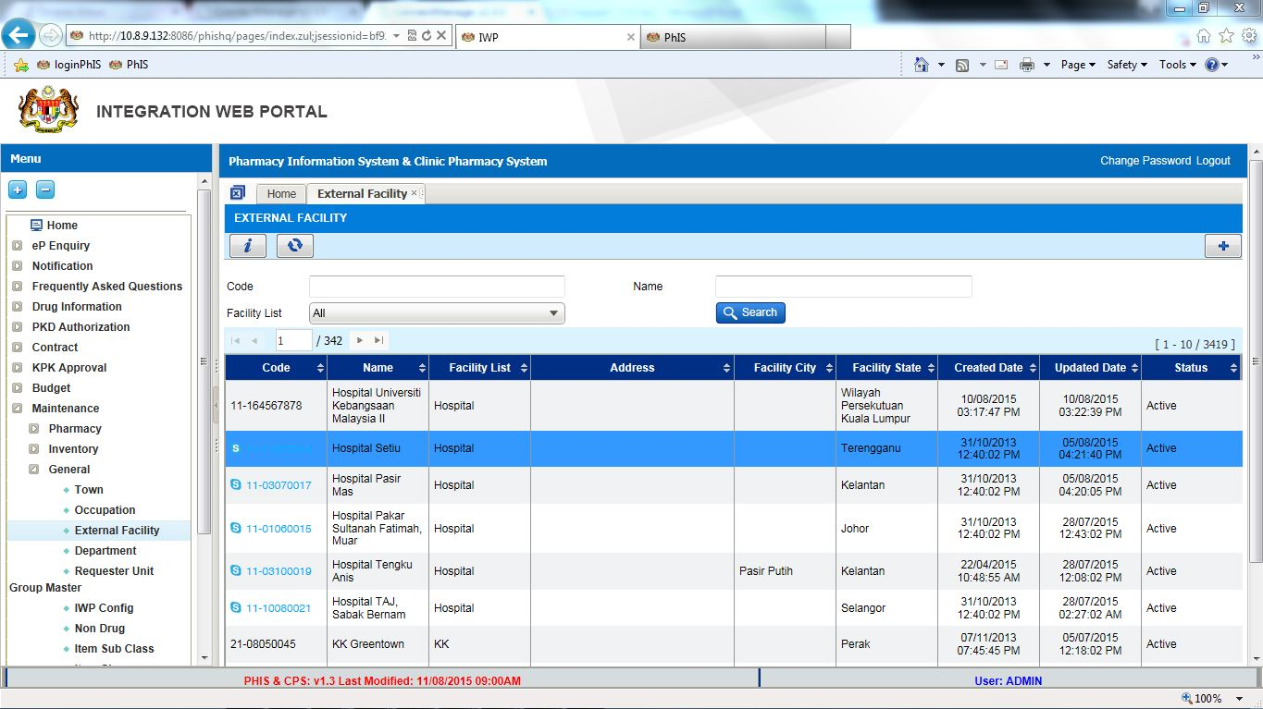

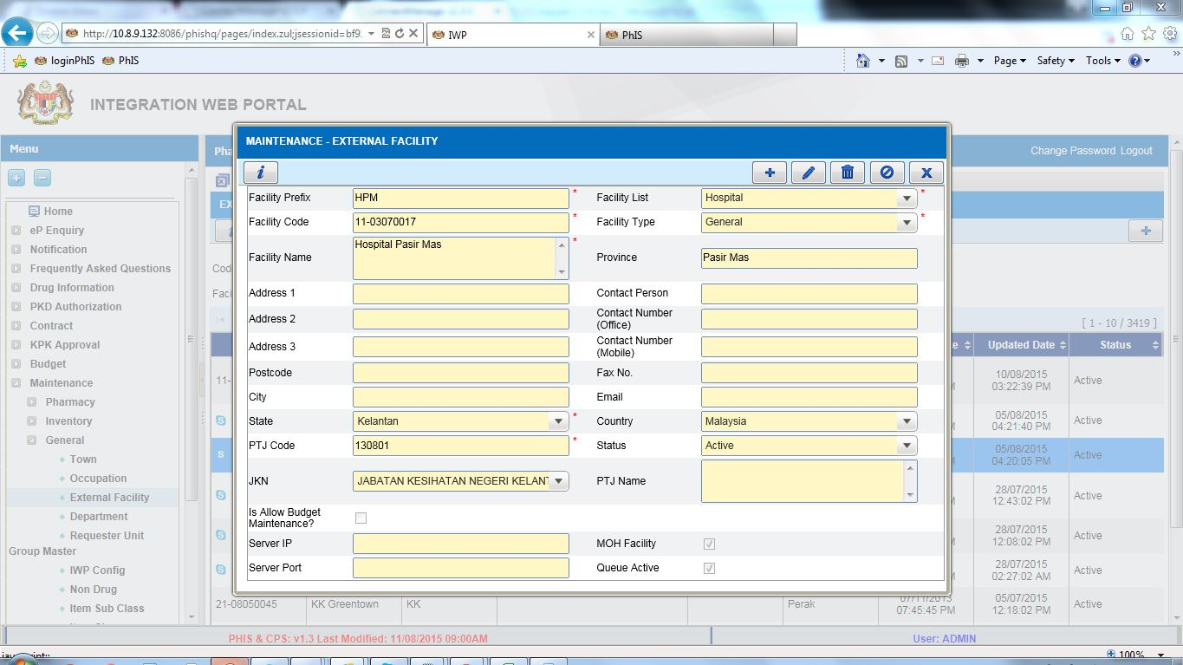

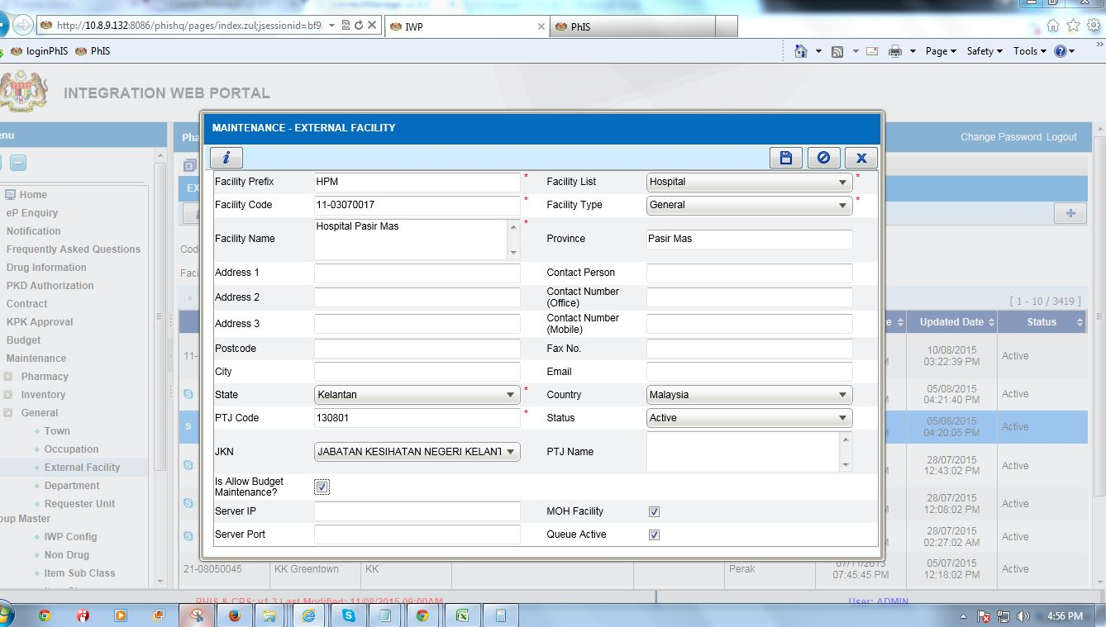

Pharmacy Inventory - Requester Unit
Ticket No | Module | Title | Description | Resolution
I-PhIS011856315S | Pharmacy Inventory | Request to block to create 2 requester unit for Main Store (Level 1) | Currently system didn’t block on this. It will impact on transaction created when having 2 requester unit catalogue | Add validation when creating requester unit for level 1

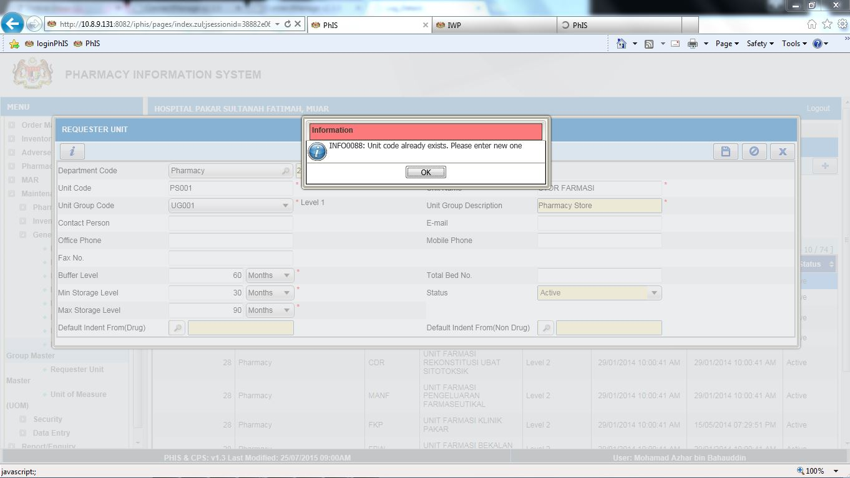

Pharmacy Inventory - Quotation
Ticket No | Module | Title | Description | Resolution
I-PhIS008479814S | Pharmacy Inventory | Quotation - Quotation status function | User request to inactive "Confirm" status function for wrong quotation that they had done, so they cannot proceed to purchase order transaction.For example, user keyed in wrong reference number but they cannot edit it. So they want to inactive it. | Add Cancel function for those confirmed Quotation.

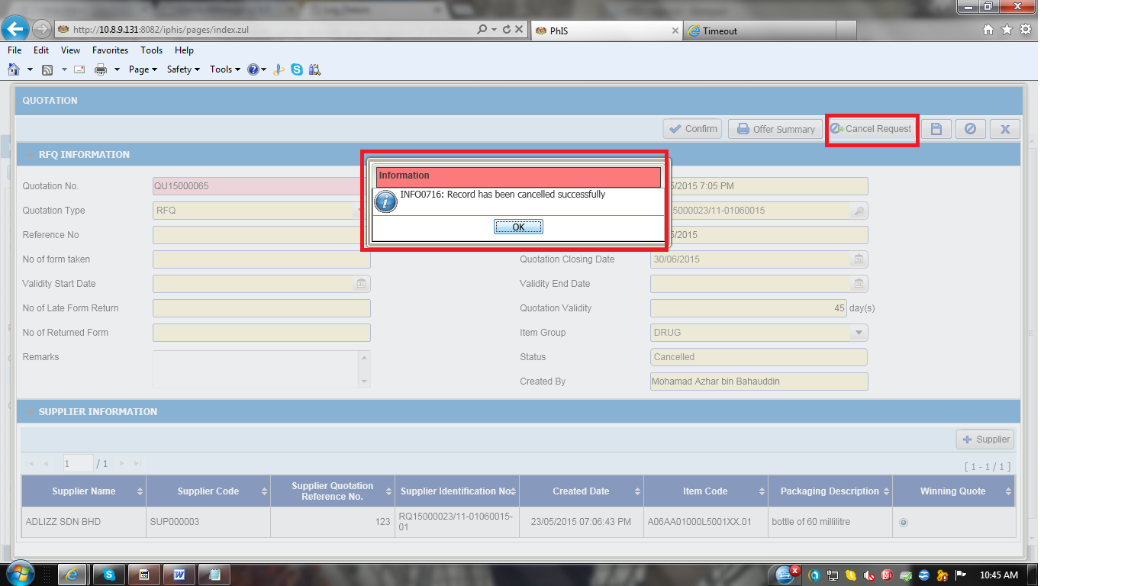

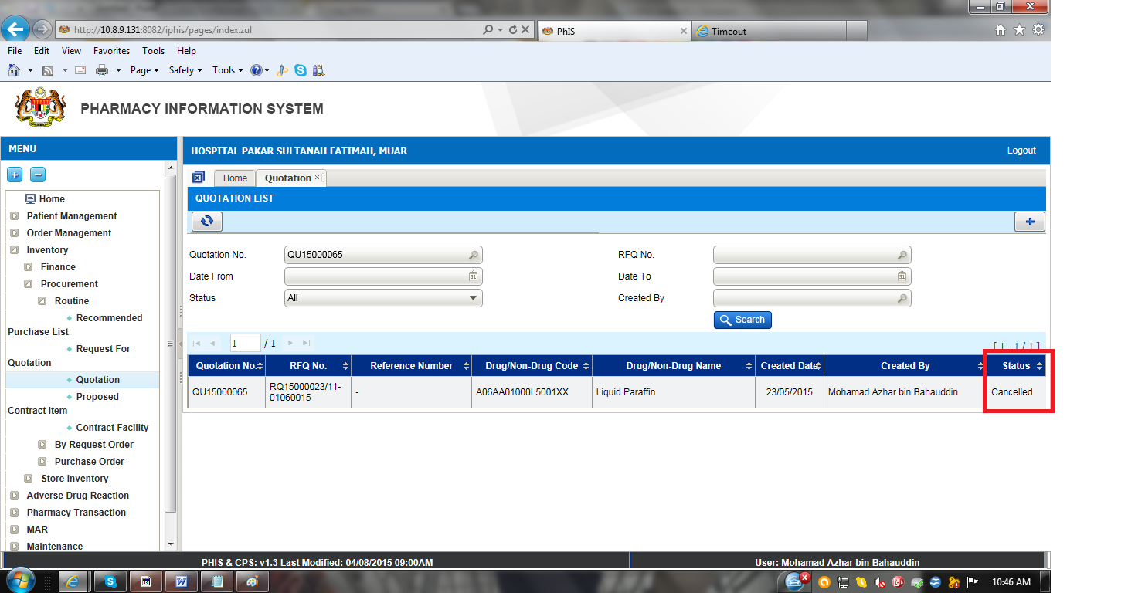
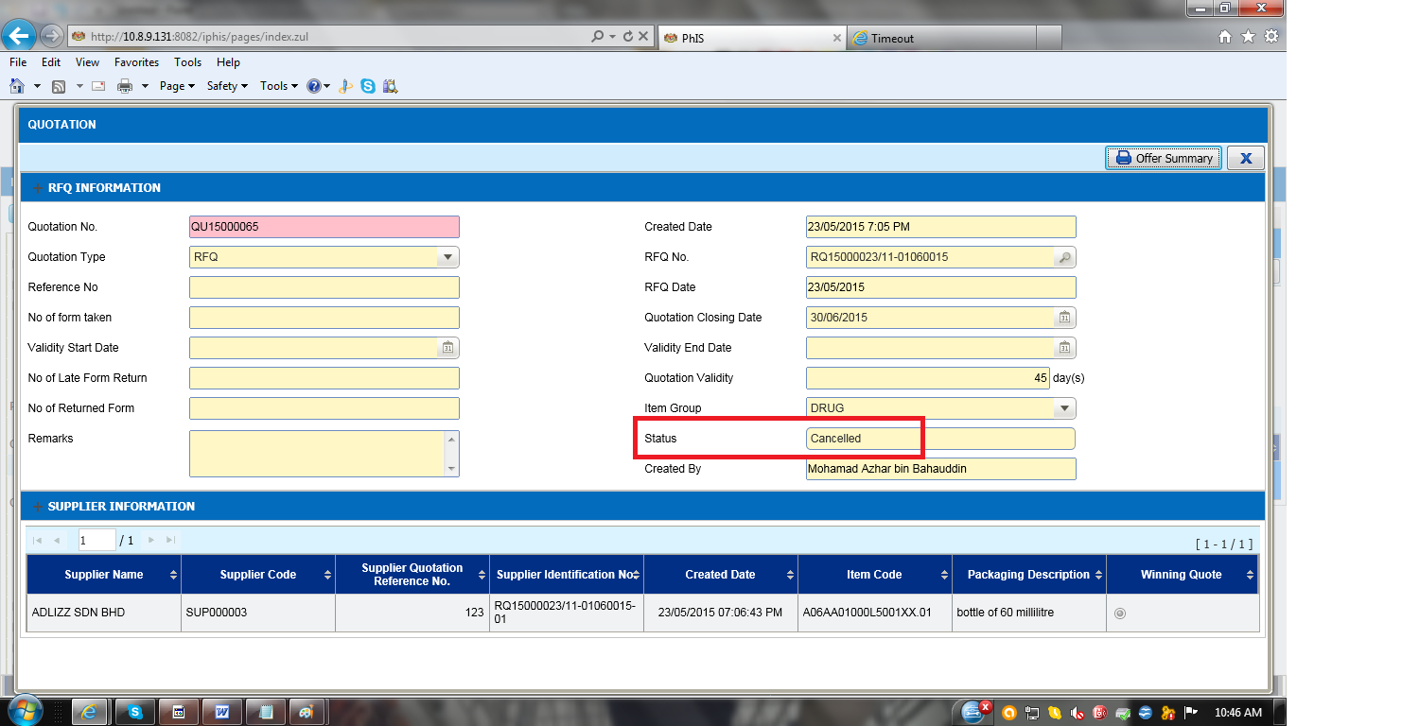

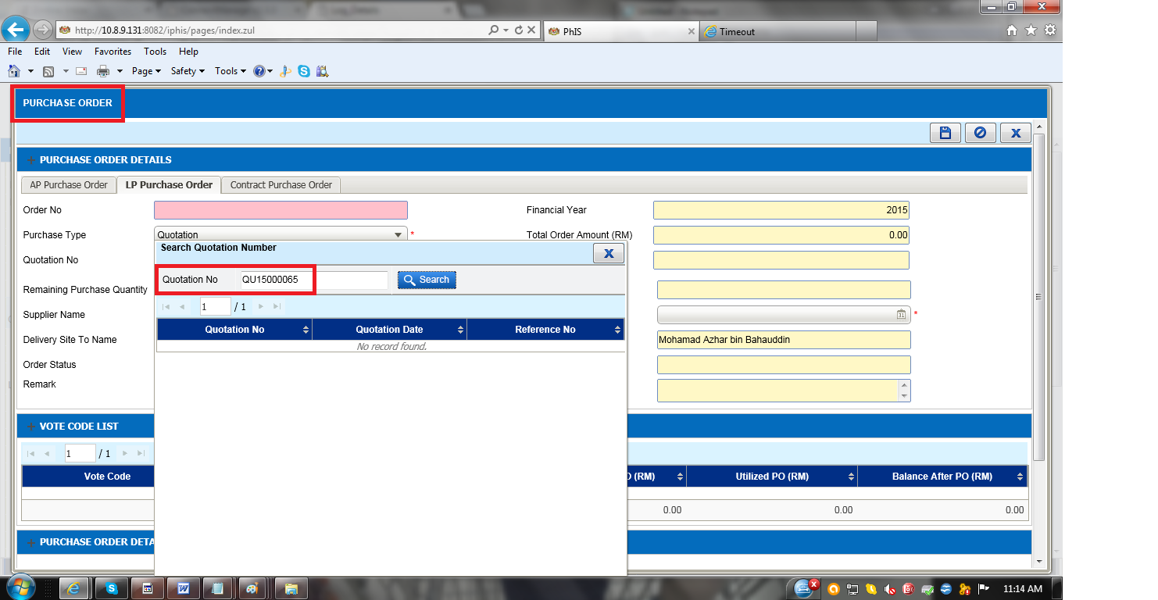

Report/Enquiry – Counselling Registry
Ticket No | Module | Title | Description | Resolution
UAT Log | Report/Enquiry | Enquiry (Medication Counselling) | Total no of counselling by each 'Pegawai'  Status counselling - order/reported/in progress/follow up.  Can generate report for 'No of patient was schedule' & 'no of patient not attend'. | As per Request

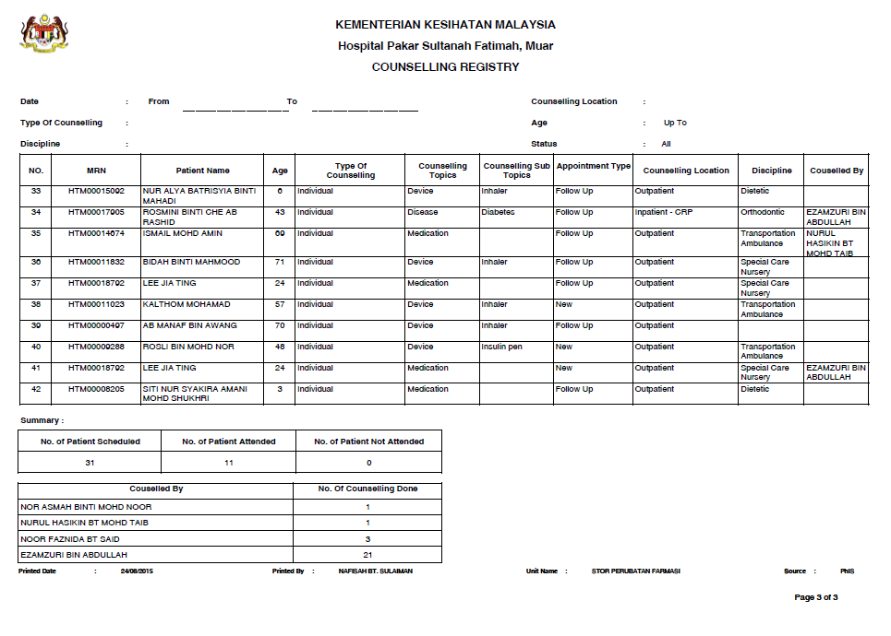

Report/Enquiry – Item/Product Buffer Level
Ticket No | Module | Title | Description | Resolution
I-PhIS008590615S | Report/Enquiry | Item/Product Buffer Level | Indicate whether the quantity is in PKU or SKU. | Display the UOM at the label

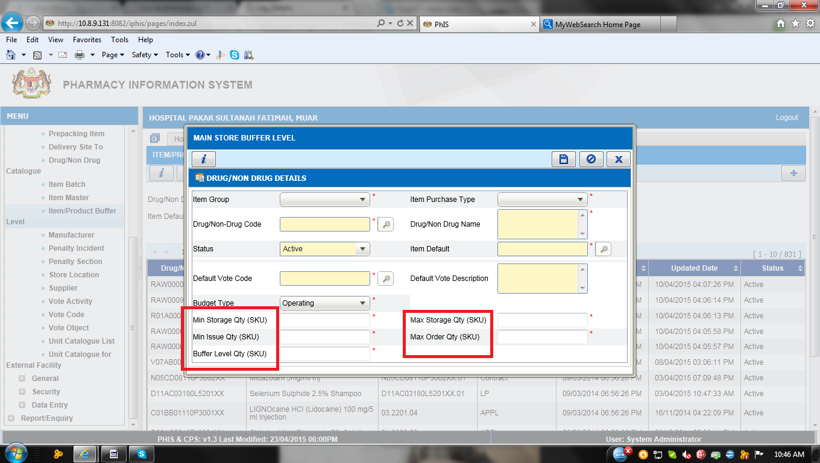

Report/Enquiry – Ward Stock Report
Ticket No | Module | Title | Description | Resolution
I-PhIS007349714S | Report/Enquiry | INV - Ward Stock Report | Changes out the listing page & report output  Listing Page  1) Dispense From make it drop down selection criteria and retrieve the value from dispense location table & the field is mandatory  2) Requesting Unit make it search band box and allow for user to select check box which requesting unit required  Report layout  1) Add in Total No Of Item  2) Total Cost (RM)  At the bottom section | As per request

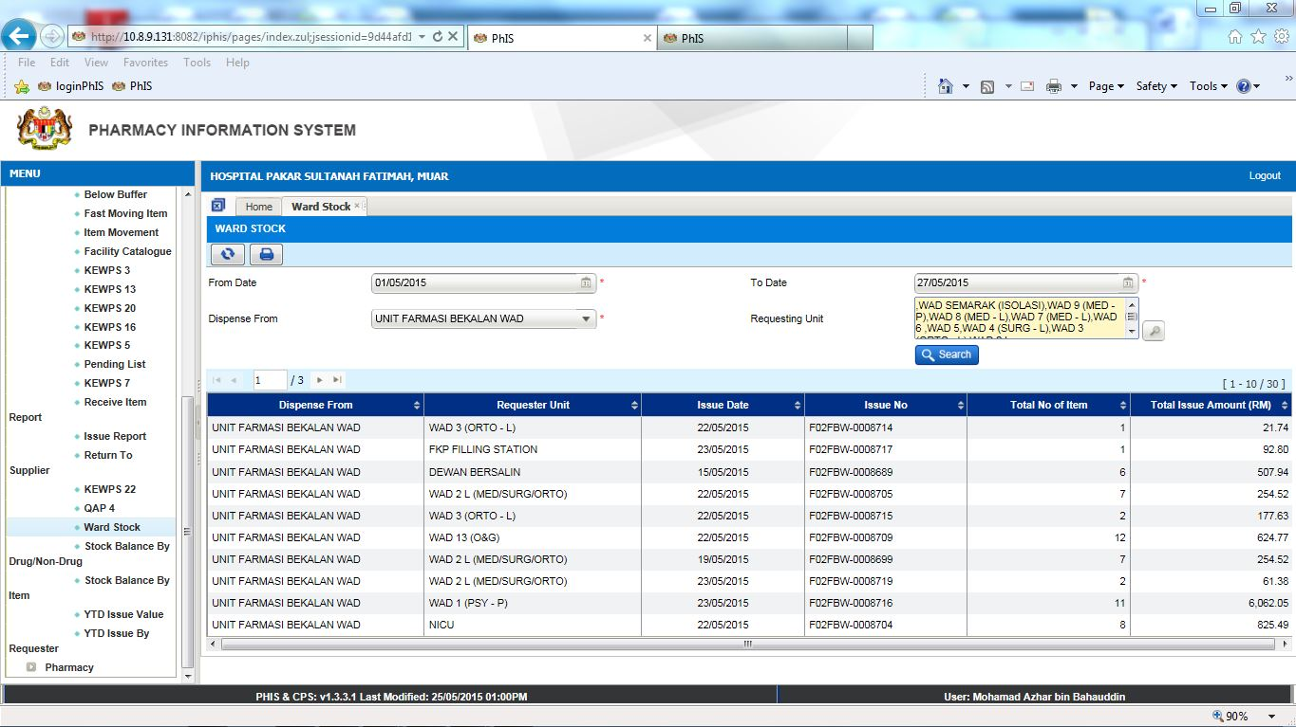

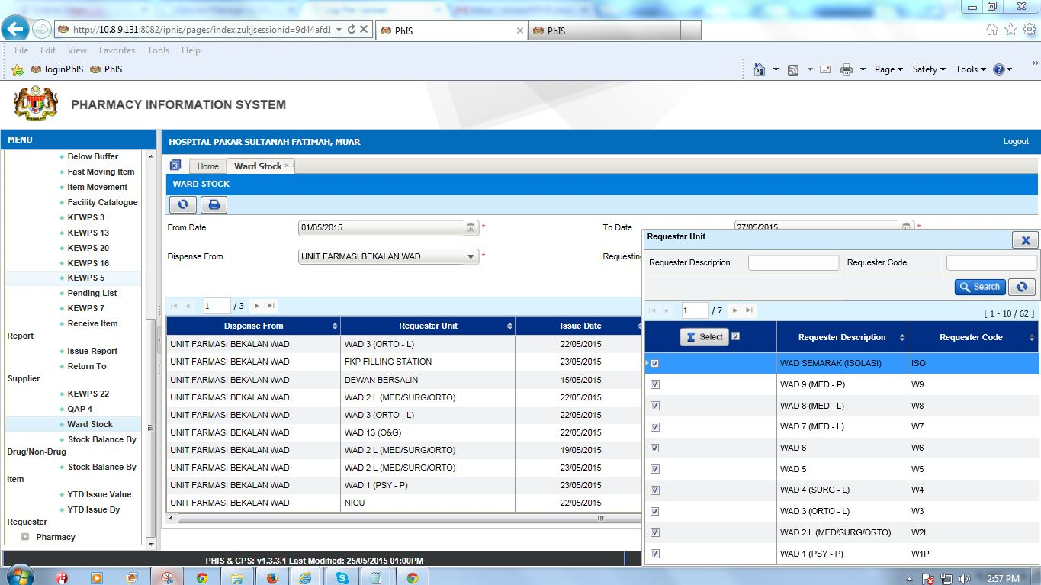

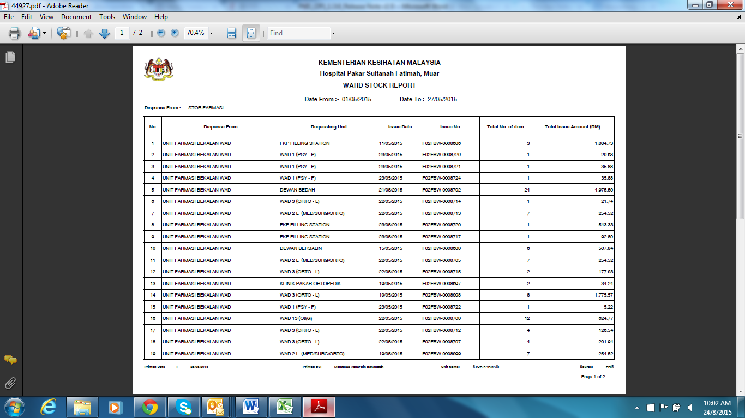

Report/Enquiry – KPI 2B
Ticket No | Module | Title | Description | Resolution
I-PhIS009822715S | Report/Enquiry | Laporan Tempoh Pendispensan Farmasi Pesakit Luar (KPI-2B) | 1. No. of Prescription - Quantity not accurate  2. No. of item - by drug, not by total quantity dispensed. | 1. The total number of prescription acknowledged with patient arrival. Group by date  2. Total number of drugs for the prescription acknowledged on that date.
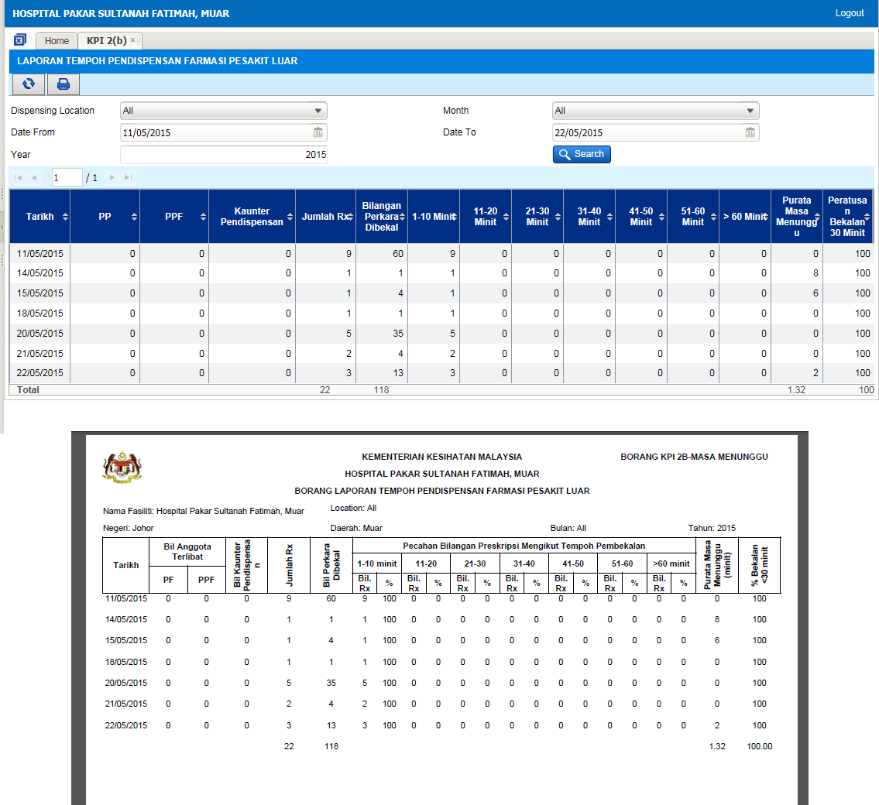

Report/Enquiry – Back Order Report
Ticket No | Module | Title | Description | Resolution
I-PhIS008606415S | Order Management - Web | Back Order Report | Request to provide option to select Financial Year for Back Order Report. Currently only have current financial year. | Change Financial Year field to selection field

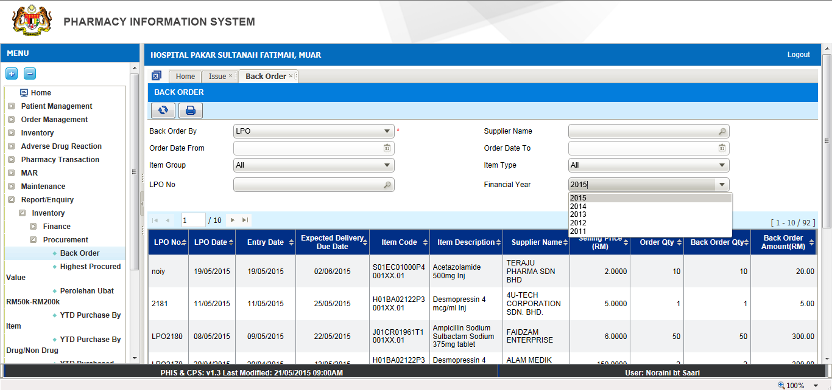

Note:

The solution for other requests are explained in quick guide document, please refer to the following quick guide document.

- PhIS_CPS_Quick_Guide_1.3.6_CDR - Label_v1.0
- PhIS_CPS_Quick_Guide_1.3.6_Counselling Order- Add word Time for button Schedule_v1.0
- PhIS_CPS_Quick_Guide_1.3.6_DICE - at HQ_v1.0
- PhIS_CPS_Quick_Guide_1.3.6_Extemp_Split Dose_v1.0
- PhIS_CPS_Quick_Guide_1.3.6_Galenical-Work Order_v1.0
- PhIS_CPS_Quick_Guide_1.3.6_Inventory v1.0
- PhIS_CPS_Quick_Guide_1.3.6_IWP v1.0
- PhIS_CPS_Quick_Guide_1.3.6_MAR_v1.0
- PhIS_CPS_Quick_Guide_1.3.6_MTAC – Diet & Lifestyle_v1.0
- PhIS_CPS_Quick_Guide_1.3.6_MTAC reporting - Change LFT_v1.0
- PhIS_CPS_Quick_Guide_1.3.6_OM_Med_Order_v1.0
- PhIS_CPS_Quick_Guide_1.3.6_OM_Mobile_IPOP_MaxDuration_v1.0
- PhIS_CPS_Quick_Guide_1.3.6_Pharmacist Note - To add character counts
- PhIS_CPS_Quick_Guide_1.3.6_Pharmacy_v1.0
- PhIS_CPS_Quick_Guide_1.3.6_Prepacking_SKU_PKU_v1.0
- PhIS_CPS_Quick_Guide_1.3.6_Print Allergy Card - Adjust data alignment_v1.0
- PhIS_CPS_Quick_Guide_1.3.6_TDM Order – Drug Search_v1.0
- PhIS_CPS_Quick_Guide_1.3.6_TDM Reporting – Toxic indicator_v1.0

Deployment - Procedures

List of Items to be Deployed
No. | Items | Components | Path
1 | HQ Patch Script | PatchScripts_IWP_v1.3.6.txt  PatchScripts_IWP_v1.3.6_Functions.txt | https://10.8.9.130:44330/svn/Workspace_Dataware/31_Implementation/Applications/PhIS ReleaseV1.3.6/hq/scripts
2 | HQ Application | phishq_v1.3.6.war | https://10.8.9.130:44330/svn/Workspace_Dataware/31_Implementation/Applications/PhIS ReleaseV1.3.6/hq/war
3 | HQ Patch Script | PatchScripts_PhIS_Immediate_v1.3.6.txt | https://10.8.9.130:44330/svn/Workspace_Dataware/31_Implementation/Applications/PhIS ReleaseV1.3.6/hq/war
4 | Facility Patch Script | PatchScripts_PhIS_v1.3.6.txt  PatchScripts_PhIS_v1.3.6_DataPatch.txt PatchScripts_PhIS_v1.3.6_Function.txt  PatchScripts_PhIS_v1.3.6_HPSF.txt PatchScripts_PhIS_v1.3.6_HSM.txt PatchScripts_PhIS_v1.3.6_HKM.txt PatchScripts_PhIS_v1.3.6_HTM.txt  PatchScripts_PhIS_v1.3.6_HMiri.txt  PatchScripts_PhIS_v1.3.6_HKulim.txt  PatchScripts_PhIS_v1.3.6_HRC.txt  PatchScripts_PhIS_v1.3.6_KKGT.txt | https://10.8.9.130:44330/svn/Workspace_Dataware/31_Implementation/Applications/PhIS ReleaseV1.3.6/facility/scripts
5 | Facility Application | iphis_v1.3.6.war | https://10.8.9.130:44330/svn/Workspace_Dataware/31_Implementation/Applications/PhIS ReleaseV1.3.6/facility/war
6 | Facility Application | PhISService_v1.3.6.war | https://10.8.9.130:44330/svn/Workspace_Dataware/31_Implementation/Applications/PhIS ReleaseV1.3.6/facility/war
7 | Mobile Application | ipadhosp-1.4.0b37-PhISDS.war | https://10.8.9.130:44330/svn/Workspace_Dataware/31_Implementation/Applications/PhIS ReleaseV1.3.6/Mobile

Backup Procedure before Deploy

Backup Procedure
Using backup tool, backup the following files and folder and database as per table below;
No. | Type | Backup Item | Description
1 | Application | /home/phisesb  /opt/phisesb  /usr/share/fonts/truetype | PhIS Integration Application  PhIS Core Application  Fonts required by PhIS
2 | Database | phisprod database | PhIS Live database

Deployment/Installation Guidelines

Deployment at Facility
Below table is described the deployment steps at Facility:
Step | Items | File Name | Source Path | Action
1 | Facility Patch Script | PatchScripts_PhIS_v1.3.6.txt  PatchScripts_PhIS_v1.3.6_DataPatch.txt PatchScripts_PhIS_v1.3.6_Function.txt  PatchScripts_PhIS_v1.3.6_HPSF.txt PatchScripts_PhIS_v1.3.6_HSM.txt PatchScripts_PhIS_v1.3.6_HKM.txt PatchScripts_PhIS_v1.3.6_HTM.txt  PatchScripts_PhIS_v1.3.6_HMiri.txt  PatchScripts_PhIS_v1.3.6_HKulim.txt  PatchScripts_PhIS_v1.3.6_HRC.txt  PatchScripts_PhIS_v1.3.6_KKGT.txt | https://10.8.9.130:44330/svn/Workspace_Dataware/31_Implementation/Applications/PhIS ReleaseV1.3.6/facility/scripts | Please ensure all the script is execute before iphis.war deploy.  Please ensure the script is executed in sequence. Script files 1 & 3 Execute as pgScript and other two Run as highlight the Script and press (F5)
2 | Facility Application | iphis_v1.3.6.war | https://10.8.9.130:44330/svn/Workspace_Dataware/31_Implementation/Applications/PhIS ReleaseV1.3.6/facility/war | Please rename the war file from iphis_v1.3.6.war to iphis.war then deploy.
3 | Facility Application | PhISService_v1.3.6.war | https://10.8.9.130:44330/svn/Workspace_Dataware/31_Implementation/Applications/PhIS ReleaseV1.3.6/facility/war | Please rename the war file from PhISService_v1.3.6.war to PhISService.war then deploy.
4 | Mobile Application | ipadhosp-1.4.0b37-PhISDS.war | https://10.8.9.130:44330/svn/Workspace_Dataware/31_Implementation/Applications/PhIS ReleaseV1.3.6/Mobile | Rename ipadhosp-1.4.0b37-PhISDS.war to ipadhosp.war and deploy.  Frontend Apps: 1.4.0r1t36  Backend Apps: 1.4.0b37

Deployment at HQ - IWP
Below table is described the deployment steps at HQ - IWP:

Step | Items | File Name | Source Path | Action
1 | HQ Patch Script | PatchScripts_IWP_v1.3.6.txt | https://10.8.9.130:44330/svn/Workspace_Dataware/31_Implementation/Applications/PhIS ReleaseV1.3.6/hq/scripts | Please ensure all the script is execute before phishq.war deploy.
2 | HQ Application | phishq_v1.3.6.war | https://10.8.9.130:44330/svn/Workspace_Dataware/31_Implementation/Applications/PhIS ReleaseV1.3.6/hq/war | Rename the war file from phishq_v1.3.6.war to phishq.war then Deploy using Glassfish Administration Console
3 | HQ Patch Script | PatchScripts_PhIS_Immediate_v1.3.6.txt | https://10.8.9.130:44330/svn/Workspace_Dataware/31_Implementation/Applications/PhIS ReleaseV1.3.6/hq/war | Execute this patch script in all current production facilities. Execute as pgScript.(F6) in pgAdmin. This file must run in all current production facilities immediate after release IWP, and this should be done with in 15 min span.

