Pharmacy Information System (PhIS)
and
Clinic Pharmacy System (CPS)

Release Note
For version 1.3.7

Version : 1.0
Document ID : PhIS_CPS/ReleaseNote/Refinement/05102015

© 2011-2015 Pharmaniaga Logistics Sdn Bhd (PLSB)

CONFIDENTIAL COPYRIGHTED MATERIAL – The information includes all concepts, comments, recommendations, and material, contained herein shall remain the property of Pharmaniaga Logistics Sdn Bhd (PLSB). No portion of this document shall be disclosed, duplicated or used in whole or in part of any purpose other than the purpose of the Pharmacy Information System & Clinic Pharmacy System (PhIS& CPS) Project execution only.

Revision History

Version No | Date of Release | Prepared by | Reviewed / Verified by | List of changes from Previous Version
1.0 | 05/10/2015 | Kee Tuan Hwa | Chew Ming Ping | First Version

Verified and Acknowledged by:
Name | Role/Designation | Organization | Signature & Date
Chew Ming Ping | Team Leader | Pharmaniaga Logistics Sdn Bhd
Hoh Choon Seng | Project Manager | Pharmaniaga Logistics Sdn Bhd

Name | Role/Designation | Organization | Signature & Date
 |  | Bahagian Perkhidmatan Farmasi (BPF), KKM
 |  | Bahagian Pengurusan Maklumat (BPM), KKM

Peer Review
Version No | Reviewed / Verified by | List Of Changes from Previous Version
1.0 | Juridah (QA) | Initial document

1 Introduction 1
1.1 Project Information 1
1.2 Objectives 1
2 Purpose 2
3 Summary – Refinement and Defect List 3
3.1 Refinement List 3
3.2 Resolved Defect List 11
4 Refinement List – Detail Changes 56
4.1 Adverse Drug Reaction – Print ADR Record 56
4.2 General Module – Item Batch 60
4.3 General Module – CDR Regimen 61
4.4 General Module – Drug Master 62
4.5 General Module – Drug Master 63
4.6 General Module – Brand 65
4.7 Manufacturing CDR – MAR Display 66
4.8 Manufacturing CDR – Regimen Status 71
4.9 Manufacturing CDR – CDR Cycle History 72
4.10 Manufacturing Extemporaneous – Alert Message 73
4.11 Manufacturing PN – Preparation 75
4.12 Manufacturing PN – Intervention 78
4.13 MTAC – Warfarin 80
4.14 Order Management – Stop Medication 82
4.15 Order Management – Medication Profile 85
4.16 Outpatient Pharmacy – Transcribe Order 88
4.17 Outpatient Pharmacy – Screening and Verification 89
4.18 Outpatient Pharmacy – Alternate Drug 91
4.19 Patient Management – Ward Management 93
4.20 Patient Management – Clinical Summary 93
4.21 Patient Management – Clinical Summary 94
4.22 Report/Enquiry – Stock Balance Report 95
4.23 Report/Enquiry – Issue Report 96
4.24 Report/Enquiry – YTD Purchase By Item 97
4.25 Report/Enquiry – PCI - CP3 Form 98
5 Deployment - Procedures 100
5.1 List of Items to be Deployed 100
5.2 Backup Procedure before Deploy 101
5.2.1 Backup Procedure 101
5.3 Deployment/Installation Guidelines 101
5.3.1 Deployment at Facility 101
5.3.2 Deployment at HQ - IWP 102

Introduction

Project Information

Project ID : | PhIS and CPS
Project Name : | Pharmacy Information System and Clinic Pharmacy System
Version No : | 1.3.7
Client Name : | Ministry of Health
Release ID : | RL15/010
Release Date : | 05/10/2015

Objectives
No. | Objective | Reference
1. | Release PhIS & CPS Application to Facility | Refer Section 3 – Refinement and Defect list

Purpose
The purpose of the document is to update the end-user of the changes and defects have been resolved to be included in the new version of application and will be deployed to production server.
This document outlines the list of request and issue to be delivered in the newer version of application and also the guidelines on how to deploy the new version of application in production.

Summary – Refinement and Defect List

Refinement List

The following refinement tickets to be delivered in PhIS ver 1.3.7.
No | Ticket No | Facility | Module | Reported Date | Title | Description | Resolution | Resolved Date | Verify Status
1 | I-PhIS012196215S | Hospital Seri Manjung | Adverse Drug Reaction (ADR) | 13/8/15 | Print Record ADR | "In report ADR , the form didn’t complete the column in System PHIS and Excel.  Last record in may have the column at suspected drug and concomitant drug. After that, the column didn’t show up.  Example  MRN : HSM00061059" | When ‘Drug type’ field has been selected system to auto check the check box.  Checked record will be display in the report printing according to the type (Suspected/ concomitant) | 1/10/15
2 | I-PhIS012216415S | Klinik Kesihatan Sungai Pelek | General Module | 17/8/15 | Item Batch - Quantity item still maintain at Bad Stock Quantity | User reported already change Batch Expiry Date from 28/2/2015 to 28/2/2018 but quantity item still maintain at Bad Stock Quantity. | 1. System should not allow to change expiry date once expired  2. System should allow to change the expiry date from as long not less than current date  3. system should not allow to change the expiry date if the batch already issue out | 5/10/15
3 | I-PhIS012126715S | Bahagian Perkhidmatan Farmasi (BPF) | General Module | 3/8/15 | CDR Regimen screen - Add search filter for the modules | User request add search filter by:-  a) Regimen Type | Add new search filter Regimen Type. List all values from ph_regimen_category. Default to ‘All’.  Once Category value is selected, display only regimen type applicable to the selected category. | 30/9/15
4 | I-PhIS012126815S | Bahagian Perkhidmatan Farmasi (BPF) | General Module | 3/8/15 | Drug master screen - Add search filter for the modules | Add search filter by:-  a. Dosage form  b. Item Sub Class | Add new filter Dosage Form, default value to empty. Dialog box to list all values in ph_dosage_forms.  Add new filter Item Sub Class, default value to All. Drop down to list all values from ph_item_subgroups. | 30/9/15
5 | I-PhIS012138815S | Bahagian Perkhidmatan Farmasi (BPF) | General Module | 5/8/15 | Drug Master - Request to add up to 2 decimal for Concentration in Extemp | In Drug Master, Extemp Preparation section, when adding new Extemp formula, to allow user to enter decimal up to 2 decimal for Concentration of Preparation field. Currently only can enter up to 1 decimal only.  Example preparation is Granisetron HCl 0.05mg/ml Oral Suspension. | As per user request | 14/9/15
6 | I-PhIS012278415S | Bahagian Perkhidmatan Farmasi (BPF) | General Module | 3/9/15 | Request auto generate when create new brand | Request auto generate when create new brand. In Brand Master, when creating new brand, to auto-generate brand code based on below:  i. Drug = DR(running no 8 char)  ii. Non Drug = ND(running no 8 char)  Validation for same Brand Code & Name: Cannot have duplicate code or name, regardless of capital letter or not. | Auto-generate brand code based on below: BRD(running no 7 char) | 30/9/15
7 | I-PhIS011202315S | Hospital Pakar Sultanah Fatimah | Manufacturing - CDR | 5/7/15 | Request in MAR to display D1, D8 instead of 2 days for CDR drug. | For CDR drugs, in MAR to display D1, D8 instead of 2 days. 2 days is confusing for staff nurse administration. Same applies to the printed Medication Chart. | MAR display D1, D8 instead of 2 days. In View MAR, MAR, and Medication Chart | 1/10/15
8 | I-PhIS009377815S | Bahagian Perkhidmatan Farmasi (BPF) | Manufacturing - CDR | 13/4/15 | CDR - Request CDR regimen sync to facility default HQ Status to Inactive | User request all CDR Regimen that sync to facility default HQ Status to Inactive | In HQ/IWP, create new record for CDR Regimen screen  Once record flow to facility, the Facility Status as above to display as Inactive. | 30/9/15
9 | I-PhIS009740815S | Hospital Pakar Sultanah Fatimah | Manufacturing - CDR | 12/5/15 | CDR Cycle History - Request layout header appear in new page | Request to change layout, header should be in new page in Cycle History report. | All columns should be dynamic based on the values. If got longer values should expand the columns.  Header part (Patient details and table header) should repeat in each printed pages. | 1/10/15
10 | I-PhIS008120514S | Klinik Kesihatan Maharani | Manufacturing - Extemporaneous | 19/11/14 | Request to disable the alert message when prepare Extemporaneous medication | Request to disable the alert message of Extemporaneous checked by; username & Password. | Remove the alert and can proceed without entering the Username and Password. Applicable for all screens, both full based and pharmacy based. | 30/9/15
11 | I-PhIS009706615S | Hospital Pakar Sultanah Fatimah | Manufacturing - PN | 11/5/15 | Preparation-Prepare worksheet sync with unit catalogue list | Expected result: Drug displayed on PN Worksheet should follow the setting in Unit Catalogue. Once drug inactive in Unit Catalogue, no need to display the drug in PN Worksheet. | when select item on preparing worksheet the item must be in unit catalogue list | 1/10/15
12 | I-PhIS008481814S | Hospital Pakar Sultanah Fatimah | Manufacturing - PN | 29/12/14 | Request to default intervention reason to ‘Others’ and auto-select Intervention Status as Accepted | Due to scenario for PN pharmacist where they may do multiple intervention to prepare the worksheet before proceed to prepare the PN bag. | Default Intervention Reason to Others  Default selection to Intervention Accepted  Others should be displayed on top of the list so that user can see the value is selected. Currently, Others is hidden at the end of the list.  Validation: If system didn’t find any value for Others, no need to default the value. Don’t display error message. | 30/9/15
13 | I-PhIS012270415S | Bahagian Perkhidmatan Farmasi (BPF) | MTAC | 1/9/15 | MTAC – Warfarin – Consent form: | User request to exclude MTAC Type – Warfarin from mandatory printing consent form. | After confirm order, system should allow to proceed for reporting screen without showing/popup the Consent Form. | 1/10/15
14 | I-PhIS010566315S | Hospital Tanah Merah | Order Management - Mobile | 21/6/15 | Order Management (IPAD) - Request to change function setting | User request to change function setting. As Doctor always click at "Yes" button but then this function will stop all other drug in prescription instead of selected one drug. Not User Friendly and confusing. | To change the message when stop or cancel current drug order.  Changes apply to both web and mobile. | 29/9/15
15 | I-PhIS012108515S | Klinik Kesihatan Greentown | Order Management - Web | 1/8/15 | Order Management - Pop up for stop order is not appropriate | Request to change the term "Yes/No/Cancel" to "One Drug (default) / All drugs / Cancel". Pop up for stop order is not appropriate. The pop up seems ask that "Are sure you want to stop the order" and doctors just click yes without read it untill finish because in fast way user don’t have time to read it all, but the actual pop up is to stop ALL drugs. This is so confiusing that many doctors accidently stop all drugs instead of stop single drug. | To change the message when stop or cancel current drug order.  Changes apply to both web and mobile. | 15/9/15
16 | I-PhIS009817215S | Bahagian Perkhidmatan Farmasi (BPF) | Order Management - Web | 1/4/15 | Medication Profile-Request Previous medication to sort by descending order | Request previous medication to sort by descending order (latest date)  *Apply to both current and previous medication.  ** Apply to web and mobile version. | As per request | 1/10/15
17 | I-PhIS012231715S | Hospital Kulim | Outpatient Pharmacy | 20/8/15 | Transcribe Order-Request no checking on wardstock for outpatient drug | User reported that she unable to perform favorite transcribe order for out patient due to drug listed as ward stock. | Do not auto-check on ward stock flag, if dispense location = OP.  User can manually check the ward stock flag if required.  1. enable the ward stock flag if drug is ward stock but do not auto check.  2. Do not copy any ward stock flag from previous record.  Apply to all scenario as below:  1. Add drug manually by enter the drug name  2. Add drug from advance search  3. Add drug from favourite list  4. Renew drug  5. Renew drug with different duration | 30/9/15
18 | I-PhIS008369814S | Hospital Kulim | Outpatient Pharmacy | 15/12/14 | Screening & Verification- Suggest for intervention Rx with function Modify Order | Suggest for intervention Rx with function Modify Order at Screening stage before click verify. | After user do intervention user can click on modify button. | 30/9/15
19 | I-PhIS012228915S | Hospital Miri | Outpatient Pharmacy | 9/8/15 | Request alternate drug between "Oral Chewable Tablet" and "Oral Tablet" | Alternate/combination, allow different dosage form. User want to alternate drug "Lamotrigine 50 mg Tablet" into "Lamotrigine 25 mg Dispersible/Chewable Tablet" but drug Lamotrigine 25 mg Dispersible/Chewable Tablet no in list alternate, because of Dosage Form is different | To allow user to choose different dosage form in alternate/combination.  When user select the drug from the list, please check on dosage form.  • If user select the main drug, the alternate drug should have same dosage form with main drug.  • if user not selecting main drug, user can select other dosage form. | 30/9/15
20 | I-PhIS009209915S | Hospital Pakar Sultanah Fatimah | Patient Management | 1/4/15 | Ward Management- Request to add column department. | User request add column department on ward management easier to view department for referral. | To add column department on Ward Management for easier to view department for referral | 14/9/15
21 | I-PhIS009210015S | Hospital Pakar Sultanah Fatimah | Patient Management | 1/4/15 | Patient Management - Clinical Summary - Add column department | User requested adding column information for department on clinical Summary on function visit list. | To add column department on Clinical Summary on function of visit list | 14/9/15
22 | I-PhIS009209815S | Hospital Pakar Sultanah Fatimah | Patient Management | 1/4/15 | Patient Management - Clinical Summary - Add column main visit/ referral | User request adding column information for main visit / referral on clinical summary on function visit list. | To add column main visit/Referral column on Clinical Summary on function of visit list | 14/9/15
23 | I-PhIS010952315S | Hospital Kulim | Report/Enquiry | 1/7/15 | Stock balance by drug and non drug - Changes on the report layout | User request to add column price | Add on column Unit Price (referring to Drug Average Price)  2. Amount (RM)  3. Standard and Non Standard | 4/10/15
24 | I-PhIS012271015S | Hospital Kulim | Report/Enquiry | 1/9/15 | Issue Report - add item purchase type (LP/APPL/Contract). | User request to add item purchase type which is (LP/APPL/Contract). | Change Request to add search criteria of Item Purchase type : All, APPL , LP & Contract | 5/10/15
25 | I-PhIS012270815S | Hospital Kulim | Report/Enquiry | 1/9/15 | YTD Purchase By Item - request changes to the report | User request to add on:  1.item group  2. Vote Code & Description  2. standard and non-standard  3. item purchase type  4. item group  5. item class.  6. item sub class  7. PKU  8. SKU  9.conversion factor. | As per request | 5/10/15
26 | I-PhIS011326315S | Hospital Kulim | Ward Pharmacy | 7/7/15 | Ward Pharmacy – PCI - CP3 forms: | 1) To add below item in PCI - CP3 forms  1. Dr’s stamp and sign  2. Wrong patient  3. Drug not in formulary  4. Drug administration error  5. Unclear handwriting  Referring to report PF 6.3 (b)  2) Outcome – change to 200 characters | As per request | 1/10/15

Verified and Acknowledged By:
Signature: |  | Name:
Date: |  | Designation:

Signature: |  | Name:
Date: |  | Designation:

Resolved Defect List
The following are the summary of resolved defect list that included in PhIS and CPS version 1.3.7.
No | Ticket No | Facility | Module | Reported Date | Title | Description | Root Cause/Analysis | Resolved Date | Verify Status
1 | I-PhIS012250415S | Bahagian Perkhidmatan Farmasi (BPF) | IWP | 25/8/15 | User profile - Click save shows error | User reported when edit the existing user profile hit the error Error 462.  User: Fayizatul Akmar | Message not created into IWP. Previously this message belongs to PhIS not IWP. As a resolutiuon, message already included into IWP | 4/9/15
2 | I-PhIS012276715S | Hospital Besut | General Module | 3/9/15 | Store location-Cannot add new store location | User reported cannot add new store location. When user click add button and search unit available but only appear 14 units and the one user want to select not available in the list. User inform it should have 17 units available. Check in requested unit master all units available and status active. | Requester Unit's Department have a flag for patient visit. The bandbox showing all those units which have value 'Y' for this flag. | 4/9/15
3 | I-PhIS012258715S | Hospital Besut | Pharmacy Inventory | 27/8/15 | Store Location - Only display 7 requester code when click search button | User report only display 7 Requester Code when search Unit Code at Store Location. | Requester Unit's Department have a flag for patient visit.  When add new store location, while search the unit system will only those units which have value 'Y' for this flag. | 8/9/15
4 | I-PhIS012409915S | Hospital Besut | Pharmacy Inventory | 28/9/15 | RPL - Usage & Issue Quantity incorrect | User Pn.Azlina reported in RPL screen for column Usage & Issue Quantity, for example shows 12 but when click in details the Issue quantity shows 10 and Usage 0. | Issue qty calculated by login requester unit as well indent drug/Nondrug requester units.  Expected is only Rpl Creator requester unit need to consider. | 30/9/15
5 | I-PhIS012441015S | Hospital Besut | Pharmacy Inventory | 1/10/15 | Item / Product Buffer Level - Item appear is wrong category. | User reported item appear is wrong category  Item is contract but appear LP  A01AB01000P5001C  B05CB10955M4001xx  N07BC02110L9001xx | Product Buffer level listing got issue, its showing all items belongs to Drug instead of only default item. | 2/10/15
6 | I-PhIS012242015S | Hospital Hulu Terengganu | Pharmacy Inventory | 23/8/15 | Purchase Order- Item contract price not updated in system | User reported unit price for item code J01DC02233T1001XX.01 in Purchase Order screen shows as RM14.82. Suppose the price is RM14.76 as mentioned in Contract for Facility screen. Kindly refer File Upload for further details.  Item: Cefuroxime Axetil 125mg Tablet  Item Purchase Type: Contract  KKM Code Contract Ref No: KKM-58/2013/F(U)  Item code: J01DC02233T1001XX.01  ID: 840120115016 | Currently in contract purchase order item price was refer to the contract no. will old revision no. | 26/8/15
7 | I-PhIS012251515S | Hospital Hulu Terengganu | Pharmacy Inventory | 25/8/15 | Contract purchase order-Price not tally | User reported unit price for item code J01DC02233T1001XX.01 in Purchase Order screen shows as RM14.82. Suppose the price is RM14.76 as mentioned in Contract for Facility screen. Kindly refer File Upload for further details.  Item: Cefuroxime Axetil 125mg Tablet  Item Purchase Type: Contract  KKM Code Contract Ref No: KKM-58/2013/F(U)  Item code: J01DC02233T1001XX.01  ID: 840120115016 | Currently in contract purchase order item price was refer to the contract no. will old revision no. | 26/8/15
8 | I-PhIS012363515S | Hospital Kapit | Pharmacy Inventory | 18/9/15 | External Indent - RIL only generate 0 quantity item | User Miss Evangelin reported that she had generate RIL in Indent screen but the indent list generate item with 0 stock available quantity supposed should generate item that below buffer level. | Logic issue:- null value case was not handled for Pending receive Quantity at the time of generating RIL | 30/9/15
9 | I-PhIS012393115S | Hospital Kapit | Pharmacy Inventory | 23/9/15 | Online Issue - Price not appear in Borang Pesanan dan Pengeluaran Stok | 1.User report price not appear when he print Borang Pesanan dan Pengeluaran Stok as attachment in File Upload.  2.It happen to to all drug and non drug.  3.Problem happen when user do internal indent for intra facility.  4. User also tried offline issue and price come out as attachment in File Upload. | This is master data issue. Patches provided for mentioned transaction | 1/10/15
10 | I-PhIS012372115S | Hospital Kemaman | Report/Enquiry | 21/9/15 | Payment Summary List-Unable to search Payment Summary List by Date Range | Reported that no record found when search Payment Summary List by Date Range , but able to record exist if search by YTD.  Scenario:  1). Date Range : Date Range  From Date :20/9/2015 To Date: 20/9/2015  Result : No record found (Refer screenshot 1)  2). Date Range : Date Range  From Date :20/9/2015 To Date: 21/9/2015  Result : Record exist (Refer screenshot 2)  3). Date Range : Date Range  From Date :19/9/2015 To Date: 20/9/2015  Result : No Record found (Refer screenshot 3)  4). Date Range : YTD  Result: Record exist (Refer screenshot 4). | YTD date range was not correctly applied for search | 23/9/15
11 | I-PhIS012317615S | Hospital Kulim | Manufacturing - CDR | 9/9/15 | CDR Record Retrieval - Unable to print label at Dispensing History | Cannot print label, screen display blank page.  Reported by: Heng Zhi Yee  Module: Manufacturing - CDR  Location: Hospital Kulim Farmasi Bekalan Wad  Time: 10.00 AM,9/09/2015 | In preparation and dispensing for label printing getting records from cdr dose frequency where supply status not close.  After dispensed the status is changed to Close. So that in Record retrieval is not displaying. Now Changed the logic not consider the supply status in Record Retrieval. | 11/9/15
12 | I-PhIS012167015S | Hospital Kulim | Outpatient Pharmacy | 9/8/15 | Dispensing - Incorrect dosage unit mentioned at label | User reported label printed incorrect dosage unit for drug Glycerin 25%, Sodium Chloride 15% Enema, 20ml (Ravin). User claimed if she select dosage in ml there is no issue. However, if she select dosage in tube, the label mentioned incorrect unit.  Example :  If user choose 20ml in label mentioned 20ml/1 tube.  If user choose 1 tube in label mentioned 1ml/0.05 tube  ID: 800502075172 | For drug with 'value to be displayed' are quantity and strength, wrong dose will displayed when ordered by quantity since system will always put the ratio compared between quantity and strength | 23/8/15
13 | I-PhIS012293915S | Hospital Kulim | Outpatient Pharmacy | 8/9/15 | Transcribe order-Unable to click proceed to dispense, Drug allocate fully supply. | User report when transcribe order for patient partial supply and click proceed to dispense, Drug allocate fully supply.  User id:871231146132 | Code pass wrong flag and system always do fully allocate everytime user check on Proceed To Dispense checkbox. | 8/9/15
14 | I-PhIS012232015S | Hospital Kulim | Ward Pharmacy | 20/8/15 | CP1 - Score divide not correctly for Morisky scale | User reported at Ward pharmacy for Morisky scale : score divide not correctly for question number 8.  Never /rarely: 1 score  One in while: 0.75score  All the time: 0.5score  Sometimes: 0.25score  Usually: 0 score  User id : 840815065668  Time : 12.00 am  Date : 19/08/15 | CP1 - Score divide not correctly for Morisky scale | 26/8/15
15 | I-PhIS012424815S | Hospital Miri | Clinical Pharmacokinetic Services (CPS) & TDM | 30/9/15 | TDM - TDM order received by pharmacy was delayed | TDM order which was made at 2.50pm 25/9/15 by Dr. David Lee, witnessed by TDM pharmacist, was not received by pharmacy until 4.15pm 25/9/15. The reporting was delayed as the pharmacist needed to wait for the doctor to make a new order. | The Order created by the doctor flow to the TDM verification screen (pharmacist). Fixed in latest version. | 30/9/15
16 | I-PhIS012220315S | Hospital Miri | Inpatient Pharmacy | 17/8/15 | Preparation - Partially dispensed drug display as fully dispense | All the patient status are wrong.  Which is the true status are partially dispend changed to fully dispend  PARTIALLY DISPEND ---> FULLY DISPEND  MRN :  HSM00082288  HSM00081080  HSM00055280  HSM00083311  HSM00083137  HSM00052229  HSM00062358  HSM00074054  Name : Zuraidah Binti Mat Adam  ID: 811129115386  Time Happen: 11.00 AM | The problem is one condition of calculate the current date and order end date time of drug is wrong, then it makes the complete checkbox is checked and dim, then the drug will be considered as fully dispensed. e.g: the order end date time is 20th August, so if today is 18th, then the date interval is calculated wrong and has value is 1, then system will auto check the complete checkbox. That's why this problem is only happend for IP and at last round. | 25/8/15
17 | I-PhIS012229115S | Hospital Miri | Inpatient Pharmacy | 19/8/15 | Dispensing - Prescription disappear at dispensing screen | User reported prescription (Esomeprazole 40mg bd) disappear at dispensing screen. User confirmed she already prepared for this prescription and checked on Record Retrieval status are prepared.  User ID: 821125-13-5434 | patched the data to change drug status to Fully Dispensed. | 24/8/15
18 | I-PhIS012248315S | Hospital Miri | Order Management - Web | 25/8/15 | Medication Order - No response when click Add | User reported unable to add drug for patient. Previously already order the same drug but doctor stop the order. Try create new order. Able to research and select drug. When click add, page not responding and drug not added.  MRN: 69836  Drug: Ampicillin 1g + Sulbactam 500mg Inj  Dosage: 1200 mg  Route: Intravenous  Frequency: Q6H | Root Cause : Changed the logic added condition if STAT frequency is allow duplicates allow to add the drug otherwise stop the current active STAT drug and add new one.  PROBLEM ALSO HAPPENED WHEN USER ADD STAT FOR NEW ORDER AFTER CHOOSE NORMAL FREQUENCY FOR PREVIOUS ORDER.ALERT ON CHECKING ACTIVE MEDICATION IS DISPLAYED. | 27/8/15
19 | I-PhIS012255515S | Hospital Miri | Order Management - Web | 26/8/15 | Medication Order - Doctor able to order same drug in the same duration | User reported doctor able to order same drug in the same duration. This should not be happen because it will cause medication error. At Drug Master screen 'Allow Duplicate Order' not tick.  RX: FSW0000002828, duration 23/08/2015-28/08/2015  RX: FSW0000002777, duration 21/08/2015-26/08/2015  Drug: Captopril 25 mg tablet  Frequency: TDS | In Manage Order modify the drug validation is not there for the drug if active drugs are there in other prescriptions.  Now the validated added in Manage Order Modify and Normal Authorisation Drug Modify. | 8/9/15
20 | I-PhIS012262215S | Hospital Miri | Order Management - Web | 28/8/15 | Medication Order- Unable to search drug | User reported unable to search drug Acycolvir 250mg/10ml Inj when he using web (PC). He only can order that medication when using mobile (Ipad).  MRN: HMIRI00136409  Drug: Acycolvir 250mg/10ml Inj  ID: 860926526121  time: 9:30AM | Cross checked the with web query seems okay. After fixes done by web cannot reproduces the issue. | 15/9/15
21 | I-PhIS012158915S | Hospital Miri | Outpatient Pharmacy | 8/8/15 | Record Retrieval - Order disappear after Release Batch. | User reported after Release/Discard Batch 1 drug order at screen Dispensing, the ordered has not appear at any screen  ID : 811112135276  Username : Mrs Loi Mee Hua  Time Incident Happened : 4.30 PM | Queue ordered is not activated back after release batch | 23/8/15
22 | I-PhIS012229015S | Hospital Miri | Outpatient Pharmacy | 19/8/15 | Screening & Verification - Cannot find patient | 1.User already acknowledge Patient at Acknowledge screen.  2.User key in queue detail, tick patient arrive and click Acknowledge.  3.After that patient is missing. Check at clinical summary, drug status Acknowledged & ordered for same Rx.  4. One of the druq already expired.  5.When check at Screening & verification & Acknowledge Screen, no record found.  Name : LOI MEE HUA  ID: 811112135276  Time happen : 1230 | Data patching to enable patient record in Acknowledgement & Screening listing. | 24/8/15
23 | I-PhIS012255215S | Hospital Miri | Outpatient Pharmacy | 26/8/15 | Screening & Verification - Missing Patient Rx | After user click verify at stage Screening & Verification, Rx patient missing. User already check at preparation screen and dispensing screen still not found. Kindly refer File Upload for further details.  User ID: ID: 811112135276  Time Incident Happen: 1536  MRN: HMIRI00126299 | The searching function for tapered drug inside Preparation and Dispensing listing is not correct and Ordered/Hold drug is not correctly displayed in Screening screen after partial dispensed. | 7/9/15
24 | I-PhIS012265515S | Hospital Miri | Outpatient Pharmacy | 30/8/15 | Order quantity is different with original prescription | User report order quantity in the original prescription is not tally with the order quantity in prescription in the order as attachment in File Upload.  ID : 811112135276  Username : Mrs Loi Mee Hua | After change the frequency, previously system calculate the order quantity assigned to order_qty field only but not assigned the calculated order quantity to order_qty_ori field. Suppose is should be recorded into both values after adding drug. After fixing the code, it is assigned to order_qty_ori field also. | 3/9/15
25 | I-PhIS012322415S | Hospital Miri | Outpatient Pharmacy | 10/9/15 | Dispensing - unable to click button SPUB at dispensing stage | User unable to click button SPUB at dispensing.  Name: Loi Mee Hua  User ID: 811112135276 | Patient is unknown patient. That is why SPUB checkbox is disabled means user cannot send online SPUB for unknown patient. Fixing the code if the patient is suddenly unknown then changed to known patient, then SPUB checkbox should be enabled. | 18/9/15
26 | I-PhIS012295915S | Hospital Miri | Pharmacy Inventory | 8/9/15 | Manual receiving - Unable to do receiving By level 2 & level 3 | User reported unable to do manual receiving due to shows error 'no stock available against this drug'. | There was an validation to check available quantity of supplying unit should be greater requesting quantity | 15/9/15
27 | I-PhIS012328415S | Hospital Miri | Pharmacy Inventory | 10/9/15 | Issuing - Manual receive screen, stock available is not tally with stock available in unit catalog | User want to do stock replenish to level 3, found level 2 no stock. Hence to do manual receive (Level 2) from level 1. The manual receive screen said that the item has stock but checked in unit catalog satellite pharmacy level 2, its has no stock. However manual receive can be done, hence no screen shot to prove the unit catalog Satellite Pharmacy has no stock.  Item code: 07.2401.04  User ID : 821125-13-5434 | There was an validation to check available quantity of supplying unit should be greater requesting quantity  Patch data | 21/9/15
28 | I-PhIS012343615S | Hospital Miri | Pharmacy Inventory | 15/9/15 | Receive Item -Cant do manual receive for all item | Cannot do manual receive even the receive from unit have stock. User have tried receive from other level 2, also giving the same pop up. | There was an validation to check available quantity of supplying unit should be greater requesting quantity | 15/9/15
29 | I-PhIS012349915S | Hospital Miri | Pharmacy Inventory | 16/9/15 | Receive item-Cannot do manual receive | The user already fill the information that needed at receive item for intra facility, after that user click save button for proceed to next step, then the pop up button appear( no stock available against this drug )  User id:891210136398 | Qc : There was an validation to check available quantity of supplying unit should be greater requesting quantity | 17/9/15
30 | I-PhIS012224715S | Hospital Miri | Report/Enquiry | 18/8/15 | Prescription Management - Negative waiting time | User check on report, some of the patient have negative at Waiting Duration. Kindly refer File Upload for further details.  User: Loi Mee Hua  ID: 811112135276  Time Incident Happen: 1000 | Duration Wating is negative because queue_end_datetime is greater than queue_start_datetime. | 25/8/15
31 | I-PhIS012271315S | Hospital Miri | Report/Enquiry | 1/9/15 | Receiving - Error when click save button | User already fill the information that needed,but when User click the search button the pop up error appear (An error has occurred.Please contact your system administrator)  Time Incident Happened : 04.10 PM  ID : 89051815169  Name : Mr Ong Sang Geng | There was present unnecessary code to sort the result of report. That code has technical issue for blank LPO number. | 8/9/15
32 | I-PhIS012279415S | Hospital Miri | Report/Enquiry | 3/9/15 | Report SPUB Activities - No data for the total cost of item supplied | Report/Enquiry > Pharmacy > OP/IP > SPUB Activities  User reported no data for the total cost of item supplied. Kindly refer File Upload for further action.  ID: 821125135434 | Wrong query for Total Cost of Item Supplied | 15/9/15
33 | I-PhIS012362515S | Hospital Miri | Ward Pharmacy | 18/9/15 | CP1-Different item appear | User inform balance from previous supply for patient's previous medication such as IV ampicillin 1g+sulbactam 500mg show up as 11mg and Ascorbic acid 7mg.  085420033 EXT 141/163 | CP1-Wrong UOM displayed in PCI previous medication | 2/10/15
34 | I-PhIS012294115S | Hospital Pakar Sultanah Fatimah | Clinical Pharmacokinetic Services (CPS) & TDM | 8/9/15 | TDM-Serum creatinine print out jump to creatinine clearance | Doctor fill in serum creatinine but when print out it will jump to creatinine clearance, happened to all patient  User id: 750214015762 | The Serum creatinine & creatinine clearance value display in wrong column when print eport. | 29/9/15
35 | I-PhIS012329015S | Hospital Pakar Sultanah Fatimah | Inpatient Pharmacy | 11/9/15 | Screening & Verification- Patient Record did not flow | User reported patient record (inpatient) did not flow to satellite pharmacy.  Details Provided by user :  MRN : HPSF0000115329  ID : 891031145803  Name : Ms Huzaifa  Time Incident Happened : 4.00PM  Date : 10.09.2015  Drug ordered :  1)Aerosofine  2)celecoxite  3)deseloratadine  4)oxymetazoline nasal spray | Because It dont have data in ph_dispensing. | 21/9/15
36 | I-PhIS012321415S | Hospital Pakar Sultanah Fatimah | MAR - Web | 9/9/15 | MAR- Order ferquency CONt show freq PRN | User reported order frequency CONt, appear freq PRN at record function.  Pt mrn: HPSF00034871  Drug Name: Adrenaline Acid Tartrate 1mg/ml Inj  Username: Noraini bt Saari  Userid: 750214015762  Time Incident: 9/6/2015 4:44  Step: MAR > Medication Administration Record | Previously system display based on MAR Type inside record function. In Frequency table, MAR Type for frequency CONT is PRN. | 15/9/15
37 | I-PhIS012321515S | Hospital Pakar Sultanah Fatimah | MAR - Web | 9/9/15 | MAR- Drug not appear for next day. | User reported rdered drug for 5 day but appeared only for 1 day, 1st day prescribe by doctor.  Patient MRN : HPSF00034871  Drug Name : Tramadol HCl 50 mg Capsule  50 mg , PRN, Oral  5 Days [09/09/2015-14/09/2015]  Username: Noraini bt Saari  Userid: 750214015762  Time Incident: 9/9/2015 4:54 | Wrong code on PRN | 17/9/15
38 | I-PhIS012373615S | Hospital Pakar Sultanah Fatimah | MAR - Web | 21/9/15 | MAR - Unit weight not appear in drug chart | User reported when when print drug chart, unit weight not appear the kg . | Logic yet to implement | 22/9/15
39 | I-PhIS012236015S | Hospital Pakar Sultanah Fatimah | Order Management - Web | 20/8/15 | Medication Order - Cannot add drug | User reported cannot add drug. No response when click on Add button.  Drug names : augmentin, maxolon  MRN: 43916  Staff id: 891121045566 | Root Cause : Changed the logic added condition if STAT frequency is allow duplicates allow to add the drug otherwise stop the current active STAT drug and add new one.  PROBLEM ALSO HAPPENED WHEN USER ADD STAT FOR NEW ORDER AFTER CHOOSE NORMAL FREQUENCY FOR PREVIOUS ORDER.ALERT ON CHECKING ACTIVE MEDICATION IS DISPLAYED. | 7/9/15
40 | I-PhIS012241215S | Hospital Pakar Sultanah Fatimah | Order Management - Web | 22/8/15 | Medication Order - Page not responding after click add at medication order | User reported unable to add drug for patient. Previously already order the same drug but doctor stop the order. Try create new order. Able to research and select drug. When click add, page not responding and drug not added.  MRN: 69836  Drug: Ampicillin 1g + Sulbactam 500mg Inj  Dosage: 1200 mg  Route: Intravenous  Frequency: Q6H | Root Cause : Changed the logic added condition if STAT frequency is allow duplicates allow to add the drug otherwise stop the current active STAT drug and add new one.  PROBLEM ALSO HAPPENED WHEN USER ADD STAT FOR NEW ORDER AFTER CHOOSE NORMAL FREQUENCY FOR PREVIOUS ORDER.ALERT ON CHECKING ACTIVE MEDICATION IS DISPLAYED. | 27/8/15
41 | I-PhIS012242015S | Hospital Pakar Sultanah Fatimah | Order Management - Web | 21/8/15 | Medication Order- Unable to add drug | User reported unable to add drug for patient. Previously already order the same drug but doctor stop the order. Try create new order. Able to research and select drug. When click add, page not responding and drug not added.  MRN: 69836  Drug: Ampicillin 1g + Sulbactam 500mg Inj  Dosage: 1200 mg  Route: Intravenous  Frequency: Q6H | Root Cause : Changed the logic added condition if STAT frequency is allow duplicates allow to add the drug otherwise stop the current active STAT drug and add new one.  PROBLEM ALSO HAPPENED WHEN USER ADD STAT FOR NEW ORDER AFTER CHOOSE NORMAL FREQUENCY FOR PREVIOUS ORDER.ALERT ON CHECKING ACTIVE MEDICATION IS DISPLAYED. | 27/8/15
42 | I-PhIS012246815S | Hospital Pakar Sultanah Fatimah | Order Management - Web | 24/8/15 | Medication Order-Item not appear when add item | User reported unable to add drug for patient. Previously already order the same drug but doctor stop the order. Try create new order. Able to research and select drug. When click add, page not responding and drug not added.  MRN: 69836  Drug:Ampicillin 1g + Sulbactam 500mg Inj  Dosage: 1200 mg  Route: Intravenous  Frequency: Q6H | Root Cause : Changed the logic added condition if STAT frequency is allow duplicates allow to add the drug otherwise stop the current active STAT drug and add new one.  PROBLEM ALSO HAPPENED WHEN USER ADD STAT FOR NEW ORDER AFTER CHOOSE NORMAL FREQUENCY FOR PREVIOUS ORDER.ALERT ON CHECKING ACTIVE MEDICATION IS DISPLAYED. | 27/8/15
43 | I-PhIS012249615S | Hospital Pakar Sultanah Fatimah | Order Management - Web | 25/8/15 | Medication Order- Unable to add drug | User reported unable to add drug for patient. Previously already order the same drug but doctor stop the order. Try create new order. Able to research and select drug. When click add, page not responding and drug not added.  MRN: 69836  Drug: Ampicillin 1g + Sulbactam 500mg Inj  Dosage: 1200 mg  Route: Intravenous  Frequency: Q6H | Root Cause : Changed the logic added condition if STAT frequency is allow duplicates allow to add the drug otherwise stop the current active STAT drug and add new one.  PROBLEM ALSO HAPPENED WHEN USER ADD STAT FOR NEW ORDER AFTER CHOOSE NORMAL FREQUENCY FOR PREVIOUS ORDER.ALERT ON CHECKING ACTIVE MEDICATION IS DISPLAYED. | 27/8/15
44 | I-PhIS012255615S | Hospital Pakar Sultanah Fatimah | Order Management - Web | 26/8/15 | Medication Order - Unable to add drug | User reported unable to add drug for patient. Previously already order the same drug but doctor stop the order. Try create new order. Able to research and select drug. When click add, page not responding and drug not added.  MRN: 69836  Drug: Ampicillin 1g + Sulbactam 500mg Inj  Dosage: 1200 mg  Route: Intravenous  Frequency: Q6H | Root Cause : Changed the logic added condition if STAT frequency is allow duplicates allow to add the drug otherwise stop the current active STAT drug and add new one.  PROBLEM ALSO HAPPENED WHEN USER ADD STAT FOR NEW ORDER AFTER CHOOSE NORMAL FREQUENCY FOR PREVIOUS ORDER.ALERT ON CHECKING ACTIVE MEDICATION IS DISPLAYED. | 27/8/15
45 | I-PhIS012256015S | Hospital Pakar Sultanah Fatimah | Order Management - Web | 27/8/15 | Medication Order - Unable to add drug | User reported unable to add drug for patient. Previously already order the same drug but doctor stop the order. Try create new order. Able to research and select drug. When click add, page not responding and drug not added.  MRN: 69836  Drug: Ampicillin 1g + Sulbactam 500mg Inj  Dosage: 1200 mg  Route: Intravenous  Frequency: Q6H | Root Cause : Changed the logic added condition if STAT frequency is allow duplicates allow to add the drug otherwise stop the current active STAT drug and add new one.  PROBLEM ALSO HAPPENED WHEN USER ADD STAT FOR NEW ORDER AFTER CHOOSE NORMAL FREQUENCY FOR PREVIOUS ORDER.ALERT ON CHECKING ACTIVE MEDICATION IS DISPLAYED. | 27/8/15
46 | I-PhIS012256215S | Hospital Pakar Sultanah Fatimah | Order Management - Web | 27/8/15 | Medication Order - Unable to add drug | User reported unable to add drug for patient. Previously already order the same drug but doctor stop the order. Try create new order. Able to research and select drug. When click add, page not responding and drug not added.  MRN: 69836  Drug: Ampicillin 1g + Sulbactam 500mg Inj  Dosage: 1200 mg  Route: Intravenous  Frequency: Q6H | Root Cause : Changed the logic added condition if STAT frequency is allow duplicates allow to add the drug otherwise stop the current active STAT drug and add new one.  PROBLEM ALSO HAPPENED WHEN USER ADD STAT FOR NEW ORDER AFTER CHOOSE NORMAL FREQUENCY FOR PREVIOUS ORDER.ALERT ON CHECKING ACTIVE MEDICATION IS DISPLAYED. | 27/8/15
47 | I-PhIS012259815S | Hospital Pakar Sultanah Fatimah | Order Management - Web | 27/8/15 | Medication Order - Unable to add item | User reported when she add item no respond. She tested with other ID but still the same. She want to prescribe item Aminophylline.  Found active drug in current medication with frequency single dosage at medication profile. Guide doctor to do renew Rx and modify order at manage order. Doctor able to add drug. | same as I-PhIS012241215S. Issue as per user's description. Once drug already added as STAT, when create new order for the same drug but different freq, nothing happened when click on Add button. Workaround is Doctor have to do renew rx for this drug, and modify at medication order screen. | 1/9/15
48 | I-PhIS012276015S | Hospital Pakar Sultanah Fatimah | Order Management - Web | 2/9/15 | Medication Order - Unable to add drug | User (Doctor) would like to do normal order drug for patient at ward 16. Doctor cannot add drug due to no response from system  Details As Below  MRN : HPSF0000114115  IC : 790211115000  Drug : 1 Bag Metronidazole 500 mg/ml injection 500 mg TDS Q8hours.  Time Incident happened : 1140PM  Name : Dr Noratikah  ID : 891017146294 | Changed the logic added condition if STAT frequency is allow duplicates allow to add the drug otherwise stop the current active STAT drug and add new one.  PROBLEM ALSO HAPPENED WHEN USER ADD STAT FOR NEW ORDER AFTER CHOOSE NORMAL FREQUENCY FOR PREVIOUS ORDER.ALERT ON CHECKING ACTIVE MEDICATION IS DISPLAYED. | 7/9/15
49 | I-PhIS012179715S | Hospital Pakar Sultanah Fatimah | Pharmacy Inventory | 11/8/15 | Task List not appear the latest issue transaction type. | User report after deployment version 1.3.5 , the latest issue transaction type not appear at Task List . User need to go to Inventory > Store Inventory > Issue > Issue to see the latest issue.  Name: Muhamad Azrul Bin Mohd Khaidir  ID: 850621015573  Time Happen : 10.30 AM 11/08/2015 | When Approved RIQ screen, the record not listed in Task list due to missing code. | 24/8/15
50 | I-PhIS012294515S | Hospital Pakar Sultanah Fatimah | Report/Enquiry | 8/9/15 | Report/Enquiry - Value for Laporan Tempoh Pendispensan Farmasi Pesakit Luar not same | User reported the value total still not same.  1. No. Of Prescription - Quantity not accurate.  2. No. of Item - by drug, not by total quantity dispensed.  Refer this No. Report : I-PhIS008388314S  User id : 750214015762  Date : 07/09/2015  Time : 12.30 PM | Previously when search by ALL location, system will consider all order from OP visit type together with the OP order that have being dispensed inside IP dispense location. When search by location, system already display correct value since the system will check by dispense location=OP. Total no of item is displaying correct value already. | 9/9/15
51 | I-PhIS012321315S | Hospital Pakar Sultanah Fatimah | Report/Enquiry | 9/9/15 | Ward Stock - Requester unit all clinic, appeared ward. | Report ward stock screen, select requester unit all clinic but appeared data clinic kanak-kanak and ward 18. | in coding there was a wrong code to get selected requester unit sequence. that code refered wrong value | 18/9/15
52 | I-PhIS012235115S | Hospital Pakar Sultanah Fatimah | Ward Pharmacy | 20/8/15 | Ward Pharmacy - Can't print CP1 | User report when they print CP1, appear error HTTP 410. Only for this patient.  Detail:  MRN: HPSF00111685  Name :Cik Noraini Bt. Saari  ID : 750214015762  Time Happen: 10.12 AM 20/08/2015 | Ward Pharmacy - Can't print CP1. Previously system stored as BigDecimal data type but in jasper it will only read the value as Integer data type. Thus the system cannot print report with decimal value. | 2/9/15
53 | I-PhIS012430115S | Hospital Papar | Outpatient Pharmacy | 30/9/15 | Transcribe Order - Cannot proceed to screenning & verification | 1. User reported some button missing when do transcribe order for some patient  2. User informed 'Queue Series', 'Queue No' & Clinic TCA are missing, only got 'Original Prescriber Name' & 'Original Order Transaction Number'.  3. User add drug  4. User click confirm then nothing happened, suppose proceed to Screening & verification Screen.  Step:  User click on New Patient without select dispensing location.  Patient IC : 601021125282  User : Encik Mohd Hafifi  Contact No : 0195710201 | Previously no alert msg displayed to ask user to select dispense location | 1/10/15
54 | I-PhIS012202515S | Hospital Putrajaya | Pharmacy Inventory | 14/8/15 | Purchase Order - Total amount not changed after save | User reported total Amount (RM) Purchase Order of APPL not changed when saved. The drug which she changed the approved quantity was Ampicilin 500mg from 5600 to 560 (PO15000165). However the amount of money remained (RM12,992) the same after reduction of quantity. The amount should be (RM1,299.20). Also happen to another PO (PO15000171) the amount remained (RM1896.60) where is should be (RM174.00).  PO number:  1)PO15000165  2)PO15000171 | Amount was being updated after status change instead on immediately after changing the quantity | 25/8/15
55 | I-PhIS012432515S | Hospital Putrajaya | Pharmacy Inventory | 30/9/15 | Purchase Order- Packing for item contract incorrect. | User reported when do purchase order item contact, the packing is incorrect.  Contract no:KKM-147/2015/F(U)  Items: LOSARTAN 50MG  Correct packing is pack of 30 tablet  in PHIS is pck of 1 tablet  Guide user retrieve contract facility but problem still persist. | Currently in contract purchase order item price was refer to the contract no. will old revision no. | 2/10/15
56 | I-PhIS012276315S | Hospital Rehabilitasi Cheras | General Module | 3/9/15 | Report/Enquiry -Request calculation for Prescription Dispensed Report and KPI(2b) | User want to know either Prescription Dispensed Report and Laporan Tempoh Pendispensan Farmasi Pesakit Luar calculate for item or dispense.  User inform calculation different for Prescription Dispensed Report and Laporan Tempoh Pendispensan Farmasi Pesakit Luar  User id : 890414145574  Contact No:0163308225  Report/Enquiry - Pharmacy - Inpatient/Outpatient -Prescription Dispensed Report  Report/Enquiry - Pharmacy - Inpatient/Outpatient - KPI 2(b) | Data Problem:  In pharmacy Acknowlagement queue start date time > queue end date time.  Unable to simulate in testing environment .  Data patch provided | 11/9/15
57 | I-PhIS012172715S | Hospital Rehabilitasi Cheras | Inpatient Pharmacy | 10/8/15 | Transcribe Order - Unable to stop drug and waiting time | User reported when she renew visit for one of the patient, system displayed drug status that already expire. User also claimed the waiting time keeps moving. User want to stop that drug and want to perform new transcribe. Others patient do not have any issue. Kindly refer File Upload for further details.  MRN: HRC00074129  ID: 860817526796 | Previously system display all the status inside Transcribe Order including Expired, STOP, CANCELLED or DISCONTINUE. | 23/8/15
58 | I-PhIS012171015S | Hospital Rehabilitasi Cheras | Pharmacy Inventory | 10/8/15 | RPL - Unable to save and approve after delete item and edit quantity at RPL screen | User reported unable to save and approve after user delete item and edit quantity from 8 items to 7 items for non drug(LP item) at RPL screen. Found alert message Request to purchase quantity should be less than(Max storage quantity - Available quantity) is appeared. Kindly refer File Upload for further details.  ID:810802105168 | RPL details was not showing latest available quantity .The available qty shown is the quantity which was catered at the time of creating RPL.  Actually the criteria (Request quantity + available quantity < max storage quantity) was not full fill to generate the RPL | 21/8/15
59 | I-PhIS012171415S | Hospital Rehabilitasi Cheras | Pharmacy Inventory | 10/8/15 | RPL - Unable to print RPL item list | User reported that she unable to print the RPL report after she generate the RPL for APPL, Non drug. After save then she click button print the screen shows processing then nothing happen.  But for LP item she able to print the list without save.  User ID: 810802105168 | Some of the drug/Non-Drug do not have default items and suppose it have multiple items. For those kind of drug code is restricted to any one of its items as default item  but result may give multiple items so error occurred | 25/8/15
60 | I-PhIS012196315S | Hospital Seri Manjung | Inpatient Pharmacy | 13/8/15 | Inpatient - Status wrongly display as fully dispensed, should be partial dispense | All the patient status are wrong.  Which is the true status are partially dispend changed to fully dispend  PARTIALLY DISPEND ---> FULLY DISPEND  MRN :  HSM00082288  HSM00081080  HSM00055280  HSM00083311  HSM00083137  HSM00052229  HSM00062358  HSM00074054  Name : Zuraidah Binti Mat Adam  ID: 811129115386  Time Happen: 11.00 AM | The problem is one condition of calculate the current date and order end date time of drug is wrong, then it makes the complete checkbox is checked and dim, then the drug will be considered as fully dispensed. e.g: the order end date time is 20th August, so if today is 18th, then the date interval is calculated wrong and has value is 1, then system will auto check the complete checkbox. That's why this problem is only happend for IP and at last round. | 25/8/15
61 | I-PhIS012200515S | Hospital Seri Manjung | Inpatient Pharmacy | 14/8/15 | Clinical summary -Status drug for partially dispensed change to fully Dispensed | Doctor order some drug but when pharmacy check back the status of drug at medication profile it show the status of drug should be partially dispensed become fully dispensed .  MRN : HSM00082589  Staff id: 811129115386  Incident: 1157am | The problem is one condition of calculate the current date and order end date time of drug is wrong, then it makes the complete checkbox is checked and dim, then the drug will be considered as fully dispensed. e.g: the order end date time is 20th August, so if today is 18th, then the date interval is calculated wrong and has value is 1, then system will auto check the complete checkbox. That's why this problem is only happend for IP and at last round. | 25/8/15
62 | I-PhIS012220715S | Hospital Seri Manjung | Inpatient Pharmacy | 17/8/15 | Preparation - Partial Supply auto change to Fully Dispensed | All the patient status are wrong.  Which is the true status are partially dispend changed to fully dispend  PARTIALLY DISPEND ---> FULLY DISPEND  MRN :  HSM00082288  HSM00081080  HSM00055280  HSM00083311  HSM00083137  HSM00052229  HSM00062358  HSM00074054  Name : Zuraidah Binti Mat Adam  ID: 811129115386  Time Happen: 11.00 AM | The problem is one condition of calculate the current date and order end date time of drug is wrong, then it makes the complete checkbox is checked and dim, then the drug will be considered as fully dispensed. e.g: the order end date time is 20th August, so if today is 18th, then the date interval is calculated wrong and has value is 1, then system will auto check the complete checkbox. That's why this problem is only happend for IP and at last round. | 25/8/15
63 | I-PhIS012226815S | Hospital Seri Manjung | Inpatient Pharmacy | 18/8/15 | Manage Order - Status drug for partially dispensed automatically change to fully Dispensed | All the patient status are wrong.  Which is the true status are partially dispend changed to fully dispend  PARTIALLY DISPEND ---> FULLY DISPEND  MRN :  HSM00082288  HSM00081080  HSM00055280  HSM00083311  HSM00083137  HSM00052229  HSM00062358  HSM00074054  Name : Zuraidah Binti Mat Adam  ID: 811129115386  Time Happen: 11.00 AM | The problem is one condition of calculate the current date and order end date time of drug is wrong, then it makes the complete checkbox is checked and dim, then the drug will be considered as fully dispensed. e.g: the order end date time is 20th August, so if today is 18th, then the date interval is calculated wrong and has value is 1, then system will auto check the complete checkbox. That's why this problem is only happend for IP and at last round. | 25/8/15
64 | I-PhIS012238715S | Hospital Seri Manjung | Inpatient Pharmacy | 21/8/15 | Screening & Verification - Patient Rx Missing | 1.User reported patient rx missing.  2.Cannot find patient at Screening & Verification Screen but found user at Preparation Screen.  3.Inside Preparation Screen, not include RX W60000039610.  Rx : W60000039610  MRN : HSM00019217  user : Pn Zuraida | Order normal record is created but dispensing normal record is not created into DB. Suspected due to user does not click on OK button after alert msg 'Record saved and confirmed successfully' is displayed when confirming order | 4/9/15
65 | I-PhIS012239915S | Hospital Seri Manjung | Inpatient Pharmacy | 21/8/15 | Dispensing- Partial supply drug become full supply before end date | All the patient status are wrong.  Which is the true status are partially dispend changed to fully dispend  PARTIALLY DISPEND ---> FULLY DISPEND  MRN :  HSM00082288  HSM00081080  HSM00055280  HSM00083311  HSM00083137  HSM00052229  HSM00062358  HSM00074054  Name : Zuraidah Binti Mat Adam  ID: 811129115386  Time Happen: 11.00 AM | The problem is one condition of calculate the current date and order end date time of drug is wrong, then it makes the complete checkbox is checked and dim, then the drug will be considered as fully dispensed. e.g: the order end date time is 20th August, so if today is 18th, then the date interval is calculated wrong and has value is 1, then system will auto check the complete checkbox. That's why this problem is only happend for IP and at last round. | 25/8/15
66 | I-PhIS012255715S | Hospital Seri Manjung | Inpatient Pharmacy | 26/8/15 | Clinical Summary - Status drug for partially dispensed change to fully Dispensed | User reported ordered drug by doctor show the status of fully dispensed instead of showing partially dispensed.  MRN : HSM00077503 ( LING SUK YEN )  MRN : HSM00063017 ( RUSILAWANI BINTI ABD RAZAK )  MRN : HSM00084223 ( HAFIZAH BT MOHD ALI )  MRN : HSM00084050 (WAN MOHAMMED BIN HJ. WAN ABDUL RAHMAN )  MRN : HSM00085063 (KAVITHA A/P PERUMAL)  MRN : HSM00084638 ( ROSNIZA BT CHE ROSS )  MRN : HSM00078861 ( WAJIHAH ASATIZAH BINTI MOHD TAUFIK )  MRN : HSM00083573 ( CHIK BINTI ABU SEMAN )  Username:Zuraida Binti Mat Adam  Userid: 811129115386  Time Incident:12.30AM | The problem is due to one condition to calculate the current date and order end date time of drug is wrong, then it makes the complete checkbox is checked and dim, then the drug will be considered as fully dispensed. e.g: the order end date time is 20th August, so if today is 18th, then the date interval is calculated wrong and has value is 1, then system will auto check the complete checkbox. This problem is only happened for IP and at last round. | 4/9/15
67 | I-PhIS012284415S | Hospital Seri Manjung | Inpatient Pharmacy | 4/9/15 | Dispensing - Partial Dispensed change to Fully Dispense | 1.User reported 2 patient are partial dispensed but status changed to Fully Dispense.  2. Drug from both patient should end date at 5/9/2015 but end date of supply at 4/9/2015.  3. Issue happened after release new version  Drug Name : Ampicillin 1g + Sulbactam 500mg Inj  Patient 1 : HSM00069830  Patient 2 : HSM00003389  User id : 811129115386  Date : 4/9/2015. | same as ticket I-PhIS012196315S. This problem is because of the calculation error when the balance qty = 1 day. This condition makes the complete checkbox is checked and dim, then the drug will be considered as fully dispensed. e.g: the order end date time is 20th August, so if today is 18th, then the date interval is calculated wrong and has value is 1, then system will auto check the complete checkbox and when pharmacist dispense the drug, status auto change to fully dispensed | 7/9/15
68 | I-PhIS012328515S | Hospital Seri Manjung | Inpatient Pharmacy | 10/9/15 | Medication Profile- Partial Dispensed Status Auto change to fully dispensed | Drug Simvastatin 20 mg Tablet status appear Fully Dispensed before the End Date it should be Partial Supply .  ID : 811129115386  Time : 2pm | The problem is due to one condition to calculate the current date and order end date time of drug is wrong, then it makes the complete checkbox is checked and dim, then the drug will be considered as fully dispensed. e.g: the order end date time is 20th August, so if today is 18th, then the date interval is calculated wrong and has value is 1, then system will auto check the complete checkbox. This problem is only happened for IP and at last round. | 17/9/15
69 | I-PhIS012328615S | Hospital Seri Manjung | Inpatient Pharmacy | 10/9/15 | Screening and Verification - Patient MRN not appear | User from Pharmacy Satellite report patient MRN HSM00087236 not appear at Screening and Verification . It shoud be appear at Pharmacy Satellite after Ordered by Doctor.  ID : 811129115386  Time : 1400 | Because visit_type value for Satellite Pharmacy is saved as wrong value in ph_queue_ordered. Suppose should be IP but stored as OP. Order was created from mobile | 17/9/15
70 | I-PhIS012328715S | Hospital Seri Manjung | Inpatient Pharmacy | 10/9/15 | Screening & Verification - MRN Patient not appear | User from Pharmacy Satellite report patient MRN HSM00085320 not appear at Screening and Verification . It shoud be appear at Pharmacy Satellite after Ordered by Doctor.  ID : 811129115386  Time : 2PM | Medication order created by Mobile application. Value of visit_type is wrong value in table ph_queue_ordererd. | 17/9/15
71 | I-PhIS012411615S | Hospital Seri Manjung | Inpatient Pharmacy | 28/9/15 | Screening & verification- Unable to find patient | User reported doctor ordered discharge medication by ipad (mobile). However, unable to find patient at screening & verification screen. Check at Record Retrieval, patient appear, order status ordered and dispensing location is Satellite Pharmacy.  MRN: HSM00044638 | Because visit_type is stored wrong value in ph_queue_ordered when doing discharge medication from mobile | 2/10/15
72 | I-PhIS012360315S | Hospital Seri Manjung | Order Management - Web | 18/9/15 | Medication Profile - Status drug for partially dispensed change to fully Dispensed | Doctor order drug (please refer the attachment) but when pharmacy check back the status of drug at medication profile it show the status of drug should be partially dispensed become fully dispensed .  MRN : HSM00002598  User ID: 811129115386 | The problem is due to one condition to calculate the current date and order end date time of drug is wrong, then it makes the complete checkbox is checked and dim, then the drug will be considered as fully dispensed. e.g: the order end date time is 20th August, so if today is 18th, then the date interval is calculated wrong and has value is 1, then system will auto check the complete checkbox. This problem is only happened for IP and at last round. | 23/9/15
73 | I-PhIS012188015S | Hospital Seri Manjung | Pharmacy Inventory | 12/8/15 | Task list-Pending for issue not appear at task list | User reported at task list not appear status pending for issue after approve indent from unit for new PhIS version. Previous version user inform have pending for issue at task list.  User ID: 860417387037 | In RIQ at the time of approval , code to create the task list was commented. Previously it was present .  we have similar ticket for the same bug which is fixed C2-PhIS007244415B | 25/8/15
74 | I-PhIS012206715S | Hospital Seri Manjung | Pharmacy Inventory | 14/8/15 | Slow Moving Item - List data incorrect | User reported when he generate list for slow moving item for period 6 months, he found out the data incorrect. At Last Transaction Date column in Slow Moving Item Information screen shows the date is 06/02/2015 but at Item Movement screen there have transaction (Issue) on 23/6/2015. He also informed there is no transaction has been made for this item on 06/2/2015 at Item Movement screen. There is a lot of item with the wrong data but he provide example of 1 item.  Item: Tertaspan 6% IV Soln  Item code: B05AA06905P9901b.01 | Criteria to generate Slow moving List was not correct | 26/8/15
75 | I-PhIS012284615S | Hospital Seri Manjung | Pharmacy Inventory | 5/9/15 | Receive item - Popup error appear when add item | User want do receive manual but cannot save after add item.Appear no stock available against this drug .  User Name : EE SHU TING  Ic No : 800831085232 | validation to check for Quantity available for supplier unit was added. | 14/9/15
76 | I-PhIS012284615S | Hospital Seri Manjung | Pharmacy Inventory | 5/9/15 | Receive item - Popup error appear when add item | User want do receive manual but cannot save after add item. Appear "no stock available against this drug". | There was an validation to check available quantity of supplying unit should be greater requesting quantity | 15/9/15
77 | I-PhIS012328815S | Hospital Seri Manjung | Pharmacy Inventory | 10/9/15 | Receiving manual intra (level 3) - Poppup Error Message Error | User complain when she do manual "Manual Receive"Drug Danazol 200 mg Capsule. The system will show pop up. | There was an validation to check available quantity of supplying unit should be greater requesting quantity | 15/9/15
78 | I-PhIS012179115S | Hospital Seri Manjung | Report/Enquiry | 11/8/15 | Item movement- Qty issue in report is incorrect | User reported that the Bandage Crepe 7.5cm BPC was issued with 24 roll only . However, in item movement, the system show that the item had been issued with 216 item as shown in attachment. The item movement should show that only 24 roll had been issued to Outpatient department, but it show incorrect quantity.  ID: 841016095179  time: 11.34am  Issue: N02-0010704  non-drug code: N1080070001 | Unable to simulate with current version. Need to consider this bug for more observation | 24/8/15
79 | I-PhIS012320915S | Hospital Tanah Merah | Medication Counseling | 9/9/15 | Medication Counselling (Ordering) - Order time appeared to be AM | Pharmacist tend to order counselling session at 5pm. After selection time accordingly, order time appeared to be AM. | Appointment Date field did not show AM/PM. | 22/9/15
80 | I-PhIS012189115S | Hospital Tanah Merah | Outpatient Pharmacy | 12/8/15 | Dispensing-Re-dispensed qty become '0' | Re-dispensed quantity for patient become â€˜0â€ and label cannot be print as redispensed quantity zero.  In fact medication already fully supplied.  Drug:  Lopinavir 100mg + Ritonavir 25mg Tablet  Raltegravir 400mg tablet | Formula & Program Logics Error.  During allocation of Redispense drugs, Available qty calculation was wrong, it was calculated as available - ordered qty instead of calculating available - dispensed qty. | 25/8/15
81 | I-PhIS012335115S | Hospital Tangkak | Pharmacy Inventory | 13/9/15 | Purchase order - Cannot approve APPL order | User reported when do purchase order APPL and want to approve the order appear info message or alert info 3268 integration failed please approved this record again. .  User already try again but problem still persist.  PO details:  PO15000028  Current order status is open.  Steps: click approve order> Click Yes> Alert message appear.  Next order able to approved. | Missing financial year for PO that created from RPL. Due to this PO not able to push to IWP. | 14/9/15
82 | I-PhIS012338715S | Hospital Tangkak | Pharmacy Inventory | 14/9/15 | Item/Product Buffer Level- Unable to edit Item Purchase Type | User reported when check item Potassium Chloride 600 mg SR Tablet. Item Purchase Type is LP. Correct type is APPL. User unable to create order if request type RPL.  Check at Drug/Non Drug Catalogue, item default is 02.3014.01 and item type is APPL. | Currently in prod buffer level listing screen, it displayed all drug & non drug list with all the items related. | 14/9/15
83 | I-PhIS012255315S | Hospital Tumpat | General Module | 26/8/15 | Purchase order - Back Order still appear after cancelled | User inform at Back Order still appear eventhough item already cancelled.  LPO no : L150797  User Id : 860812295394  Report/Enquiry - Inventory - Procurement - Back Order | Filter for purchase orders with status 'Cancelled Lpo' was missed out while fetching data to generate back order report | 28/8/15
84 | I-PhIS012443115S | JKWP Kuala Lumpur & Putrajaya | Pharmacy Inventory | 1/10/15 | Contract Purchase Order - System appear item from revision 1 | User reported when make contract purchase order, appear on details item referring to revision 1. System should appear for revision 2.  KKM Contract Reference No.: KKM-147/2015/F(U) | Currently in contract purchase order item price was refer to the contract no. will old revision no | 2/10/15
85 | I-PhIS012284115S | Klinik Kesihatan Balakong | Outpatient Pharmacy | 4/9/15 | Preparation - No Prepare and Close button to proceed | User makes transcribe order. After allocate drug for patient, user unable to proceed next screen which is Dispense screen due to no Prepare button and Close button appear.  Time Incident Happen: 12pm  ID: 850509085096 | User is not assigned to the correct role | 9/9/15
86 | I-PhIS012277915S | Klinik Kesihatan Bandar Kota Bharu | IWP | 3/9/15 | IWP - No remark is created at Order Authorization | User reported there is no remark created even though user claimed she put remark at remark field before approve that order.  ID: 790723146134 | no coding was applied to save remarks into DB | 7/9/15
87 | I-PhIS012334515S | Klinik Kesihatan Bandar Maharani | Outpatient Pharmacy | 13/9/15 | Screening & Verification - Partially supply change to Fully supply | 1. User reported for order supply more that 30 days, drug will supply partially.  2.Transcribe order accordingly.  3.However when tick Proceed to Dispense, partial supply drug turn to fully supply.  4.This issue happen to many patient since last week.  MRN: 11780  Drug: Hydrochiorothiazide 50 mg Tablet, | Wrong coding pass when user tick the proceed to dispense button | 15/9/15
88 | I-PhIS012334515S | Klinik Kesihatan Bandar Maharani | Outpatient Pharmacy | 13/9/15 | Screening & Verification - Partially supply change to Fully supply | 1. User reported for order supply more that 30 days, drug will supply partially.  2.Transcribe order accordingly.  3.However when tick Proceed to Dispense, partial supply drug turn to fully supply.  4.This issue happen to many patient since last week.  MRN: 11780  Drug: Hydrochiorothiazide 50 mg Tablet, | Wrong coding pass when user tick the proceed to dispense button | 15/9/15
89 | I-PhIS012249915S | Klinik Kesihatan Bandar Maharani | Pharmacy Inventory | 25/8/15 | Indent - Unable to add item | User reported that she's unable to add item for Indent (Inter) to HPSF.User saved the indent she made earlier and tried to add item before send for approval. However an error 'please contact system administrator' was prompted when user tried to add item.  Indent no: R15000068 | null checking was not handled for ptj code part in case of adding item for already saved Indent | 27/8/15
90 | I-PhIS012285815S | Klinik Kesihatan Bandar Maharani |  | 6/9/15 | Screening & Verification - Partially supply change to Fully supply | 1. User reported for order supply more that 30 days, drug will supply partially.  2.Transcribe order accordingly.  3.However when tick Proceed to Dispense, partial supply drug turn to fully supply.  4.This issue happen to many patient after version update.  mykad: 721024015611  drug:  Folic Acid 5 mg Tab  Simvastatin 20 mg tab | Code pass wrong flag and system always do fully allocate everytime user check on Proceed To Dispense checkbox. | 8/9/15
91 | I-PhIS012358915S | Klinik Kesihatan Batu 14 | Pharmacy Inventory | 17/9/15 | Receive Item - Issue Note Number not appear. | User reported issue note number not appear for indent no: R150000006. Only have Receipt Number: P150000007.  Name: Ms Chai  User ID: 850531145462  Contact No: 012-2426150 | This is familiarization issue not a bug. Some records does not have Issue Note Number because Issue note is not get generated for that issue transaction. | 21/9/15
92 | I-PhIS012359115S | Klinik Kesihatan Batu 14 | Pharmacy Inventory | 17/9/15 | Receive Item - Appear more than 1 indent number. | 1) User reported already do receive item for indent no: R15000004.  2) But when check in system, the same indent number appear for 4 times.  3) User received for 1 indent, but still appear the other 3 same indent number.  4) Step:  Inventory > Store inventory > Receive Item > Inter Facility > click add button > choose facility name > Receive Item Against (Issue Note) > Indent no.  Indent no - R15....04  Name: Ms Chai  User ID: 850531145462  Contact No: 012-2426150 | fixed code when user select more then one issue record to download from screen.Handled exception to refresh task list Found error prompt when user select more then one record to download | 21/9/15
93 | I-PhIS012356115S | Klinik Kesihatan Batu 2 1/2 | Outpatient Pharmacy | 17/9/15 | Medication Order - Order did not appear at Acknowledgement | User receive SPUB order from KK Sri Bandi, after view the order and confirm, screen did not change. Order didn't appear at Acknowledge and Screening & Verification.  User: Azura binti Sulaiman  ID: 820801115486  Info from SIT.  1. Receive online SPUB from KK Sri Bandi  2. Click on external notification Online SPUB R1 Request Received.  3. Pop up Message. Click.  4. Click on register. Department : General Medicine. Save  5. Proceed to medication. Yes  6. Medication Order. Click on Online SPUB  7. Pop info message. Double click  8. Drug list appear. Click on Confirm.  9. Not proceed to next stage. | Dispensing location is null thus no action will works after confirm order button is clicked. This function already done in 1.3.7. | 18/9/15
94 | I-PhIS012219615S | Klinik Kesihatan Buntong | Pharmacy Inventory | 17/8/15 | RPL-Print button not functioning | User reported she already created and save RPL,APPL (Non Drug) transaction but when she click print button, RPL report not appear. RPL No: RP15000003.  User id: 850921015778 | Some of the drug/Non-Drug do not have default items and suppose it have multiple items. For those kind of drug the code is done to restricted any one of its item as default item  but result gives multiple items because of that error occurred | 25/8/15
95 | I-PhIS012392715S | Klinik Kesihatan Buntong | Pharmacy Inventory | 23/9/15 | Purchase Order (contract) - KKM Contract not updated | User reported that the KKM contract code is not updated in Contract Purchase Order. KKM contract code in Contract Purchase Order is the old one. User checked in Contract Facility and there is a latest code revision.  Item: Losartan.  KKM code: 147/2015. | Currently in contract purchase order item price was refer to the contract no. will old revision no. | 23/9/15
96 | I-PhIS012256515S | Klinik Kesihatan Cheras | Pharmacy Inventory | 27/8/15 | Receive item (inter facility)-Duplicate indent number | User reported receive double for the same indent. user already done receiving inter facility. The problem just found out after done receiving.  Details:  Indent no./Issue no./receipt no.:  1. R000060/N02PS001-0000392/P150000081 & /P150000082  2. R000048/N02PS001-0000412/P150000089 & /P150000090 | Error was prompted when user select more than one record to download from inter facility screen. | 27/8/15
97 | I-PhIS012333415S | Klinik Kesihatan Greentown | General Module | 12/9/15 | Prepacking - Quantity to prepack is change itself | Quantity to prepack save as 360 but when it saved, close screen and open again it become 36000. Happened almost to all drugs  User id : 721126086226  Time : 12.00 pm  Date : 10/09/15 | Wrong calculation was done being production complete | 14/9/15
98 | I-PhIS012240115S | Klinik Kesihatan Greentown | Medication Counseling | 21/8/15 | Medication Counselling - Medication Counselling Report not print all notes | User inform Pharmacist Note only print half of it.  User id : 840528085914  Date : 21/08/15  Time : 4.30 pm | Medication Counselling - Medication Counselling Report not print all notes | 27/8/15
99 | I-PhIS012240415S | Klinik Kesihatan Greentown | Outpatient Pharmacy | 21/8/15 | Screening & Verification - Drug status become Fully Dispense | Drug status become Fully Dispense even still have Balance Quantity.  User id : 840528085914  Date : 4.30 pm  Time : 21/08/15  MRN : KKE08004500019807 | Data patching done to repair the record. Suspected due to Complete checkbox is checked when do dispensing. | 3/9/15
100 | I-PhIS012218315S | Klinik Kesihatan Kampung Simee | Pharmacy Inventory | 17/8/15 | Task List - Transaction of stock replenish appeared at Task List | User reported stock replenish transaction displayed at Task List page. It is should not appear supposely. Kindly refer File Upload for further details.  User: Nurjihan Zakaria  ID: 860213035478 | Previously no checking for task list on auto topup | 25/8/15
101 | I-PhIS012261715S | Klinik Kesihatan Kampung Simee | Pharmacy Inventory | 28/8/15 | Prepacking - Remarks not show full content | User report when preview worksheet at prepacking remarks not show full content.  ID:731107086158  Name: ZUBAIDAH | Due to Remark filed max length , remarks field restricted on showing large text | 4/9/15
102 | I-PhIS012268715S | Klinik Kesihatan Kampung Simee | Pharmacy Inventory | 1/9/15 | Prepacking - No available stock is created after do prepacking | SIT reported user already do prepacking for metFORMIN HCl 500 mg Tablet but the item shows no value for Stock Available SKU and Stock Available PKU but Prepacking Status is Completed. As a result, user is unable to do stock replenish due to item can not be found. Kindly refer File Upload for further details.  User: Zubaidah  ID: 731107086158 | new batch no field was allowing to enter more character then length of column in back end.  because of that error occurred. | 8/9/15
103 | I-PhIS012283415S | Klinik Kesihatan Kampung Simee | Pharmacy Inventory | 4/9/15 | Task List - Indent already receive still appear as Pending To Receive at Task List | SIT reported user from Galenical made indent to Main Store. User informed already Receive Internal for that indent yesterday(3/9/2015). However, in the Task List that indent still appear and the status is Pending to Receive.  Issue Note no: N02-0000090  Receipt No: RI 15000037  User: Zainal  ID: 680114045437 | Data Patch | 17/9/15
104 | I-PhIS012361615S | Klinik Kesihatan Kapit | Pharmacy Inventory | 18/9/15 | Indent (Inter Facility) - RIL generate with 0 stock available quantity | User Miss Evangelin reported that she had generate RIL in Indent screen but the indent list generate item with 0 stock available quantity supposed should generate item that below buffer level. | Logic issue:- null value case was not handled for Pending receive Quantity at the time of generating RIL | 30/9/15
105 | I-PhIS012298015S | Klinik Kesihatan Lundang Paku | IWP | 8/9/15 | Purchase Order - Price not updated. | User reported for PO15000012 user ordered 160 quantity and Officer amend to 140. The price shows in IWP is still the old(RM1664.10). The correct price should be RM1615.90  ID : 790723146134 | Same issue as Budget, if the approved qty amended its not taking the updated qty, its taking the order qty | 10/9/15
106 | I-PhIS012253415S | Klinik Kesihatan Padang Luas | General Module | 26/8/15 | Facility Information - Unable to save facility information | User report when click button save an error has occurred An error has occurred. Please contact your system administrator .  Time Incident Happen: 10.30 am  ID: 65112603542 | Error displayed while changing the category (HOSP/KK?PKD).  Missing condition on change of facility type. | 28/8/15
107 | I-PhIS012342115S | Klinik Kesihatan Pasir Akar | Pharmacy Inventory | 14/9/15 | Task List - Transaction of stock replenish appeared at Task List | User inform stock replenish but need to receive even though user already setting Auto top up to Yes  User id : 710418045334  Contact no : 0192079675 | Unable to reproduce the bug in 1.3.6 environment .  suspected that auto receiving flag is not up in facility information screen. | 18/9/15
108 | I-PhIS012386915S | Klinik Kesihatan Sagil | Pharmacy Inventory | 22/9/15 | Recommended Purchase List (RPL) - Cannot print RPL details | User reported have 1 RPL cannot print details. User click the RPL then click button print but the PDF not appear. Use try print other RPL no problem.  RPL no: RP15000005. | Repaired code to use first item as default item when their are no default item for an drug/non-Drug | 23/9/15
109 | I-PhIS012418015S | Klinik Kesihatan Semenyih | Pharmacy Inventory | 29/9/15 | Indent (Inter Facility) - Double indent no | User Miss Carol reported that she want to do receiving but have double indent no. She need to receive the indent from PKD Hulu Langat.  RO no:  1) R15000019  2) R15000020  3) R15000021  4) R15000022  5) R15000023 | Found error prompt when user select more then one record to download from inter facility screen.  The error was, while refreshing the task list it cause window to be closed and coding was not properly handle this issue. | 29/9/15
110 | I-PhIS012337815S | Klinik Kesihatan Sungai Mati | Outpatient Pharmacy | 13/9/15 | Medication Return - Error appear when click save and confirm button. | User reported an error appear Please Contact Your System Admin when she to click save and confirm button for medication return. Happen to all patient and only for this screen. Refer attachment in File Upload. | Null pointer exception not handled for return status value. (Coding mistake) | 21/9/15
111 | I-PhIS012356415S | Klinik Kesihatan Sungai Mati | Outpatient Pharmacy | 17/9/15 | Transcribe order-Cannot change next collection date | User reported after transcribe and confirm order, try to change next collection date before verify but the date will blank or back to original date base on supply duration. | refetch from database and clear the temporary store for supply duration | 21/9/15
112 | I-PhIS012246915S | Klinik Kesihatan Telok Panglima Garang | Outpatient Pharmacy | 24/8/15 | Preparation-Item Batch Details Screen display supply duration =1day even when allocate for 1 month | Item Batch Details(click on reserve quantity) Screen display supply duration =1day even when allocate for 1 month  1. User allocate 60 Tablet for 30 days, but when check inside reserve quantity, display duration 1 day  User id : 710418045334  Contact no : 0192079675  Last modified :12/6/2015 | Patch script as tested able to allocate accordingly. Calculation in supply duration is tally with allocation qty. | 4/9/15
113 | I-PhIS012362715S | Klinik Kesihatan Telok Panglima Garang | Outpatient Pharmacy | 18/9/15 | Dispensing - Cannot proceed to dispense after discard drug | User reported cannot proceed to dispense after discard one drug (metFORMIN HCl 500 mg Tablet). An error appear This order has been prepared or modified by someone else. Please select other patient . | Only alert message is wrong. Suppose alert 'All active drugs must be prepared before can proceed with dispensing' need to be displayed instead of 'This order has been prepared or modified by someone else. Please select other patient'. Suppose all drugs are in Prepared or Uncollected before can dispense. If not, the drug that is not in these status should be hold. | 22/9/15
114 | I-PhIS012316215S | Klinik Kesihatan Telok Panglima Garang | Pharmacy Inventory | 9/9/15 | Stock Replenish - need to receive eventhough auto top up | User inform stock replenish but need to receive even though user already setting Auto top up to Yes  User id : 710418045334  Contact no : 0192079675 | Unable to reproduce the bug in 1.3.6 environment .  suspected that auto receiving flag is not up in facility information screen. | 18/9/15
115 | I-PhIS012245115S | Klinik Kesihatan Tengkawang | Outpatient Pharmacy | 24/8/15 | Screening & Verification - Cannot find patient | 1. User reported cannot find patient in any screen.  2. User also unable to check at Record Retrieval due to error contact admin appear for this patient record  MRN: KKE11005400074194  User: Ms Nor Sita Saman  ID: 870726115026 | Issue happened because user not login with dispense location and start doing transcribing order from Patient Registration/Quick Registration screens. After user confirm order, record for order normal will be created but not in dispensing. Thus the record will be displayed in Record Retrieval with null dispense location and no record on Dispensing part. | 4/9/15
116 | I-PhIS012272815S | Makmal Ubat & Stor Bhgn Miri | IWP | 2/9/15 | IWP - Error msg pop up appear at Order Authorization screen | User reported an error msg Unknown exception:java.lang.NullPointerException pop up appear when user do the PKD authorization at IWP causes user cant proceed with the procurement. Kindly refer File Upload for further details. | Vote code used by this facility not available in HQ, some how the vote codes were created in facility. | 7/9/15
117 | I-PhIS012282115S | MUSN Kuching | Pharmacy Inventory | 4/9/15 | Purchase Order- Unable to save PO for LP Quotation | User reported unable to save PO for LP Quotation.  User purchased 20,000 vials and total cost RM 767,400.00. (RM 38.37 per vial).  Click save and alert message displayed, 'INFO0798: Order amount must more than 500,000 for item Japanese Encephalitis Vaccine 1 mL.'.  Item: Japanese Encephalitis.  Quotation: Q15000095  Steps;  1) Inventory> Procurement>Purchase Order  2) Select, LP Purchase Order. Purchase type: Quotation. Quotation: Q15000095.  3) Enter qty and vote code.  4) Click Save and found message.  Quotation  1)Create new, quotation type = eP  2)Add the details of item & save record. | Message wrong in production | 8/9/15

Verified and Acknowledged By:
Signature: |  | Name:
Date: |  | Designation:

Signature: |  | Name:
Date: |  | Designation:

Refinement List – Detail Changes

Adverse Drug Reaction – Print ADR Record

Ticket No | Title | Description | Resolution
I-PhIS012196215S | Print Record ADR | "In report ADR , the form didn’t complete the column in System PHIS and Excel.  Last record in may have the column at suspected drug and concomitant drug. After that, the column didn’t show up. | When ‘Drug type’ field has been selected system to auto check the check box.  Checked record will be display in the report printing according to the type (Suspected/ concomitant)

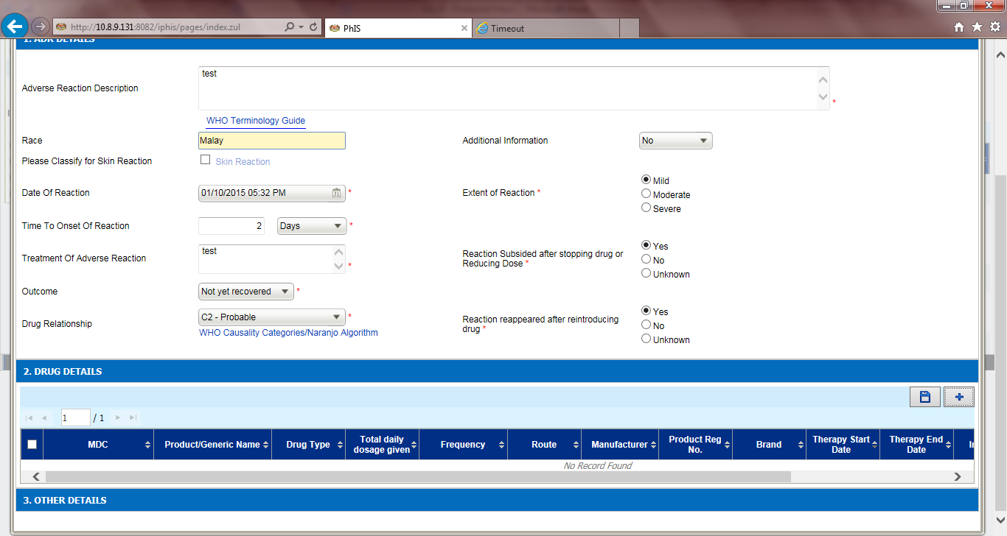

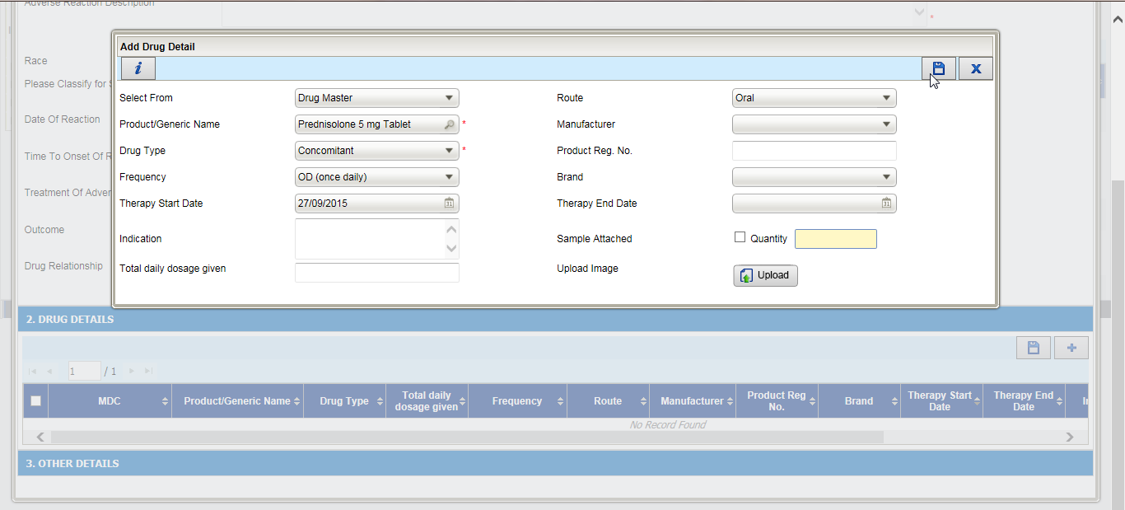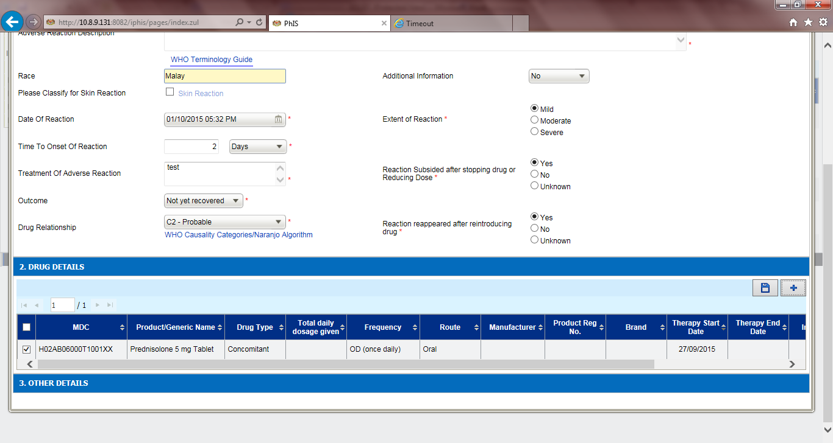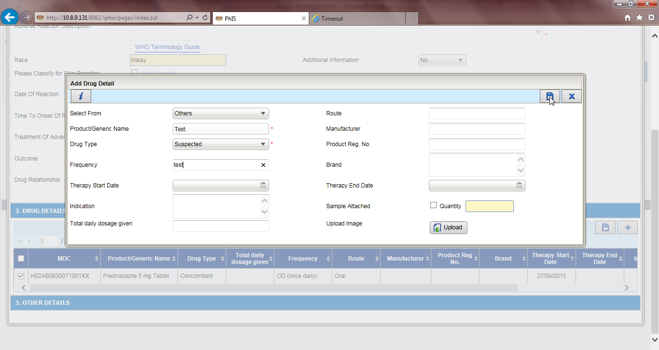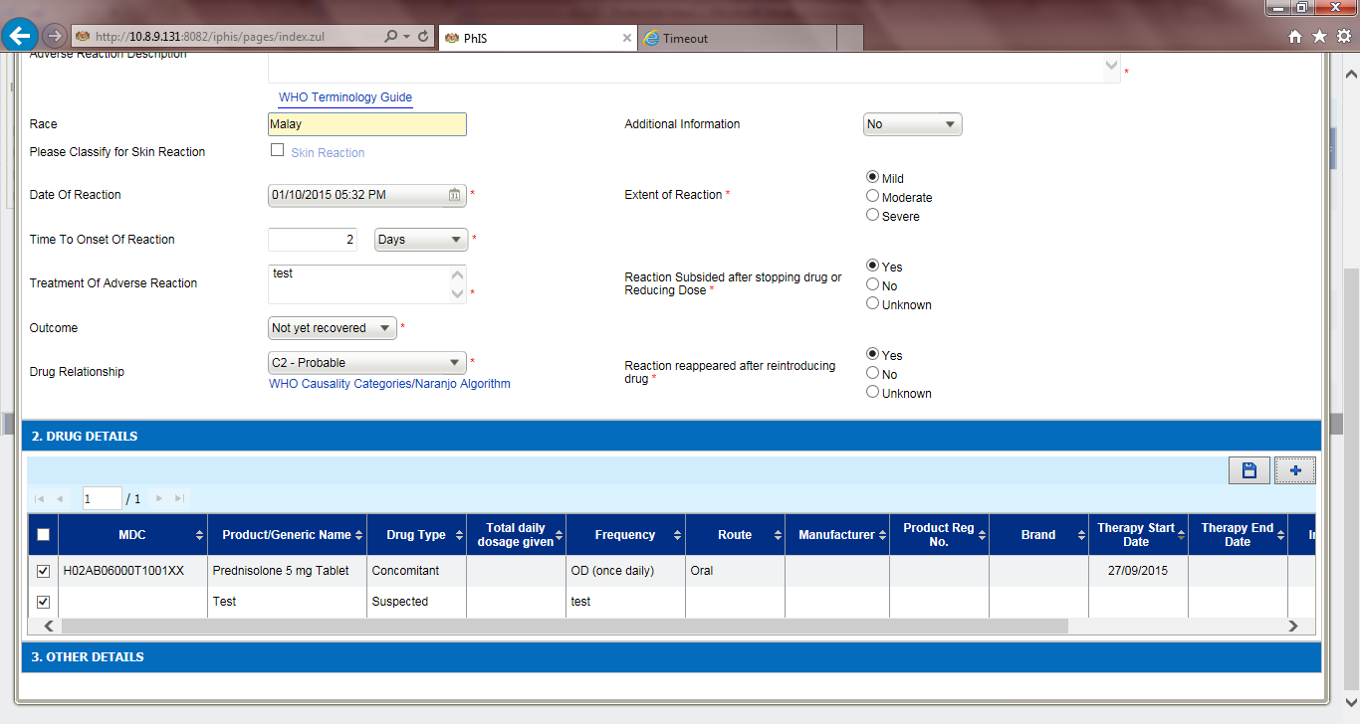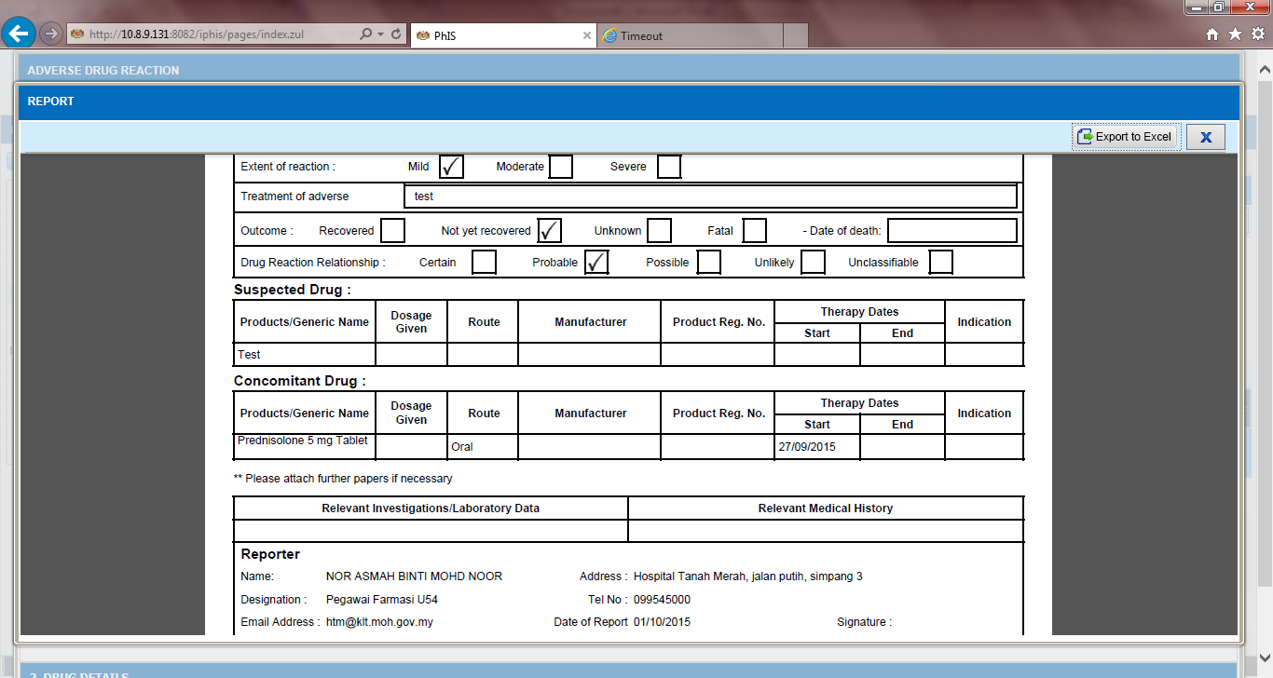

General Module – Item Batch

Ticket No | Title | Description | Resolution
I-PhIS012216415S | Item Batch - Quantity item still maintain at Bad Stock Quantity | User reported already change Batch Expiry Date from 28/2/2015 to 28/2/2018 but quantity item still maintain at Bad Stock Quantity. | 1. System should not allow to change expiry date once expired  2. System should allow to change the expiry date from as long not less than current date  3. system should not allow to change the expiry date if the batch already issue out

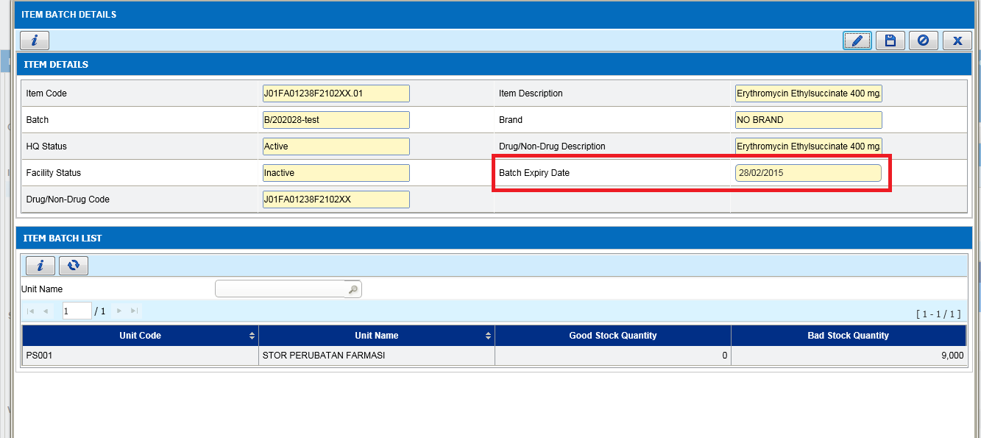

General Module – CDR Regimen
Ticket No | Title | Description | Resolution
I-PhIS012126715S | CDR Regimen screen - Add search filter for the modules | User request add search filter by:-  a) Regimen Type | Add new search filter Regimen Type. List all values from ph_regimen_category. Default to ‘All’.  Once Category value is selected, display only regimen type applicable to the selected category.

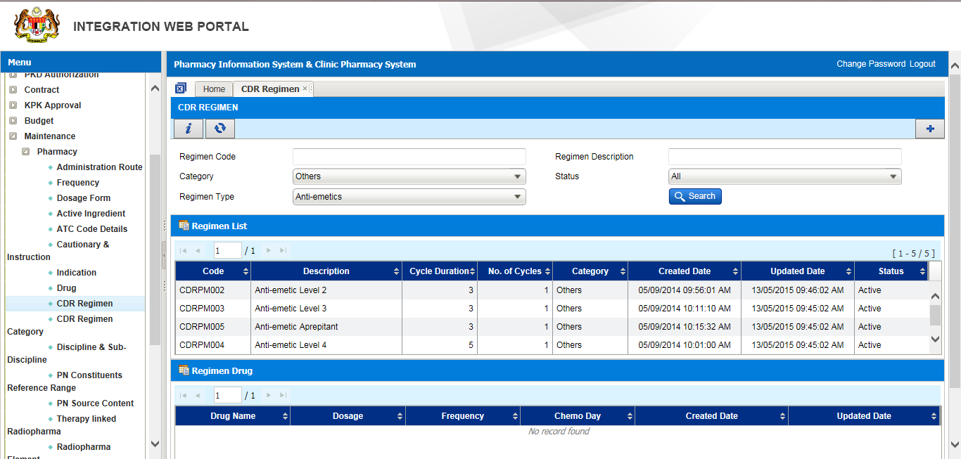

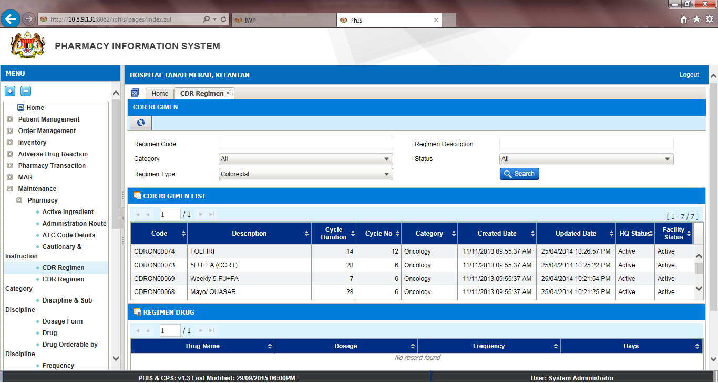

General Module – Drug Master
Ticket No | Title | Description | Resolution
I-PhIS012126815S | Drug master screen - Add search filter for the modules | Add search filter by:-  a. Dosage form  b. Item Sub Class | Add new filter Dosage Form, default value to empty. Dialog box to list all values in ph_dosage_forms.  Add new filter Item Sub Class, default value to All. Drop down to list all values from ph_item_subgroups.

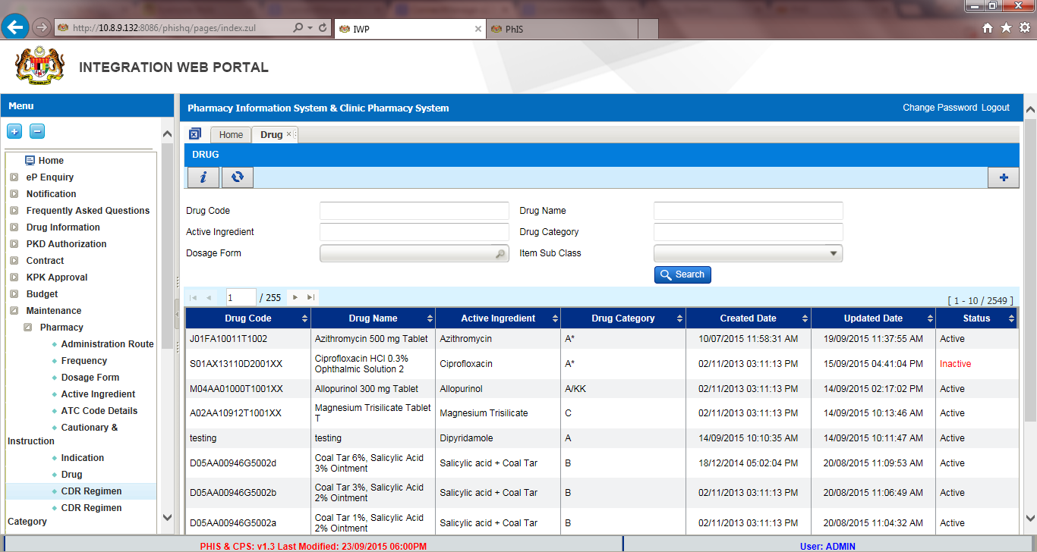

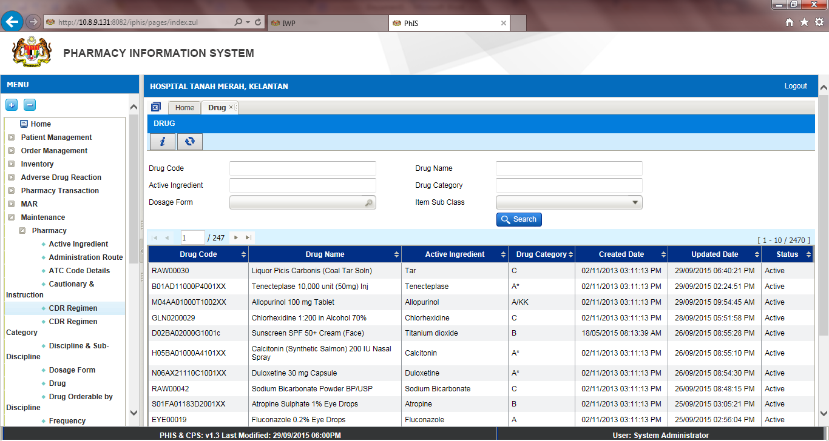

General Module – Drug Master
Ticket No | Title | Description | Resolution
I-PhIS012138815S | Drug Master - Request to add up to 2 decimal for Concentration in Extemp | In Drug Master, Extemp Preparation section, when adding new Extemp formula, to allow user to enter decimal up to 2 decimal for Concentration of Preparation field. Currently only can enter up to 1 decimal only.  Example preparation is Granisetron HCl 0.05mg/ml Oral Suspension. | As per user request

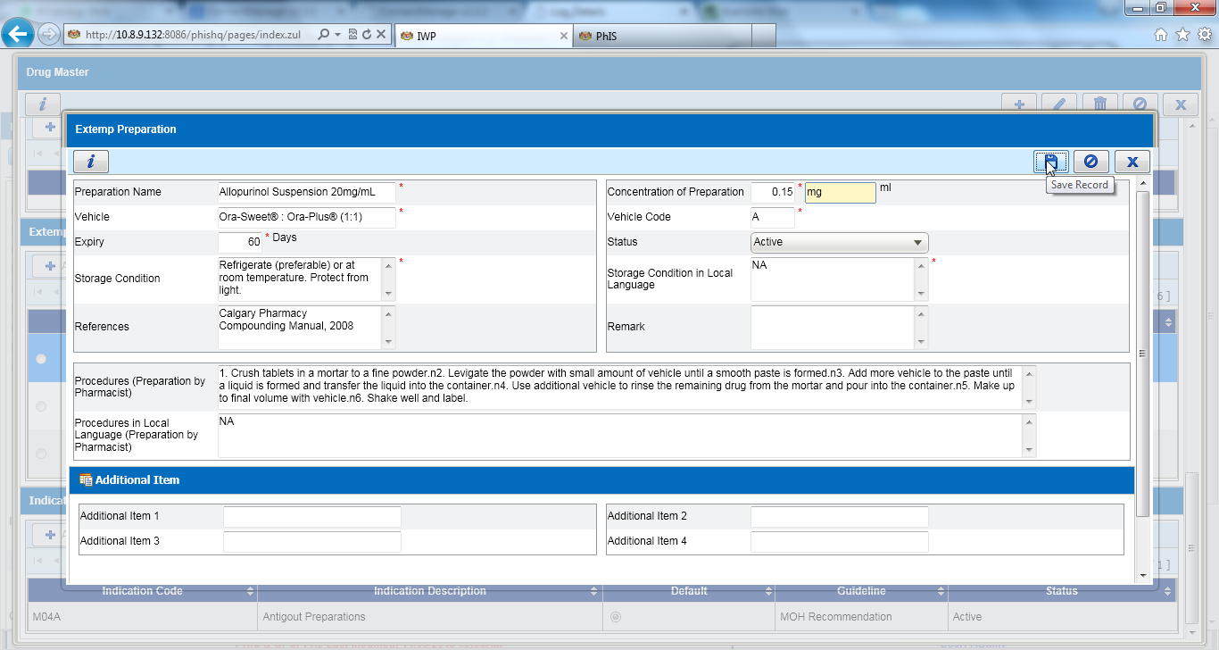

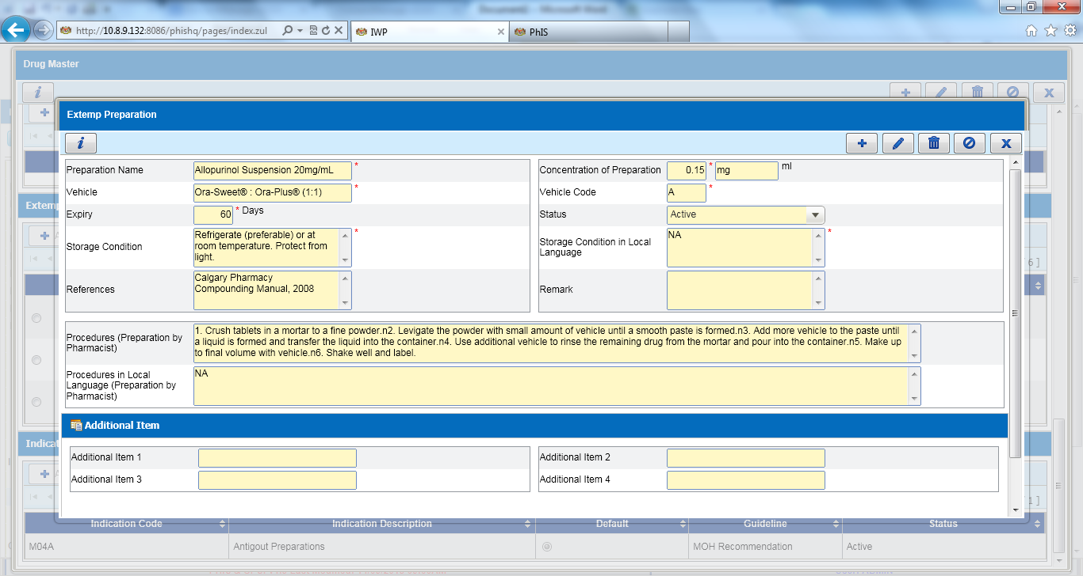
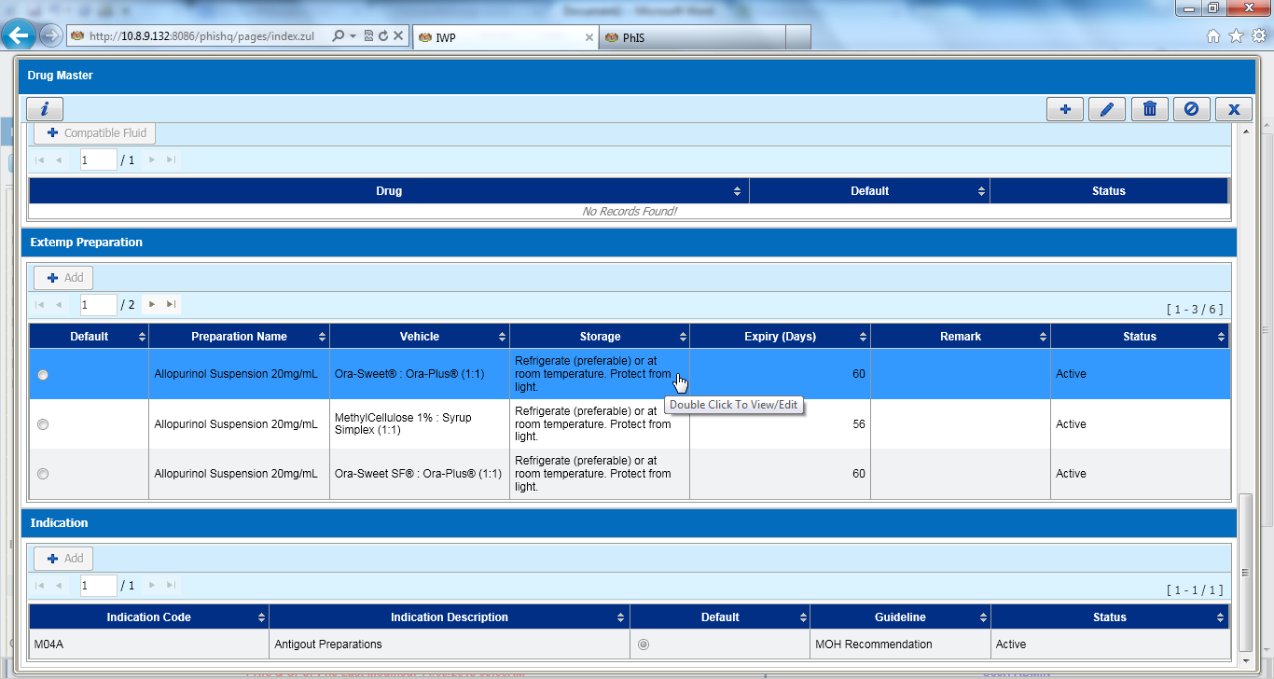

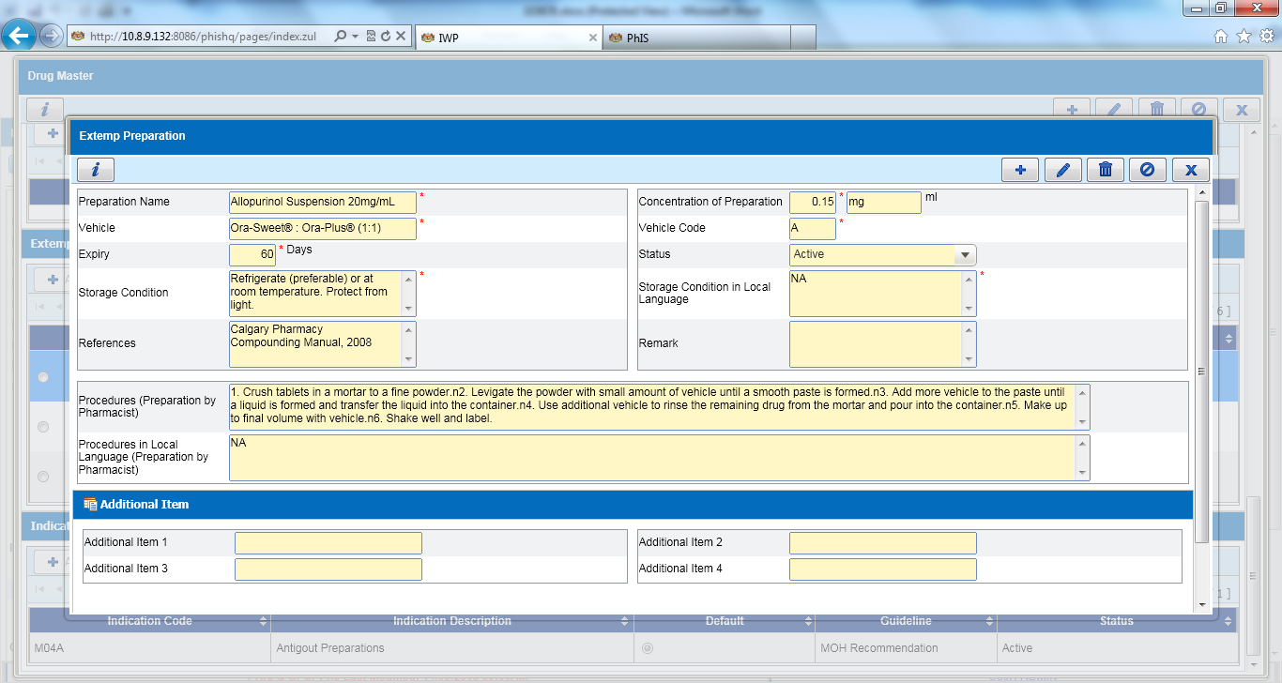

General Module – Brand
Ticket No | Title | Description | Resolution
I-PhIS012278415S | Request auto generate when create new brand | Request auto generate when create new brand. In Brand Master, when creating new brand, to auto-generate brand code based on below:  i. Drug = DR(running no 8 char)  ii. Non Drug = ND(running no 8 char)  Validation for same Brand Code & Name: Cannot have duplicate code or name, regardless of capital letter or not. | Auto-generate brand code based on below: BRD(running no 7 char)

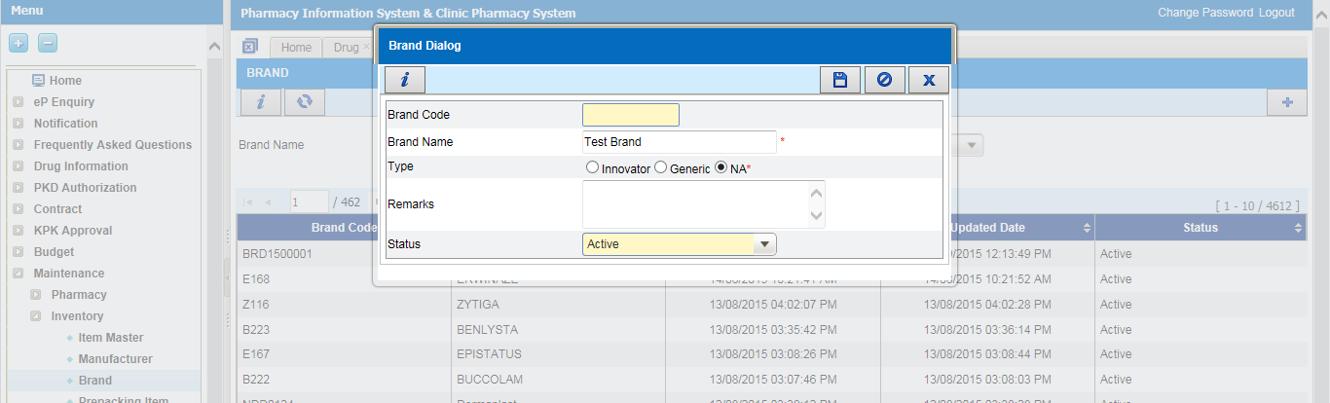

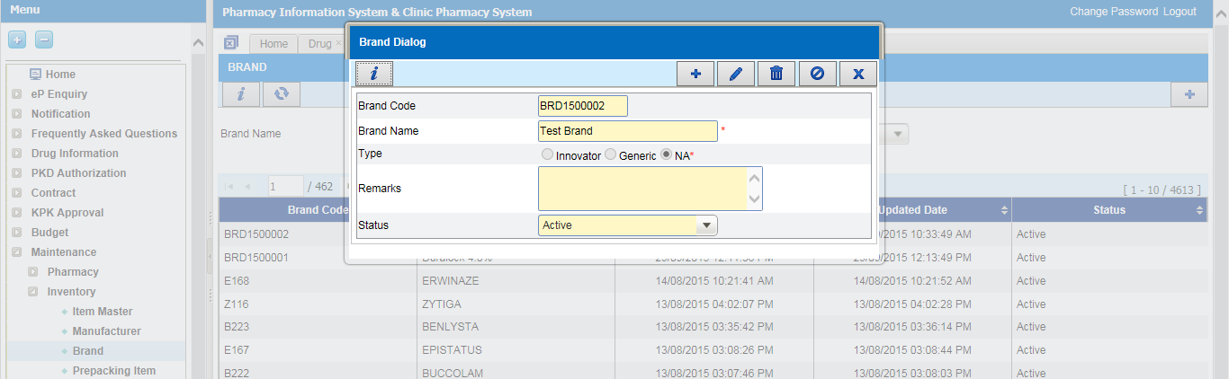

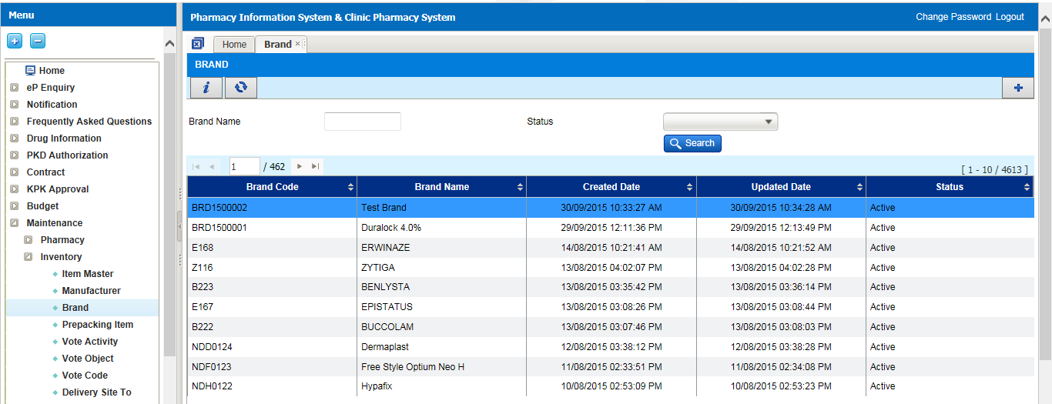

Manufacturing CDR – MAR Display
Ticket No | Title | Description | Resolution
I-PhIS011202315S | Request in MAR to display D1, D8 instead of 2 days for CDR drug. | For CDR drugs, in MAR to display D1, D8 instead of 2 days. 2 days is confusing for staff nurse administration. Same applies to the printed Medication Chart. | MAR display D1, D8 instead of 2 days. In View MAR, MAR, and Medication Chart

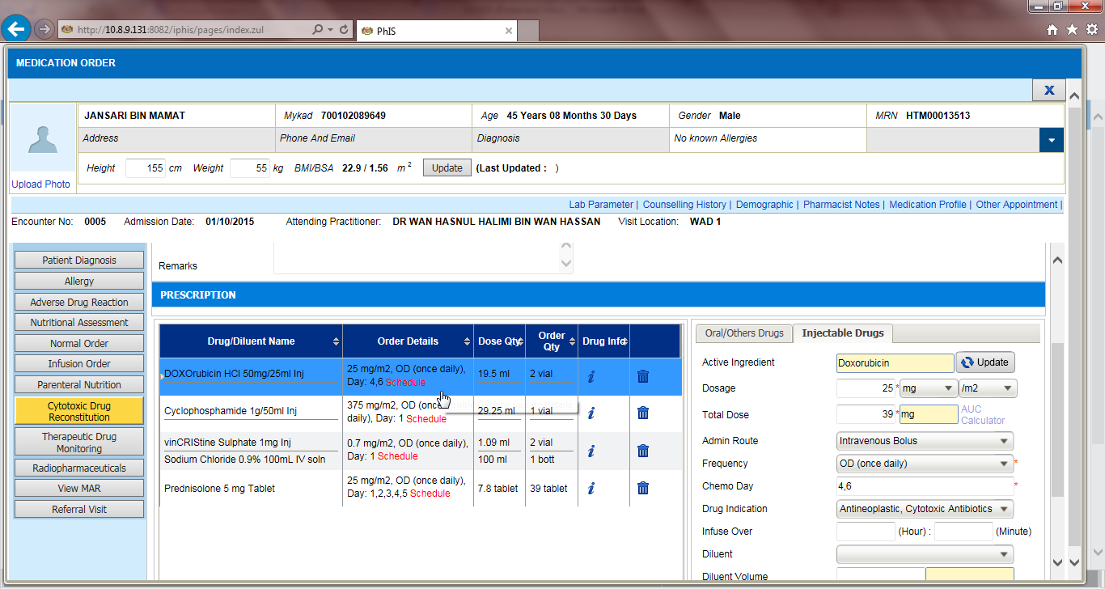

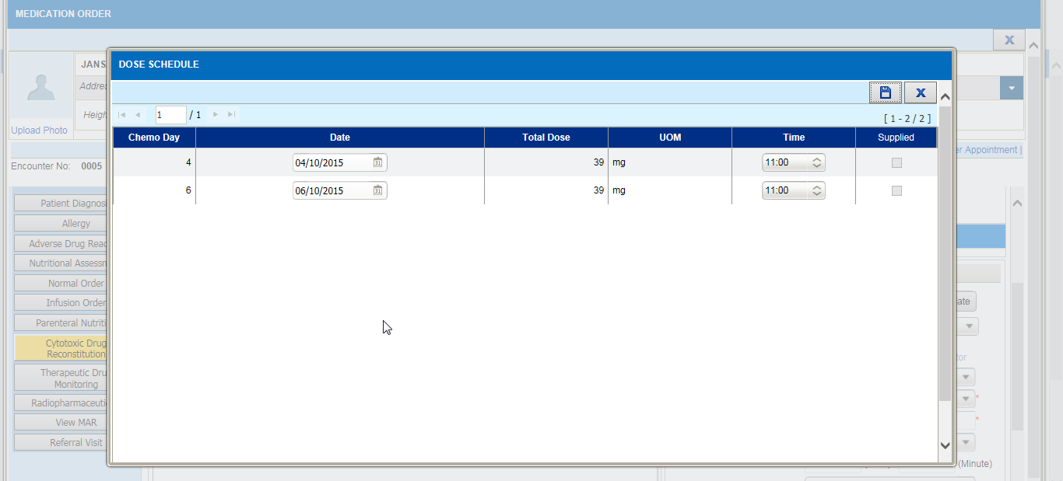
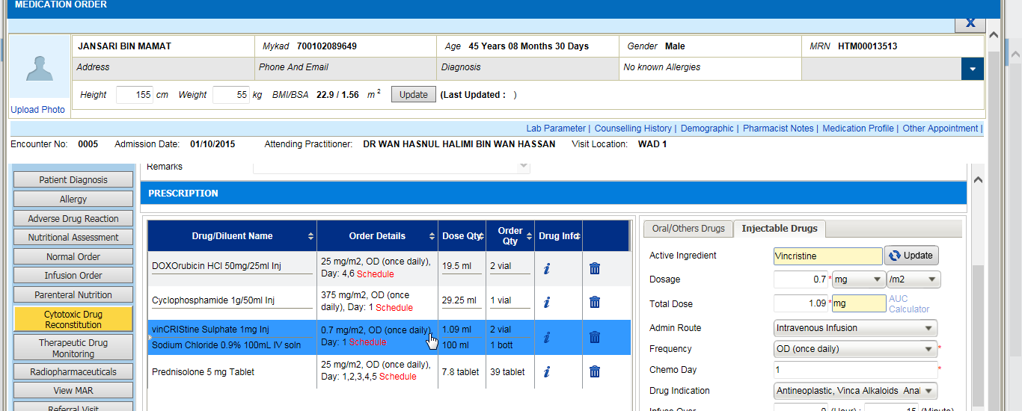
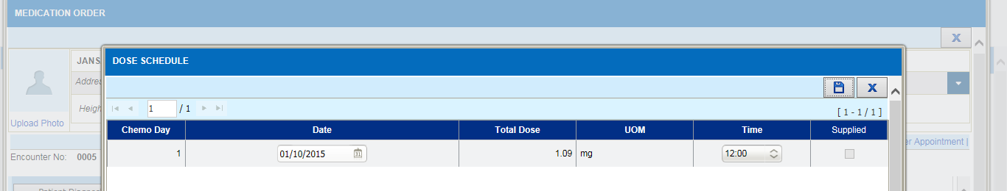
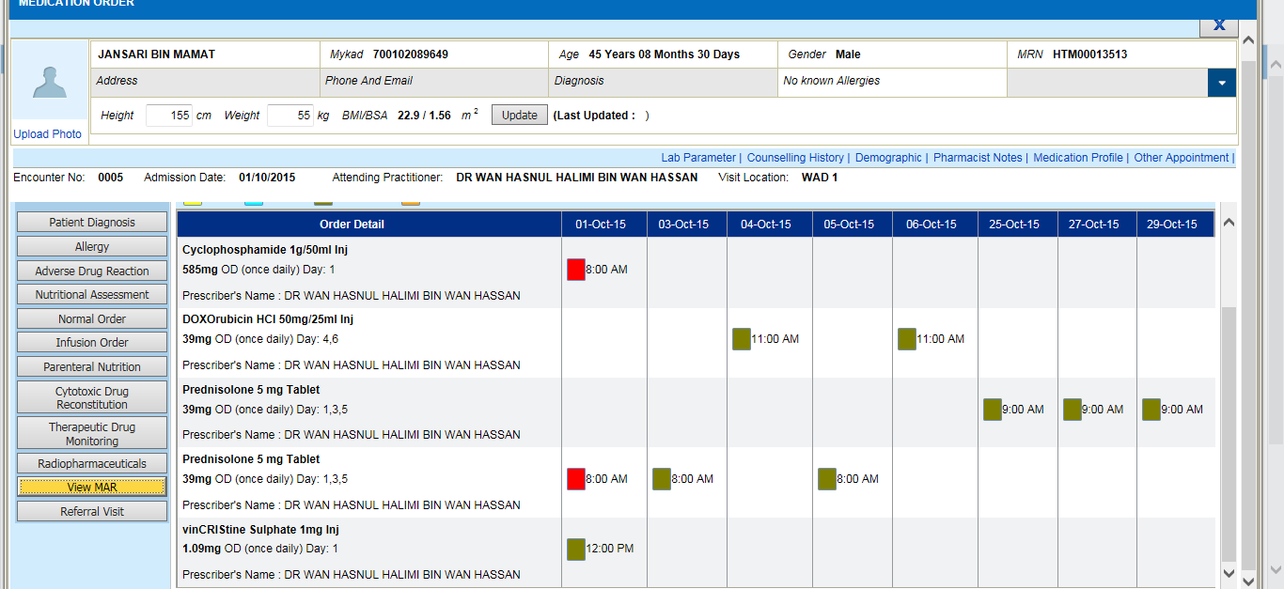
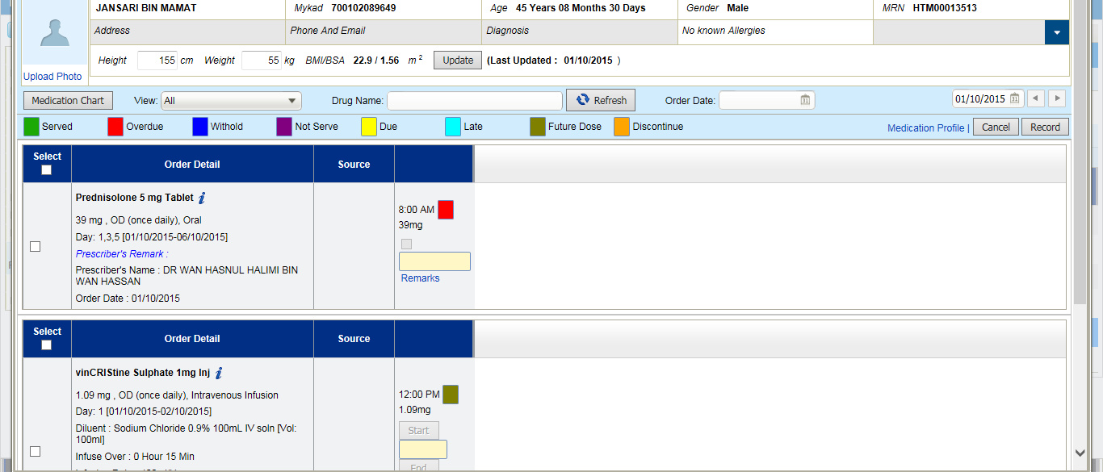

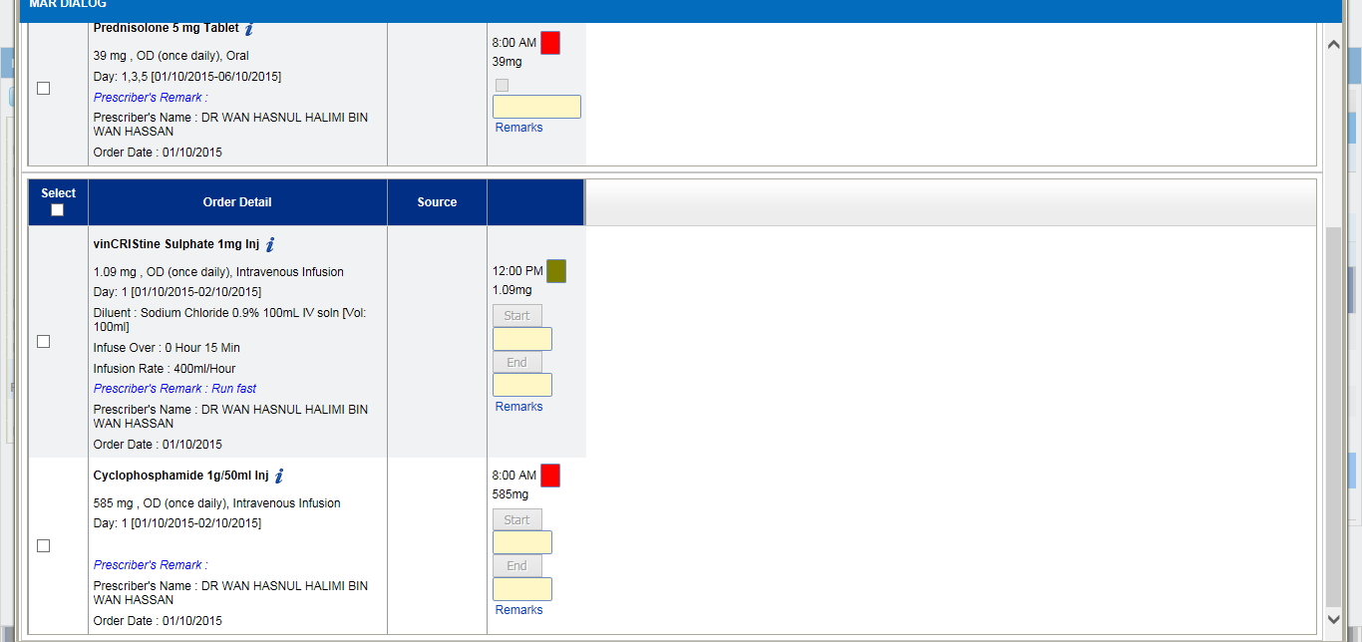
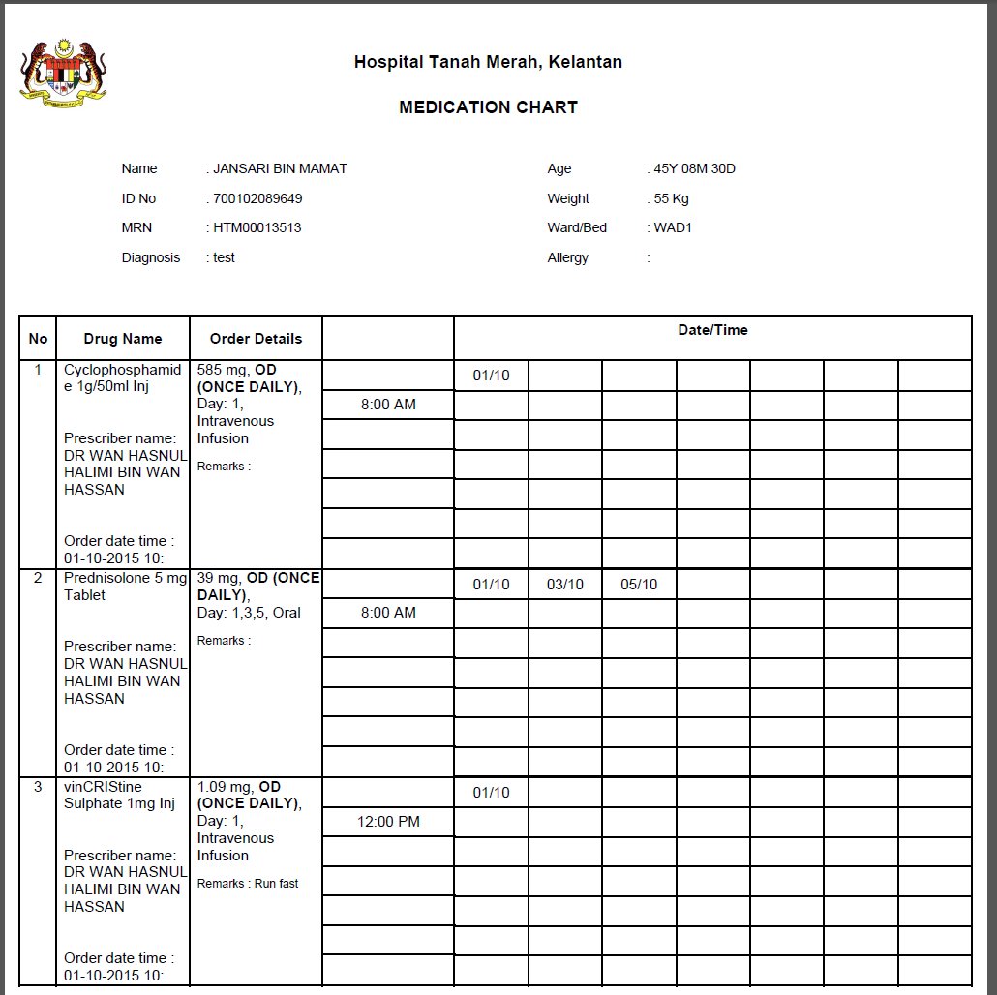
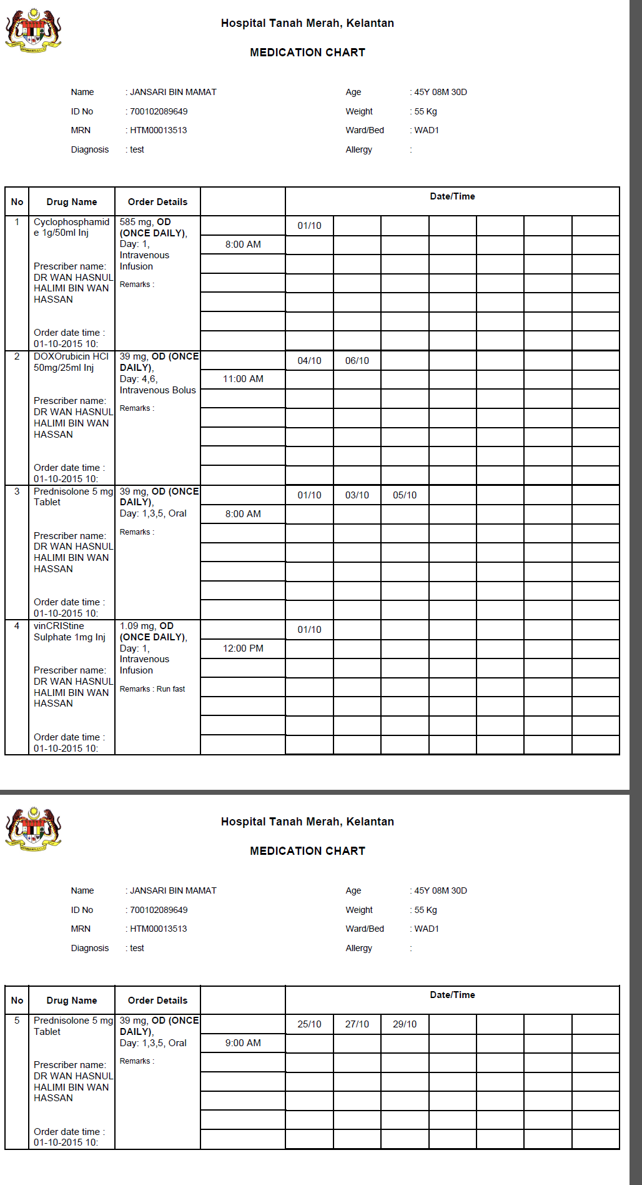
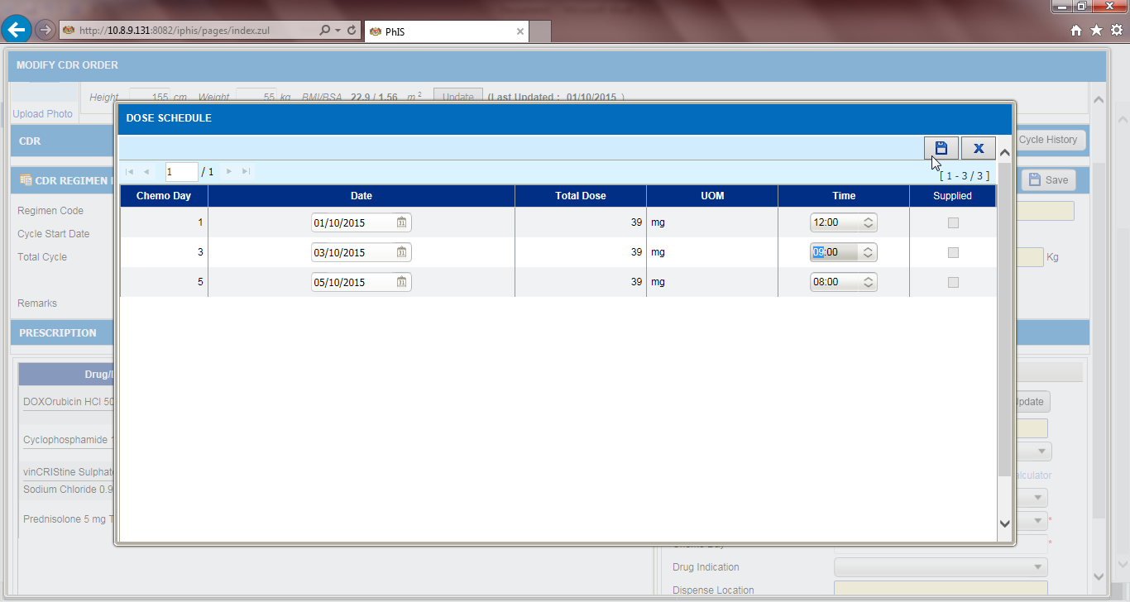
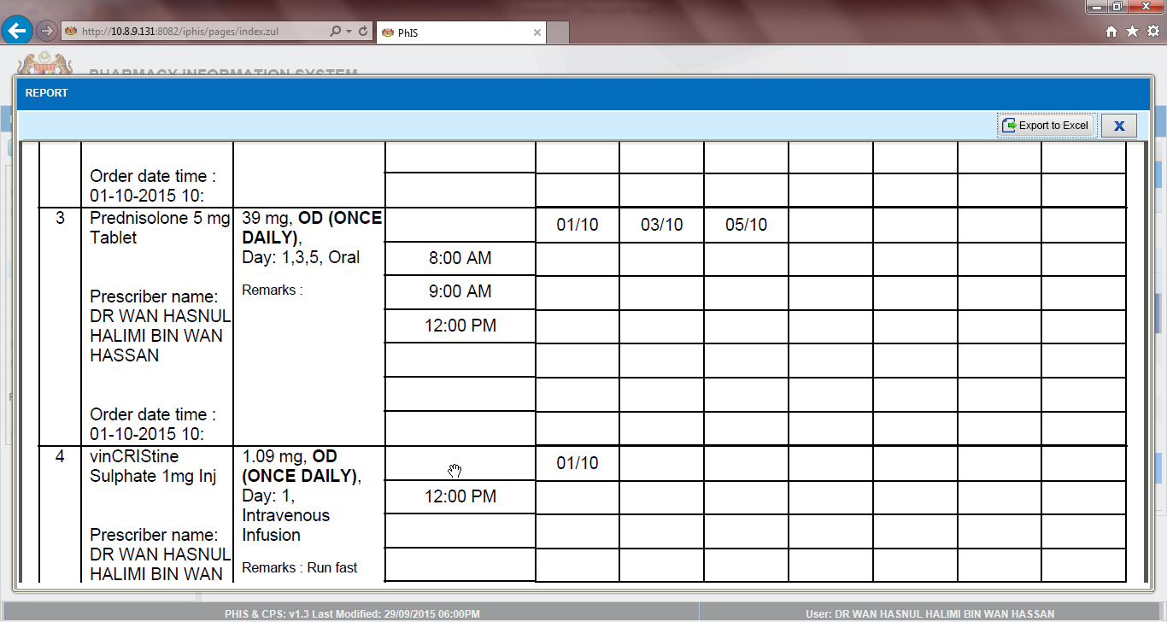

Manufacturing CDR – Regimen Status
Ticket No | Title | Description | Resolution
I-PhIS009377815S | CDR - Request CDR regimen sync to facility default HQ Status to Inactive | User request all CDR Regimen that sync to facility default HQ Status to Inactive | In HQ/IWP, create new record for CDR Regimen screen  Once record flow to facility, the Facility Status as above to display as Inactive.

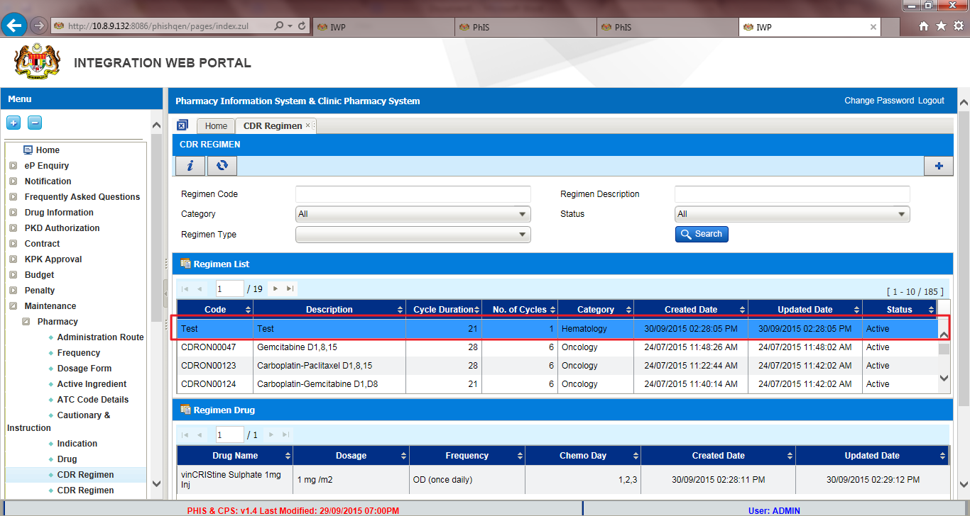

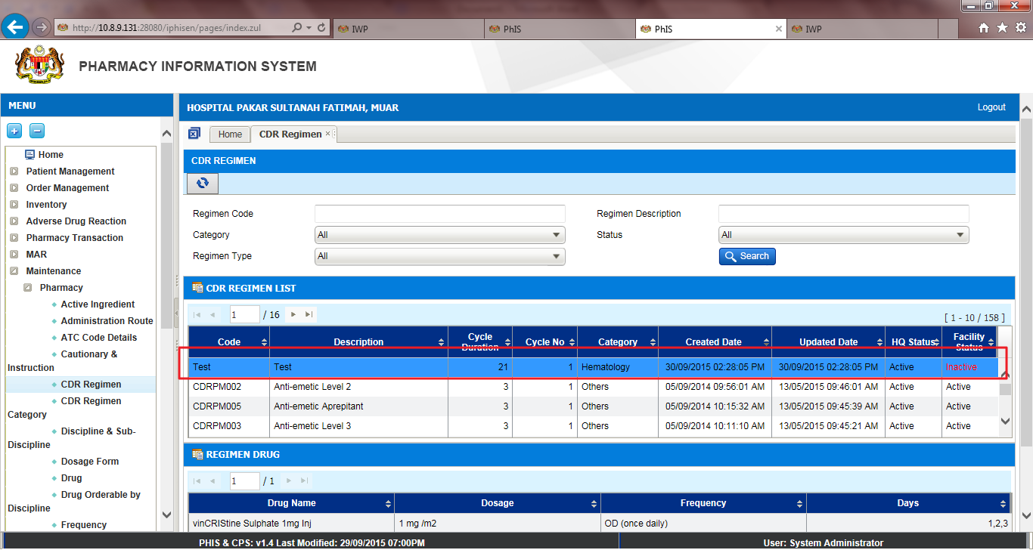

Manufacturing CDR – CDR Cycle History
Ticket No | Title | Description | Resolution
I-PhIS009740815S | CDR Cycle History - Request layout header appear in new page | Request to change layout, header should be in new page in Cycle History report. | All columns should be dynamic based on the values. If got longer values should expand the columns.  Header part (Patient details and table header) should repeat in each printed pages.

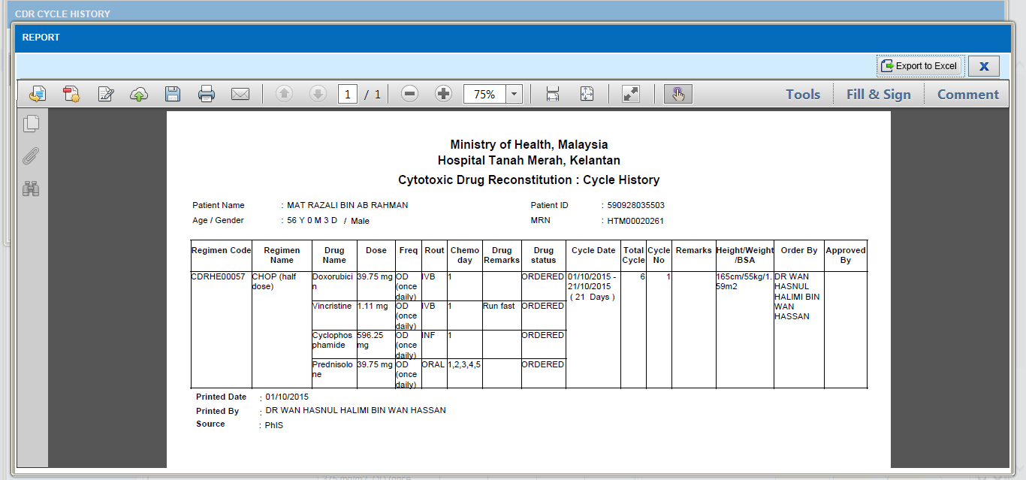

Manufacturing Extemporaneous – Alert Message
Ticket No | Title | Description | Resolution
I-PhIS008120514S | Request to disable the alert message when prepare Extemporaneous medication | Request to disable the alert message of Extemporaneous checked by; username & Password. | Remove the alert and can proceed without entering the Username and Password. Applicable for all screens, both full based and pharmacy based.

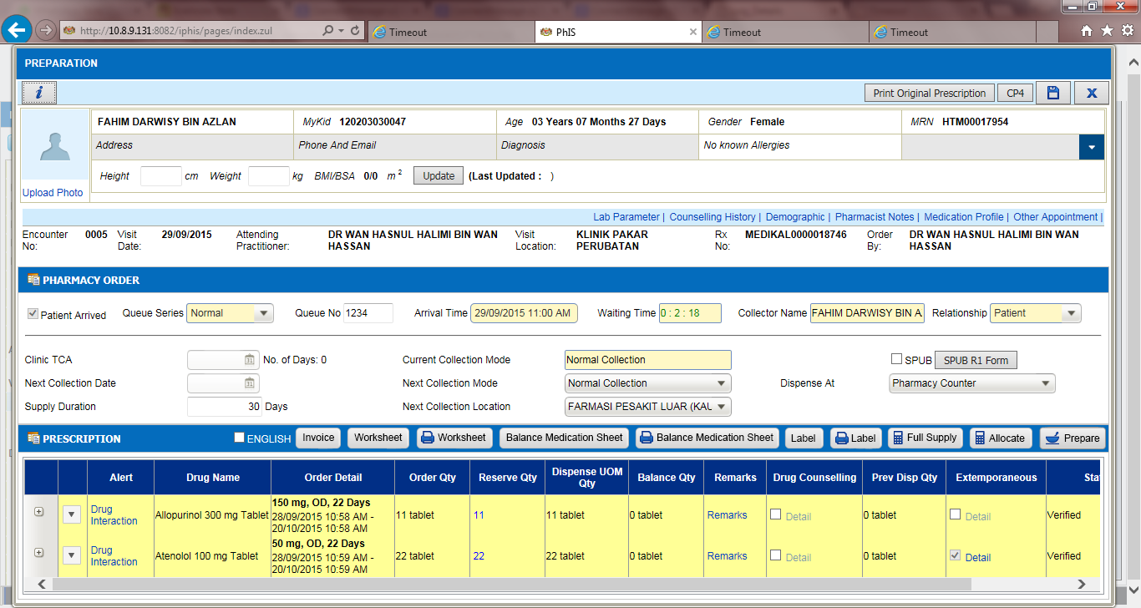

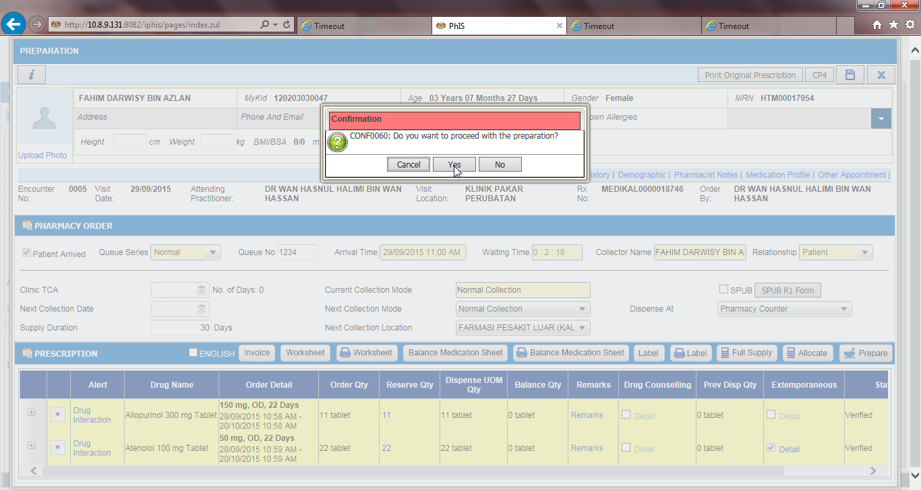
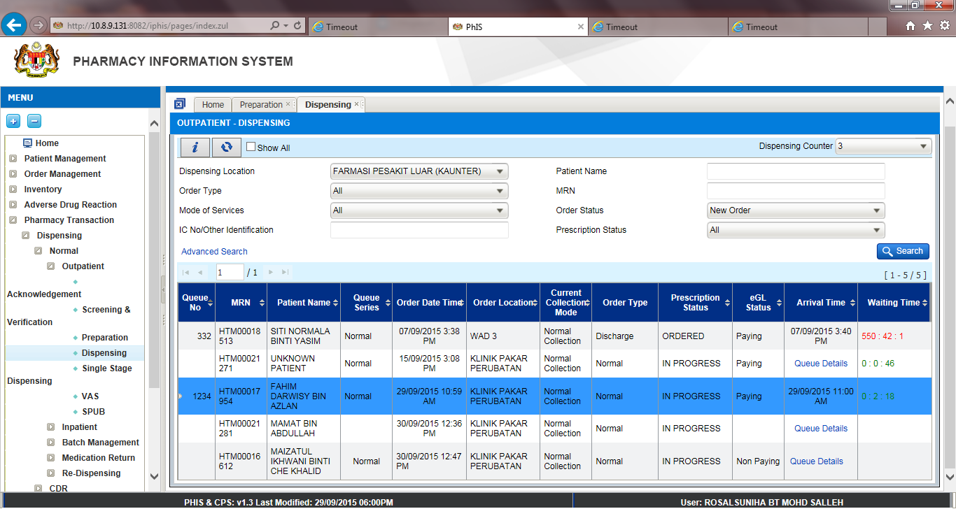

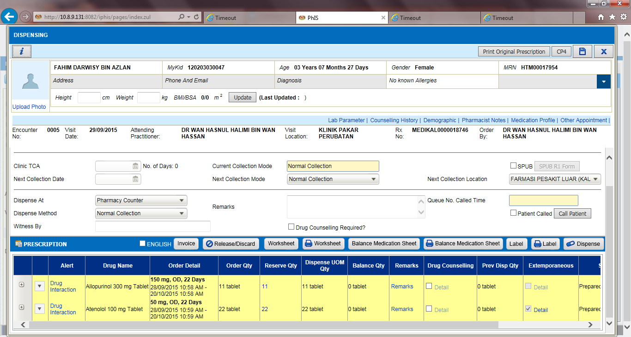

Manufacturing PN – Preparation
Ticket No | Title | Description | Resolution
I-PhIS009706615S | Preparation-Prepare worksheet sync with unit catalogue list | Expected result: Drug displayed on PN Worksheet should follow the setting in Unit Catalogue. Once drug inactive in Unit Catalogue, no need to display the drug in PN Worksheet. | when select item on preparing worksheet the item must be in unit catalogue list

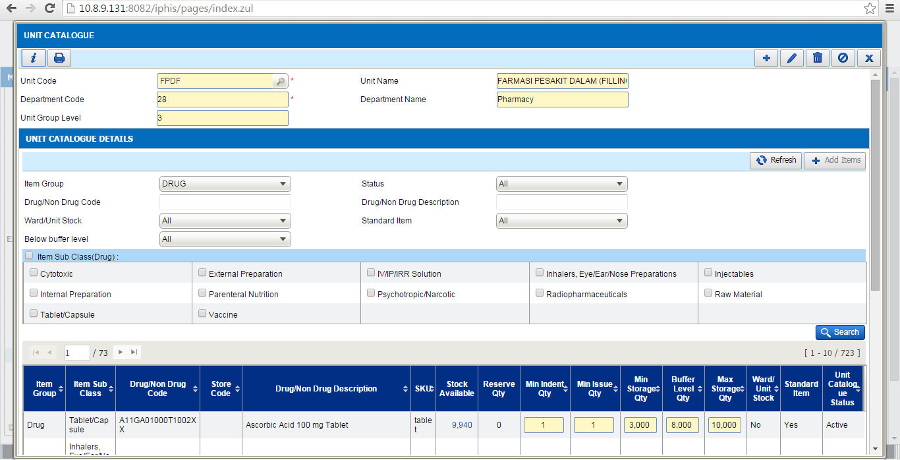

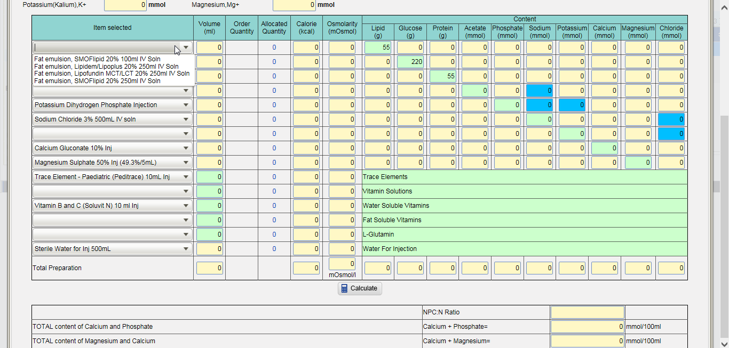

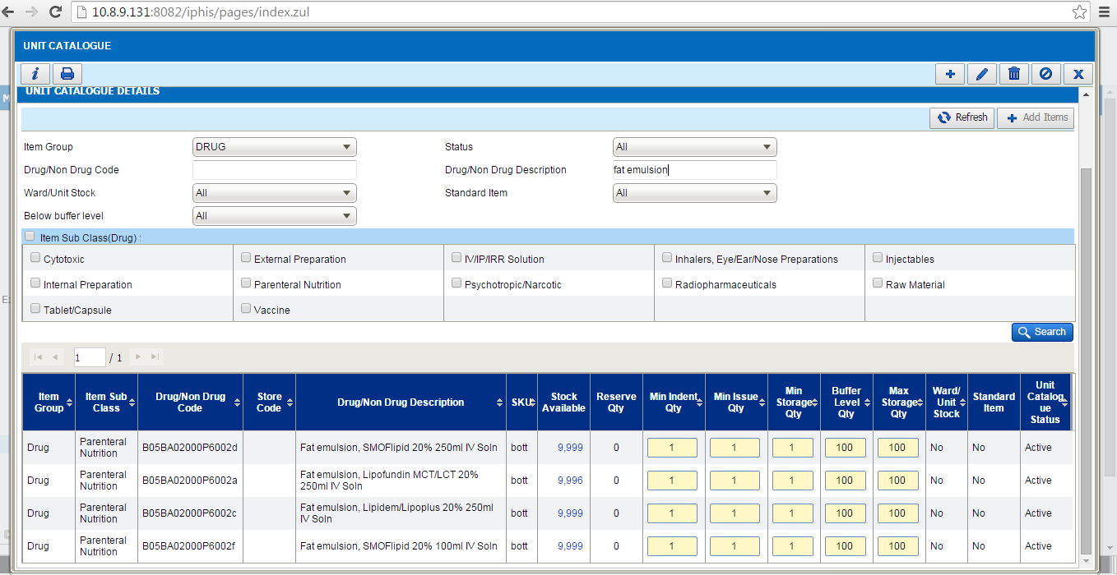

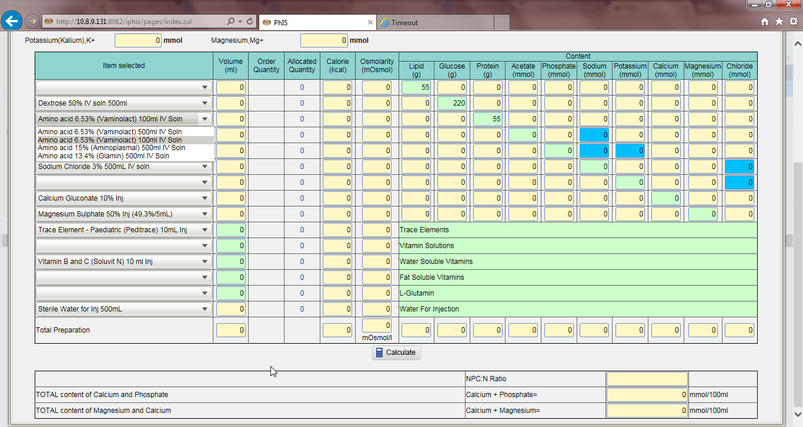

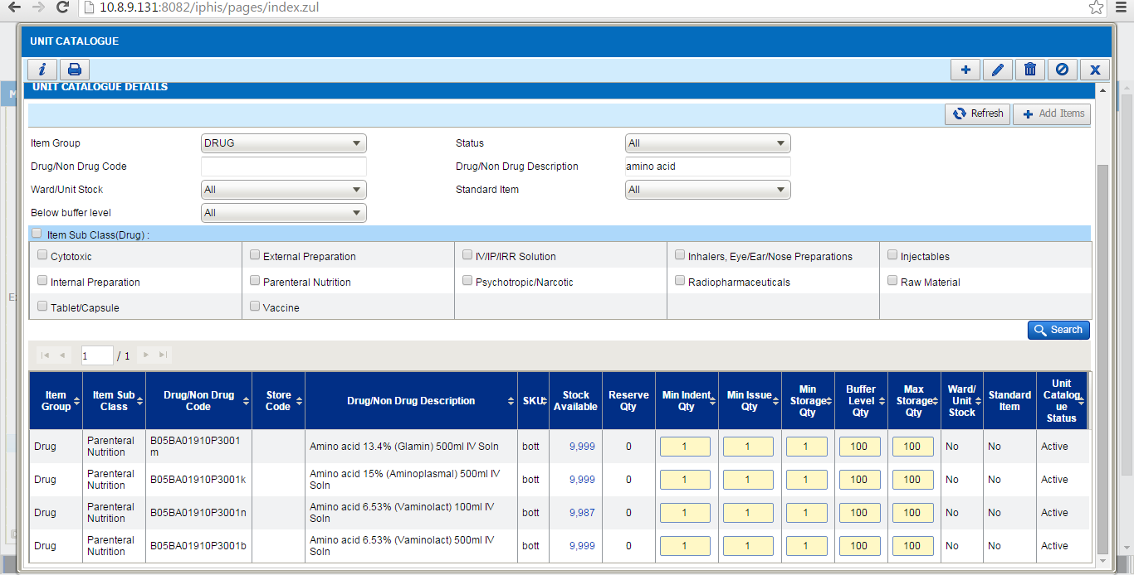
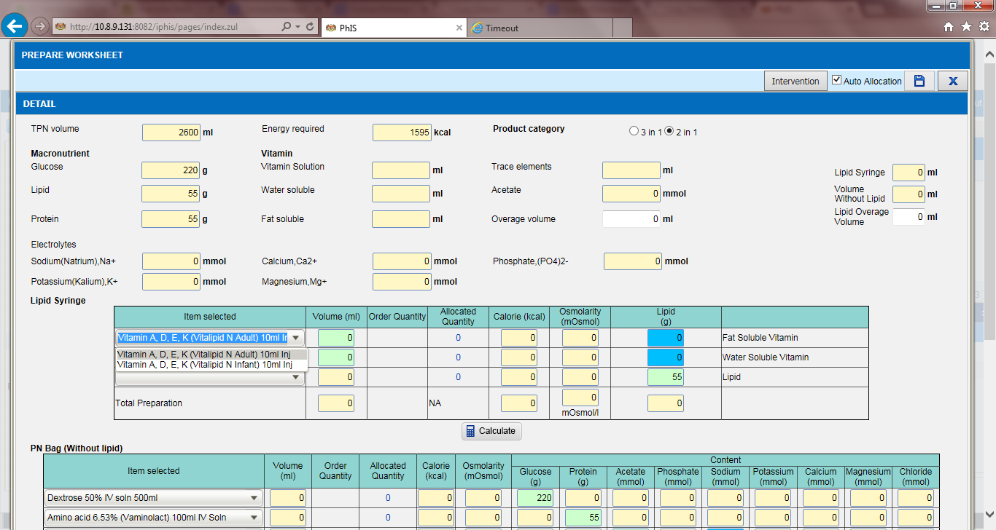

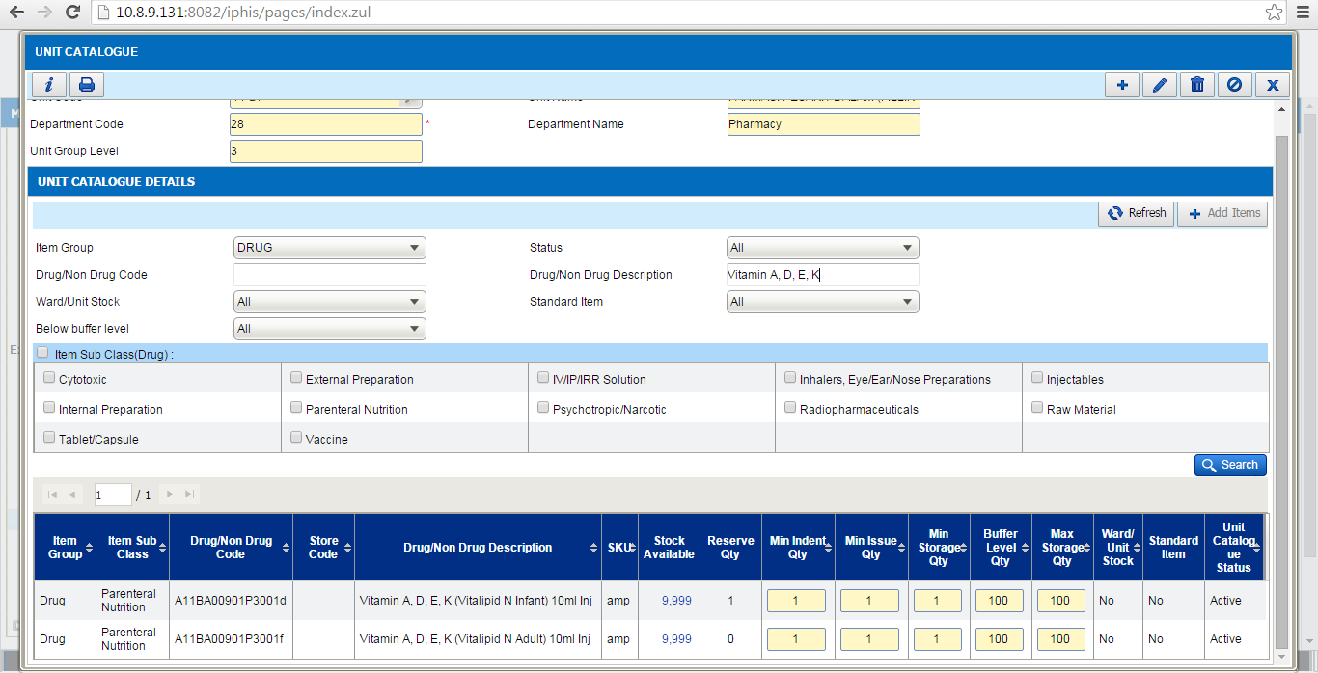

Manufacturing PN – Intervention
Ticket No | Title | Description | Resolution
I-PhIS008481814S | Request to default intervention reason to ‘Others’ and auto-select Intervention Status as Accepted | Due to scenario for PN pharmacist where they may do multiple intervention to prepare the worksheet before proceed to prepare the PN bag. | Default Intervention Reason to Others  Default selection to Intervention Accepted  Others should be displayed on top of the list so that user can see the value is selected. Currently, Others is hidden at the end of the list.  Validation: If system didn’t find any value for Others, no need to default the value. Don’t display error message.

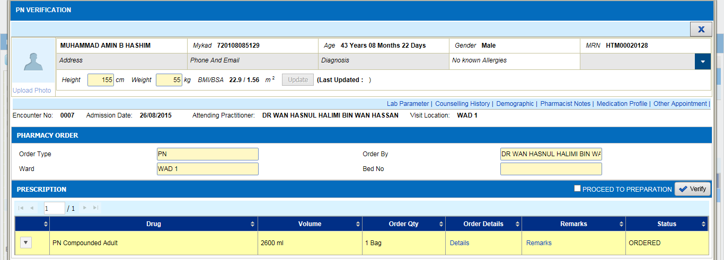

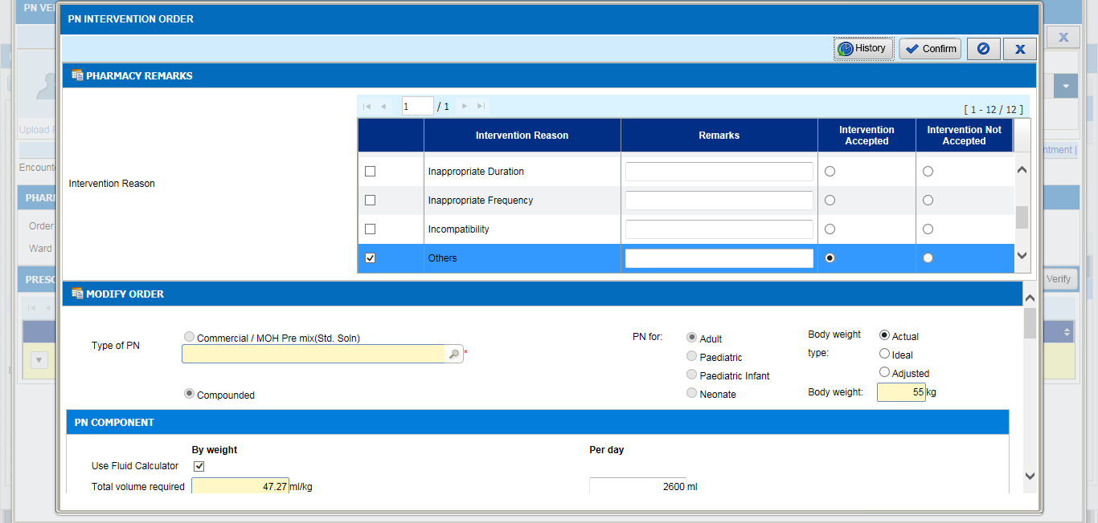
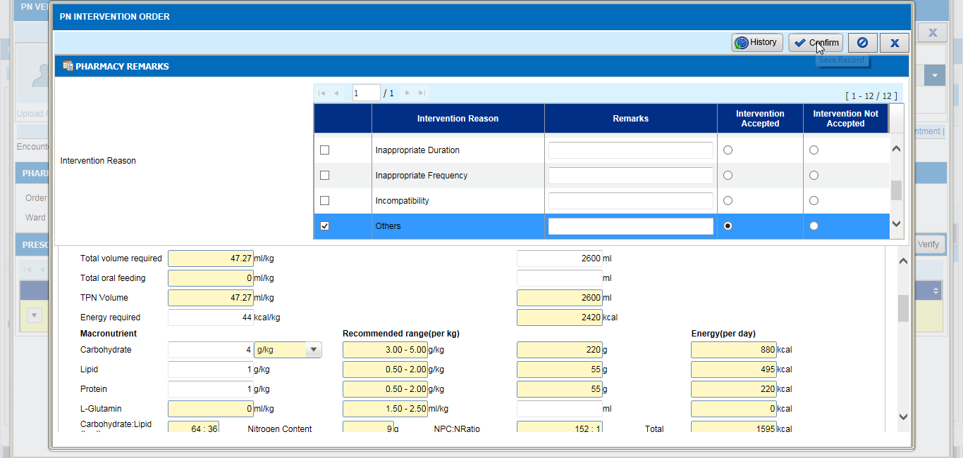

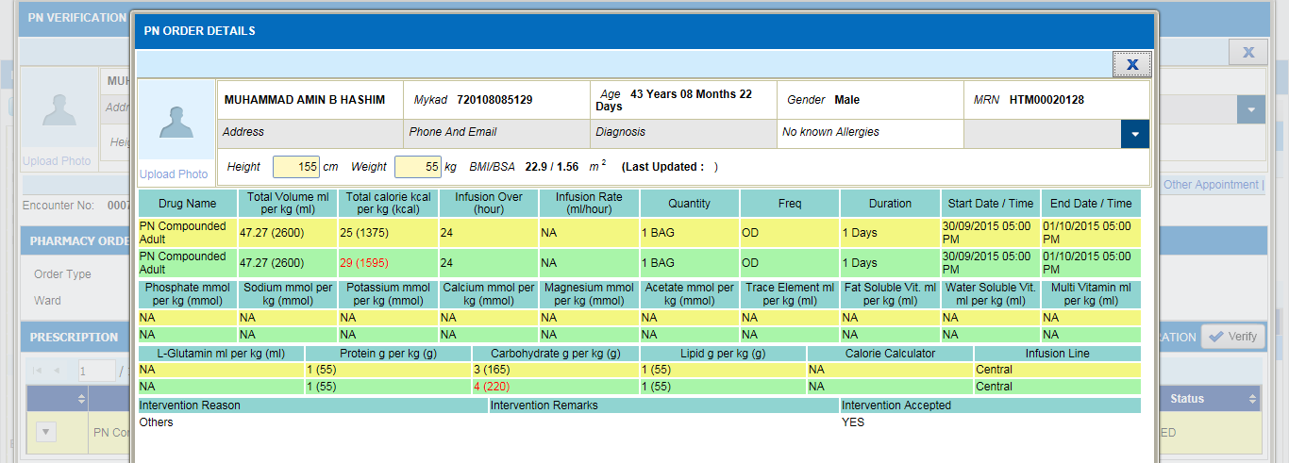

Pharmacy Based:
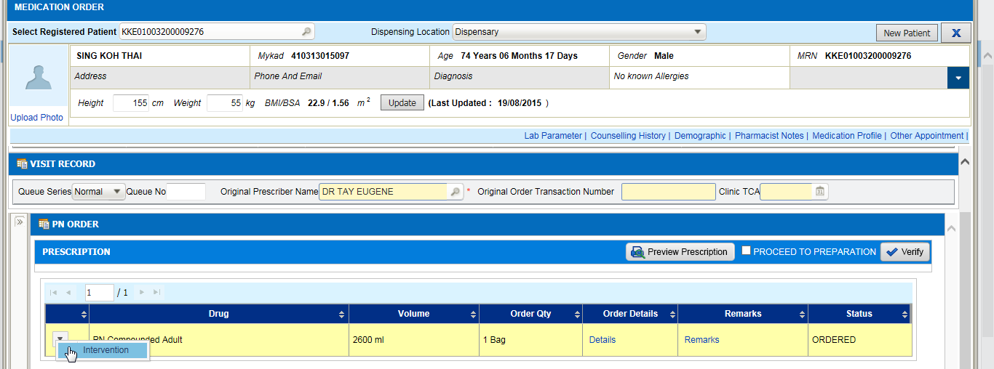
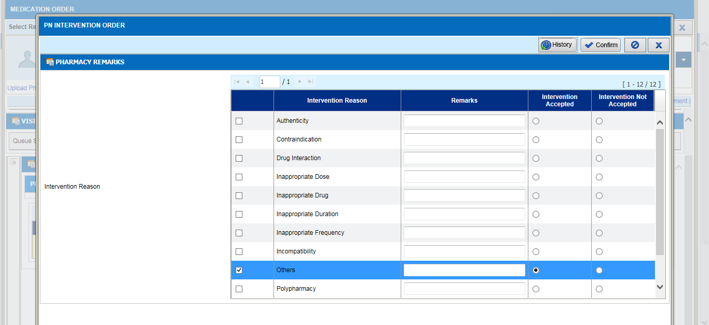

MTAC – Warfarin
Ticket No | Title | Description | Resolution
I-PhIS012270415S | MTAC – Warfarin – Consent form: | MTAC – Warfarin – Consent form:  User request to exclude MTAC Type – Warfarin from mandatory printing consent form. | After confirm order, system should allow to proceed for reporting screen without showing/popup the Consent Form.

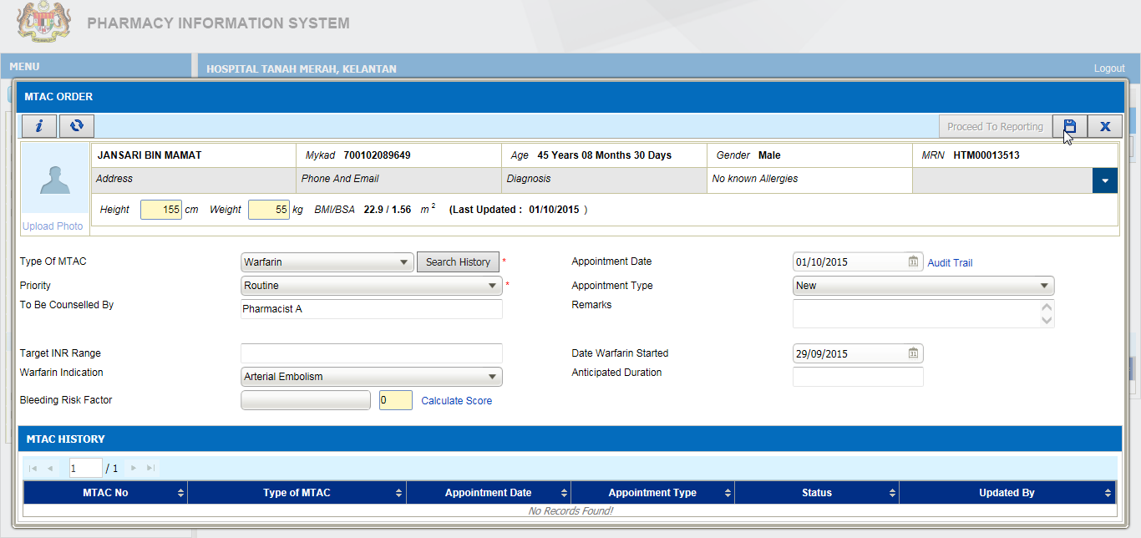
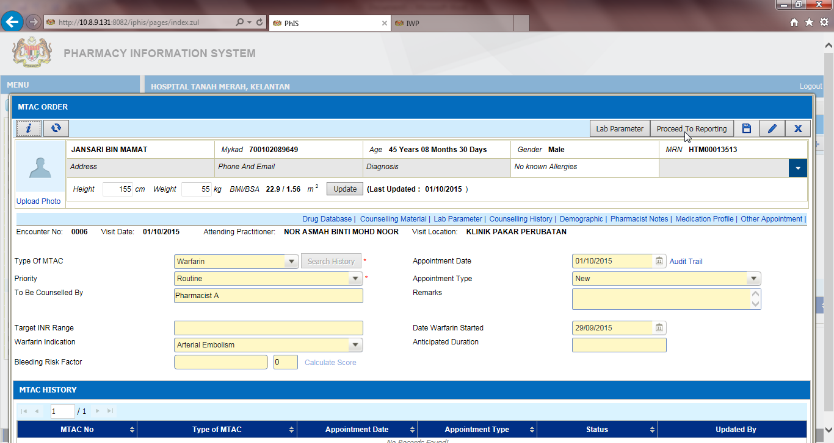

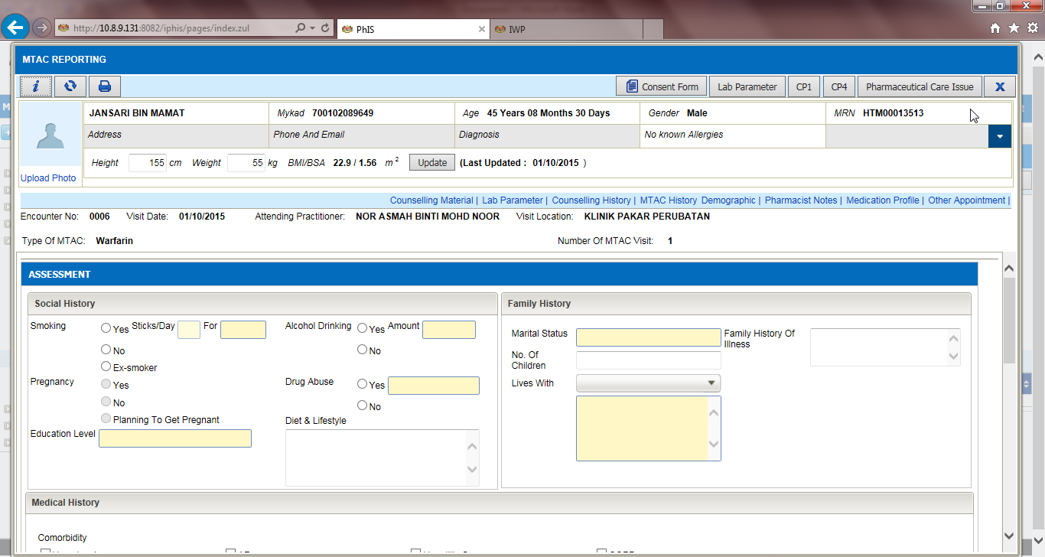

Order Management – Stop Medication
Ticket No | Title | Description | Resolution
I-PhIS010566315S | Order Management (IPAD) - Request to change function setting | Order Management (IPAD) - Request to change function setting.  User request to change function setting. As Doctor always click at "Yes" button but then this function will stop all other drug in prescription instead of selected one drug. Not User Friendly and confusing. | To change the message when stop or cancel current drug order.  Changes apply to both web and mobile.
I-PhIS012108515S | Order Management - Pop up for stop order is not appropriate | Order Management - Pop up for stop order is not appropriate.  Request to change the term "Yes/No/Cancel" to "One Drug (default) / All drugs / Cancel". Pop up for stop order is not appropriate. The pop up seems ask that "Are sure you want to stop the order" and doctors just click yes without read it until finish because in fast way user don’t have time to read it all, but the actual pop up is to stop ALL drugs. This is so confusing that many doctors accidently stop all drugs instead of stop single drug. | To change the message when stop or cancel current drug order.  Changes apply to both web and mobile.

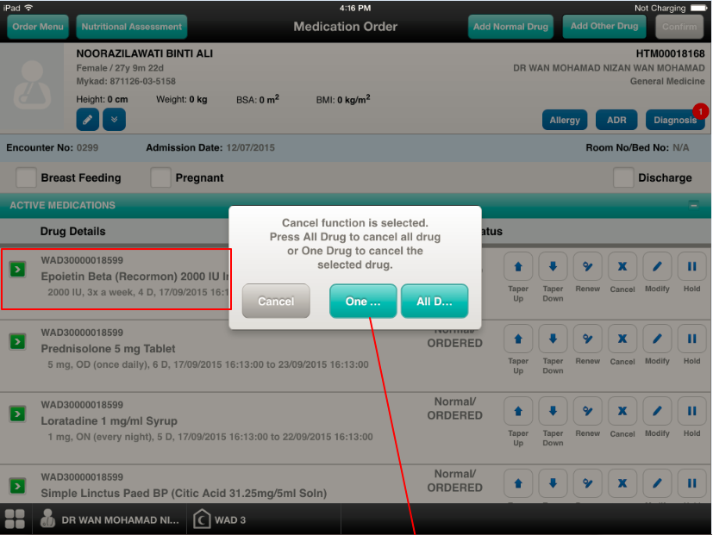
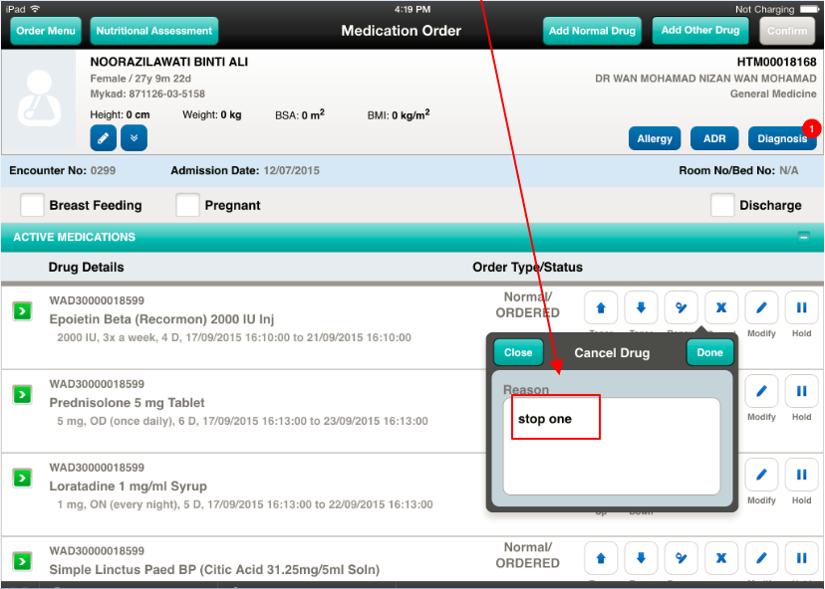

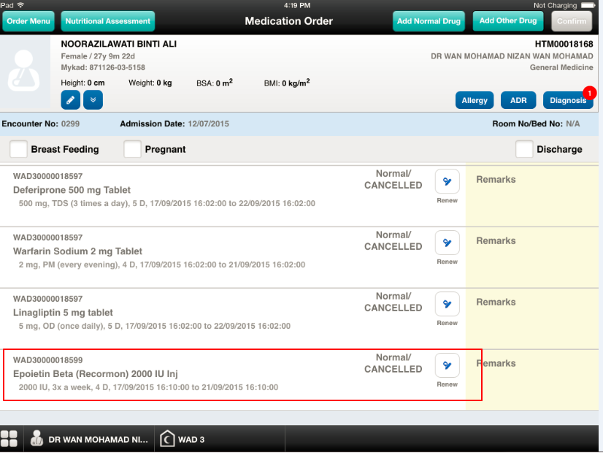

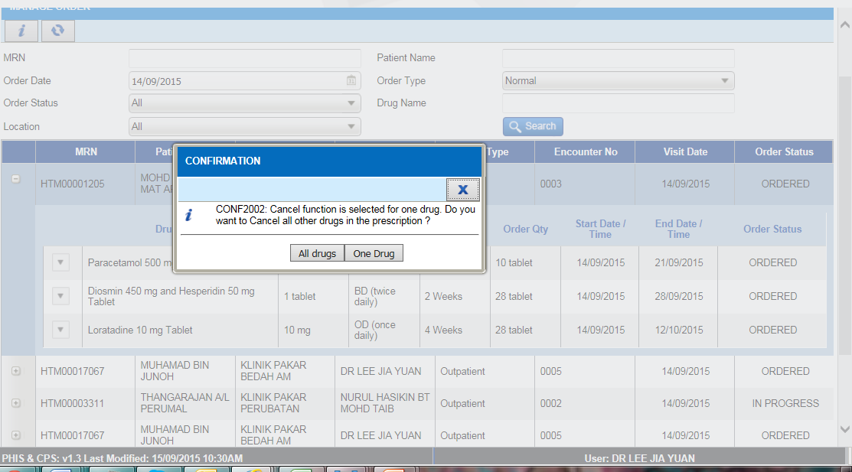

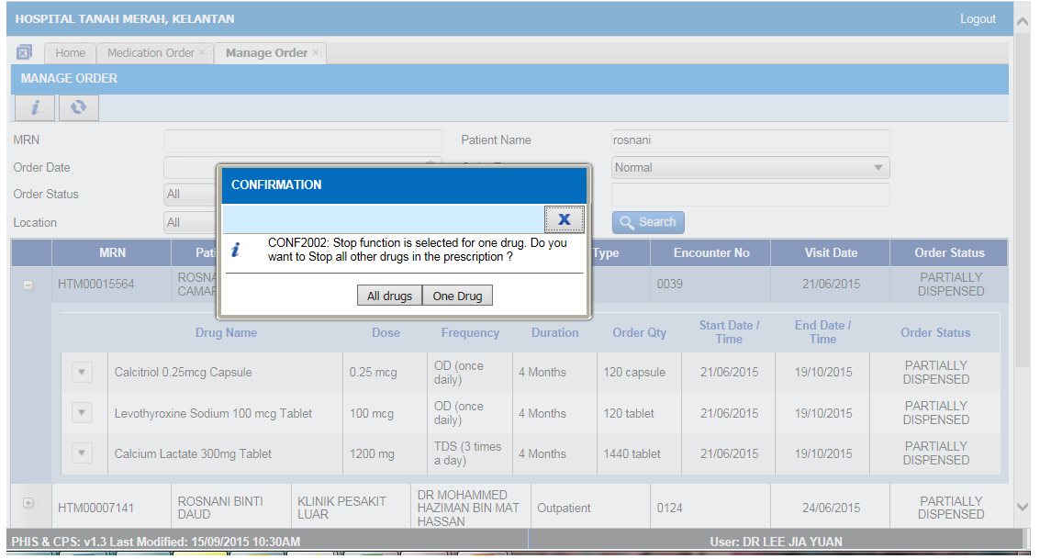

Order Management – Medication Profile
Ticket No | Title | Description | Resolution
I-PhIS009817215S | Medication Profile-Request Previous medication to sort by descending order | Medication Profile-Request Previous medication to sort by descending order.  Request previous medication to sort by descending order (latest date)  *Apply to both current and previous medication.  ** Apply to web and mobile version. | As per request

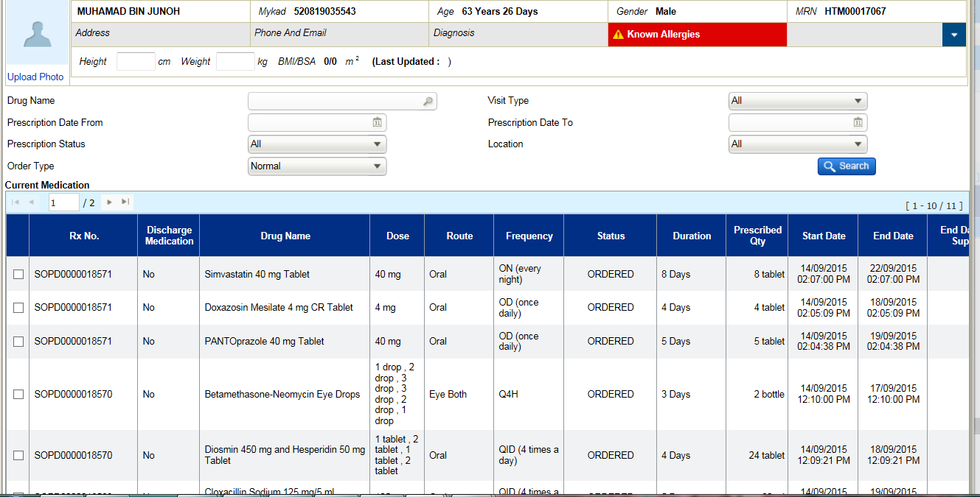

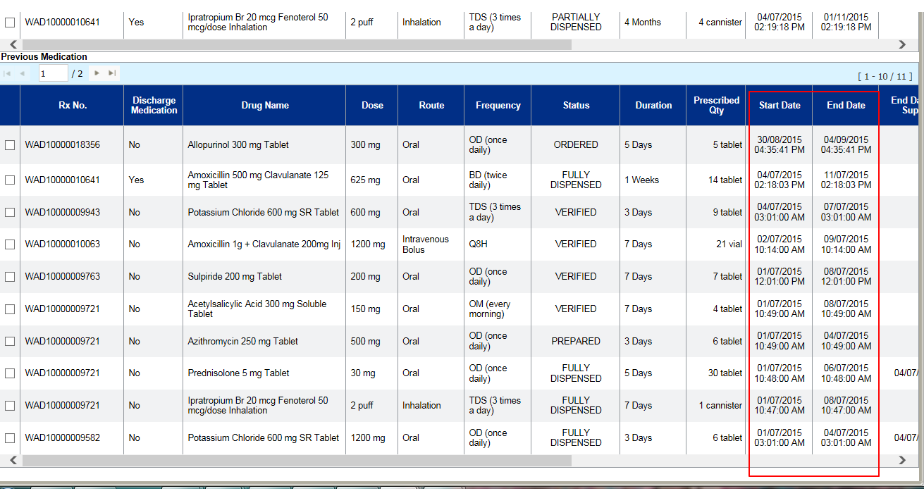

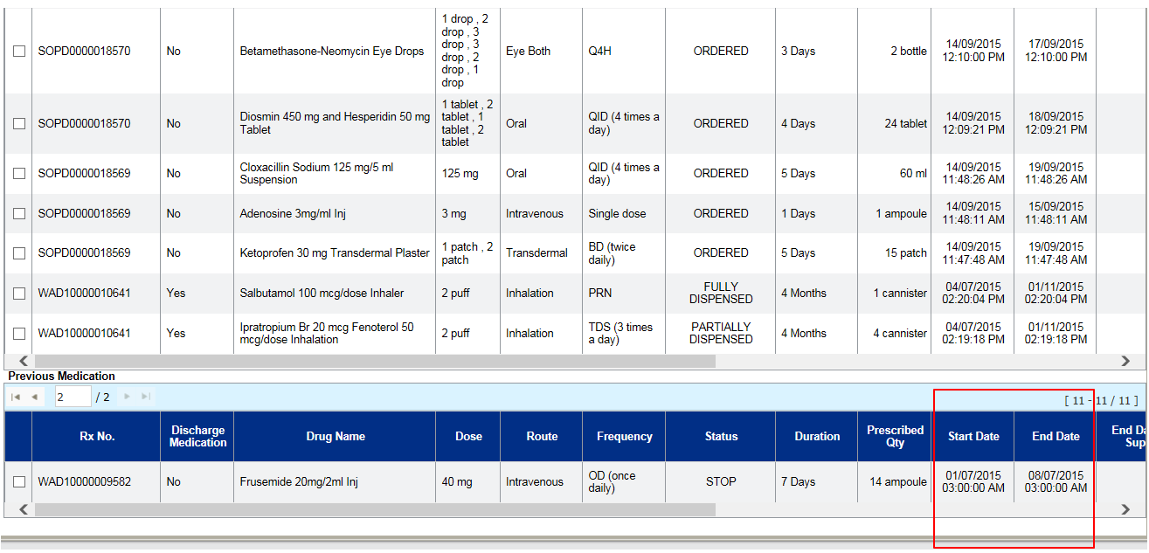

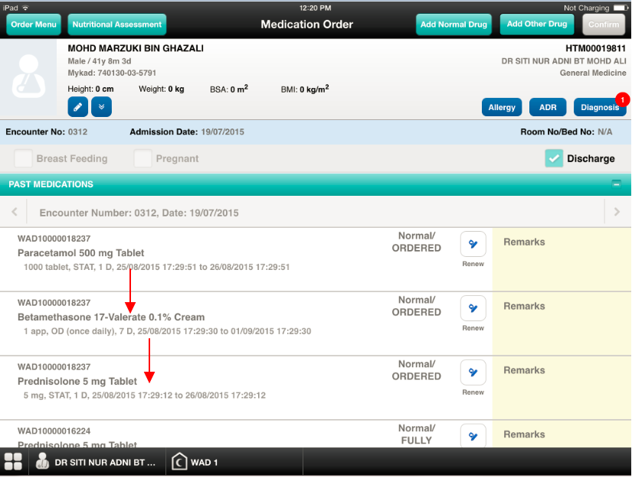

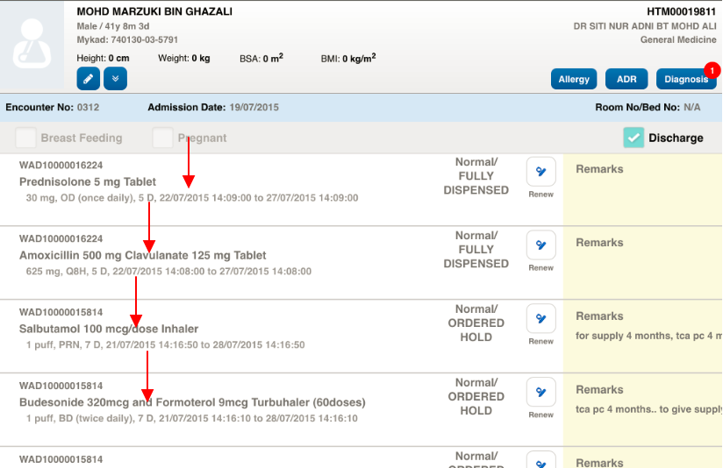

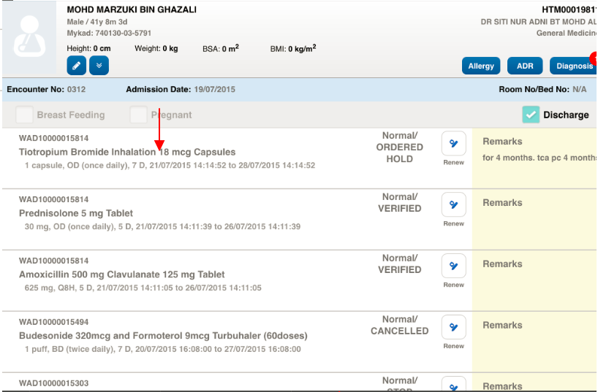

Outpatient Pharmacy – Transcribe Order
Ticket No | Title | Description | Resolution
I-PhIS012231715S | Transcribe Order-Request no checking on wardstock for outpatient drug | Transcribe Order-Request no checking on wardstock for outpatient drug. User reported that she unable to perform favourite transcribe order for out patient due to drug listed as ward stock. | Please do not auto-check on ward stock flag, if dispense location = OP.  User can manually check the ward stock flag if required.  1. enable the ward stock flag if drug is ward stock but do not auto check.  2. Do not copy any ward stock flag from previous record.  Apply to all scenario as below:  1. Add drug manually by enter the drug name  2. Add drug from advance search  3. Add drug from favourite list  4. Renew drug  5. Renew drug with different duration

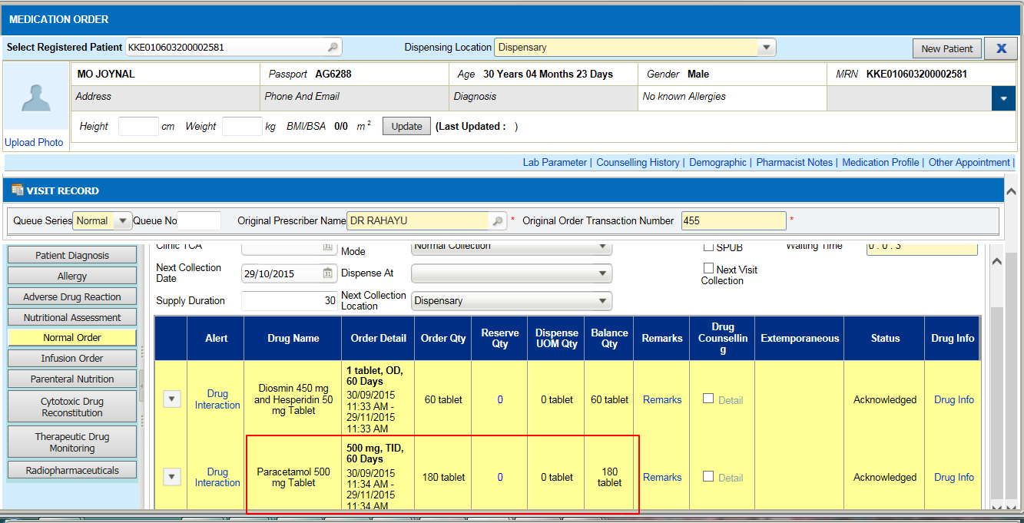

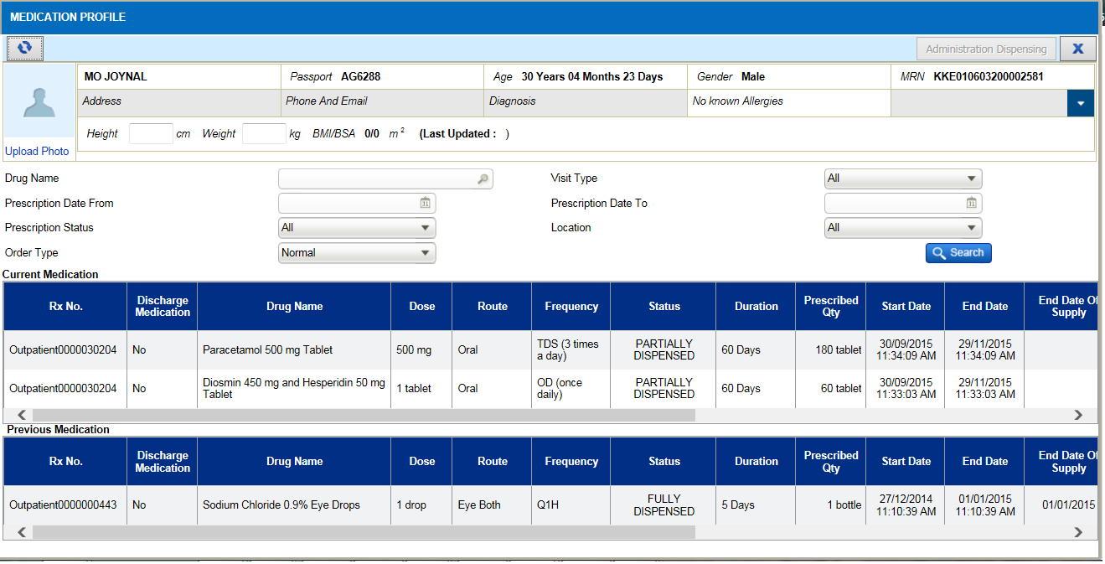

Outpatient Pharmacy – Screening and Verification
Ticket No | Title | Description | Resolution
I-PhIS008369814S | Screening & Verification- Suggest for intervention Rx with function Modify Order | Screening & Verification- Suggest for intervention Rx with function Modify Order. Suggest for intervention Rx with function Modify Order at Screening stage before click verify. | After user do intervention user can click on modify button.

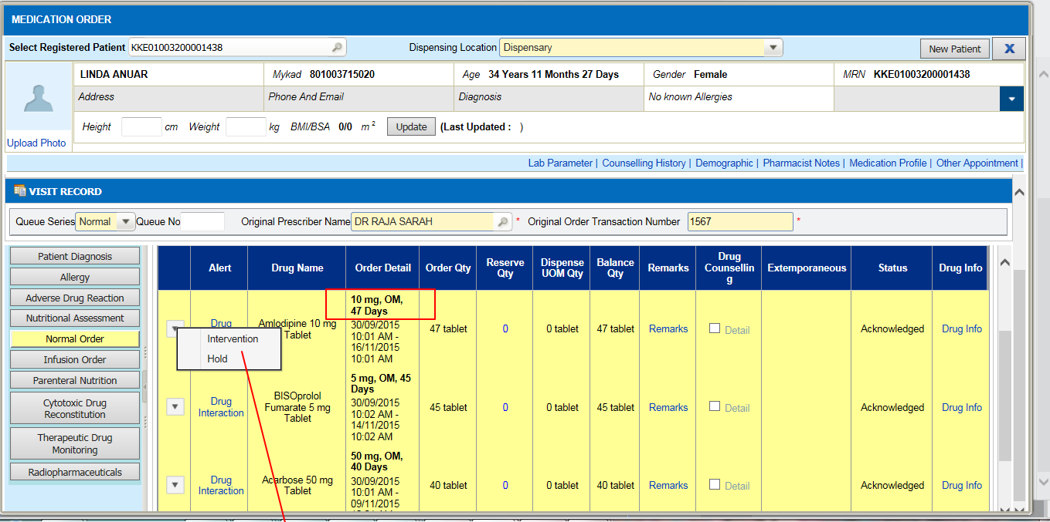

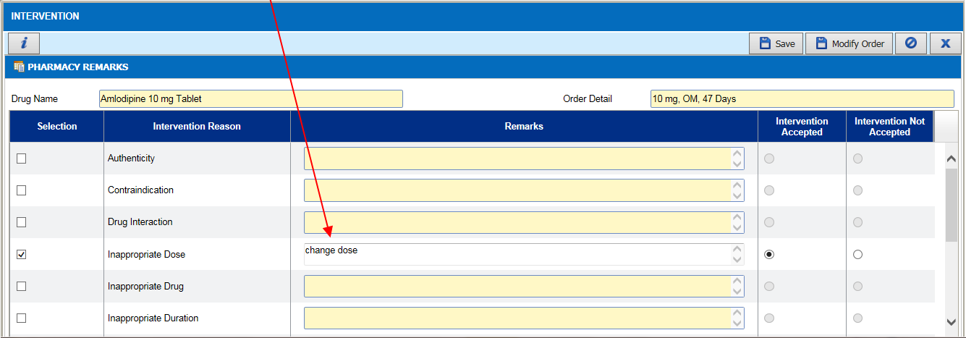

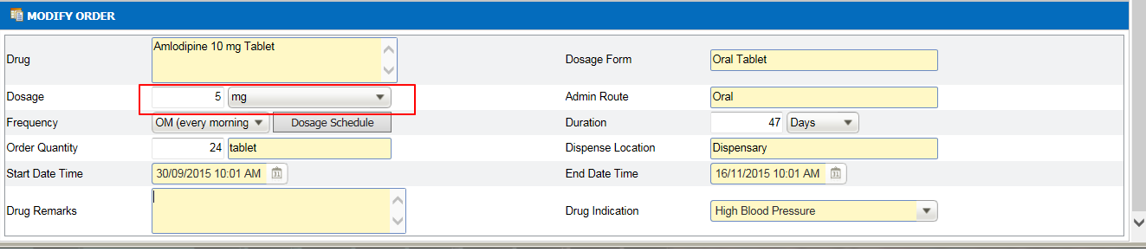

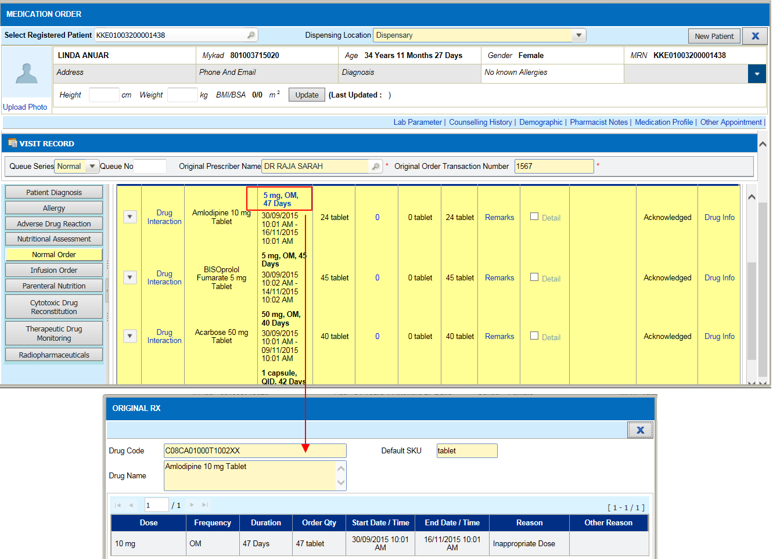

Outpatient Pharmacy – Alternate Drug
Ticket No | Title | Description | Resolution
I-PhIS012228915S | Request alternate drug between "Oral Chewable Tablet" and "Oral Tablet" | Alternate/combination, allow different dosage form. User want to alternate drug "Lamotrigine 50 mg Tablet" into "Lamotrigine 25 mg Dispersible/Chewable Tablet" but drug Lamotrigine 25 mg Dispersible/Chewable Tablet no in list alternate, because of Dosage Form is differen | To allow user to choose different dosage form in alternate/combination. When user select the drug from the list, please check on dosage form.  • If user select the main drug, the alternate drug should have same dosage form with main drug.  • if user not selecting main drug, user can select other dosage form.

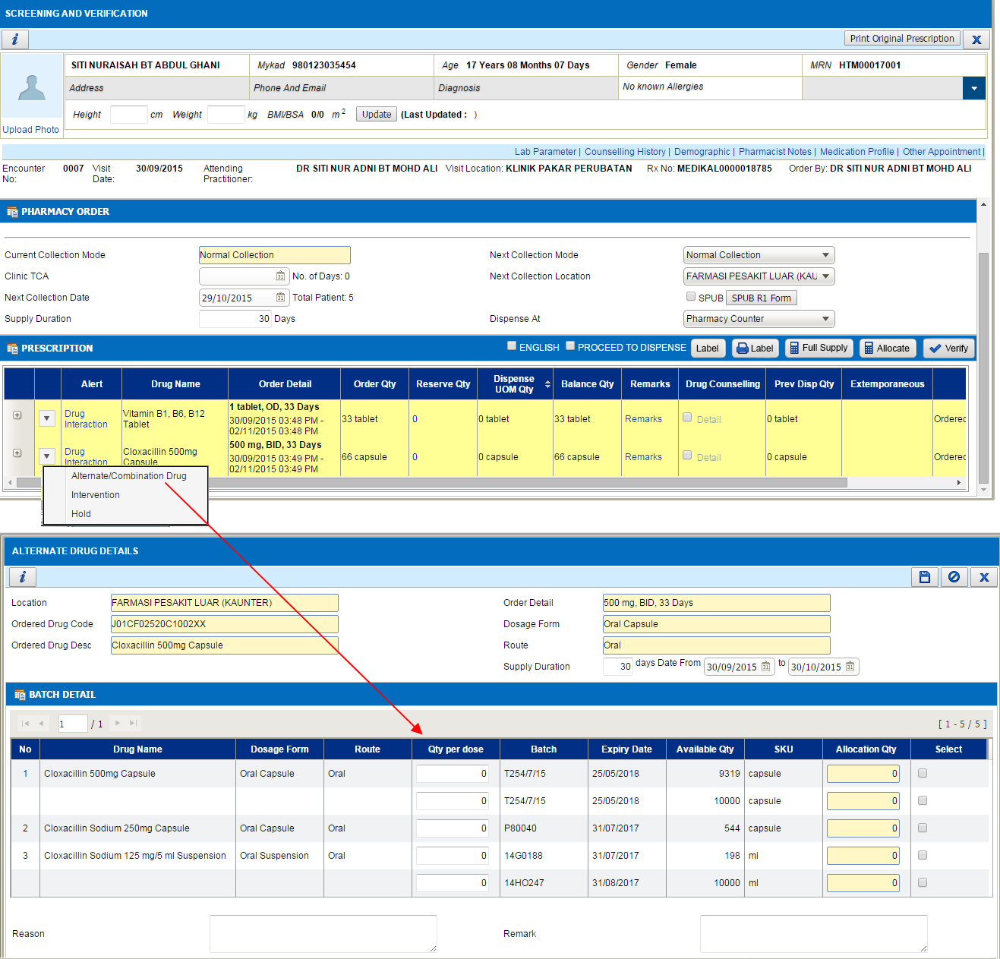

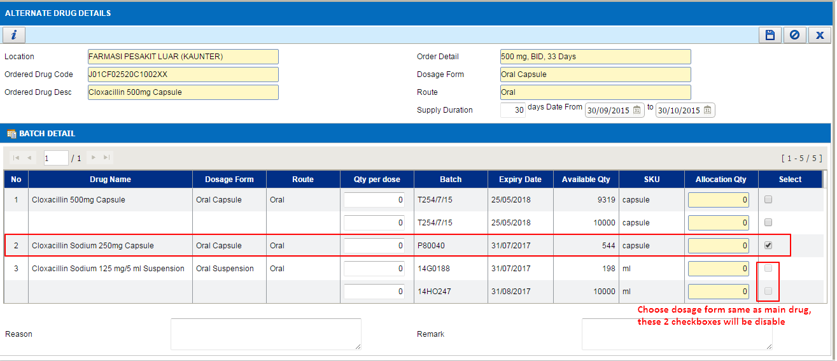

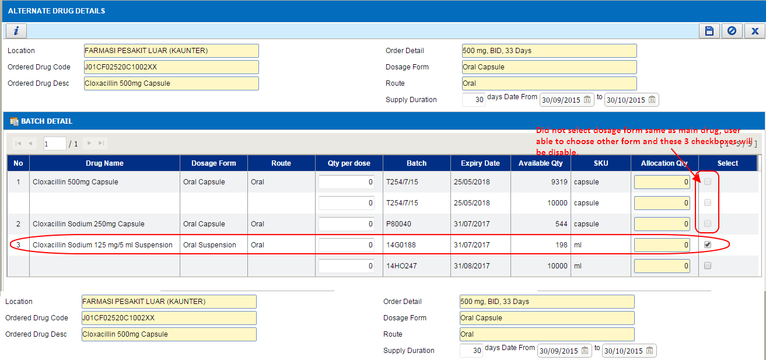

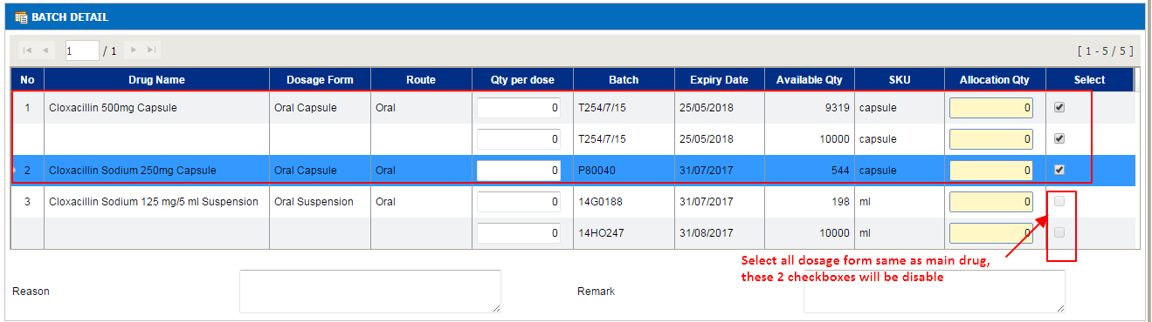

Patient Management – Ward Management
Ticket No | Title | Description | Resolution
I-PhIS009209915S | Ward Management- Request to add column department. | User request add column department on ward management easier to view department for referral. | To add column department on Ward Management for easier to view department for referral

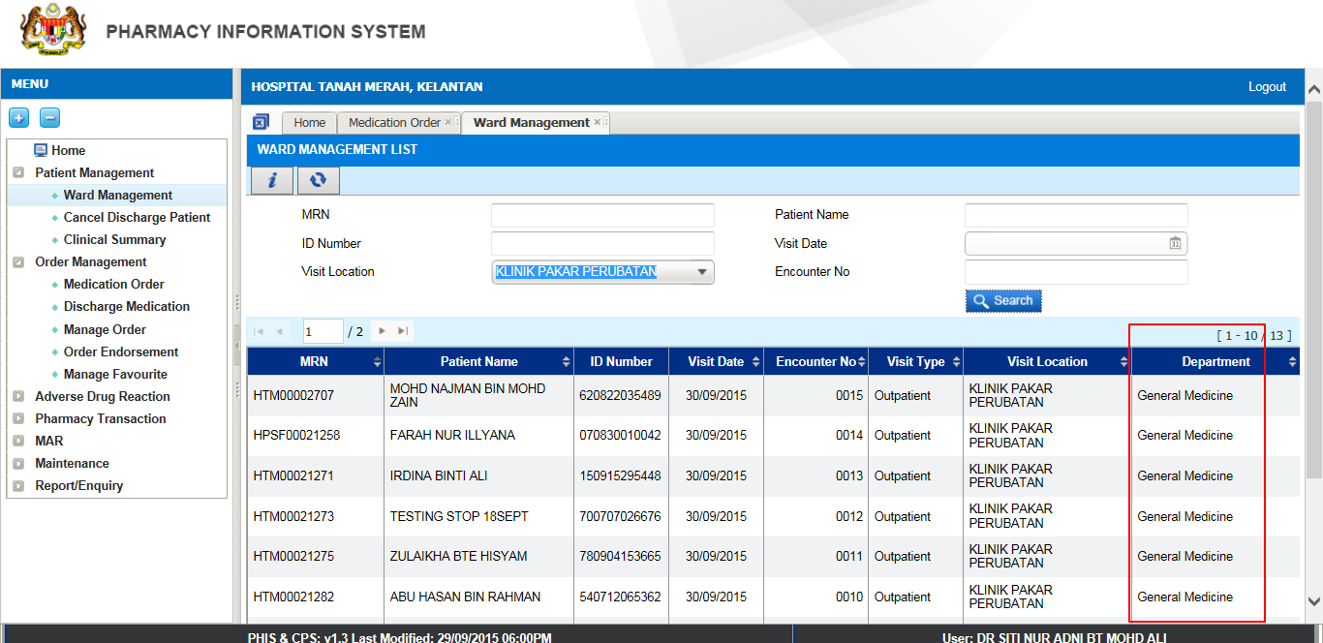

Patient Management – Clinical Summary
Ticket No | Title | Description | Resolution
I-PhIS009210015S | Patient Management - Clinical Summary - Add column department | User requested adding column information for department on clinical Summary on function visit list. | To add column department on Clinical Summary on function of visit list

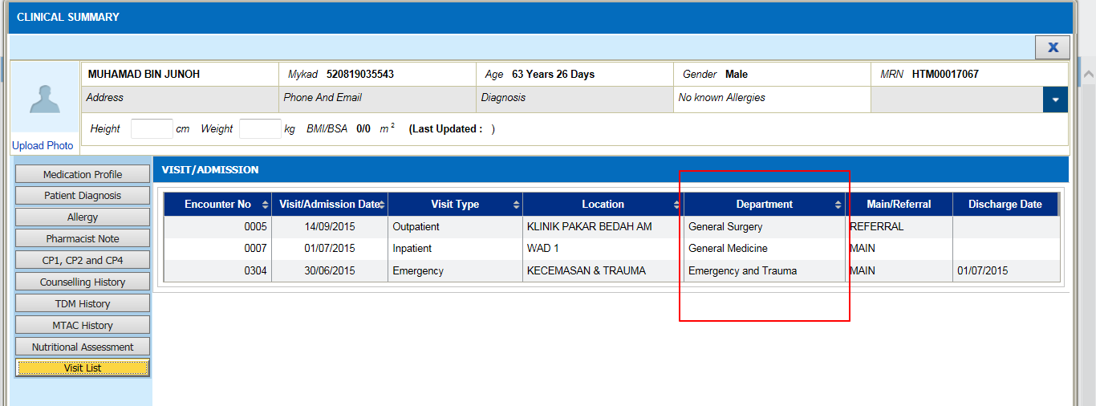

Patient Management – Clinical Summary
Ticket No | Title | Description | Resolution
I-PhIS009209815S | Patient Management - Clinical Summary - Add column main visit/ referal | User request adding column information for main visit / referral on clinical summary on function visit list. | To add column main visit/Referral column on Clinical Summary on function of visit list

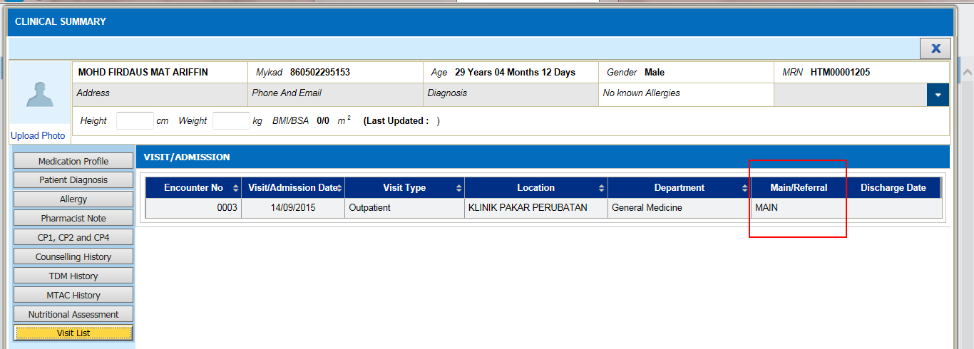

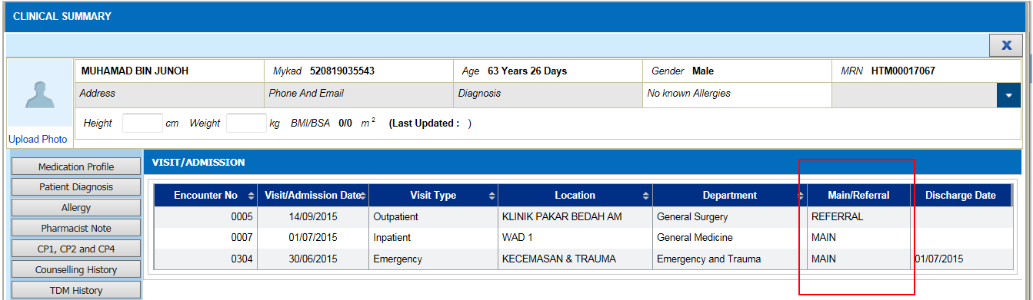

Report/Enquiry – Stock Balance Report
Ticket No | Title | Description | Resolution
I-PhIS010952315S | Stock balance by drug and non drug - Changes on the report layout | User request to add column price | 1. Add on column Unit Price (referring to Drug Average Price)  2. Amount (RM)  3. Standard and Non Standard

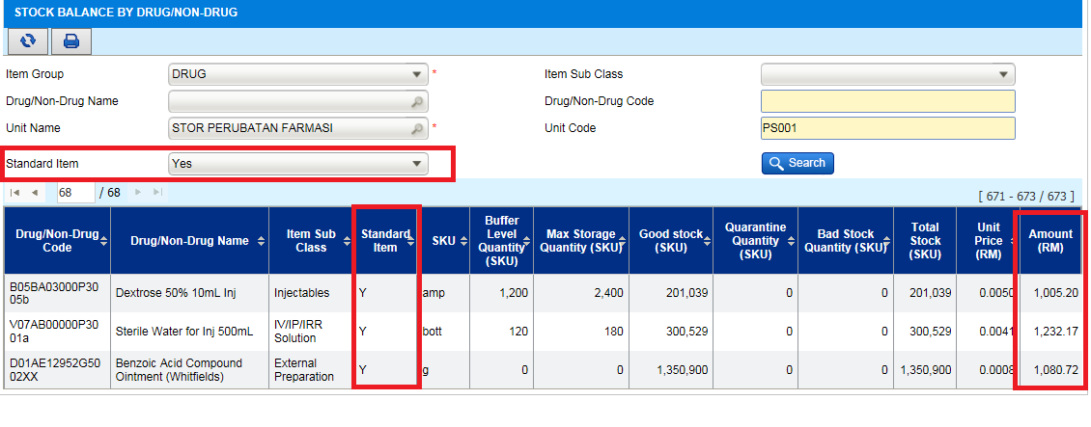

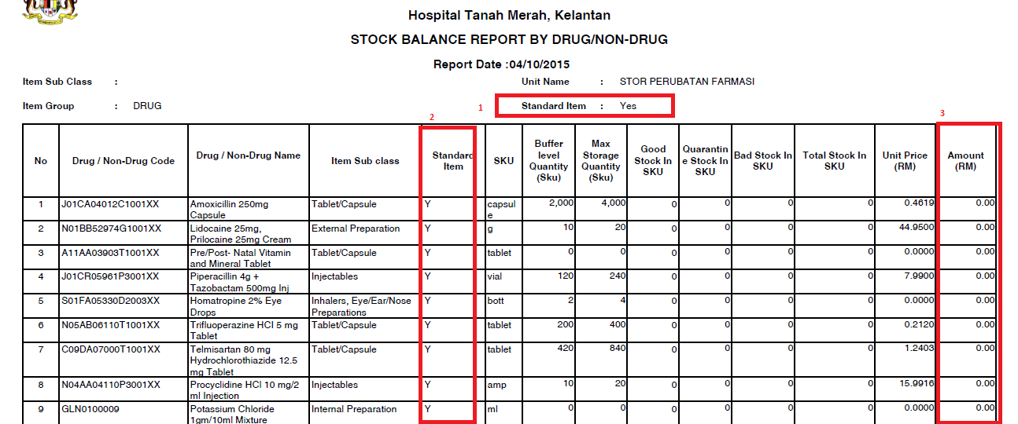

Report/Enquiry – Issue Report
Ticket No | Title | Description | Resolution
I-PhIS012271015S | Issue Report - add item purchase type (LP/APPL/Contract). | User request to add item purchase type which is (LP/APPL/Contract). | Add search criteria of Item Purchase type : All, APPL , LP & Contract

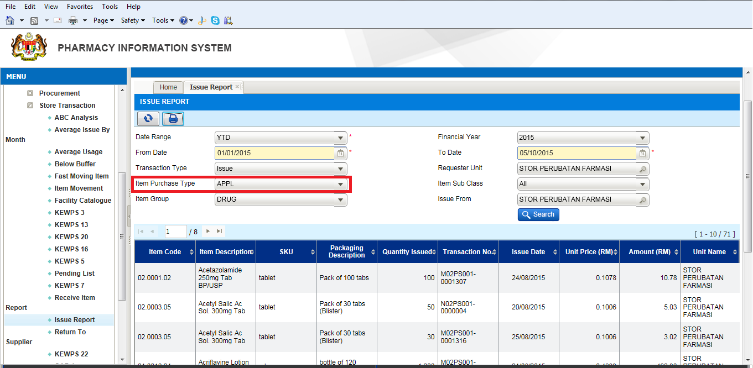

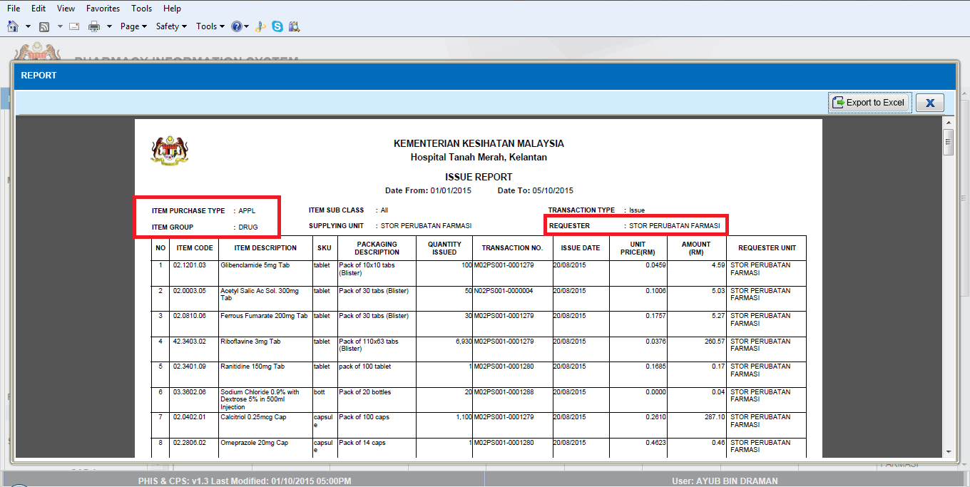

Report/Enquiry – YTD Purchase By Item
Ticket No | Title | Description | Resolution
I-PhIS012270815S | YTD Purchase By Item - request changes to the report | User request to add on:  1.item group  2. Vote Code & Description  2. standard and non-standard  3. item purchase type  4. item group  5. item class.  6. item sub class  7. PKU  8. SKU  9.conversion factor. | As per request

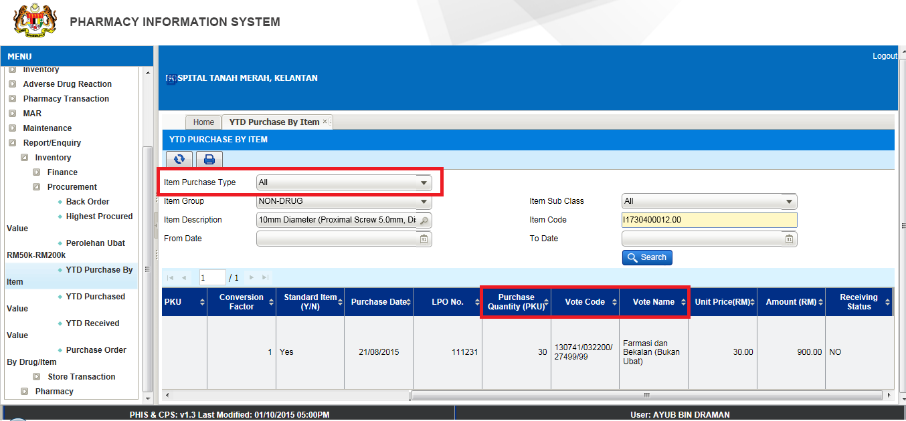

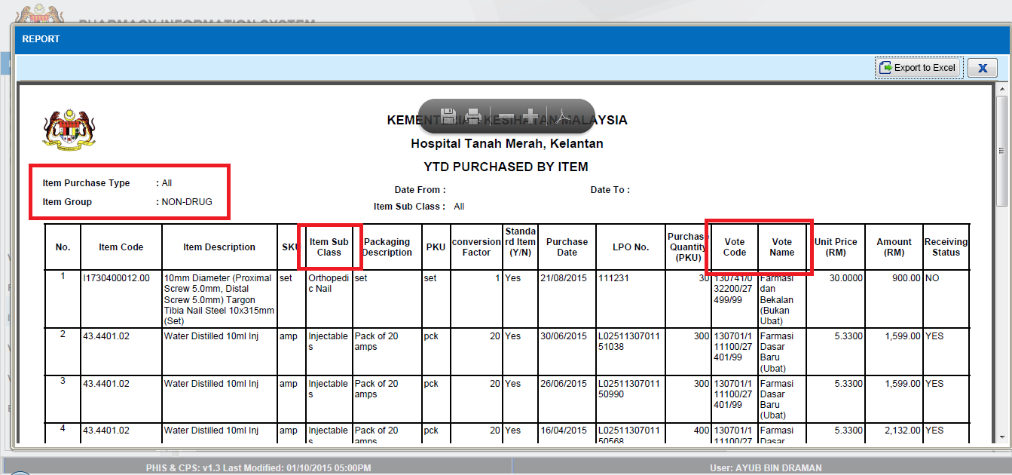

Report/Enquiry – PCI - CP3 Form
Ticket No | Title | Description | Resolution
I-PhIS011326315S | Ward Pharmacy – PCI - CP3 forms: | 1) To add below item in PCI - CP3 forms  1. Dr’s stamp and sign  2. Wrong patient  3. Drug not in formulary  4. Drug administration error  5. Unclear handwriting  Referring to report PF 6.3 (b)  2) Outcome – change to 200 characters | As per request

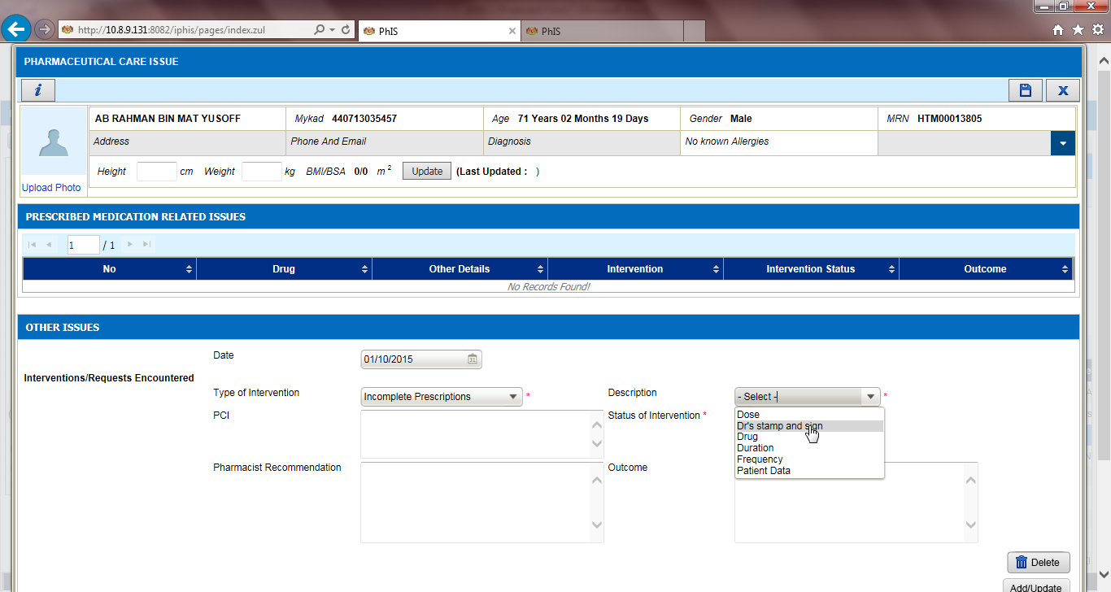

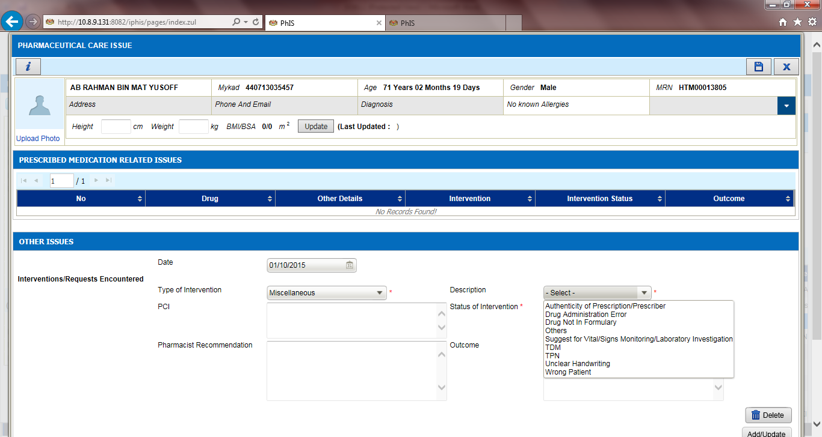
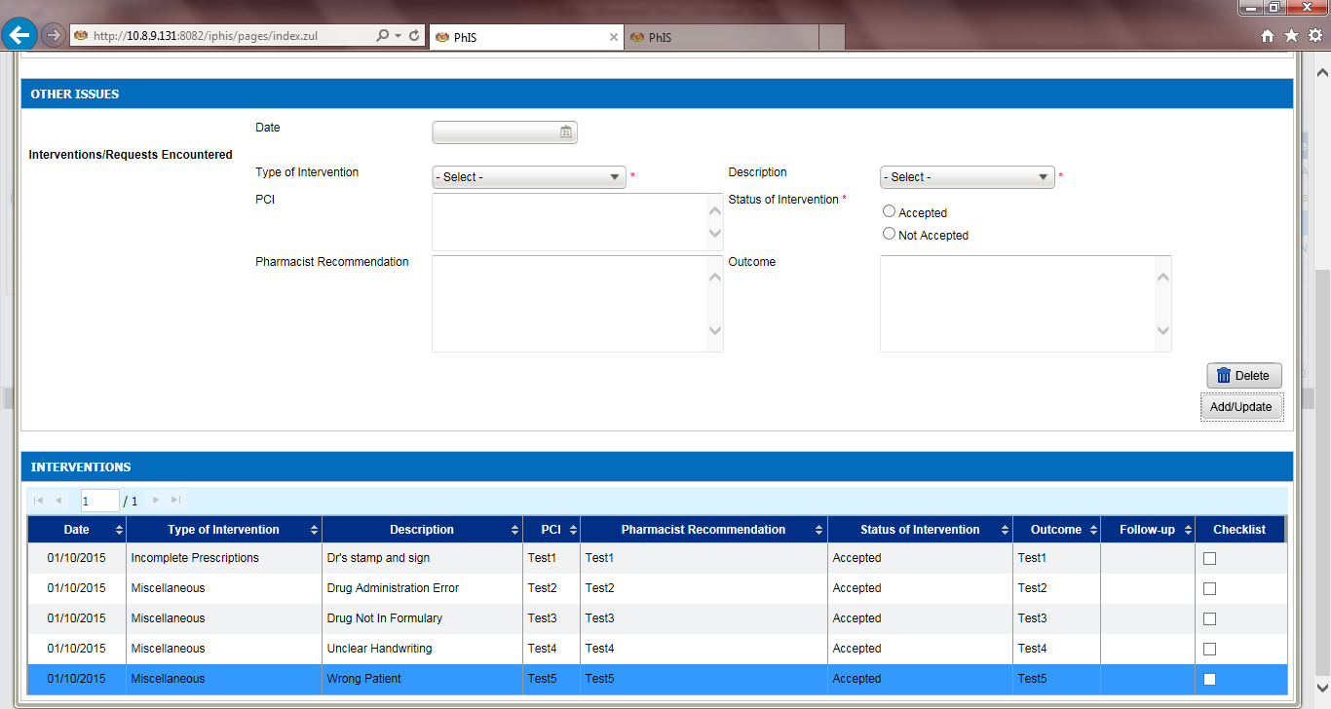

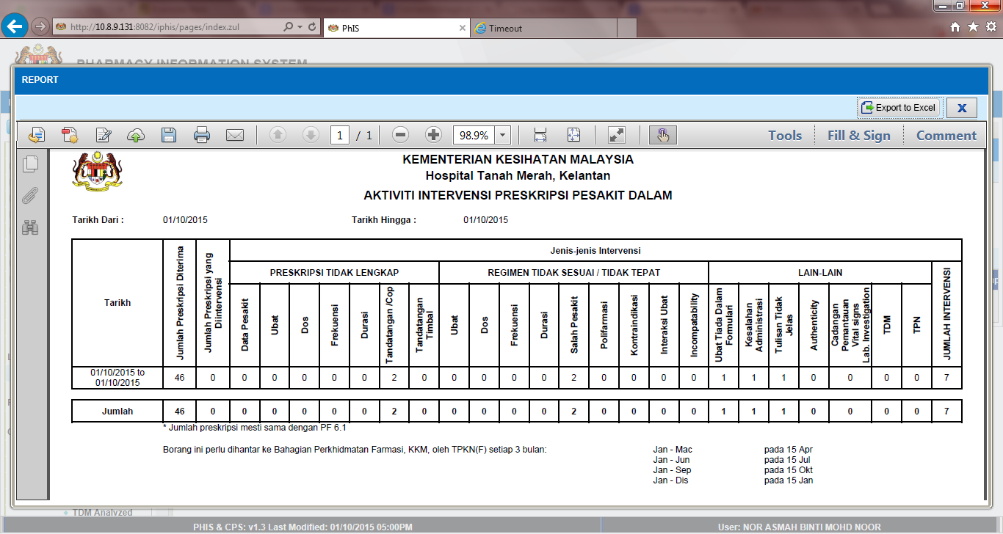

Deployment - Procedures

List of Items to be Deployed
No. | Items | Components | Path
1 | HQ Patch Script | PatchScripts_IWP_v1.3.7.txt  PatchScripts_REPO_v1.3.7.txt | https://10.8.9.130:44330/svn/Workspace_Dataware/31_Implementation/Applications/PhIS ReleaseV1.3.7/hq/scripts
2 | HQ Application | phishq_v1.3.7.war | https://10.8.9.130:44330/svn/Workspace_Dataware/31_Implementation/Applications/PhIS ReleaseV1.3.7/hq/war
3 | HQ Application | epservice_v1.3.7.war | https://10.8.9.130:44330/svn/Workspace_Dataware/31_Implementation/Applications/PhIS ReleaseV1.3.7/hq/war
4 | Facility Patch Script | PatchScripts_PhIS_v1.3.7.txt  PatchScripts_PhIS_v1.3.7_DataPatch.txt PatchScripts_PhIS_v1.3.7_HPSF.txt PatchScripts_PhIS_v1.3.7_HSM.txt PatchScripts_PhIS_v1.3.7_HKM.txt PatchScripts_PhIS_v1.3.7_HTM.txt  PatchScripts_PhIS_v1.3.7_HospitalKapit.txt  PatchScripts_PhIS_v1.3.7_HKulim.txt  PatchScripts_PhIS_v1.3.7_KKGT.txt  PatchScripts_PhIS_v1.3.7_KKChemor.txt  PatchScripts_PhIS_v1.3.7_KKBandarPutra.txt | https://10.8.9.130:44330/svn/Workspace_Dataware/31_Implementation/Applications/PhIS ReleaseV1.3.7/facility/scripts
5 | Facility Application | iphis_v1.3.7.war | https://10.8.9.130:44330/svn/Workspace_Dataware/31_Implementation/Applications/PhIS ReleaseV1.3.7/facility/war
6 | Facility Application | PhISService_v1.3.7.war | https://10.8.9.130:44330/svn/Workspace_Dataware/31_Implementation/Applications/PhIS ReleaseV1.3.7/facility/war
7 | Facility Application | PhISSchedulers_v1.3.7.jar | https://10.8.9.130:44330/svn/Workspace_Dataware/31_Implementation/Applications/PhIS ReleaseV1.3.7/facility/jar
8 | New Cronjob | 00 1 * * *  PhISSchedulers.jar 17 | /usr/java/jdk1.6.0_37/bin/java -jar /home/phisesb/phisjars/PhISSchedulers.jar 17
9 | Mobile Application | ipadhosp-1.4.0b42-PhISDS.war | https://10.8.9.130:44330/svn/Workspace_Dataware/31_Implementation/Applications/PhIS ReleaseV1.3.7/Mobile

Backup Procedure before Deploy

Backup Procedure
Using backup tool, backup the following files and folder and database as per table below;
No. | Type | Backup Item | Description
1 | Application | /home/phisesb  /opt/phisesb  /usr/share/fonts/truetype | PhIS Integration Application  PhIS Core Application  Fonts required by PhIS
2 | Database | phisprod database | PhIS Live database

Deployment/Installation Guidelines

Deployment at Facility
Below table is described the deployment steps at Facility:
Step | Items | File Name | Source Path | Action
1 | Facility Patch Script | PatchScripts_PhIS_v1.3.7.txt  PatchScripts_PhIS_v1.3.7_DataPatch.txt PatchScripts_PhIS_v1.3.7_HPSF.txt PatchScripts_PhIS_v1.3.7_HSM.txt PatchScripts_PhIS_v1.3.7_HKM.txt PatchScripts_PhIS_v1.3.7_HTM.txt  PatchScripts_PhIS_v1.3.7_HospitalKapit.txt  PatchScripts_PhIS_v1.3.7_HKulim.txt  PatchScripts_PhIS_v1.3.7_KKGT.txt  PatchScripts_PhIS_v1.3.7_KKChemor.txt  PatchScripts_PhIS_v1.3.7_KKBandarPutra.txt | https://10.8.9.130:44330/svn/Workspace_Dataware/31_Implementation/Applications/PhIS ReleaseV1.3.7/facility/scripts | Please ensure all the script is execute before iphis.war deploy.  Please ensure the script is executed in sequence. Script files 1 & 3 Execute as pgScript and other two Run as highlight the Script and press (F5)
2 | Facility Application | iphis_v1.3.7.war | https://10.8.9.130:44330/svn/Workspace_Dataware/31_Implementation/Applications/PhIS ReleaseV1.3.7/facility/war | Please rename the war file from iphis_v1.3.7.war to iphis.war then deploy.
3 | Facility Application | PhISService_v1.3.7.war | https://10.8.9.130:44330/svn/Workspace_Dataware/31_Implementation/Applications/PhIS ReleaseV1.3.7/facility/war | Please rename the war file from PhISService_v1.3.7.war to PhISService.war then deploy.
4 | Facility Application | PhISSchedulers_v1.3.7.jar | https://10.8.9.130:44330/svn/Workspace_Dataware/31_Implementation/Applications/PhIS ReleaseV1.3.7/facility/jar | Rename PhISSchedulers_v1.3.7.jar to PhISSchedulers.jar and copy to /home/phisesb/phisjars/ folder in production servers. Backup existing Jar before copy new one.
5 | New Cronjob | 00 1 * * *  PhISSchedulers.jar 17 | /usr/java/jdk1.6.0_37/bin/java -jar /home/phisesb/phisjars/PhISSchedulers.jar 17 | Please add new cronjob PhISSchedulers entry. This is scheduler for house keeping of staging, log, integration tables
6 | Mobile Application | ipadhosp-1.4.0b42-PhISDS.war | https://10.8.9.130:44330/svn/Workspace_Dataware/31_Implementation/Applications/PhIS ReleaseV1.3.7/Mobile | Rename ipadhosp-1.4.0b37-PhISDS.war to ipadhosp.war and deploy.  Frontend Apps: 1.3.0r1t40  Backend Apps: 1.4.0b42

Deployment at HQ - IWP
Below table is described the deployment steps at HQ - IWP:

Step | Items | File Name | Source Path | Action
1 | HQ Patch Script | PatchScripts_IWP_v1.3.7.txt  PatchScripts_REPO_v1.3.7.txt | https://10.8.9.130:44330/svn/Workspace_Dataware/31_Implementation/Applications/PhIS ReleaseV1.3.7/hq/scripts | Please ensure all the script is execute before phishq.war deploy.
2 | HQ Application | phishq_v1.3.7.war | https://10.8.9.130:44330/svn/Workspace_Dataware/31_Implementation/Applications/PhIS ReleaseV1.3.7/hq/war | Rename the war file from phishq_v1.3.7.war to phishq.war then Deploy using Glassfish Administration Console
3 | HQ Application | epservice_v1.3.7.war | https://10.8.9.130:44330/svn/Workspace_Dataware/31_Implementation/Applications/PhIS ReleaseV1.3.7/hq/war | Rename the war file from phishq_v1.3.7.war to phishq.war then Deploy using Glassfish Administration Console

