Pharmacy Information System (PhIS)
and
Clinic Pharmacy System (CPS)

Release Note
For version 1.3

Version : 1.0
Document ID : PhIS_CPS/ReleaseNote/Refinement/22042015

© 2011-2015 Pharmaniaga Logistics Sdn Bhd (PLSB)

CONFIDENTIAL COPYRIGHTED MATERIAL – The information includes all concepts, comments, recommendations, and material, contained herein shall remain the property of Pharmaniaga Logistics Sdn Bhd (PLSB). No portion of this document shall be disclosed, duplicated or used in whole or in part of any purpose other than the purpose of the Pharmacy Information System & Clinic Pharmacy System (PhIS& CPS) Project execution only.

Revision History

Version No | Date of Release | Prepared by | Reviewed / Verified by | List of changes from Previous Version
1.0 | 22/04/2015 | Kee Tuan Hwa | Chew Ming Ping | First Version

Verified and Acknowledged by:
Name | Role/Designation | Organization | Signature & Date
Chew Ming Ping | Team Leader | Pharmaniaga Logistics Sdn Bhd
Hoh Choon Seng | Project Manager | Pharmaniaga Logistics Sdn Bhd

Name | Role/Designation | Organization | Signature & Date
 |  | Bahagian Perkhidmatan Farmasi (BPF), KKM
 |  | Bahagian Pengurusan Maklumat (BPM), KKM

Peer Review
Version No | Reviewed / Verified by | List Of Changes from Previous Version
1.0 | Juridah (QA) | Initial document

1 Introduction 1
1.1 Project Information 1
1.2 Objectives 1
2 Purpose 2
3 Summary – Refinement and Defect List 3
3.1 Refinement List 3
3.1.1 Pharmacy Inventory 3
3.1.2 Order Management 23
3.1.3 Outpatient and Inpatient Pharmacy 30
3.1.4 Clinical Modules 47
3.1.5 Clinical Pharmacokinetic Services 55
3.1.6 Manufacturing 61
3.1.7 Report/Enquiry 70
3.1.8 IWP, Administration and General 79
3.1.9 Minor Refinement from UAT 1.3 87
3.2 Resolved Defect List 95
4 Refinement List – Detail Changes 123
4.1 Pre-Requisites 123
4.1.1 HQ Level 123
4.1.2 Facility Level 128
4.2 Details of the Refinement List 135
5 Deployment - Procedures 137
5.1 List of Items to be Deployed 137
5.2 Backup Procedure before Deploy 138
5.2.1 Backup Procedure 138
5.3 Deployment/Installation Guidelines 139
5.3.1 Deployment at Facility 139
5.3.2 Deployment at HQ - IWP 140

Introduction

Project Information

Project ID : | PhIS and CPS
Project Name : | Pharmacy Information System and Clinic Pharmacy System
Version No : | 1.3
Client Name : | Ministry of Health
Release ID : | RL15/003
Release Date : | 22/04/2015

Objectives
No. | Objective | Reference
1. | Release PhIS & CPS Application to Facility | Refer Section 3 – Refinement and Defect list

Purpose
The purpose of the document is to update the end-user of the changes and defects have been resolved to be included in the new version of application and will be deployed to production server.
This document outlines the list of request and issue to be delivered in the newer version of application and also the guidelines on how to deploy the new version of application in production.

Summary – Refinement and Defect List

Refinement List

Pharmacy Inventory
NO | Ticket No | Module | Facility | Comment By | Reported Date | Title | Description | Additional Information | Solution
1 |  | Pharmacy Inventory | BPF | Adam | 16/12/13 | Indent | - Add column for Created By at item level - No need  - Add print button at listing screen | 19/12: no issue for Add Column  19/12: provide 1 more enquiry report to generate of indent information | Refer to Quick Summary
2 |  | Pharmacy Inventory | BPF | Azhar | 17/12/13 | RFQ | RFQ screen  1. Only after status 'Confirm', 'Lampiran Q' button will be available.  2. Same drug cannot be added in RFQ in the same year.  - Prompt msg "RFQ No:xxx was generated on xxxx. Do you want to create new RFQ?"  Add Drug/Non-Drug screen  - 'Request Qty' change to 'Request Qty(SKU)'.  (No need to add validation).  3. Offer summary report  Add field  - 'Advertisement Date' field below 'RFQ Date' field.  - Tarikh Luput Sijil Pendapatan Kewangan Malaysia(Mandatory)  - Tarikh Luput Sijil Bumiputra (Mandatory) | 20/12: (for issue no 2 and no 3)  meanwhile issue no 1: will be proceed in the current application  3/12/2014 : Add Drug/Non-Drug screen  - 'Request Qty' change to 'Request Qty(SKU)'.  (No need to add validation) - Drop this section from request lis | Refer to Quick Summary
3 |  | Pharmacy Inventory | BPF | Azhar | 17/12/13 | RFQ/Quotation | Quotation Report  Page 1  1. Bil.Sebutharga  - User need to confirm wheather need to display 'RFQ No' or 'Quotation No'.  2. Perkara  *xxxxxxxxxxxxxxxxxxxxxxxxxxxxxxxx  3. Tarikh Sebut Harga Dipanggil = Created Date  4. Tarikh Sebut Harga Dibuka = Advertisement Date  Page 2  1. Remove the column  - Perihal Item  - No.SebutHarga Syarikat  - Catitan  2. Add new column  - Tarikh Luput Sijil Pendapatan Kewangan Malaysia(Mandatory)  - Tarikh Luput Sijil Bumiputra (Mandatory) |  | Refer to Quick Summary
4 |  | Pharmacy Inventory | BPF | Azhar | 11/6/13 | Procurement - Purchase Order - LP | Suggestion to have Procurement History at the Add Purchase Order Item prompted screen. Column as below: *System will only display for that current year  - LPO Date  - LPO No  - LPO Status  - Supplier Name  - Brand  - eP Approved Qty  - Unit Price (RM)  - Total Amount (RM) | 27/8: Will impact system performance and information can be viewed from report/enquiry  20/2: refer to the "  YTD Purchase By Item". In the report, need to change Item Description to drug or non drug code | Refer to Quick Summary
5 |  | Pharmacy Inventory | BPF |  | 19/12/13 | Receive From Supplier - KEW.PS 1 | KEW.PS 1 - Refer print screen | 23/12: critical  2/1/14: KIV  21/2: KEW.PS format cannot be changed | Refer to Quick Summary
6 |  | Pharmacy Inventory | BPF | Pn.Salwa/Pn.Musliha | 8/7/13 | Report/Enquiry - ADD | Transaction report (contract facility) | 15/7: get confirmation from core team  21/2: MOH will give format | Refer to Quick Summary
7 |  | Pharmacy Inventory | BPF | Azhar | 18/12/13 | Contract Facility | Facility should allow to view all contract information from HQ eventhough the facility is not allocated the contract.  Currently user only can view those contract that allocate to the facility | 19/12:  suggest to provide user id to access to view the contract screen at HQ | Refer to Quick Summary
8 |  | Pharmacy Inventory | BPF | Azhar | 18/12/13 | Procurement (RPL Contract) | Request to add in Contract No & Contract Period at EPO screen | 19/12: follow others standardization of others (APPL/LP)  21/2: refer to same issue 141 | Refer to Quick Summary
9 |  | Pharmacy Inventory | BPF | Cik Noraini | 12/7/13 | Indent - External | indenter facility  Provide type 'Indent type' as drop down 'Normal & Patient-Based'. Once select Patient Base, come out another section of Patient detail (refer to OP comment log/requirement).  Selecting the drug code - pop up detail information of the patient and the quantity request for each patient.  Provide attachment whereby sending the request, contained of Patient information.  Receiver Unit  Supply based on the drug code and not until patient details.  One off situation, no pending concept same current function. Able to print out the attachment sending by the requester | 3/12: this request related to SPUB where external indent required to be open up at level 2 through external indent | Refer to Quick Summary
10 |  | Pharmacy Inventory | BPF |  | 23/1/14 | PHIS header | Currently header shown header as Pharmacy Information System & Clinic Pharmacy System.  Suggestion:-  Hospital user, display : Pharmacy Information System  Clinic user, display : Clinic Pharmacy System | 3/12/14 : confirmed to proceed | Refer to Quick Summary
11 | I-PhIS001535314S | Pharmacy Inventory | HPSF | En. Azhar | 21/5/14 | RIQ . | User request to add new function. When user double click on RIQ, it will show No. of Fully supply, No. of partial and No. of yet supply. | 3/12/2014: To have a History Issue Transaction  (RIQ) - to know the more information in the listing page | Refer to Quick Summary
12 | I-PhIS001537414S | Pharmacy Inventory | HPSF | Stephanie | 21/5/14 | RIQ listing page | User request refinement at RIQ listing page to differentiate those indent that already perform issue and haven't done anything yet. For those indent haven't done anything yet make it BOLD and already done and still pending make it normal font size. | 27/5: Refinement, will include in future refinement release  3/12/2014: To show only the pending issue qty only same.(RIQ) - to make more userfriendly, so that users will know which Indent still not yet done | Refer to Quick Summary
13 | I-PhIS001537514S | Pharmacy Inventory | HPSF | Stephanie | 21/5/14 | RIQ listing page | Request at RIQ issue quantity screen when click button edit add 2 more column at the bottom section;  1) last issue quantity  2) last issue date  This 2 column capturing from supplying unit that issue out through (RIQ) for the respective unit only. | (RIQ) - to know the more information in the listing page | Refer to Quick Summary
14 | I-PhIS001541514S | Pharmacy Inventory | HPSF | En. Azhar | 23/5/14 | Task list | User request indent need to be differentiated in the task list by color coding eg(red). | RIQ (Tasklist) easy to differentiate | Refer to Quick Summary
15 | I-PhIS001631414S | Pharmacy Inventory | HPSF | Noraini binti Saari | 9/6/14 | Issue Note | User request to provide changes on Issue Note listing page screen.  1) Add in column Group  2) Add in in column Sub class.  The objective to assist user to identify the Issue Note is referring to which group type (Drug/Non Drug) and whats the sub class for each Indent.  Now user need to double click the transaction to see the details. | 16/6: can only for Item Group but not Item Sub-class  1/8: need to display the item group in the issue listing page | Refer to Quick Summary
16 | I-PhIS007230314S | Pharmacy Inventory | HPSF | Azhar | 6/7/14 | Stock Adjustment | Request to add PKU field information at Stock Adjustment\Add Adjustment Item screen. | 6/8: agree to display the changes | Refer to Quick Summary
17 | I-PhIS007286514S | Pharmacy Inventory | HPSF | Noraini Shaari | 15/7/14 | Notification Module | Request for changes on notification screen.  1. Request Menu Notification screen is stand alone and not put under Recall Product Notification screen.  2. Listing Page Add in Remarks column next to Keyword/Reason. Please refer below screen.  3. Once transaction Save and status = Open ONLY , should have edit function whereby allow to edit:-  Keyword/Reason  Remarks  Start Date  End Date  4. Keyword/Reason column request the column length is 100 current is 50 | Allow to change no 1 & 3 only  To change the keyword/Reason to Title  To extend the length title as 200 characters  To extend the length of remarks as 300 characters | Refer to Quick Summary
18 | I-PhIS007345914S | Pharmacy Inventory | HPSF | En. Azhar | 24/7/14 | Stock Adjustment | Request to provide UOM option at Stock adjustment module. Only applicable to level 1 (Main Store) . Level 2 user always default to UOM = SKU and not allow to change the UOM.  1. If Transaction Type = Stock Taking, then UOM value will be defaulted to based on the selection criteria from Count sheet. But allow to change.  2. If Transaction Type = Routine Checking, then UOM value will be defaulted to SKU but allow to change it to PKU. The quantity based on the selection criteria of UOM. | 6/8: new policy (for between facility for loose item/manufacturing & SPUB - allow level 2) item  Provide option for PKU/SKU from 'physical checking' up to 'Stock adjustment' follow what hve been defined. Meanwhile at Stock adjustment 'Routine Checking need to provide option 'SKU/PKU' for main store only. | Refer to Quick Summary
19 | I-PhIS007480014S | Pharmacy Inventory | HPSF | Miss Noraini | 24/8/14 | Issue - Ward Stock | Issue: To enable user to select multiple subclass item using checkbox.User dont want to use the dropdown menu. | ward stock - to make more user friendly, so that users can choose more than one sub class -> big impacts | Refer to Quick Summary
20 | I-PhIS007509714S | Pharmacy Inventory | Kinta | HONG JEE YAN | 27/8/14 | Offline Issue | Offline Issue - The message is misleading. Should not reset the detail while users choose C  Suggestion message: Criteria has been changed, do you want to process? | 3/12/2014: Suggestion message: Criteria has been changed, do you want to reset? | Refer to Quick Summary
21 | I-PhIS007571814S | Pharmacy Inventory | HPSF | Rohidayah | 8/9/14 | Indent | Pharmacist request to show maximum storage in indent screen for staff nurses access right. | 3/13/2014: To show the max storage & default packaging description  1. hide the 'sent to facility status' if internal indent  2.add the search feature for drug or non drug  3. change the Requesting Unit -> Supplying unit in the listing page | Refer to Quick Summary
22 | I-PhIS007635814S | Pharmacy Inventory | HPSF | Cik Noraini | 18/9/14 | Offline Issue & Own Consumption | Offline Issue, Request to:  1) Add on Maximum Storage quantity column.  2) Issue Quantity change the label name to Consumption Quantity | to help users to know how much should be issued by adding  >>max storage, SKU, packaging description , stock condition (ALL, with stock, without stock) | Refer to Quick Summary
23 | I-PhIS007636014S | Pharmacy Inventory | Kinta | LAY HOOK KAM | 18/9/14 | Quotation | Change the free text field to yellow coloured field as the value will be pulled from the Total Amount (RM) in the Offer Details section |  | Refer to Quick Summary
24 | I-PhIS007636114S | Pharmacy Inventory | Kinta | LAY HOOK KAM | 18/9/14 | Quotation | Quotation - Unit Price (SKU) is not automatically calculated for drug 'Pre/Post-Natal Multivitamin Capsule' |  | Refer to Quick Summary
25 | I-PhIS007636414S | Pharmacy Inventory | Kinta | LAY HOOK KAM | 18/9/14 | Quotation | Add in column: 'Reference No' and 'Drug Name & Code' in the Quotation Listing Page |  | Refer to Quick Summary
26 | I-PhIS007636514S | Pharmacy Inventory | HPSF | Cik Noraini | 18/9/14 | Offline Issue | Sub class - request to provide checkbox when selecting the sub class | offline issue to make more userfriendly, so that users can choose more than one sub class -> big impacts | Refer to Quick Summary
27 | I-PhIS007636814S | Pharmacy Inventory | Kinta | LAY HOOK KAM | 18/9/14 | Quotation | Supplier Quotation Details screen: Add in 'Packaging Description' when search for item |  | Refer to Quick Summary
28 | I-PhIS007637114S | Pharmacy Inventory | HPSF | Cik Noraini | 18/9/14 | Issue - Ward Stock | Ward Stock - Add on column maximum storage quantity (referring to requester unit) | to help users to know how much should be issued by adding  >>max storage, SKU, packaging description , stock condition (ALL, with stock, without stock) | Refer to Quick Summary
29 | I-PhIS007637814S | Pharmacy Inventory | Kinta | LAY HOOK KAM | 18/9/14 | Usage Qty | Usage & Issue Quantity hyperlink - No indication whether the quantity stated is in SKU or PKU. |  | Refer to Quick Summary
30 | I-PhIS007638114S | Pharmacy Inventory | HPSF | Cik Noraini | 18/9/14 | Own Consumption report | Own Consumption report  User request to add on SKU & PKU column at report listing. |  | Refer to Quick Summary
31 | I-PhIS007638214S | Pharmacy Inventory | HPSF | En azhar | 18/9/14 | Payment | 1. Change the type from 'Payment with credit note' to a drop down list as below:  a. Cancel the LPO  b. Full payment  c. Payment with credit note  2. In the PO listing page, we need to link the LPO with the payment status by adding the payment status in front page. Default value is OPEN | 3/12/2014: No need to change the (1)  And, In the PO screen, need to add 2 buttons such as 'cancel order' button for without LPO number (pending for eP appoval) and ' cancel LPO' button (ep Approved). For with LPO number. It will impact on the budget movement. | Refer to Quick Summary
32 | I-PhIS007638314S | Pharmacy Inventory | HPSF | En.Azhar | 18/9/14 | RIQ listing page | RIQ listing page  Objective: To know more the detail in the front page  Listing coloumn should have the values as below:  1. Indent No  2. Indent Date  3. Requester Uinit  4. Item Group  5. Total no of Item indented  6. Total no of Pending to Issue Items | To get more information in the detail page.So that, users will feel more user friendly and able to know the Issue status | Refer to Quick Summary
33 | I-PhIS007639714S | Pharmacy Inventory | HPSF | En.Azhar | 18/9/14 | Indent | Objective: Indenter can know the status in their listing page without call supplying unit  1. In the listing page, we need to add the fields as below:  a. no of Issue note number, on click on the number, a new windows will be prompted out and list out the related Issue No for that indent. Sorting the Issue number based on the approved Issue note date | 3/12/2014: Suggestion  To show the RIQ status such as open, closed, rejected, partial supply, full supply  Pending List Report  1. no need to filter the status  2. no need to fix the date range  3. need to show the issue note number for each item | Refer to Quick Summary
34 | I-PhIS007657714S | Pharmacy Inventory | HPSF | En.Azhar Baharuddin | 22/9/14 | Usage Qty | User request to change the formula of Usage Quantity. The formula should based on the respective month only. Current formula is based on the accumulative quantity from the last 3 month. |  | Refer to Quick Summary
35 | I-PhIS007659714S | Pharmacy Inventory | BPF | Pn Ezatul | 22/9/14 | Offline Issue | Currently Unit Catalogue only apply to Internal Facility  With this request , user can perform offline issue for external facility based on Unit Catalogue. |  | Refer to Quick Summary
36 | I-PhIS007671814S | Pharmacy Inventory | HPSF | En.Azhar Baharuddin | 23/9/14 | Receiving from Supplier - Requisition Order | User request to auto insert the transaction after approved the receiving process from non standard item. Purpose to have auto insert the issue transaction after approved the receiving process from non-standard item can refer attachment for further details. | Do not advise to auto create transaction  3/12:Somehow still need to cater to allow user to issue non standard item if they do not use requisition process.  Need to cater function Non standard item able to do indent process. | Refer to Quick Summary
37 | I-PhIS007723714S | Pharmacy Inventory | KKGT | Madam Chong | 2/10/14 | Offline Issue | Offline Issue - Request to have checkbox function where by the default value is With Stock.  When click button SEARCH , automatically display only item with stock. Else allow user to choose With & Without Stock and will display item with item with Zero quantity and with stock. |  | Refer to Quick Summary
38 | I-PhIS007753714S | Pharmacy Inventory | KKGT | Sabrina Lee Lai Fong | 8/10/14 | Indent | Request for the facility user to manually define the duration/period for the indent record to be maintained as open. Currently the duration is fixed as 14 days. | 3/12: confirmed to proceed .Configurable at Facility Information screen. The columns in days | Refer to Quick Summary
39 | I-PhIS007763714S | Pharmacy Inventory | HPSF | : En.Azhar Baharudin | 13/10/14 | RIQ . | User request In the Inventory module, recommend issue quantity (RIQ) module  i. Need to display the package description near to the drug mas  ii. Need to display the SKU  iii. Able to issue quantity more than indent quantity |  | Refer to Quick Summary
40 | I-PhIS007771714S | Pharmacy Inventory | KKGT | Ms.Indra | 13/10/14 | Receive Inter Facility | Receive Inter Facility - User requests to remove validation function of the quantity that have been enter based on conversion factor. Should allow to enter any quantity without checking on conversion factor for the respective item selected. |  | Refer to Quick Summary
41 | I-PhIS007859714S | Pharmacy Inventory | BPF | Puan Ezatul Rahayu | 24/10/14 | Offline issue own consumption | Issue - To shorten the step and alert (following order management module)  only for Own consumption |  | Refer to Quick Summary
42 | I-PhIS007963814S | Pharmacy Inventory | HPSF | Noraini binti Saari | 6/11/14 | Prepacking | Reported that need to update stock when do prepacking. |  | Refer to Quick Summary
43 | I-PhIS008109714S | Pharmacy Inventory | HPSF | Noraini binti Saari | 19/11/14 | offline issue (ward stock) | User request hospital to able to do top up function directly to level 3 , similar function as clinic. By setting the configuration of facility information "Auto top up" |  | Refer to Quick Summary
44 | I-PhIS008111714S | Pharmacy Inventory | HPSF | Noraini binti Saari | 19/11/14 | Issue - Ward Stock | 1) User request to Label name module of ward/unit stock change Stock Replenish'  2. Change all the term related to Ward/unit stock in entire phis to 'Stock Replenish'  3) Ward Stock Screen , request change function by allowing the login ID to select Unit Name which is will be list out level 3 requester unit. By default the value is referring to user profile requesting unit. The stock will be deduct from the selected Unit Name |  | Refer to Quick Summary
45 | I-PhIS008111814S | Pharmacy Inventory | HPSF | Noraini binti Saari | 19/11/14 | Issue - Ward Stock | Ward Stock Screen, request Unit Name include in level of the unit for example ;Farmasi Bekalan Wad (level 3) |  | Refer to Quick Summary
46 | I-PhIS008243914S | Pharmacy Inventory | HPSF | Noraini | 2/12/14 | Issue | Request to remove one step. Without press the 'generate issue note' button, indenter able to do receiving. |  | Refer to Quick Summary
47 | I-PhIS008263814S | Pharmacy Inventory | HSM | LOW MOOI LING | 3/12/14 | Receive Item (Intra Facility) | User reported when to receive more than 1 item in 1 receive item intra facility record  Currently,show the 'Add Item' button is not available after 1 item is added into the list |  | Refer to Quick Summary
48 | I-PhIS008265814S | Pharmacy Inventory | HSM | ZUNNUR BT. IDRIS | 3/12/14 | Purchase Order | User request to display Contract Number in the Purchase Order Report (Print Out Report). | take from supplier table, if the supplier does not have the contract number, it will leave blank | Refer to Quick Summary
49 | I-PhIS008281814S | Pharmacy Inventory | HPSF | En. Azhar Baharudin | 4/12/14 | Prepacking | Pre packed item that have been generated with new item code is invisible at main store level user for all transaction module related to Inventory. I.e purchase order, receiving, distribution module & stock control. This is because is not used by the main store user and to avoid confusion as a user. |  | Refer to Quick Summary
50 | I-PhIS008289814S | Pharmacy Inventory | HSM | AZMAN B MUHAMAD | 5/12/14 | Receiving | HSM cannot receive item via Receive Inter Facility due to Hospital Angkatan Tentera (HAT) Lumut is not registered in MOH facility list. | Data Issue and External Facility Master | Refer to Quick Summary
51 | I-PhIS008331814S | Pharmacy Inventory | HSM | Pn Zunnur | 10/12/14 | Cancel PO | User request to be able to cancel from PhIS any PO with eP status, eP approved. Reason as below,  1) The vote code assigned is wrongly selected.  2) Supplier unable to supply to HSM due to uncertain reason.  Cannot provided screen shot or references number due to no incident happened under PhIS project. | 10/2: in v1.3, only cater for cancellation of LPO for LP & Contract. Can't handle for APPL due to integration process which impact on the process.  Cancellation of order without LPO done for APPL, LP & Contract. | Refer to Quick Summary
52 | I-PhIS008529915S | Pharmacy Inventory | HSM | EE SHU TING | 5/1/15 | Receive Item | User request to put packaging description when searching at item description. |  | Refer to Quick Summary
53 | I-PhIS008572215S | Pharmacy Inventory | HSM | AZMAN B. MOHAMMAD | 9/1/15 | Stock balance report | User request to add new column for:  1)Amount per unit (RM)  2)Total amount (RM)  3)Require this two column for send report to MOH to calculate amount and nilai pegangan that particular item. | item will be based on avarage price | Refer to Quick Summary
54 | I-PhIS008701815S | Pharmacy Inventory | PKD Kinta | HONG JEE YAN | 23/1/15 | Purchase Order | User request to allow to enter 'LPO Date' for Contract item less than 'Order Date' when user want to perform 'eP-Approve.' Currently alert message 'LPO date cannot be less than order date' will pop up if user enter LPO date less than Order date. | Will remove this validation | Refer to Quick Summary
55 | I-PhIS001525314S | Pharmacy Inventory | KKGT | Madam Cheong | 20/5/14 | external facility unit catalogue | Indent-external screen - User suggest to generate a list as a indent intra (within facility); cause to enable for fast entry. | To create an external facility unit catalogue | Refer to Quick Summary
56 | I-PhIS007423914S | Pharmacy Inventory | PKD Kinta | HONG JEE YAN | 13/8/14 | Issue listing | To add 'Facility Name' column at the Issue Listing Page. | Need to consider the internal and external case | Refer to Quick Summary
57 | I-PhIS007547114S | Pharmacy Inventory | PKD Kinta | Puan Roslina binti Ghazali @ Md. Yusof | 3/9/14 | External Indent | Request Indent Type: External Facility  Click on the + Add Item button  'All Quantity must be in (SKU)' sentence should be placed on top I the 'Add Indent Item' screen. | Label issue | Refer to Quick Summary
58 | I-PhIS007547714S | Pharmacy Inventory | PKD Kinta | Puan Husni/Miss Jennifer | 3/9/14 | Receiving (Inter Facility) | Request display SKU, Packaging Description & Conversion Factor when add item into the Receiving list | add more information | Refer to Quick Summary
59 | I-PhIS007548114S | Pharmacy Inventory | PKD Kinta | Puan Husni/Miss Jennifer | 3/9/14 | Physical Checking | Request to Include 'Brand' column in report.  Brand is displayed in the application but not available in the report. | add more information | Refer to Quick Summary
60 | I-PHIS007677814 | Pharmacy Inventory | HPSF | En Azhar | 7/4/14 | Receive From Supplier | Add "Less than DO quantity" & "More than DO quantity" in dropdown list at "Reason For Reject" column.  1) If select less/more than DO quantity, it will update "Kurang/Lebih" column in KEWPS-2  2) If select more than DO quantity, it will update "Kurang/Lebih" column and flow to return to APPL | 9/4 discussion - to add reason for reject  1) refinement  2) refinement | Refer to Quick Summary
61 | I-PhIS008099914S | Pharmacy Inventory | HTM | En. Muhammad Fadhli Ngah | 18/11/14 | Average usage | To display 'Average per Month' value without have to click on the hyperlink  Suggestion: Mouse over or directly display |  | Refer to Quick Summary
62 | I-PhIS008100014S | Pharmacy Inventory | HTM | En. Muhammad Fadhli Ngah | 18/11/14 | Average usage | Mohon button untuk pilih lebih dari 3 bulan seperti yang sedia ada.  (Boleh set berapa bulan yang dikehendaki) |  | Refer to Quick Summary
63 | I-PhIS008100114S | Pharmacy Inventory | HTM | En. Muhammad Fadhli Ngah | 18/11/14 | RPL | Estimated Annual Purchase Value (RM)<50k, >50k  Suggest to differentiate by Color |  | Refer to Quick Summary
64 | I-PhIS008100614S | Pharmacy Inventory | HTM | En. Muhammad Fadhli Ngah | 18/11/14 | Purchase Order | To display 'Available Quantity' for item selected in the Add Purchase Order screen |  | Refer to Quick Summary
65 | I-PhIS008101314S | Pharmacy Inventory | HTM | En. Muhammad Fadhli Ngah | 18/11/14 | Purchase Order | Creator = Approval  Request for Approved Quantity (PKU) to be enabled to enter  Current: User has to enter Order Quantity (PKU), save the transaction & double click on item to enter the Approved Quantity (PKU) |  | Refer to Quick Summary
66 | I-PhIS008101714S | Pharmacy Inventory | HTM | En. Muhammad Fadhli Ngah | 18/11/14 | RPL | Request to differentiate (bold/field color) the amount for easy viewing. |  | Refer to Quick Summary
67 | I-PhIS008103714S | Pharmacy Inventory | HTM | En. Mohd Afiq Ariffin | 18/11/14 | Purchase Order | Request to display Contract 'Start Date' and 'End Date' fields in the Contract Purchase Order screen. |  | Refer to Quick Summary
68 | I-PhIS008104014S | Pharmacy Inventory | HTM | En. Mohd Afiq Ariffin | 18/11/14 | Receiving Supplier | Manufactured Date should not be mandatory | Only apply to non-drug item | Refer to Quick Summary
69 | I-PhIS008104214S | Pharmacy Inventory | HTM | En. Muhammad Fadhli Ngah | 18/11/14 | Receiving manual | Received From' field currently defaulted to only MOH Facility & is non editable.  HTM user received item from non MOH facility also (HUSM etc). |  | Refer to Quick Summary
70 | I-PhIS008138114S | Pharmacy Inventory | HSM | NORLAILA ABDUL GHANI | 19/11/14 | Stock transfer | Stock Transfer - User experienced that she unable to send/transfer the drug list.  (Error promt - Supply quantity should be greater than 0 and less than 0 for Ampicillin 500mg Inj)  Suggest to change the alert prompt to stated stock at maximum quantity | Stock avaiable is more than max storage  Data issue on message | Refer to Quick Summary
71 |  | Pharmacy Inventory | HPSF | En Azhar | 7/4/14 | Distribution - Issue | Refinement : 1) Need to display the Max Storage for the indenter’s unit. | 9/4 discussion - agree | Refer to Quick Summary
72 |  | Pharmacy Inventory | HPSF |  | 7/4/14 | Procurement - Request For Quotation | Lampiran Q :  1) Request No. Telefon & No. Fax for Main Store can be stored at Maintenance screen. (Currently, No. Telefon capturing from Hospital information screen)  2) Changes on information (refer attachment) | 9/4 discussion - agree | Refer to Quick Summary
73 |  | Pharmacy Inventory | HPSF |  | 7/4/14 | Procurement - Quotation | Offer Summary Report :  1) Bil. Sebutharga should refer to RFQ no. (currently refer to Quotation No.)  2) Section "Perkara" add in Offer Quantity. | 9/4 discussion -  1) Data integrity -should refer to Quotation No (unique ID)  2) To add header on top of table "Ringkasan Tawaran Sebutharga - Perihal Iem & Kuantiti Diperlukan, numbering as 1/3,2/3 etc. Sebutharga kuantiti - change to Kuantiti Diperlukan | Refer to Quick Summary
74 |  | Pharmacy Inventory | HPSF |  | 7/4/14 | Procurement - Quotation | Offer Summary Report :  1) Column No. Sebut Harga Syarikat move to after Perihal Item column.  2) Page 2 of 3 : on top of table information need to display Drug Name & Quantity.  3) Column Tempoh Sah Laku is refering to Delivery Lead Period (DAYS) & request to Control By Item Level because current operational flow once supplier can offer two different item.  4) Page 3 of 3 : No Sebut Harga should refer to RFQ No. | 9/4 discussion - refer to item 22  3) Refer to new pekeliling - 1 syarikat 1 tawaran sahaja. To include in sayarat tawaran.  4) No Sebutharga refer to Quotation Number | Refer to Quick Summary
75 |  | Pharmacy Inventory | HPSF |  | 7/4/14 | Procurement - Quotation | Winning quotation : Request to print out SURAT SETUJUTERIMA SEBUTHARGA (BEKALAN). |  | Refer to Quick Summary
76 |  | Pharmacy Inventory | HPSF |  | 7/4/14 | Stock Adjusment | Againts count sheet, main store user should allow to do adjusment in PKU. Currently the flow is only in SKU. |  | Refer to Quick Summary
77 |  | Pharmacy Inventory | HPSF | En Azhar | 6/4/14 | Procurement - Purchase Order | Purchase Order Report:  - Request to remove 'Budget Type' column  - Request to fit the report into one page only, maximum item is 5 | 9/4 dicussion - agree | Refer to Quick Summary
78 |  | Pharmacy Inventory | HPSF | En. Azhar | 17/2/14 | Physical Checking | Filter by APPL/LP item in the listing. Suggestion: To sort by the Store Location. | 28/3: confirm to add sorting by Store Location. Filter by Item Type | Refer to Quick Summary
79 |  | Pharmacy Inventory | HPSF | En. Azhar | 17/2/14 | Condemn (KEW.PA-18) | For the Jenis Aset, include SKU description e.g.: (tab) | 28/3: Select Item then auto display the type | Refer to Quick Summary
80 | I-PhIS008021914S | Pharmacy Inventory | KK Bakri | Miss Tan | 12/11/14 | Indent | Request additional function as below;  Indent  -Adding item purchase type in the header  -RIL need to cater on this information  -One drug / non drug has multiple items, default items item  purchase type will be applied  While press Add item, should be in listing  -need to consider the item purchase type  -need to show max storage, buffer level and stock available  External Indent  -Adding item purchase type in the header  -Need to generate the RIL based on product buffer level  -One drug / non drug has multiple items, default items item purchase type will be applied  While press Add item, should be listing  1.need to consider the item purchase type  2.need to show max storage, buffer level and stock available |  | Refer to Quick Summary
81 | I-PhIS008077914S | Pharmacy Inventory | KKBM | Rohani bt Esa | 16/11/14 | Physical Checking | Request to have 'Add Item' button, so that we can add on more item and not only item that we already choose. |  | Refer to Quick Summary
82 | I-PhIS008079714S | Pharmacy Inventory | KKBM | Rohani bt Esa | 16/11/14 | Intra facility (Receive - Manual) | Request for Intra facility receive manual able to receive items more than 1. |  | Refer to Quick Summary
83 | I-PhIS008079914S | Pharmacy Inventory | KKBM | Rohani bt Esa | 16/11/14 | Slow Moving Item | Able to choose either PKU or SKU for Offer Quantity. |  | Refer to Quick Summary
84 | I-PhIS008255814S | Pharmacy Inventory | KKBM | Zakiah A. Rahman | 3/12/14 | external facility unit catalogue | Request to create Klinik 1 Malaysia unit catalogue list for purchasing and issuing. | how to link the purchasing for Klinik 1 malaysia | Refer to Quick Summary
85 | I-PhIS008590815S | Pharmacy Inventory | HKLM | Puan Hidayah | 11/1/15 | Quotation | During selecting Item Code for Winning Supplier - Display the Item Description for easy selection |  | Refer to Quick Summary
86 | I-PhIS008738115S | Pharmacy Inventory | HKLM | -Puan Nurul Hidayah | 28/1/15 | KEWPS 1 & 2 | Request to add 'Batch No. & Expiry Date' information in KEW.PS-2.  To add in label for 'Batch No. & Expiry Date' in KEW.PS-1. |  | Refer to Quick Summary
87 | I-PhIS008738215S | Pharmacy Inventory | HKLM | -Puan Fadzliza | 28/1/15 | KEWPS 10 & 11 | Request to arrange the list of item in 1 issue note (KEW.PS10 & KEW.PS 11) by AP Item, LP Item & Contract Item by sequence. | But we only will refer to default packaging only, One drug has multiple items | Refer to Quick Summary
88 | I-PhIS008739015S | Pharmacy Inventory | HKLM | -En Muhayudin | 28/1/15 | Prepacking | Request to able to select requester unit name (as per indent screen) |  | Refer to Quick Summary
89 | I-PhIS008917915S | Pharmacy Inventory | BPF | Cik Norhaliza | 24/2/15 | Purchase Order | Purchase order- Request to have configurable function to edit the order date or not | Configure at Facility Information screen 'Order Date Edit Flag' default value = No | Refer to Quick Summary

Verified and Acknowledged By:
Signature: |  | Name:
Date: |  | Designation:

Signature: |  | Name:
Date: |  | Designation:

Order Management

NO | Ticket No | Module | Facility | Comment By | Reported Date | Title | Description | Additional Information | Solution
1 |  | Order Management - Web | BPF | Puan Azuawana | 11/11/13 | KPK Drug -Recommendation in HQ | To add "Pengarah kanan perkhidmatan farmasi / pengarah amalan & perkembangan / pengarah penguatkuasa" section in HQ screen. Currently this field is blank in form. | To be displayed in KPK form  2/1/14/; change to Low | Refer to Quick Summary
2 | I-PHIS007694514 | Order Management - Web | BPF | En.Nazri | 27/12/13 | Medication Order | replacement dose scenario eg:vomitted'-allow pharmacist create order | *Require confirmation from MOH on policy  20/2/14:pharmacist can re-dispense, but require DD authorization | Refer to Quick Summary
3 | I-PHIS007563514 | Order Management - Web | BPF | Pn Siti Suhaila | 17/12/13 | All Order Type | Stop order – No reason button. To enable the reason column/pop up | refer cancel order | Refer to Quick Summary
4 | I-PhIS006993714S | Order Management - Mobile | HPSF | Dr.Ng Chiun Yann | 29/5/14 | Order Authorization - Mobile | Submodule: Order authorization.  IPAD version does not have 'search' criteria to filter order to authorize, it displaying all patients from department (General medicine/Ward 7). | Reported by Jeyakanth (trainer).  Request to filter by ward, web has this feature | Refer to Quick Summary
5 | I-PhIS007215914S | Order Management - Mobile | HPSF | Dr.Lee Yin Ru | 3/7/14 | Medication order - Mobile | user request column to make differences between outpatient or inpatient medication on patient's profile. currently Doctor can't differentiate medication on patient's profile whether its outpatient or inpatient medication. | 21/8: 'Current Medication' change to 'Active Medication'.  User to familiarize with Rx No (start with location code) | Refer to Quick Summary
6 | I-PhIS001635314S | Order Management - Web | HPSF | Dr.Chew Sin Hong | 10/6/14 | Medication Order | Module:Order Management (It should be implemented on both web & mobile).  Request to not make STAT frequency by default to all drugs, make it as check box. So if dr needed he may click the check box instead of scrolling on frequency drop down menu. | 21/8: To add STAT checkbox next to frequency field when create the order. If STAT checkbox is checked, create as 2 order (line) | Refer to Quick Summary
7 | I-PhIS001639314S | Order Management - Web | HPSF | Dr.Nor Azwana Mesran | 10/6/14 | Medication Order - Allergy | Allergic Screen: User unable to record allergic on NSAIDs. System doesn't list down that in the options. |  | Refer to Quick Summary
8 | I-PhIS007196014S | Order Management - Web | KKGT | Dr. Nurul Mursyidah Bt Shohaimi | 30/6/14 | Medication Order | 1. Doctor Request to arrange the favourite list by frequence drug used.  2. Request to add favourite drug by decease. | 21/8:  #1. no changes  #2. in enhancement | Refer to Quick Summary
9 | I-PhIS007219314S | Order Management - Web | KKGT | Dr Paream | 3/7/14 | Medication Order - Allergy | 1) In the drug allergic criteria, user request to add another criteria exp (Drug Group) 2)This multiple group can auto trigger any active ingredient or drug contain in the group example NSAID | 5/8: currently MIMS only can check by active ingredient or lowest level of ATC (level 5)  30/9: Pending. Mapping for checking with substance class. | Refer to Quick Summary
10 | I-PhIS007219514S | Order Management - Web | KKGT | DR. MOHANAKALAWATHY AIYATHURAI | 3/7/14 | Medication Order - Allergy | Usually patient knows that they are allergic to Antibiotics or Pain Killer but they do not know the exact name of the drug. Doctor request to declare allergic by the Allergic Group |  | Refer to Quick Summary
11 | I-PhIS007296514S | Order Management - Web | KKGT | Lee Lai Fong | 16/7/14 | Medication Order | Allow to press 'Enter' button for Search Items, rather than using mouse to click the SEARCH button | 21/8: In Advance search, after enter drug name and press enter key, auto search the drug name based on search value. | Refer to Quick Summary
12 | I-PhIS007346014S | Order Management - Web | HPSF | Noraini Saari | 24/7/14 | Medication Order | -To insert MAR in Order Screen.The MAR recommended to be embedded in the page or any way possible except any pop-up behavior.  -To have manage order function including Renew Function inside the MAR.  Reason: Fast and Less Click. | 21/8: Provide link below patient banner.  5/11: To allow doctor to view MAR from Medication Order and clinical summary. Both Web and Mobile | Refer to Quick Summary
13 | I-PhIS007443914S | Order Management - Web | HPSF | Noraini Saari/Dr Khir | 17/8/14 | Medication Order | User Request to add role Enable function to add 'New referral visit' for Role Group Doctor (HO|MO). | 21/8: OK  To provide link in medication order to allow doctor to refer patient to other prescriber. | Refer to Quick Summary
14 | I-PhIS007546614S | Order Management - Web | HPSF | Cik Noraini Saari | 3/9/14 | Medication Order - Manage Order | User request to add prompt and function discontinue for any order overlap. This allow the other Doctor to stop previous medication and reorder with new order and the start date will start on the same date and time.  This will impact pharmacy`s business process also which is it will remove the drugs effected from pharmacist screen. If click Yes, then need to discontinue. If click No, then the screen will remains at original screen (order medication).  Reason: Many prescription cases, shows that previous dose ordered by other doctors are required to be amend based on patient`s condition. |  | Refer to Quick Summary
15 | I-PhIS007662214S | Order Management - Web | KKGT | DR. VISHANTHRI A/P S. KULASINGAM | 22/9/14 | Manage Order | Request to add cancel prescription button, save time then to select and cancel drug one by one. |  | Refer to Quick Summary
16 | I-PhIS007711714S | Order Management - Web | HPSF | Noraini Bt Saari | 1/10/14 | Manage Order | User request to make changes in drug color for manage order screen.  When user expend drug, highlight with another color | Not recommended for high volumn drug | Refer to Quick Summary
17 | I-PhIS008164114S | Order Management - Web | HPSF | Dr. Mohamad Khir Abdullah | 20/11/14 | Manage Order | User request to enable select multiple drug when cancel/stop and key in one time reason. |  | Refer to Quick Summary
18 | I-PhIS008164214S | Order Management - Web | HPSF | Dr. Mohamad Khir Abdullah | 20/11/14 | Medication Order | User request to set current date(Pic 3) when using Renew Rx with different duration(Pic 2) in Medication Profile from Discharge Medication menu(Pic 1). |  | Refer to Quick Summary
19 | I-PhIS008640015S | Order Management - Web | KKGT | Dr. Paraem Kaur@ Pramjit | 16/1/15 | Manage Order | Doctor request if want to stop the drug ,the reason field will be not as compulsory. |  | Refer to Quick Summary
20 | I-PhIS008681915S | Order Management - Web | HPSF | NORAINI BT SAARI | 21/1/15 | Medication Order | User requested to add column order type on screen medication ordered for doctor to know type of drug have been ordered.  Type ordered : Normal, PN, TDN , etc. |  | Refer to Quick Summary
21 | I-PhIS007439814S | Patient Management | KKGT | Doctor Marina Dhamayanthi | 16/8/14 | Clinical Summary | User reported that data not synchronize at clinical summary and medication profile. Drug LOVAstatin 20 mg Tablet cannot see at clinical summary. | This is design issue, in Clinical Summary - Main screen, system has defaulted to display 5 drugs(latest) only regardless how many drugs in 1 prescription. If want to view more drugs, user need to click on Previous Medication button. To improve the design, we proposed to display the latest medication order in Clinical summary, if prescription >= 5 drugs, user can click to next page | Refer to Quick Summary
22 | I-PhIS007523814S | Patient Management | HPSF | Noraini Shaari | 29/8/14 | Clinical Summary | Sub module: Clinical Summary> Previous Medication> Dispensed Quantity.  To add verified by and prepared by to the same person if user use proceed to dispense function. | Sometime verified and prepared by do not have value due to skip certain step in dispensing process such as proceed to dispense | Refer to Quick Summary
23 | I-PhIS007831714S | Patient Management | HPSF | Dr Zul Imran bin Malek Abdul Hamid | 20/10/14 | Visit Management | User request to system enable to Auto Discharge each patient after 24 hour registration for Klinik Luar Waktu Pejabat & Emergengy And Trauma |  | Refer to Quick Summary
24 | I-PhIS007847914S | Patient Management | KKGT | MARLEE ILIANA | 21/10/14 | Visit Management | User request to set OPD as a default location options for visit. Since there are no department set as default yet and it should be no harm if set OPD as default. | 14/11: Decision by MOH team. To be configured by facility. | Refer to Quick Summary
25 | I-PhIS008095814S | Patient Management | KKGT | LEE LAI FONG | 17/11/14 | Visit Management | User request to be able to put manually patient arrive time base on QMS number by adding one more field on patient registration screen and also can be generate into PER-PL 102 report. |  | Refer to Quick Summary
26 | I-PhIS008163914S | Patient Management | HPSF | Noraini Saari | 20/11/14 | Visit Management | User request to have MRN searching for Cancel Discharge Patient(Pic 1). |  | Refer to Quick Summary
27 | I-PhIS008435814S | Patient Management | KKGT | MARLEE ILIANA | 19/12/14 | Visit Management | When user want to Renew Visit for patient,user need to click Renew Visit and need to click edit button and can key in Room No. User request when do Renew Visit,user can key in Room No without click edit button. |  | Refer to Quick Summary
28 | I-PhIS008435914S | Patient Management | KKGT | MARLEE ILIANA | 19/12/14 | Visit Management | User request for location to be handle by user role. For example, registration clerk at OPD Clinic can only create visit for OPD Clinic, Chronic Clinic and FMS Clinic. User at klinik Tibi and Quit Smoking Clinic can only create visit for klinik Tibi and Quit Smoking Clinic. | currently for visit it open to all location. (not by user location)  13/2: in enhanvement 1.3. default location for OP | Refer to Quick Summary
29 |  | Order Management - Web | HPSF | Noraini Saari | 20/2/14 | KPK | External notification untuk KPK perlu ada if HQ reject application/received/approved |  | Refer to Quick Summary
30 | UAT Log | Patient Management | HPSF |  | 25/3/14 | Patient Registration | Auto complete fill for "daerah" & "location" instead click and search in drop-down box | 26/3: Provide quick data entry for all drop-down list  - PLSB to check with SA | Refer to Quick Summary
31 | I-PhIS008472314S | Order Management - Web | HKLM | Malini Devi a/p Ramadras | 26/12/14 | Transcribe Order | Request to enable dropdown menu at frequency setup. |  | Refer to Quick Summary
32 | I-PhIS008617815S | Patient Management | KK Bakri | Cher Pei Pei | 14/1/15 | Patient management | User request to set default as Outpatient at field:  i) Visit Type  ii) Department  iii) Location | will expand to pharmacy based  To set default visit location based on value configured in facility details. | Refer to Quick Summary

Verified and Acknowledged By:
Signature: |  | Name:
Date: |  | Designation:

Signature: |  | Name:
Date: |  | Designation:

Outpatient and Inpatient Pharmacy
NO | Ticket No | Module | Facility | Comment By | Reported Date | Title | Description | Additional Information | Solution
1 | I-PHIS007565214 | Outpatient Pharmacy | BPF | Najwa | 17/12/13 | Intervention | Intervention Status must not be auto. Must be by Intervention Reason para | Currently intervention status is for all intervention. Need to change the status by reason. Impact on structure. (apply to all type of order) | Refer to Quick Summary
2 | I-PHIS007565214 | Outpatient Pharmacy | BPF | Najwa, Aisyah, Sabrina | 17/12/13 | Partial Dispense | Should allow to do intervention after partial dispensed.  To capture reason (and remarks) only without modify the order. | Critical | Refer to Quick Summary
3 |  | Outpatient Pharmacy | BPF | Najwa | 5/4/13 | Medication re-dispensed | To change the display of medication dispense into table form where multiple medication can be redispense together. |  | Refer to Quick Summary
4 |  | Outpatient Pharmacy | BPF |  |  | All screen | Wrap the header name and content to fit screen |  | Refer to Quick Summary
5 |  | Outpatient Pharmacy | BPF | Sabrina | 17/12/13 | Dispensing | To make prepare location as default.  1. Add prepare location in Data Entry VAS.  2. Display default value in collection details for prepare and storage location  3. destination - change to drop down list- Show State list |  | Refer to Quick Summary
6 |  | Outpatient Pharmacy | BPF |  | 15/7/13 | SPUB Listing -Notification | Removed 'registered' SPUB R1 from SPUB Listing. Request Receive must count un-register only. |  | Refer to Quick Summary
7 |  | Outpatient Pharmacy | BPF |  | 11/7/13 | SPUB R1 | Once SPUB R1 Form is shown during registration of the received SPUB, no need to click SPUB R1 Form again at the medication order screen and can confirm order straight away (avoid duplication step) | optional | Refer to Quick Summary
8 |  | Outpatient Pharmacy | BPF |  | 15/7/13 | SPUB(Online)-Medication Order | Cannot allow SPUB R1 Form or new medication order for SPUB online. | retrieve online order only | Refer to Quick Summary
9 | I-PHIS007565214 | Outpatient Pharmacy | BPF | Aisyah | 16/12/13 | Intervention | Intervention Status (Accepted and Not Accepted) - Rename to more relevant term  --> Do not default to 'Accepted'. Mandatory to declare before dispensing. | Standardize for all Order modules  20/2/14: 1. Term - maintain  2. default -> perlu tukar | Refer to Quick Summary
10 |  | Outpatient Pharmacy | BPF | Pn Najwa,  Pn Norhalina | 22/1/14 | Intervention | Allow user to update 'Total Order Quantity' for drugs during allocation. | Solution - Remove 'Absolute Dispensed Qty'  05/03/2015: Define by facility.'Absolute Dispensed Qty' at facility level. | Refer to Quick Summary
11 |  | Inpatient Pharmacy | BPF | Norehan/Sarimah | 18/12/13 | MAR- Infusion | Add another remark after click on the END button or END time can be editable | 20/2/14: Time is not editable  11/4: Workaround, can append new remark during click end time  Add remark will do later | Refer to Quick Summary
12 |  | Inpatient Pharmacy | BPF | Sarimah | 18/12/13 | MAR | High Alert Drug- need to include drug info inside MAR (MIMS) | 20/2/14: Drug info for all drugs. | Refer to Quick Summary
13 |  | Inpatient Pharmacy | BPF | Nadzifah | 29/10/13 | Medication Profile | Add patient consumption to patient medication profile (e.g. : after discharge the patient) | add new column - Administered (next to 'Dispensed Qty' column). Value available for inpatient only. | Refer to Quick Summary
14 | I-PhIS007775714S | Outpatient Pharmacy | KKGT | Lee Lai Fong | 13/10/14 | Screening and Preparation | User requested to be Application (App) instead of gram (g) for dose intervention for Betamethasone Valerate 1 in 4 cream. | Screening/Intervention-to change intervention | Refer to Quick Summary
15 | I-PhIS007150414S | Outpatient Pharmacy | HPSF | Pn.Aishah | 23/6/14 | Screening and Preparation | Request To allow Save record if user select reason inappropriate drug.  Intervention if inappropriate drug was selected as reason. Pharmacist cannot change drug right? But system does not allow intervention to saved without any modification. So the intervention cannot be saved because there is no save button. |  | Refer to Quick Summary
16 | I-PhIS007190314S | Outpatient Pharmacy | KKGT | Thayalan A/L Jaganthan | 26/6/14 | Acknowledgement | 1) User key in 1067 instead of 1097 (the correct queue no.)  2) User click on Acknowledge  3) User request to allow edit queue no after click on Acknowledge | 5/8: Allow to edit.  Queue no unique by  1. Date  2. Patient  3. Rx | Refer to Quick Summary
17 | I-PhIS007546914S | Outpatient Pharmacy | HPSF | Puan Siti Aishah | 3/9/14 | Screening and Preparation | User request to clean the pending data in pharmacy transaction page, with auto dispense to all drug that in status Acknowledge,Verified,Prepare,partial Prepare. Include Details prepare for 30 days if the duration still valid and change it to Partial Dispense if the Duration less than 2 days,then Dispense all and change the status Dispense.  Reason: Nurses didn't Discharge due to census report requirement not comply.No patient class.Need to check with HQ and SMRP.  HQ,Please advice.  - Manual Dispensing (Data Cleaning) only can be made on certain prescription only due to several reason.Many cannot be proceed due to patient already discharge, drug that controlled and etc. | Clean incomplete data  Provide Incomplete Dispense Report and data patching | Refer to Quick Summary
18 | I-PHIS007697414 | Outpatient Pharmacy | HPSF |  | 26/3/14 | Outpatient - Acknowledge | Question from pharmacist:  - to enable auto refresh instead to click 'refresh' button |  | Refer to Quick Summary
19 | no ticket no | Outpatient Pharmacy | HPSF |  | 27/3/14 | Outpatient - Screening | processing time slow ~ 10 seconds |  | Refer to Quick Summary
20 | I-PhIS007947814S | Outpatient Pharmacy | KKGT | NOR HANISAH SARAH BT. MOHD | 5/11/14 | Screening and Preparation | User reported the Original Prescription (Opr) not same as doctor ordered. Doctor ordered 4mg but at OPr shows 8mg Perindopril |  | Refer to Quick Summary
21 | I-PhIS007971814S | Outpatient Pharmacy | KKGT | LEE LAI FONG | 7/11/14 | Screening and Preparation | User request to add Drug Status in the Printed Original Prescription to avoid for medication error. |  | Refer to Quick Summary
22 | I-PhIS008005714S | Outpatient Pharmacy | KKGT | HARVEEN KAUR OLIKH A/P INDERJEET SINGH | 10/11/14 | Screening and Preparation | Drug duration ordered in original prescription not same with drug duration ordered by Doctor  Drug ordered: Insulin/regular isophane(Mixtard-30) 100 IU/mL Penfill |  | Refer to Quick Summary
23 | I-PhIS007827714S | Outpatient Pharmacy | HPSF | Pn Aishah | 19/10/14 | Screening and Preparation | To update latest modification by Doctor at original prescription.  Reason : By manual practice any modification by doctor ,the doctor will edit it in the same prescription paper,so should any modification at original prescription also be printed and treat as original prescription.  Pharmacist will only process screening for the latest modification done by doctor.  This is as per advice by our user. | Recommended after discussed with core team.User can use 'Drug orderable by prescriber' to control those drugs without stock. When stock available, user can remove those drugs from the list/ | Refer to Quick Summary
24 | I-PhIS007218814S | Outpatient Pharmacy | KKGT | Ridzuan bin Ramli | 3/7/14 | Clinical Summary | User request to enable function reprint prescription even after dispensing process. The main reason is user need to check back the prescription for patient safety and correct medication dispense |  | Refer to Quick Summary
25 | I-PhIS007150614S | Outpatient Pharmacy | HPSF | Pn.Aishah | 23/6/14 | Clinical Summary | reported how to reprint BMS once the prescription is dispensed. It couldn’t be found anywhere in the system. |  | Refer to Quick Summary
26 | I-PhIS007482314S | Outpatient Pharmacy | HPSF | Puan Aishah | 25/8/14 | Clinical Summary | User request to add print original prescription at clinical summary. If ever the prescription is lost in PhIS at least user are able to print it to give manual to patient. |  | Refer to Quick Summary
27 | I-PhIS007243714S | Outpatient Pharmacy | HPSF | Siti Aisyah binti Mohd Roslan | 8/7/14 | Clinical Summary | User request to view the intervention record and original Rx in other screen. Maybe in medication profile screen.  Reason: If intervention is done. The order detail will change to blue. But the original order is lost. It should be able to be viewed by us if anything occurs in the future.  **Original Rx can only be view in Pharmacy Transaction Screens. | 5/8: Original Rx can only be view in Pharmacy Transaction Screens.  21/8: To add link to view 'Original Rx' in medication profile | Refer to Quick Summary
28 | I-PhIS007964614S | Outpatient Pharmacy | HPSF | Noraini Saari | 6/11/14 | Clinical Summary | Re-Route the Dispense Medication to other dispense location. |  | Refer to Quick Summary
29 | I-PhIS007949714S | Outpatient Pharmacy | KKGT | LEE LAI FONG | 5/11/14 | Screening and Preparation | User request to be able reallocate twice. After click button Allocate, if drugs is not allocated as wanted qty, they can just change the Supply Duration then click allocate again. |  | Refer to Quick Summary
30 | I-PhIS007237814S | Outpatient Pharmacy | HPSF | Siti Aisyah binti Mohd Roslan | 7/7/14 | Screening and Preparation | Request to be able to stop waiting time or cancel acknowledgement if prescription has any intervention or dispensing of medicine is cancelled due to any reason. For the time being if dispensing of medicine is cancelled nothing could be done but to leave the prescription hanging. If intervention done ,waiting time should be stop.  Scenario 1: Pharmacist wrongly acknowledge 1 from 2 prescription. Due to the prescription is planned to be dispensed on future date/time or intervention.  Scenario 2 : Pharmacist detect certain type of intervention will cause the prescription should be cancelled. But to inform Doctor to Cancel the order will impact KPI waiting time not more than 30 minute.  Solution: To add function Cancel prescription at intervention screen.  If tick the cancel prescription.  Impact: | 1- The order item STATUS will become pending to stop.  2- Applied to INPATIENT and OUTPATIENT  3- The prescription will be hide in all pharmacist transaction page.  4- If In 1 prescription has 1 item that in status pending to stop, The prescription will be hide in all pharmacist transaction page. Queue waiting time details will be deleted.  5- If in 1 prescription has 3 item and 1 item pending to stop. The 1 item will be hide in all pharmacist transaction page. The other 2 should remain in the prescription.  6- It will flow to ENDORSEMENT page of the prescriber. Same rule as function INTERVENTION.  21/8: Allow to stop waiting time at any stage. Status of prescription will remain.  Data will be included in report KPI_2B  To provide 'patient call' button at dispensing screen. (screening and preparation). | Refer to Quick Summary
31 | I-PhIS007482514S | Outpatient Pharmacy | HPSF | Puan Aishah | 25/8/14 | Screening and Preparation | User request to enable all drug have function complete supply after user ticked Proceed to dispense. Reason (Log by user): Allocation for reserve quantity for ophthalmology & dermatology prescription must be done one by one by each drug. Can there be a full supply button where if we click that button the system will automatically allocate by order quantity. Saves a lot of of time if this can be done.  *if this is possible then we dont have to wait for the processing pop up to disappear for each drug. | 23/10: To add 'complete dispense' button. Allocation qty= order qty. | Refer to Quick Summary
32 | I-PhIS007511814S | Outpatient Pharmacy | HPSF | Pn Aishah | 27/8/14 | Screening and Preparation | Request to enable select current collection mode at outpatient preparation. |  | Refer to Quick Summary
33 | I-PhIS007536414S | Outpatient Pharmacy | HPSF | Puan Siti Aishah | 2/9/14 | Screening and Preparation | User request to enable searching by all Order Type without using filteration function. The reason are discharge medication cannot be prepared because cannot be find in screening and verification if use filter by Normal Order. PhIS defaulted to Normal Order. |  | Refer to Quick Summary
34 | I-PhIS007964014S | Outpatient Pharmacy | KKGT | INDRA SUBA A/P RAMAKRISHNAN | 6/11/14 | Screening and Preparation | User reported At Screening & verification screen, Next Collection Date show a wrong date. System did not calculate the Next Collection Date.  Order Date : 6/11/2014  Supply Duration : 30 days  Next Collection Date : 20/11/2014  Suppose Next Collection Date is 5/12/2014  Not happened to all patient but frequently happened. |  | Refer to Quick Summary
35 | I-PhIS007645914S | Outpatient Pharmacy | HPSF | Puan Siti Aishah | 18/9/14 | Screening and Preparation | Next collection date should start at the end date of supply.  Currently system auto decide next collection date to 30 days. Which is wrong due to some drug user only prepared for a duration of 15 day due to drug shortage and etc. |  | Refer to Quick Summary
36 | I-PhIS007537014S | Outpatient Pharmacy | HPSF | Puan Siti Aishah | 2/9/14 | Screening and Preparation | User reported need to add Pharmacy acknowledgement tab at all screen due to user could not add patient queue details because the screen preparation automatically opens.  Location : Outpatient Pharmacy |  | Refer to Quick Summary
37 | I-PhIS007737914S | Outpatient Pharmacy | KKGT | LEE LAI FONG | 4/10/14 | Dispensing | User request to be able do alternate drug for partial supply. For current practice, if pharmacist once wrongly do alternate, they cannot change the alternate for second visit, they have to give the same (wrongly alternated) drug for future visit. |  | Refer to Quick Summary
38 | I-PhIS007754914S | Outpatient Pharmacy | HPSF | Noraini Saari | 8/10/14 | Dispensing | Request to add release batch function, at dispensing screen both IP and OP dispensing screen.  Module: Pharmacy Transactions page IP and OP. |  | Refer to Quick Summary
39 | I-PhIS008037914S | Outpatient Pharmacy | HPSF | NORAINI BT SAARI | 13/11/14 | All Dispensing stage | User request to add 'Order Type' column at all screen. For screen Acknowledgement and Dispensing user request to replace eGL status with Order Type. |  | Refer to Quick Summary
40 | I-PhIS007929814S | Outpatient Pharmacy | KKGT | THAYALAN A/L JAGANTHAN | 4/11/14 | SPUB | User Reported Wrong Next Collection Date for SPUB  Rx Date: 04/11/2014  Duration entered: 30 Days  Next Collection Date displayed: 18/11/2014 (field is yellow in color & uneditable) |  | Refer to Quick Summary
41 | I-PhIS007929714S | Outpatient Pharmacy | KKGT | Thayalan A/L Jaganthan | 4/11/14 | SPUB | User request to have 'SPUB R1 Form' at Screening & Verification stage instead of at 'Dispensing' stage |  | Refer to Quick Summary
42 | I-PhIS007511714S | Outpatient Pharmacy | HPSF | Pn Aishah | 27/8/14 | SPUB | SPUB R1 form unable to be prepared during preparation stage. Please add button and its function at preparation stage.  Patient Details : HPSF0003182 | 22/10: To add 'SPUB R1' button next to SPUB checkbox in screening and preparation screen. | Refer to Quick Summary
43 | I-PhIS007754414S | Outpatient Pharmacy | HPSF | Puan Siti Aishah | 8/10/14 | SPUB | Request to add SPUB checking and set the SPUB location upon acknowledge que.  Module: ACKNOWLEDGEMENT |  | Refer to Quick Summary
44 | I-PhIS001701414S | Outpatient Pharmacy | HPSF | Pn.Aisyah | 17/6/14 | Preparation | Request to change some name in Balance medication sheet (BMS)  a. Dispensed by : doesnt function this way because it is printed at preparation stage. Please change  1. dispensed by to filled/dispensed by.  2. Supply by to filled/dispensed by  Reason:  i. If printed at preparation level this part will be empty  ii. Dispense person is recorded in system. If we ever need to know who dispensed system can trace.  iii. Filling person cannot be traced anywhere unless he/she signs on this BMS |  | Refer to Quick Summary
45 | I-PhIS007266514S | Outpatient Pharmacy | HPSF | Pn Siti Aishah | 10/7/14 | Preparation | User request to add patients barcode MRN at prescription balance sheet report. | 21/8: Below MRN. | Refer to Quick Summary
46 | I-PhIS007321014S | Outpatient Pharmacy | HPSF | Siti Aisyah binti Mohd Roslan | 20/7/14 | Preparation | Please set which eye or ear at prescription page. Have to open one by one to see which eye or ear. Label all is set as both eyes or ears. Need to amend one by one by one by one by one by one by one. Informed during UAT already. | 6/8: Added in label (I-PhIS007205814S), need to add in all pharmacy transaction screens and BMS. | Refer to Quick Summary
47 | I-PhIS007646014S | Outpatient Pharmacy | HPSF | Puan Siti Aishah | 18/9/14 | Preparation | To set column Record Dispense (MaklumatPendispensan) at BMS to record not based on dispense quantity but change to Prepared Quantity (Reserved Quantity) at (Outpatient >Screening and Verification ) and (Outpatient> Preparation). |  | Refer to Quick Summary
48 | UAT Log | Outpatient Pharmacy | HPSF |  | 12/3/14 | OP - Preparation | Please refer balance medical sheet(heading at evey page). | To add heading in all pages if the list more than 1 page.  TBC | Refer to Quick Summary
49 | I-PhIS007320714S | Outpatient Pharmacy | HPSF | Siti Aisyah binti Mohd Roslan | 20/7/14 | Screening and Preparation | For application not allocate accordingly.  Description :Aqueous cream still have balance stock but still partially dispensed but end date & end date of supply is the same supposed to be fully dispensed. . |  | Refer to Quick Summary
50 | I-PhIS001575314S | MAR - Web | HPSF | Norsalizawati | 2/6/14 | MAR | User unable to add remarks as the 'edit' function not found.  Patient: Mohamed Nazri bin Mohamed Dak.  All 'due' serving (serving status). | 5/8: Remarks only available if overdue  21/8:Enable the link. | Refer to Quick Summary
51 | I-PhIS001627314S | MAR - Web | HPSF | Noraini binti Saari | 8/6/14 | MAR | Request MAR Dialog and View MAR screens:  1. Sort order details in alphabetical order (drug name).  2. Ward stock to be highlighted in different colour. (refer to inpatient pharmacy).  Apply to both mobile and web. |  | Refer to Quick Summary
52 | I-PhIS007401714S | MAR - Web | HPSF | Doctor Wan Seng Lian | 7/8/14 | MAR | User request to sort patient by location. User want to view MAR by location. |  | Refer to Quick Summary
53 | I-PhIS007715814S | Inpatient Pharmacy | HPSF | Noraini saari | 1/10/14 | Screening and Preparation | User request to enable authorization details. Name of Authorizer and Date and Time Authorized at MAR DIALOG and Medication History. | Screening/Intervention-to change intervention | Refer to Quick Summary
54 |  | Inpatient Pharmacy | HPSF |  | 12/3/14 | MAR | Print out medication chart not complete |  | Refer to Quick Summary
55 | I-PhIS007609714S | Inpatient Pharmacy | HPSF | Cik Noraini Saari | 12/9/14 | Fill List | System Processing very slow after user click YES take more than 5 second.  Ward Details: Ward 6 |  | Refer to Quick Summary
56 | I-PhIS007609814S | Inpatient Pharmacy | HPSF | Cik Noraini Saari | 12/9/14 | Fill List | Unable to generate fill list, prompt appear Please allocate quantity for drug.  Please enable auto allocate/combination Alternate Drug Preparation at fill list for partial dispense. Which drug need to allocate? In dispensing cannot do allocation but still ask to allocate.  Fill List: The alternate drug is partial Dispense, then when user want to resupply for the partial dispense drug using the fill list ,the system auto allocate 0 for that drug causing the prompt please allocate drug and user need to open the preparation page again to allocate it before using the fill list. Recommended to please fix this immediately. | Currently after partial dispense, system will not auto allocate the alternate drug. This ticket is put under request. | Refer to Quick Summary
57 | I-PhIS001551414S | Inpatient Pharmacy | HPSF | Muazzam (Trainer) | 27/5/14 | Drug Label | Label have to untick in local language. User request to set English by default |  | Refer to Quick Summary
58 | I-PhIS001569514S | Inpatient Pharmacy | HPSF | Noraini bt Saari | 1/6/14 | Order Routing | Order made after office hour will flow to Unit Farmasi Kecemasan. This pharmacy will handle both inpatient and outpatient order (currently configured as outpatient pharmacy only) . System should allow same location to manage both type of dispensing. After dispense the order at Unit Farmasi Kecemasan, for partial dispense case the following dispensing will be done at office hour routing. | 21/8: Solution:  1. Set by location  2. Routing by hour  To study all the options. | Refer to Quick Summary
59 |  | Inpatient Pharmacy | HPSF | Tan Sui Lin / Ani Wahida | 24/3/14 | Inpatient - Pharmacy Screen (ALL) | Processing time is slow for Pharmacy screen, average time is 10sec especially for 'SEARCH', 'SAVE' function | Continue process | Refer to Quick Summary
60 | I-PHIS007591114 | Inpatient Pharmacy | HPSF | azhar | 19/2/14 | Notification of new prescription | suggest new prescription / order should be in notification screen/list to alert staff in ward supply, cannot refresh everytime | OP doesn’t have issue, every 5s will refresh  IP doesn't have waiting time, need to manually refresh  Suggestion: to refresh but not that frequent (please decide how long)  Prpose: 5 minutes | Refer to Quick Summary
61 | I-PhIS001529314S | Inpatient Pharmacy | HPSF | Lau Kha Hong | 21/5/14 | Clinical Summary | Request to reprint drug label for fully dispense | 27/5:Time being using redispense function for printing | Refer to Quick Summary
62 | I-PhIS007717714S | Inpatient Pharmacy | HPSF | Puan Siti Aishah | 1/10/14 | Screening and Preparation | User request to enable authorization details. Name of Authorizer and Date and Time Authorized upon mouse over to the status box. Applicable to all authorized drug. | Screening and Verification-request to enable authorization detail | Refer to Quick Summary
63 | I-PhIS008037714S | Inpatient Pharmacy | HPSF | NORAINI BT SAARI | 13/11/14 | All Dispensing stage | a) User request to add prescription status column at inpatient dispensing.  b)User request to add filtering prescription status at inpatient and outpatient screen. |  | Refer to Quick Summary
64 | I-PhIS008645815S | MAR - Mobile | HSM | Dr.Lee | 19/1/15 | MAD | User requests to have stick time at the top of View MAR screen as when user scroll down/up,the time will show for easy to see it. (refer attachment) | Show time below the date and remain on top when user scroll down. | Refer to Quick Summary
65 | I-PhIS008286314S | MAR - Web | HPSF | Kwan Yee Fong | 4/12/14 | Report | User request column for generate hard copy. Add column on remark, Late Administered/Not Administered and reason.  Sub-module : Report/Inquiry |  | Refer to Quick Summary
66 | I-PhIS008253814S | Outpatient Pharmacy | KKGT | Harveen Kaur Olikh A/P Inderjeet Singh | 3/12/14 | Dispensing | Request to enable enter queue details inside Dispensing screen. |  | Refer to Quick Summary
67 | I-PhIS008559915S | Outpatient Pharmacy | KKGT | Beh Ying Shan | 7/1/15 | screening | Pharmacy requested to do intervention for frequency split dose. Pharmacy request to do intervention same with doctor. Example : Can intervene dose 30,28,26. |  | Refer to Quick Summary
68 | I-PhIS008608015S | Outpatient Pharmacy | KKGT | Loh Wei Theng | 13/1/15 | All Dispensing stage | User reported that patient flow to Dispense screen too slow. After done Preparation, user unable to search patient at Dispense screen and have to wait several minutes then re-search again then can see the patient's name. |  | Refer to Quick Summary
69 | I-PhIS008127714S | Outpatient Pharmacy | KKBM | Nor Faizah bt Abu Bakar @ Mansor | 19/11/14 | All Dispensing stage | Request to allow user search by ID Number(I/C) in all landing screen such as acknowledgement, verify, preparation,dispensing and release/discard batch screen. |  | Refer to Quick Summary
70 | I-PhIS008462714S | Outpatient Pharmacy | KKBM | Nor Faizah bt Abu Bakar @ Mansor | 24/12/14 | Transcribe Order | From TCA date by clicking, Tab button should go to drug search name field. |  | Refer to Quick Summary
71 | I-PhIS008463114S | Outpatient Pharmacy | KKBM | Zakiah bt A.Rahman | 24/12/14 | Transcribe Order | Remove record has been save successfully alert message. After click YES button for confirm order, screening and verification, preparation and dispensing. | reduce navigation | Refer to Quick Summary
72 | I-PhIS008463614S | Outpatient Pharmacy | KKBM | Nor Faizah bt Abu Bakar @ Mansor | 24/12/14 | Transcribe Order | Request original Prescriber name search field auto populate as drug search option.  Eg.: User Enter Prescriber's name keyword (Zaki) system should populate all the name's related with Zaki | impact to operation, will include in 1.3 | Refer to Quick Summary
73 | I-PhIS008684415S | Outpatient Pharmacy | KKBM | Zakiah bt A. Rahman | 22/1/15 |  | User reported PhIS Application running too slow. When user add more then 5 drugs and click Confirm at Transcribe Order page, user have to wait longer to finish Processing . So production in pharmacy so slow and make patients wait too long. |  | Refer to Quick Summary
74 | I-PhIS008710015S | Outpatient Pharmacy | KKBM | Nor Faizah bt Abu Bakar @ Mansor | 26/1/15 |  | User request no need popup message everytime she tick drug to Renew Rx with different duration . Only one popup message after tick all/selected drug. |  | Refer to Quick Summary
75 | I-PhIS008797915S | Inpatient Pharmacy | HPSF | Noraini Saari | 6/2/05 | MAR-Medication Chart | Request to display order date and time in medication chart. |  | Refer to Quick Summary
76 | I-PhIS009375815S | Outpatient Pharmacy | BPF | Fayizatul Akmar Binti Rahman | 17/4/15 | All Dispensing Process | 1. Request new drug label format for outpatient pharmacy  i. Replace current dispense datetime to patient ID  ii. Display dispense datetime at last section. (next to 'jauhi daripada kanak-kanak)  iii. Hide batch no and expiry date.  iv. Display sample start date - end date and supply duration.  2. Apply to all OP label:  i. In screening, preparation, dispensing and single stage (both preview and direct printing)  ii. In re-dispensing screen  iii. In patient centric  3.Apply to normal order and spilt dose label  4. Apply to pharmacy based too.  5. if allocate for multiple batch, only 1 label will be displayed in preview label and direct printing.  6. For Indication in english, please refer to 'Description in English' instead od 'Indication Description'. | New drug label format for outpatient pharmacy | Refer to Quick Summary
77 | I-PhIS009373815S | Inpatient Pharmacy | BPF | Fayizatul Akmar Binti Rahman | 17/4/15 | All Dispensing Process | 1. Request new drug label format for Inpatient pharmacy  i. Replace current dispense datetime to patient ID  ii. Display dispense datetime at last section. (next to prescriber name)  iii. Hide batch no and expiry date.  2. Apply to all IP label:  i. In screening, preparation, dispensing and fill list (both preview and direct printing)  ii. In re-dispensing screen  iii. In patient centric  3.Apply to normal order and spilt dose label  4. Apply to pharmacy based too.  5. if allocate for multiple batch, only 1 label will be displayed in preview label and direct printing.  6. Changes on Patient sticker (cassette label).  7. For Indication in English, please refer to 'Description in English' instead of 'Indication Description'. | New drug label and patient sticker format for inpatient pharmacy | Refer to Quick Summary

Verified and Acknowledged By:
Signature: |  | Name:
Date: |  | Designation:

Signature: |  | Name:
Date: |  | Designation:

Clinical Modules
NO | Ticket No | Module | Facility | Comment By | Reported Date | Title | Description | Additional Information | Solution
1 |  | Ward Pharmacy | BPF | Pn.Noraini Mohamad | 12/12/13 | Lab Result | lab result unit eg:mm01/L for all value(dlm normal range)follow as vs. > apply to all lab result field | Changes applied to all lab result field (Normal range)  To applied the same in all lab result hyperlink. | Refer to Quick Summary
2 | I-PhIS001647314S | Adverse Drug Reaction (ADR) | HPSF | Tan Lim Hui | 11/6/14 | ADR Reporting | User request to set Adverse Reaction Description field maximum up to 5000 characters. Replication Step:  1) Open ADR reporting screen  2) Fill up Adverse Reaction Description field.  3) Request to allow enter data maximum to 5000 characters. | 4/12/2014 - Core team decided to remain ADR description field as 1000 char, But change field Relevant medical History to 5000 vchar.  Report ADR registry will be very long list as this field have 5000 characters. | Refer to Quick Summary
3 | I-PhIS001647514S | Adverse Drug Reaction (ADR) | HPSF | Tan Lim Hui | 11/6/14 | DAC | Module : DAC (Drug Allergy Card) - Request to change DAC Serial Number running number follows as patient MRN. Replication Step:  1) Open Print Allergy Card Screen  2) Open any patient record  3) Select record to be print and Click on Print card | Current Serial Number: DAC-11-01060015-00017  Change the last running number to capture from ‘Patient MRN’  MRN: HPSF00012426  New DAC Serial Number will be as below:  DAC-11-01060015-00012426 | Refer to Quick Summary
4 | I-PhIS007387714S | Adverse Drug Reaction (ADR) | HPSF | Cik Noraini Saari | 6/8/14 | ADR Reporting | Request to add checkbox select and theres other function DELETE (TRASH ICON).  Reason : There cases when there`s so many drug in the list and we want a faster and easy way to delete those drugs. | To add check button and allow to delete multiple record for user faster and easy way to delete drugs. | Refer to Quick Summary
5 | I-PhIS007387914S | Adverse Drug Reaction (ADR) | HPSF | Cik Noraini Saari | 6/8/14 | ADR Reporting | Request : To allow more than 1 suspected drug for ADR REPORTING FUNCTION.  Reason : There some cases found that there multiple suspected drug. | Major changes as now currently rules set is only one suspected drug is allowed. | Refer to Quick Summary
6 | I-PhIS007388014S | Adverse Drug Reaction (ADR) | HPSF | Cik Noraini Saari | 6/8/14 | ADR Reporting | Request : At Column Brand Name , user request to call data Brand and Manufacturer from item batch that dispensed. | To change Brand from free text to auto captured from brand as set in Item master. Fields will be empty if there is no data entered for Brand and Manufacturer fields at the Item Master | Refer to Quick Summary
7 | I-PhIS007169814S | Medication Counseling | KKGT | LOH WEI THENG | 25/6/14 | Reporting | User request to allow longer length to key in the Pharmacist Notes. | To set max 2000 characters for Pharmacist Note field  Applied to module:  MTAC, WP , MC & TDM | Refer to Quick Summary
8 | I-PhIS008057714S | Medication Counseling | HPSF | Siti Aisyah binti Mohd Roslan | 13/11/14 | Reporting | To allow searching Ordered By field using User Name instead of User Login Name/IC No and remove double search for every drop down search. | To change from using Ic to name when searching record using 'Ordered By' | Refer to Quick Summary
9 | I-PhIS008057814S | Medication Counseling | HPSF | Siti Aisyah binti Mohd Roslan | 13/11/14 | Reporting | User asking why ‘counselling for’ still needed since already given when ordering for counselling. | To delete "Counselling For" field from the MC reporting screen as already have Topic and subtopic. | Refer to Quick Summary
10 | I-PhIS008057914S | Medication Counseling | HPSF | Siti Aisyah binti Mohd Roslan | 13/11/14 | Reporting | Unable to search for all transaction of counselling for specific date. Only by status. Please add ‘All’. | To add 'All' in the status field at MC order screen | Refer to Quick Summary
11 | I-PhIS008058014S | Medication Counseling | HPSF | Siti Aisyah binti Mohd Roslan | 13/11/14 | Order | Discipline should be captured and defaulted from visit type. Counselling location should be defaulted by visit location & dispense location. E.g. if visit location is klinik pakar perubatan then patient definitely will get medicines from outpatient so counselling location should be outpatient. | Proceed with Discipline to be captured from visit type and allow to change.  Counselling Location remain as current.  To do checking with patient visit - Discipline | Refer to Quick Summary
12 | I-PhIS008058214S | Medication Counseling | HPSF | Siti Aisyah binti Mohd Roslan | 13/11/14 | Reporting | Medication Counselling reporting - listing page not refresh/ update the status after confirm and confirm button to be dimmed after complete report. | To auto refresh listing after each transaction. E.g : After save record, autorefresh to change the status in listing from Ordered to confirmed. | Refer to Quick Summary
13 |  | Medication Counseling | HPSF | noraini | 19/2/14 | counselling location | include "other" in dropdown | Request to data owner to add new data  to add this field in MC history in Clinical summary also. | Refer to Quick Summary
14 | I-PhIS001675314S | MTAC | HPSF | Azhar | 13/6/14 | Reporting | User request to enter lab result regarding warfarin in specific details only..no need to open new window of lab results. | Currently need to open lab result screen to enter information.  Maintain, no changes BUT To Freeze Banner and adjust the screen and navigation | Refer to Quick Summary
15 | I-PhIS001701514S | MTAC | HPSF | Pn.Aisyah | 17/6/14 | Reporting | MTAC Reporting (warfarin)  Request to add another subjective information under specific details  1. Diet/Herbal/Supplement Change : Y/N | To add value :  Diet/Herbal/Supplement Change : Y/N  Need to captured in reporting screen also | Refer to Quick Summary
16 | I-PhIS001723414S | MTAC | HPSF | Cik Noraini | 19/6/14 | Lab Result | Request to allow to enter(save/edit)lab result even thought the status (MTAC Reporting) already completed.  Patient Details :Tan Lin Hui. | MTAC Reporting - Lab Result to be open for editing after status = Completed. | Refer to Quick Summary
17 | I-PhIS007486714S | MTAC | KKGT | Sabrina Lee | 25/8/14 | Lab Result | The dates for MTAC Hx and lab results are not arranged according to the latest dates | To sort descending for MTAC Hx and lab result | Refer to Quick Summary
18 | I-PhIS007487014S | MTAC | KKGT | Sabrina Lee | 25/8/14 | Reporting | The printed PDF for MTAC reporting is not same as shown in the system display. | To display selected (Yes or No) at Subjective Information in the report printing. | Refer to Quick Summary
19 | I-PhIS007487314S | MTAC | KKGT | Sabrina Lee | 25/8/14 | MTAC Reporting | Request to Only allowed doctor to view reporting after pharmacist confirm MTAC reporting not while processing status. | MTAC History - to add 'Status', Clinical summary - display status = inprogress also but don’t allow to be opened. | Refer to Quick Summary
20 | I-PhIS007487614S | MTAC | KKGT | Sabrina Lee | 25/8/14 | Reporting | Remain patient's data in MTAC reporting for the next reporting. I.e Assessment, subjective info & past medication should remain but allow for editing | Copy function | Refer to Quick Summary
21 | I-PhIS007596014S | MTAC | HPSF | Puan Siti Aishah | 10/9/14 | Reporting | MRN column does not have to be a dropdown column since ID No & Patient name is already a search field at the MTAC reporting page. | To set MRN column standardize as column MRN in other module. | Refer to Quick Summary
22 | I-PhIS007672214S | MTAC | HPSF | Noraini binti Saari | 23/9/14 | Reporting | To add RESULT LIST at column Reporting for MTAC REPORTING | Freeze Banner and adjust the screen and navigation | Refer to Quick Summary
23 | I-PhIS007672314S | MTAC | HPSF | Noraini binti Saari | 23/9/14 | Reporting | Issue: To change bullet arrangement of bullet from vertical to horizontal for column specific details>Subjective. | Cosmetic change. Alignment | Refer to Quick Summary
24 | I-PhIS007672814S | MTAC | HPSF | Noraini binti Saari | 23/9/14 | Reporting | To update column dose MG as per Warfarin`s latest dispensed dose for Type of MTAC : Warfarin only. User also able to change dose figure at the page. | Copy function for Specific Details - Allow to copy latest record from the same Type of warfarin MTAC and copy column dose only. | Refer to Quick Summary
25 | I-PhIS007673014S | MTAC | HPSF | Noraini binti Saari | 23/9/14 | Reporting | Description: If any repeated visit for all MTAC TYPE , the completed previous report data will be call for the new repeated report and user just update all the information without need to refer all the information again. Effected to all column except the current dose taken which still need to call last dispense dose and User able to change those figures.  Reason: Every repeated visit most probably have the same creteria,user only need to modify its changes. | To provide button "Copy from Previous" for Assessment Tab only in MTAC reporting with editable field .  Copy function:  1) Assessment -  Allow to copy record from previous/latest visit  2) Specific Details -  Allow to copy latest record from the same Type of MTAC only | Refer to Quick Summary
26 | I-PhIS008141714S | MTAC | HPSF | Cik Noraini Saari | 19/11/14 | Reporting | User request to add stage of CKD up to stage 5 and add in column to choose for Proteinuria Whether 'Yes' or 'Not' | MOH Core Team - Add stage for CKD - Proceed  Proteinuria - Drop  To captured in reporting | Refer to Quick Summary
27 | I-PhIS008141914S | MTAC | HPSF | Cik Noraini Saari | 19/11/14 | Reporting | To remove weight in Assessment at MTAC Reporting screen. |  | Refer to Quick Summary
28 | I-PhIS001663814S | Ward Pharmacy | HPSF | Rohidayah Abd Majid | 12/6/14 | WP -lab result VS | User request to make it sample date/time as sample date only. No need time. | improve the Alert message  Rename Sample Date/Time to Date/Time | Refer to Quick Summary
29 | I-PhIS001663914S | Ward Pharmacy | HPSF | Rohidayah Abd Majid | 12/6/14 | PCI date can select for backdated date | Description : User request PCI date can select for backdated date  Remarks : Validation need to add can select date from admission date | Record PCI for previous date.  - cannot record date before admission.  - cannot record future date. | Refer to Quick Summary
30 | I-PhIS007216014S | Ward Pharmacy | HPSF | Rohidayah binti Abd Majid | 3/7/14 | CP2 | user reported cannot view patient which discharged on cp2 listing page. Pharmacist want to add pharmaceutical care but system not allowed to trace the record. details;  Mykad: 501125015317. | Currently patient record will be remove from listing screen if patient dont have any active visit anymore or discharge. Allowed edit for discharged in the same day only | Refer to Quick Summary
31 |  | Ward Pharmacy | HPSF |  | 8/4/14 | Ward Pharmacy - CP4 | Nota Rujukan (CP4):  - after checked on [Ya] given counselling, system to give auto update as "TELAH DI KAUNSEL" | proceed | Refer to Quick Summary
32 |  | Ward Pharmacy | HPSF |  | 8/4/14 | Ward Pharmacy | Suggestion:  Put "-"/"NKDA"/"NKFA" if no allergies/diagnosis remarks recorded | for allergy - display NKA, diagnosis- display none | Refer to Quick Summary
33 |  | Ward Pharmacy | HPSF |  | 8/4/14 | Ward Pharmacy | Remove column "Non prescription medication….." if there is no prescription | to display none if no data, applied to all record in PHIS | Refer to Quick Summary
34 |  | Ward Pharmacy | HPSF |  | 8/4/14 | Ward Pharmacy - CP 1 & CP2 | To simplify the key in process:  - CP1: to pull medication history  - CP2: PCI/comments to merge as one | 1.CP1-display past medical drug history last visit from current hospital  1.1 inpatient - display discharge medication, if no discharge medication, display medication  1.2.outpatient - display medication  2. PCI -remain , update in training | Refer to Quick Summary
35 | I-PhIS008314014S | Drug Information & Consumer Education | BPF | Pn Atikah Mahfuzah | 9/12/14 | Drug Information at HQ | To allow HQ user to send question and give response in drug information module.  Facility name will be = BPF |  | Refer to Quick Summary
36 | I-PhIS008691815S | MTAC | KKGT | LOH WEI THENG | 22/1/15 | MTAC | Request to appear Warfarin Indication for Other option on Report. As for now it only shows Other and have to wright again manually on paper/report. |  | Refer to Quick Summary
37 | I-PhIS008231814S | Ward Pharmacy | HPSF | Cik Noraini Saari | 1/12/14 | Ward Pharmacy | User request to add filtering by date range at ward pharmacy listing screen. add admission date & discharged date. |  | Refer to Quick Summary
38 | I-PhIS008131714S | Drug Information & Consumer Education | KKM | Tan Chin Hui | 19/11/14 | Drug Information | User requests to exclude phone no & email as mandatory options in enquirer details screen. |  | Refer to Quick Summary
39 | I-PhIS008119914S | MTAC | KKBM | Tan Chin Hui | 19/11/14 | MTAC -Reporting | The space for Diet & Lifestyle is small space, make it more bigger |  | Refer to Quick Summary
40 | I-PhIS008175914S | MTAC | KKBM | Nor Faizah bt Abu Bakar @ Mansor | 24/11/14 | MTAC Order | If appointment date not key in , user requests to make it default to today's date. |  | Refer to Quick Summary
41 | I-PhIS008751815S | MTAC | HKLM | Wong Nyee Sin | 29/1/15 | MTAC | Request to display appointment default dated to today's date in MTAC reporting. |  | Refer to Quick Summary
42 | I-PhIS008754115S | MTAC | HKLM | Nur Husna Md Shamsuri | 29/1/15 | MTAC | Anti Retro Viral therapy (current) display drug regime name list instead of 1st regime, 2nd regime & etc. | 23/2/15 – Discussion with core team agreed to change regime to :  1) 1st line  2) 2nd line  3) 3rd line | Refer to Quick Summary
43 | I-PhIS008754715S | MTAC | HKLM | Nur Husna Md Shamsuri | 29/1/15 | MTAC | Consent Form' for MTAC doesn't need to print for subsequent visit |  | Refer to Quick Summary
44 | I-PhIS008755515S | MTAC | HKLM | Go Kai Ying | 29/1/15 | MTAC | Lab result - BUSE / RP : CrCl field - Request to be auto calculated. |  | Refer to Quick Summary
45 | I-PhIS008755915S | MTAC | HKLM | Go Kai Ying | 29/1/15 | MTAC | User request information from 'Assessment' section to be auto pulled from previous MTAC Reporting but editable. |  | Refer to Quick Summary
46 | I-PhIS008591215S | Ward Pharmacy | HKLM | LEE SEE THING | 11/1/15 | CP1 | For Morisky form in CP1, user request to add a Scale for Question No 8 follow based on the Manual Form received from KKM |  | Refer to Quick Summary

Verified and Acknowledged By:
Signature: |  | Name:
Date: |  | Designation:

Signature: |  | Name:
Date: |  | Designation:

Clinical Pharmacokinetic Services
NO | Ticket No | Module | Facility | Comment By | Reported Date | Title | Description | Additional Information | Solution
1 | I-PHIS007569914 | Clinical Pharmacokinetic Services (CPS) & TDM | BPF | Pn Syarifah & Pn Aziah | 18/12/13 | Sample Management | Sample Management – After “Save” disable button “Save” and close the sample management popup screen | Changes in TDM sample management screen | Refer to Quick Summary
2 | I-PHIS007567914, C2-INT000973014R | Clinical Pharmacokinetic Services (CPS) & TDM | BPF | Pn Aziah  Pn Rabiah | 20/2/14 | TDM Reporting | To develop report for TDM reporting screen | To develop report for TDM reporting screen.  Click on print button, TDM reporting report screen will appear in pdf format. | Refer to Quick Summary
3 | Refer to issue 41 - 48 | Clinical Pharmacokinetic Services (CPS) & TDM | BPF | Pn Aziah  Pn Rabiah | 20/2/14 | TDM calculator | To develop new layout for 21 types of calculator. | Proceed for development | Refer to Quick Summary
4 | I-PHIS007598914 | Clinical Pharmacokinetic Services (CPS) & TDM | BPF |  | 20/2/14 | TDM calculator | Calculator for Aminoglycoside |  | Refer to Quick Summary
5 | I-PHIS007599514 | Clinical Pharmacokinetic Services (CPS) & TDM | BPF |  | 20/2/14 | TDM calculator | Calculator for Carbamazepine |  | Refer to Quick Summary
6 | I-PHIS007599714 | Clinical Pharmacokinetic Services (CPS) & TDM | BPF |  | 20/2/14 | TDM calculator | Calculator for Digoxin |  | Refer to Quick Summary
7 | I-PHIS007599814 | Clinical Pharmacokinetic Services (CPS) & TDM | BPF |  | 20/2/14 | TDM calculator | Calculator for Phenobarbitone |  | Refer to Quick Summary
8 | I-PHIS007599914 | Clinical Pharmacokinetic Services (CPS) & TDM | BPF |  | 20/2/14 | TDM calculator | Calculator for Phenytoin |  | Refer to Quick Summary
9 | I-PHIS007600014 | Clinical Pharmacokinetic Services (CPS) & TDM | BPF |  | 20/2/14 | TDM calculator | Calculator for Theophylline |  | Refer to Quick Summary
10 | I-PHIS007600114 | Clinical Pharmacokinetic Services (CPS) & TDM | BPF |  | 20/2/14 | TDM calculator | Calculator for Valproic Acid |  | Refer to Quick Summary
11 | I-PHIS007600214 | Clinical Pharmacokinetic Services (CPS) & TDM | BPF |  | 20/2/14 | TDM calculator | Calculator for Vancomycin |  | Refer to Quick Summary
12 | C2-INT000973614R | Clinical Pharmacokinetic Services (CPS) & TDM | BPF | Pn Ainul  Pn Sazlin  Pn Aziah | 3/8/13 | Poisoning Case Request | To have a separate notification / alert button for all TDM poisoning cases after office hours | Task list for TDM Pharmacist  user still need to go home screen to see the notification/alert | Refer to Quick Summary
13 | I-PhIS007383714S | Clinical Pharmacokinetic Services (CPS) & TDM | HPSF | Ms Tan Sin Li | 5/8/14 | Reporting | Reported(Result Value) doesn't shown in pharmacist notes, so Doctor can't see result level. TDM reporting landing screen, error upon closed TDM completed status record after viewed.  1. After done sample management, order doesn't flow to TDM Reporting = Cannot simulate. User need to search patient MRN and click on Add button to start reporting.  2. Reported(Result Value) doesn't shown in pharmacist notes, so Doctor can't see result level. - Request  3. TDM reporting landing screen, error upon closed TDM completed status record after viewed | To add result value at Pharmacist Note. | Refer to Quick Summary
14 | I-PhIS007723814S | Clinical Pharmacokinetic Services (CPS) & TDM | HPSF | Noraini Bt. Saari | 2/10/14 | Verification | User request to auto clear ordered status cancelled after 1 week on screen TDM verification.Detail:  Happen: 2/10/2014 Time: 10:30 AM  Module: TDM Verification |  | Refer to Quick Summary
15 | I-PhIS007725714S | Clinical Pharmacokinetic Services (CPS) & TDM | HPSF | Noraini Bt. Saari | 2/10/14 | Sample Management | User request to auto clear ordered status reject after 1 week on screen sample TDM management.  Sample Management Scenario;  Steps  1. Go to Pharmacy Transaction > Clinical > TDM > Sample Management  2. Look for sample Management search results and status = Sample Rejected | Housekeeping. To auto clear ordered status = Sample Rejected & cancelled after 1 week on screen TDM Sample Management | Refer to Quick Summary
16 | I-PhIS007723914S | Clinical Pharmacokinetic Services (CPS) & TDM | HPSF | Noraini Bt. Saari | 2/10/14 | Order | User request to allow make multiple sampling type post on TDM order without control max for sampling type post. Current flow user cant make multiple sampling type on TDM order for post.  TDM Order scenario  Steps  1. First need to order normal drug for non-compliance on indication for request  2. Go to Order management > Medication Order > Therapeutic Drug Monitoring  3. Select patient condition  4. Search for TDM drug have been ordered  5. Sample type pre  6. Then after that select sample type post  7. Then select date/time  8. Insert Interval, interval need to refer TDM guide beside TDM drug  9. Repeat steps 6 until 8.  When user try multiple sampling type post appear message post sampling type already exists .  AM  Module: Order management > Medication Order > Therapeutic Drug Monitoring | To allow add Post sample again after add Post sampling. This scenario is when order for Post 1 and Post 6 sampling  Need to add another column for TDM Sample Type | Refer to Quick Summary
17 |  | Clinical Pharmacokinetic Services (CPS) & TDM | HPSF |  | 5/3/14 | TDM Guideline | For Digoxin - need to add post sample (alternative sampling) in TDM guideline, post loding dose |  | Refer to Quick Summary
18 |  | Clinical Pharmacokinetic Services (CPS) & TDM | HPSF |  | 5/3/14 | TDM Guideline | For Phenytoin - need to add post loding dose | Add data at HQ | Refer to Quick Summary
19 |  | Clinical Pharmacokinetic Services (CPS) & TDM | HPSF |  | 5/3/14 | TDM Guideline | For Vancomycin - need to add post sample | Add data at HQ | Refer to Quick Summary
20 |  | Clinical Pharmacokinetic Services (CPS) & TDM | HPSF |  | 5/3/14 | TDM Guideline | Need to add salicylate - random sample | Add data at HQ | Refer to Quick Summary
21 | I-PhIS007679914S | Clinical Pharmacokinetic Services (CPS) & TDM | KKGT | LOH WEI THENG | 25/9/14 | Verification | User (Pharmacist) request to allow Sampling Type to be editable so that if doctor wrongly order sampling type, pharmacist can change it. User id: 850601085400, Incident time: 11.45 am | Changes in TDM verification screen, by changing sample type need to change the sample information also | Refer to Quick Summary
22 | I-PhIS007646314S | Clinical Pharmacokinetic Services (CPS) & TDM | HPSF | Cik Noraini Saari | 18/9/14 | Reporting | To add TDM no at Listing page and filtering function. | To add filtering and column for TDM No in TDM reporting listing page. | Refer to Quick Summary
23 | I-PhIS007709714S | Clinical Pharmacokinetic Services (CPS) & TDM | HPSF | Noraini Bt Saari | 1/10/14 | Order | Inpatient > Inpatient Ward > Patient List > Order Menu > Other Types of Order > TDM Order  Button function for confirm order TDM not same on ipad and web page. |  | Refer to Quick Summary
24 |  | Clinical Pharmacokinetic Services (CPS) & TDM | HPSF |  | 5/3/14 | TDM | Suggest to change the term "interval" in order management to "sampling time" for better understanding | changes on TDM order only | Refer to Quick Summary
25 | I-PhIS001525714S | Clinical Pharmacokinetic Services (CPS) & TDM | KKGT | Sabrina Lee | 20/5/14 | TDM order | Task List Screen - Facility requested TDM order need to be verify to appear in Task List, so that they are alert for pending task/action. |  | Refer to Quick Summary
26 | I-PhIS009344015S | Clinical Pharmacokinetic Services (CPS) & TDM | BPF | Pn Ezatul Rahayu | 10/4/15 | Sample Management access right | Request to allow Doctor and Pharmacist to edit Sample Management screen. |  | Refer to Quick Summary

Verified and Acknowledged By:
Signature: |  | Name:
Date: |  | Designation:

Signature: |  | Name:
Date: |  | Designation:

Manufacturing
NO | Ticket No | Module | Facility | Comment By | Reported Date | Title | Description | Additional Information | Solution
1 |  | Manufacturing - CDR | BPF | Sujayah/Lee Pooi Mun | 10/7/13 | CDR Release/Discard Batch | To add remarks column with Remarks link in Release/Discard Batch. | 1. To use the same Remarks window, add Release/Discard remars, can view the screen in existing Medication Profile Remarks link  2. To implement for all orders  3. Add reason: Patient Expired, Patient Unfit | Refer to Quick Summary
2 |  | Manufacturing - CDR | BPF | Sujayah | 11/7/13 | CDR Release/Discard Batch | To edit the Search field and Listing Page table column based on the printed image. (Edit the table column, Search field) | 21/2/14: 1. Add Current Visit Location, Prep Date Range  2. MRN, Patient Name, Med Order No, Drug Name, Prep Qty, Prep Date, Status, Reason | Refer to Quick Summary
3 |  | Manufacturing - CDR | BPF | Sujayah/Lee Pooi Mun | 12/12/13 | Outsource | If accidently sent any drug order as outsource, how to cancel the outsource? To supply from own facility. | Apply to all modules  21/2/14: To check with technical team  14/11/2014: Not possible, but to check the send drug, how to manage/cancel the order for both sides (All outsource) | Refer to Quick Summary
4 |  | Manufacturing - CDR | BPF | Sujayah | 7/11/13 | Combination Drugs | Update worksheet to display all selected drug from Combination screen | CR Review (Before UAT 1.2)  Related to issue 26  21/2/14: Reconstitution fluid to load from drug master for each combination drug (In separate row, field change to text field) | Refer to Quick Summary
5 |  | Manufacturing - PN | BPF | Pn Norima | 13/12/13 | Outsource | Online-online  - Remarks from Fac B should been seen by Fac A | impact to strucure  20/2/14: Fac B can update remarks in outsource form -Applied to all outsource order  14/11/2014: Send all preparation remarks to Fac A  4/12/14: Remarks from Facility A should display to Facility B also. | Refer to Quick Summary
6 |  | Manufacturing - Radiopharma | BPF | Borhanuddin, Noratikah | 18/7/13 | Outsource | How to differentiate between Outsource Order and the not outsource one. Suggestion: To add button 'Outsource' in Ver/Pre/Dis to display the Outsource Details. | 21/2/14: Add Search criteria in Ver/Prep/Disp listing order to differentiate | Refer to Quick Summary
7 |  | Manufacturing - Radiopharma | BPF | En Borhan, En Fuad | 19/12/13 | RP GE | Batch no: Total Generator to change to Generator Batch No. | 21/2/14: Generator batch number to add in product label | Refer to Quick Summary
8 |  | Manufacturing - Radiopharma | BPF | En Borhan | 7/2/14 | Release/Discard | To follow standard - To add Discard |  | Refer to Quick Summary
9 | I-PhIS007507814S | Manufacturing - CDR | HPSF | Fairuzee Bt Nik Hamzah | 27/8/14 | CDR Order | Change the Cycle Start Date value in CDR Order screen, but the schedule date for all drugs are not updated.  Doctor needs to update one by one for each drug. | Changes in CDR Order and Manage Order screen | Refer to Quick Summary
10 | I-PhIS007646414S | Manufacturing - CDR | HPSF | Dr. Norly Salleh | 18/9/14 | CDR Order | User unable to manage draft in CDR drug order in screen medication order, after save user wants to change drug and delete. After user delete the drug regiment code wont remove and user save then close medication order screen, status still draft after close and regiment code empty. User click patient name and still unable to change because of text box is disabling. | To delete record in all related tables.  Same to apply in mobile and pharmacy based version. | Refer to Quick Summary
11 | I-PhIS007755114S | Manufacturing - CDR | HPSF | Noraini Saari | 8/10/14 | CDR Order | Request to minimize column oral drug when regimen has no oral drug.  Module: Medication Order > CDR | 27/10/2014: To update layout same as pharmacy based layout | Refer to Quick Summary
12 | I-PhIS007755314S | Manufacturing - CDR | HPSF | Noraini Saari | 8/10/14 | CDR Order | Prescription box/panel should have different color with Oral/Other Drug and Injectable Drug. | 27/10/2014: To update layout same as pharmacy based layout | Refer to Quick Summary
13 | I-PhIS007523914S | Manufacturing - CDR | HPSF | Fairuzee bt Nik Hamzah | 29/8/14 | CDR Regimen | User request To allow user in facility to set which Regimen Drug is Active or Inactive in the facility. Especially for Pre-med cases, which facility will need to allow doctor to order only the available medication in the facility. | 12/8/2014: in facility system allow to active/inactive whole regimen only, cannot by drug. To avoid standard regimen to be altered by facility.  Update function in CDR Regimen facility maintenance scree | Refer to Quick Summary
14 | I-PhIS007520014S | Manufacturing - CDR | HPSF | Fairuzee Bt Nik Hamzah | 29/8/14 | CDR Order | To include cycle details in CDR Order prescription. Details included are Total Cycle and Current Cycle and the columns as displayed in the lower section of the prescription image attached. The cycle columns should not restrict based on only 6 cycle as per the image, but should be dynamic based on the regimen order. | To add Cycle History function where user will be able to view or renew based on the previous cycle for the patient. User is also able to print the cycle history.  To allow to create future order, and when patient arrive for chemo, doctor/pharmacist will activate the order. Future order without activate, will not allow any transaction by pharmacist. MAR will create only after activate the order.  Remain MAR function only for Inpatient, Day Care and Emergency.  14/11/2014: For MAR future order, visit type must be Inpatient or Daycare | Refer to Quick Summary
15 | I-PhIS007520114S | Manufacturing - CDR | HPSF | Fairuzee bt Nik Hamzah | 29/8/14 | CDR Order | Scenario: CDR order is created as visit type: Outpatient in clinic since the patient came as outpatient. Patient will only do CDR chemo the next week in Daycare or Inpatient. For CDR order, the order is not discontinue once patient visit is inactive, due to the cycle involved. Issue arises when patient came to Daycare or Inpatient, MAR record is not available because the order is created in clinic (outpatient).  Request:  1. Only for CDR order, need to create MAR records when order is created for Outpatient visit type.  2. MAR screen should update the patient's location based on the patient's current visit location, since CDR patient can discharge and admitted again to continue chemo in another location. | Update CDR Order flow, new fields added to identify future order and new validations.  Same to apply in mobile and pharmacy based version. | Refer to Quick Summary
16 | I-PhIS007754514S | Manufacturing - CDR | HPSF | NorAini Saari | 8/10/14 | CDR Order | Request to notify pharmacist that the order have been approved by doctor or not ,if click yes then the order can proceed to verify.  Patient: All patient tested the same issue. | Update CDR Order flow, new fields added to identify future order and new validations.  Same to apply in mobile and pharmacy based version. | Refer to Quick Summary
17 | I-PhIS007754814S | Manufacturing - CDR | HPSF | NorAini Saari | 8/10/14 | CDR Order | Doctor can modify the start date and which day of treatment that the patient will take at the facility based on pre,medication and post setup.  Location: Ward 10  Patient: All patient tested the same issue. | Update CDR Order flow, new fields added to identify future order and new validations.  Same to apply in mobile and pharmacy based version. | Refer to Quick Summary
18 | I-PhIS007755014S | Manufacturing - CDR | HPSF | NorAini Saari | 8/10/14 | CDR Order | Request to able doctor to order multiple of cycle and manage either want to proceed or not. There should be a prompt message to notify doctor regarding the confirmation.  Location: Ward 10  Patient: All patient tested the same issue. | Update CDR Order flow, new fields added to identify future order and new validations.  Same to apply in mobile and pharmacy based version. | Refer to Quick Summary
19 | I-PhIS007607814S | Manufacturing - Galenical | BPF | Fayizatul Akmar Bt Rahman | 11/9/14 | Galenical Formulation | Request: In Galenical Formulation screen in HQ, to create Formulation based on Drug not by Item. Work Order also to select record based on Drug, currently by Item.  Location: BPF, Head Office |  | Refer to Quick Summary
20 | I-PhIS001615314S | Manufacturing - IV | HPSF | Fayizatul Akmar | 6/6/14 | IV Order | Request to update screen layout for Inotrope Order and MAR for Inotrope drugs, both web and mobile. | Impact to MAR screen | Refer to Quick Summary
21 | I-PhIS001615414S | Manufacturing - IV | HPSF | Fayizatul Akmar | 6/6/14 | IV Order | Request to default admin route to Intravenous Infusion for all inotrope drugs. | To auto-default admin route for all drugs in inotrope order as Intravenous Infusion. | Refer to Quick Summary
22 | I-PhIS007526214S | Manufacturing - PN | HPSF | Shantasaroopini a/p Sathia Moorthy | 29/8/14 | PN Preparation | User request in PN Preparation screen Prepare Worsheet: After save allocation for PN Calculator, should still allow user to do intervention. | 27/10/2014: Add Intervention hyperlink in Worksheet screen | Refer to Quick Summary
23 | I-PhIS007535714S | Manufacturing - PN | HPSF | Shantasaroopini a/p Sathia Moorthy | 2/9/14 | PN Preparation | User request to display the Total content of Calcium + Phosphate and Total content of Magnesium + Calcium where both value should be less than 2mmol/100ml after calculating the worksheet. When values exceed 2mmol/100ml, to display alert message, and user should not be able to save the worksheet. | Add details and validation in PN Worksheet | Refer to Quick Summary
24 | I-PhIS007623914S | Manufacturing - PN | HPSF | Cik Noraini Saari | 14/9/14 | PN Preparation | User request to add data nutrition to be view at preparation worksheet. | 27/10/2014: Will add NPC:N ratio only in PN worksheet since the calories for carb, protein and lipid already displayed on the existing worksheet. | Refer to Quick Summary
25 | I-PhIS008160114S | Manufacturing - PN | HPSF | Shantasaroopini a/p Sathia Moorthy | 20/11/14 | PN Label | User request radio button from print label for PN change to checkbox. That user can select label outpatient, inpatient and both. |  | Refer to Quick Summary
26 | I-PhIS007533714S | Manufacturing - PN | HPSF | Shantasaroopini a/p Sathia Moorthy | 2/9/14 | PN Order | Request: In PN Order screen To add mandatory symbol (*) for Infusion Line field. Please refer the attached image.  Location: Unit Farmasi Bekalan Wad |  | Refer to Quick Summary
27 | I-PhIS008085714S | Manufacturing - PN | HPSF | Noraini Saari | 17/11/14 | PN Preparation | User request: In PN Verification/Preparation/Dispensing screen, after intervention, Order Details hyperlink should include intervention reason to indicate order has been intervened. |  | Refer to Quick Summary
28 | I-PhIS008085814S | Manufacturing - PN | HPSF | Noraini Saari | 17/11/14 | PN Preparation | User request: In PN Edit Label screen, default shelf life to 48 hours but editable. By default, user no need to edit one-by-one for all orders. | 4/12/2014: Default to 24 hours. | Refer to Quick Summary
29 | I-PhIS008159914S | Manufacturing - PN | HPSF | Shantasaroopini a/p Sathia Moorthy | 20/11/14 | PN Outsource | PN Offline Outsource: Change text label Original patient MRN, bacause user getting conffuis with that label, suggestion change to outsource patient MRN. | 4/12/14: Implement to all outsource (all order type) | Refer to Quick Summary
30 | I-PhIS008205814S | Manufacturing - CDR | BPF | Fayizatul Akmar | 25/11/14 | CDR Order | User request to update CDR Order layout for full based same as CDR Order pharmacy based layout. |  | Refer to Quick Summary
31 | I-PhIS008643815S | Manufacturing - CDR | BPF | Fayizatul Akmar | 19/1/15 | CDR Preparation | Request for CDR partially dispensed order. Should not allow to intervene except for Schedule Date for each drugs. Can only edit schedule date for drugs not yet supply/dispensed. |  | Refer to Quick Summary
32 | I-PhIS008278014S | Manufacturing - Galenical | HTM | En.Muhammad Fadhli Ngah | 4/12/14 | Work Order | Request to add 'All' at column Search in Galenical work Order screen. |  | Refer to Quick Summary
33 | I-PhIS008327814S | Manufacturing - Galenical | BPF | Fayizatul Akmar | 10/12/14 | Work Order | User request in worksheet Request Qty but on screen Quantity/UOM -> Request: Quantity UOM to rename to Request Qty  In worksheet Qty Prepared but on screen Qty Produced -> Request: Quantity Prepared to rename to Qty Produced |  | Refer to Quick Summary
34 | I-PhIS008398114S | Manufacturing - Galenical | BPF | Fayizatul Akmar | 16/12/14 | Galenical Formulation | User request to allow facility to view which item available for galenical formulation by displaying formulation screen in facility (pharmacist) but read-only.  Currently facility user cannot view formulation screen, resulted to not knowing which item is not available.  Facility user can later report to HQ if item is not available based on the formulation screen. | To update facility user-role to allow to view Formulation screen | Refer to Quick Summary
35 | I-PhIS008465814S | Manufacturing - PN | HPSF | Shantasaroopini a/p Sathia Moorthy | 24/12/14 | PN Preparation | User request to add new column in listing to display the PN Start Date for each order.  Currently, only order date is displayed. In one day, multiple order may be created but different patient start date.  Pharmacist currently need to click on each record to check the start date. |  | Refer to Quick Summary

Verified and Acknowledged By:
Signature: |  | Name:
Date: |  | Designation:

Signature: |  | Name:
Date: |  | Designation:

Report/Enquiry
NO | Ticket No | Module | Facility | Comment By | Reported Date | Title | Description | Additional Information | Solution
1 | I-PHIS006825313 | Report/Enquiry | BPF |  | 12/7/13 | INV - ABC Analysis report | should be able to generate at pharmacy store and unit level based on login ID |  | Refer to Quick Summary
2 |  | Report/Enquiry | BPF | Sujayah/Lee Pooi Mun | 13/12/13 | CDR Registry | CDR Registry  1. To add the Total Cost, Total Case and Total Dose below the Listing screen.  2. To add the Regimen Category, Regimen Description (Rename from Regimen), Regimen Drug Name, Patient MRN and Name Search field. | Already highlighted in UAT 1, to be implemented After PAT | Refer to Quick Summary
3 |  | Report/Enquiry | BPF | Mohd Izzudin | 13/12/13 | Galenical Registry | 1. To view worksheet from the registry.  2. To add one more column for packaging size. [eg: pack of 15g or pack of 30g] |  | Refer to Quick Summary
4 |  | Report/Enquiry | BPF |  |  | IV Admixture & CDR Registry | IV Admixture and CDR Registry |  | Refer to Quick Summary
5 |  | Report/Enquiry | BPF |  |  | Release/Discard Report | IV Admixture & CDR - Release/Discard Report |  | Refer to Quick Summary
6 |  | Report/Enquiry | BPF | Lee Pooi Mun | 10/7/13 | Release/Discard Report | Med profile should be updated with the order status = DISCARD also.  For all types of order | 21/2/14: 1. Returned Qty column changed Release/Discard Qty  2. Applicable for all orders  3. Add popup screen once user clicks on the qty value  14/11/2014: Not to add hyperlink in medication profile, add new Release/Discard report, include worksheet ID | Refer to Quick Summary
7 |  | Report/Enquiry | BPF | Pn Norlida | 16/12/13 | INV - PKD Budget Movement | Transfer/Virement PKD  Rename all Budget Transfer to Budget Virement |  | Refer to Quick Summary
8 |  | Report/Enquiry | BPF | En.Adam | 27/12/2013 | Stock Balance Report | Add in searching by Drug Code/Non drug code and item code |  | Refer to Quick Summary
9 | I-PHIS007594914 | Report/Enquiry | BPF | Pn Syarifah & Pn Aziah | 18/12/13 | TDM Analyzed Repor | TDM Analyzed Report – Filtering  1) 'TDM' Drug – to filter by active ingredient  2) Cost – to add this filter  3) refer to new format |  | Refer to Quick Summary
10 | I-PHIS007592914 | Report/Enquiry | BPF |  | 10/7/13 | TDM Analyzed report | To retrieve data of rejected sample from outsource and external also internal |  | Refer to Quick Summary
11 | I-PHIS007592914 | Report/Enquiry | BPF |  | 10/7/13 | TDM Registry | To retrieve data - after office hours / office hours |  | Refer to Quick Summary
12 |  | Report/Enquiry | BPF | Pn Syarifah & Pn Aziah | 18/12/13 | TDM Registry | TDM Registry – Discipline – to clarify again with Pn Faiz |  | Refer to Quick Summary
13 | I-PHIS007592914 | Report/Enquiry | BPF | Pn Syarifah & Pn Aziah | 18/12/13 | TDM Registry | TDM Registry report to be merge with TDM Result reporting (refer to new format) |  | Refer to Quick Summary
14 | I-PHIS007595014 | Report/Enquiry | BPF | Pn Syarifah & Pn Aziah | 18/12/13 | TDM Result Reporting | TDM Result Reporting – to remove this report as will be merge with TDM registry |  | Refer to Quick Summary
15 |  | Report/Enquiry | BPF |  |  | Extemp Registry | The freshly prepared worksheet should be included in patient's medication profile | 20/2/14: To standard label, worksheet, prescription  14/11/2014: Improve report to include details from worksheet | Refer to Quick Summary
16 |  | Report/Enquiry | BPF | Pn. Akmalyatun Kamal | 6/12/13 | PN Registry | To enable pharmacist print back label if already dispense the order -suggest to get information from clinical summary | 20/2/14: Implement for normal and special order too.(Standardization)  14/11/2014: Update PN report | Refer to Quick Summary
17 | I-PhIS007887714S | Report/Enquiry | KKGT | DR. SREE | 28/10/14 | Buku Daftar Pesakit Luar (PER-PL102) Modification | User request for able to sort by two types of ages:  1) Baby until 12 years old(12y11m30d)  2) 13 years and aboveL  Report can be print by date & time |  | Refer to Quick Summary
18 |  | Report/Enquiry | HPSF | S.Shanta | 17/3/14 | Parenteral Nutrition Statisitic | Tiada ruang untuk neonates dan peadriatic infant. |  | Refer to Quick Summary
19 |  | Report/Enquiry | HPSF | S.Shanta | 17/3/14 | PN Statistics | Drop down menu untuk Age Range tiada neonates dan peadriatic infant. |  | Refer to Quick Summary
20 | I-PhIS001643614S | Report/Enquiry | HPSF | Noraini binti Saari | 10/6/14 | Prepacking Registry | Request:  To add 'total prepacking item types' to count the item name/types prepacked.  To add options for user to print report grouped based on each item, for user to view the prepacked qty per item. | To update report: Prepacking Registry.  Will include in PAT Batch 2 | Refer to Quick Summary
21 |  | Report/Enquiry | HPSF |  | 25/3/14 | Prescription Status | Why Prescription Status do not have 'All Status' | 26/3: Report/Enquiry - Prescription Status | Refer to Quick Summary
22 | I-PhIS007475314S | Data Mining - PhARM | BPF | Suzana | 22/8/14 | KPI 1A | KPI 1A  This KPI should be drop,the data captured in PF5.2 |  | Refer to Quick Summary
23 | I-PhIS008209814S | Report/Enquiry | BPF | Fayizatul Akmar | 26/11/14 | Extemp Registry | User request to improve extemporaneous registry report to include details as per in worksheet. User can refer to report instead of medication profile. |  | Refer to Quick Summary
24 | I-PhIS008209914S | Report/Enquiry | BPF | Fayizatul Akmar | 26/11/14 | CDR- Add Release/Discard report | User request to add Release/Discard report with worksheet ID for user to refer the Release/Discard transaction details. |  | Refer to Quick Summary
25 | I-PhIS008210014S | Report/Enquiry | BPF | Fayizatul Akmar | 26/11/14 | PN | User request to improve PN report to include details as per in label and worksheet for user reference. | Too many information to display in report. Instead can reprint label and worksheet in new patient centric function as per requested in incident ticket: I-PhIS001529314S | Refer to Quick Summary
26 | I-PhIS008385914S | Report/Enquiry | HPSF | Noraini bt Saari | 16/12/14 | CDR Dilution/Admin List and CDR Outsource | User request to add date range for Preparation Date and Administration Date for CDR Dilution/Admin List and CDR Outsource. |  | Refer to Quick Summary
27 | I-PhIS008386014S | Report/Enquiry | HPSF | Noraini bt Saari | 16/12/14 | PN Registry | Request by user below:  1. Add numbering for each records  2. Add filter by: Indication, Order Location, Dept, Discipline  3. Add 'Total Patient' for each patient type: Neonate, Paed, Adult |  | Refer to Quick Summary
28 | I-PhIS008386114S | Report/Enquiry | HPSF | Noraini bt Saari | 16/12/14 | PN Summary | Request by user below:  1. Add numbering for each records  2. Should display records for all PN Type  3. Reason for Stopping to display as empty column, not '0'  4. Add 'Total Patient' for each patient type: Neonate, Paed, Adult |  | Refer to Quick Summary
29 | I-PhIS008386214S | Report/Enquiry | HPSF | Noraini bt Saari | 16/12/14 | PN Statistics | Request by user below:  1. Record displayed is not tally with PN Summary and PN Registry report  2. Total for each value should be calculated/sum up correctly  3. Qty for commercial is not displayed correctly  4. Add numbering for each records |  | Refer to Quick Summary
30 | I-PhIS008386314S | Report/Enquiry | HPSF | Noraini bt Saari | 16/12/14 | Extemp Registry | Request by user below:  1. Add filter by: Dispense Location, Preparation Name  2. Standardize numbering format  3. Add summary for total preparation name  4. Verified by of proceed to dispense should update according to Prepared By  5. Drug Name searching change from freetext to search box  6. Add in listing column Preparation Name, Qty, and Drug Name column should display the original drug name  7. Excel sheet name should be same with report name |  | Refer to Quick Summary
31 | I-PhIS008386414S | Report/Enquiry | HPSF | Noraini bt Saari | 16/12/14 | Galenical Registry | Request by user below:  1. Production Deviation column should resize to smaller column size  2. Sorting report by Worksheet ID  3. Excel sheet name should be same with report name |  | Refer to Quick Summary
32 | I-PhIS008386514S | Report/Enquiry | HPSF | Noraini bt Saari | 16/12/14 | Prepacking Registry | Request by user below:  1. Update sequence by Date Packed  2. Add Prepared By column, refers to user who created the prepacking record  3. Searching by: Drug Name and Drug sub class  4. Total Qty Produced: Different value displayed on screen and on printed report  5. Total Qty Produced should display based on PKU  6. Excel sheet name should be same with report name |  | Refer to Quick Summary
33 | I-PhIS008386614S | Report/Enquiry | HPSF | Noraini bt Saari | 16/12/14 | Aktiviti Pembungkusan Semula Ubat | Request by user below:  1. Request to include report in facility report.  2. Bil. Paket: Actual produced qty (PKU) for all pack size for each drug  3. Bil. Jenis: Drug Name used in Prepacking, regardless of the pack size  4. Anggota Terlibat: Manual entry |  | Refer to Quick Summary
34 | I-PhIS008387814S | Report/Enquiry | HPSF | Siti Aisyah bt Mohd Roslan | 16/12/14 | Drug Usage by Patient | User request new report.  1. Filter by :  i. Date Range  ii. Drug name  iii. Active ingredient  iv. Dosage Form  2. Column:  i. No  ii. Patient Name  iii. ID No  iv. MRN  v.Quantity Dispensed  vi.Last Dispensing Date  vii.Drug Name |  | Refer to Quick Summary
35 | I-PhIS008389814S | Report/Enquiry | HPSF | Siti Aisyah bt Mohd Roslan | 16/12/14 | Prescription Status | User request to add 'All' at Prescription Status |  | Refer to Quick Summary
36 | I-PhIS008389914S | Report/Enquiry | HPSF | Siti Aisyah bt Mohd Roslan | 16/12/14 | Drug Utilisation | User requested as follow :  1. Add order details  2. Dispensed by not displayed for some record  3. Add filter by subclass  4. Add filter by 'Order Location'  5. Add 'Order Location' column  6. Add total for: (This total accurate if user filter by drug only)  i. Order Quantity  ii. Dispensed Quantity  iii. Cost |  | Refer to Quick Summary
37 | I-PhIS008390014S | Report/Enquiry | HPSF | Noraini Saari | 16/12/14 | Medication Counselling Registry | User requested as follow:  1) Filtering - To include only data with status Inprogress and confirm in report.  2) 'Appointment Date From' and 'Appointment Date To' rename to Counselling Date From and Counselling Date To |  | Refer to Quick Summary
38 | I-PhIS008390214S | Report/Enquiry | HPSF | Noraini Saari | 16/12/14 | DAC Registry | User requested as follow:  1) To add column for Age , should captured from :  (Current date - patient date of birth)  2) To add column for Status  3) To add column for Printed = Yes / No  4) To add summary to calculate how many cases have been print and to calculate the status;  - Total No of Printed card  - Total No of Not Printed card  - Total No of suspected Allergy cases  - Total No of Confirmed Allergy cases |  | Refer to Quick Summary
39 | I-PhIS008391814S | Report/Enquiry | HPSF | Tan Sin Li | 16/12/14 | TDM Analysis | User request to,  1) To add summary for total no of recommendation |  | Refer to Quick Summary
40 | I-PhIS008392114S | Report/Enquiry | HPSF | Tan Sin Li | 16/12/14 | TDM Registry | User request,  1) To add summary for :  - indication of request  - Toxic  - Status  2) To add column for Outsource and Location  Date: 15/12/2014 |  | Refer to Quick Summary
41 | I-PhIS008392314S | Report/Enquiry | HPSF | Tan Lim Hui | 16/12/14 | ADR Report Listing | User request to make the 'drug Reaction' column bigger at ADR Report Listing. |  | Refer to Quick Summary
42 | I-PhIS008393014S | Report/Enquiry | HPSF | Cik Noraini | 16/12/14 | KEWPS 3 | Supposed only main store able to print the report control by user access but currently able to view by level 2 & 3. |  | Refer to Quick Summary
43 | I-PhIS008393314S | Report/Enquiry | HPSF | Cik Noraini | 16/12/14 | INV - Unit Catalogue | Request able to generate list of report for ward stock where the quantity available is below than buffer level. |  | Refer to Quick Summary
44 | I-PhIS008393414S | Report/Enquiry | HPSF | Cik Noraini | 16/12/14 | INV - Receive item | User request level 2 & level 3 by default to 'intra facility'  listing page & report layout --> unit name referring to 'received from unit'. |  | Refer to Quick Summary
45 | I-PhIS008833815S | Report/Enquiry | BPF | Puan Ezatul Rahayu | 12/2/15 | Incomplete Dispensing Report | User request new report to display all incomplete dispensing transaction. |  | Refer to Quick Summary

Verified and Acknowledged By:
Signature: |  | Name:
Date: |  | Designation:

Signature: |  | Name:
Date: |  | Designation:

IWP, Administration and General
NO | Ticket No | Module | Facility | Comment By | Reported Date | Title | Description | Additional Information | Solution
1 |  | IWP | BPF |  | 13/6/13 | Contract HQ - enquiry report | Data Mining - need to know Accumulated Purchase Order from ALL Facility against the Contract No | 20/2: MOH will give the format for this report  Built in the cognos  Low | Refer to Quick Summary
2 |  | IWP | BPF |  | 4/4/13 | Contract HQ - New screen | HQ request to have a new screen for monitoring purpose. This screen will contain of column KKM Code Contract No, Facility Name, Contract Qty, Purchased Qty | phase 2, enquiry at HQ level - BI | Refer to Quick Summary
3 | I-PhIS007544114S | IWP | BPF | Fayizatul | 3/9/14 | Contract HQ | User request for 'Contract HQ' user at IWP be able to view Item maintenance screen & able to approved Contract HQ.  Need to assigned role group. | User acess assignment. | Refer to Quick Summary
4 | I-PhIS007801714S | IWP | BPF | Wan Utma | 16/10/14 | Contract HQ | User request for cotract HQ column 'Title' make it as mandatory field. |  | Refer to Quick Summary
5 | I-PhIS007659814S | IWP | BPF | Fayizatul Akmar | 22/9/14 |  | Contract HQ - Currently quantity allocate, added facility and status is approved only able to the respective facility that have been added to proceed with purchase order.  Request no need to based on quantity allocate and added facility. Any facility can perform contract purchase. |  | Refer to Quick Summary
6 | I-PhIS007611914S | IWP | BPF | Pn.Faezatul | 12/9/14 |  | Item Master - Request to change button for Inactive Record  1. Go to Maintenance-Inventory-Item Master  2. Double click one existing record with 'Active' status.  3. The button used currently is for 'Delete' |  | Refer to Quick Summary
7 | I-PhIS008744115S | IWP | BPF | Kee Tuan Hwa | 29/1/15 | Contract HQ | Objective-User request to allow to select all facilities for contract which created by HQ. |  | Refer to Quick Summary
8 |  | General Module | BPF | Najwa, Sabrina. Aisyah | 18/12/13 | Data entry - Daily error recorded | Personnel involved should be drop down list. PF,PPF,PRP,Trainee |  | Refer to Quick Summary
9 |  | General Module | BPF | Najwa, Sabrina. Aisyah | 18/12/13 | Data Entry- Outpatient Pharmacy | Value added service  1. Other Appoinment: Need to provide field to enter type of appointment  2. should add 5 other appoinment (5 set)  3. should be at bottom part. |  | Refer to Quick Summary
10 |  | General Module | BPF | Najwa, Sabrina. Aisyah | 18/12/13 | Data Entry- Outpatient Pharmacy | Value added service - UMP  1. Add - No of packages uncollected for UMP.  2. Collection date by courier, add additional(up to 8) schedule & actual  3. Add prepare location |  | Refer to Quick Summary
11 |  | General Module | BPF | Najwa, Sabrina. Aisyah | 18/12/13 | Data Entry- Outpatient Pharmacy | Pharmacist information should separate no for during office hour and after office hours |  | Refer to Quick Summary
12 | I-PHIS007600614 | General Module | BPF | Azhar | 10/6/13 | General | The 'Created By' will refer to the Full Name instead of Login ID (applicable to All screen) refer to login name |  | Refer to Quick Summary
13 | I-PhIS007331814S | General Module | BPF | Fayizatul Akmar Bt Rahman | 23/7/14 | Administration Route | user request Additional fields;  Route of administration  a. Field name: Administration factor  b. Field value: number  c. Add/edit at IWP/HQ only  d. At facility drug master view only  e. Objective:  i. To include in order quantity calculation.  ii. Allow accurate calculation for route with double administration eg Both eyes and both ears. |  | Refer to Quick Summary
14 | I-PhIS007331914S | General Module | BPF | Fayizatul Akmar Bt Rahman | 23/7/14 | UOM | user request additional fields;  Unit of Measure (UOM)  a. Field name: Description in local language  b. Field value: Character (malay translation for the existing UOM description)  c. Add/edit at IWP/HQ only  d. At facility drug master view only  e. Objective:  i. Display correct description on label in malay. |  | Refer to Quick Summary
15 | I-PhIS007331714S | General Module | BPF | Fayizatul Akmar Bt Rahman | 23/7/14 | Drug Master | User request Additional fields in drug master;  1. Defined Daily Dose (DDD) value for each drug.  a. Field name: Defined Daily Dose  b. Field column: set by BPF  i. DDD value/number (must allow fraction and empty value)  ii. UOM select from UOM table  c. Access:  i. Add/edit at IWP/HQ only  ii. At facility drug master view only  d. Objective:  i. Report/Enquiry: Drug Utilization/consumption Statistics  2. Frequency for drug in drug master  a. Field name: Guideline  b. Field value:  i. MOH Recommendation  ii. Off-label  c. Add/edit at IWP/HQ only  d. At facility drug master view only  e. Objective:  i. Allow prescriber to order frequency not recommended by MOH Guideline/Micromedex/MIMS  ii. Allow monitoring the use of off-label frequency.  3. Indication for drug in drug master  a. Field name: Guideline  b. Field value:  i. MOH Recommendation  ii. Off-label  c. Add/edit at IWP/HQ only  d. At facility drug master view only  e. Objective:  i. Allow prescriber select indication not recommended by MOH Guideline/Micromedex/MIMS  ii. Allow monitoring of the off-label indication |  | Refer to Quick Summary
16 | I-PhIS001522114S | General Module | HPSF | Masnizar | 20/5/14 | User Profile | User suggest to add group of location or enable multiple selection of location because MO always change location |  | Refer to Quick Summary
17 | I-PhIS001522214S | General Module | HPSF | Masnizar | 20/5/14 | User Profile | User suggest to include scheduling function to facilitate the movement because MO always change location | 16/6: Done study with En Masnizar | Refer to Quick Summary
18 | I-PhIS007365914S | General Module | HPSF | Tan Cha Sin | 1/8/14 | General | User reported page loading slow (7-9seconds) and it affects all modules. |  | Refer to Quick Summary
19 |  | General Module | HPSF |  | 23/3/14 | General | Processing takes too much time |  | Refer to Quick Summary
20 | I-PhIS007955714S | General Module | HPSF | Noraini Saari | 6/11/14 | Unit catalogue | Unit catalogue - User request to disable function auto sort by updated date after user close pop-up box (opened item details in the unit catalogue).  Reason : Ease and less hassle to update unit catalogue, for example ,  When updating item catalogue, the item is at page 9,but after user double click the item detail, then user close the pop-up box, the page revert to page 1.User dont want to repeat to change every time update is done. |  | Refer to Quick Summary
21 | I-PhIS007481714S | General Module | HPSF | En Azhar | 25/8/14 | Performance | Inventory module quite slow in processing especially in Task list home page when click from 1 page to another page.  2. stock balance report.  3. Generally all module especially at main store which login by level 1 user. |  | Refer to Quick Summary
22 | I-PhIS001559614S | General Module | KKGT | Khairul Anwar | 30/5/14 | Acknowledgement, Screening and Verification, Preparation, and Dispensing. | User request for 'Auto Refresh' on the screen | 27/1: user request to auto refresh for screen acknowledgement, screening and verification, preparation, and dispensing due to currently user need to refresh manually or click something at system to update new order or data. for example when doctor confirm new order pharmacy will get the order once the system auto refresh. | Refer to Quick Summary
23 | I-PhIS008307814S | General Module | KKGT | INDRA SUBA A/P RAMAKRISHNAN | 8/12/14 | Task List | User request to clear the old Transaction (5 transaction) at Task List as attachment. | Transaction has been created long back ago & user did not complete until issuing. By the time user want to do issuing they do not have sufficient stock. | Refer to Quick Summary
24 | I-PhIS008388514S | General Module | HPSF | Siti Aisyah bt Mohd Roslan | 16/12/14 | Data Entry-Drug Supply Registry | User request ascending sorting when filter by External Facility List. | Sorting according to request | Refer to Quick Summary
25 | I-PhIS008523815S | General Module | BPF | Cik Fayizatul Akmar Bt Rahman | 5/1/15 | Drug Master | Drug master - Frequency and Administration Route list.  1. Frequency and Administration Route value are define by HQ in IWP.  2. By default, HQ will define the default value. This value will flow to pharmacy for the first time only.  3. Facility able to change the default value based on facility usage.  4. Any changes on default value at HQ, will not impact value define at facility. |  | Refer to Quick Summary
26 | I-PhIS008581915S | General Module | HSM | AINOL JAMAL BIN MOHAMED NORDIN | 9/1/15 | User Profile | User request to add 'All Clinic' and 'All Nursing Unit' in User Profile function - Granted Location . |  | Refer to Quick Summary
27 | I-PhIS008749815S | General Module | BPF | Fayizatul Akmar | 29/1/15 | Supplier Master | In HQ Supplier Maintenance screen, request system to auto-generate Supplier Code and non-editable. Format remain as existing record, example: SUP0001111 |  | Refer to Quick Summary
28 | I-PhIS008749915S | General Module | BPF | Fayizatul Akmar | 29/1/15 | Non-Drug | In HQ Item Master screen, when creating new record for Non-Drug, system to auto display Item Class, no need user to select since value already available in Non Drug master. |  | Refer to Quick Summary
29 | I-PhIS008077714S | General Module | KKBM | Rohani bt Esa | 16/11/14 |  | To reduce OK Alert message generally through the system. |  | Refer to Quick Summary

Verified and Acknowledged By:
Signature: |  | Name:
Date: |  | Designation:

Signature: |  | Name:
Date: |  | Designation:

Minor Refinement from UAT 1.3

The following refinement tickets were raised during UAT 1.3 session and will deliver in PhIS ver 1.3.
NO | Ticket No | Reported Date | Module | Title | Description | Additional Information | Solution
1 | C2-INT004250115B | 9/4/15 | Administration | Drug Master | To update all data to MOH recommendation (for freq) |  | As per Request
2 | C2-INT004328115R | 13/4/15 | Administration | Drug Master (Facility)-Define Daily Dose-Change UOM field | User request to change UOM field to drop down list at facility. |  | As per Request
3 | C2-INT004412915R | 15/4/15 | Administration | Unit catalog - Field item group default to Drug | Step : 1.Maintenance - Inventory - Unit Catalogue List - at listing page,select any record -then field item group - default to Drug Expected Result : 1. Field item group default to Drug refer attachment |  | As per Request
4 | C2-INT004414115R | 15/4/15 | Administration | Unit catalog - Need to sorting at label name on screen Quantity Available | Step : 1. Store Inventory - Issue - at listing page,select transaction type Stock Replenish - then click button unit catalog - click at stock available value - need to sorting at all label name Expected Result : 1. need to sorting at all label name on Quantity Available screen refer attachment |  | As per Request
5 | C2-INT004456115R | 16/4/15 | Administration | Maintenance - Item Master, Drug & Non Drug | 1) Rename field Average Price (SKU) (RM) to Item Average Price (SKU) ( RM) 2) add new field as Drug average price(SKU) (RM) Drug Master 3) Add new field Drug Average Price (RM) Non-Drug Master 4) Add new field Non-Drug Average Price (RM) " |  | As per Request
6 | C2-INT004342215B | 13/4/15 | ADR | ADR - Drug details list | To sort drug detail record according to The latest Theraphy Start Date. If the Theraphy start date is empty, record will be at the last row. Also apply in ADR Report. Step: 1. Login as 810930016282 , 1234 2. Go to ADR Reporting screen 3. Add drug details record |  | As per Request
7 | C2-INT004492115R | 17/4/15 | DICE | To remove mandatory field | User requests to exclude phone no & email as mandatory options in enquirer details screen. |  | Remove validation of phone no & email.
8 | C2-INT004500115R | 17/4/15 | Inpatient Pharmacy | Medication Chart | 1. To include administration route 2. To display Wardstock flag. E.g: Frusemide 40 mg tablet (WS) 3. To display own medication flag. E.g: Dexamethasone 0.5 mg tablet (Own Med) 4. For split dose, include time in order details. E.g: 10IU (8.00am), 20IU(2.00PM) 5. Time display in time column should be in ascending order. Currently if order made after first serving time, it will show next serving time first. (e.g.: first serving time is at 8AM, next serving time is 2PM. if order made after 8AM it will show 2PM first.) 6. Sort the drug name in alphabetical order and order date. (for example for taper it should be displayed in sequence.) 7. Strikethrough Drug name and Order details if drug has been discontinued 8. Remove blank space in header 9. Allow user to print selected drugs only by adding check box and 'Medication Chart' button in MAR screen. |  | As per Request
9 | C2-INT004344115R | 13/4/15 | Inventory | Receiving Supplier - Receive Category equal to blank for all purchase type | If receive category is equal to blank for all purchase type receiving, set the item group as non editable field once LPO no has been selected. Currently system allow to change the item group and it will impact to receiving and also the report. |  | As per Request
10 | C2-INT004412315R | 15/4/15 | Inventory | Issue Screen-Rename label name at listing page | Step : 1. Store Inventory - Issue - At listing page on label name Indent No. Expected Result : 1. Rename label name Indent No. to Reference No/Indent No. b)The value reference Number need to referring from offline issue for Reference No. a)The value Indent number need to referring from Riq screen on Indent Number. refer attachment |  | As per Request
11 | C2-INT004412415R | 15/4/15 | Inventory | Offline Issue & Stock Replenish-Position for sub class Drug & Non-Drug need to be alphabetical. | Step : 1. Store Inventory - Issue - Create new record - on tab Offline Issue & Stock Replenish Expected Result : 1. Position for sub class Drug & Non-Drug need to be alphabetical. refer attachment |  | As per Request
12 | C2-INT004412515R | 15/4/15 | Inventory | Offline Issue - Remove icon asterisk and no mandatory field manual indent reference no. | Step : 1. Store Inventory - Issue - create new record - offline issue - field Manual Indent Reference No. no need be mandatory & remove icon asterisk Expected Result : 1. field Manual Indent Reference No. no need be mandatory & remove icon asterisk refer attachment |  | As per Request
13 | C2-INT004412615R | 15/4/15 | Inventory | Offline Issue (Own Consumption)-Add new label name remarks at layout report | Step : 1. Store Inventory - Issue - at listing page - select record offline issue on type Own Consumption - click button print to see layout report Expected Result : 1. Add label name Remarks at own consumption report refer attachment |  | As per Request
14 | C2-INT004412715R | 15/4/15 | Inventory | Stock Replenish-Rename label name Remarks to Remarks (Drug Label) | Step : 1. Store Inventory - Issue - Create new record - on tab Stock Replenish - at item details - label name Remarks Expected Result : 1.Rename label name Remarks to " Remarks (Drug Label)" refer attachment |  | As per Request
15 | C2-INT004412815R | 15/4/15 | Inventory | Stock Replenish-Add new label name SKU at drug label report | 600508015983-Lvl 2 /1234 Step : 1. Store Inventory - Issue - Create new record - on tab Stock Replenish - then click drug label printer - click button print and need to add new label name SKU Expected Result : 1. -Add new label name SKU at report drug label refer attachment |  | As per Request
16 | C2-INT004414215R | 15/4/15 | Inventory | Indent & Ext. Indent-Add new column Item Purchase type | Step : 1. Store Inventory -Indent- Create New record-at item details Expected Result : 1.Request to have column Purchase Type based on value APPL, Contract & LP refer attachment |  | As per Request
17 | C2-INT004414315R | 15/4/15 | Inventory | Internal Indent-Need to display value at label name pending receive qty | Step : 1. Store Inventory - Indent - at listing page - select record as status reject - then at label name Pending Receive Quantity - need to display value if that record not do receiving yet. Expected Result : 1. Pending Receive Quantity should only refer to information of item that haven't received yet. refer attachment |  | As per Request
18 | C2-INT004416115R | 15/4/15 | Inventory | RPL - Maintain the Request to purchase quantity when add/ change the vote code | Suggest to maintain Request to purchase quantity when add/ change the vote code. Pls refer attachment |  | As per Request
19 | C2-INT004416215R | 15/4/15 | Inventory | PO report - Contract PO, to add contract no and contract end date | Contract PO. PO report To add contract no and contract end date in the purchase order report. |  | As per Request
20 | C2-INT004416315R | 15/4/15 | Inventory | Quotation-Offer Summary, Bil column value | Offer summary report Suggest to include total number of tenderer in column Bil. If total of tender are 3, the value should be displayed in that column as follow. i.e - 1/3,2/3,2/3 (Total tenderer = 3) |  | As per Request
21 | C2-INT004438115R | 16/4/15 | Inventory | 1.3 Prepacking - Rename from Prepack Qty (PKU) to Expected Prepack Qty (PKU) | Expected result: To rename from Prepack Qty (PKU) to Expected Prepack Qty (PKU) |  | As per Request
22 | C2-INT004446115R | 16/4/15 | Inventory | Indent / Issue Screen (Kew.PS-10 & Kew.PS-11) - Re-size font to 8 | Step : 1. Store inventory - Indent - at listing page,select latest record - generate report Kew.Ps-11. and generate report kew.ps-10. 2. Store inventory - Issue - at listing page,select latest record - generate report Kew.Ps-10 and generate report kew.Ps-11. 3. Store inventory - receive item - intra facility or inter facility - at listing page - select any record but the receiving type as Issue note and generate report Kew.ps-10 and Kew.Ps-11 Expected result : 1. The font size all layout report need to be size font 8 *Font Size need be at screen : Ext.Indent ,Indent Screen, Issue Screen & Receiving Screen on type Issue Note Refer attachment |  | As per Request
23 | C2-INT004448115R | 16/4/15 | Inventory | Indent/Issue Screen(RIQ)-(Kew.PS-11) - Outstanding QTY from request - issue | Step : 1. Store inventory - Indent - create new record - select any criteria and add item then save record -send for approval and approve record - login lvl 1 to approve RIQ record - and at issue screen,generate issue note as KEW.PS-11. *For offline issue,stock replenish & direct issue,the qty need to be 0. *For External Indent / RiQ as 'Baki Kuantiti Di Pesan' = Indent Qty - Suppiled Qty And rest of Issue Type will display 0 as 'Baki Kuantiti Di Pesan" In Issue Screens only and Receiving also Expected result : 1st Point : Label name 'Baki Kuantiti Di Pesan' = Outstanding QTY from request - issue -Baki Kuantiti Di Pesan = Outstanding QTY from request - total issue Example: Indent QTY = 100 Issue no 123 1. issue 20 So that value will be 80 Issue no 124 1. issue 30 so that value will be 50 Issue no 125 1. issue 10 & closed it So that value will have 40 2nd Point -Need to display that value in Salinan Stor & Salinan Pemesan Refer attachment |  | As per Request
24 | C2-INT004464115R | 17/4/15 | Inventory | 1.3 Prepacking - Update Qty on click of Production Complete | Expected result: To update function on click of Production Complete button. |  | As per Request
25 | C2-INT004488115R | 17/4/15 | Inventory | 1.3 Prepacking - Update Field Name | Expected result: For prepacking screen, Worksheet and Prepacking Registry report: 1. Prepacked by rename to Worksheet Prepared by 2. Checked by rename to Prepacked by |  | As per Request
26 | C2-INT004434215R | 16/4/15 | Manufacturing | 1.3 CDR Cycle History - Sorting and don't display null | Expected result: 1.When no value for Total Cycle in Cycle History, display as empty column, should not display as null. 2.Cycle History should sort based on the Cycle Start Date, in ascending order |  | As per Request
27 | C2-INT004468215R | 17/4/15 | Manufacturing | 1.3 CDR Pharmacy Based - Hide Future Order function | Expected result: For Pharmacy based only, to hide Future Order function. |  | As per Request
28 | C2-INT004528215R | 20/4/15 | Manufacturing | 1.3 CDR Dose Schedule - Should allow edit the Schedule Time | Expected result: i. Time should be editable in Dose Schedule screen, user should able to change the schedule time. ii. Same should be applied in Manage Order Modify Order and Intervention screen. |  | As per Request
29 | C2-INT004510115R | 20/4/15 | Order Management | Patient Allergy - Substance Class (Web) | 1) To display list of related Substance class when select Active Ingredient. 2) To display list of related Active Ingredient when select Substance Class. 3) If the selected radio button is Active Ingredient, by default Allergen type = Drug Please refer to the attached file for details. |  | As per Request
30 | C2-INT004512215R | 20/4/15 | Order Management | Patient Allergy - Substance Class (Mobile) | 1) To display list of related Substance class when select Active Ingredient. 2) To display list of related Active Ingredient when select Substance Class. 3) If the selected radio button is Active Ingredient, by default Allergen type = Drug Please refer to attached file for details |  | As per Request
31 | C2-INT004550315R | 21/4/15 | Order Management | 'Patient Centric' rename to 'Record Retrieval' | Patient Centric rename to 'Record Retrieval'. Changes apply to menu and screen header. |  | As per Request
32 | C2-INT004502115R | 18/4/15 | Outpatient Pharmacy | Balance Medication Sheet | 1. Standard the font Size for English and Malay Version. 2. 'Personnel' column: i. Split the column into 2, with title F & D ii . Remove the name in personnel column iii. Apply to all personnel column in malay and english version. 3. Filled / Dispensed by: Displayed name of the user who print the BMS at preparation /Dispensing or single stage. 4. For Malay Version - Change the title to 'Balance Medication Sheet' too. 5. 'Filled / Dispensed by' in malay version, change to 'Disediakan / Dibekal oleh' |  | As per Request
33 | C2-INT004550215R | 21/4/15 | Outpatient Pharmacy | Rename 'Complete Supply' button to 'Full Supply' | Rename 'Complete Supply' button to 'Full Supply'. *Apply to all screen with 'complete supply' button. |  | As per Request
34 | C2-INT004286215B | 10/4/15 | Report/Enquiry | DAC Registry - Age | The age not filter record by month. Only allow to filter record by year. Step: 1. Loginas 810930016282 , 1234 2. Go to Report / Enquiry - DAC Registry screen 3. Filter the age |  | As per Request
35 | C2-INT004374315R | 14/4/15 | Report/Enquiry | PN Summary report - Rename to PN Compounded Summary | Expected result: Rename report from PN Summary to PN Compounded Summary |  | As per Request
36 | C2-INT004414415R | 15/4/15 | Report/Enquiry | Report Enquiry-Receive Item Report-Need to rename from to by | Step : 1. Report Enquiry - Inventory - Store transaction - Receive Item Report - at field name Received From Unit Name Expected Result : 1. Change name "from" to "by" refer attachment |  | As per Request
37 | C2-INT004496115R | 17/4/15 | TDM | Calculator for Digoxin - Note for F | To make correction for Digoxin (Applies to all Digoxin calculator) F : Note: Tablet = 0.7 Elixir = 0.8 Soft Gelatin capsule / Injection = 1 Refer to attached file. |  | As per Request
38 | C2-INT004498115R | 17/4/15 | TDM | TDM Order - rename sample x & y | To rename sample X & Y to : x = Post 1 y = Post 2 Applied to all related screen |  | As per Request
39 | C2-INT004498215R | 17/4/15 | TDM | Calculator for Vancomycin Pre & Post | To rename to calculate area under curve(AUC)" to "To calculate Area Under Curve (AUC) over 24hrs" |  | As per Request

Verified and Acknowledged By:
Signature: |  | Name:
Date: |  | Designation:

Signature: |  | Name:
Date: |  | Designation:

Note: Please refer to PhIS and CPS UAT Refinement Solution document for the solution and test result.

Resolved Defect List
The following are the summary of resolved defect list that included in PhIS and CPS version 1.3.
No | Ticket No. | Facility | Module | Reported Date | Description | Additional Information | Root Caused | Resolved Date | Verify Status
1 | I-PhIS008855815S | HSM | Drug Information & Consumer Education | 13/2/2015 | User reported that the field 'Question is relevant or irrelevant?' always = Irrelevant after 'Send Response' checkbox is checked. |  | Formula & Program Logics Error | 17/2/2015
2 | I-PhIS009023815S | HPSF | Drug Information & Consumer Education | 11/3/2015 | User have access to response in Drug Information but user can't response at screen. | Refer attachment 1 | Screen Display & User Interface Error | 17/3/2015
3 | I-PhIS008683915S | KKGT | General Module | 22/1/2015 | Pn.Siti as KKGT user can see allocation for Muar |  | Filter added in View table to include the ptj code on search criteria | 23/1/2015
4 | I-PhIS008692015S | KKGT | General Module | 22/1/2015 | User as KKGT user can see Vote Code and Vote Name for others facility. |  | Filter criteria added ptj code in the listing | 23/1/2015
5 | I-PhIS008947915S | KKGT | General Module | 28/2/2015 | User reported that Dispensary Unit Catalogue List show negative value inside Reserve Qty column. There are 186 drugs with negative value. |  | Multiple deduction of reserve qty when system do dispensing for multiple drugs inside 1 prescription. | 10/3/2015
6 | I-PhIS008625815S | KKBM | IWP | 14/1/2015 | User reported she already approve the allocation budget at Task List IWP but the status still pending for approval and display in task list. User already check in PhIS system the status for budget allocation already approve. |  | tasklist not updated since unable to initialize tasklist object | 20/1/2015
7 | I-PhIS008971915S | PKD Kinta | IWP | 3/3/2015 | User reported in budget movement vote code display duplicate when search the vote.  Go the budget movement and select clinic KK greentown. Select vote, found out vote code duplicate. |  | facility code filter not present | 5/3/2015
8 | I-PhIS008979915S | PKD Kinta | IWP | 3/3/2015 | User reported that report layout problem:  1. Report layout should be same with hospital layout (bug)  2. Select budget type = operating but display as dasar baru (bug)  3. Header section not display PKD Kinta dtl (refer attachment) |  | report format was not equal to facility | 10/3/2015
9 | I-PhIS009019815S | BPF | IWP | 11/3/2015 | User reported she unable to delete item in panel Items Quantity and due to that she can't add new facility.  Contract No : KKM-123/2014/F(U). Item : Lactulose 3.35g/5ml liquid |  | Multiple Entry doe same Contract Item. | 16/3/2015
10 | I-PhIS008931815S | HPSF | Manufacturing - PN | 25/2/2015 | Reported that unable to calculate the lipid syringe. Nothing happened when click on Calculate button. Details as below:  Patients weight = 3 kg  Volume = 15ml/kg  Total volume = 45ml  Lipid = 3g/kg  Order with details as above, then pharmacist open in Preparation screen, open worksheet 2 in one. | Refer attachment. | cannot calculate if only lipid is ordered in lipid syringe 2 in 1 worksheet. Only can calculated if vitamin is ordered together with lipid | 25/2/2015
11 | I-PhIS008799815S | HSM | MAR - Web | 7/2/2015 | User reported medication prescribed as BD dose frequency, but in screen the time for serving medications appears as TDS. Please refer attachment's for screen shot.  MRN:HSM00062815  Drug: Cefoperazone 1g Inj |  | When order is modified two times, the schedule in MAR is not updated back. | 12/2/2015
12 | I-PhIS009024215S | HPSF | MAR - Web | 11/3/2015 | Name of doctor who prescribe the medication different between apps & medication chart. |  | Currently, the prescriber name take value from the attending practitioner name. should take the name that confirm the order | 12/3/2015
13 | I-PhIS009163915S | HPSF | MAR - Web | 27/3/2015 | Reported name print in medication chart not same with doctor name who prescribe the medication which is show Dr. Siti Azliza Bt Yaacob, in the clinical summary. The info is not tally with MAR record and clinical summary.  MRN : HPSF00082134 |  | currently, system take the attending practitioner column instead of confirmed by column | 31/3/2015
14 | I-PhIS008640215S | KKGT | MTAC | 16/1/2015 | All these drug is a Past Medication History and should not be on Current Medication List field. |  | Formula & Program Logics Error | 27/1/2015
15 | I-PhIS008637815S | KKGT | Order Management - Web | 16/1/2015 | Doctor cannot see previous medication. Have two pages, but can see page 2 only.  MRN : KKE08004500011582 |  | System save draft status on previous medication with blank record. *Please refer the attachment | 23/1/2015
16 | I-PhIS008697915S | HSM | Order Management - Web | 22/1/2015 | Unable to confirm order for discharge order due to active medication alert prompt, need to stop current medication. |  | This problem have been fixed in the current version. Please wait for the next release version | 23/1/2015
17 | I-PhIS008725915S | KKGT | Order Management - Web | 27/1/2015 | Reported Prescribed by name shown as Dr Sree Kantan Nayar A/L P.K.S Nayar but actual user is Ms Loh Wei Theng. |  | Show prescribed by value from patient visit treating doctor or specialist | 29/1/2015
18 | I-PhIS008737815S | KKGT | Order Management - Web | 28/1/2015 | Reported that draft status still appear even after deleting the drug. Steps:  1. User once save order as draft  2. User open screen again and delete the drug on Medication Order screen  3. Still appear as a draft  4. User can enter the screen too but shows no drug. If this is a not an error or it is just normal, how to delete/cancel the draft status |  | Previously the record header is not deleted even if there is no drugs at all in prescription. The status is still maintained as DRAFT. | 23/2/2015
19 | I-PhIS008817815S | KKGT | Order Management - Web | 10/2/2015 | Reported that Doctor want to order the drug. Once the doctor choose the drug as shown as attachment, it will show the pop menu, please set dosage . Then doctor click ok once again to set the dosage and it's appear pop up menu, please set the dosage as shown as attachment. |  | Drug duration record is there for the drug but all values like dose , dose uom, default duration , default duration uom are no values. | 18/3/2015
20 | I-PhIS008837815S | HSM | Order Management - Web | 12/2/2015 | User detect the qty is wrong when she want to do the preparation. Done simulate with user and find out the problem occur during order management-dosage schedule. Qty should 21 vial instead of 63 vial. |  | wrong formula implemented for split dose calculation | 16/2/2015
21 | I-PhIS009011815S | KKBM | Order Management - Web | 9/3/2015 | User reported indication drug not shown at drug label. NAME : ALI MRN : KKE010603200004100 |  | Coding not implement show indication for preview and direct printing when add drug by favorite | 25/3/2015
22 | I-PhIS009025915S | KKGT | Order Management - Web | 11/3/2015 | Cannot put duration for drug Glycerin due to Yellow Field |  | Validation issue | 25/3/2015
23 | I-PhIS009073815S | HSM | Order Management - Web | 18/3/2015 | User reported old medication authorization still show in task list. But when user click, no record found.  (example : TL0000002607) |  | Formula & Program Logics Error | 7/4/2015
24 | I-PhIS009111815S | HPSF | Order Management - Web | 21/3/2015 | User reported drug can't endos, apper error ERR0000: Error Processing Your Request! Please Contact System Administrator |  | Formula & Program Logics Error | 30/3/2015
25 | I-PhIS008543915S | KKBM | Outpatient Pharmacy | 6/1/2015 | User reported after she click Dispense button, the error message Failed to mount. Unable to get value of the property 'firstChild'. Object is null or undefined was prompted. According to user, sometimes the error was prompted even though she do nothing.  Scenario :  - user create new patient & visit.  - user transcribe order and confirm.  - user verify, prepare the drug & dispense.  - but when user click dispense button, error prompt failed to mount. Unable to get value of the property 'firstChild'. Object is null or undefined |  | Java script error after dispense | 21/1/2015
26 | I-PhIS008562015S | KKBM | Outpatient Pharmacy | 7/1/2015 | User reported dispense UOM already changed from ml to Bott in Drug Master but in Item batch system still capturing by ml. | familiarity issue  1. default is refer to SKU.  2. User needs to change the dispense UOM in the item batch detail | Auto allocation calculations changed to as per default dispense Uom conversion factor. | 20/1/2015
27 | I-PhIS008562115S | KKBM | Outpatient Pharmacy | 8/1/2015 | User reported, dispense UOM in verify screen by Bott at preparation, screen by ml. | refer attachment | Auto allocation calculations changed to as per default dispense Uom conversion factor. | 19/1/2015
28 | I-PhIS008612715S | KKBM | Outpatient Pharmacy | 14/1/2015 | User reported want to stop order,but when click stop function no action taken. System did not appeared the pop window for enter reason and cant stop also. |  | System not handling code for stop function for uncollected status in manage order. | 19/1/2015
29 | I-PhIS008629915S | KKGT | Outpatient Pharmacy | 14/1/2015 | Drug dosage not same from original prescription with Preparation screen. Verified with doctor that she ordered for 0.5 mg as shown in Original Prescription but it turn out to be 5 mg at Preparation screen. | See Attachment 1 | System not auto calculate order quantity when modify dosage to decimal point less than zero.(eg 0.5) | 26/1/2015
30 | I-PhIS008635915S | KKGT | Outpatient Pharmacy | 16/1/2015 | Cannot enter queue number. Prescription have no queue number but do not have Queue Detail link at search screen.  MRN : KKE08004500034387 |  | queue number not mandatory in screening and verification screen | 21/1/2015
31 | I-PhIS008679815S | KK Bakri | Outpatient Pharmacy | 21/1/2015 | User reported after she click dispense button error prompt failed to mount. Unable to get value of the property 'firstChild'. Object is null or undefined . But sometimes user do nothing error still prompt out.  Scenario :  - user create new patient & visit  - user transcribe order and confirm  - user verify, prepare the drug & dispense  - but when user click dispense button, error prompt failed to mount. Unable to get value of the property 'firstChild'. Object is null or undefined |  | Java script error after dispense | 21/1/2015
32 | I-PhIS008710115S | KKBM | Outpatient Pharmacy | 26/1/2015 | User reported error appear please contact your system administrator at reserve quantity and preparation screen only in certain time especially peak hour. User claimed only for her id appear error.  Step: Order management > Click Transcibe Order > Select Patient > Add Drug > Click Comfirm > Tick Preceed To Dispense > Click Number at reserve quantity  User double clicked the Reserve Qty link instead of single clicked |  | error for Unique Id error when double click hyperlink at reserve quantity | 3/3/2015
33 | I-PhIS008757815S | KKBM | Outpatient Pharmacy | 29/1/2015 | User reported when click Label button (direct print), supply duration captured wrong on drug label. Duration supply drug is ( 30 hari ), but on drug label captured ( 84 hari ).  MRN no: KKE01003200008115  Scenario :  1. User do partial supply.  Step : Pharmacy Transaction > Dispensing > Normal > Outpatient > Single Stage Dispensing.  2. At single stage dispensing screen user insert supply duration.  Step : insert duration supply drug > Click allocate > click print label (label) > dispense.  3. medication profile > i) to check start date & end date drug | Step 1: After alert on Active Medication, user change to future start date. Then click confirm,allocate and print label.  Step 2: User start order using Renew with Different Duration function then print label. | Wrong duration, end date recorded by system for previous dispensing record | 2/3/2015
34 | I-PhIS008761815S | KK Bakri | Outpatient Pharmacy | 1/2/2015 | user reported couldn't do intervention at preparation screen. User would like to edit the drug dosage, but intervention function cannot be select.  Patient MRN: KKE01003100004066 | 8.60921E+11 | coding disable intervention for SPUB | 4/3/2015
35 | I-PhIS008778015S | KKGT | Outpatient Pharmacy | 5/2/2015 | User reported that UOM Qty not follow dispense UOM. UOM Qty remain same as gram even Dispense UOM changed into pck of 15gram |  | system display uom code instead of uom description | 24/2/2015
36 | I-PhIS008778115S | KKGT | Outpatient Pharmacy | 5/2/2015 | User reported that odd numbers coming out at Supply Duration instead of default 30 . |  | due Expired drug in order,system does not handle next collection date and supply duration calculation. So impact is system use to supply all qty ordered | 6/2/2015
37 | I-PhIS008778215S | KKGT | Outpatient Pharmacy | 5/2/2015 | Reserve Qty number keep increasing. When edit again and save it just keep increase and increase |  | system is wrongly save reserve quantity for alternate drug | 16/2/2015
38 | I-PhIS008869815S | KKBM | Outpatient Pharmacy | 16/2/2015 | User reported drug label captured wrong date supply and days when do partial supply. When user did direct print for patient named Normala A.Hamid in Medication Profile screen, start date shows 29/01/2015 (duration 112 days) but drug label printed as 28/02/2015 (duration 30 days). When user did print preview (drug label) for patient named Omar bin Alias, start date shows 17/02/2015 (duration 19 days) instead of 18/01/2015 (duration 79 days) in Medication Profile screen. | Scenario (direct print):  1. User do partial supply  Step : Pharmacy Transaction > Dispensing > Normal > Outpatient > Single Stage Dispensing  2. At single stage dispensing screen user click Label button (Preview print)  Step : Click Label button ( preview print)  Scenario (preview print):  1. User do partial supply  Step : Pharmacy Transaction > Dispensing > Normal > Outpatient > Single Stage Dispensing  2. At single stage dispensing screen user click Label button (Preview print)  Step : Click Label button ( preview print) | Start date in Label not stored in table | 26/3/2015
39 | I-PhIS008886115S | HPSF | Outpatient Pharmacy | 18/2/2015 | User report cant make alternate drug, Error message pop up Please contact administrator while perform alternate drug. |  | code does not load data from db correctly | 23/2/2015
40 | I-PhIS008893815S | KKGT | Outpatient Pharmacy | 21/2/2015 | Same patient with different Rx can be acknowledged using same queue number.  MRN: KKE08004500062701  Queue No: 1005  Step:  1. First Rx (OPDC0000046799), user acknowledge in Acknowledgment screen  2. Second Rx (OPDC0000042105), user acknowledge in Screening & Verification screen |  | Missing validation for same queue number inside Screening screen. | 9/3/2015
41 | I-PhIS008903915S | KKGT | Outpatient Pharmacy | 23/2/2015 | Cannot do Reserve quantity manually. It shows error INFO3103 . But after click Allocate button then can do reserve quantity manual again. | Steps and explanation is on Attachment 2 | Problem happened due to negative reserve qty issue last time. Now negative reserve qty already resolved by running script on negative reserve qty at 1am daily. The list of batches is maintained before and after click on Allocate button. | 26/3/2015
42 | I-PhIS008904115S | KKGT | Outpatient Pharmacy | 23/2/2015 | Cannot Proceed to Dispense. Once click button Proceed to Dispense, error prompt Please contact system administrator |  | maybe code is wrong that time. | 24/3/2015
43 | I-PhIS008923815S | KKBM | Outpatient Pharmacy | 25/2/2015 | User reported Drug label captured wrong date and days when do partial supply.  (should be today : 24/02/2015)  Scenario :  1. User do partial supply  Step : Pharmacy Transaction > Dispensing > Normal > Outpatient > Single Stage Dispensing.  2. At single stage dispensing screen user click Label button (direct print)  Step : Click Label button ( direct print) |  | Start date not updated to database. | 24/3/2015
44 | I-PhIS008947815S | KKGT | Outpatient Pharmacy | 28/2/2015 | User reported that she forgot to allocate quantity for drug Hydrochlorothiazide 50 mg Tablet and user had click on prepare button. The Rx has flow to Dispensing and user had click on Call Patient button. When user want to do release batch, all other drug in the Rx can be released except for drug Hydrochlorothiazide 50 mg Tablet because it cannot be found in Release Batch screen. So user cannot dispense this Rx.  MRN: KKE08004500000995  Rx No: KRONIK0000030973 |  | No validation checked for partial dispense with alternate drug allocation | 24/3/2015
45 | I-PhIS008965815S | KKGT | Outpatient Pharmacy | 3/3/2015 | Hit error No Batch Allocation done when click Print button but Allocation already done by Alternate function. | 8.71112E+11 | the auto allocation code did wrong, they don't do auto allocation when user click verify button. | 1/4/2015
46 | I-PhIS008967815S | KKGT | Outpatient Pharmacy | 3/3/2015 | Reported that unable to print due to no drug listed to be printed. |  | Data & Data Type Error | 26/3/2015
47 | I-PhIS008993815S | KKGT | Outpatient Pharmacy | 5/3/2015 | When auto allocate drug using Allocate button, the drug will be allocated with extra 1 pack or bottle or tube.  Example: Doctor prescribed piriton 9 tab. Default UOM is 10 tab perpack but when auto allocate, the allocation will be 20 tab (2 pack) instead of 10 tab (1 pack). In Item Batch Details screen, the drug will be allocated |  | Formula & Program Logics Error (Conversion factor logic was wrong) | 7/4/2015
48 | I-PhIS009001815S | KKGT | Outpatient Pharmacy | 7/3/2015 | User can Dispense medication without entering Queue Number.  Step 1: User acknowledge patient arrival in Screening & Verification screen by tick on Patient Arrive checkbox without entering Queue No.  Step 2: User prepare the Rx.  Step 3: In Dispensing screen, the Waiting Time start counting even without the Queue No as attachment 1.  Step 4: User can Dispense the Rx normally.  MRN: KKE08004500073375 |  | system allow to proceed with verify and preparation if not enter queue number | 9/3/2015
49 | I-PhIS009007815S | KKGT | Outpatient Pharmacy | 9/3/2015 | User cannot print drug label and no drug listed. Found alert message 'INFO0330: Please select atleast one drug'.  MyKad: 490427085897 |  | same issue with ticket I-PhIS008967815S | 16/3/2015
50 | I-PhIS009022215S | KKBM | Outpatient Pharmacy | 11/3/2015 | User reported tried to manually inserted date but cannot edit and only happen for certain drug.  Drug Name: Acarbose 50 mg Tablet , metFORMIN HCl 500 mg Tablet  Scenario:  When End Date not auto capture from TCA Date user try to manually inserted date but cannot edit and only happen for certain drug.  Step : Order Management > Transcribe Order > insert patient I/C > Salect Patient > Fill up info. Visit  Step : Insert Date TCA 09/09/2015 > Select Drug Acarbose 50 mg Tablet > manually edited end date |  | js issue unable to remove attribute readonly | 7/4/2015
51 | I-PhIS009029815S | KKGT | Outpatient Pharmacy | 12/3/2015 | Unable to print drug label in Dispensing screen. Alert message INFO3095: No batch allocation done for PERINDOpril 8 mg Tablet or Selected drug cannot have more than 1 batch. appear as attachment 1.  MRN: 003396 | Attachment 1 was obtained from KKGT test server because user has already Fully Dispensed medication for this patient in KKGT Production Server. | same issue with ticket I-PhIS00 8965815S  The auto allocation code did wrong, they don't do auto allocation when user click verify button. | 13/3/2015
52 | I-PhIS009035915S | KKGT | Outpatient Pharmacy | 13/3/2015 | Unable to print drug label. No drug listed to be printed. | Refer attachment. | same issue with ticket I-PhIS008967815S  Data & Data Type Error | 13/3/2015
53 | I-PhIS009063815S | KKGT | Outpatient Pharmacy | 17/3/2015 | User reported that print label at Screening & Verification screen for 15 tablet Irbesartan 300mg Tablet and when user click print preview,the label printed the price for drug Irbesartan 300mg Tab not same with second label.  Drug : Irbesartan 300mg Tablet  MRN NO : KKE08004500034478 |  | Formula & Program Logics Error  (Wrong formula for calculation ) | 25/3/2015
54 | I-PhIS009115815S | HKulim | Outpatient Pharmacy | 23/3/2015 | User tried to do renew rx with different duration, after that key in different duration 120 days and then the pop-up show up please set order routing for the user location for the drug .User also reported error appear please set order routing for the user location for the drug and after click ok it appear pop up message duplicate drug . |  | Coding set order routing during renew | 24/3/2015
55 | I-PhIS009165815S | HSM | Outpatient Pharmacy | 27/3/2015 | Reported that print out SPUB form not equal with dispensed drug.  1) User tick SPUB in screen Acknowledged, Screening, Preparation and Dispensing for patient HSM00064723 , Prescription No : MED0000008713) .  2) In Dispensing screen, when user tick SPUB and click SPUB R1 form, after print out the form user found that drug list not tally with dispensed drug.  3) Only maximum 10 drugs are printed in SPUB form. But the dispensed drugs have 14 drugs. |  | Screen Display & User Interface Error | 3/4/2015
56 | I-PhIS008748015S | KKGT | Patient Management | 29/1/2015 | User reported unable to print patient label using Print with Preview button. Error message as Attachment appear. Direct Print button able to print patient label. |  | Patient name length not fit in label | 5/2/2015
57 | I-PhIS008663815S | HPSF | Pharmacy Inventory | 20/1/2015 | Item appear at Purchase Order even though the Drug Code - N01AX03110P3001XX & item code 03.2001.01 is inactive.  System should check the Drug/Non Drug status.  Inventory (Purchase Order supplementary - Drug Status is Inactive but user still allow to purchase the item). |  | Active filter was missing while fetching the items to create the purchase order. | 5/2/2015
58 | I-PhIS008719815S | HSM | Pharmacy Inventory | 26/1/2015 | After save and generate issue note, system generated duplicate items for ward 2.  Unit stock no: F02FBW-0000643  Item: Diclofenac Sodium 25mg Suppository/  Ipratropium Br 0.5mg, Salbutamol 2.5mg Neb (UDV) |  | possibility due to while too many transaction approved at 1 time it will impact on the item details. | 27/2/2015
59 | I-PhIS008769815S | HSM | Pharmacy Inventory | 4/2/2015 | User have approved the indent no N02-0003028, but this transaction still appear at the task list. Other indent process is disappear from the task list after approve. |  | Data and logic problem | 13/2/2015
60 | I-PhIS008776015S | HPSF | Pharmacy Inventory | 4/2/2015 | Order No : 1734 & 1741 , User cant proceed with received item. | Please refer attachment. | Pending Amount become negative | 31/3/2015
61 | I-PhIS008793915S | HSM | Pharmacy Inventory | 6/2/2015 | Value in column 'Stock Available in Supplying unit ' same with 'Stock Available in Requester unit '. Issue happen since Dec 2014. |  | After approval good stock of issue was showing instead of available qty of issuer / requester | 17/2/2015
62 | I-PhIS008801815S | KK Bakri | Pharmacy Inventory | 8/2/2015 | User Reported found double transaction recorded at Item Movement on the system. At 7 January 2015, user just make a transaction (issue to ward/unit) but system capture twice transaction. refer attachment for screen shot.  Drug: Ticlopidine HCl 250 mg tablet  transaction no. F02PS001-0000003 |  | Double transaction recorded due to the different user approved the same record at the same time. The transaction created twice in system. | 24/2/2015
63 | I-PhIS008831815S | HSM | Pharmacy Inventory | 12/2/2015 | User reported that Issued Item became double.  Scenario:  1. User approved Issue Ward/Unit stock NO F02FBW-00081. (Refer attachment1).  2.When user clicked on Generate Issue Note button at Issue screen, several item of non drug Injectables became double item Issue: -  - DOPAMINE 40MG/ML INJ,  - DOBUTAMINE 250MG/20ML INJ,  - ERTAPENEM 1G INJ,  - PHENYTOIN SODIUM 250MG/5ML INJECTION.  3. The double items that appeared after generate Issue Note have similar Batch Number, Stock Available and Issue Quantity. (Refer attachment 2 & 3). |  | possibility due to while too many transaction approved at 1 time it will impact on the item details. | 27/2/2015
64 | I-PhIS008839815S | HSM | Pharmacy Inventory | 12/2/2015 | Reported that amount for non drug shows 0 if user didn't select anything in Supplying Unit. If Supplying Unit selected, non drug will shows amount. |  | Filter has wrongly apply to this report. | 23/2/2015
65 | I-PhIS008839915S | HSM | Pharmacy Inventory | 12/2/2015 | User printed issue note on the same day as issue shown different quantity whilst printed on the other date,followed as issued in the system. |  | Because of wrong calculation | 2/3/2015
66 | I-PhIS008901815S | HSM | Pharmacy Inventory | 23/2/2015 | User reported she unable to do receiving due to LPO no. not exist in system and there is no error popup when select LPO no. | Refer attachment for details order. | Pending amount negative | 31/3/2015
67 | I-PhIS008919815S | KKGT | Pharmacy Inventory | 24/2/2015 | User reported an error was prompted when tick other DO Number checkbox. User need to do separately by selecting one DO Number only at one time. |  | Error was Because whenever list box have more then 10 items the 11th item do not get rendered until user does not click on next page.  and while checking validation we need that next page record.  same thing happens here. | 23/3/2015
68 | I-PhIS008925815S | HSM | Pharmacy Inventory | 25/2/2015 | After user save and approved the issue items, stock available requester unit suddenly equal with stock available supplier unit.  Step: After open Issue screen, user click Ward/Unit Stock tab, and click Ward/Unit Stock button to generate ward/unit stock drug for the requester unit. |  | After approval good stock of issue was showing instead of available qty of issuer / requester | 26/2/2015
69 | I-PhIS008957915S | HSM | Pharmacy Inventory | 2/3/2015 | Reported after approve and generate issue note, system automatically generate items which is not necessary/selected by user.  Issue note no - 000095  Correct issue note no - 000096 |  | on double click 'ward stock' button Issue details was not cleared properly for second time click. | 9/3/2015
70 | I-PhIS009002015S | KKGT | Pharmacy Inventory | 7/3/2015 | Reported that some item does not automatically display previously entered Unit Price when user perform receiving.  Inventory > Store Inventory > Receive Item > Inter Facility | Step 1: Create New Record  Step 2: Select Facility Name & Receive Item Against (Manual)  Step 3: Click Add Item  Step 4: Select Item Group & Item Description  Step 5: After select Item Description, system should auto display previously entered Unit Price  For some item, system auto display previous entered Unit Price. But for some item, user have to manually enter the Unit Price even this is not the first time user perform receiving for this item. | Previously function was to display updated unit price every time a item is received.  now as per Kee's instruction, unit price component should be default to zero  and should have validation for blank or zero value | 16/3/2015
71 | I-PhIS009037915S | HSM | Pharmacy Inventory | 13/3/2015 | User want to receive item by manual. After put all the details and save, user found out that expired date not tally in the Unit Catalogue. Which the expiry date is +1day. |  | common utility code got this issue | 26/3/2015
72 | I-PhIS009038015S | HSM | Pharmacy Inventory | 13/3/2015 | User found out that the same Item code and same batch appear double with different Batch Expiry Date which is +1day with the correct one. |  | Validation and logic issue | 19/3/2015
73 | I-PhIS009038115S | HSM | Pharmacy Inventory | 13/3/2015 | User want to receive item, but Lotion Calamine BPC appear in 3 row, after check in Pending Receive Qty, the rejected indent item still appear in Pending Receive Qty. |  | After Rejecting indent  calculation for pending issue Quantity was not done properly | 25/3/2015
74 | I-PhIS009038315S | HSM | Pharmacy Inventory | 13/3/2015 | User done doing Issue Own Consumption, after save and approved, suddenly her unit name change from OT to Ward Supply Pharmacy. |  | For New records Unit name should be the logged in Unit  but for old record this value should came from issue table.  there was no difference in both cases  but now code corrected | 18/3/2015
75 | I-PhIS009085815S | HKulim | Pharmacy Inventory | 19/3/2015 | User reported after he do receiving from supplier, all supplier name have change to Pharmaniaga from Alam Medi. User choose Receive category is Free Of Charge (FOC) for LP item.  Scenario:  1. User do receiving (Receive From Supplier)  Step : Go to Login Page > Insert Username and Password > Go to menu > Inventory > Receive Item > Receive From Supplier  2. User click plus button to create new record  Step : Click Plus Button (+) to create new record  3. After click Receive From Supplier, user fill up all column then user choose Receive Item Against as LP DO and choose Receive Item Category as FOC (Free Of Charge).  Step : Fill up all column | 4. After fill up all column, user click add item to add drug  Step : Click add Item on the right  5. After click add item button, it appear Add Item screen. Then User fill up all column and save it.  6. After user click save button, then click close button. After that, user see listing page of Receive Item From Supplier for LP Item  7. All Supplier Name including LP Item change to Pharmaniaga Logistics Sdn Bhd | on change of 'Receive Category' there was code to set default Supplier value to 'PHARMANIAGA LOGISTIC SDN.BHD. '  now fixed | 21/3/2015
76 | I-PhIS009108415S | HKulim | Pharmacy Inventory | 20/3/2015 | User reported that eP status pending for eP approval and LPO no not appear. When user click the Approve button, eP status must be display as eP Approved and include with LPO No at APPL Item.Then, user click the button ep Approve , LPO No was no display in a system and user print out the Purchase Order , LPO No was included in Borang APPL . | Refer attachment. | Pending amount negative | 30/3/2015
77 | I-PhIS009127815S | HTM | Pharmacy Inventory | 24/3/2015 | Reported user enter details in Receive item as LP DO or Contract DO,once Send for Approval, it reverted to Pharmaniaga Logistic Sdn Bhd.  Happen for receive category = FOC | Same issue as reported at KULIM before I-PhIS009085815S | resolved in 1.3  on change of 'Receive Category' there was code to set default Supplier value to 'PHARMANIAGA LOGISTIC SDN.BHD. ' | 26/3/2015
78 | I-PhIS009145815S | HTM | Pharmacy Inventory | 25/3/2015 | User has print report for 'Peruntukan dan Perbelajaan Operating' and found out that title in column report shown as 'Peruntukan Dasar Baru'. | already solve this issue,please refer this ticket I-PhIS008980415S,this problem have been fixed in the current version in our office link. Please wait for the next release version 1.3 | Jasper Report issue | 26/3/2015
79 | I-PhIS009179815S | HTM | Pharmacy Inventory | 29/3/2015 | Report generated by Purchase Order By Item Report show Approved under eP Status column but in reality there is still no approval status from eP Homepage for this PO15000001. |  | App Screen list rendering PO Status and eP Status pointing same status column. | 3/4/2015
80 | I-PhIS008721815S | HPSF | Report/Enquiry | 27/1/2015 | User reported unable to generate report for the same day and time range apply. | Please refer attachment. | Searching based on Acknowledged Date/Time From/To are not working. | 27/1/2015
81 | I-PhIS008733815S | HSM | Report/Enquiry | 28/1/2015 | User detected that report generated by Item Movement report for drug Salbutamol 2mg/ml Syrup not tally as issue note under Issue Note no : NO2-000814. refer attachment for screenshot. |  | Calculation of pending qty was incorrect and the validation message for Recommended issue qty was not present in coding | 3/3/2015
82 | I-PhIS008745815S | HSM | Report/Enquiry | 29/1/2015 | User reported could not search and view report based on date from and to and also through dispense location for report Inpatient prescription |  | Wrong query for overall Inpatient Prescription report. | 30/1/2015
83 | I-PhIS008809815S | HSM | Report/Enquiry | 9/2/2015 | User reported when generated report YTD issue by Month for January 2015 total amount is different between generated report by Excel format and PDF format. Total amount generate in excel is 360,854.18 but in PDF format only last amount calculated and the amount is 848.40. Refer attachment for screen shot. | report/enquiry-Store Transaction-issue report  problem  after print report click export to excel, result on report and excel its not same | Wrong formula was used in pdf format | 17/2/2015
84 | I-PhIS008851815S | HPSF | Report/Enquiry | 13/2/2015 | When generate this report login as level 2 user , the output not tally with when level 1 user generate the report. The number of items also seems not correct even login as level 1 user. |  | The drug display in Facility Catalogue report are different in Level 1 & level 2. | 25/2/2015
85 | I-PhIS008929815S | HPSF | Report/Enquiry | 25/2/2015 | Record in budget movement was displayed double value. Movement of PO ep approved happen 2 times. Check on the PO details, its referring to the non drug order. |  | Double click issue | 2/4/2015
86 | I-PhIS008958215S | HSM | Report/Enquiry | 2/3/2015 | Reported user want to generate Ward Stock report, she want to select by Requesting Unit, but nothing shown in the list (which mean user cannot generate report by requesting unit).  Other issue is when user select Item Sub Group, only Psychotropic/Narcotic show all the requesting unit involve. But other sub group not show all requesting unit involve in Ward Stock issue. |  | Wrong criteria was being applied to filter requester unit | 5/3/2015
87 | I-PhIS008971815S | HPSF | Report/Enquiry | 3/3/2015 | User reported:  1). Vote code 090401/032200/27401/99, 1st allocation for 2 transaction not updated correctly. When select this vote code and found out 2 transaction for allocation created but when check at allocation screen only 1 transaction created. |  | Issue with financial year in report query. | 5/3/2015
88 | I-PhIS008973815S | HPSF | Report/Enquiry | 3/3/2015 | 1. Select option by 'frequency of issuing' select only 1 month , value of frequency not correct supposed by user login ID unit  2. Quantity by SKU  Some of the amount value zero even unit price have value. |  | filter criteria for issuer_unit_cod was missing | 9/3/2015
89 | I-PhIS008973915S | HPSF | Report/Enquiry | 3/3/2015 | Supposed list out based on login unit ID (requester Unit) . Currently it display all and not based on login unit ID (Requester Unit) |  | filter criteria for issuer unit missing | 6/3/2015
90 | I-PhIS008975815S | HPSF | Report/Enquiry | 3/3/2015 | Login as En Azhar ID. Generate the report as of YTD and select item group All. Found out the display value = 0.  N1360040001.02 (need to check the output) |  | Displayed sum of approved quantity and Sum of amount without checked the value is zero or not | 23/3/2015
91 | I-PhIS008980115S | HPSF | Report/Enquiry | 3/3/2015 | User reported that the display information (by date & time) in Budget Movement report not sorting properly. User search using vote code 090401/032200/27499/99 (farmasi bekalan bukan ubat). |  | Sorting done based on created date | 10/3/2015
92 | I-PhIS008980415S | HPSF | Report/Enquiry | 3/3/2015 | User reported:  1. Error spelling for 'Tempoh Laporan: suku kedua' and select 'operating' but at title section display 'dasar baru'.  2. 090401/030500/ 27401/01 (perubatan am) - display twice and need to reconfirm (checked at allocation transaction only 1 transaction created) - need to check data. |  | - Jasper Report issue | 16/3/2015
93 | I-PhIS009350015S | PKD Kinta | General Module | 10/4/2015 | Offline issue: Item issued have duplicate record in Item Movement as Attachment 1.  Item Name:  1. Alendronate Sodium 70mg Tab  2. Atorvastatin 40mg Tab  3. Betahistine Dihydrochloride 24mg Tab  4. Bimatoprost 0.03% Ophthalmic Solution  5. Clopidogrel 75mg Tab  6. Ezetimibe 10mg Tab  Manual Issue Note No.: M02PS001-0000866 |  | Double click issue | 21/4/2015
94 | I-PhIS009365815S | HKulim | General Module | 12/4/2015 | User reported frequency for sentence drug already set for default but when user transcribe order the default frequency is not follow what user have been change at drug master.  Steps : -  1-Maintenance  2-Pharmacy  3-Drug  4-Select Drug  5-Drug Master  6-go to column frequency. |  | drug master is not properly save when user change the default frequency in drug master screen | 20/4/2015
95 | I-PhIS009207915S | KK Bakri | Outpatient Pharmacy | 31/3/2015 | User reported cannot to click TDS PRN as default frequency when to save. When user choose TDS PRN as default frequancy but cant click it.  Steps :  Maintenance > pharmacy > drug > Choose Chlorpheniramine Maleate 4 Mg Tablet > Click button edit > find frequency > choose page 2 > choose TDN PRN > Double Click default |  | disable even in pagination | 8/4/2015
96 | I-PhIS009361815S | KK Bakri | Outpatient Pharmacy | 12/4/2015 | User reported that the quantity of drug is confusing for the value that shown at order detail on SPUB.  MRN Patient : 01027  ID Number: 581106015891  SPUB Number : SPUB_00000223. |  | This the number format issue. It's already fixed in 1.3 version. Please refer the attachment. | 14/4/2015
97 | I-PhIS009457915S | HKulim | Outpatient Pharmacy | 19/4/2015 | User reported patient is missing in screen preparation while this patient is partially dispensed. Patient data should be in preparation screen.  MRN: HKLM00066928 |  | ph_queue_ordered.loc_setup_seqno dont have value so it cant search Partial Dispense | 21/4/2015
98 | I-PhIS009475815S | KKBM | Outpatient Pharmacy | 20/4/2015 | User reported drug indication not shown at drug label. User use function favourite at transcribe order.  MRN PATIENT : KKE010603200004100 |  | Coding not implement show indication for preview and direct printing when add drug by favorite  same as I-PhIS009011815S | 21/4/2015
99 | I-PhIS009233815S | HSM | Pharmacy Inventory | 3/4/2015 | The situation as follow:  1) User reported that she unable to click save doing receive from supplier. Error please contact administrator appear when save.  2) Then after a few times trying and re login, able to save but unable to send for approval. Same error popup.  3) Already try from other PC and other login ID, still can proceed.  4) While other transaction receive from supplier was normally working, only this transaction problem. |  | System fail to store ph_receive_ext_dtls.  Reason :  1. If more than 10 items are coming in listing of Receiving screen, System unable to read information of next paging record (Case only happen in for user don't open paging ). | 12/4/2015
100 | I-PhIS009235815S | HSM | Pharmacy Inventory | 3/4/2015 | User has done doing Issue own consumption, when she check in item movement, all issued drug has been deduct twice in same Transaction No. |  | Double transaction recorded due to the different user approved the same record at the same time. The transaction created twice in system. | 8/4/2015
101 | I-PhIS009299815S | KK Bakri | Pharmacy Inventory | 7/4/2015 | User report quantity for Ferric Ammonium Citrate 400mg / 5 ml is zero (o). This drug have received from HPSF (Inter Facility). But when check quantity at item master system show zero (0) quantity. |  | Coding issue  While calculating average price for drug , list empty checking was not done. | 9/4/2015
102 | I-PhIS009320115S | HPSF | Pharmacy Inventory | 9/4/2015 | User reported after make a receiving item received become duplicate.  DO no: 96835155 |  | Batch Insertion looping two times, so the same DO inserting into DB twice. No Constraint added in DB to avoid this issue.  same issue as I-PhIS009320115S | 10/4/2015
103 | I-PhIS009341815S | HPSF | Pharmacy Inventory | 10/4/2015 | User reported after make a receiving item received become duplicate for all items. Details as below:  Item code: 12.0411.03 / 12.0411.04 | Refer Attachment 1 | same issue as I-PhIS009320115S  Batch Insertion looping two times, so the same DO inserting into DB twice. No Constraint added in DB to avoid this issue. | 10/4/2015
104 | I-PhIS009411815S | HPSF | Pharmacy Inventory | 15/4/2015 | Product Complaint - Others unit make product complaint and send for investigate and status = pending for investigate. At facility information screen already set the DICE unit.  But as DICE unit that need to investigate cant proceed with investigation. |  | Rights checking carried out by created by user not by login user . So save button is hidden | 17/4/2015
105 | I-PhIS009271915S | KKGT | Report/Enquiry | 7/4/2015 | User reported PF 5.5(b) report does not tally with MTAC order screen as Attachment 4. |  | Report for Diabetes Melitus incorrect | 13/4/2015

Verified and Acknowledged By:
Signature: |  | Name:
Date: |  | Designation:

Signature: |  | Name:
Date: |  | Designation:

Refinement List – Detail Changes

Pre-Requisites
After version 1.3 has been deployed to production, the following configuration is required to execute before system can be used.

HQ Level

Roles Group
- Add Lab Parameter access right to Roles Group, this is new function and access right need to be assigned for Pharmacist as below:
- Lab_prameter

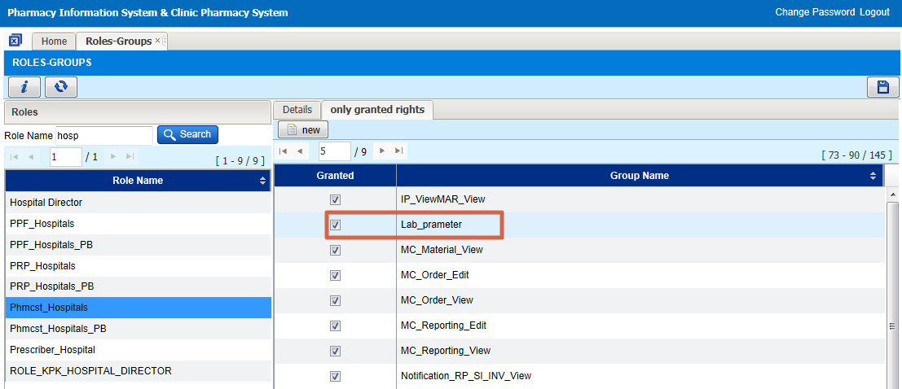

- Once this access right has been set, the access right will synchronize to all facility and user will able to see new ‘Lab Parameter’ sub menu under Clinical Menu

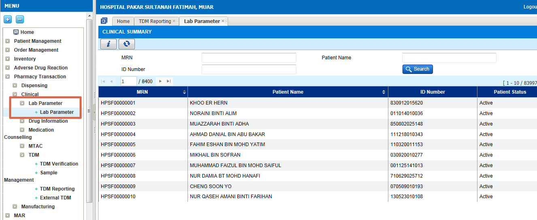

UOM-Description in Local Language
- UOM description in local language must be defined at IWP.
- By default, existing records will have description in local language same as measurement description.
- Changes can be made at IWP
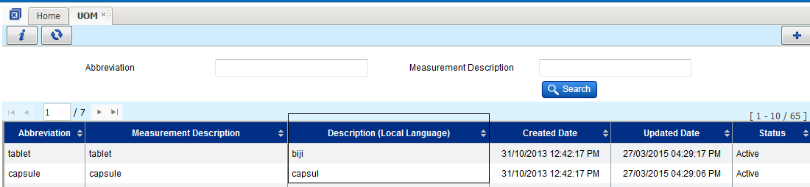
Screen 1: UOM

Administration Route – Add ‘Factor’
- Factor must be defined at IWP.
- By default, all records will have Factor = 1.

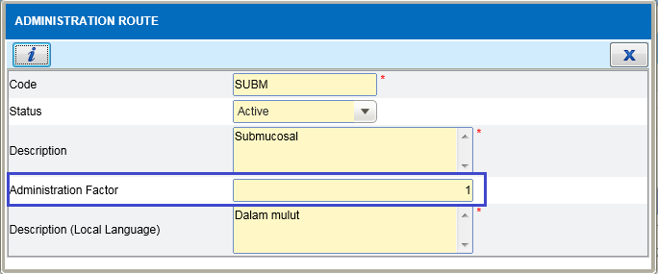
Screen 2: Administration Route

Frequency and Indication
- By default, all existing records will have ‘MOH Recommendation’ as Guideline value.
- Changes can be made at IWP.

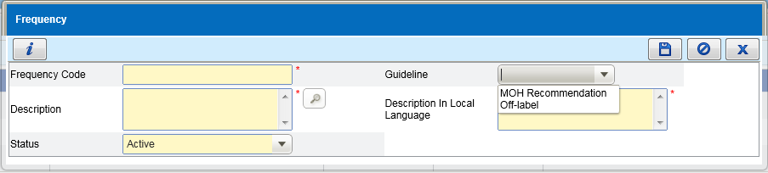
Screen 3: Frequency

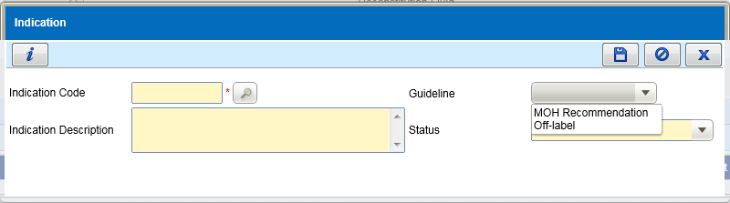
Screen 4: Indication

TDM Sample Type
- New added Sample type and need be set to the at TDM Guideline in HQ
- Post1
- Post2
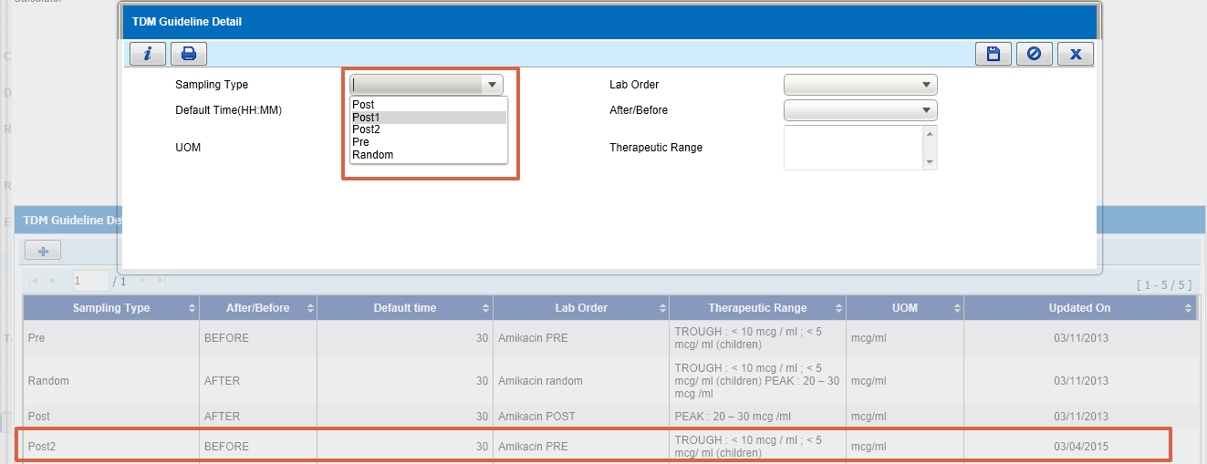

- After add sample type in TDM Guideline at HQ then only this sample type available for ordering.

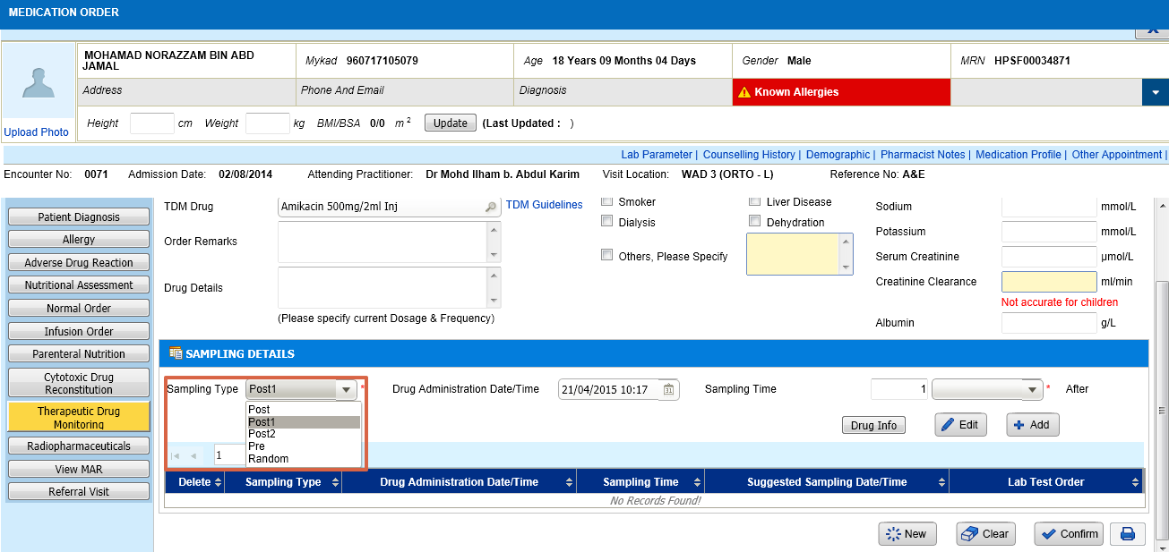

TDM Calculator
- Calculator need to be set at TDM Guideline at HQ based on drug name. List of calculator as below:
- Aminoglycoside Pre
- Aminoglycoside Post
- Aminoglycoside Pre & post
- Aminoglycoside Post1 & Post2
- Vancomycin Pre
- Vancomycin Post
- Vancomycin Pre –Post
- Digoxin
- Carbamazepine
- Phenobarbitone
- Theophylline
- Valproic Acid
- Phenytoin
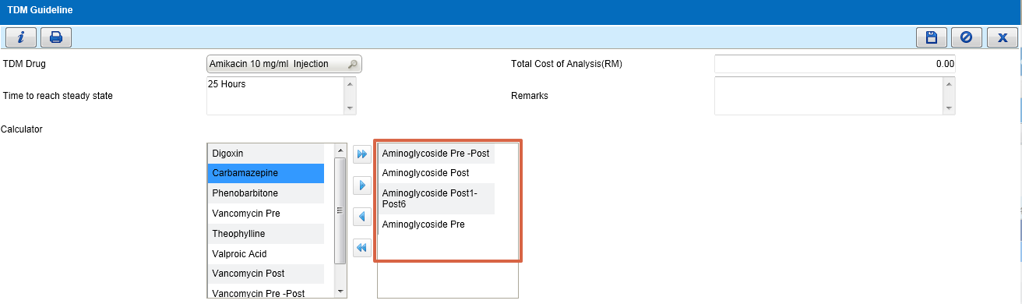

- Based on the calculator selected for the TDM drug, calculator will appear as below:
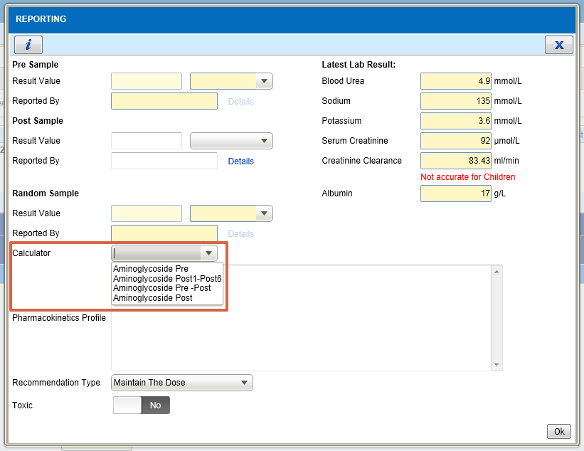

Item Master (for Prepacking)
Prepacking Item must be created in HQ and exists in facility Prepacking Item in Inventory section of the maintenance menu.
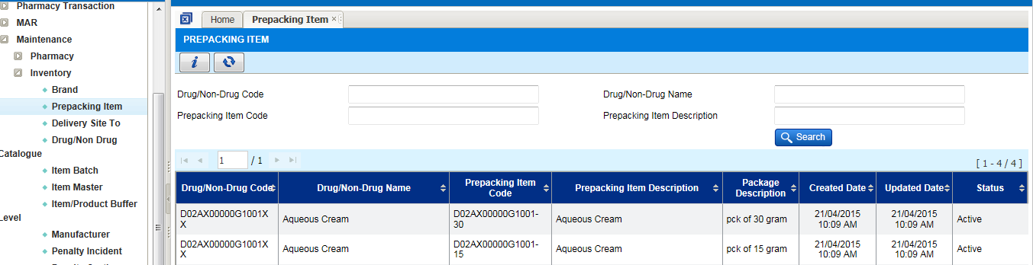

Facility Level

Facility Information screen

- RPL Weeks - is used to ask the system to close the RPL transaction no after base on the setting
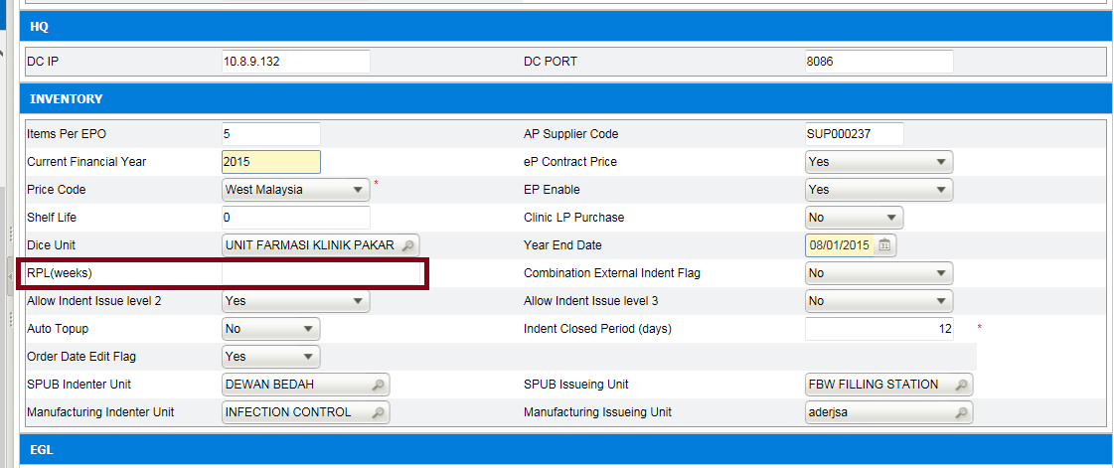

- Indent Closed Period (days) - Indent Closed Period (days) is used to ask the system to close the indent after how many days. This is cannot be empty. Default value is 20 days
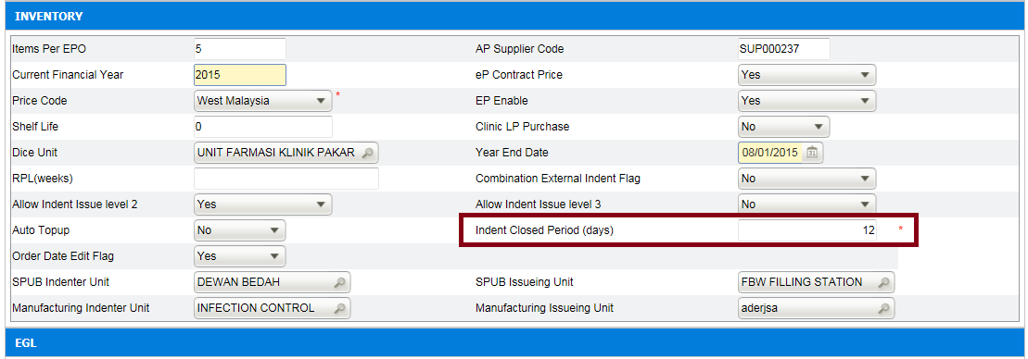

- Order Date Edit Flag - Order Date Edit Flag is used for key the in order in back dated date for LP & Contract Purchase Order. Default value is ‘NO’.
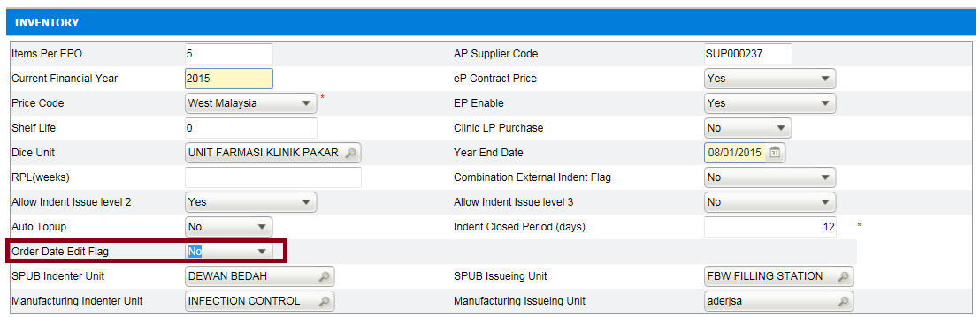

- Main Store Tel No & Main Store Fax No – use for Request For Quotation screen when generate the Lampiran Q. The information of Main Store Tel No & Main Store Fax No will be display if the setting has been done.
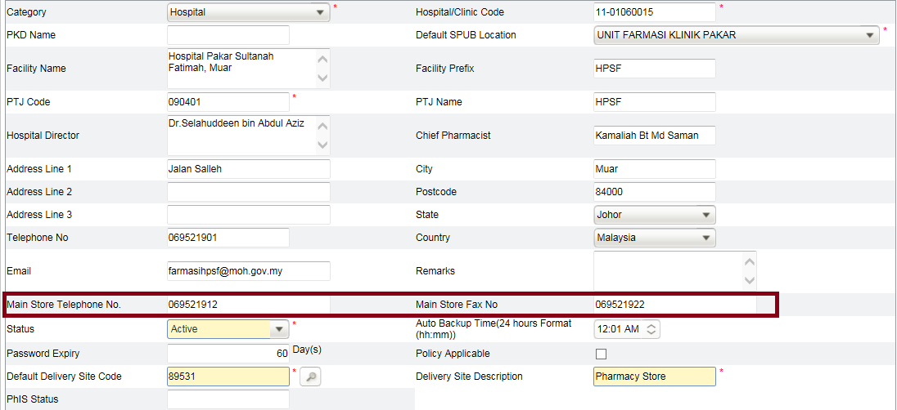

- SPUB Indenter Unit - SPUB Indenter Unit is used for which unit will request the SPUB indent from others facilities.
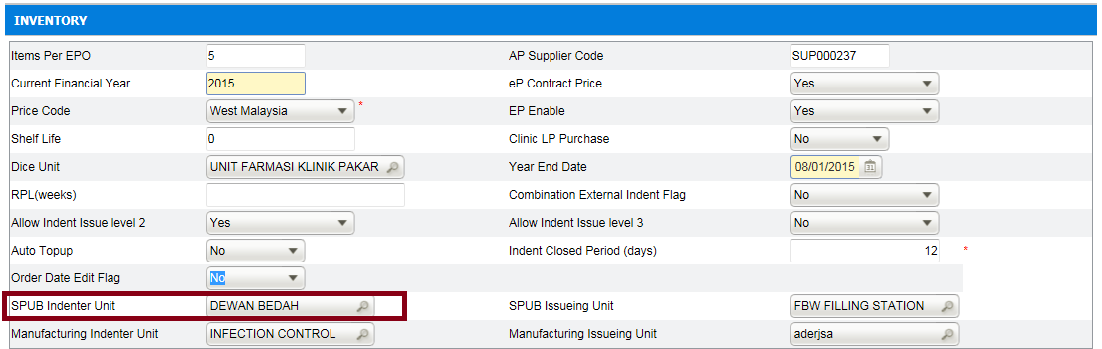

- SPUB Issuing Unit - SPUB Issuing Unit is used for that unit will issue the SPUB item
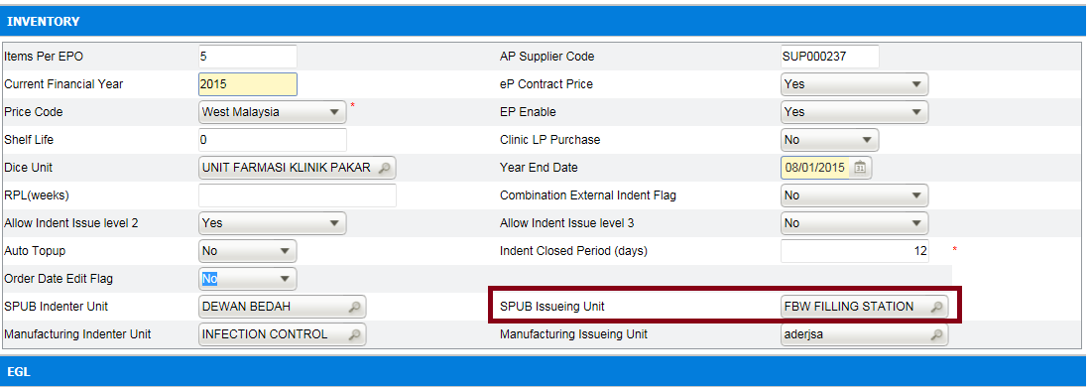

- Manufacturing Indenter Unit - Manufacturing Indenter Unit is used for which unit want to request the manufacturing item from other facilities
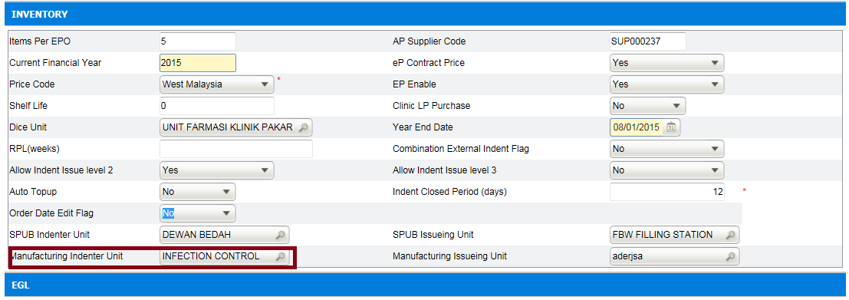

- Manufacturing Issuing Unit - Manufacturing Issuing Unit is used for which unit will issue manufacturing items
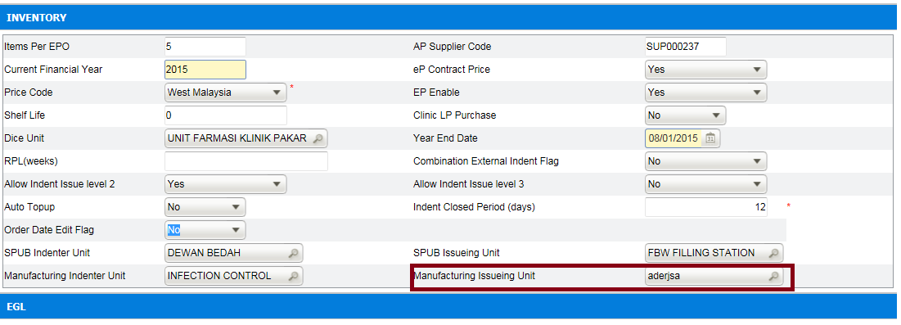

Prescriber (Auto Discharge for Emergency Patient)
System to auto-discharge emergency patient after 24 hours. Discharge doctor information is mandatory for every discharge record. System will use this dummy user information when auto discharge the patient.
- Create 1 dummy user as doctor in user profile.
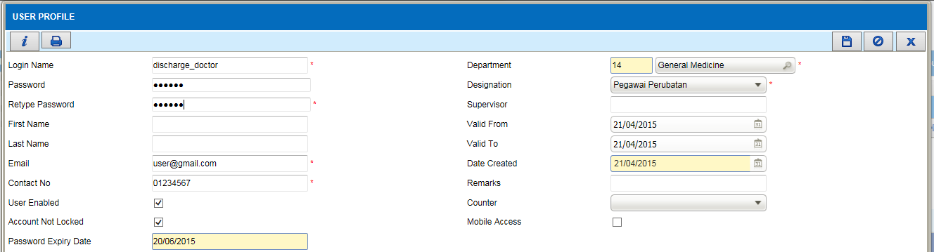

- Create new prescriber master using the dummy user id.
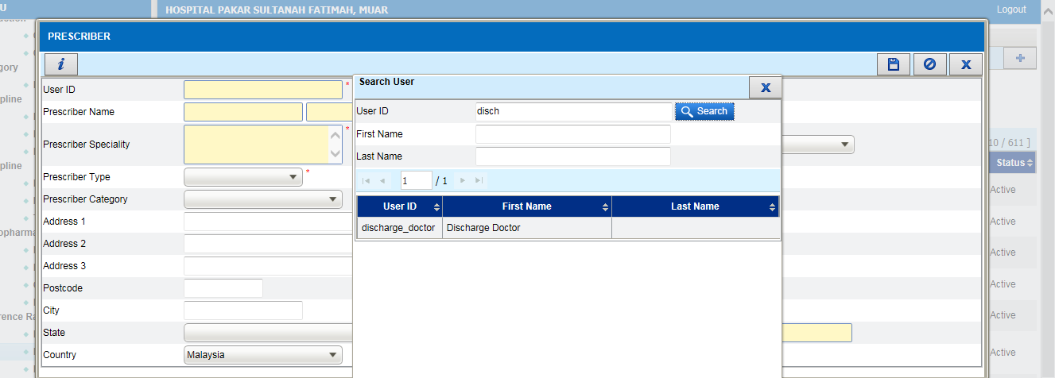
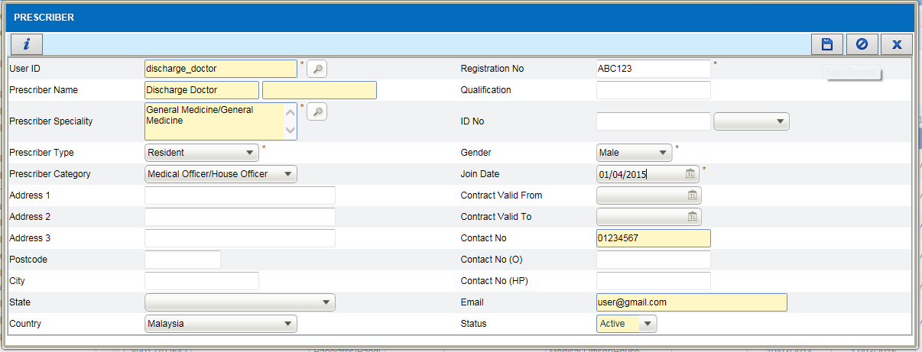

- Open facility information screen, search for prescriber in ‘Default Prescriber’ field under ‘Clinical’ section. Assign the dummy prescriber created earlier as default prescriber value. Save the information.
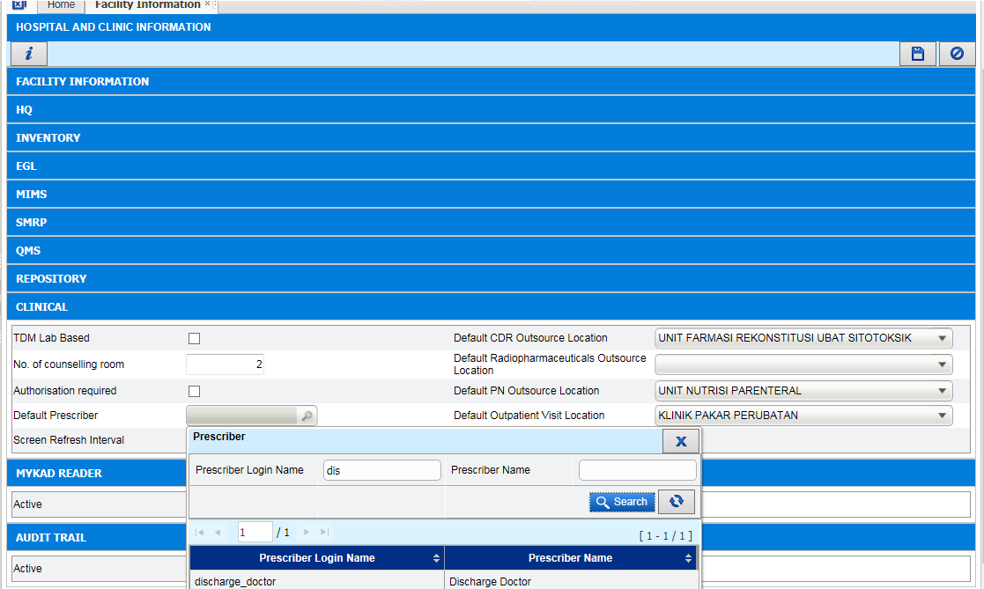
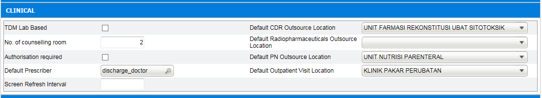

Unit Catalogue (for Prepacking)
Drug to be prepack must exist in unit catalog:
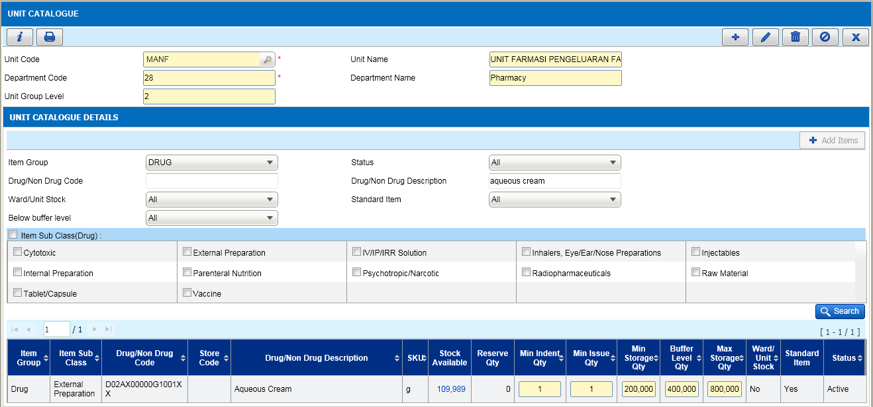

Item Master (for Prepacking)
Original Item to be prepack must be selected as Repack Item in Item Master:
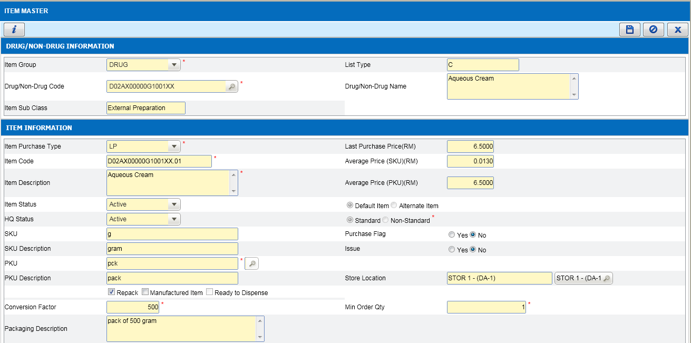

Dispense UON (for Prepacking)
Dispense UOM must exist with the same conversion factor as the new Prepacking Item created.
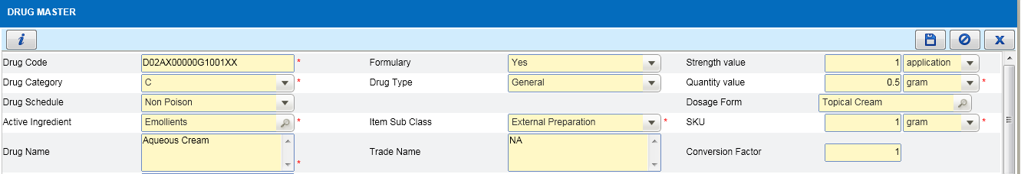
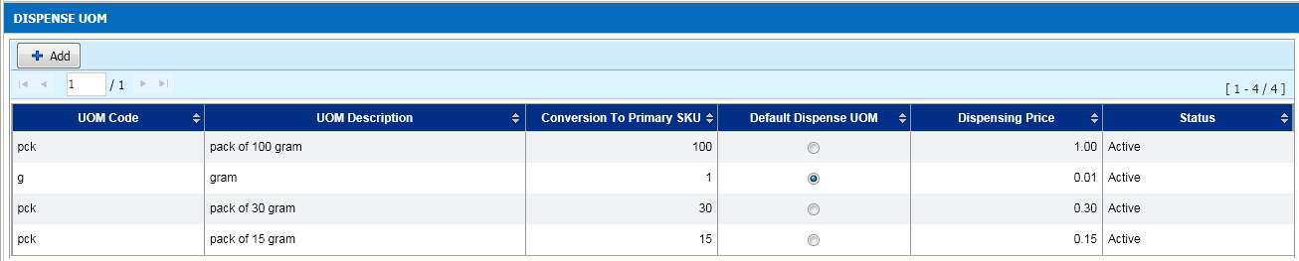

Data Entry for Aktiviti Pembungkusan Ubat Semula (PF 6.6b) report
Record in Prepacking Details screen in Data Entry menu should be created for to display value in column ‘Aktiviti Pembungkusan Semula Dibuat Secara Berpusat atau Unit Based (Nyatakan)’ in the report.
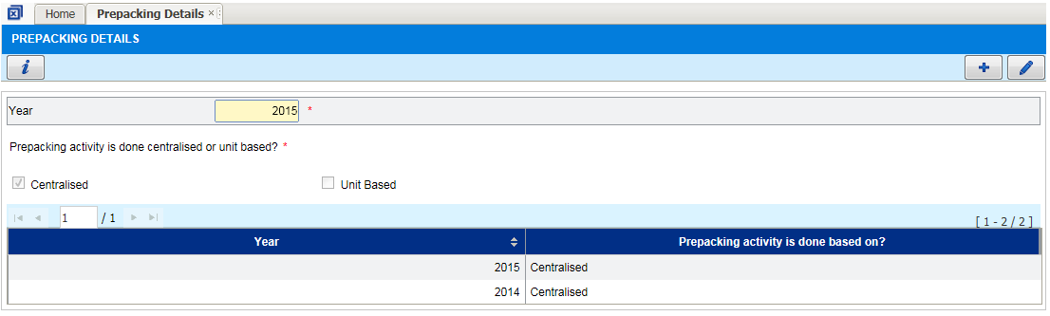
Value will affect the report as below:
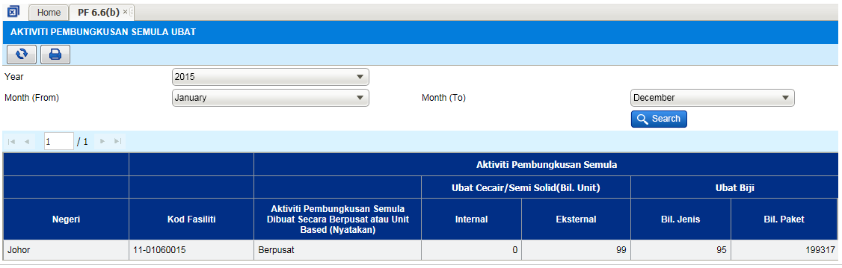

Details of the Refinement List

Please refer the following quick summary document on the solution for the enhancement or refinement

No | Module | Document
1 | Inventory | PhIS_CPS_Summary_1.3_INV_Condemn_ Mgt_v1.0
2 | Inventory | PhIS_CPS_Summary_1.3_INV_Ext_Indent_v1.0
3 | Inventory | PhIS_CPS_Summary_1.3_INV_Indent_v1.0
4 | Inventory | PhIS_CPS_Summary_1.3_INV_Issue_v1.0
5 | Inventory | PhIS_CPS_Summary_1.3_INV_Physical Checking_1.0
6 | Inventory | PhIS_CPS_Summary_1.3_INV_Procurement_v1.0
7 | Inventory | PhIS_CPS_Summary_1.3_INV_Product Recall_v1.0
8 | Inventory | PhIS_CPS_Summary_1.3_INV_Rcv_Inter_Facility_1.0
9 | Inventory | PhIS_CPS_Summary_1.3_INV_Rcv_Intra_Facility_1.0
10 | Inventory | PhIS_CPS_Summary_1.3_INV_Rcv_Supplier_v1.0
11 | Inventory | PhIS_CPS_Summary_1.3_INV_RFQ_Quotation_v1.0
12 | Inventory | PhIS_CPS_Summary_1.3_INV_RPL_v1.0
13 | Inventory | PhIS_CPS_Summary_1.3_INV_Slow moving_v1.0
14 | Inventory | PhIS_CPS_Summary_1.3_INV_Stock Transfer_v1.0
15 | Order Management | PhIS_CPS_Summary_1.3_PM_v0.1
16 | Order Management | PhIS_CPS_Summary_1.3_Pharmacist_Notes_v1.0
17 | Order Management | PhIS_CPS_Summary_1.3_PM_Patient_Centric_v1.0
18 | Order Management | PhIS_CPS_Summary_1.3_OM_Web_v1.0
19 | Order Management | PhIS_CPS_Summary_1.3_OM_Mobile_v1.0
20 | Order Management | PhIS_CPS_Summary_1.3_SDR_v1.0
21 | Outpatient & Inpatient | PhIS_CPS_Summary_1.3_OPIP_v1.0
22 | Outpatient & Inpatient | PhIS_CPS_Summary_1.3_PB_v1.0
23 | Outpatient & Inpatient | PhIS_CPS_Summary_1.3_MAR_Web_v1.0
24 | Outpatient & Inpatient | PhIS_CPS_Summary_1.3_MAR_Mobile_v1.0
25 | Clinical | PhIS_CPS_Summary_1.3_WP_v1.0
26 | Clinical | PhIS_CPS_Summary_1.3_MTAC_v1.0
27 | Clinical | PhIS_CPS_Summary_1.3_MC_v1.0
28 | Clinical | PhIS_CPS_Summary_1.3_ADR_v1.0
29 | Clinical | PhIS_CPS_Summary_1.3_Lab_Parameter_v1.0
30 | Clinical | PhIS_CPS_Summary_1.3_TDM_v1.0
31 | Manufacturing | PhIS_CPS_Summary_1.3_Manf_ Galenical_v1.0
32 | Manufacturing | PhIS_CPS_Summary_1.3_Manf_Prepacking_v1.0
33 | Manufacturing | PhIS_CPS_Summary_1.3_Manf_ IV_v1.0
34 | Manufacturing | PhIS_CPS_Summary_1.3_Manf_CDR_Mobile_v1.0
35 | Manufacturing | PhIS_CPS_Summary_1.3_Manf_ CDR_v1.0
36 | Manufacturing | PhIS_CPS_Summary_1.3_Manf_ CDR_PB_v1.0
37 | Manufacturing | PhIS_CPS_Summary_1.3_Manf_ PN_v1.0
38 | Manufacturing | PhIS_CPS_Summary_1.3_ Release_Discard_v1.0
39 | Report/Enquiry | PhIS_CPS_Summary_1.3_INV_Report_v1.0
40 | Report/Enquiry | PhIS_CPS_Summary_1.3_PH_Report_v0.1
41 | Report/Enquiry | PhIS_CPS_Summary_1.3_Clinical_Report_v1.0
42 | Report/Enquiry | PhIS_CPS_Summary_1.3_Manf_ Report_v1.0
43 | IWP/Administration | PhIS_CPS_Summary_1.3_IWP_ Contract_Summary_v1.0
44 | IWP/Administration | PhIS_CPS_Summary_1.3_Maintenance_v1.0

Deployment - Procedures

List of Items to be Deployed
No. | Items | Components | Path
1 | HQ Patch Script | 1. PatchScripts_IWP_v1.3.txt  2. PatchScripts_IWP_v1.3_DataPatch.txt  3. DrugPricePatchScript.txt | https://10.8.9.130:44330/svn/Workspace_Dataware/31_Implementation/Applications/PhIS ReleaseV1.3/hq/scripts
2 | HQ Application | phishq_v1.3.war | https://10.8.9.130:44330/svn/Workspace_Dataware/31_Implementation/Applications/PhIS ReleaseV1.3/hq/war
3 | HQ Application | epservice_v1.3.war | https://10.8.9.130:44330/svn/Workspace_Dataware/31_Implementation/Applications/PhIS ReleaseV1.3/hq/war
4 | HQ Application | masterRelease_v1.3.jar | https://10.8.9.130:44330/svn/Workspace_Dataware/31_Implementation/Applications/PhIS ReleaseV1.3/hq/jar
5 | HQ Patch Script | ActiveIngredientMapping.xlsx | https://10.8.9.130:44330/svn/Workspace_Dataware/31_Implementation/Applications/PhIS ReleaseV1.3/hq/jar
6 | HQ Patch Script | PatchScripts_PhIS_v1.3_ImmediateRelease.txt | https://10.8.9.130:44330/svn/Workspace_Dataware/31_Implementation/Applications/PhIS ReleaseV1.3/facility/scripts
7 | HQ Application | PhISSchedulers_v1.3.jar | https://10.8.9.130:44330/svn/Workspace_Dataware/31_Implementation/Applications/PhIS ReleaseV1.3/facility/jar
8 | Facility Patch Script | 1. PatchScripts_PhIS_v1.3.txt  2. PatchScripts_PhIS_v1.3_DataPatch.txt  3. PatchScripts_PhIS_v1.3_HPSF.txt  4. PatchScripts_PhIS_v1.3_HSM.txt  5. PatchScripts_PhIS_v1.3_HKM.txt  6. PatchScripts_PhIS_v1.3_HTM.txt  7. PatchScripts_PhIS_v1.3_KKGT.txt  8. PatchScripts_PhIS_v1.3_KKBM.txt  9. PatchScripts_PhIS_v1.3_KKB.txt | https://10.8.9.130:44330/svn/Workspace_Dataware/31_Implementation/Applications/PhIS ReleaseV1.3/facility/scripts
9 | Facility Application | iphis_v1.3.war | https://10.8.9.130:44330/svn/Workspace_Dataware/31_Implementation/Applications/PhIS ReleaseV1.3/facility/war
10 | Facility Application | phisqms_v1.3.war | https://10.8.9.130:44330/svn/Workspace_Dataware/31_Implementation/Applications/PhIS ReleaseV1.3/facility/war
11 | Facility Application | PhISSchedulers_v1.3.jar | https://10.8.9.130:44330/svn/Workspace_Dataware/31_Implementation/Applications/PhIS ReleaseV1.3/facility/jar
12 | Facility Application - MIMS | mims_v1.3.jar | https://10.8.9.130:44330/svn/Workspace_Dataware/31_Implementation/Applications/PhIS ReleaseV1.3/facility/MIMS
13 | Mobile Application | ipadhosp-1.4.0b16-PhISDS.war | https://10.8.9.130:44330/svn/Workspace_Dataware/31_Implementation/Applications/PhIS ReleaseV1.3/Mobile
14 | Mobile Application | iphismobile_user_v1.3.war | https://10.8.9.130:44330/svn/Workspace_Dataware/31_Implementation/Applications/PhIS ReleaseV1.3/Mobile

Backup Procedure before Deploy

Backup Procedure
Using backup tool, backup the following files and folder and database as per table below;
No. | Type | Backup Item | Description
1 | Application | /home/phisesb  /opt/phisesb  /usr/share/fonts/truetype | PhIS Integration Application  PhIS Core Application  Fonts required by PhIS
2 | Database | phisprod database | PhIS Live database

Deployment/Installation Guidelines

Deployment at Facility
Below table is described the deployment steps at Facility:
Step | Items | File Name | Source Path | Action
1 | Facility Patch Script | 1. PatchScripts_PhIS_v1.3.txt  2. PatchScripts_PhIS_v1.3_DataPatch.txt  3. PatchScripts_PhIS_v1.3_HPSF.txt  4. PatchScripts_PhIS_v1.3_HSM.txt  5. PatchScripts_PhIS_v1.3_HKM.txt  6. PatchScripts_PhIS_v1.3_HTM.txt  7. PatchScripts_PhIS_v1.3_KKGT.txt  8. PatchScripts_PhIS_v1.3_KKBM.txt  9. PatchScripts_PhIS_v1.3_KKB.txt | https://10.8.9.130:44330/svn/Workspace_Dataware/31_Implementation/Applications/PhIS ReleaseV1.3/facility/scripts | Please ensure all the script is execute before iphis.war deploy.  Please ensure the script is executed in sequence. Script files 1 & 3 Execute as pgScript and other two Run as highlight the Script and press (F5)
2 | Facility Application | iphis_v1.3.war | https://10.8.9.130:44330/svn/Workspace_Dataware/31_Implementation/Applications/PhIS ReleaseV1.3/facility/war | Please rename the war file from iphis_v1.3.war to iphis.war then deploy.
3 | Facility Application | phisqms_v1.3.war | https://10.8.9.130:44330/svn/Workspace_Dataware/31_Implementation/Applications/PhIS ReleaseV1.3/facility/war | Please rename the war file from phisqms_v1.3.war to phisqms.war then deploy. (Optional)
4 | Facility Application | PhISSchedulers_v1.3.jar | https://10.8.9.130:44330/svn/Workspace_Dataware/31_Implementation/Applications/PhIS ReleaseV1.3/facility/jar | Please rename the jar file from PhISSchedulers_v1.3.jar to PhISSchedulers.jar and copy to /home/phisesb/phisjars/ folder.  This is optional if IWP release has done so, but please check the jar file date and size as verification, if different then release the jar file
5 | Facility Application - MIMS | mims_v1.3.jar | https://10.8.9.130:44330/svn/Workspace_Dataware/31_Implementation/Applications/PhIS ReleaseV1.3/facility/MIMS | Backup mims.jar from /home/phisesb/MIMS/ and copy mims_v1.3.jar to /home/phisesb/MIMS/ and rename file from mims_v1.3.jar to mims.jar.
6 | Mobile Application | ipadhosp-1.4.0b16-PhISDS.war | https://10.8.9.130:44330/svn/Workspace_Dataware/31_Implementation/Applications/PhIS ReleaseV1.3/Mobile | Rename ipadhosp-1.4.0b16-PhISDS.war to ipadhosp.war and deploy.  Frontend Apps: 1.3.0r1t16  Backend Apps: 1.4.0b16
7 | Mobile Application | iphismobile_user_v1.3.war | https://10.8.9.130:44330/svn/Workspace_Dataware/31_Implementation/Applications/PhIS ReleaseV1.3/Mobile | Rename iphismobile_user_v1.3.war to iphismobile_user.war and deploy.

Deployment at HQ - IWP
Below table is described the deployment steps at HQ - IWP:

Step | Items | File Name | Source Path | Action
1 | HQ Patch Script | 1. PatchScripts_IWP_v1.3.txt  2. PatchScripts_IWP_v1.3_DataPatch.txt  3. DrugPricePatchScript.txt | https://10.8.9.130:44330/svn/Workspace_Dataware/31_Implementation/Applications/PhIS ReleaseV1.3/hq/scripts | Please ensure all the script is execute before phishq.war deploy.
2 | HQ Application | phishq_v1.3.war | https://10.8.9.130:44330/svn/Workspace_Dataware/31_Implementation/Applications/PhIS ReleaseV1.3/hq/war | Rename the war file from phishq_v1.3.war to phishq.war then Deploy using Glassfish Administration Console
3 | HQ Application | epservice_v1.3.war | https://10.8.9.130:44330/svn/Workspace_Dataware/31_Implementation/Applications/PhIS ReleaseV1.3/hq/war | Rename the war file from epservice_v1.3.war to epservice.war then Deploy using Glassfish Administration Console.
4 | HQ Application | masterRelease_v1.3.jar | https://10.8.9.130:44330/svn/Workspace_Dataware/31_Implementation/Applications/PhIS ReleaseV1.3/hq/jar | Rename the war file from masterRelease _v1.3.jar to masterRelease.jar and copy to HQ production servers on path '/home/phisesb/phisjars/'
5 | HQ Patch Script | ActiveIngredientMapping.xlsx | https://10.8.9.130:44330/svn/Workspace_Dataware/31_Implementation/Applications/PhIS ReleaseV1.3/hq/jar | Follow Bellow Steps to insert Active Ingredient Mapping.  1. Copy downloaded file to /home/phisesb/MIMS/  2. Open Command Line and login as root user  3. Goto /home/phisesb/phisjars/  4. Issue java -jar masterRelease.jar 18  5. Copy the output for verification
6 | HQ Patch Script | PatchScripts_PhIS_v1.3_ImmediateRelease.txt | https://10.8.9.130:44330/svn/Workspace_Dataware/31_Implementation/Applications/PhIS ReleaseV1.3/facility/scripts | Execute this patch script in all current production facilities. Execute as pgScript.(F6) in pgAdmin. This file must run in all current production facilities immediate after release IWP, and this should be done with in 15 min span.
7 | HQ Application | PhISSchedulers_v1.3.jar | https://10.8.9.130:44330/svn/Workspace_Dataware/31_Implementation/Applications/PhIS ReleaseV1.3/facility/jar | Please copy jar file to all current production facilities inorder to make sure all current production integration works fine. Please rename the jar file from PhISSchedulers_v1.3.jar to PhISSchedulers.jar and copy to /home/phisesb/phisjars/ folder. Restart Cron job once done.

