Function Flow | Lab Parameter – Hepatitis in current Version 1.3.4 | Lab Parameter – Hepatitis in new Version 1.3.5
1.  Lab Parameter – Hepatitis | - Open Lab Parameter screen  - Click on hepatitis section  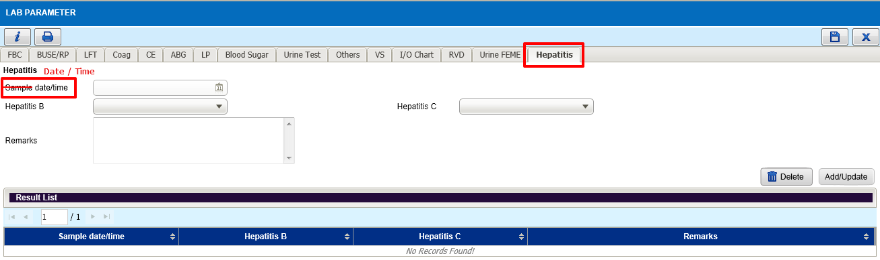 | - Open Lab Parameter screen  - Click on hepatitis section  - Renamed Sample Date/Time to ‘Date/Time’  