Function Flow | Morisky Scale in current Version 1.3.4 | Morisky Scale in new Version 1.3.5
1.  MTAC Reporting – Compliance | - Open MTAC Reporting screen, in section reporting click on ‘Compliance’ – Calculate Score  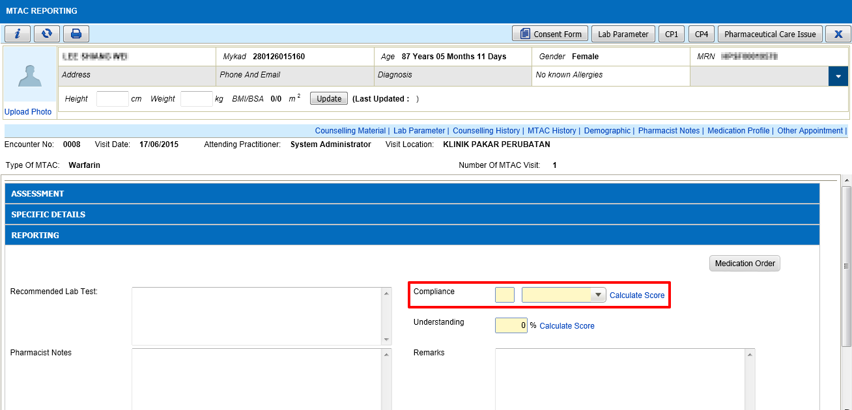  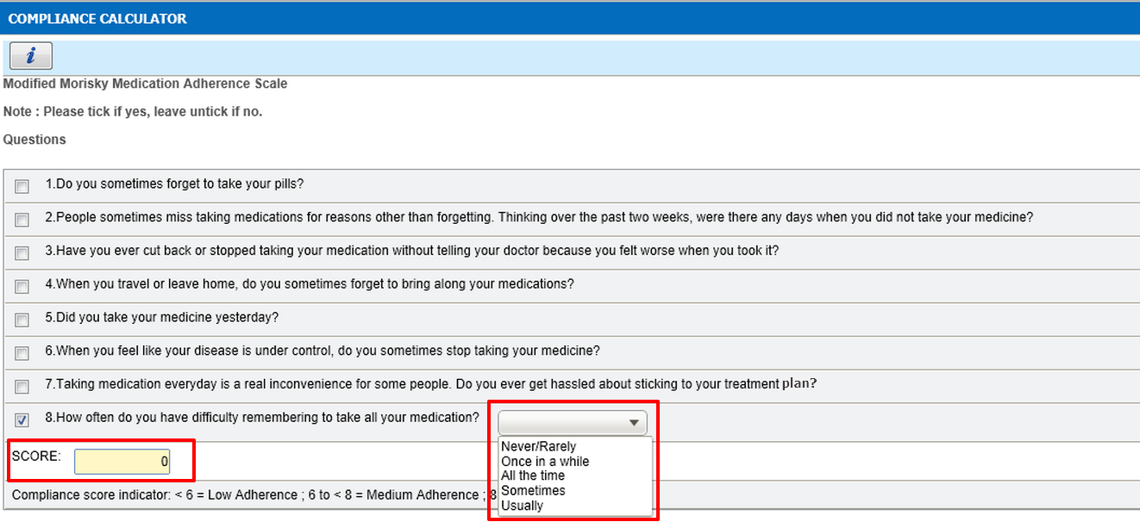  - Tick on question No 8, drop down field have score as below:  - Never/Rarely = 1  - Once in a while = 1  - All the time= 0  - Sometimes= 0  - Usually= 0 | - Open MTAC Reporting screen, in section reporting click on ‘Compliance’ – Calculate Score  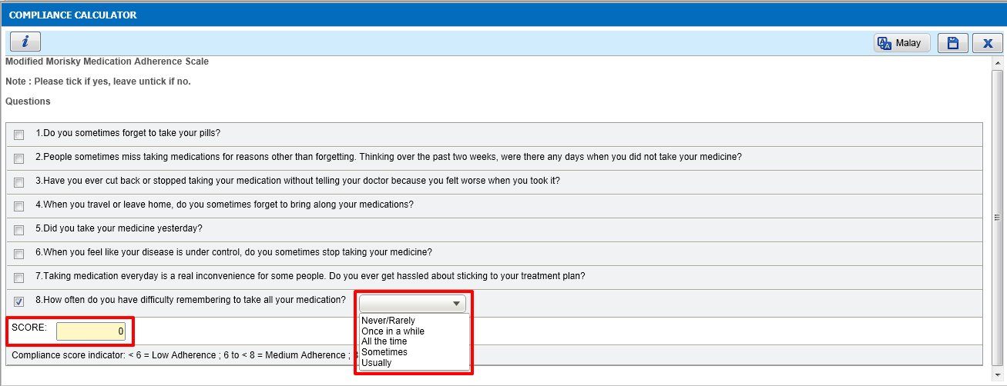  - Tick on question No 8, drop down field have score as below:  - Never/Rarely = 1  - Once in a while = 0.75  - All the time= 0.5  - Sometimes= 0.25  - Usually= 0

