Function Flow | Complete dispense in current Version 1.3.4 | Complete dispense in new Version 1.3.5
1.  Complete Dispense | 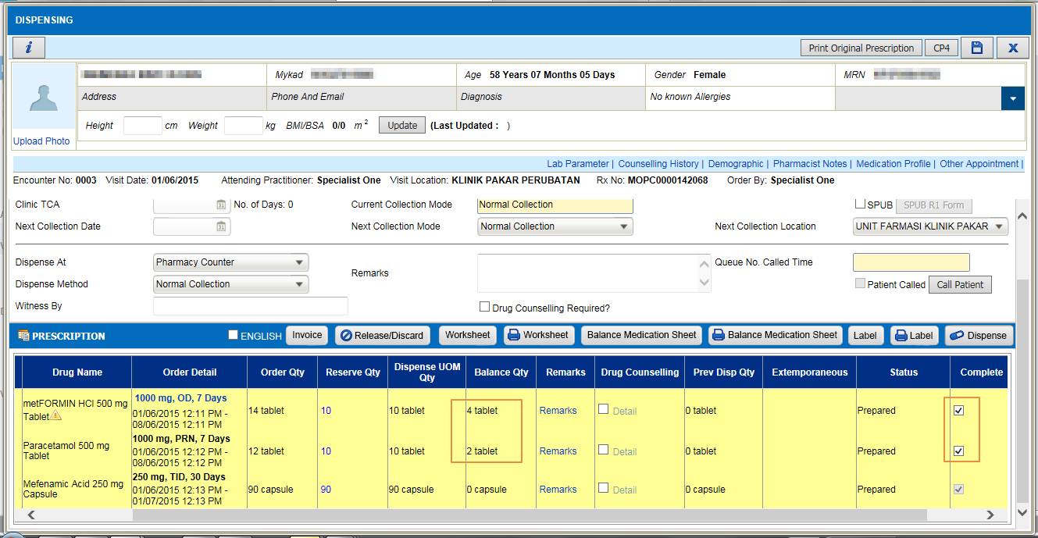  - System will auto check ‘Complete Dispense’ checkbox in dispensing screen even balance quantity > 0 for the following order.  - In Drug Master (configuration at facility level)  - Default Qty When PRN Frequency Selected  - Absolute Dispense Qty | - System will auto check ‘Complete Dispense’ checkbox in dispensing screen if balance quantity = 0.  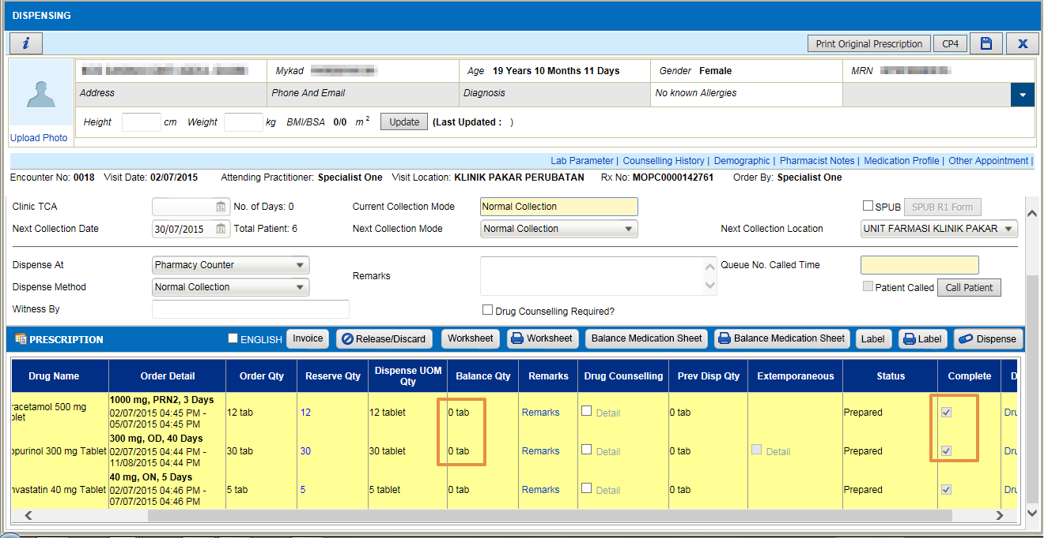  - System will remove default value for complete checkbox if balance > 0 for PRN and absolute dispense qty..  