Function Flow | Edit Patient in current Version 1.3.4 | Edit Patient in new Version 1.3.5
1.  Edit Patient | 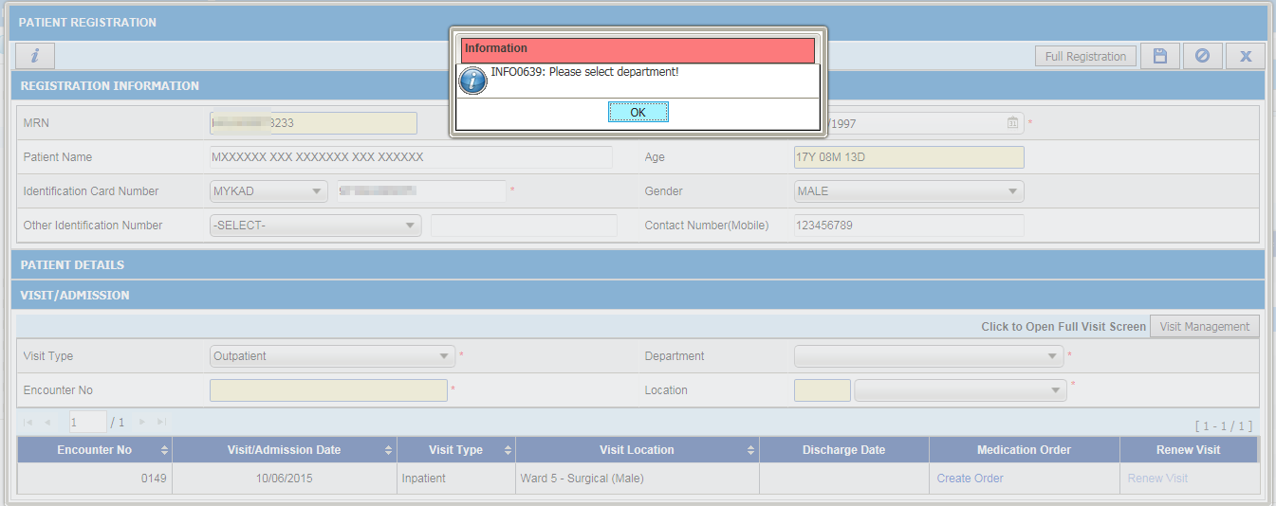  - In Quick Patient Registration screen, alert message will be displayed when user click on Save button.  - User not able to update patient information if visit information not entered.  - As workaroud solution user use full Patient Registration screen to update patient information. | 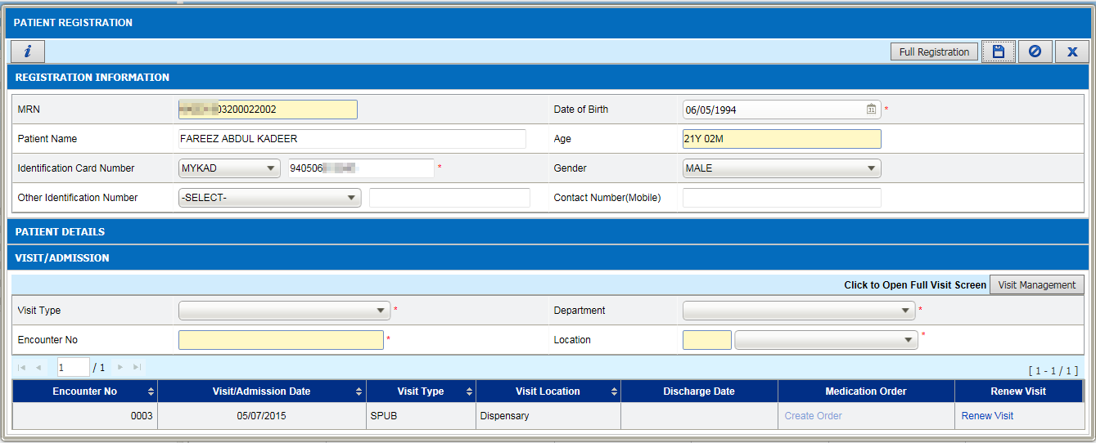  - In Quick Patient Registration screen, visit information will be blank when user click on edit button. User able to update patient information without enter visit information.  