Function Flow | Type of Intervention – Miscellaneous field in current Version 1.3.4 | Type of Intervention – Miscellaneous field in new Version 1.3.5
1.  MTAC Reporting – Pharmaceutical Care Issue | - Open MTAC Reporting screen  - Click on PCI screen - Select Type of Intervention = Miscellaneous and select Description  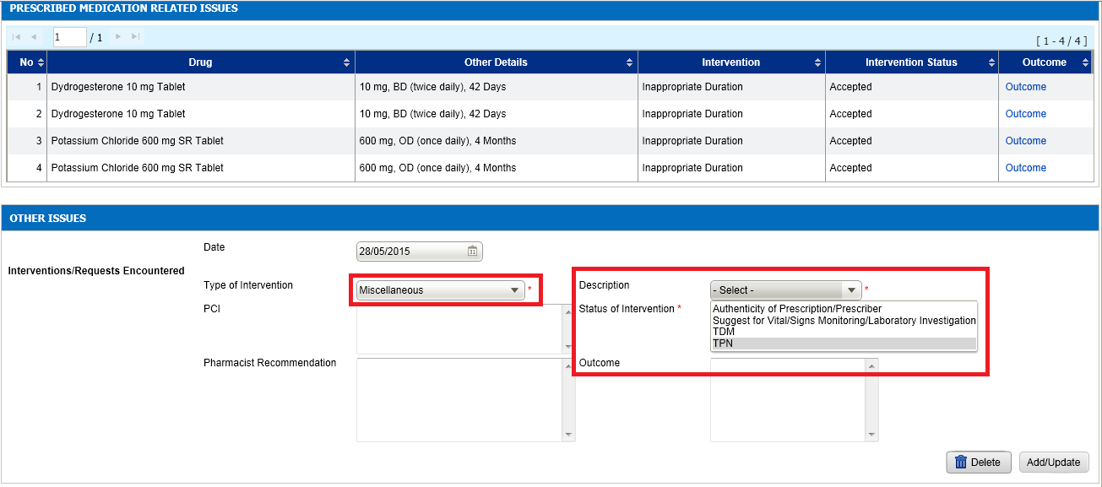 | - Open MTAC Reporting screen  - Click on PCI screen - Select Type of Intervention = Miscellaneous and select Description  - 'Others' has been added in the drop down list  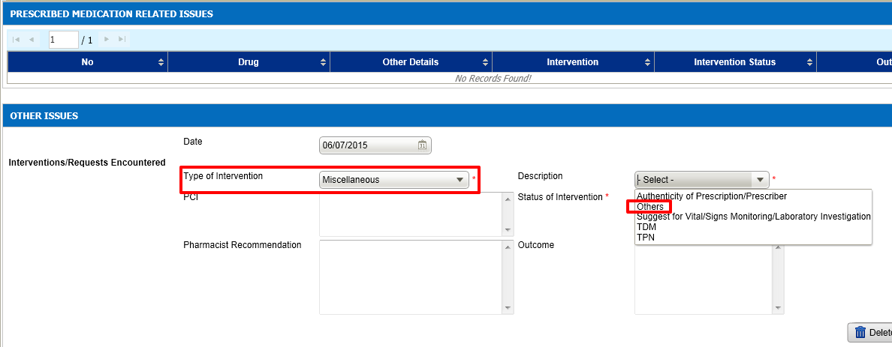  - This changes applied to all PCI screen in MTAC and WP also

