Function Flow | PN Label (Commercial Additive) in current Version 1.3.4 | PN Label (Commercial Additive) in new Version 1.3.5
1.  PN Edit Label | 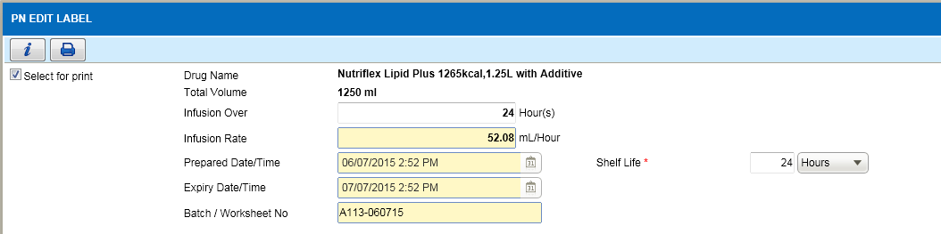  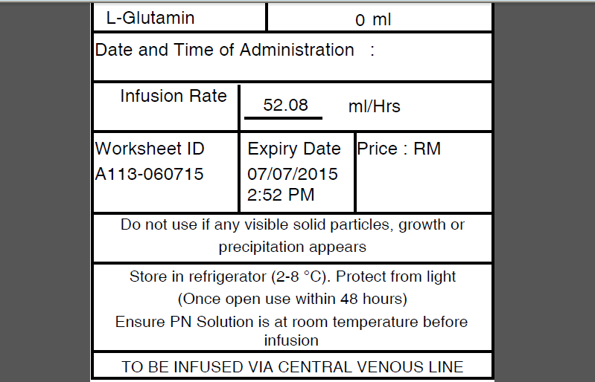  - Open Edit Label screen for PN Label as above.  - In Label, value ‘Once open use within 48 hours’ is hardcoded not following edit label screen.  - Value ‘To be infused via central venous line’ also hardcoded not following the order details. | 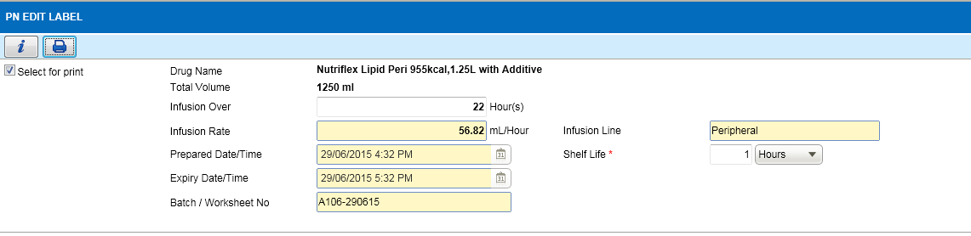  - Open Edit Label screen for PN Label as above.  - Added new field to display Infusion Line. Value is as per order details.  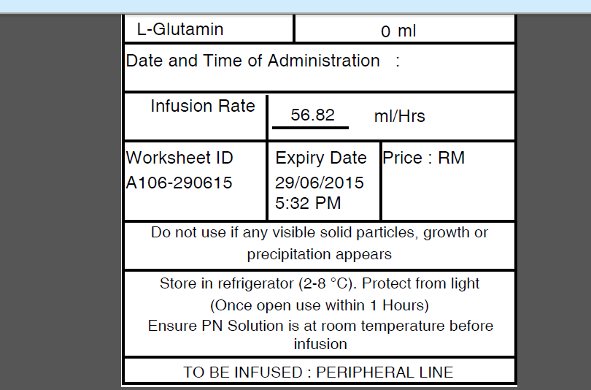  - Click on Print button to view the label in PDF format.  - Shelf Life and Infusion Line is updated on the label as the example above.

Function Flow | PN Label (Commercial) in current Version 1.3.4 | PN Label (Commercial) in new Version 1.3.5
1.  PN Edit Label | 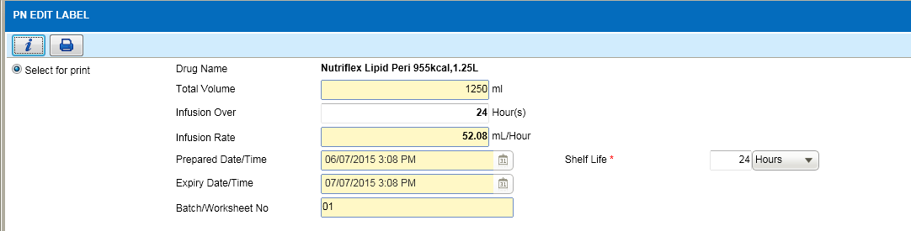  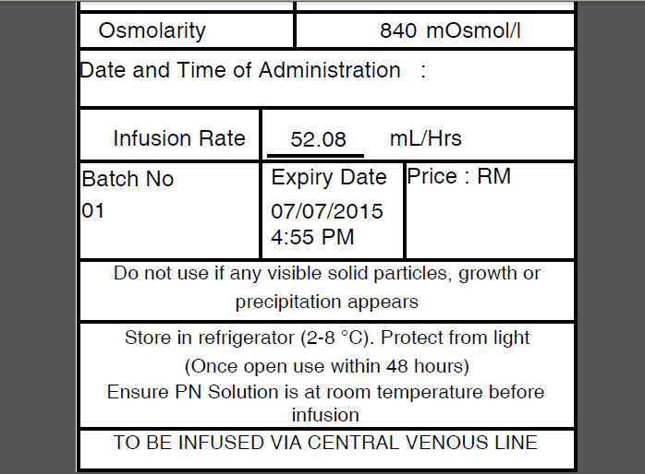  - Open Edit Label screen for PN Label as above.  - In Label, value ‘Once open use within 48 hours’ is hardcoded not following edit label screen.  - Value ‘To be infused via central venous line’ also hardcoded not following the order details. | 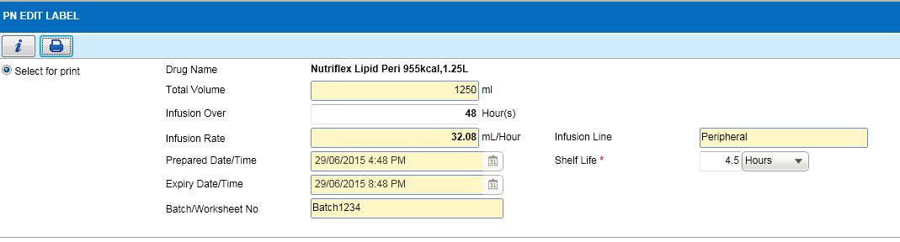  - Open Edit Label screen for PN Label as above.  - Added new field to display Infusion Line. Value is as per order details.  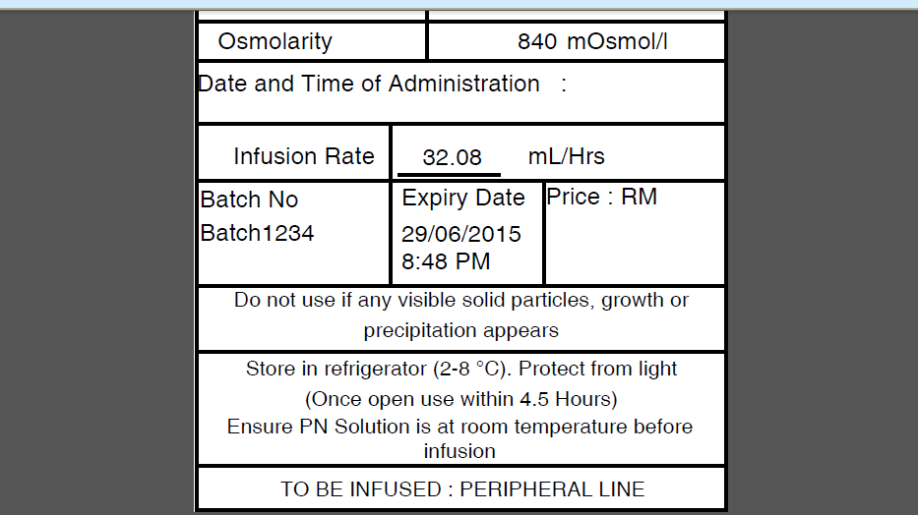  - Click on Print button to view the label in PDF format.  - Shelf Life and Infusion Line is updated on the label as the example above.

Function Flow | PN Label (Compounded 3 in 1) in current Version 1.3.4 | PN Label (Compounded 3 in 1) in new Version 1.3.5
1.  PN Edit Label | 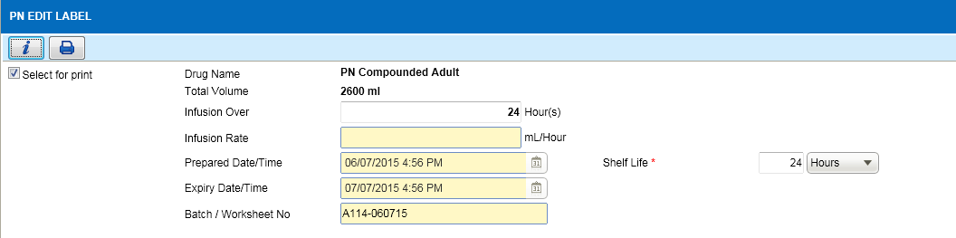  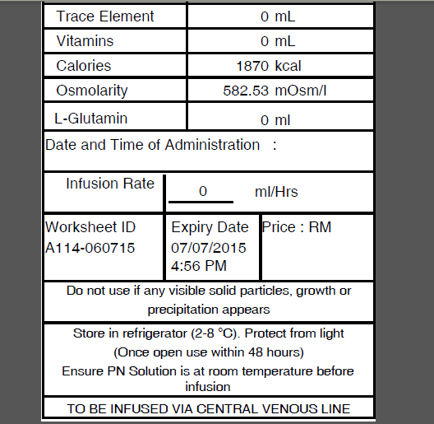  - Open Edit Label screen for PN Label as above.  - In Label, value ‘Once open use within 48 hours’ is hardcoded not following edit label screen.  - Value ‘To be infused via central venous line’ also hardcoded not following the order details. | 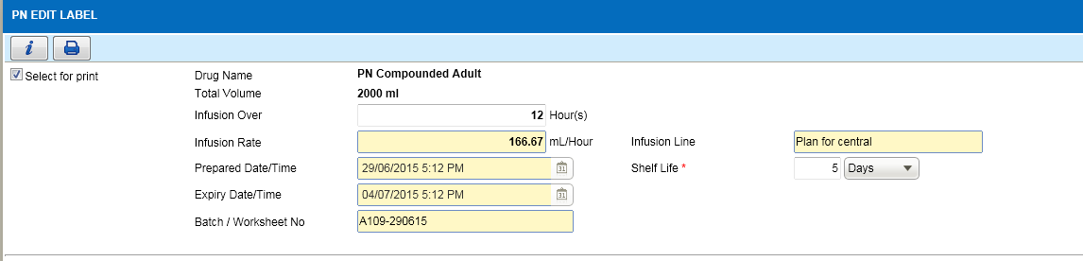  - Open Edit Label screen for PN Label as above.  - Added new field to display Infusion Line. Value is as per order details.  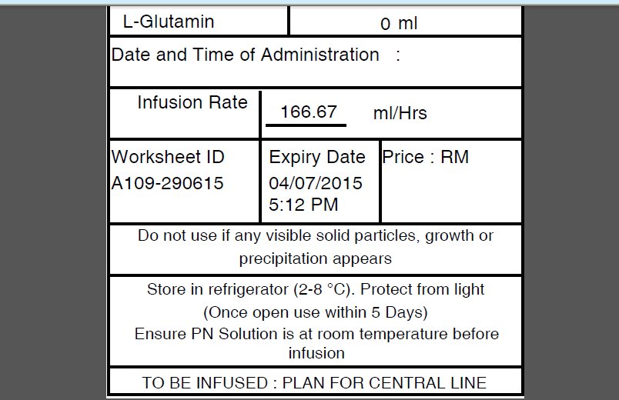  - Click on Print button to view the label in PDF format.  - Shelf Life and Infusion Line is updated on the label as the example above.

Function Flow | PN Label (Compounded 2 in 1) in current Version 1.3.4 | PN Label (Compounded 2 in 1) in new Version 1.3.5
1.  PN Edit Label | 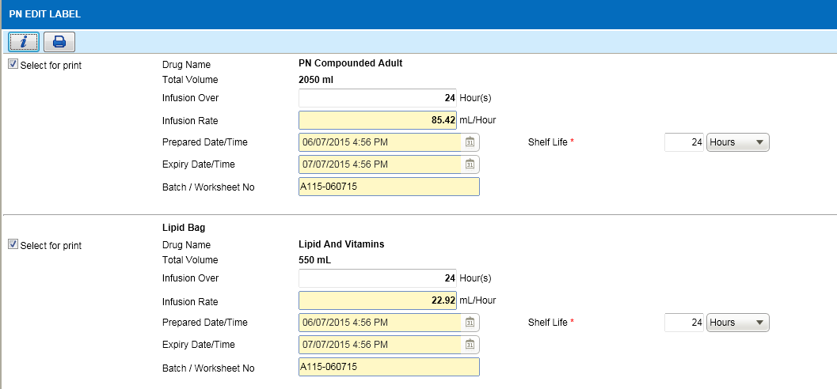  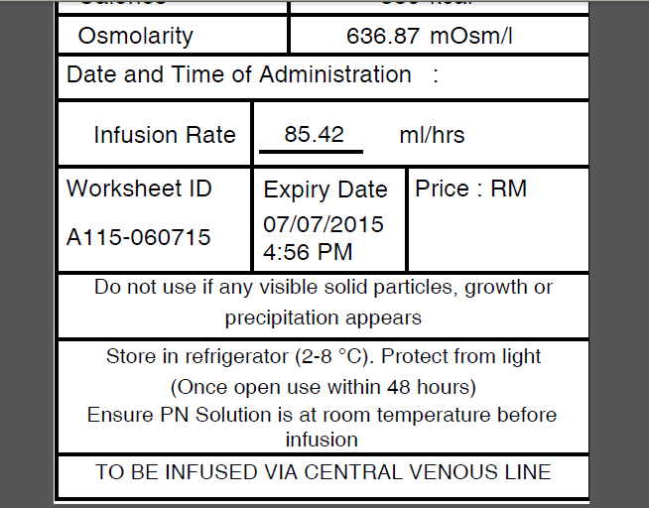  - Open Edit Label screen for PN Label as above.  - In Label, value ‘Once open use within 48 hours’ is hardcoded not following edit label screen.  - Value ‘To be infused via central venous line’ also hardcoded not following the order details. | 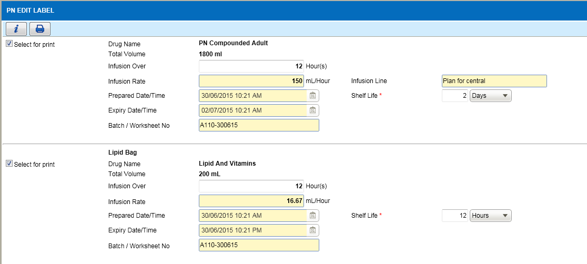  - Open Edit Label screen for PN Label as above.  - Added new field to display Infusion Line. Value is as per order details.  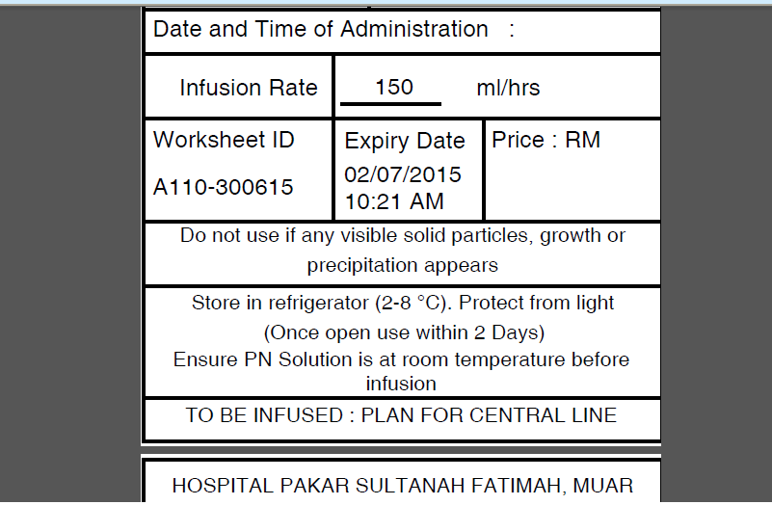  - Click on Print button to view the label in PDF format.  - Shelf Life and Infusion Line is updated on the label as the example above.

