Function Flow | Prepacking Transaction in current Version 1.3.4 | Prepacking Transaction in new Version 1.3.5
1.  Prepacking screen | 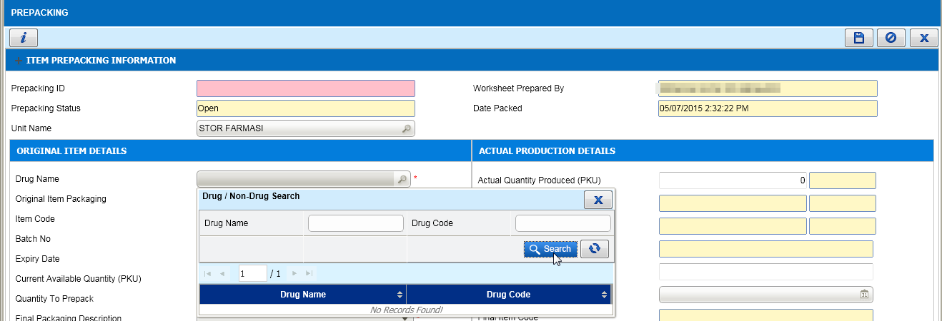  - Open Prepacking screen by login using Level 1 unit as example above.  - Search the Drug Name, no record displayed due to Level 1 unit not allowed to do Prepacking transaction. | 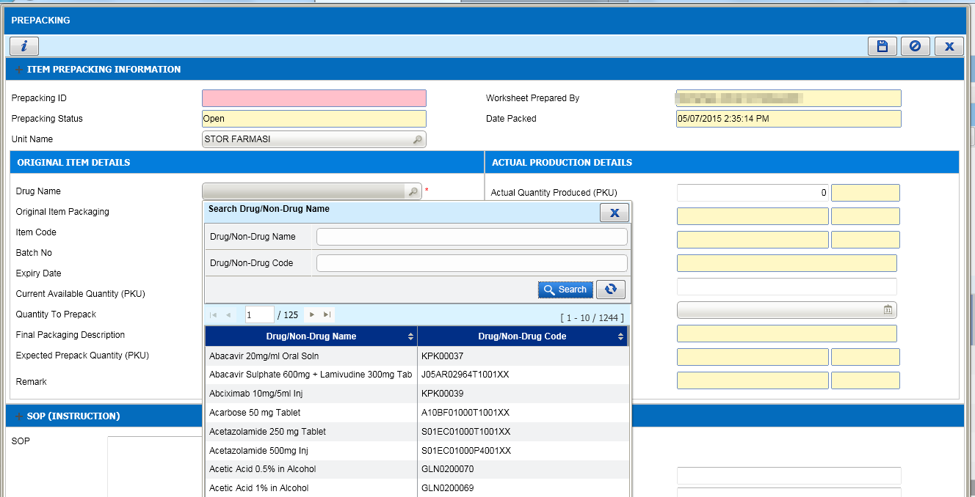  - Open Prepacking screen by login using Level 1 unit as example above.  - Search the Drug Name, drug records displayed based on the facility Drug/Non Drug Catalog due to Level 1 don’t have Unit Catalogue.  - Users from other unit level (Level 2 and 3) also able to search and select the Level 1 unit for Prepacking.

