Function Flow | ‘Oredered By’ field in current Version 1.3.4 | ‘Oredered By’ field in new Version 1.3.5
1.  Medication Counselling – Ordered By field | - Open Medication Counselling Order listing screen  - Click on ‘Ordered By’ field search icon  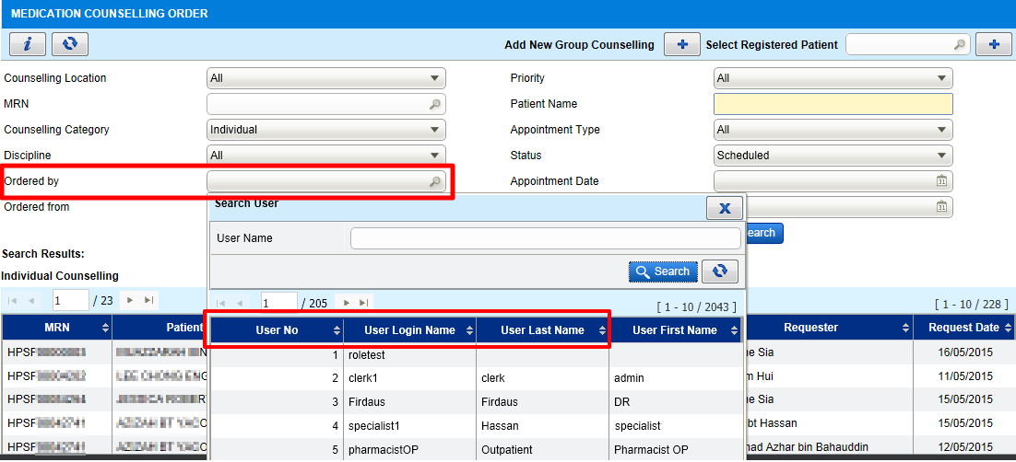 | - Open Medication Counselling Order listing screen  - Click on ‘Ordered By’ field search icon  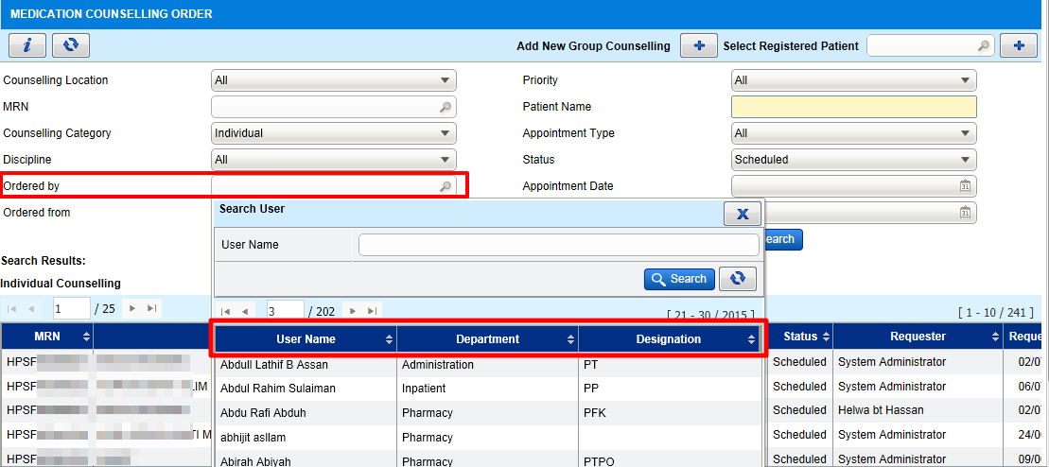  - Changes on the search user result listing.  - Changes should apply to MTAC Order listing screen also.

