Function Flow | CDR Infusion Label in current Version 1.3.5 | CDR Infusion Label in new Version 1.3.6
1.  CDR Label | 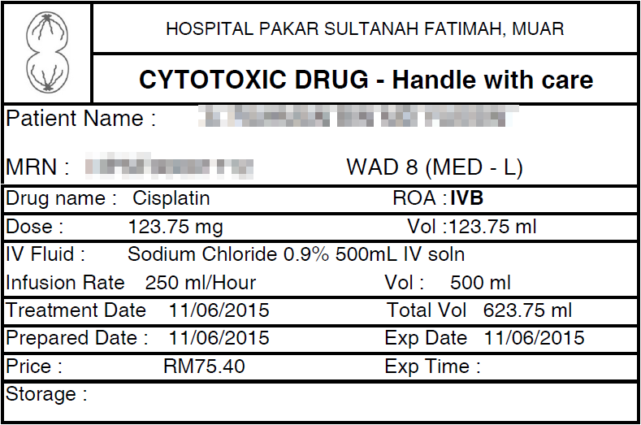  - In CDR Infusion drug label, no Infuse Over value displayed | 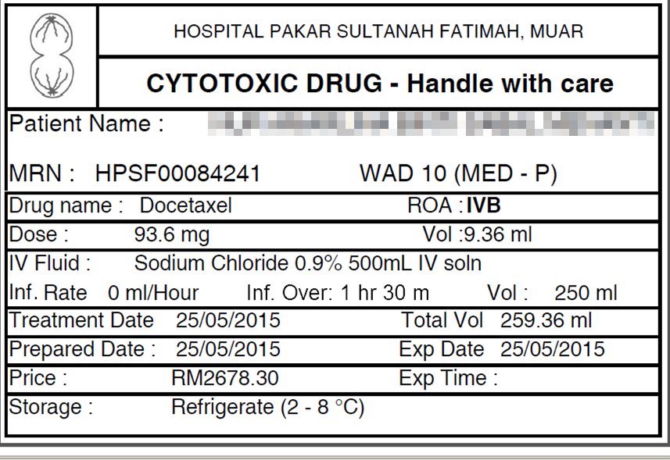  1  - Rearrange layout and added new field ‘Infuse Over’. Will display value based on order.

