Function Flow | Counselling Order – Schedule Time in current Version 1.3.5 | Counselling Order – Schedule Time in Version 1.3.6
1.  Counselling Order – Schedule Time | - Open Medication Counselling Order Screen  - Create New counselling order  - Request to add word 'Time' for button 'Schedule'.  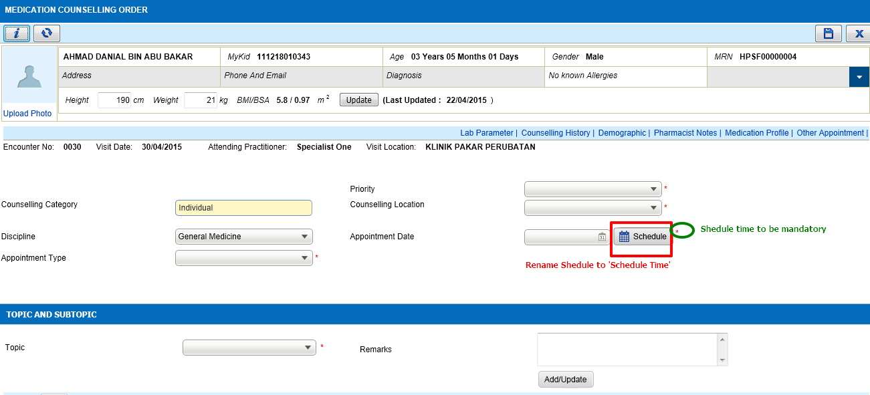 | - Open Medication Counselling Order Screen  - Create New counselling order  - Modify the wording of image button from 'Schedule' to 'Schedule Time' and set the field as mandatory  