Function Flow | DICE at HQ current Version 1.3.5 | New DICE at HQ Version 1.3.6
1.  DICE – HQ | - Using HQ application, open Drug Information screen from the menu, system will show DI listing screen  - Click on ‘Add New’ button  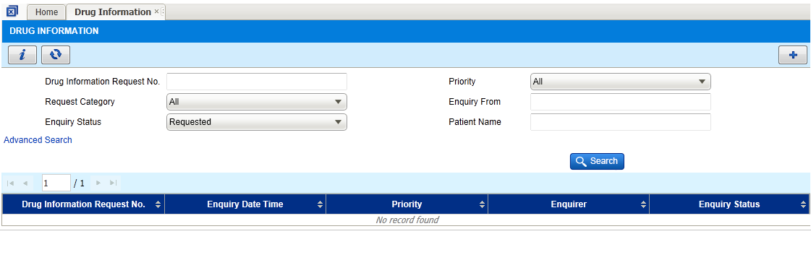  - System will show drug information screen  - Enquiry from field shows ‘HQ’  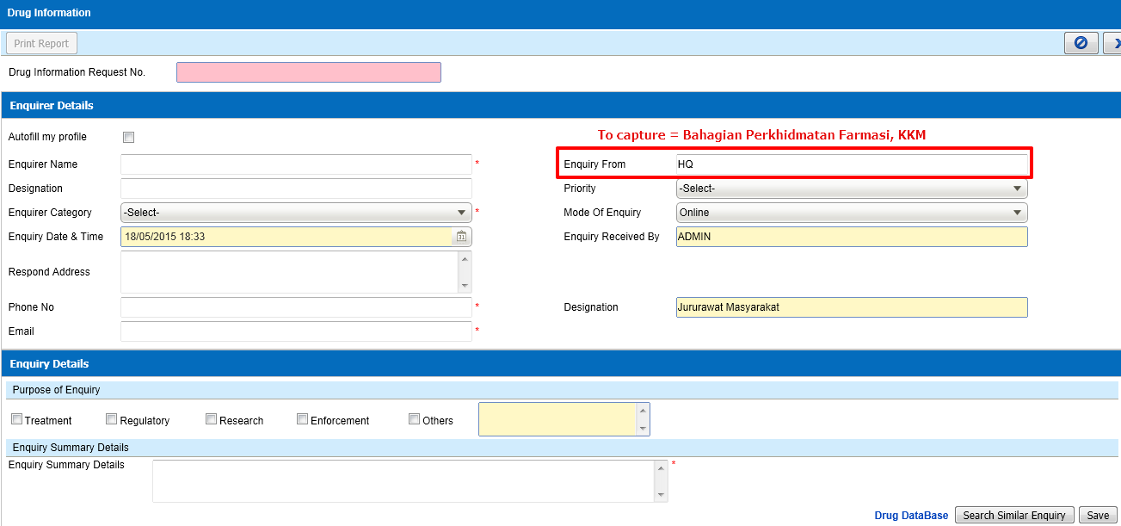 | - Using HQ application, open Drug Information screen from the menu, system will show DI listing screen  - Click on ‘Add New’ button  - System will show drug information screen  - Enquiry from field has been change from ‘HQ’ to “Bahagian Perkhidmatan Farmasi, KKM”  