Function Flow | Extemp Label for Split Dose in current Version 1.3.5 | Prepacking Transaction in new Version 1.3.6
1.  IP/OP Preparation | 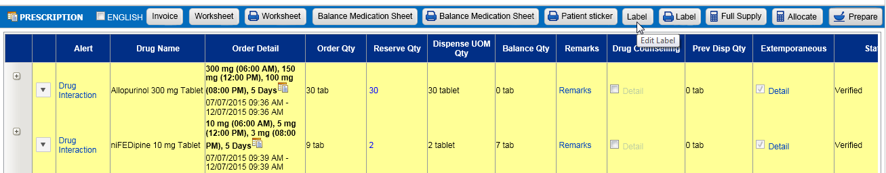  2  1  - In Outpatient/Inpatient Pharmacy Preparation screen, if dose ordered is in Split Dose (1) and drug is prepared as Extemporaneous (2) drug, when view label, dose is displayed as below:  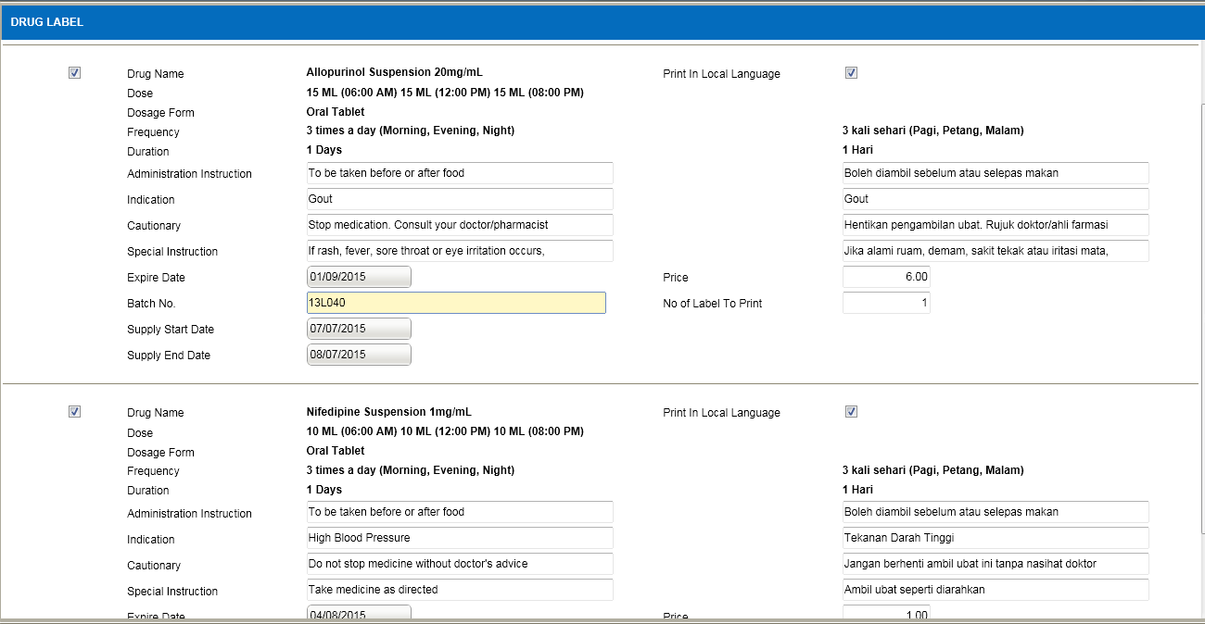  5 | 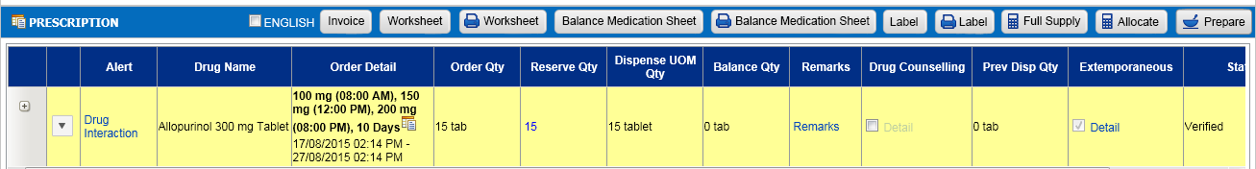  2  1  - In Outpatient/Inpatient Pharmacy Preparation screen, if dose ordered is in Split Dose (1) and drug is prepared as Extemporaneous (2) drug, when view label, dose is updated to display as below:  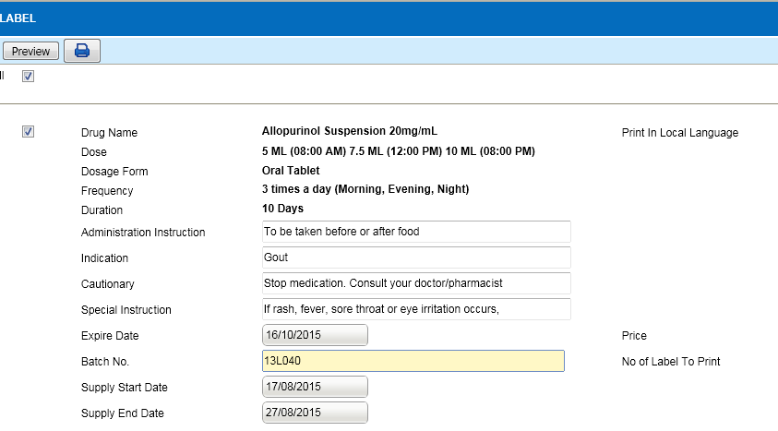  - Dose is calculated based on Dosage and extemp concentration.  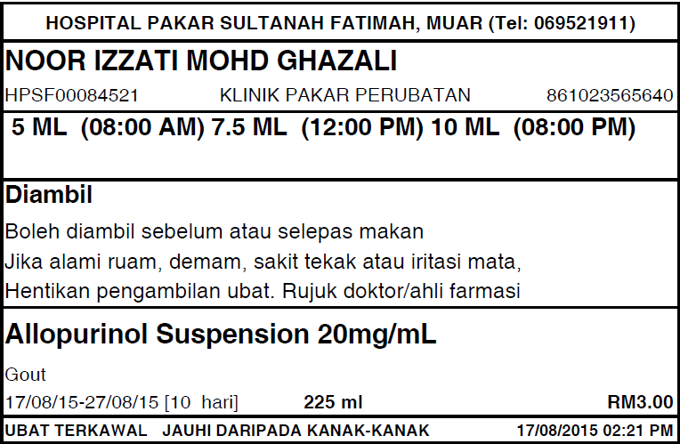  3  - If extemp preparation done by patient is selected, the instruction label is with split dose information is displayed as below:  