Function Flow | Work Order transaction in current Version 1.3.5 | Work Order transaction in new Version 1.3.6
1.  Work Order – Production Complete | 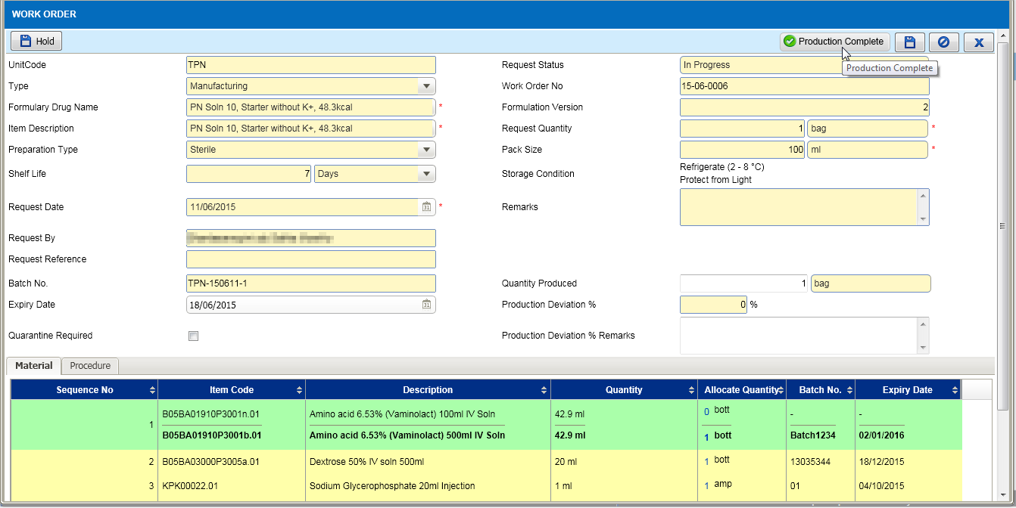  1  - On click of Production Complete button (1), Checked By pop up screen is displayed as below for user to key-in the username and password (2):  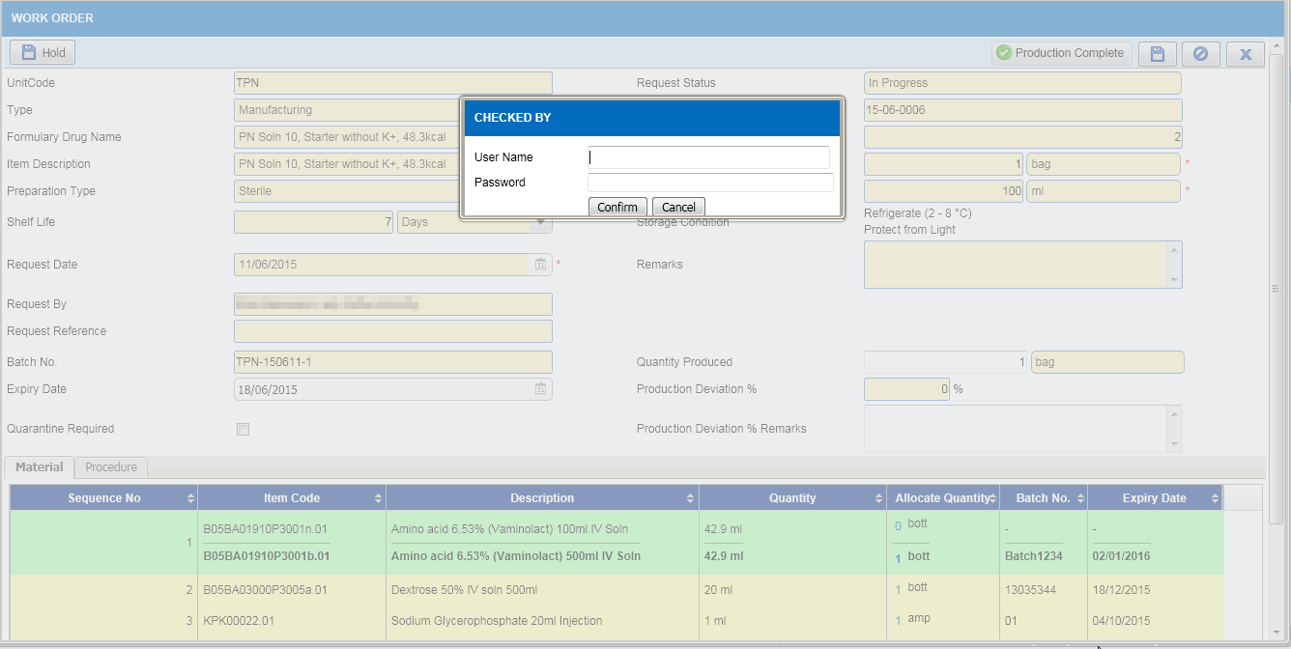  2 | 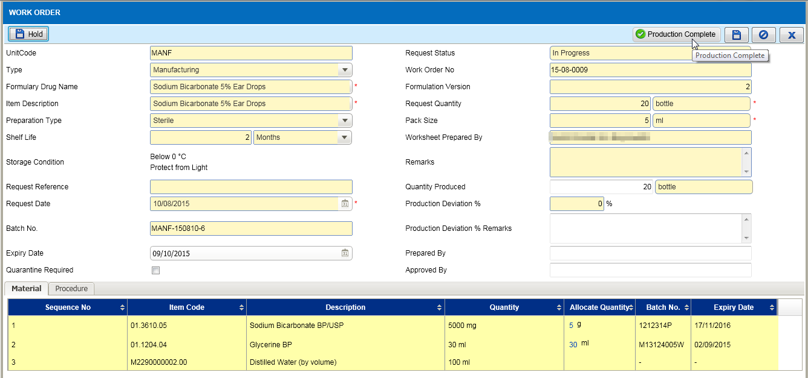  1  - On click of Production Complete button (1), system directly update the record status to Completed without the username and password pop up:  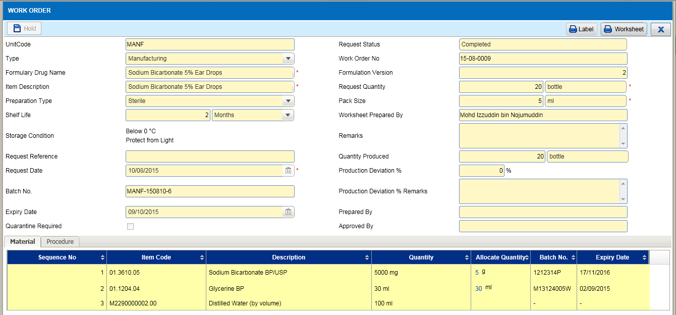
2.  Work order – Prepared By, Approved By | 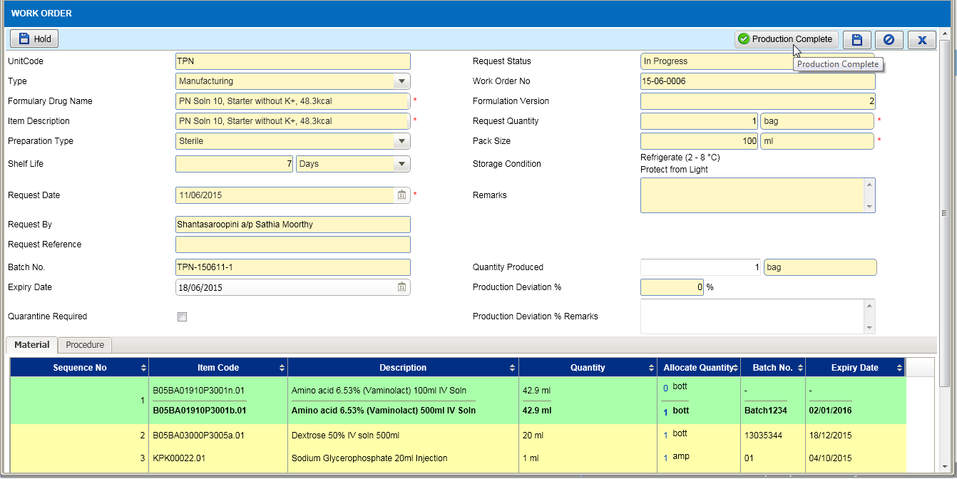  - Current function, don’t have field for user to key in Prepared By and Approved By.  - Worksheet is displayed as below:  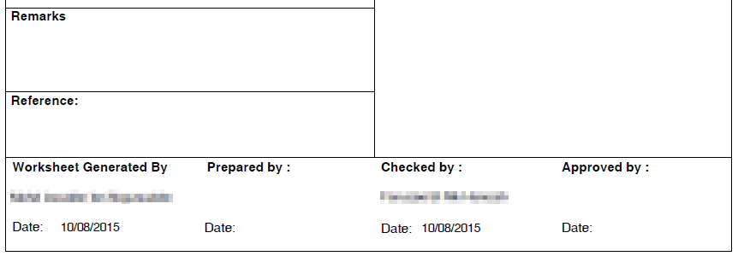 | 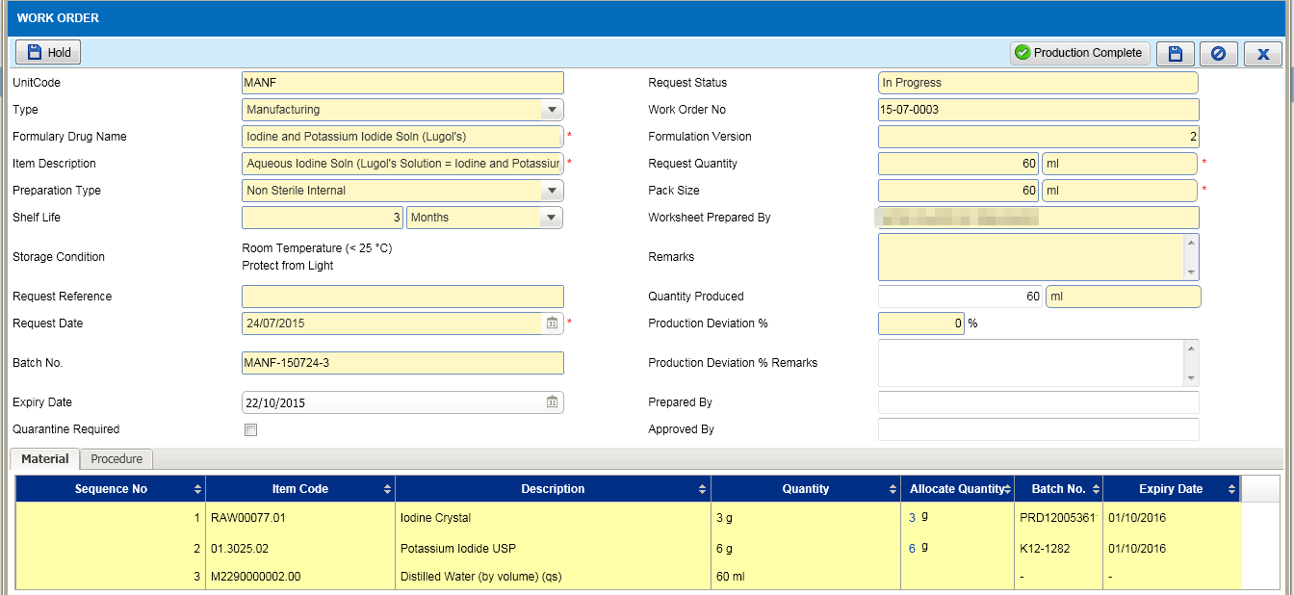  1  - When record status ‘In Progress’ added new fields for user to key in Prepared By and Approved By (1).  - Updated the screen and worksheet layout.  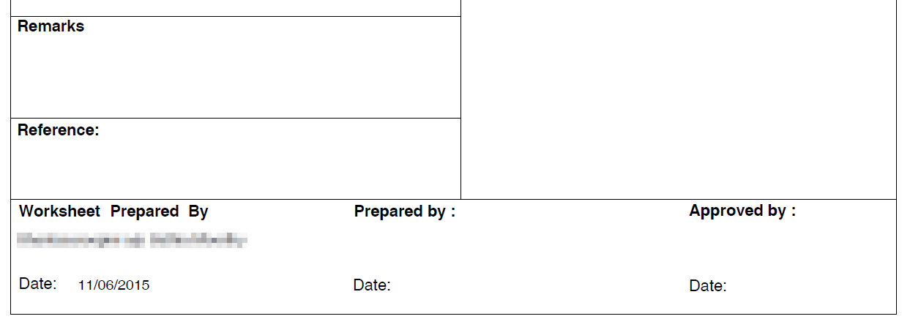
3. Work Order - Worksheet | 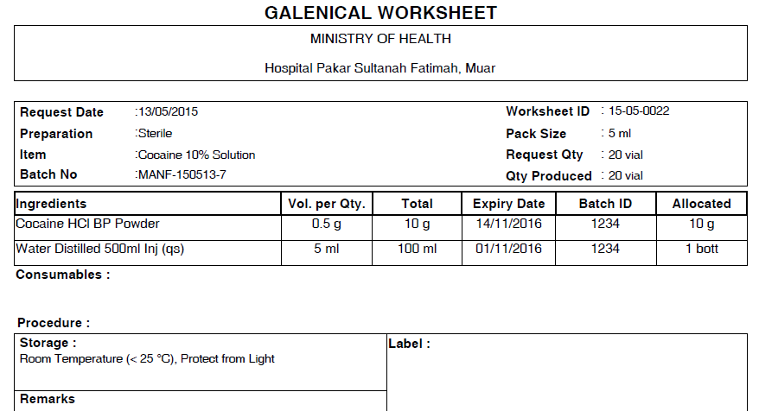  - Current worksheet do not display the Shelf Life and Expiry Date. | 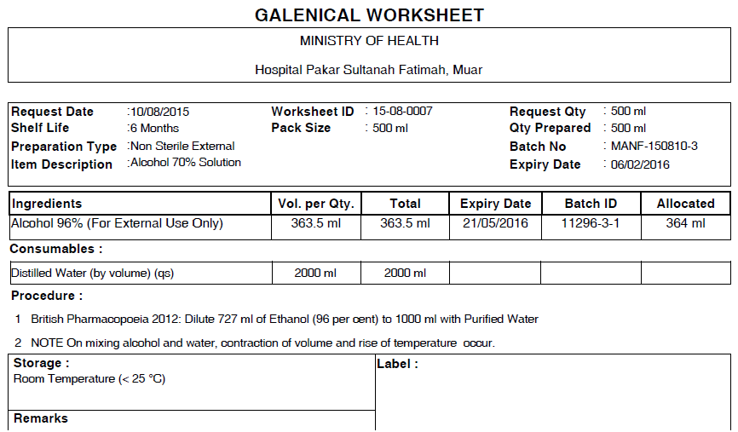  1  - Updated the worksheet layout and added fields to display Shelf Life and Expiry Date.

