Function Flow | Vote Code screen (IWP) Version 1.3.5 | Vote Code screen (IWP) Version 1.3.6
IWP – Vote Code screen- List of facility base on facility type = PKD, KK & MUSN/PBFN Only | 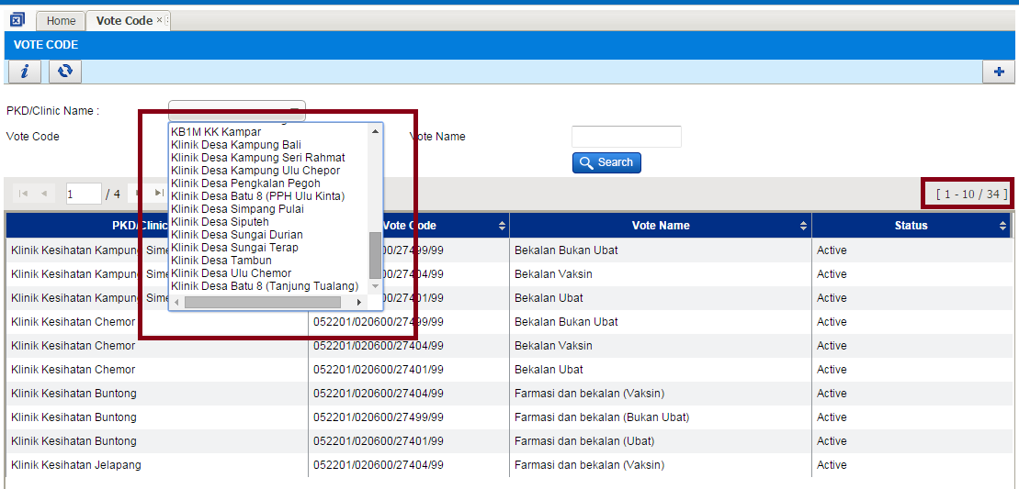  - Login to IWP as PKD user  - Go to Vote Code screen  - Click button PKD/Clinic Name – will list all type of facility including KKIA & KK1M which is not using PhIS | 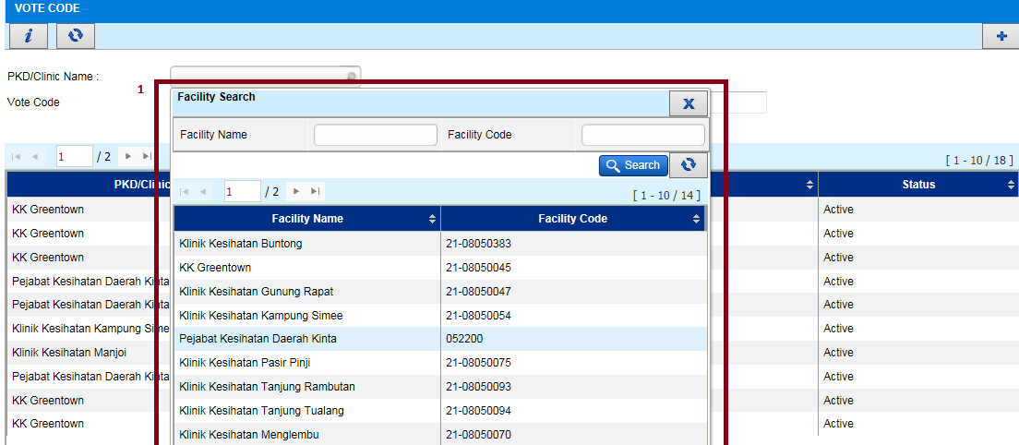  - Login to IWP as PKD user  - Go to Vote Code screen  - Click button PKD/Clinic Name – will list facility type = KK, PKD & MUSN/MUSB only which is have same PTJ Code

Function Flow | IWP – Contract HQ screen – Contract Facility list section (Version 1.3.5) | IWP – Contract HQ screen – Contract Facility list section (Version 1.3.6)
Contract HQ –Add on filter field in contract facility list to search by facility | 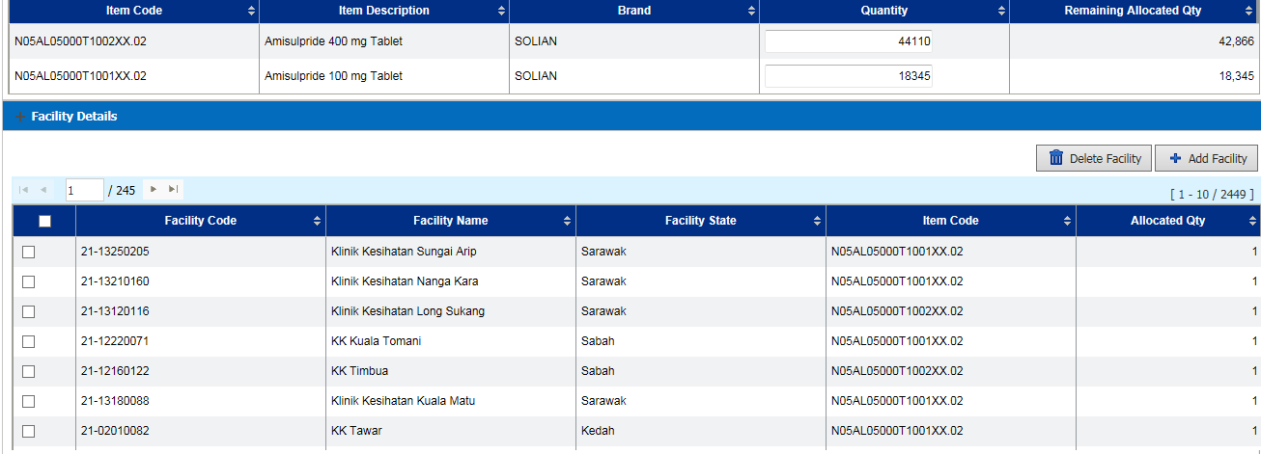  - Login to IWP as creator of Contract HQ user  - Go to Contract HQ screen  - At listing page double click one of the Contract detail  - At Facility detail section,user can see all the facility which already allocate with the contract but can’t search base on the facility name | 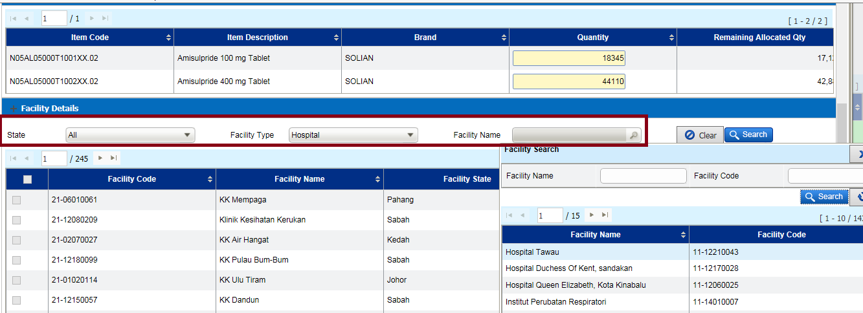  - Login to IWP as creator of Contract HQ user  - Go to Contract HQ screen  - At listing page double click one of the Contract detail  - At Facility detail section,add on searching filter by :  - State  - Facility Type  - Facility Name  - Once search, if the respective facility available in the contract detail , the facility information will auto populate

Function Flow | IWP – PKD Authorization screen (Version 1.3.5) | IWP – PKD Authorization screen (Version 1.3.6)
PKD Authorization – The quantity approved must be multiply of Min Order Quantity | 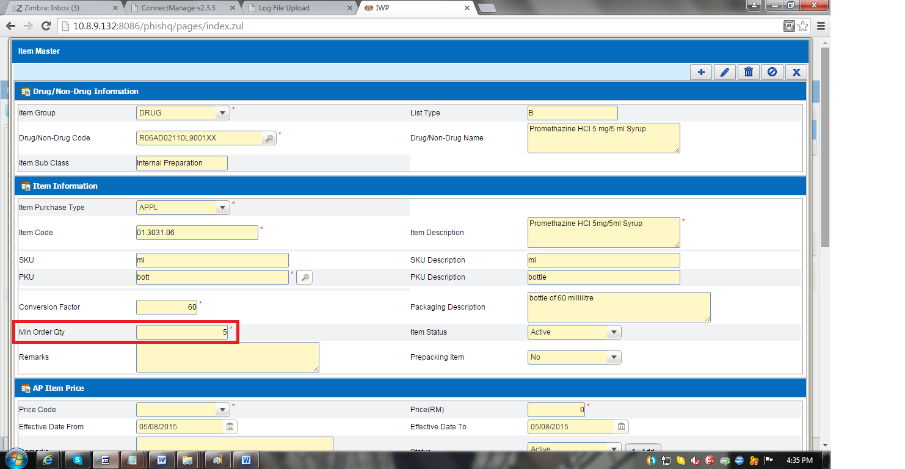  - At item master screen check the Min Order Quantity (MOQ) | - At item master screen check the Min Order Quantity (MOQ)

Function Flow | IWP – PKD Authorization screen (Version 1.3.5) | IWP – PKD Authorization screen (Version 1.3.6)
 | 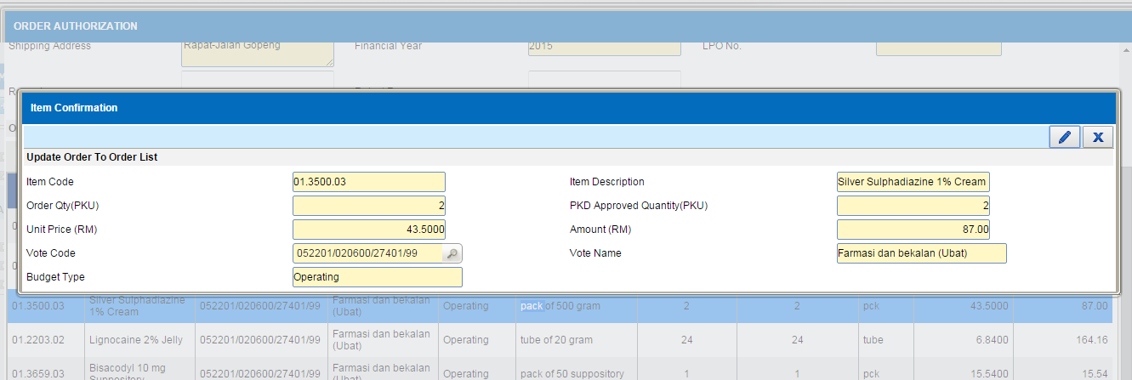  - Login as PKD user and go to Request Order Authorization screen  - Select any order from clinic which required to be approved.  - Select one of the item and double click  - While click button ‘Approved’ system didn’t checking the Min Order Quantity (MOQ) and allow to approved any quantity entered as long not more than order quantity | 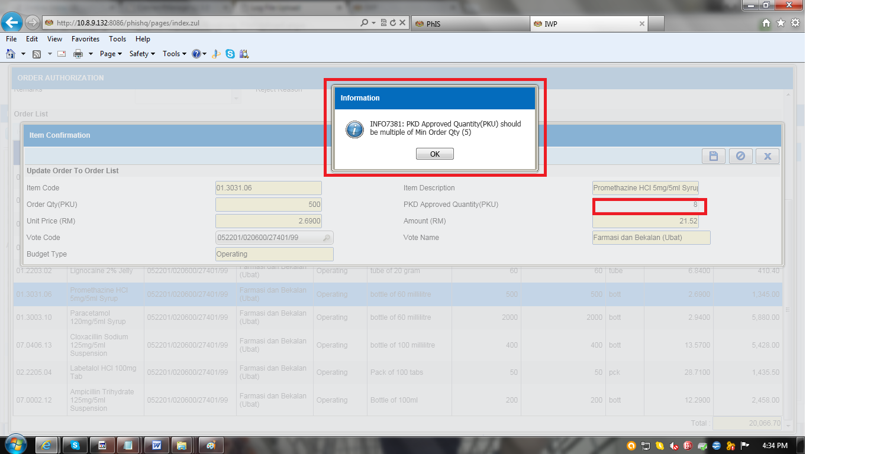  - Login as PKD user and go to Request Order Authorization screen  - Select any order from clinic which required to be approved.  - Select one of the item and double click  - While click button ‘Approved’ system will checked the Min Order Quantity (MOQ) and the quantity to be approved quantity must be multiply of Min Order Quantity

