Function Flow | External Indent – For Sabah & Sarawak Facility (Version 1.3.5) | External Indent – For Sabah & Sarawak Facility (Version 1.3.6)
External Indent – For Sabah & Sarawak | 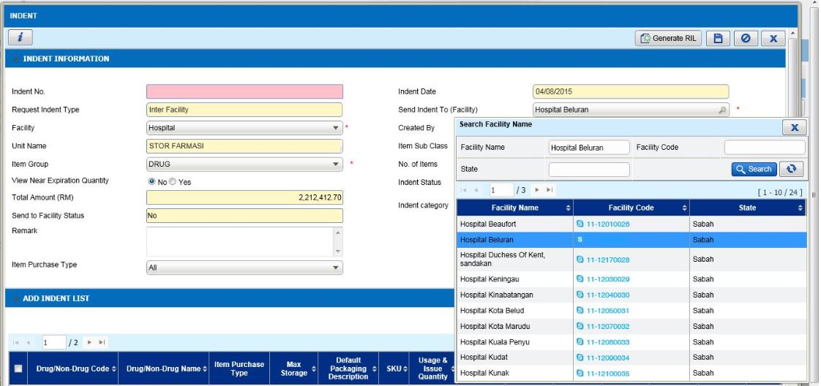  - Go to External Indent screen  - Generate RIL or add the drug/non drug manually by click Add item button.  - If the user from facility either Sabah or Sarawak state, if the PTJ code between Indenter facility and Supplying facility is same then system will allow to Indent more than 10 drug/non drug in 1 transaction  - If the user from facility either Sabah or Sarawak state, if the PTJ code not tally between Indenter facility and Supplying facility then system will not allow to Indent more than 10 drug/non drug in 1 transaction | 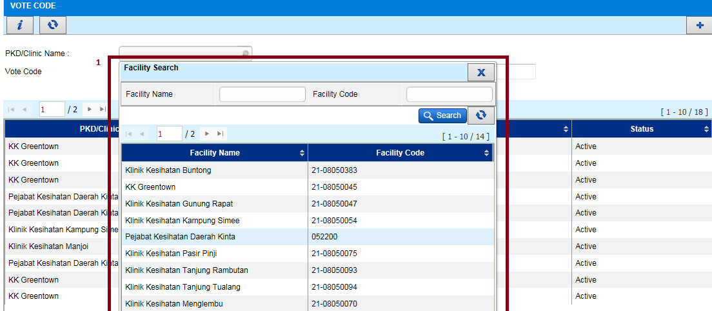  - Go to External Indent screen  - Generate RIL or add the drug/non drug manually by click Add item button.  - If the user from facility either Sabah or Sarawak state, either the PTJ code between Indenter facility and Supplying facility is same or not system will allow to Indent more than 10 drug/non drug in 1 transaction  - System will checking base on state of the 2 facility. If the state as Sabah or Sarawak and the PTJ Code either same or not between the 2 facility, system will allow to indent than 10 drug/non drug in 1 transaction

Function Flow | Inventory – External Indent (Version 1.3.5) | Inventory – External Indent (Version 1.3.6)
External Indent - Retrieve External Indent & Issue Online for Ext Indent need to display the name of the Indenter facility’s username (KEWPS 10) | 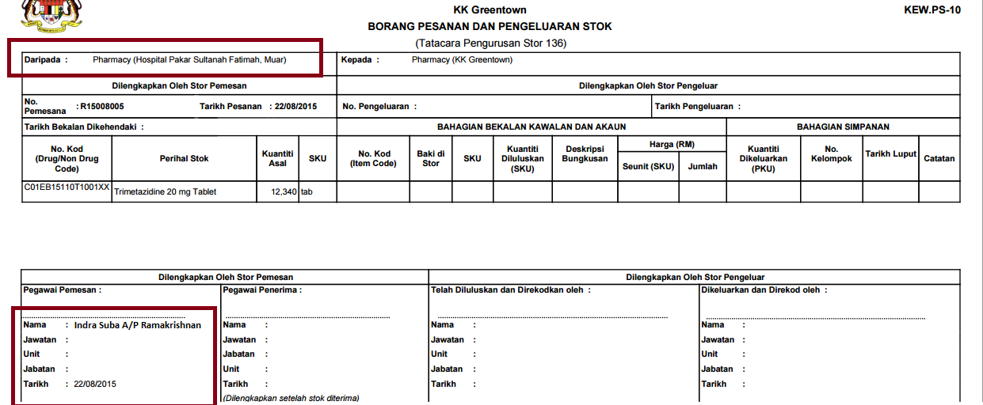  External Indent screen:  - Login to Indent screen as Main store user  - Select option ‘External Indent’  - Click button ‘Retrieve’ to retrieve the Indent from others facility  - Then go to External Indent transaction that have been pulled from Retrieve button  - Generate KEWPS 10  - Name of the Indenter’s facility user will be display | 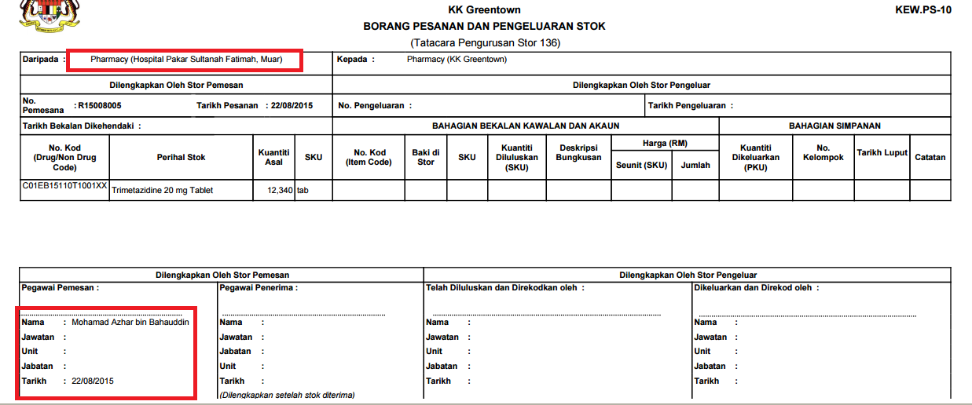  External Indent screen:  - Login to Indent screen as Main store user  - Select option ‘External Indent’  - Click button ‘Retrieve’ to retrieve the Indent from others facility  - Then go to External Indent transaction that have been pulled from Retrieve button  - Generate KEWPS 10  - Name of the Indenter’s facility user will be display

Function Flow | Inventory – External Indent (Version 1.3.5) | Inventory – External Indent (Version 1.3.6)
 | 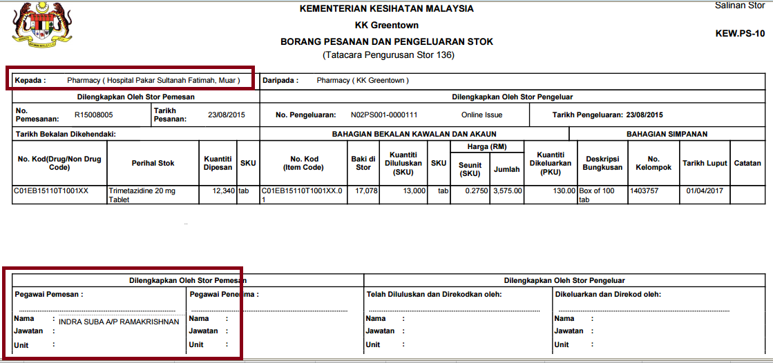Online Issue screen:  - Login to Issue Online screen as Main store user  - Select the External Indent transaction no  - Double click the detail  - Generate the Issue once transaction have been approved  - View the KEWPS10  - Nama ‘Pemesan’ is referring to the supplying’s facility user name | 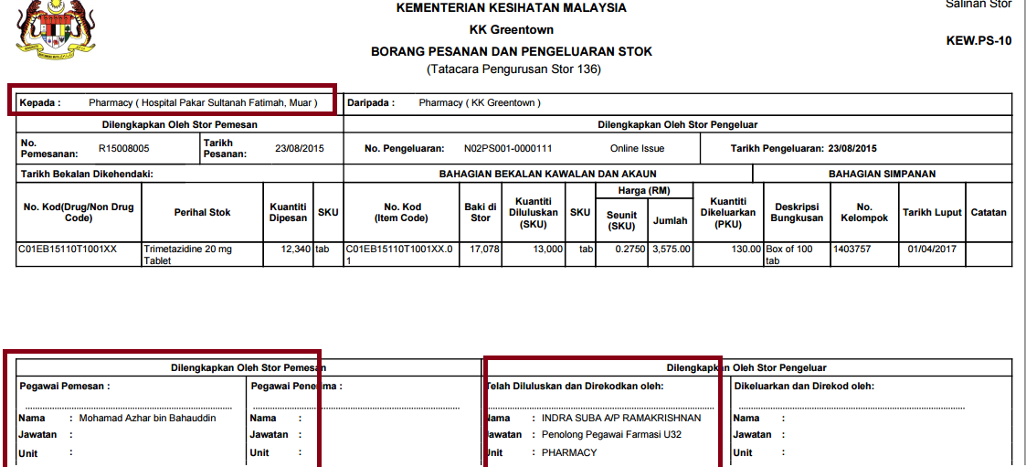  Online Issue screen:  - Login to Issue Online screen as Main store user  - Select the External Indent transaction no  - Double click the detail  - Generate the Issue once transaction have been approved  - View the KEWPS10  - Nama ‘Pemesan’ is referring to the Indenter’s facility user name

Function Flow | Offline Issue – Own Consumption & Internal (Version 1.3.5) | Offline Issue – Own Consumption & Internal (Version 1.3.6)
Offline Issue -Type of Internal & Own Consumption- Need to have button unit catalog | 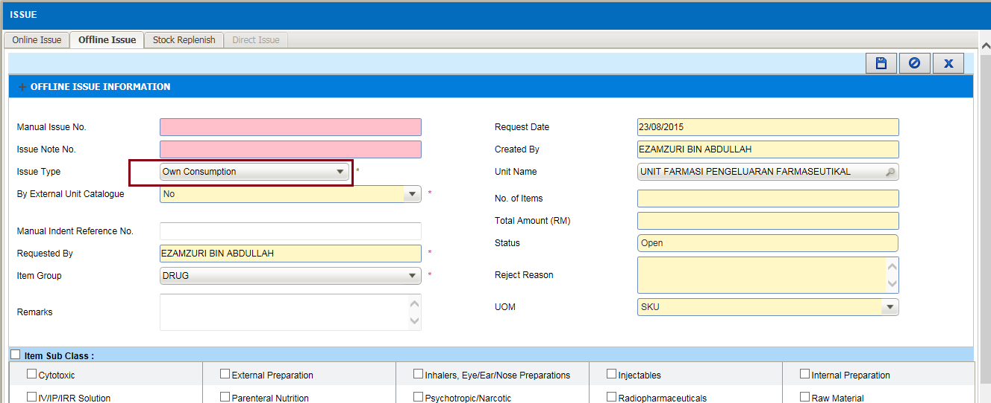  Own Consumption:  - Login as level 2 or level 3 user  - Go to Issue screen Offline Issue  - Select ‘Issue Type’ as Own Consumption  - Unable to see ‘Unit Catalogue’ button | 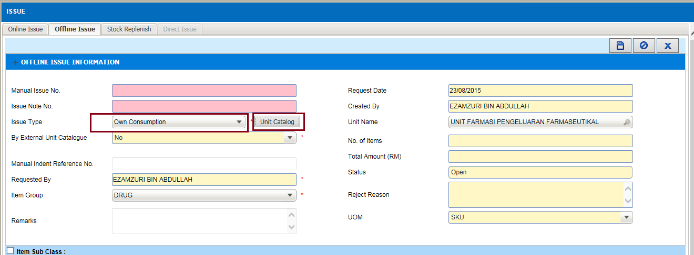  Own Consumption:  - Login as level 2 or level 3 user  - Go to Issue screen Offline Issue  - Select ‘Issue Type’ as Own Consumption  - Able to see ‘Unit Catalogue’ button base on user requester unit id  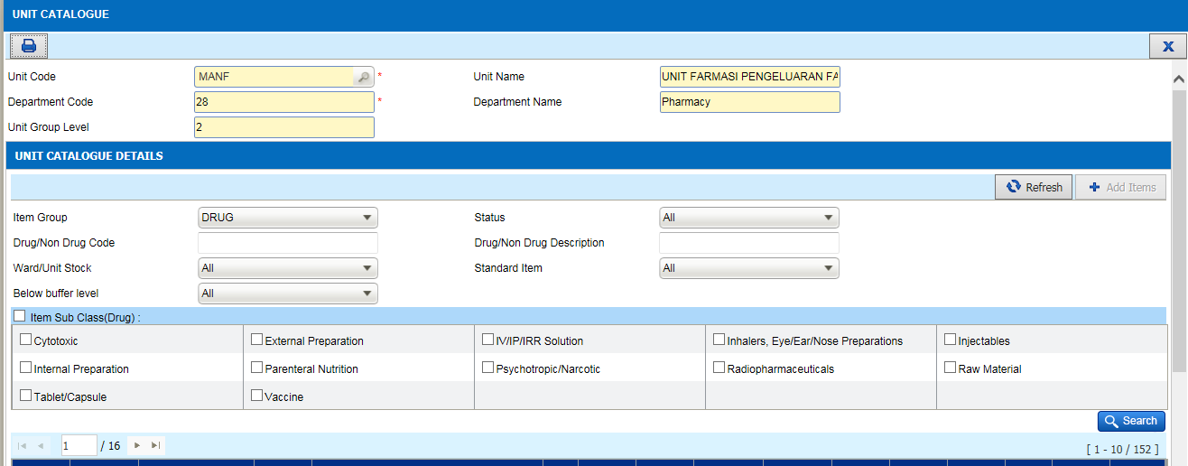

Function Flow | Offline Issue – Own Consumption & Internal (Version 1.3.5) | Offline Issue – Own Consumption & Internal (Version 1.3.6)
 | 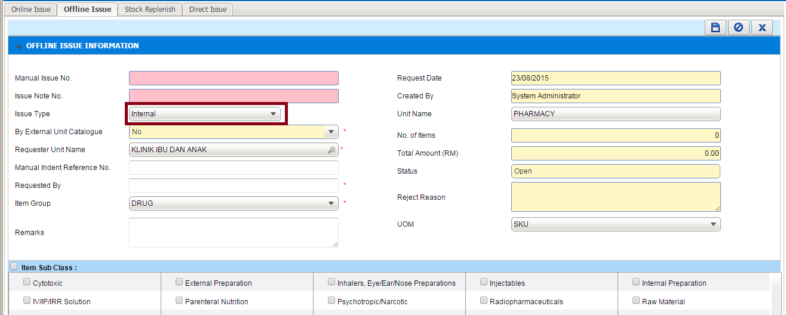  Internal:  - Login as level 1 or 2 user login id  - Go to Issue screen Offline Issue  - Select ‘Issue Type’ as Internal  - Unable to see ‘Unit Catalogue’ button | 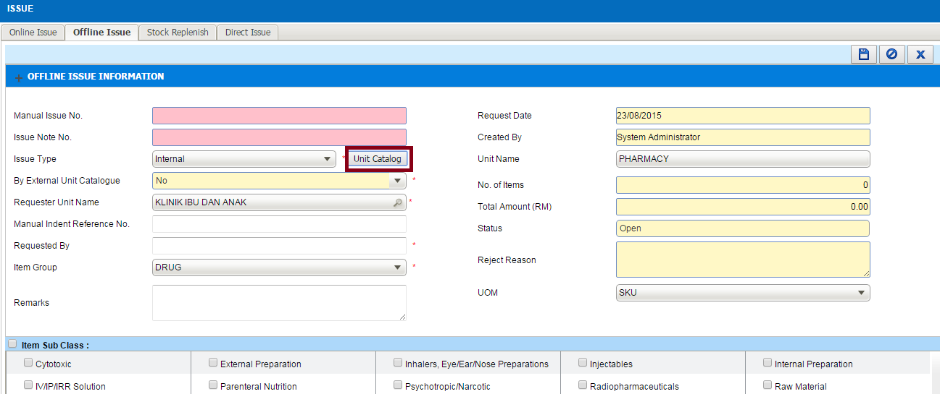  Internal:  - Login as level 1 or 2 user login id  - Go to Issue screen Offline Issue  - Select ‘Issue Type’ as Internal  - Able to see ‘Unit Catalogue’ button once select the requester unit as below screen

Function Flow | Offline Issue – Issue Type = External (Version 1.3.5) | Offline Issue – Issue Type = External (Version 1.3.6)
Offline Issue – Issue Type = External (To cater for External Unit Catalogue) | 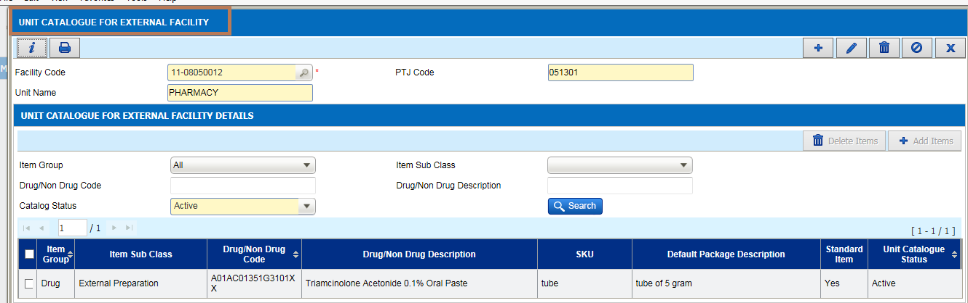  Unit Catalogue for external Facility  - This maintenance is available at Maintenance under Inventory section but not functioning | Unit Catalogue for external Facility  - This maintenance is available at Maintenance under Inventory section and will relate to Offline Issue for Issue type = External

Function Flow | Offline Issue – Issue Type = External (Version 1.3.5) | Offline Issue – Issue Type = External (Version 1.3.6)
 | 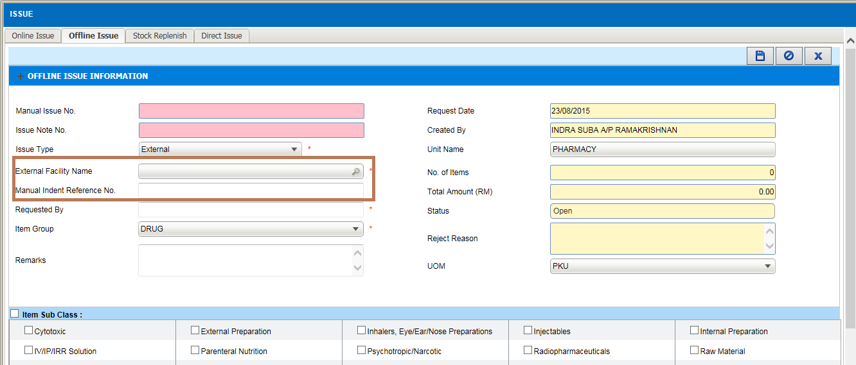  Offline Issue  - When select Issue type = External then External Facility Name is mandatory field | 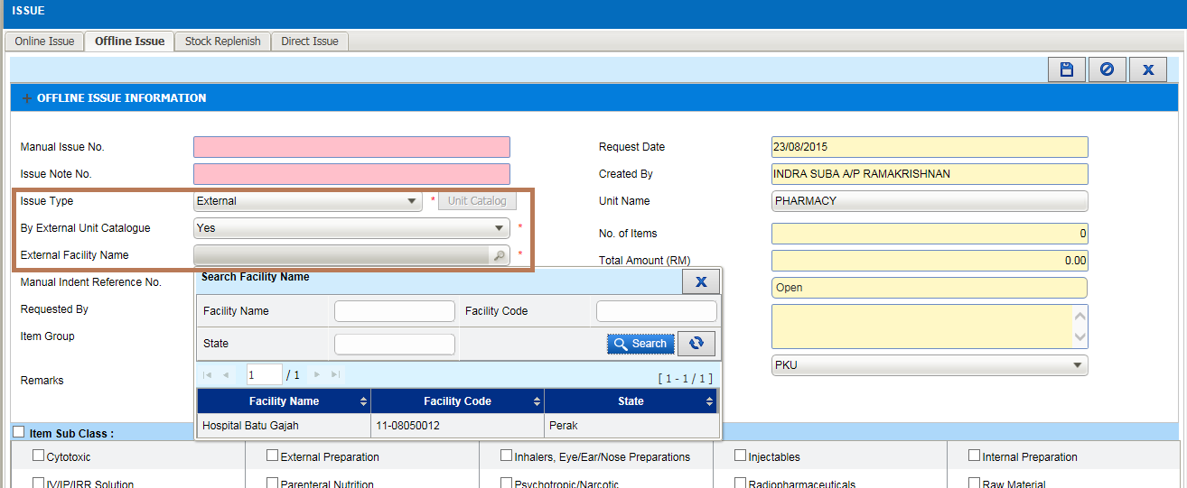  Offline Issue  - When select Issue type = External then add one 1 more filter which is By External Unit Catalogue either Yes or No and by default = No  - If No still remain the previous function whereby directly select the External facility name and list of drug/non drug when click Ad Item button will refer to supplying unit stock in hand  - If Yes will refer to External Unit Catalogue available and when click button Add Item , will base on the drug/non drug available in the supplying unit

Function Flow | Recommended Issue Quantity – RIQ (Version 1.3.5) | Recommended Issue Quantity – RIQ (Version 1.3.6)
5.  RIQ screen - Allow to select from which unit should be able to deduct the stock from | 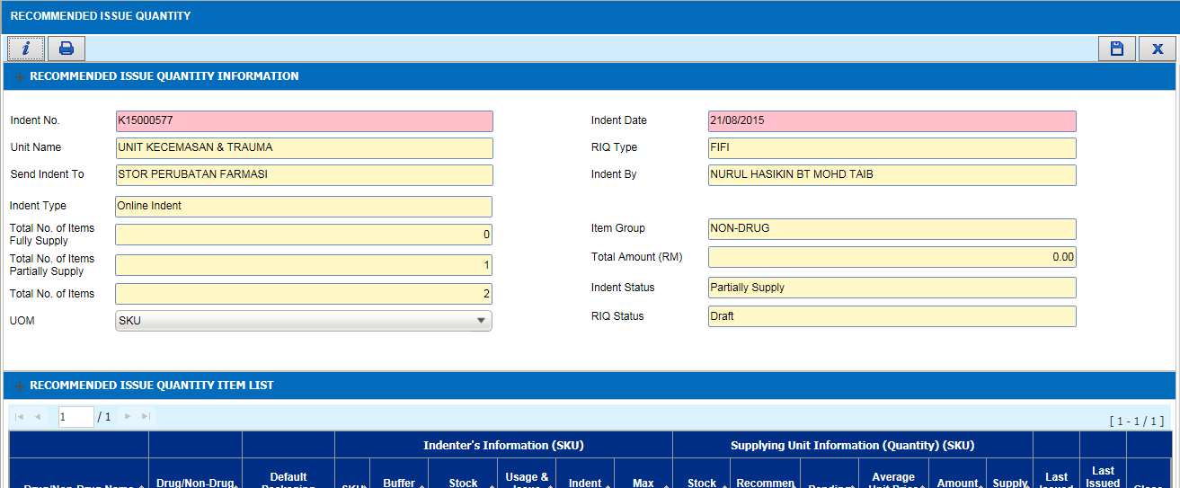  RIQ screen  - No changes on the current version | 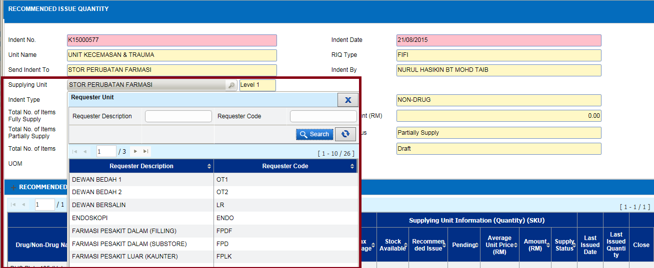  RIQ screen  - In RIQ screen add on 1 more filter of Supplying Unit. It’s referring where the stock will deducted. By default it display to the user login ID where the indent send to.  - If login as level 1 user If “Supplying Unit” = Level 1 , will be display all the requester whereby the default Indent To is referring to Level 1.  - If “Supplying Unit” = Level 2, will be display all the requester whereby the default Indent To is referring to the respective requester supplying Unit.  - Once selected, the current stock is based on the selected supplying unit.  - The transaction will flow to Issue Note screen once approved

Function Flow | Recommended Issue Quantity – RIQ (Version 1.3.5) | Recommended Issue Quantity – RIQ (Version 1.3.6)
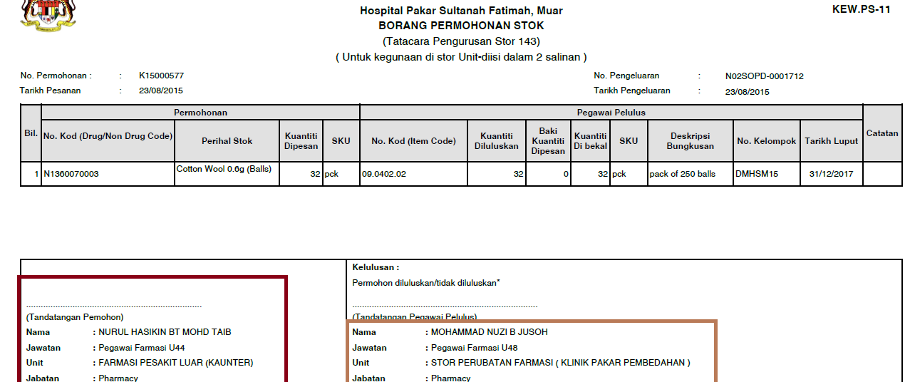

- At the bottom section at section kelulusan.
  - It will display user user unit name and in bracket ()will be display from where the stock was deducted from the system.
  - If the supplying unit same as the original indent flow to ,it wouldn’t display the information in bracket ().

Function Flow | Item Movement (Version 1.3.5) | Item Movement (Version 1.3.6)
6.  Item Movement – To add on packaging description next to item description while searh the item | 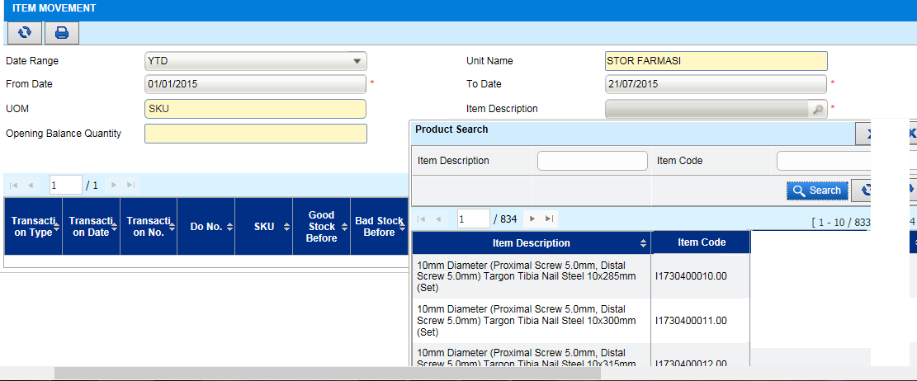  - When search item code at Item Description searching column, only display Item Code & Item Description only | 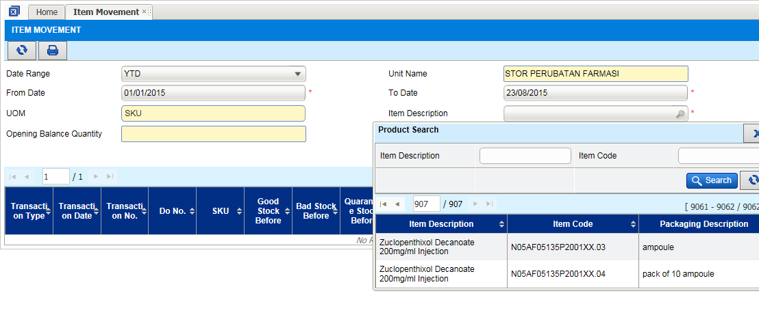  - When search item code at Item Description searching column, add one 1 more column which is Packaging Description next to Item Code

Function Flow | Purchase Order screen (Version 1.3.5) | Purchase Order screen (Version 1.3.6)
7.  Purchase Order screen – Request to remove Vote Code list section once Order status = Approved | 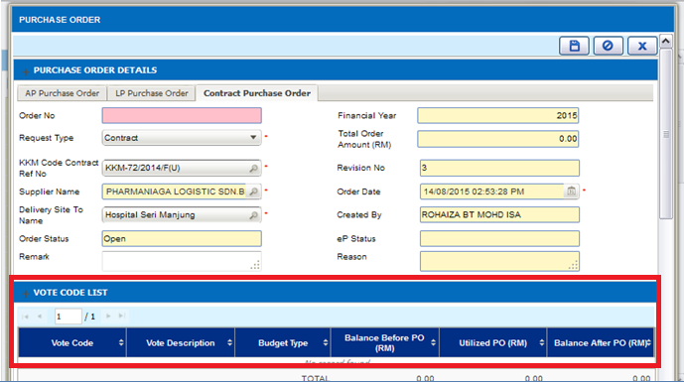  - Go to Purchase Order screen  - At the bottom section can se Vote Code List section  - This value will refer to dynamic value which is keep on changing whenever user call the order no in any order status | 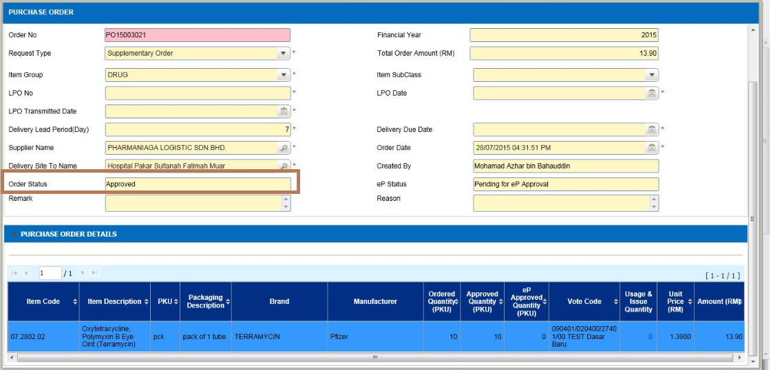  - Go to Purchase Order screen  - At the bottom section can se Vote Code List section  - This vote code list section will be remove from the list once the order status = Approved to avoid confusion to the user

