Function Flow | Medication Administration Record in current Version 1.3.5 | Medication Administration Record in new Version 1.3.6
1.  MAR (Web) | Existing Medication Administration Record screen  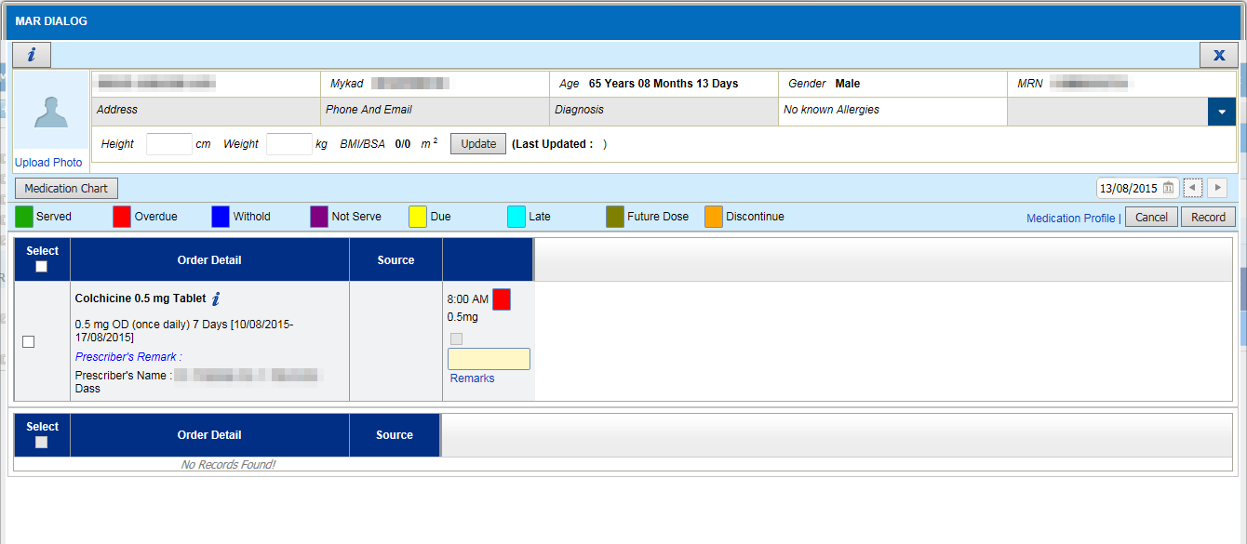  - No drug route displayed  - No order date displayed  - No own medication indicator  - Discontinued drug displayed on top  - No searching function | Improvement in Medication Administration Record screen  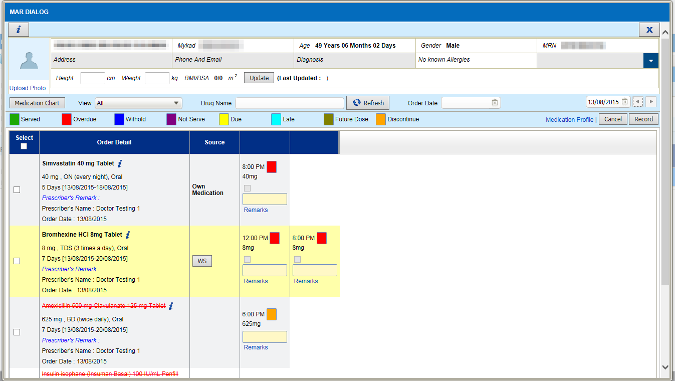  - To include administration route , next to frequency value  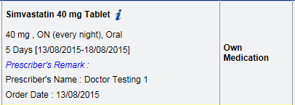  - To display 'Own Medication' in source column if drug is 'Own Medication'  - Discontinue drug should be listed a bottom  - Display Order Date below prescriber name  - Allow to search drug by All/Active/Inactive medication  - All - All status  - Active - All status except cancel, stop and expired.  - Inactive - Status = Cancel, stop and expired.  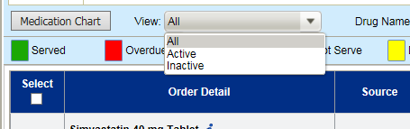  - Allow to search by drug name (auto complete search by drug name)  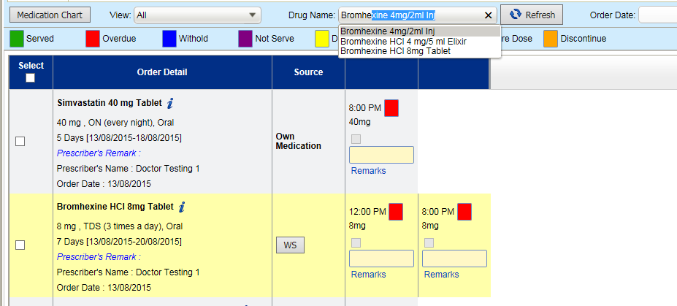  - Allow to search by Order Date  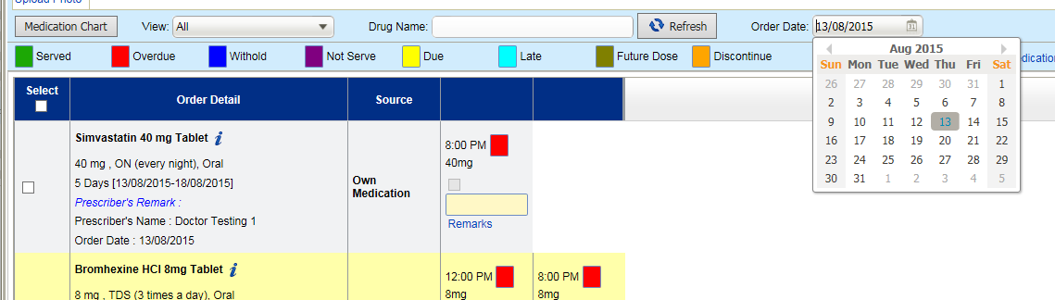
2. Medication Chart  (Layout) | Print Medication Chart  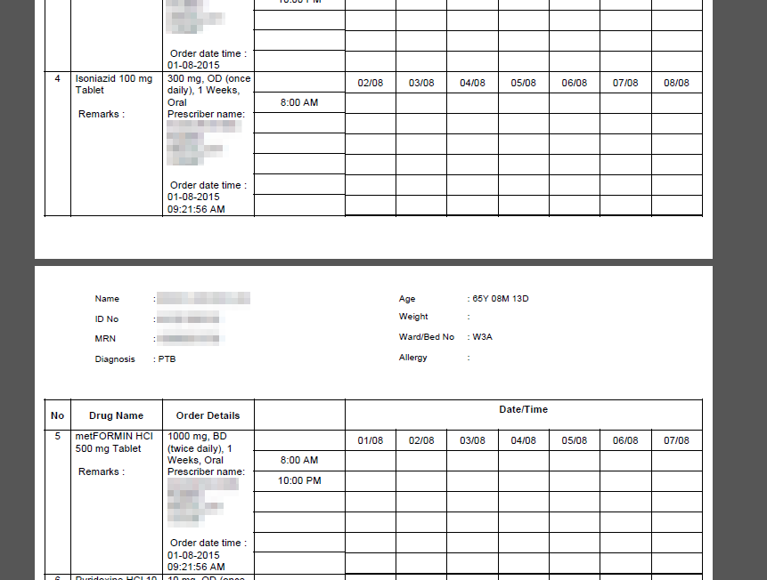  - No header on second page  - No highlight on frequency | Print Medication Chart  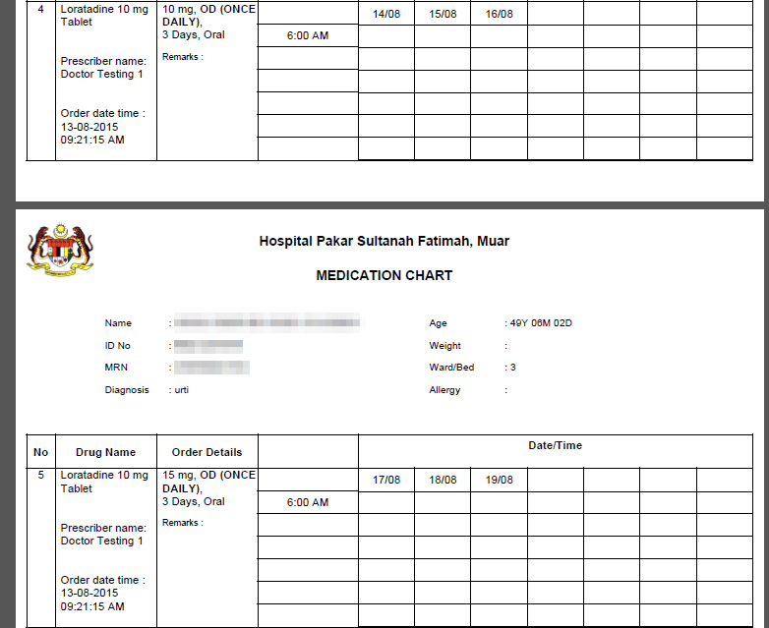  - Add Header title in every page.  - Frequency in capital letter and BOLD.  - Re- arrange prescriber name, order date and remarks
3. Medication Chart  (Print taper) | Print Taper drug  - In MAR screen, taper drug will be displayed by date.  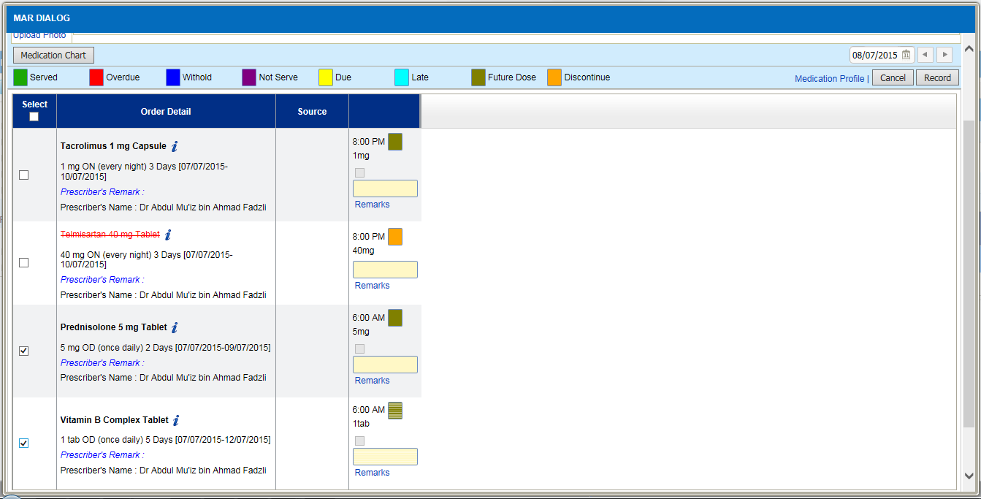  - When user selects the main drug, child drug will not be printed out.  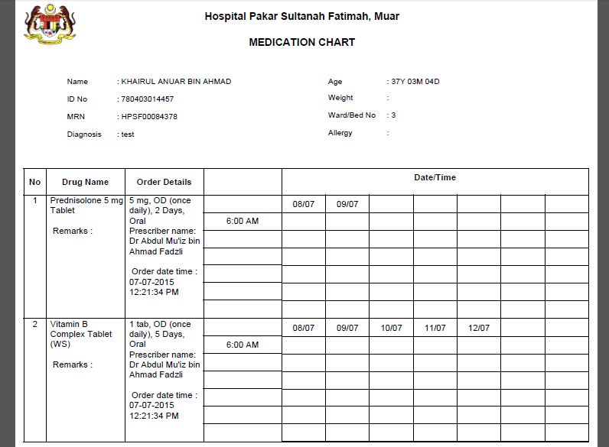 | Print taper drug  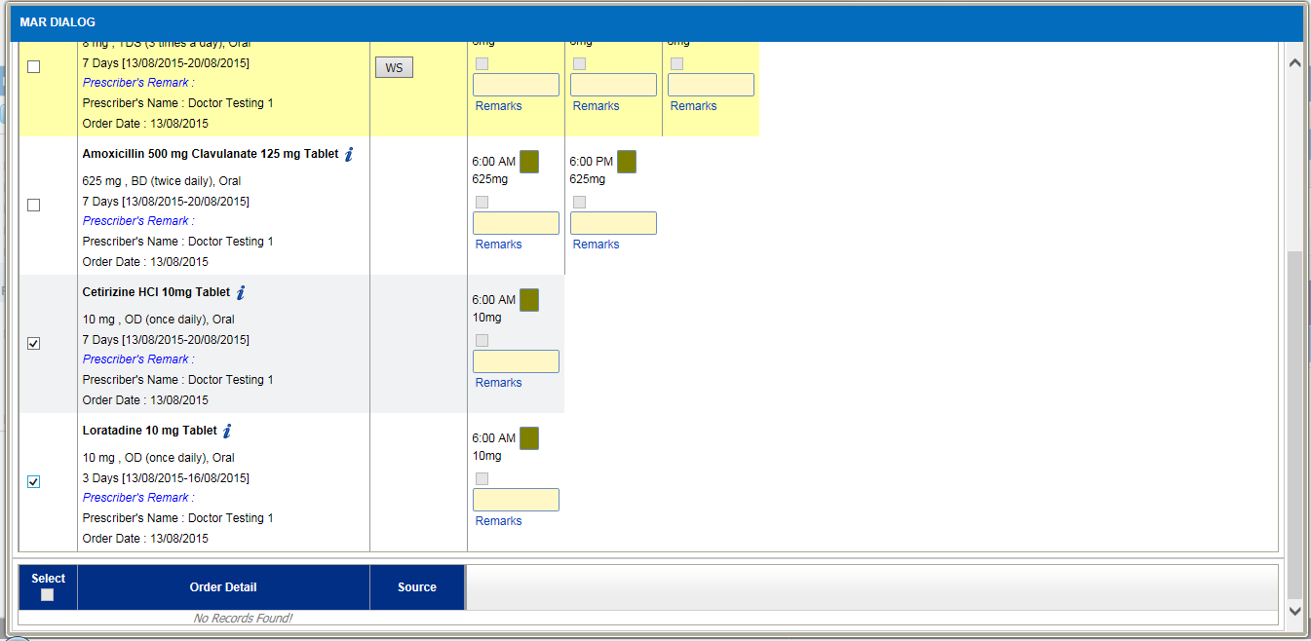  When user print taper drug in medication chart (by selecting main drug), child drug should be included in the medication chart too.  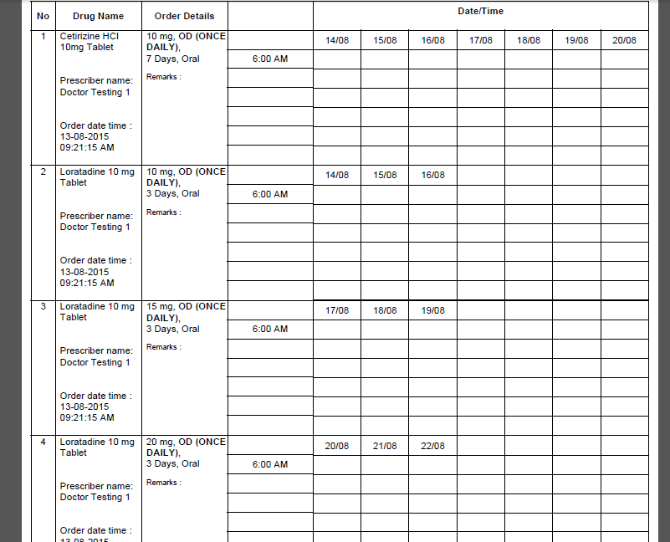
4.  MAR (Mobile) | 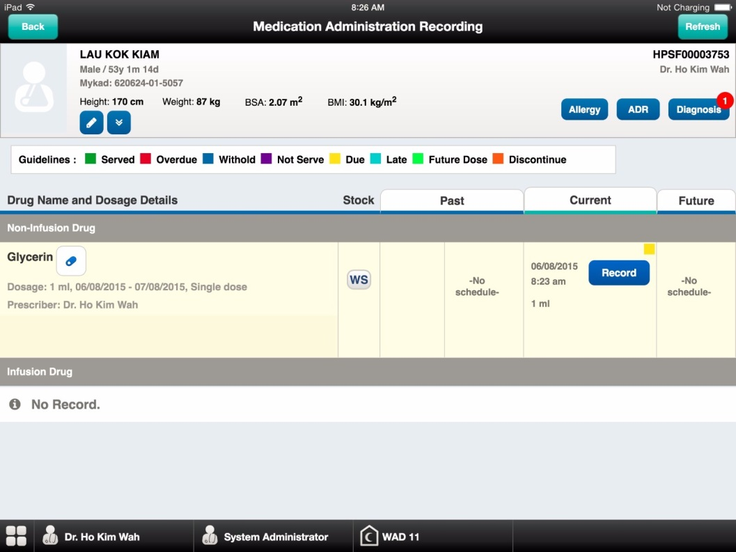 | 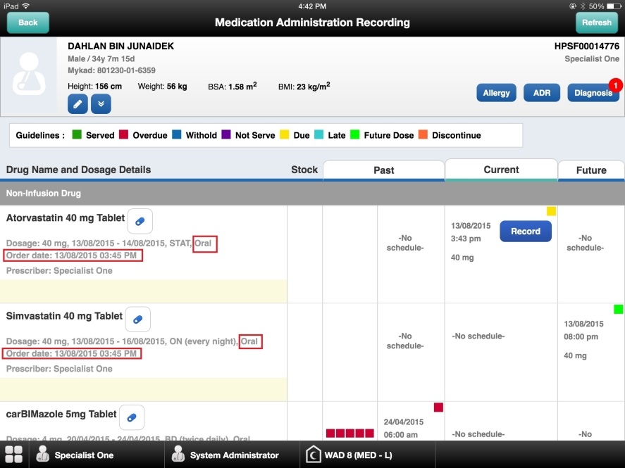  Add admin route and order date in MAR screen.

