Function Flow | MTAC Reporting – Diet&Lifestyle field in current Version 1.3.5 | MTAC Reporting – Diet&Lifestyle field in Version 1.3.6
1.  MTAC Reporting – Diet&Lifestyle | - To make the column Diet & Lifestyle bigger  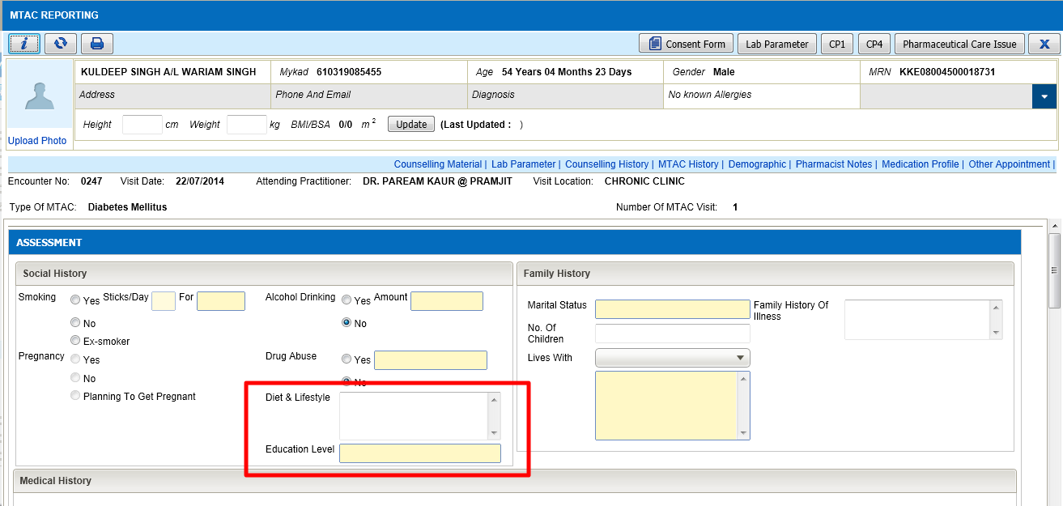 | - Column Diet & Lifestyle has been adjusted to be bigger  