Function Flow | MTAC reporting – LFT in current Version 1.3.5 | MTAC reporting – LFT in new Version 1.3.6
1.  Lab Parameter – LFT | - Open Lab Parameter screen  - Click on LFT section  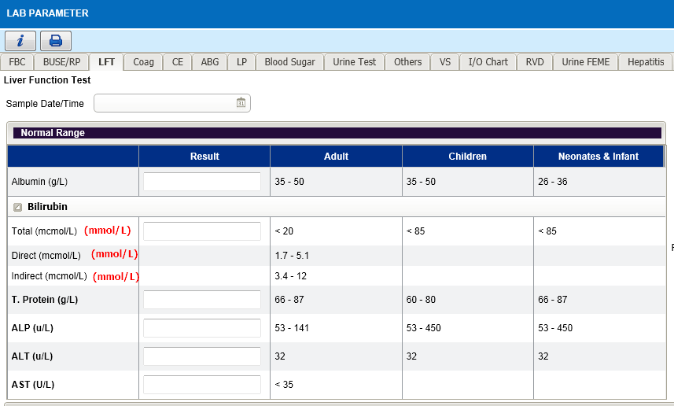 | - Open Lab Parameter screen  - Click on LFT section  - Unit mcmol/L rename to mmol/L