Function Flow | Current Version 1.3.5 | New Version 1.3.6
1.  Add all drug from Favourite List (I-PhIS009817615S) | 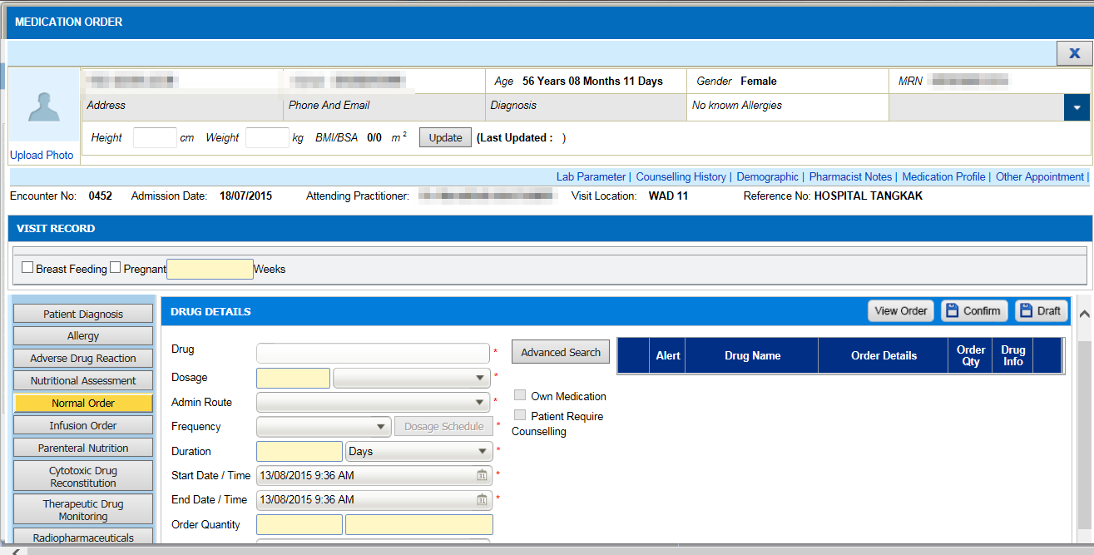  1  2  - In Order Management->Medication Order, click on Normal Order(1).  - Then, click on Advance Search(2) button and screen Advance Search will appear.  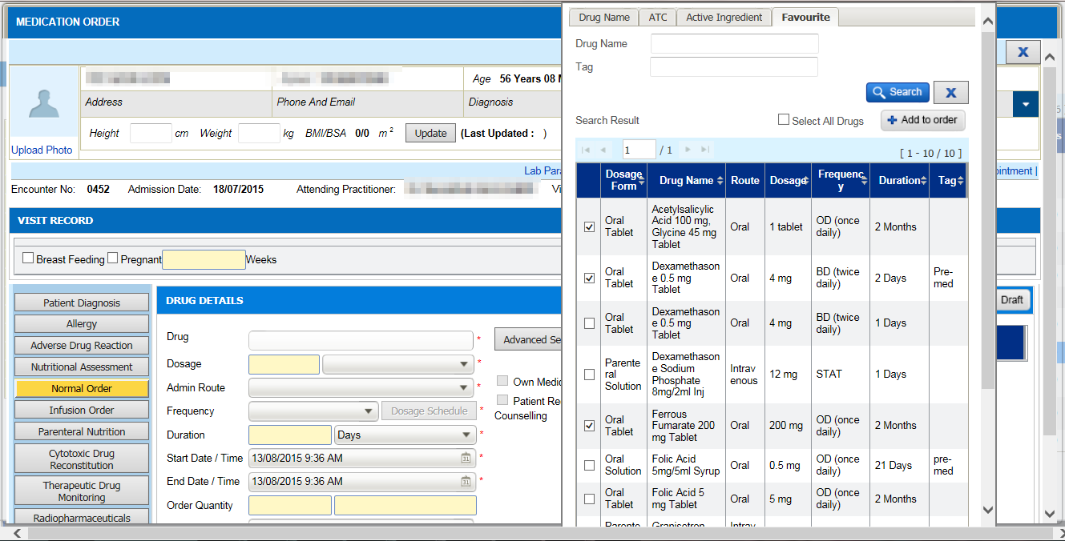  4  3  - Click on Favorite(3) tab and the list of drug which has been added ealier into favorite list will appear.  - Choose any drug one by one by clicking on the checkbox(4) located at the left of this screen.  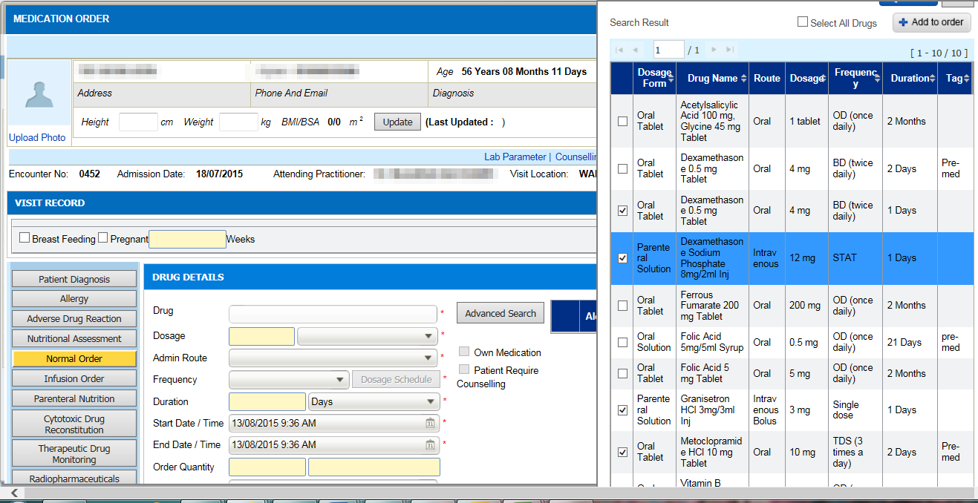  5  - Then, click on Add to Order(5) button.  - User will be able to seet the selected drug in draft prescription list(6).  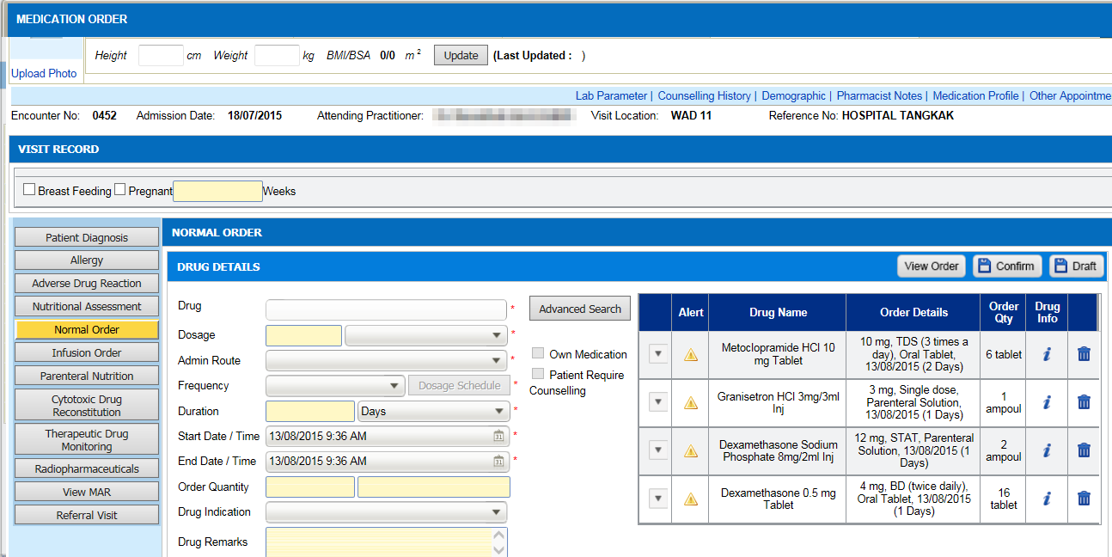  6 | 1  2  - In Order Management->Medication Order, click on Normal Order(1).  - Then, click on Advance Search(2) button and screen Advance Search will appear.  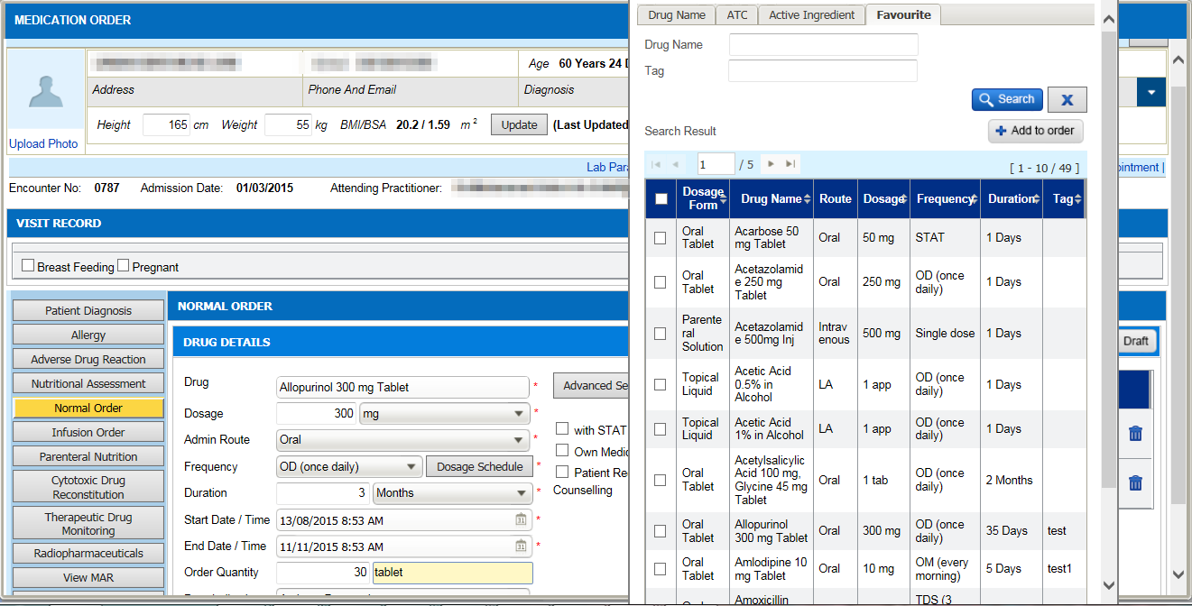  4  3  - Click on Favorite(3) tab and the list of drug which has been added ealier into favorite list will appear.  - Choose all drug by clicking on a single checkbox(4).  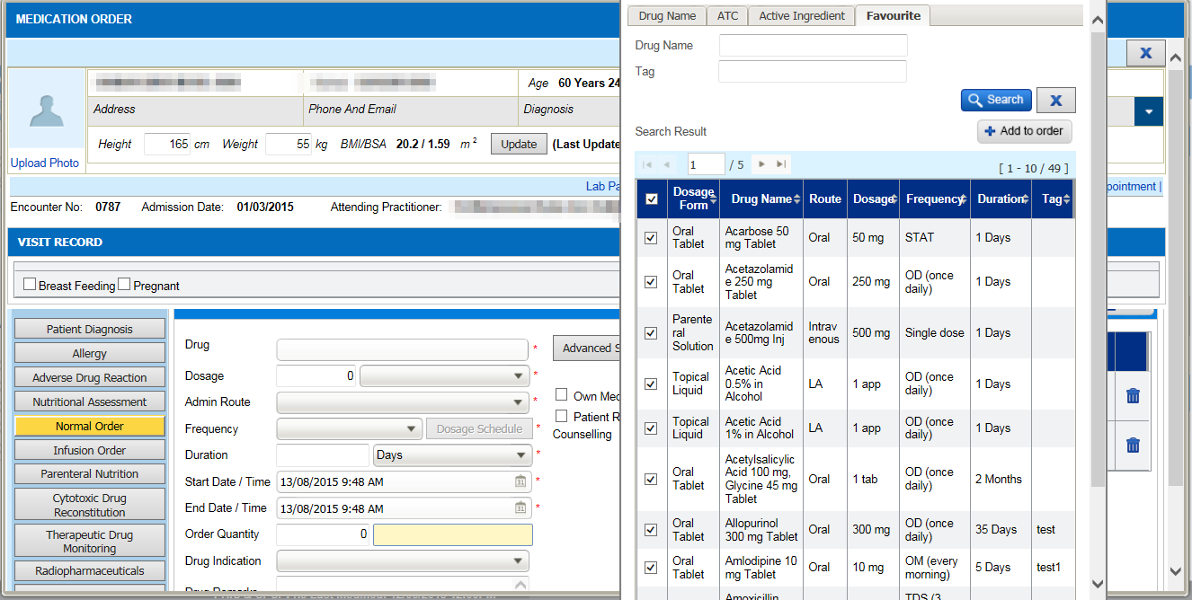  5  - Then, click on Add to Order(5) button.  - User will be able to see all selected drugs in draft prescription list(6).  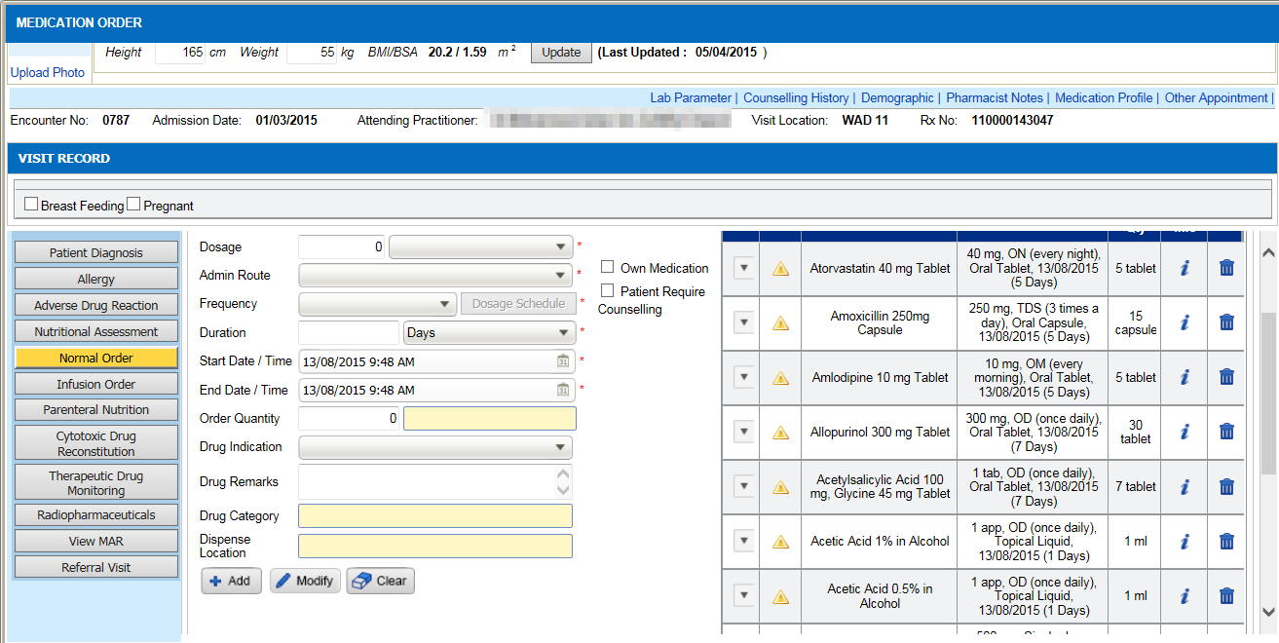  6

