Function Flow | Current Version 1.3.5 | New Version 1.3.6
1.  IP/OP Max Duration Setting (I-PhIS01 0518515S) | 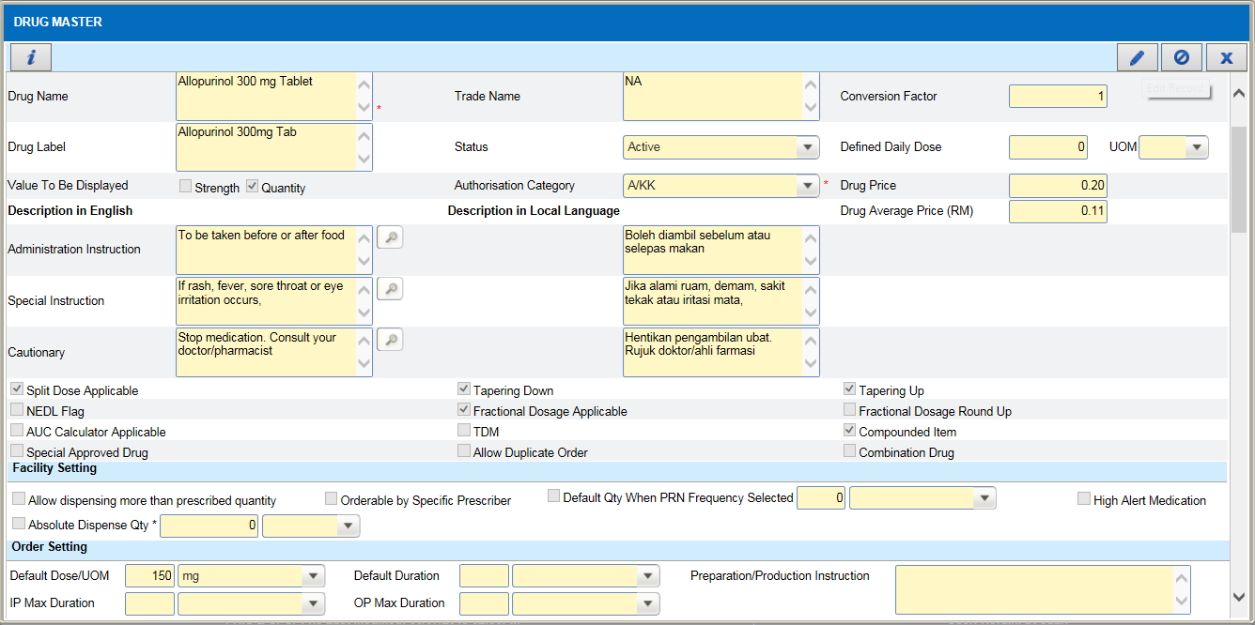  1  - In Maintenance->Pharmacy->Drug Master, search for a drug to edit its IP and OP Max Duration.  - Once open drug master screen, click on Edit(1) button to edit the drug details.  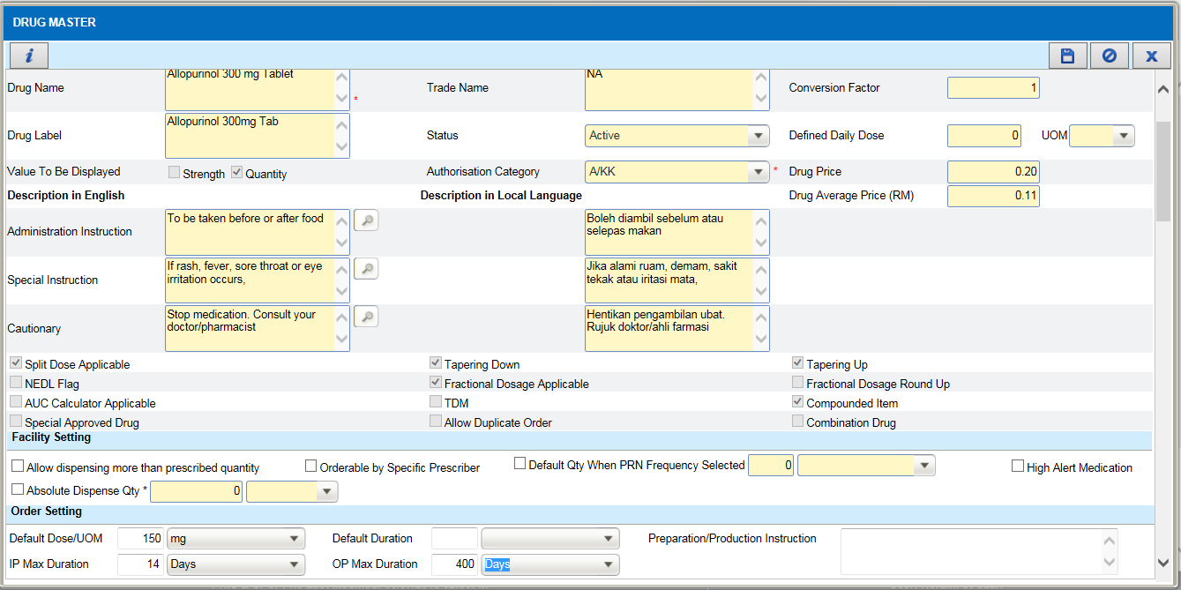  3  2  - Change the IP and OP Max Duration(2), eg: IP Max Duration= 14 days and OP Max Duration=400 days.  - Clcik on Save(3) button to save the information.  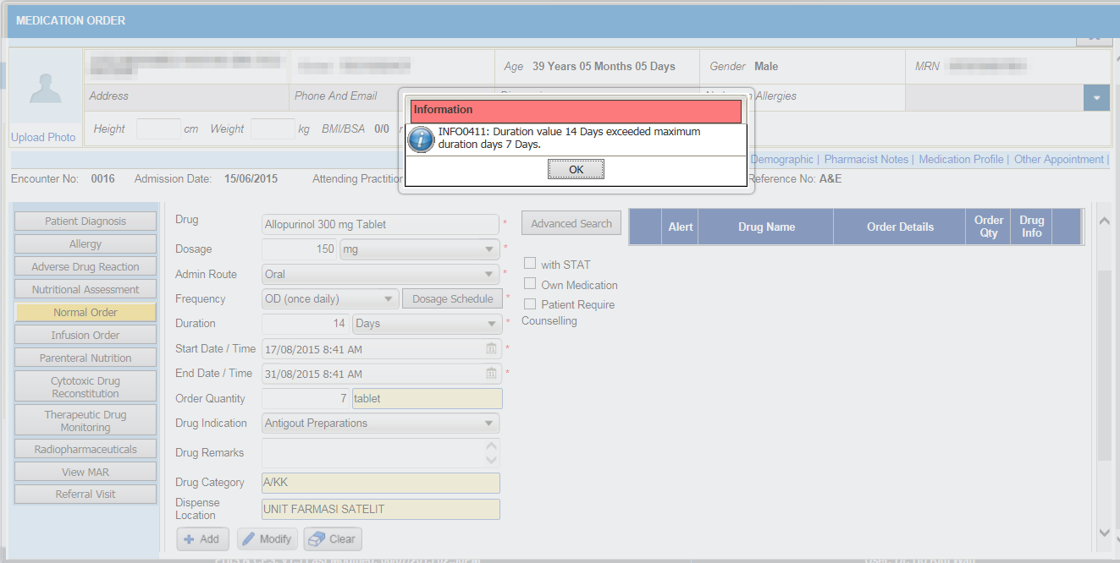  4  5  - Login as doctor and go to Order Management->Medication Order->Normal Order and order the above drug.  - Set the duration = 14 days (for IP) and then click on Add(4).  - An alert of “duration has exceed 7 days”(5) will appear since the global setting duration for IP is 7 days.  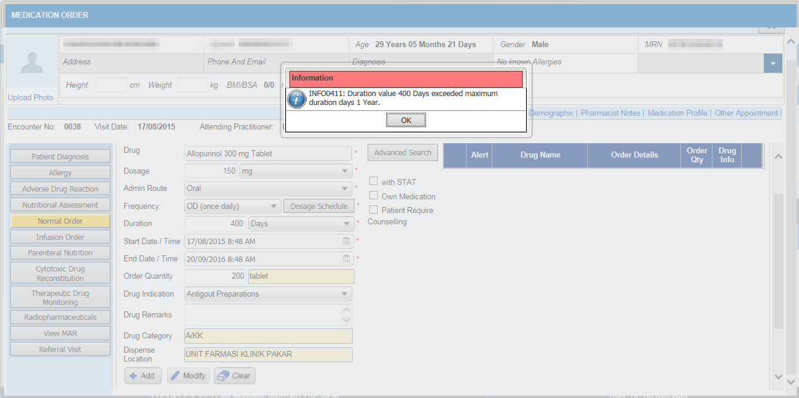  6  7  - Set the duration = 400 days (for OP) and then click on Add(6).  - An alert of “duration has exceed 1 year”(7) will appear since the global setting duration for OP is 1 year or 365 days. | 1  - In Maintenance->Pharmacy->Drug Master, search for a drug to edit its IP and OP Max Duration.  - Once open drug master screen, click on Edit(1) button to edit the drug details.  2  3  - Change the IP and OP Max Duration(2), eg: IP Max Duration= 14 days and OP Max Duration=400 days.  - Clcik on Save(3) button to save the information.  4  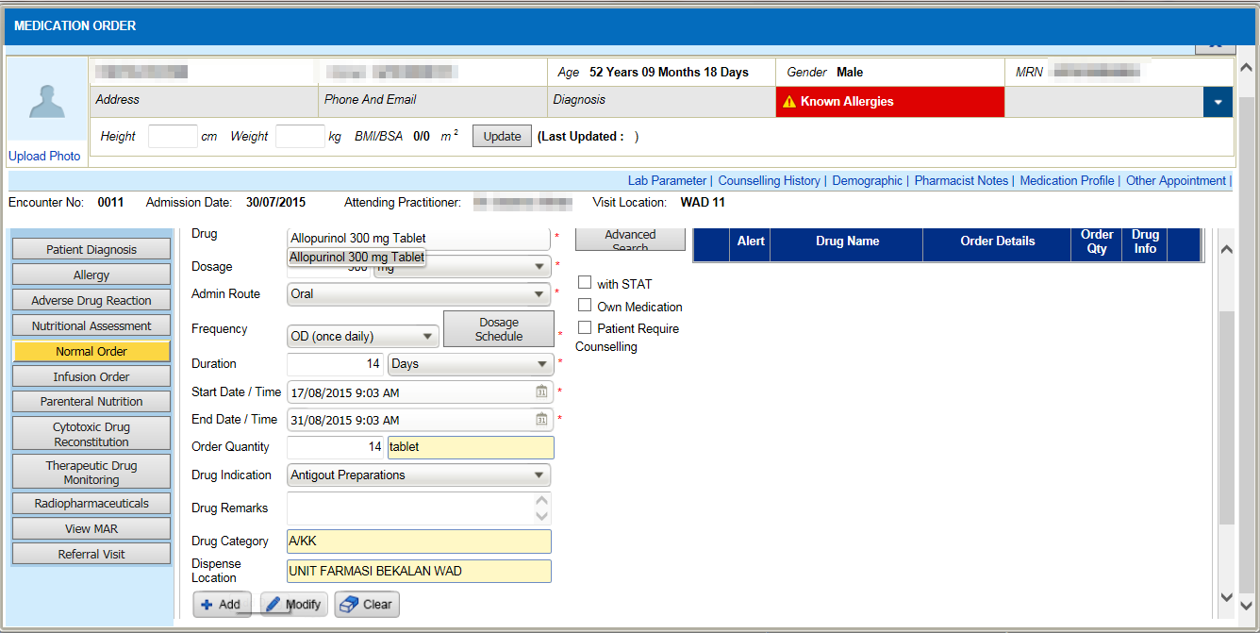  4  - Login as doctor and go to Order Management->Medication Order->Normal Order and order the above drug.  - Set the duration = 14 days (for IP) and then click on Add(4).  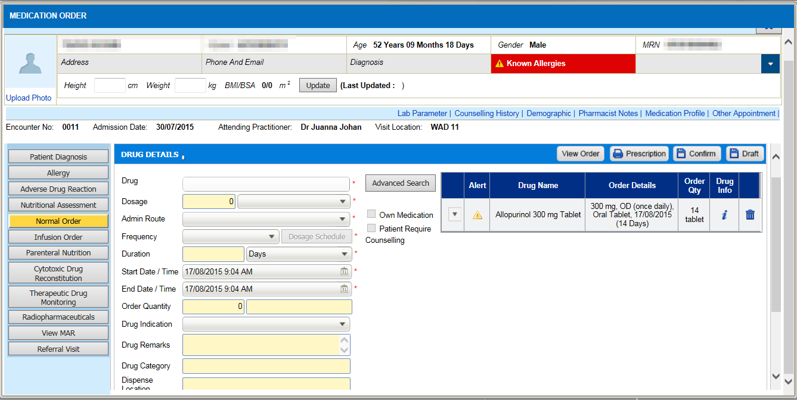  5  - Drug will be inserted into draft list(5). System allow user to override the global setting for IP.  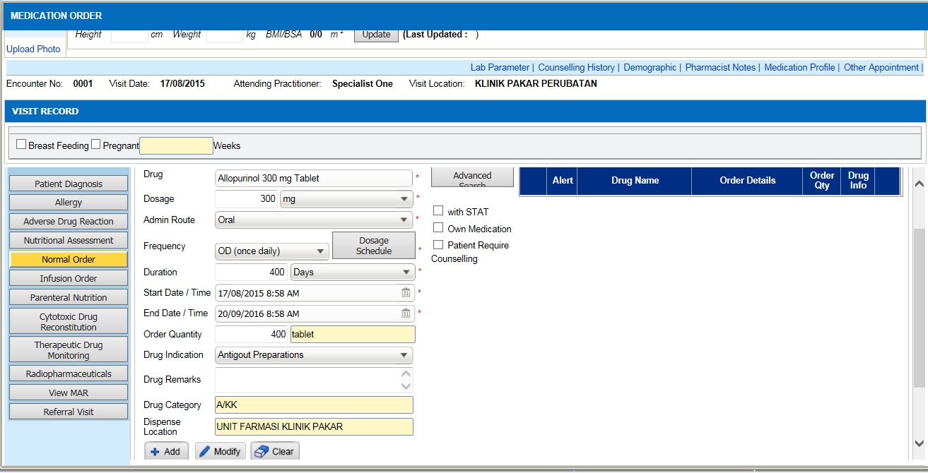  6  - Set the duration = 400 days (for OP) and then click on Add(6).  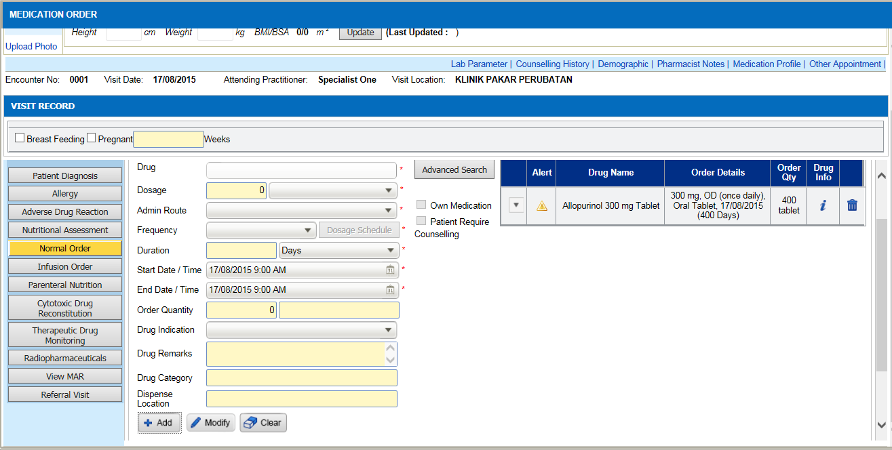  7  - Drug will be inserted into draft list(7). System allow user to override the global setting for OP.

