Function Flow | Current Version 1.3.5 | New Version 1.3.6
1.  Stop / Cancel Reason in Medication Profile (I-PhIS00 8934115S, I-PhIS00 8896515, I-PhIS00 8896415, I-PhIS010 014715S, I-PhIS00 8896515, I-PhIS01 0758315S, I-PhIS00 9509815S, I-PhIS01 0758315S, I-PhIS01 1718315S) | 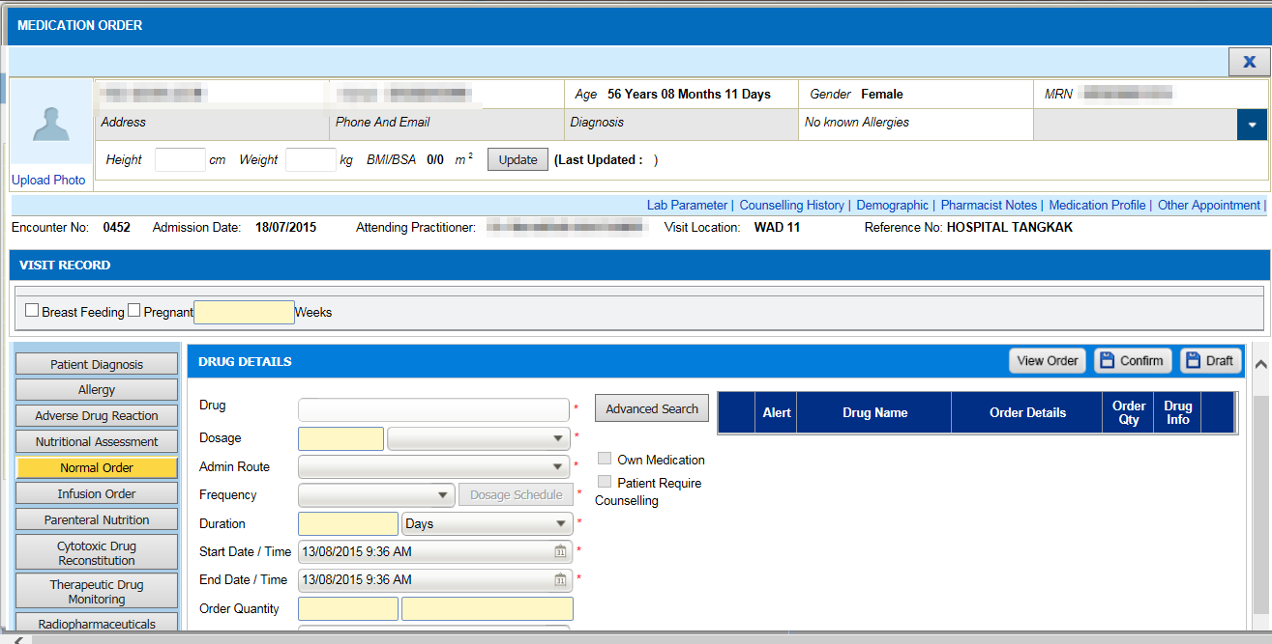  1  - In Order Management->Medication Order, click on Medication Profile(1) to view the drug list.  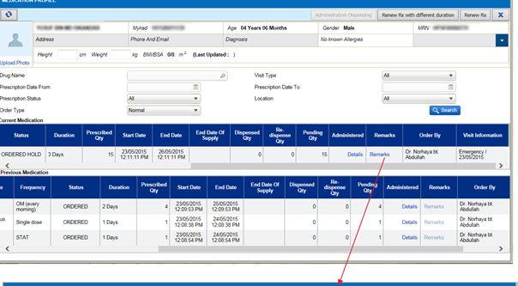  2  - Search a drug with STOP or CANCELED status.  - Click on Remark(2) link Remark column.  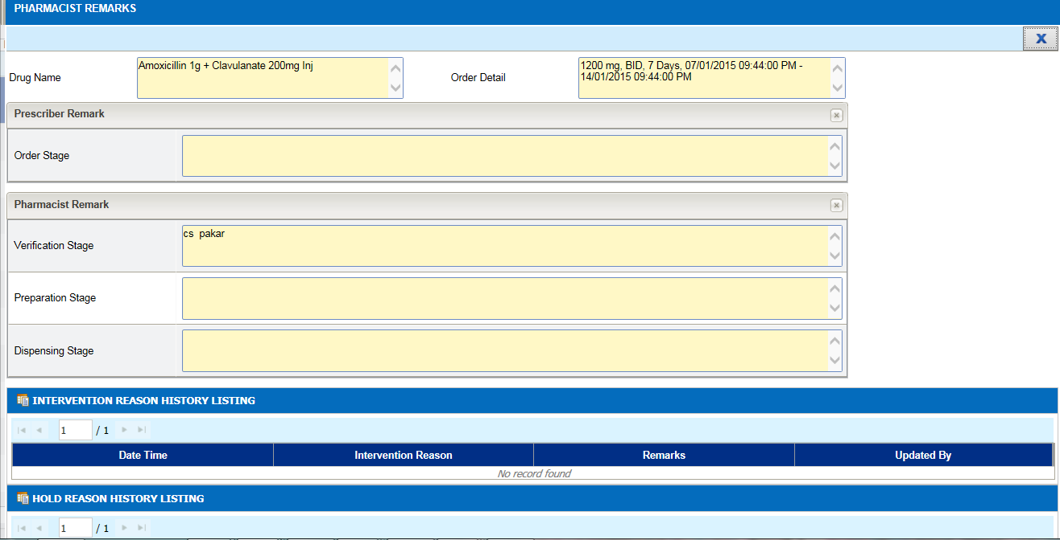  3  - Pharmacist Remark(3) screen will appear but there are no view to view on reason for a STOP/CANCEL drug. | 1  - In Order Management->Medication Order, click on Medication Profile(1) to view the drug list.  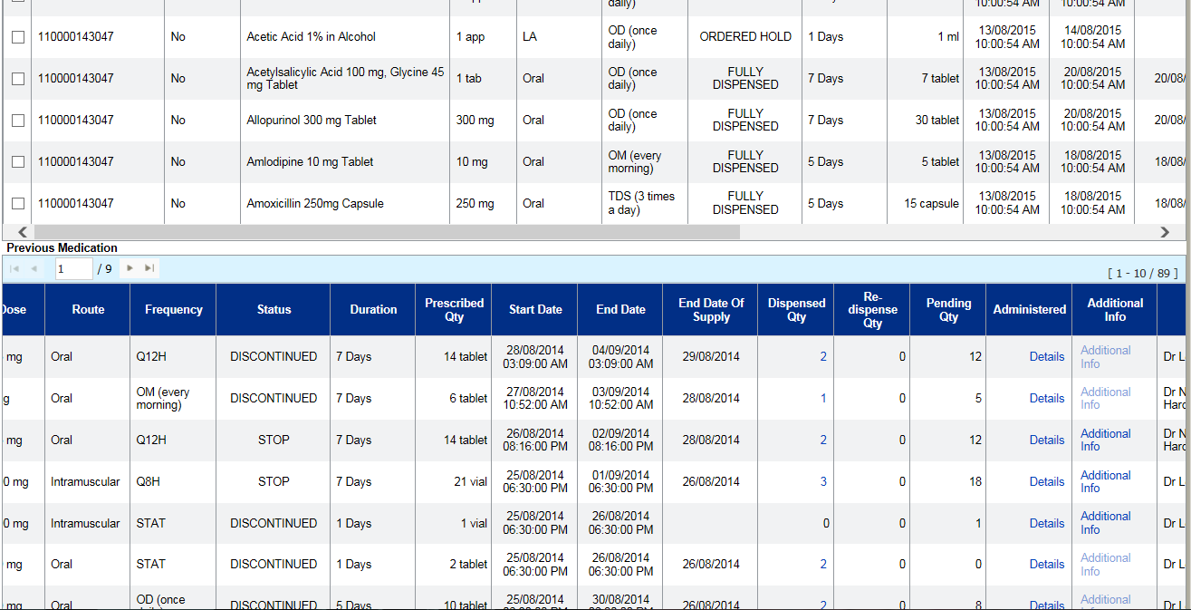  2  - Search a drug with STOP or CANCELED status.  - Click on Additional Info(2) link Additional Info column. Previously, it was known as “Remarks” column.  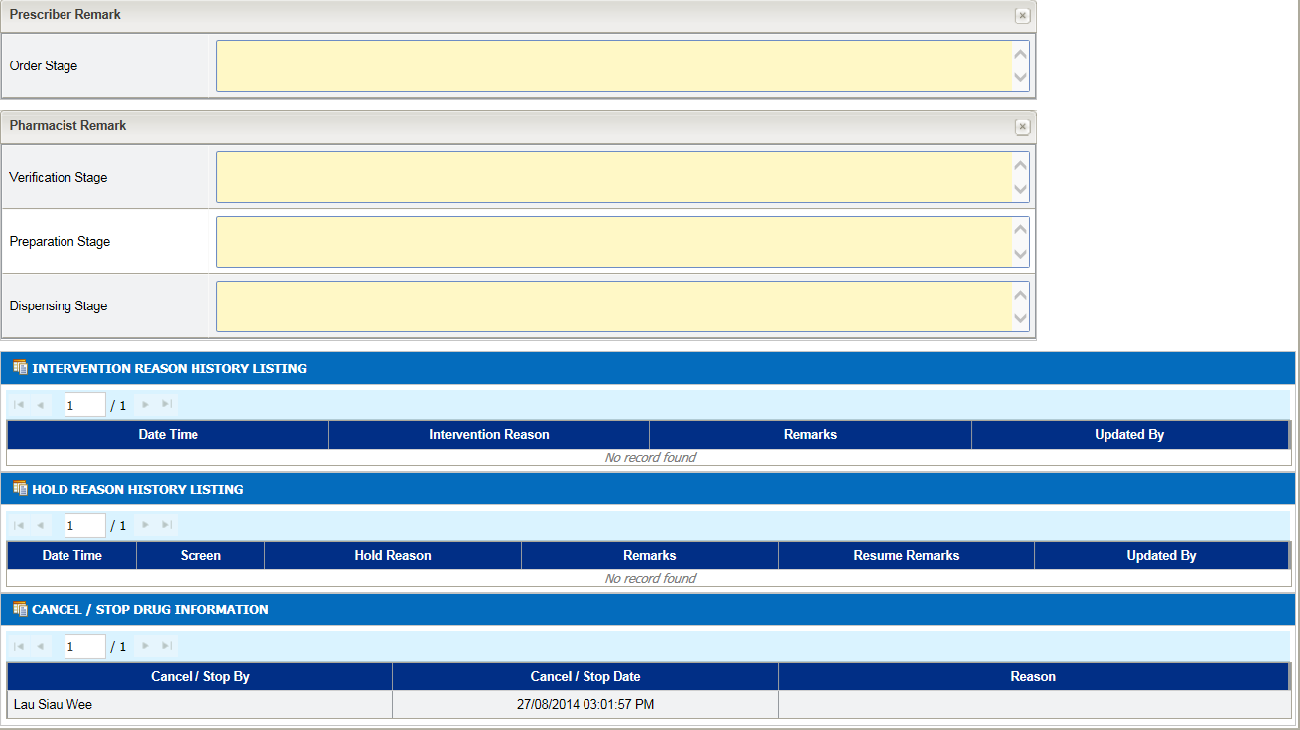  3  4  - Pharmacist Remark(3) screen will appear.  - User can see the drug is being Stop/Cancel by who, date and time STOP/Cancel and the reason(4).

