Function Flow | Current Version 1.3.5 | New Version 1.3.6
1.  Add all drug from Favourite List | 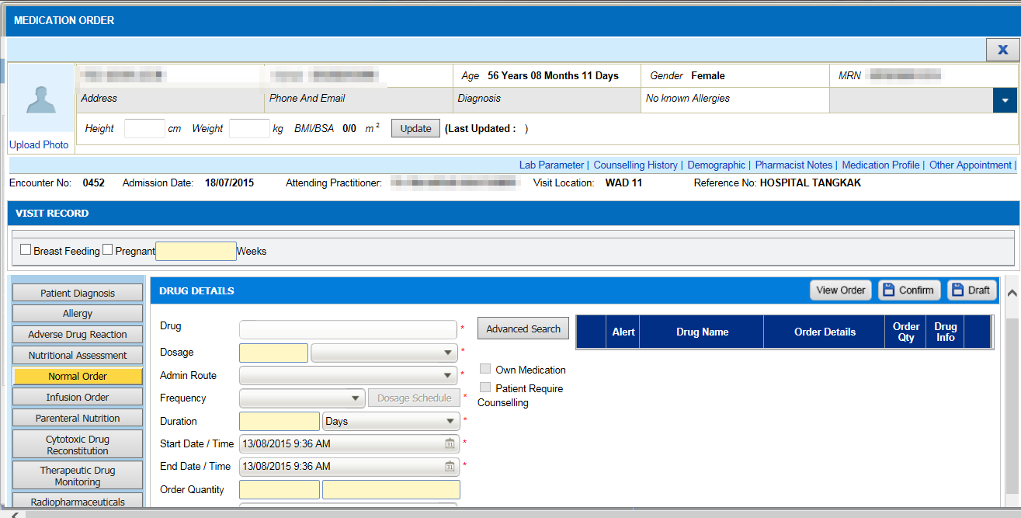  1  2  - In Order Management->Medication Order, click on Normal Order(1).  - Then, click on Advance Search(2) button and screen Advance Search will appear.  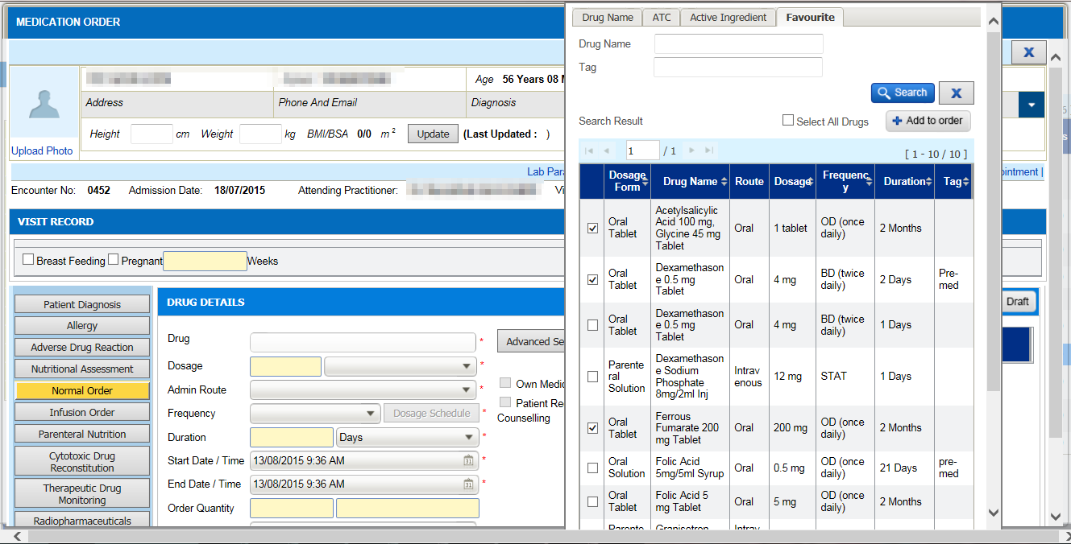  4  3  - Click on Favorite(3) tab and the list of drug which has been added ealier into favorite list will appear.  - Choose any drug one by one by clicking on the checkbox(4) located at the left of this screen.  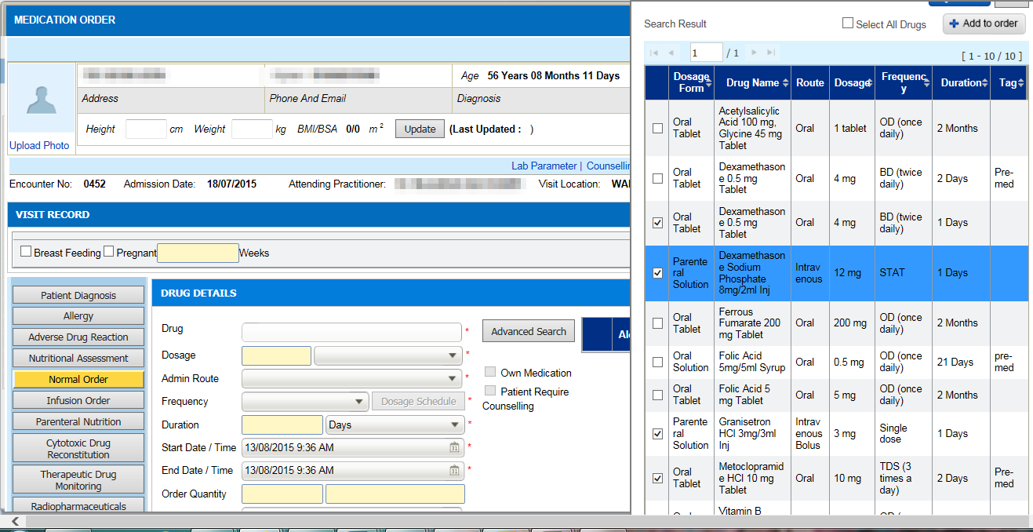  5  - Then, click on Add to Order(5) button.  - User will be able to seet the selected drug in draft prescription list(6).  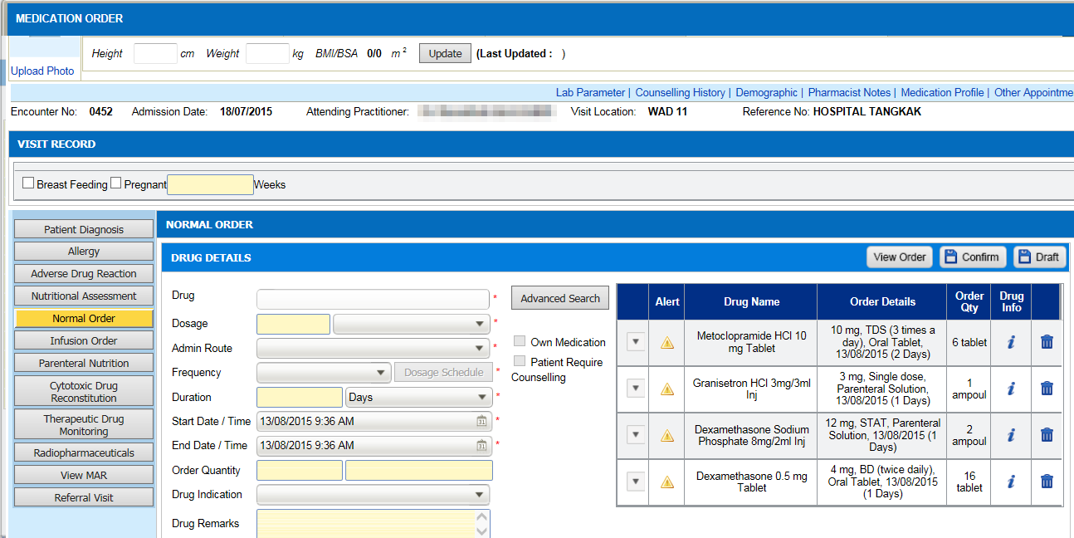  6 | 1  2  - In Order Management->Medication Order, click on Normal Order(1).  - Then, click on Advance Search(2) button and screen Advance Search will appear.  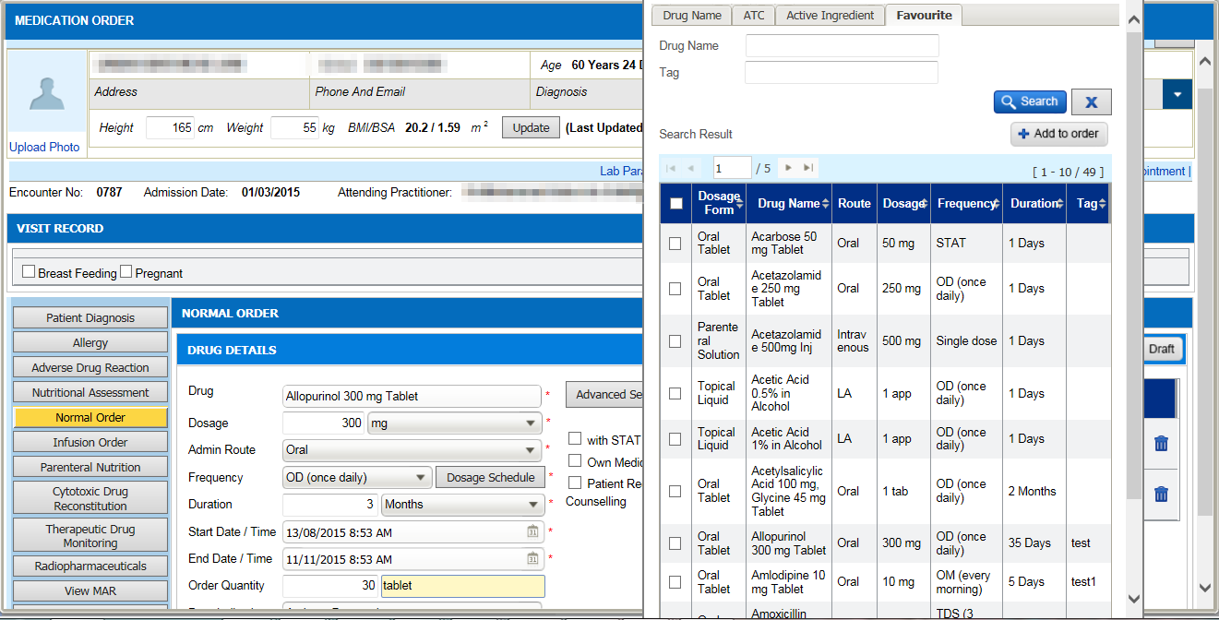  4  3  - Click on Favorite(3) tab and the list of drug which has been added ealier into favorite list will appear.  - Choose all drug by clicking on a single checkbox(4).  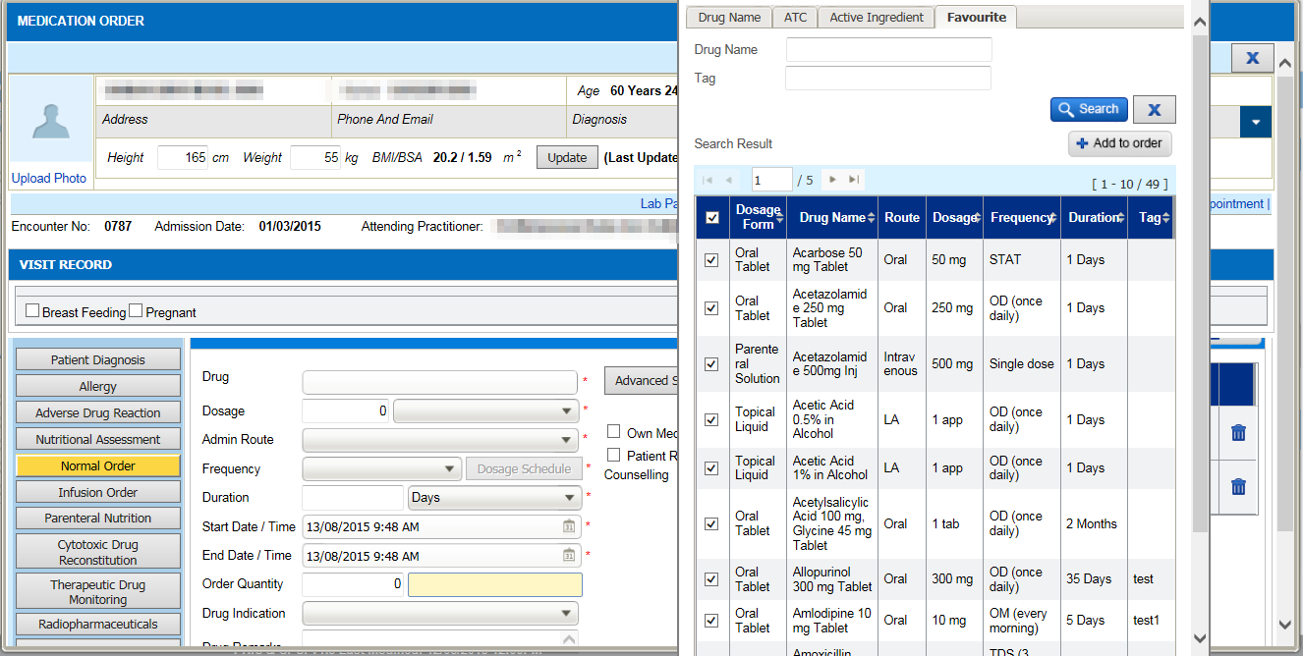  5  - Then, click on Add to Order(5) button.  - User will be able to see all selected drugs in draft prescription list(6).  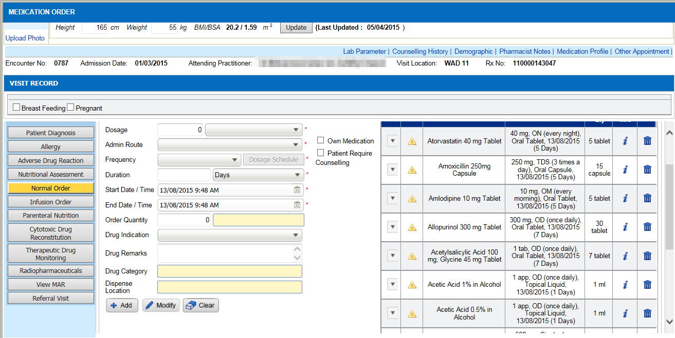  6
2. Add UOM in Prescibe Qty Column | 2  1  - In Order Management->Medication Order, click on Normal Order(1).  - Click on Medication Profile(2) to view the drug list.  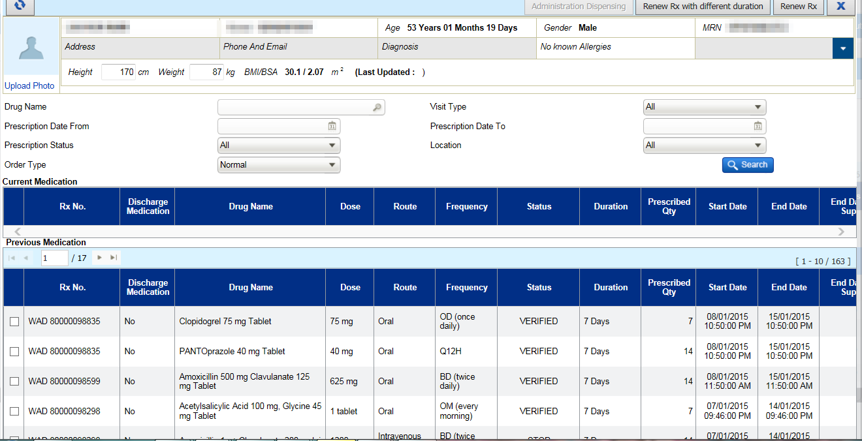  3  - The Prescribed Qty(3) is shown but without UOM Qty. | 2  1  - In Order Management->Medication Order, click on Normal Order(1).  - Clik on Medication Profile(2) to view the drug list.  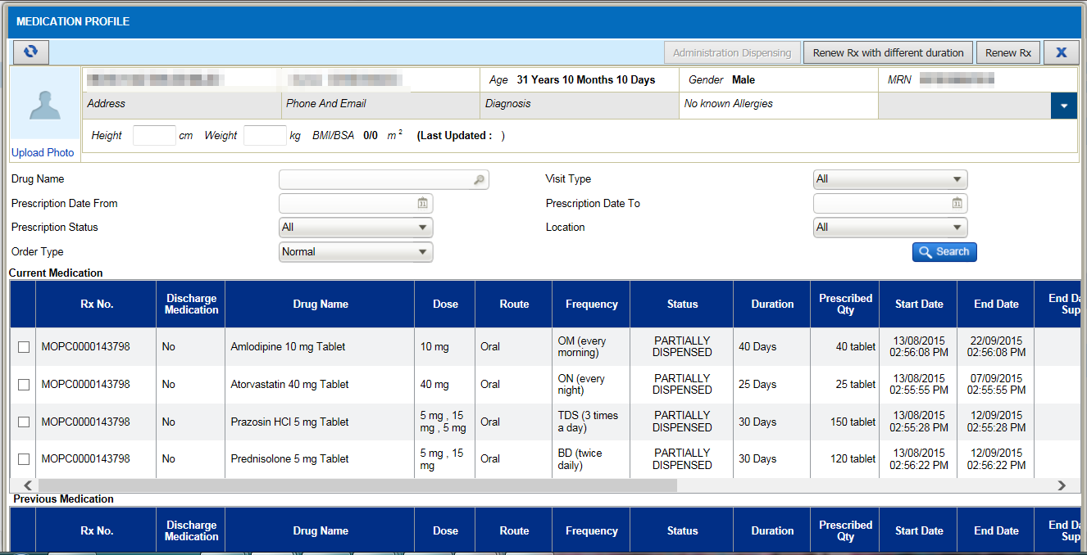  3  - The Prescribed Qty(3) is shown with UOM Qty.
3.  Stop / Cancel Reason in Medication Profile | 1  - In Order Management->Medication Order, click on Medication Profile(1) to view the drug list.  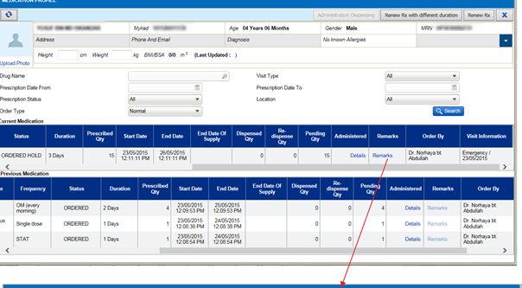  2  - Search a drug with STOP or CANCELED status.  - Click on Remark(2) link Remark column.  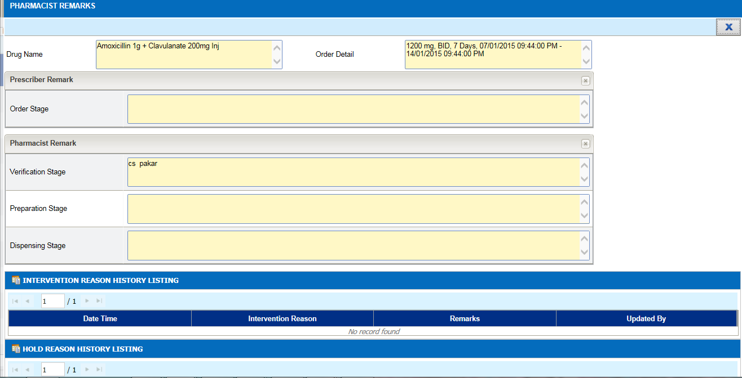  3  - Pharmacist Remark(3) screen will appear but there are no view to view on reason for a STOP/CANCEL drug. | 1  - In Order Management->Medication Order, click on Medication Profile(1) to view the drug list.  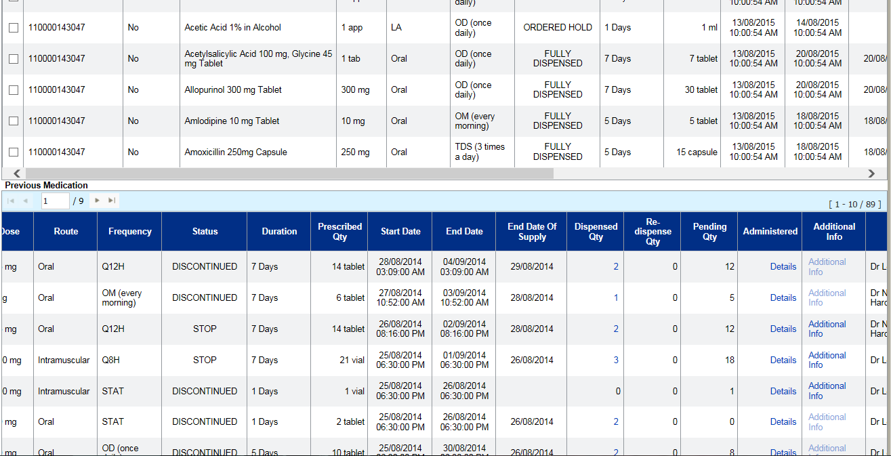  2  - Search a drug with STOP or CANCELED status.  - Click on Additional Info(2) link Additional Info column. Previously, it was known as “Remarks” column.  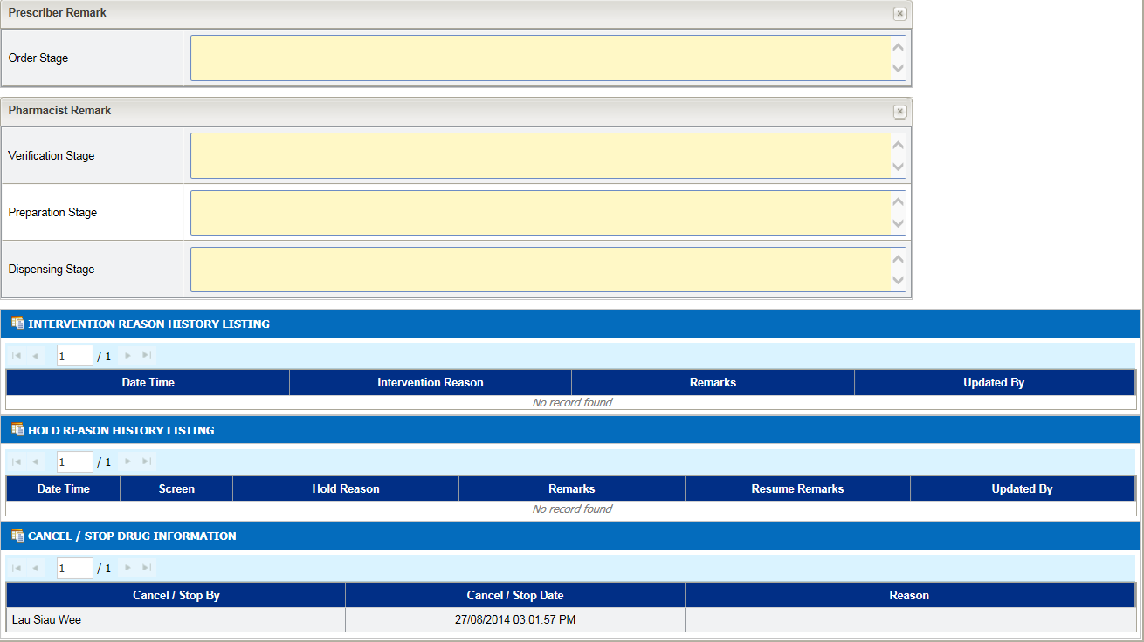  3  4  - Pharmacist Remark(3) screen will appear.  - User can see the drug is being Stop/Cancel by who, date and time STOP/Cancel and the reason(4).
4.  IP/OP Max Duration Setting | 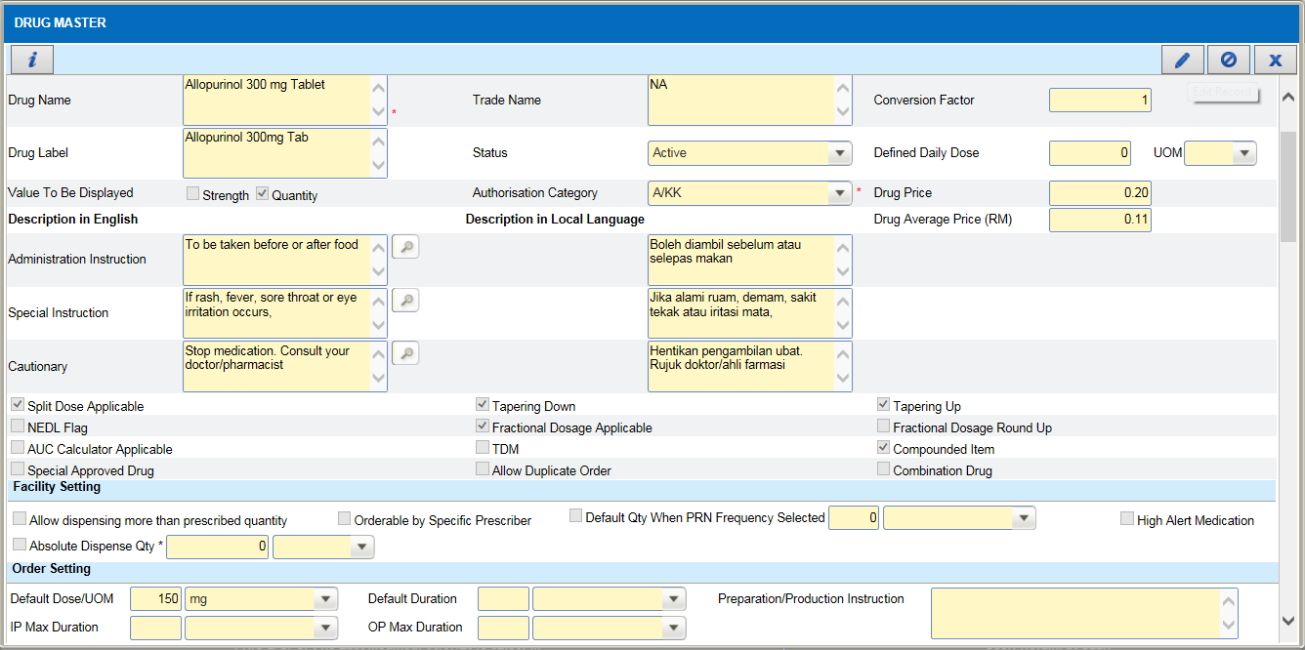  1  - In Maintenance->Pharmacy->Drug Master, search for a drug to edit its IP and OP Max Duration.  - Once open drug master screen, click on Edit(1) button to edit the drug details.  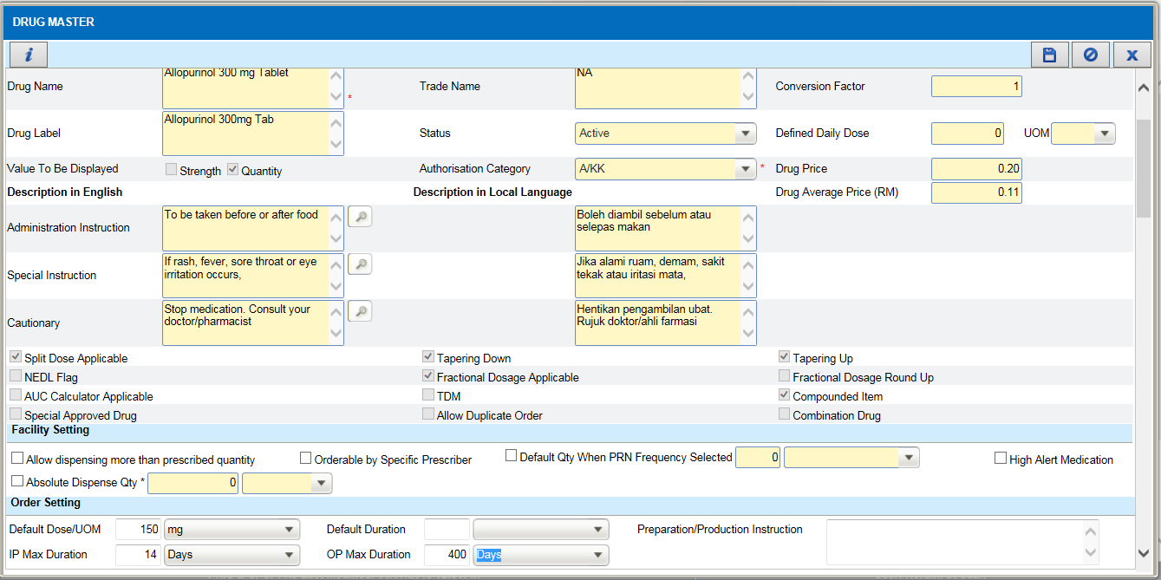  3  2  - Change the IP and OP Max Duration(2), eg: IP Max Duration= 14 days and OP Max Duration=400 days.  - Clcik on Save(3) button to save the information.  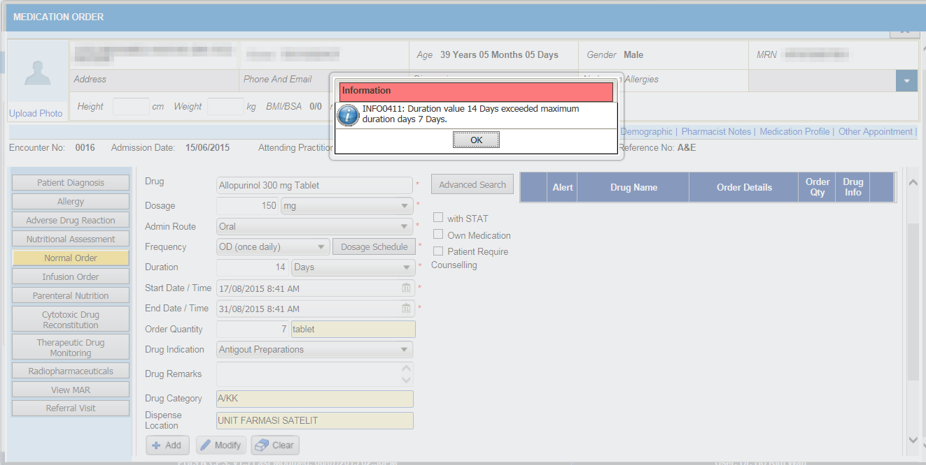  4  5  - Login as doctor and go to Order Management->Medication Order->Normal Order and order the above drug.  - Set the duration = 14 days (for IP) and then click on Add(4).  - An alert of “duration has exceed 7 days”(5) will appear since the global setting duration for IP is 7 days.  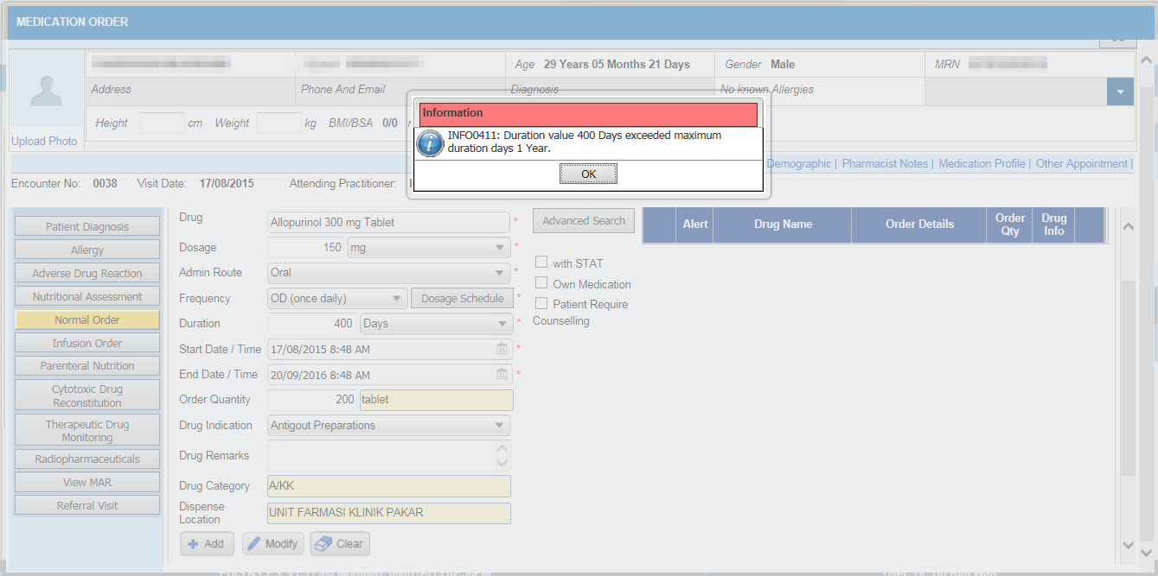  6  7  - Set the duration = 400 days (for OP) and then click on Add(6).  - An alert of “duration has exceed 1 year”(7) will appear since the global setting duration for OP is 1 year or 365 days. | 1  - In Maintenance->Pharmacy->Drug Master, search for a drug to edit its IP and OP Max Duration.  - Once open drug master screen, click on Edit(1) button to edit the drug details.  2  3  - Change the IP and OP Max Duration(2), eg: IP Max Duration= 14 days and OP Max Duration=400 days.  - Clcik on Save(3) button to save the information.  4  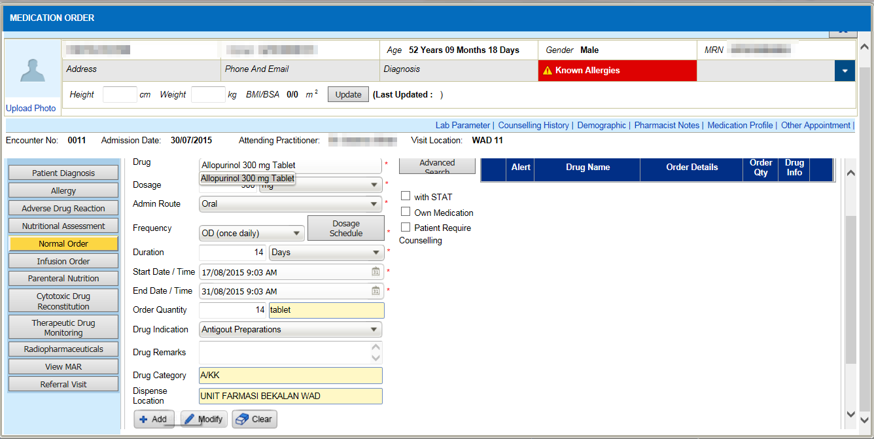  4  - Login as doctor and go to Order Management->Medication Order->Normal Order and order the above drug.  - Set the duration = 14 days (for IP) and then click on Add(4).  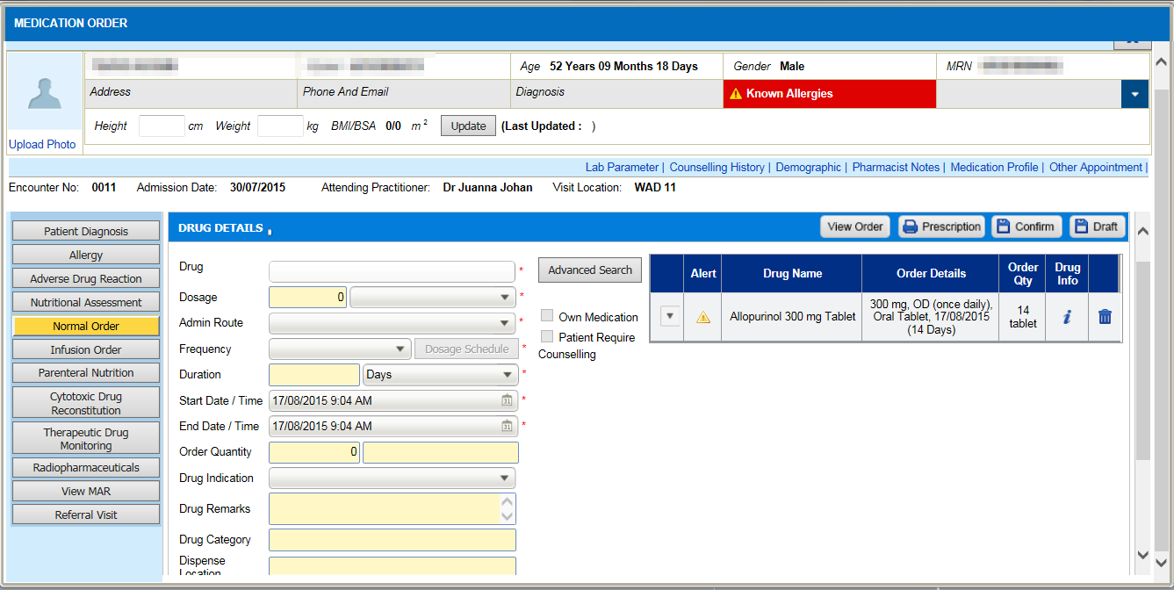  5  - Drug will be inserted into draft list(5). System allow user to override the global setting for IP.  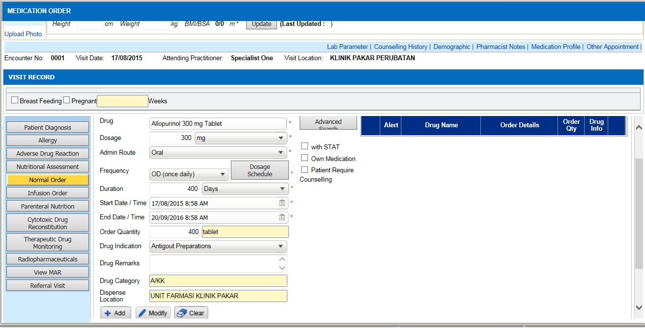  6  - Set the duration = 400 days (for OP) and then click on Add(6).  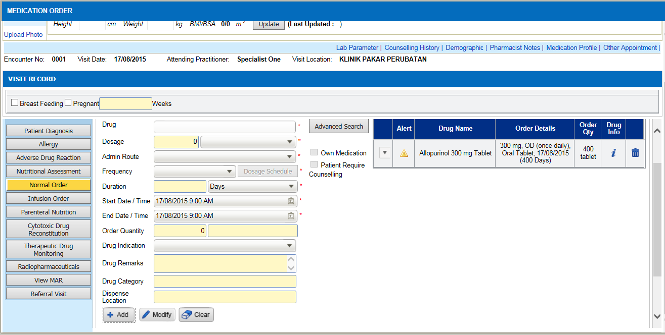  7  - Drug will be inserted into draft list(7). System allow user to override the global setting for OP.
5.  Stop Previous Order Alert | 1  - In Order Management->Medication Order, click on Medication Profile(1) to view the drug list.  3  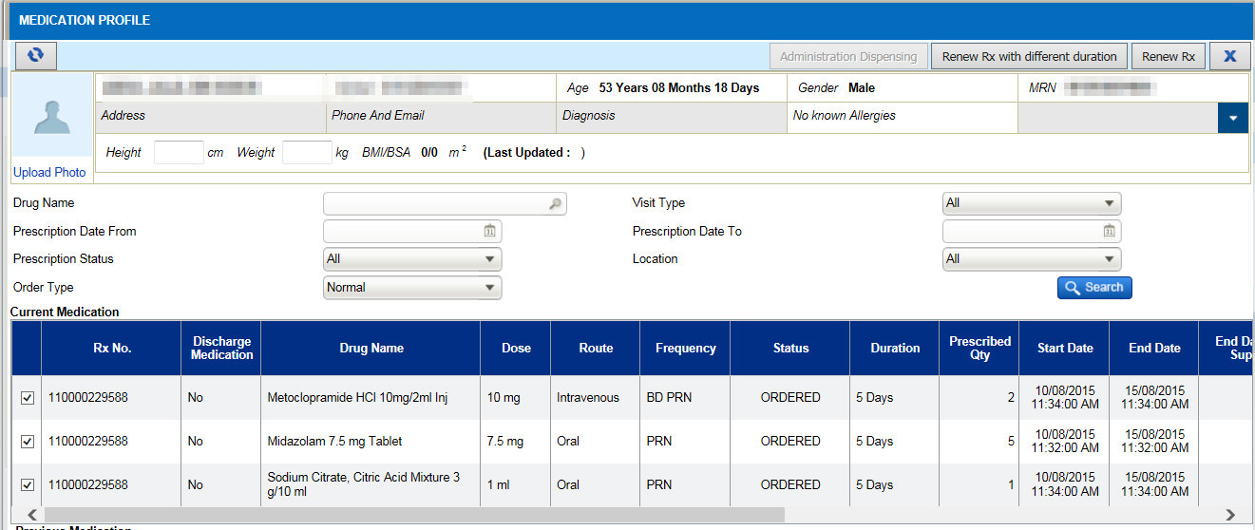  2  - Tick on the checkbox(2) for renew.  - Clcik on Renew with Different duration(3) button.  - A renew pop up screen will appear.  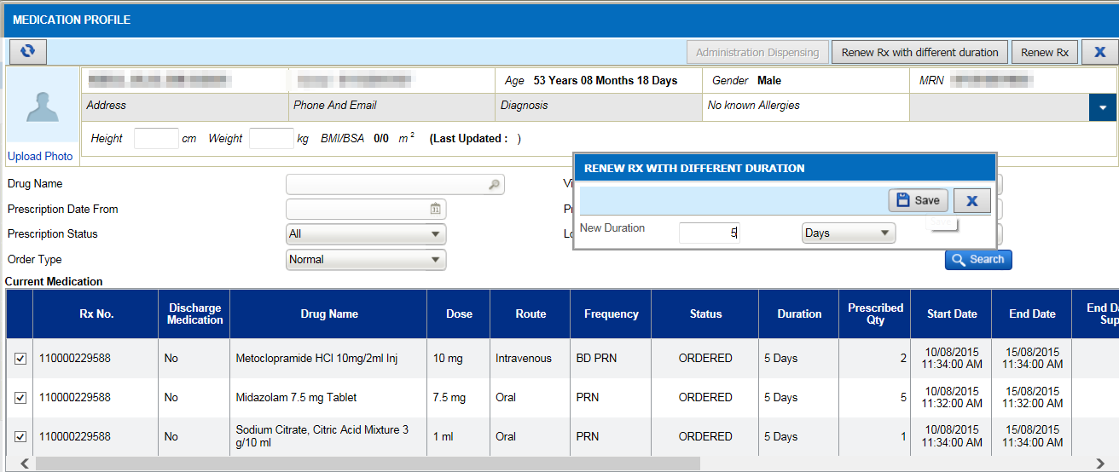  4  - Click on Save(4).  - Alert to stop or continue current (5) order will appear.  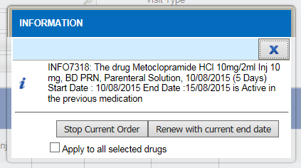  5  - The message appear as “Stop Current Order / Renew with current end date” and additional checkbox as “Apply to all selected drugs”. | 1  - In Order Management->Medication Order, click on Medication Profile(1) to view the drug list.  2  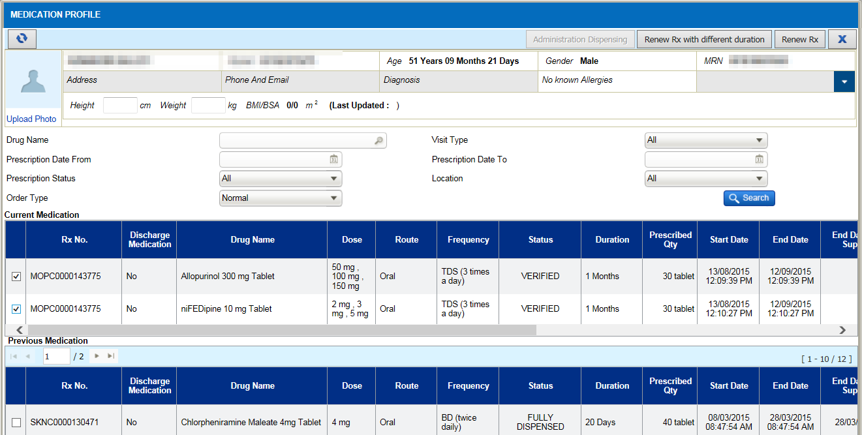  3  - Tick on the checkbox(2) for renew.  - Clcik on Renew with Different duration(3) button.  - A renew pop up screen will appear.  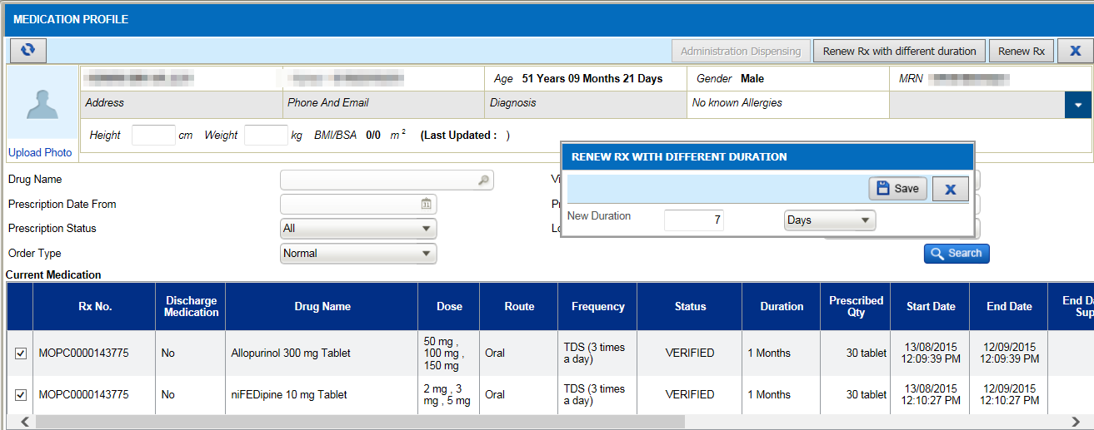  4  - Click on Save(4).  - Alert to stop or continue current (5) order will appear.  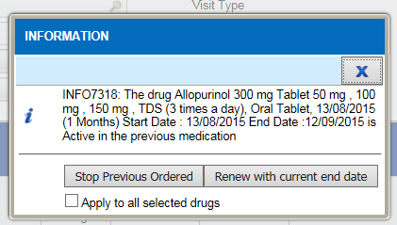  5  - The message appear as “Stop Previous Order / Renew with current end date” and additional checkbox as “Apply to all selected drugs”.

