Function Flow | Current Version 1.3.5 | New Version 1.3.6
1.  Stop Previous Order Alert (I-PhIS00 9818515, I-PhIS00 9686015, I-PhIS01 1086315S) | 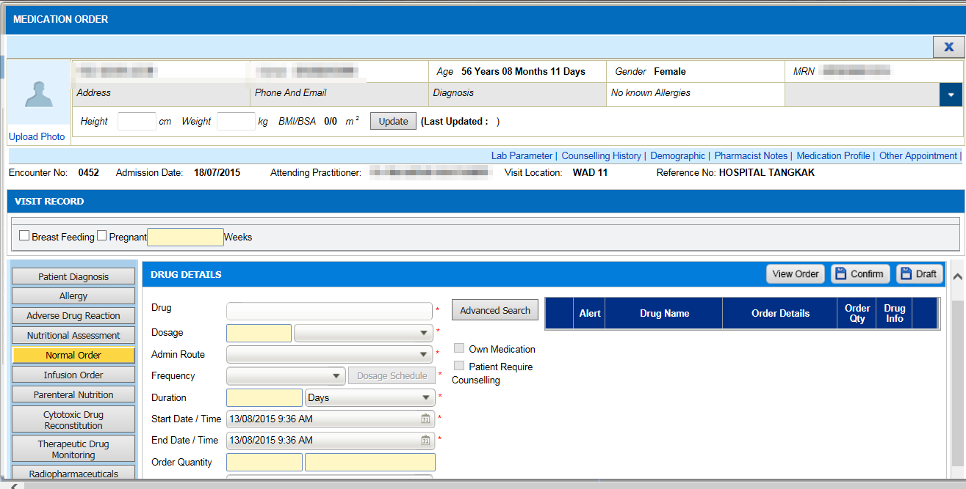  1  - In Order Management->Medication Order, click on Medication Profile(1) to view the drug list.  3  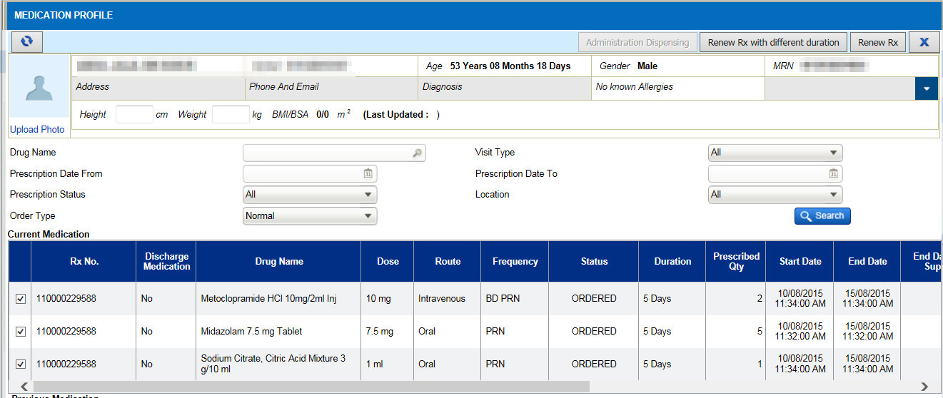  2  - Tick on the checkbox(2) for renew.  - Clcik on Renew with Different duration(3) button.  - A renew pop up screen will appear.  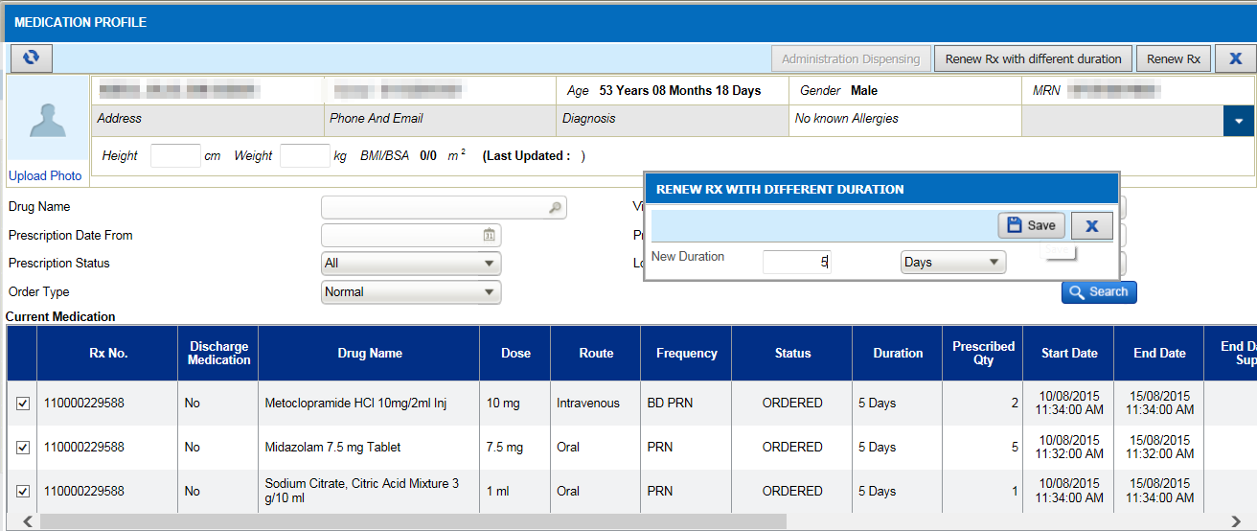  4  - Click on Save(4).  - Alert to stop or continue current (5) order will appear.  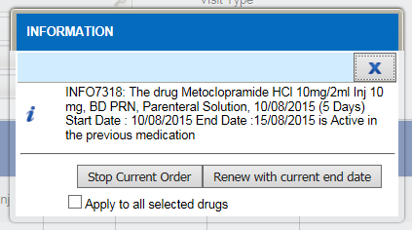  5  - The message appear as “Stop Current Order / Renew with current end date” and additional checkbox as “Apply to all selected drugs”. | 1  - In Order Management->Medication Order, click on Medication Profile(1) to view the drug list.  2  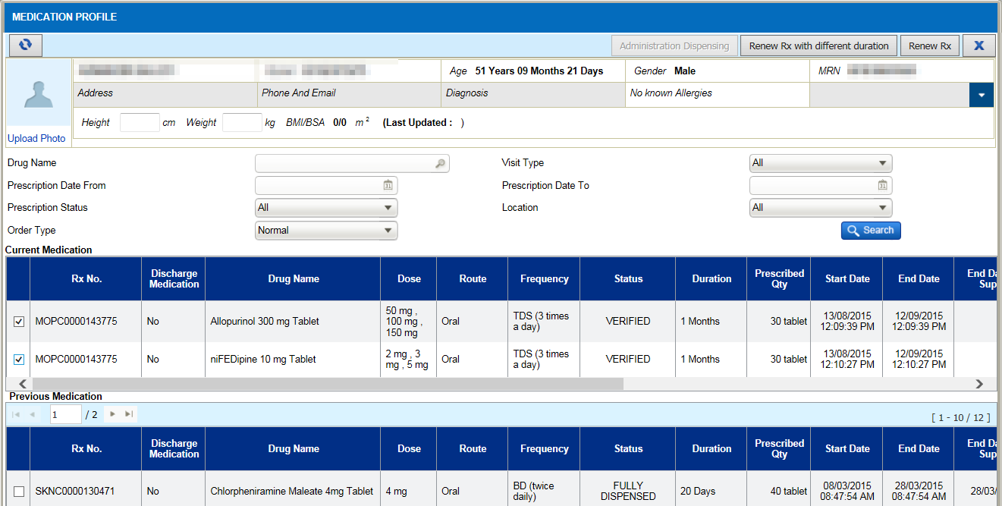  3  - Tick on the checkbox(2) for renew.  - Clcik on Renew with Different duration(3) button.  - A renew pop up screen will appear.  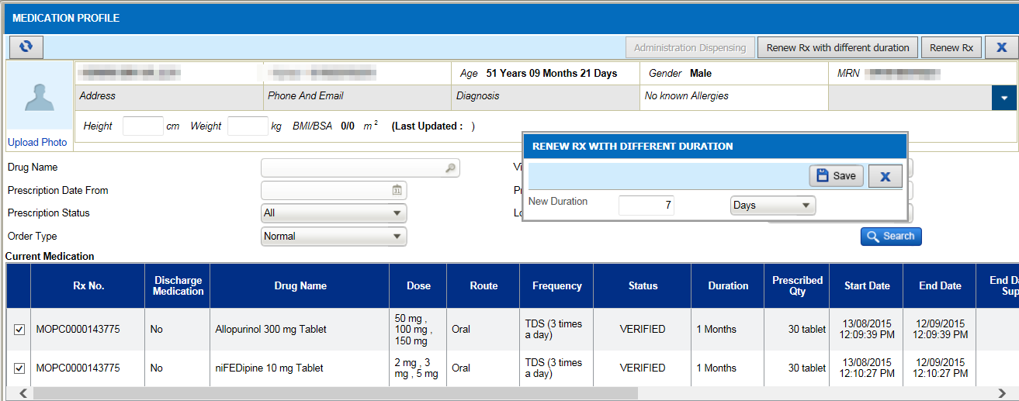  4  - Click on Save(4).  - Alert to stop or continue current (5) order will appear.  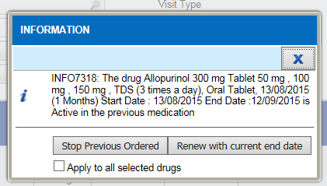  5  - The message appear as “Stop Previous Order / Renew with current end date” and additional checkbox as “Apply to all selected drugs”.

