Function Flow | Pharmacist Note fields in current Version 1.3.5 | Pharmacist Note fields in Version 1.3.6
1.  Pharmacist Note fields | - To add character counter at 'pharmacist note' field.  - Apply to all Pharmacist Note field at MTAC, MC, WP and TDM screen  MTAC Reporting screen  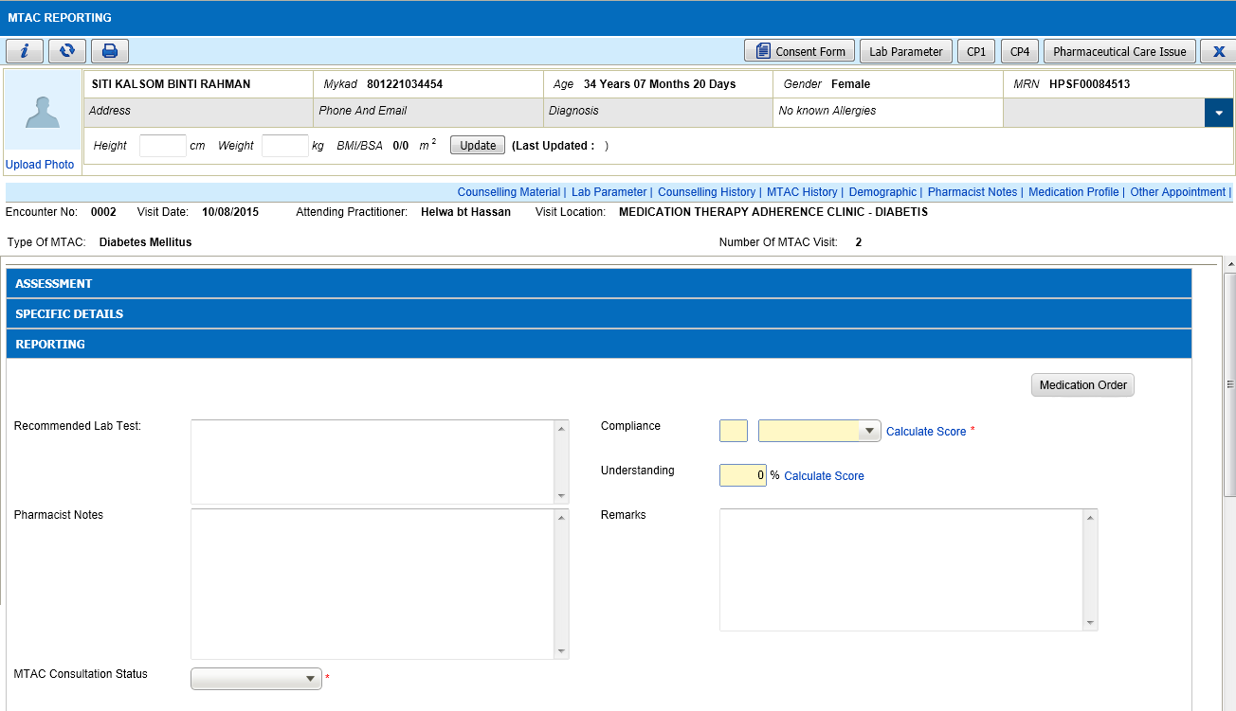  Medication Counselling Screen  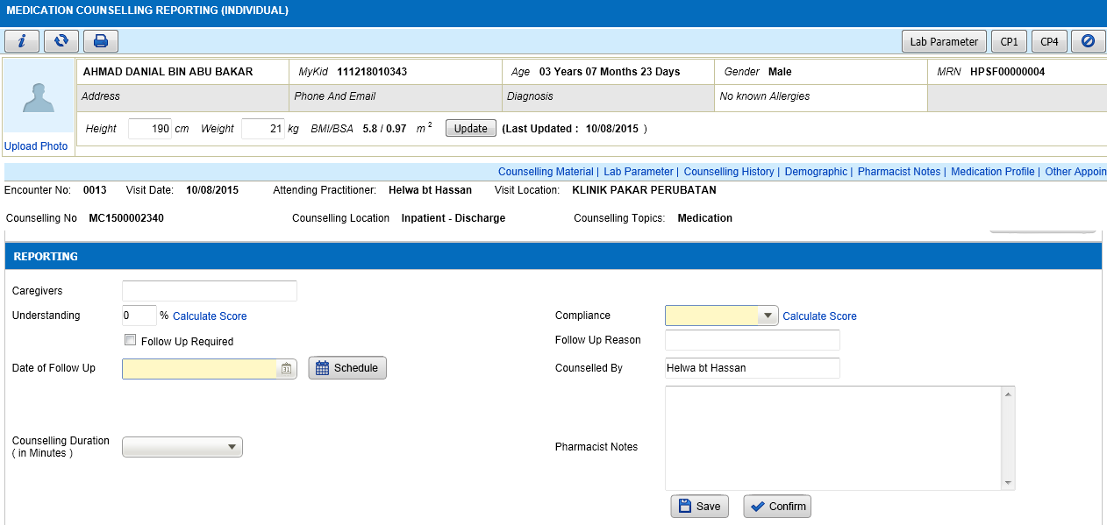  TDM Reporting Screen  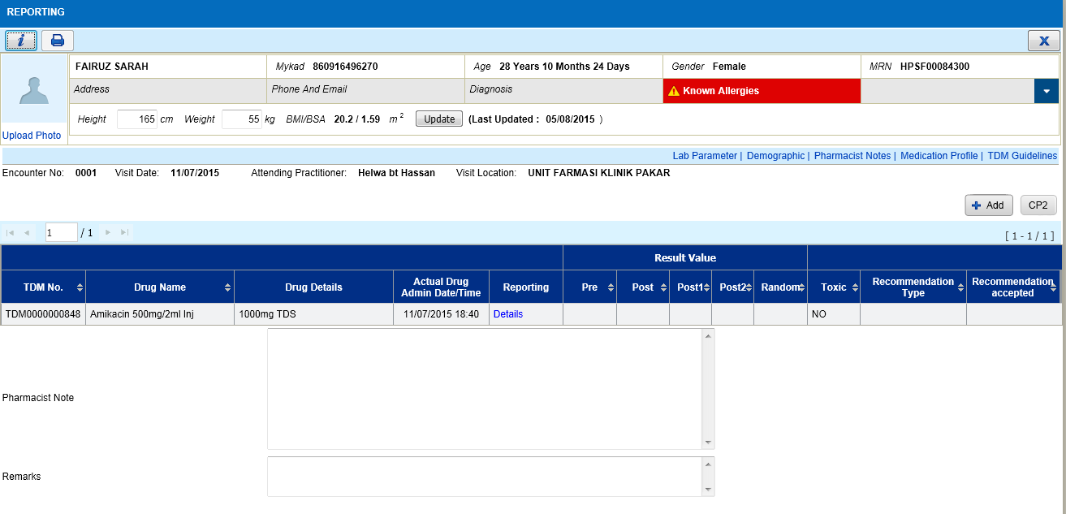  Ward Pharmacy Screen  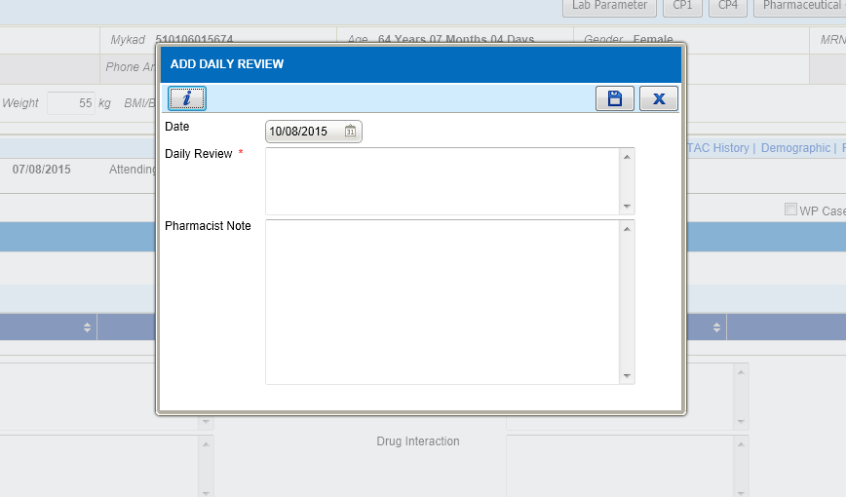 | - Added character counter at 'pharmacist note' field.  - Apply to all Pharmacist Note field at MTAC, MC, WP and TDM screen  MTAC Reporting screen  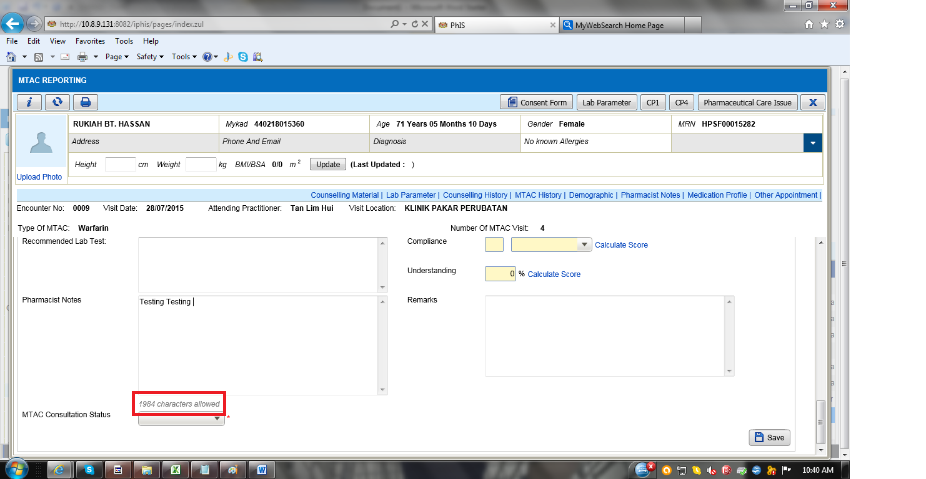  Medication Counselling Screen  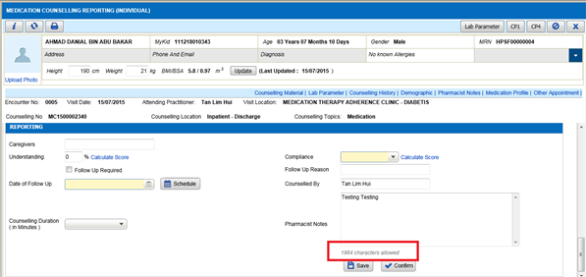  TDM Reporting Screen  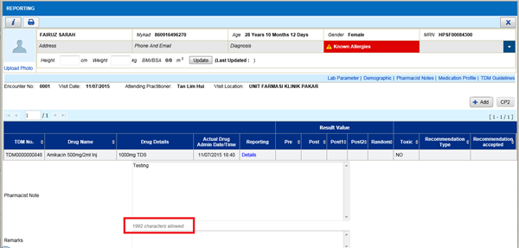  Ward Pharmacy Screen  