Function Flow | Outpatient/Inpatient Pharmacy in current Version 1.3.5 | Outpatient/Inpatient Pharmacy in new Version 1.3.6
1.  Auto allocate alternate drug | Auto allocate for partial supply drug.  - Alternate drug will display when open for partial supply drug  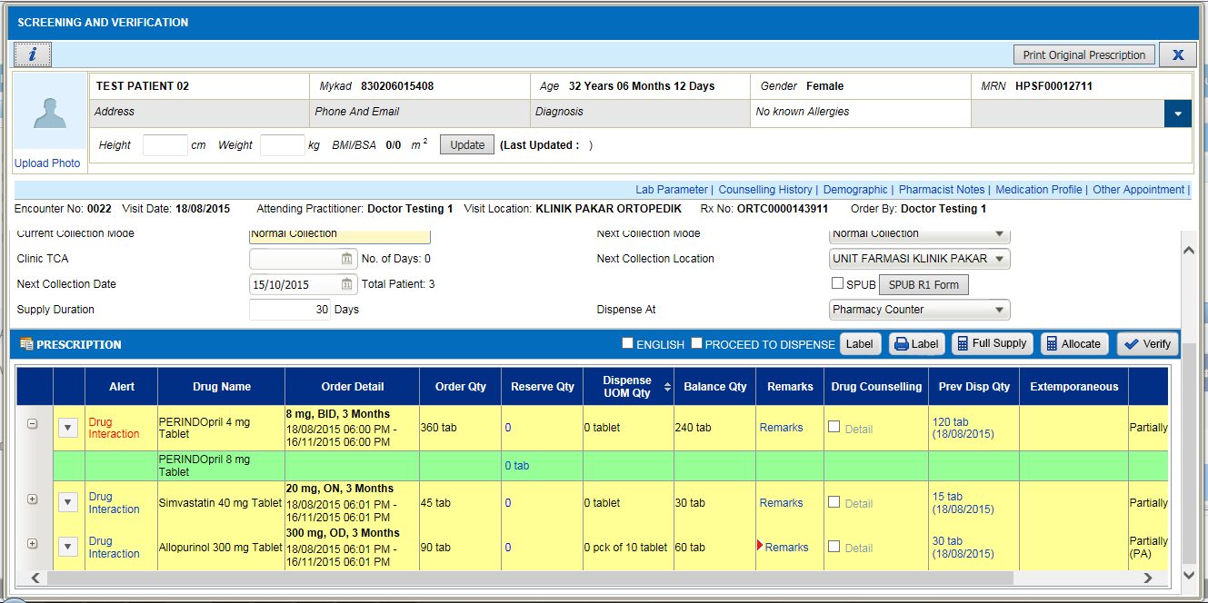  - On click of ‘Allocate’ button, system will auto calculate for all active drug including alternate drug based on supply duration entered.  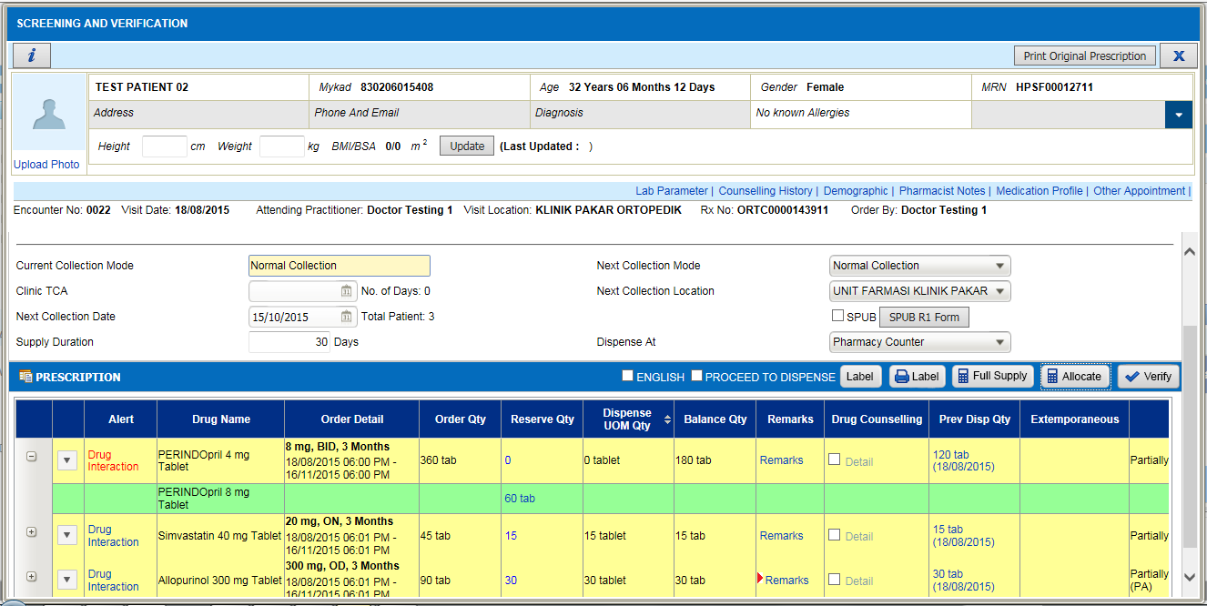  - Change the supply duration value and click on ‘Allocate’ button, system only re-calculate for normal drug. No changes on alternate drug. | Auto allocate for partial supply drug.  - Alternate drug will display when open for partial supply drug  - On click of ‘Allocate’ button, system will auto calculate for all active drug including alternate drug based on supply duration entered.  - Change the supply duration value and click on ‘Allocate’ button, system will re-calculate for all active drug including alternate drug based on new supply duration entered.  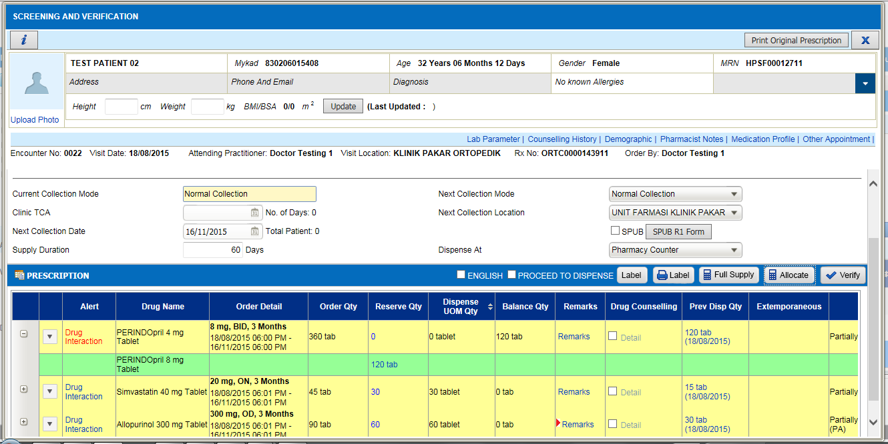
2. Discharge Label | - Discharge medication routed to inpatient pharmacy  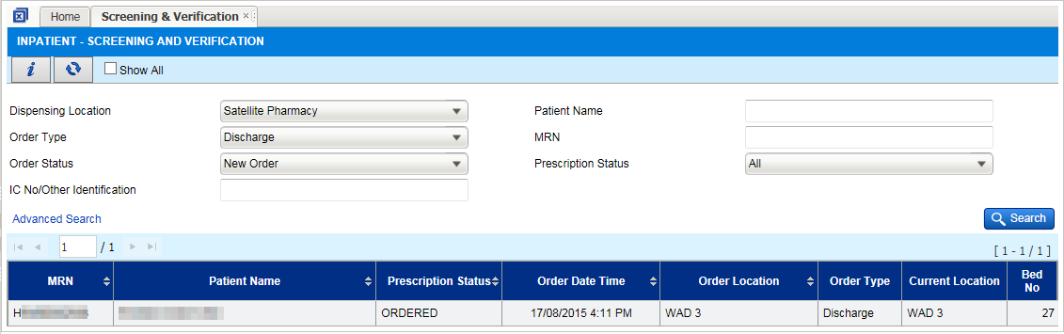  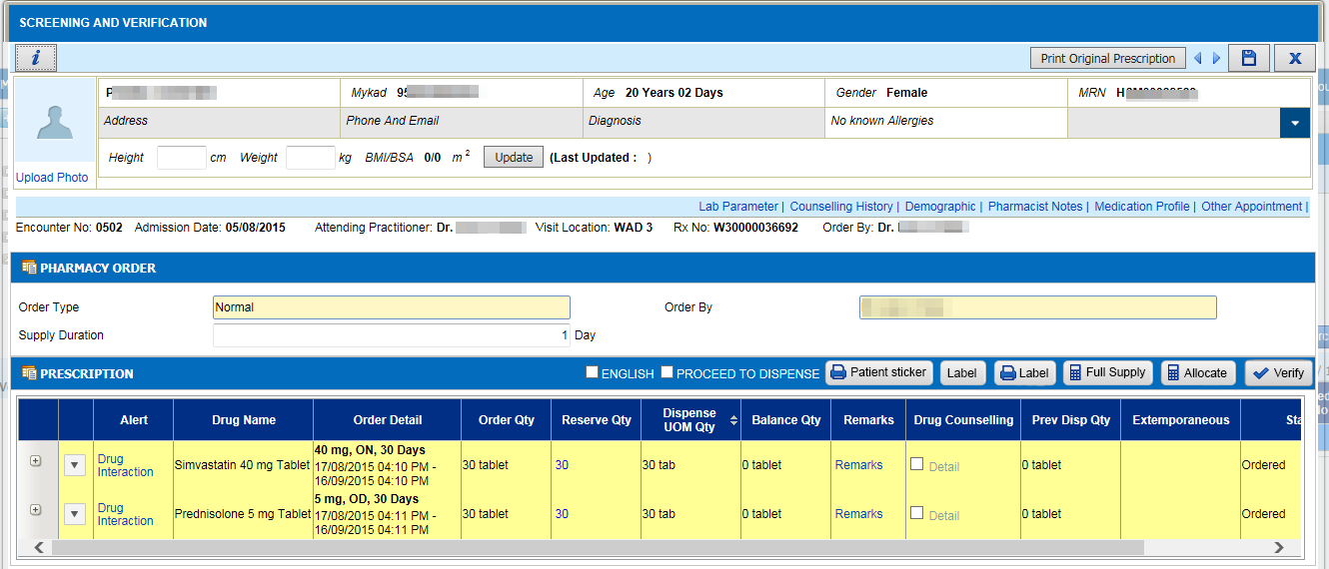  - Discharge label printed in inpatient label format.  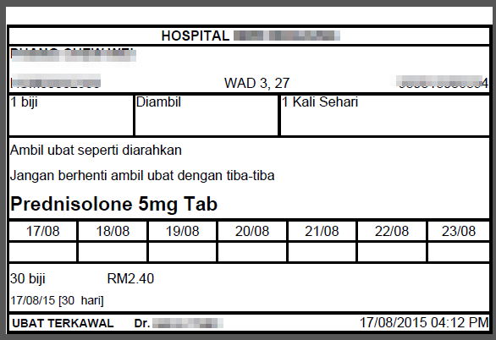 | - Inpatient pharmacy to print outpatient drug label for discharge medication in inpatient screen.  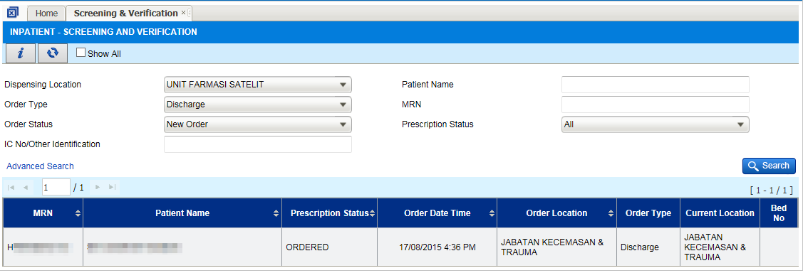  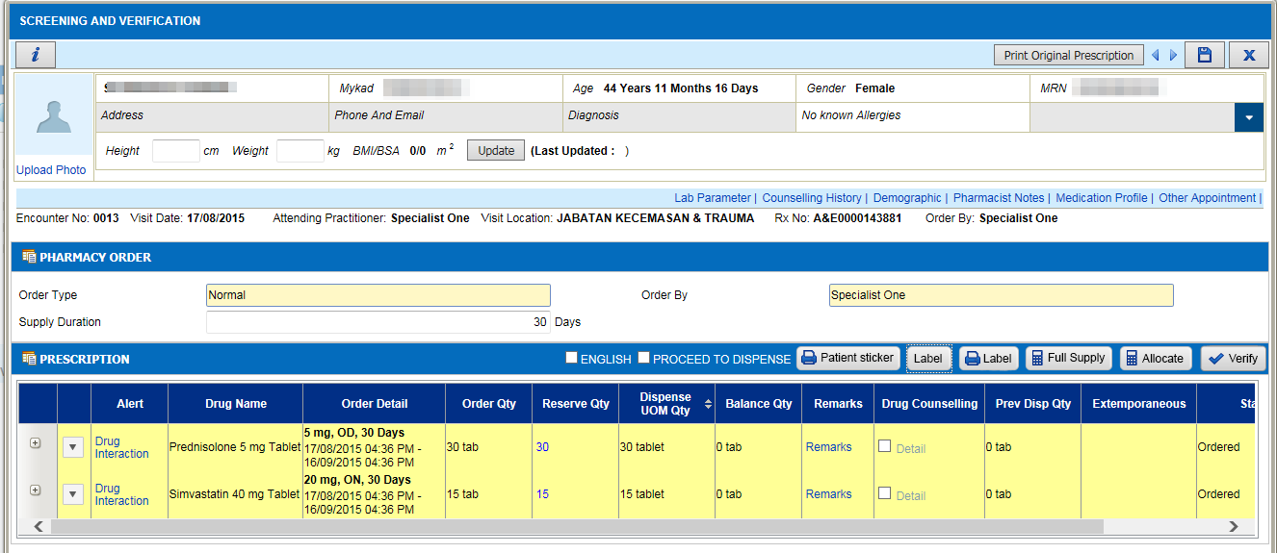  - Discharge label will be printed in outpatient label format.  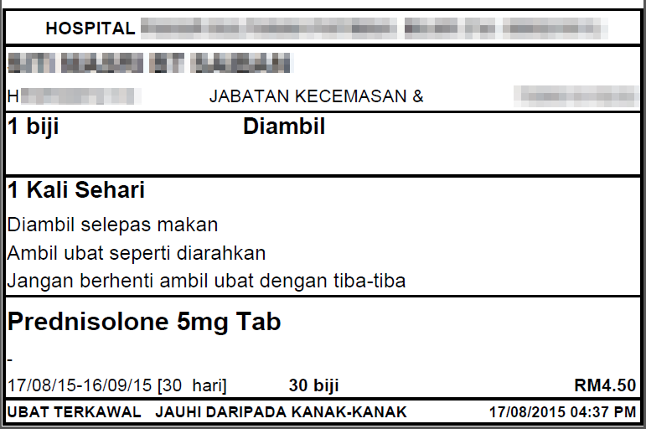
3.  Default Prescriber Name | Cursor defaulted to Drug Name when open Transcribe Order screen after create/select the visit  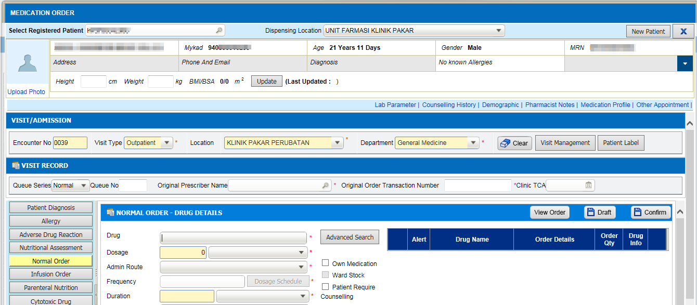 | Cursor defaulted to Prescriber Name when open Transcribe Order screen after create/select the visit  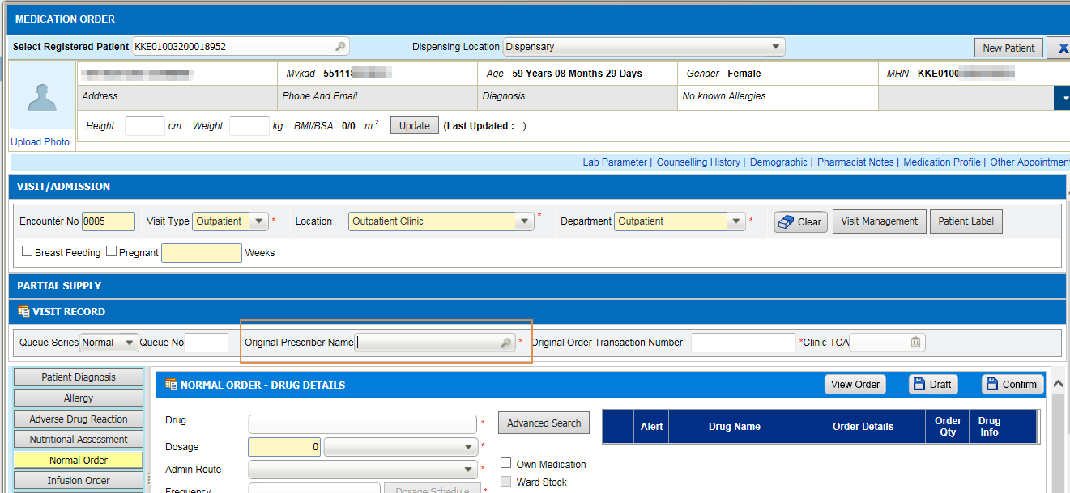  Subsequently, after add the drug, it will be defaulted to drug name.  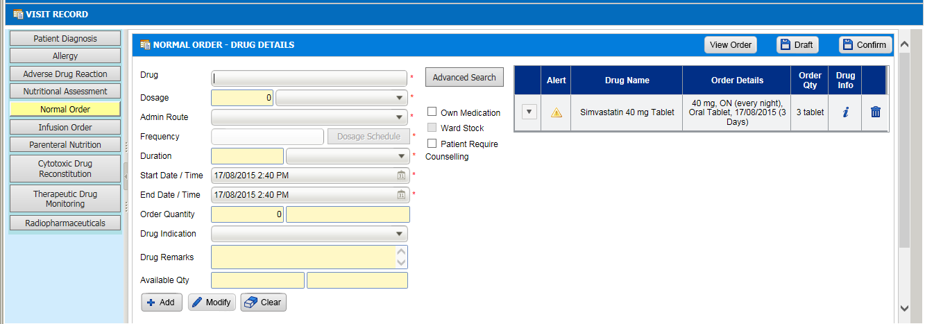
4.  Full Supply in transcribe order | No Full Supply button in Transcribe Order screen. System will allocate based supply duration entered.  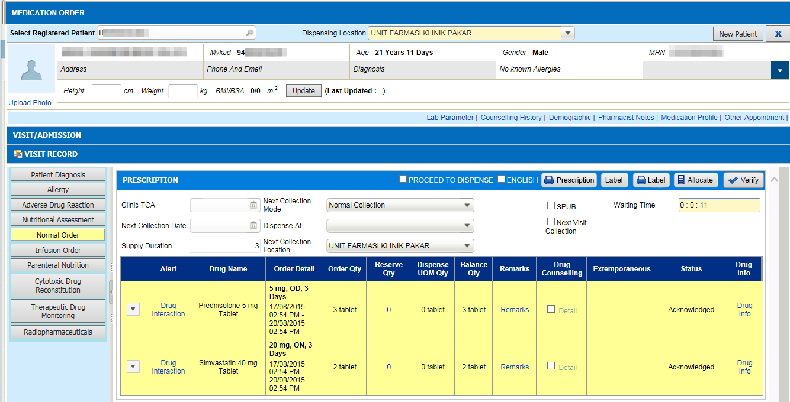 | Add Full Supply button in Transcribe Order screen. System will allocate based quantity ordered when user click on Full Supply button.  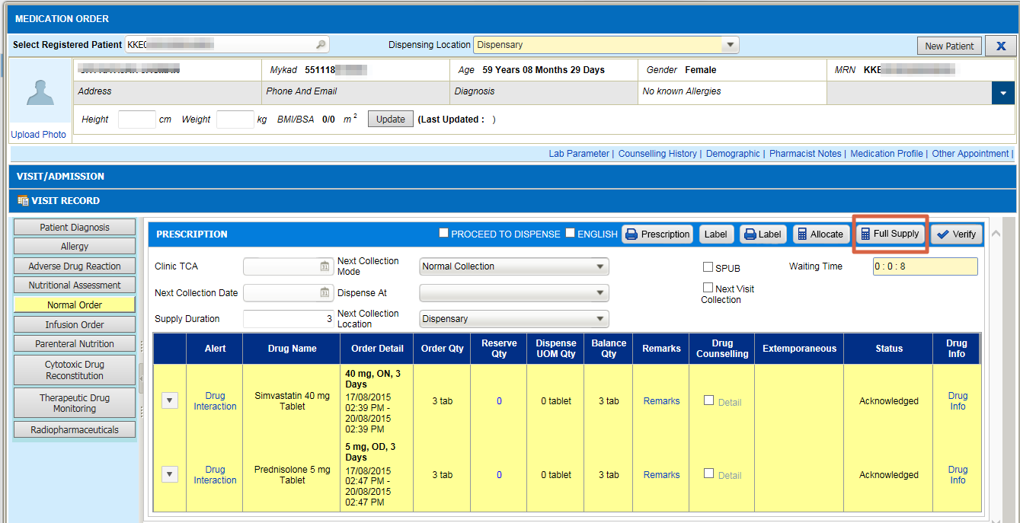
5.  Patient registry - New Filter | 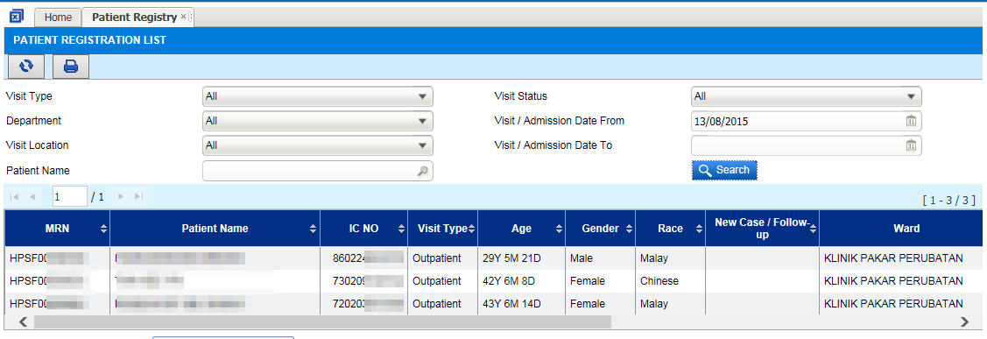 | 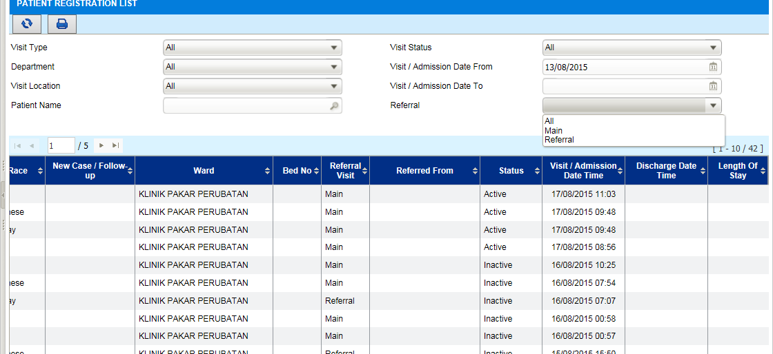  Add new search criteria for user to search by referral visit:  - All - Show all main and referral visit  - Main - Show Main visit only. Hide referral visit from the list  - Referral - Show referral visit only. Hide main visit from the list.

