Function Flow | Prepacking Transaction in current Version 1.3.5 | Prepacking Transaction in new Version 1.3.6
1.  Prepacking – Create New record | 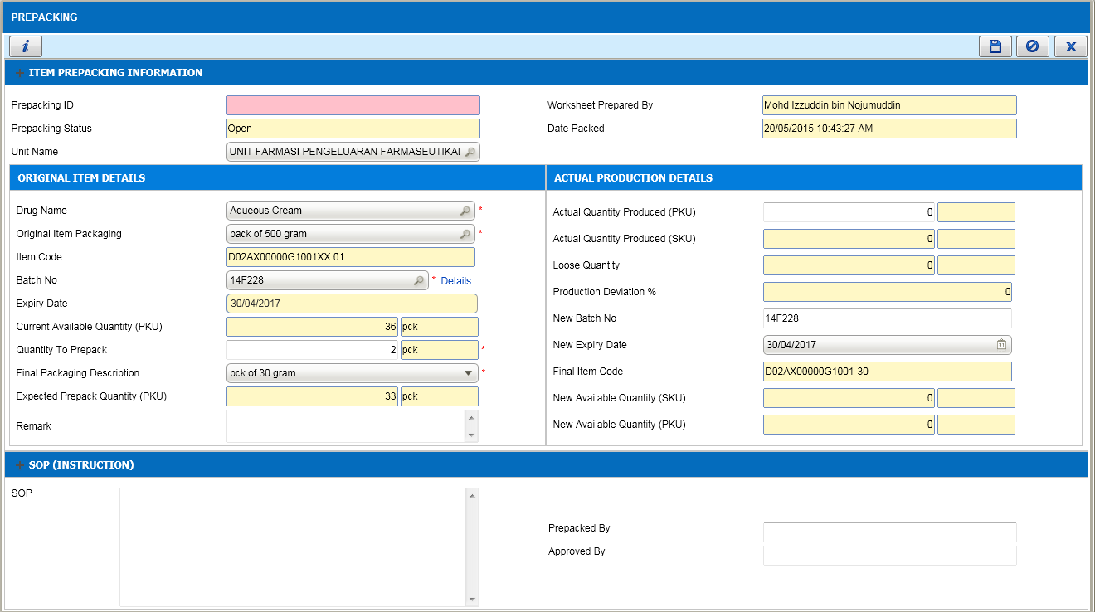  1  - In Prepacking transaction, Current Available Quantity and Quantity to Prepack (1) is always shown in PKU quantity.  5 | 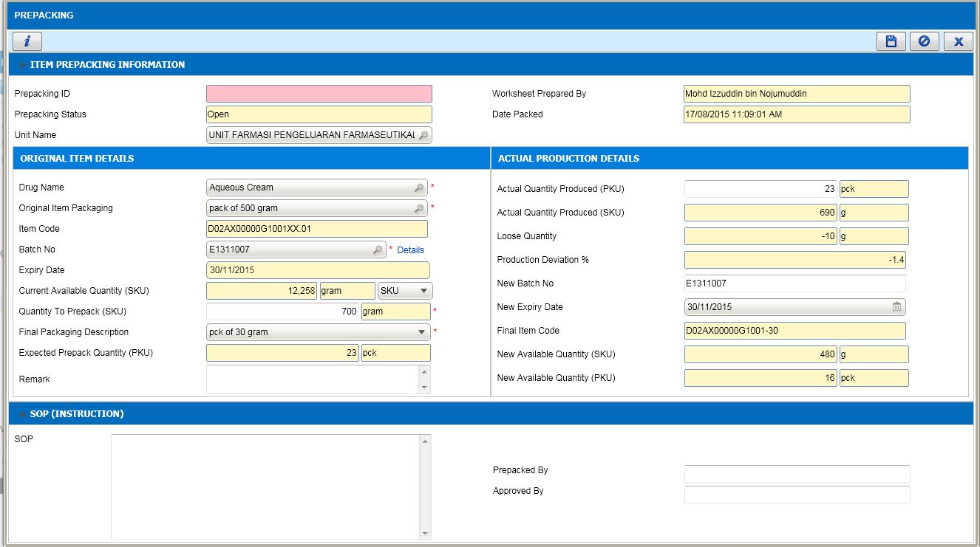  1  - In Prepacking transaction, added function for displaying stock in SKU or PKU quantity. By default, SKU is selected (1).  - Once SKU is selected, Current Available Qty is displayed in SKU Qty and able to enter Quantity to Prepack in SKU Qty. No decimal value allowed.  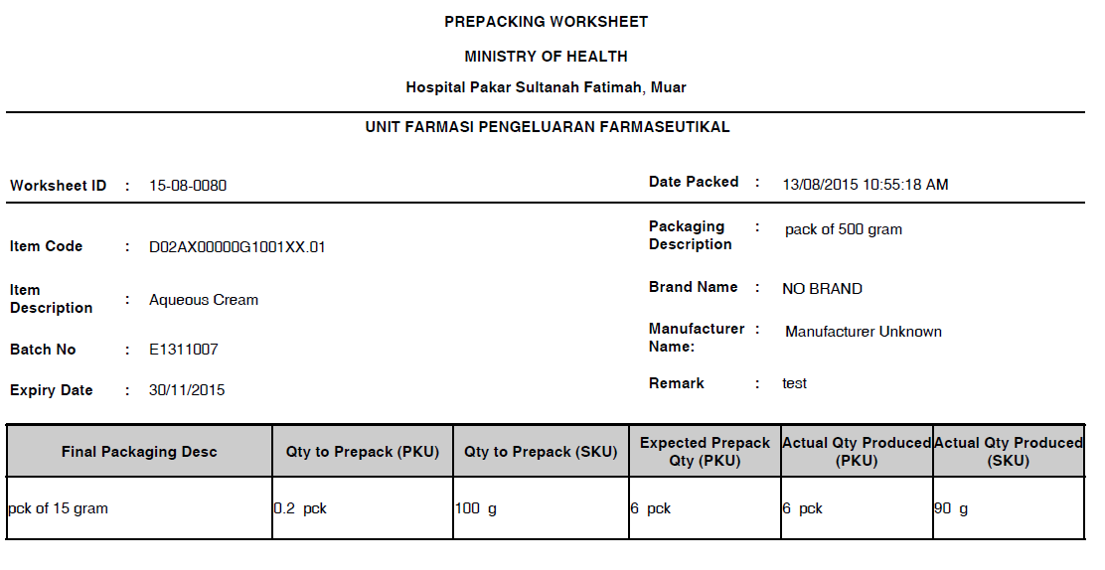  2  - Once SKU is selected, in Worksheet, system will display Qty Prepack (PKU) in decimal as above (if applicable).  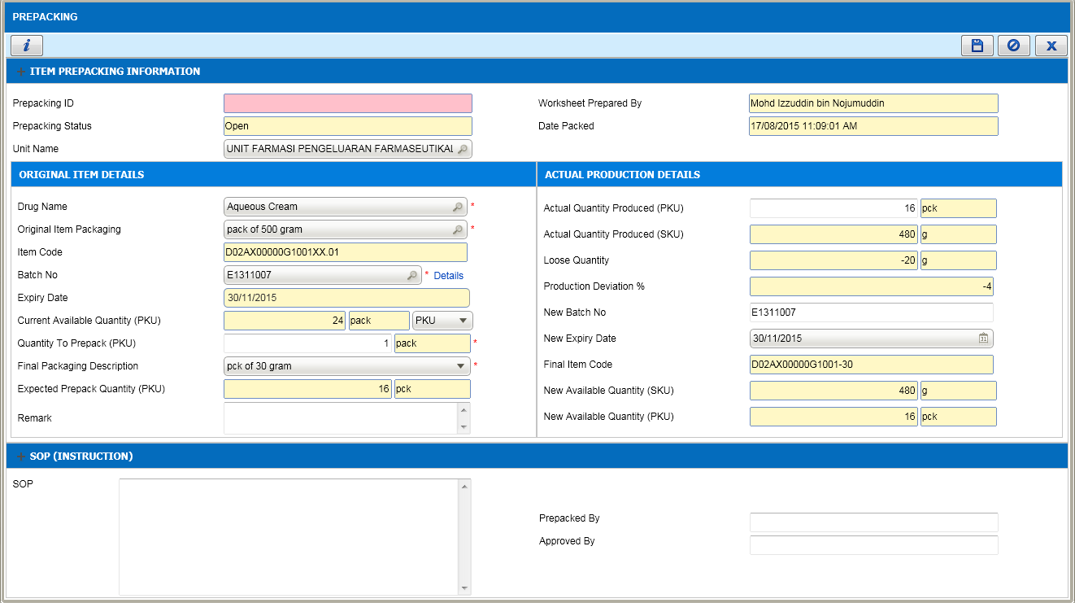  3  - Once PKU is selected, Current Available Qty is displayed in PKU Qty and able to enter Quantity to Prepack in PKU Qty. No decimal value allowed.

