Function Flow | Print Allergy Card in current Version 1.3.5 | Print Allergy Card in Version 1.3.6
1.  Print Allergy Card Screen | - Click on Print Allergy Card Menu  - System will display Print Allergy card listing screen  - Select Patient and tick on the allergies record  - Click Print in Malay or Print in English  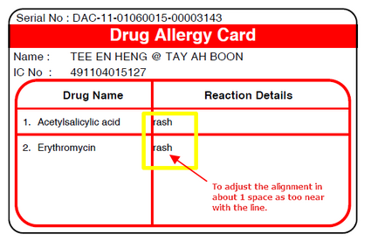 | - Click on Print Allergy Card Menu  - System will display Print Allergy card listing screen  - Select Patient and tick on the allergies record  - Click Print in Malay or Print in English  - Reaction Details column has been align accordingly  