Function Flow | TDM Order – Dosage Decsription in current Version 1.3.5 | TDM Order – Dosage Decsription in Version 1.3.6
1.  TDM Order – Dosage Description | - Open medication order screen – Therapeutic Drug Monitoring  - Select ANY indication request  - Click on TDM Drug and search for All drugs  - ‘All Drugs’ will capture information of Drug from Drug Master including ‘Dosage Desc’  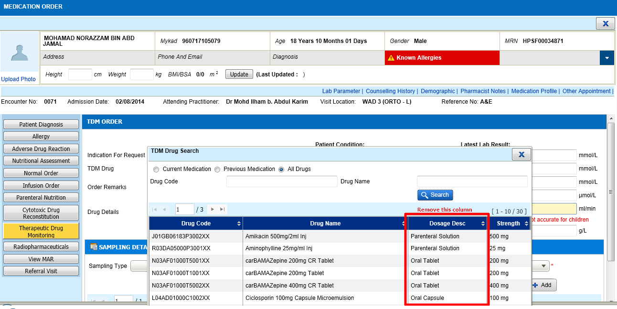 | - Open medication order screen – Therapeutic Drug Monitoring  - Select ANY indication request  - Click on TDM Drug and search for All drugs  - ‘Dosage Desc’ has been removed from the All drug search result.  