Function Flow | TDM Reporting – Toxic Indicator in current Version 1.3.5 | TDM Reporting – Toxic Indicator in Version 1.3.6
1.  TDM Reporting – Toxic Indicator | - Open TDM Reporting listing screen  - User request to display by default both toxic and non-toxic record in the TDM reporting listing screen.  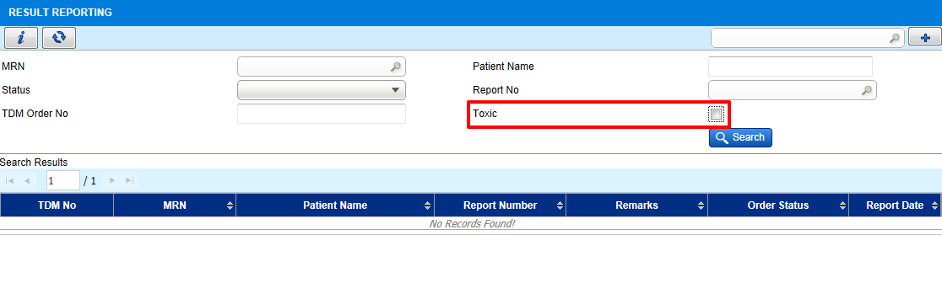 | - Open TDM Reporting listing screen  - Changed toxic check box to drop down field with value:  - All - display all toxic and non toxic record  - Toxic - to filter toxic record only  - Non toxic - to filter Non toxic record only  