Function Flow | Current Version 1.3.4 | New Version 1.3.5
Main page | 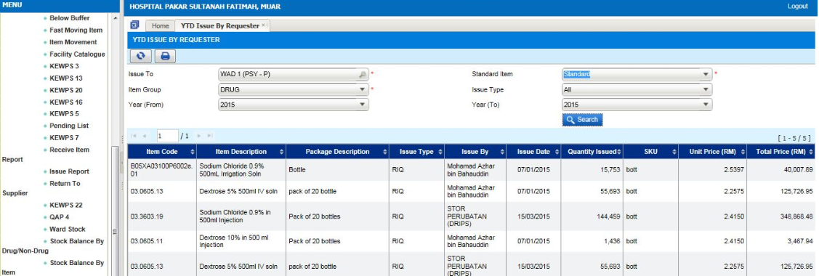  - Select Reports Inventory Stock Transaction  - Select report ‘YTD Issue By Requester’ | 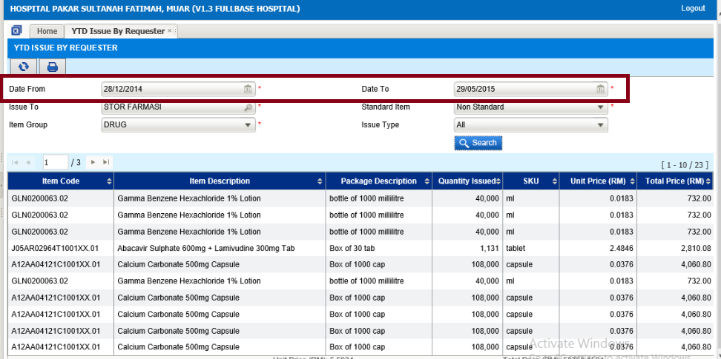  - Select Reports Inventory Stock Transaction  - Select report ‘YTD Issue By Requester’  - At listing page ‘Date From’ & ‘Date To’ is mandatory to key in by the user
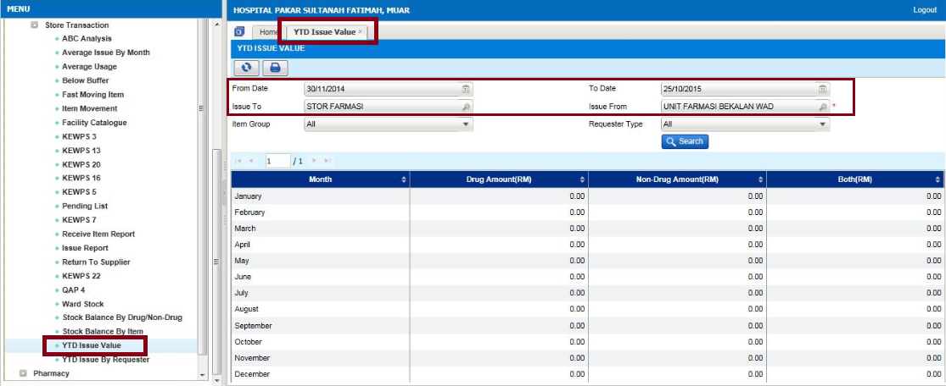
- Select Reports Inventory Stock Transaction
- Report name at menu change from ‘YTD Issue By Month’ to ‘YTD Issue Value’
- Add on ‘Date From’ & ‘Date To’ searching function
- Change label ‘Requester Name’ to ‘Issue To’
- Change label ‘Supplying Unit’ to ‘Issue From’ and this field is mandatory
- Remove field ‘Financial Year’
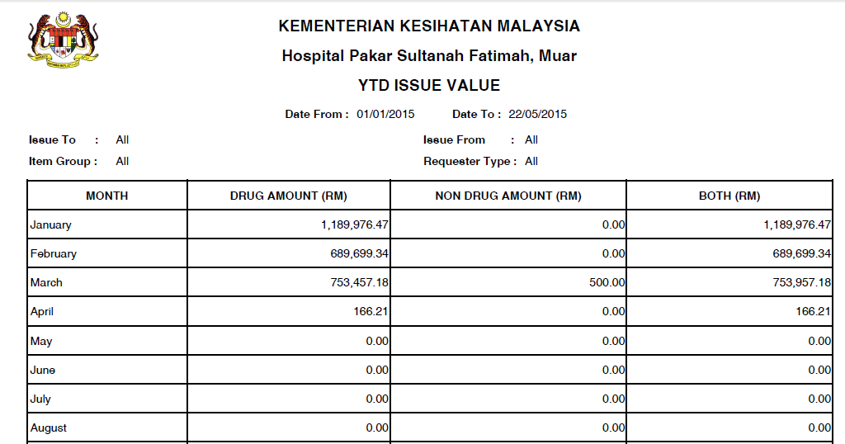
- Click button print
- Report layout as per display

