Function Flow | Current Version 1.3.4 | New Version 1.3.5
Main page | 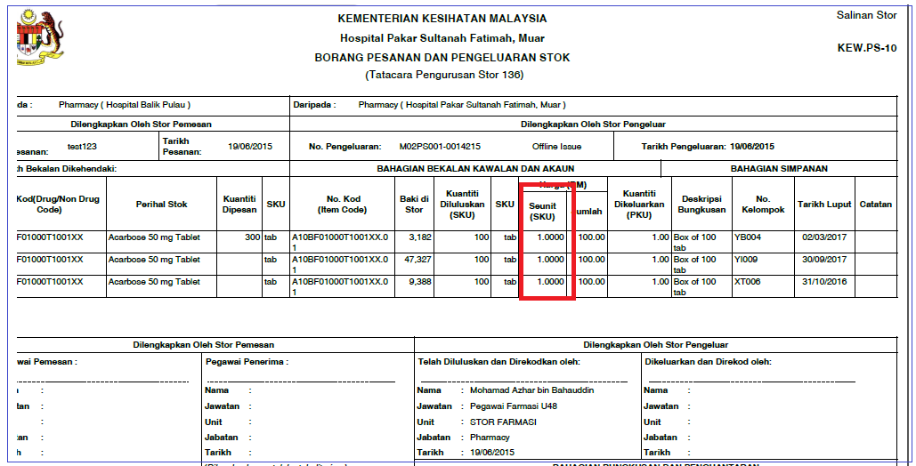  - Login as level 1 user (Main Store)  - Go to Store Inventory Issue Offline Issue  - Issue Type = External Facility  - Performed offline issue and Generate Issue Note (KEWPS 10)  - The average price is referring to Drug Average Price | 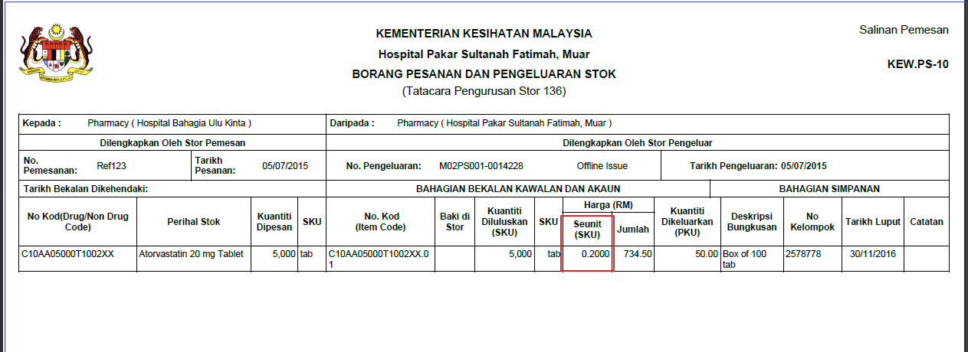  - Login as level 1 user (Main Store)  - Go to Store Inventory Issue Offline Issue  - Issue Type = External Facility  - Performed offline issue and Generate Issue Note (KEWPS 10)  - The average price now change to ‘Item Average Price’
Main page |  | 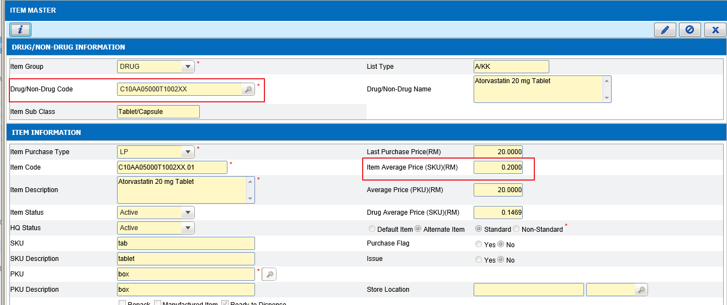  - Go to maintenance screen Item Master screen  - Searh for the item code.  - System will display Item average price and Drug average price  - Item average price will be captured in KEWPS 10

