Function Flow | Current Version 1.3.4 | New Version 1.3.5
Main page | 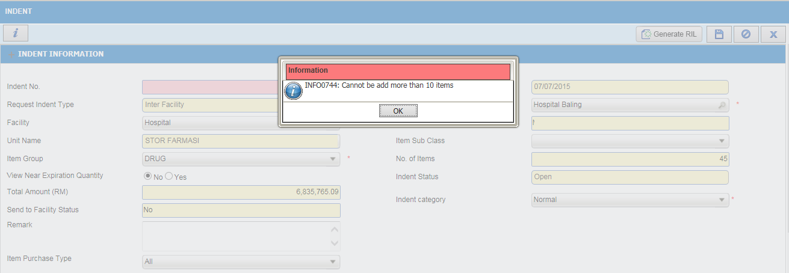  - Login as level 1 user (Main Store)  - Go to Store Transaction Indent  - Select External Indent  - Select External Facility, Select Generate RIL , system will list all the drug which is below buffer leve from product buffer level.  - When click button ‘SAVE’ system will prompt , can’t be more than 10 items | 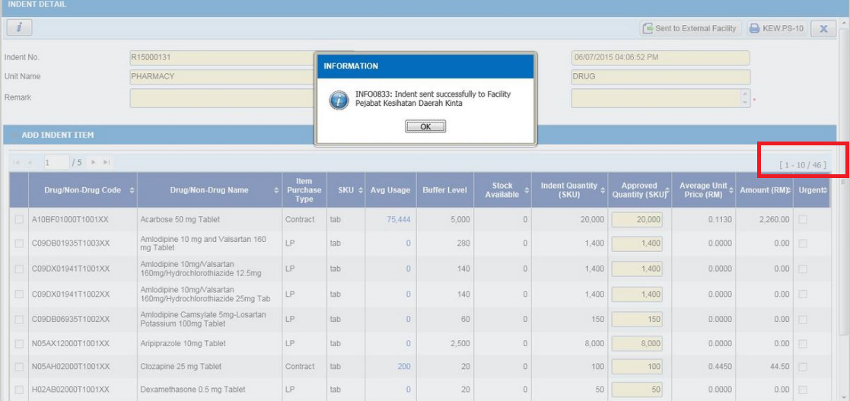  - Login as level 1 user (Main Store)  - Go to Store Transaction Indent  - Select External Indent  - Generate RIL , system will list all the drug which is below buffer leve from product buffer level.  - While click button ‘SAVE’, System will check is the facility PTJ code same PTJ code with the ‘Send Indent To Facility’:  - If Yes , system will allow to save more than 10 items  - IF No, system will not allow to save more than 10 items
 | 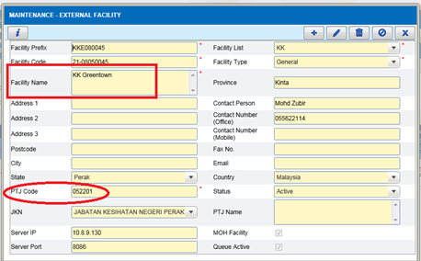  - External Facility screen (Indenter Facility) | - External Facility screen (Indenter Facility)
 | 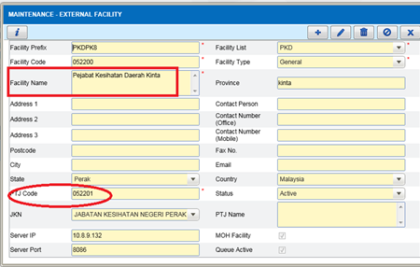  - External Facility screen (Suppying Facility) | - External Facility screen (Suppying Facility)

