Function Flow | Current Version 1.3.4 | New Version 1.3.5
Main page | 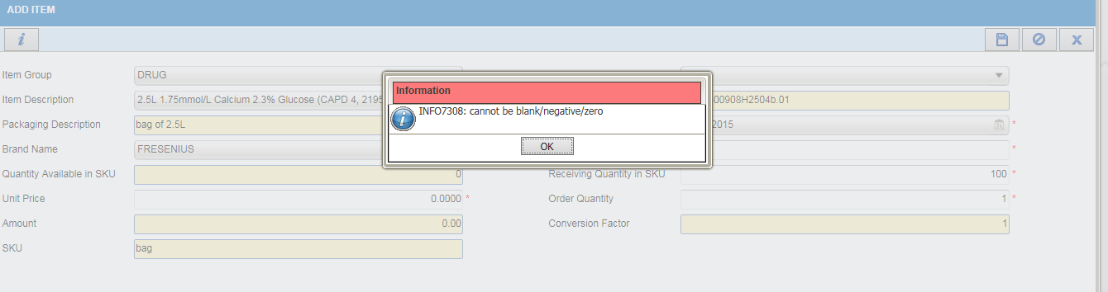  - Login as level 1 user (Main Store)  - Go to Store Inventory Receive Item Click Receive Inter Facility  - Select option ‘Manual’  - Column Unit Price is mandatory | 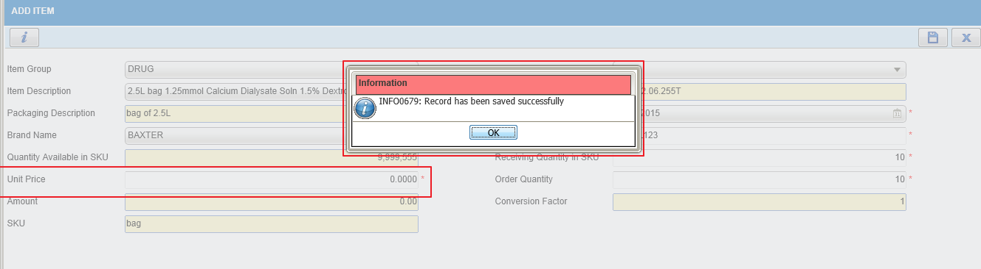  - Login as level 1 user (Main Store)  - Go to Store Inventory Receive Item Click Receive Inter Facility  - Select option ‘Manual’  - Column Unit Price is mandatory and allow to key in ‘0.0000’ value

