Function Flow | Current Version 1.3.4 | New Version 1.3.5
Main page | 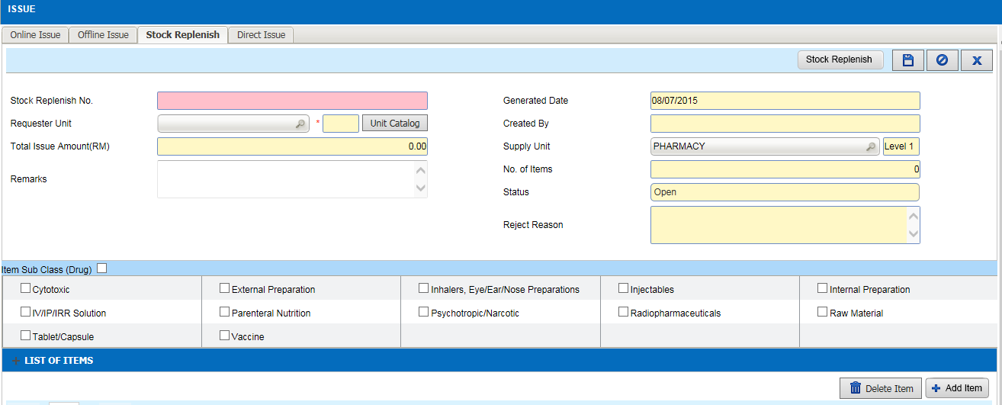  - At Facility type = Clinic  - Login as Main Store user  - Select Store Inventory Store Transaction Issue  - Select Stock Replenish  - No option to select UOM. The backend default to SKU | 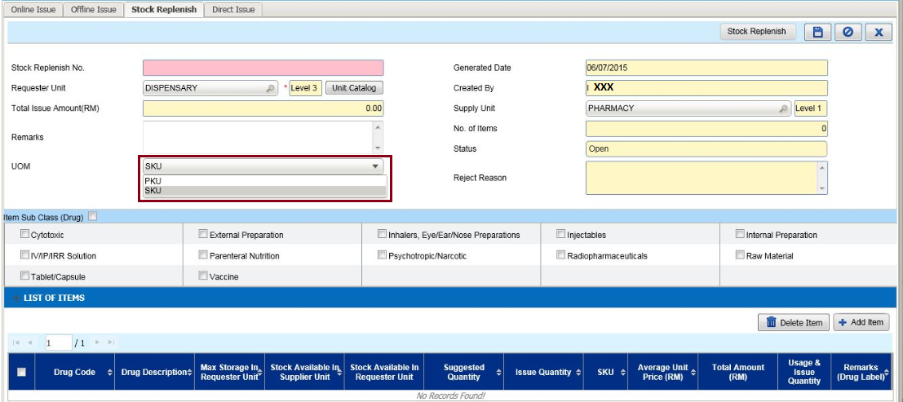  - At Facility type = Clinic  - Login as Main Store user  - Select Store Inventory Store Transaction Issue  - Select Stock Replenish  - UOM have 2 option which is ‘PKU’ & ‘SKU’
 | 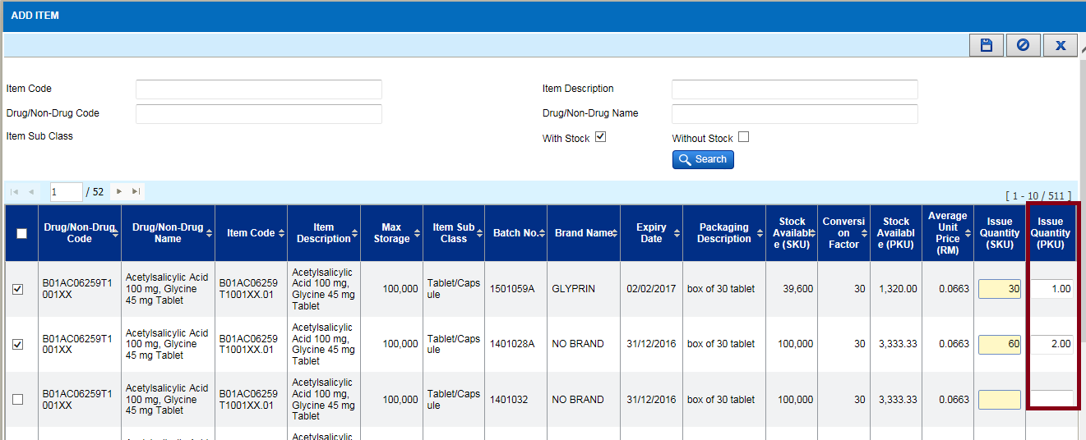  - At Facility type = Clinic  - Login as Main Store user  - Select Store Inventory Store Transaction Issue  - Select Stock Replenish  - User only able to key in quantity in PKU | 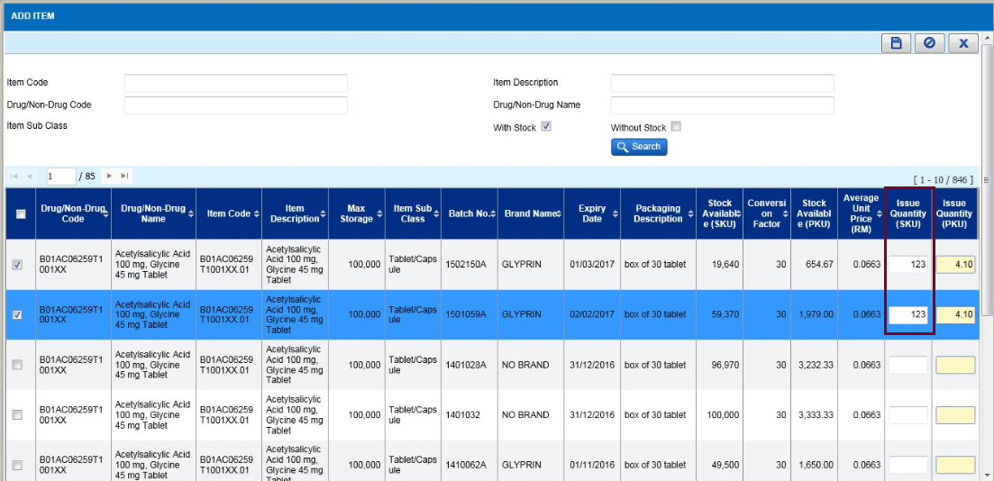  - At Facility type = Clinic  - Login as Main Store user  - Select Store Inventory Store Transaction Issue  - Select Stock Replenish  - UOM have 2 option which is ‘PKU’ & ‘SKU’  - When select UOM = SKU , user able to key in quantity in SKU

